

Meta Ads Performance Audit
Client: NeedleFree (Comfort-In)
Campaign: PA - Sales - LP - All - CBO - 17.1
Period: 17 February 2026 – 23 February 2026

Executive Summary
The NeedleFree (Comfort-In) campaign is delivering solid results with a blended CPP of $10.30 across 44 purchases. Total ad spend for the period was $453.41 with an average CTR of 2.97%. The top performer achieved a CPP of $0.24 ((22-12-2025) - (5)). CTR is within healthy range for e-commerce campaigns.

Key Metrics
Period | Spend | Purchases | CPP | CTR
This Week | $453.41 | 44 | $10.30 | 2.97%
This Month | $1,821.60 | 158 | $11.53 | 3.24%
Since Starting | $4,566.36 | 401 | $11.39 | 4.17%

Latest Batch — Top Performers
# | Release Lot | CPP | Purchases | CTR | Ad ID | Preview
🔥 | Feb-18 | $0.72 | 4 | 0.99% | ...620653771 | 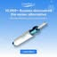
2 | Feb-18 | $0.76 | 4 | 2.24% | ...620609971 | 
⭐ | Feb-18 | $1.10 | 2 | 4.67% | ...620573371 | 
4 | Feb-18 | $1.64 | 6 | 1.97% | ...621951571 | 
5 | Feb-18 | $3.21 | 4 | 1.39% | ...621951971 | 

Top 5 Performers by CPP — All Time
# | Release Lot | CPP | Purchases | CTR | Ad ID | Preview
🔥 | Dec-22 | $0.24 | 22 | 2.31% | ...434619171 | 
2 | Feb-10 | $0.28 | 6 | 1.02% | ...790733771 | 
⭐ | Jan-7 | $0.52 | 4 | 2.68% | ...925871771 | 
4 | Jan-20 | $0.57 | 4 | 0.73% | ...245221971
5 | Feb-18 | $0.72 | 4 | 0.99% | ...620653771
🔥 = Top performer | ⭐ = Volume star | Sorted by cost per conversion (lowest first)

Release Lot Performance
• Dec-22 Release: 22 conversions from 1 ad(s) – Best cost: $0.24
• Feb-10 Release: 6 conversions from 1 ad(s) – Best cost: $0.28
• Jan-07 Release: 4 conversions from 1 ad(s) – Best cost: $0.52
• Jan-20 Release: 4 conversions from 1 ad(s) – Best cost: $0.57
• Feb-18 Release: 4 conversions from 1 ad(s) – Best cost: $0.72

Creative Insights
Top Performer:
(22-12-2025) - (5) – 22 conversions at $0.24 cost, 2.31% CTR
Runner Up:
(10-02-2026) - (1) – 6 conversions at $0.28 cost, 1.02% CTR

Demographic Sweet Spot
• Male 25-34: 32 purchases, $4.93 CPP, 2.45% CTR
• Male 35-44: 26 purchases, $6.54 CPP, 3.02% CTR
• Male 45-54: 12 purchases, $6.16 CPP, 3.32% CTR

Key Insights
What's Working:
✓ Strong overall purchase volume with 44 conversions at an efficient $10.30 cost per purchase
✓ Healthy click-through rate of 2.97%, indicating compelling ad creative and targeting
✓ Ad set from 22-12-2025 performing exceptionally well with 22 purchases at a very low $0.24 cost

Opportunities:
→ Significant performance variance between top ad set ($0.24 CPA) and others ($0.28-$0.52 CPA) suggests room for optimisation
→ Lower CTR (1.02%) in the second-best performing ad set indicates potential creative fatigue
→ Scale potential exists given the strong conversion metrics across multiple ad sets

Recommended Next Steps
▸ Analyse creative elements and audience targeting from the top-performing 22-12-2025 ad set to replicate success across other sets
▸ Create fresh ad variations based on the best-performing creative to combat potential ad fatigue
▸ Gradually increase budget allocation to the top-performing ad set while maintaining efficiency metrics

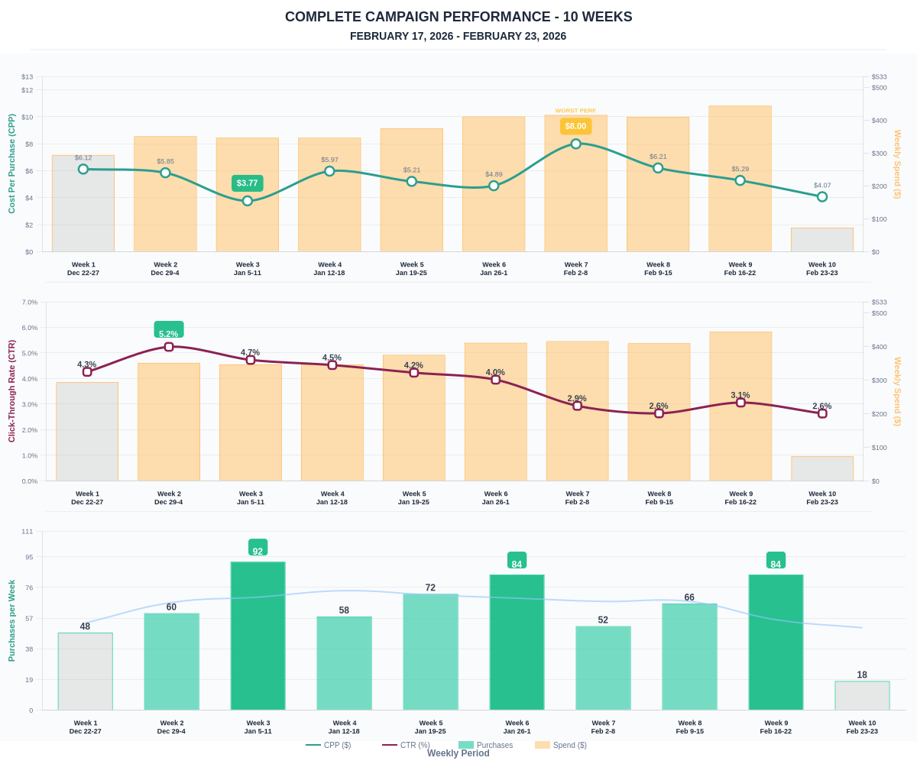

Questions? Let's chat about scaling these results.

