

Meta Ads Performance Audit
Client: NeedleFree (Comfort-In)
Campaign: PA - Sales - LP - All - CBO - 17.1
Period: 23 February 2026 – 1 March 2026

Executive Summary
The NeedleFree (Comfort-In) campaign is delivering solid results with a blended CPP of $15.14 across 32 purchases. Total ad spend for the period was $484.59 with an average CTR of 2.56%. The top performer achieved a CPP of $0.20 ((10-02-2026) - (2)). CTR is within healthy range for e-commerce campaigns.

Key Metrics
Period | Spend | Purchases | CPP | CTR
This Week | $484.59 | 32 | $15.14 | 2.56%
This Month | $1,875.01 | 145 | $12.93 | 2.91%
Since Starting | $4,977.63 | 424 | $11.74 | 4.04%

Latest Batch — Top Metrics
# | Release Lot | Spend | CPM | CTR | Ad ID | Preview
🔥 | Feb-28 | $1.28 | $33.68 | 2.63% | ...749565771 | 
2 | Feb-28 | $1.05 | $25.00 | 2.38% | ...749607571 | 
⭐ | Feb-28 | $0.58 | $19.33 | 0.00% | ...749568771 | 
4 | Feb-28 | $0.35 | $21.88 | 6.25% | ...749584571 | 
5 | Feb-28 | $0.29 | $16.11 | 0.00% | ...749525971 | 

Top 5 Performers by CPP — All Time
# | Release Lot | CPP | Purchases | CTR | Ad ID | Preview
🔥 | Feb-10 | $0.20 | 4 | 2.27% | ...790733571 | 
2 | Dec-22 | $0.25 | 22 | 2.47% | ...434619171 | 
⭐ | Feb-10 | $0.43 | 6 | 1.45% | ...790733771 | 
4 | Jan-7 | $0.53 | 4 | 2.56% | ...925871771 | 
5 | Jan-20 | $0.57 | 4 | 0.72% | ...245221971 | 
🔥 = Top performer | ⭐ = Volume star | Sorted by cost per conversion (lowest first)

Release Lot Performance
• Feb-10 Release: 10 conversions from 2 ad(s) – Best cost: $0.20
• Dec-22 Release: 22 conversions from 1 ad(s) – Best cost: $0.25
• Jan-07 Release: 4 conversions from 1 ad(s) – Best cost: $0.53
• Jan-20 Release: 4 conversions from 1 ad(s) – Best cost: $0.57

Creative Insights
Top Performer:
(10-02-2026) - (2) – 4 conversions at $0.20 cost, 2.27% CTR
Runner Up:
(22-12-2025) - (5) – 22 conversions at $0.25 cost, 2.47% CTR

Demographic Sweet Spot
• Male 35-44: 26 purchases, $7.06 CPP, 2.46% CTR
• Male 25-34: 20 purchases, $8.65 CPP, 2.17% CTR
• Male 45-54: 18 purchases, $4.14 CPP, 3.25% CTR

Key Insights
What's Working:
✓ Strong overall conversion rate with 32 purchases achieved at an efficient cost per purchase of $15.14
✓ Healthy CTR of 2.56% indicates compelling ad creative and targeting relevance
✓ Ad set (22-12-2025) - (5) performing exceptionally well with 22 purchases at a low cost of $0.25
✓ Multiple ad sets showing consistent performance with purchase activity, suggesting good campaign structure

Opportunities:
→ Significant variation in cost per purchase between top performers ($0.20 vs $0.43) indicates room for budget optimisation
→ Some ad sets showing lower CTR (1.45%) could benefit from creative refreshes
→ Scale potential exists given the strong performance of top ad sets
→ Impression to purchase ratio suggests opportunity to improve targeting efficiency

Recommended Next Steps
▸ Reallocate budget towards the best-performing ad set (22-12-2025) - (5) to maximise ROI
▸ Create new ad variations based on the creative elements of the 2.27% CTR performer
▸ Conduct audience analysis of top-performing ad sets to identify common characteristics for scaling
▸ Test increasing daily budget by 20% on ads with CPP below $0.30 to capture more conversions

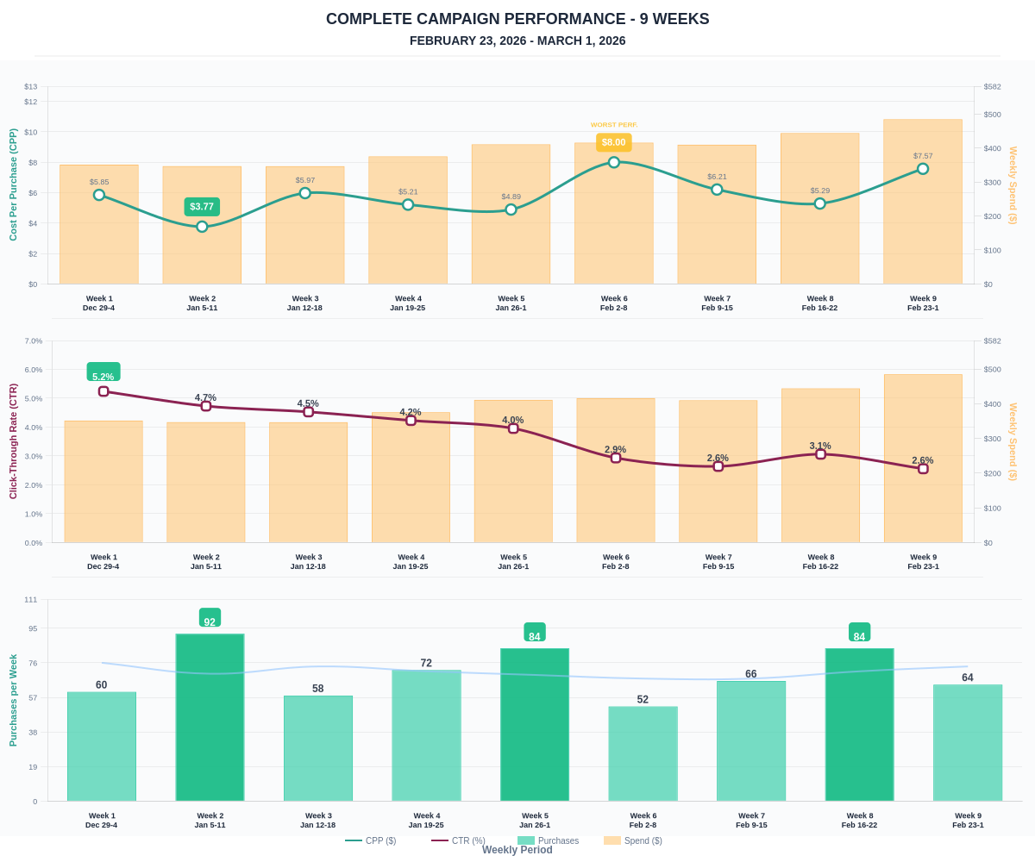

Questions? Let's chat about scaling these results.

