

Meta Ads Performance Audit
Client: NeedleFree (Comfort-In)
Campaign: PA - Sales - LP - All - CBO - 17.1
Period: 1 March 2026 – 4 March 2026

Executive Summary
The NeedleFree (Comfort-In) campaign is delivering solid results with a blended CPP of $18.90 across 13 purchases. Total ad spend for the period was $245.76 with an average CTR of 2.77%. The top performer achieved a CPP of $0.20 ((10-02-2026) - (2)). CTR is within healthy range for e-commerce campaigns.

Key Metrics
Period | Spend | Purchases | CPP | CTR
This Week | $245.76 | 13 | $18.90 | 2.77%
This Month | $1,875.21 | 143 | $13.11 | 2.78%
Since Starting | $5,157.54 | 435 | $11.86 | 3.99%

Latest Batch — Top Metrics
# | Release Lot | Spend | CPM | CTR | Ad ID | Preview
🔥 | Feb-28 | $4.13 | $15.88 | 3.85% | ...736857971 | 
2 | Feb-28 | $3.73 | $27.63 | 5.93% | ...749584571
⭐ | Feb-28 | $3.13 | $27.95 | 1.79% | ...749577771
4 | Feb-28 | $1.55 | $20.67 | 2.67% | ...749607571
5 | Feb-28 | $1.39 | $14.48 | 1.04% | ...749525771

Top 5 Performers by CPP — All Time
# | Release Lot | CPP | Purchases | CTR | Ad ID | Preview
🔥 | Feb-10 | $0.20 | 4 | 2.17% | ...790733571
2 | Dec-22 | $0.25 | 22 | 2.47% | ...434619171
⭐ | Feb-10 | $0.53 | 6 | 1.27% | ...790733771
4 | Jan-7 | $0.53 | 4 | 2.54% | ...925871771
5 | Jan-20 | $0.57 | 4 | 0.72% | ...245221971
🔥 = Top performer | ⭐ = Volume star | Sorted by cost per conversion (lowest first)

Release Lot Performance
• Feb-10 Release: 10 conversions from 2 ad(s) – Best cost: $0.20
• Dec-22 Release: 22 conversions from 1 ad(s) – Best cost: $0.25
• Jan-07 Release: 4 conversions from 1 ad(s) – Best cost: $0.53
• Jan-20 Release: 4 conversions from 1 ad(s) – Best cost: $0.57

Creative Insights
Top Performer:
(10-02-2026) - (2) – 4 conversions at $0.20 cost, 2.17% CTR
Runner Up:
(22-12-2025) - (5) – 22 conversions at $0.25 cost, 2.47% CTR

Demographic Sweet Spot
• Male 35-44: 8 purchases, $11.71 CPP, 2.96% CTR
• Male 45-54: 8 purchases, $5.37 CPP, 3.40% CTR
• Female 25-34: 4 purchases, $1.00 CPP, 6.38% CTR

Key Insights
What's Working:
✓ Strong overall CTR of 2.77% indicates compelling ad creative and targeting resonating with audience
✓ Cost per purchase at $18.90 shows efficient conversion rate for e-commerce in the medical device category
✓ Top performing ad sets demonstrate potential for scaling, particularly the set achieving 4 purchases at just $0.20 cost
✓ Consistent daily purchase volume suggests stable audience demand and reliable conversion path

Opportunities:
→ Significant variation in cost per purchase between top performers ($0.20 vs $0.53) indicates room for budget optimisation
→ CTR difference between top performers (2.17% vs 1.27%) suggests opportunity to analyse and replicate successful creative elements
→ Total impression count could be increased to capture more market share while maintaining current efficiency
→ Purchase volume varies notably between ad sets, indicating potential for audience refinement

Recommended Next Steps
▸ Reallocate budget towards the best-performing ad set (10-02-2026 - 2) with $0.20 cost per purchase to maximise efficiency
▸ Analyse creative elements and audience targeting from highest CTR ad sets to create new variations for testing
▸ Implement automated rules to adjust budgets based on cost per purchase thresholds of $0.20-$0.25
▸ Create lookalike audiences based on recent purchasers to expand reach while maintaining conversion quality

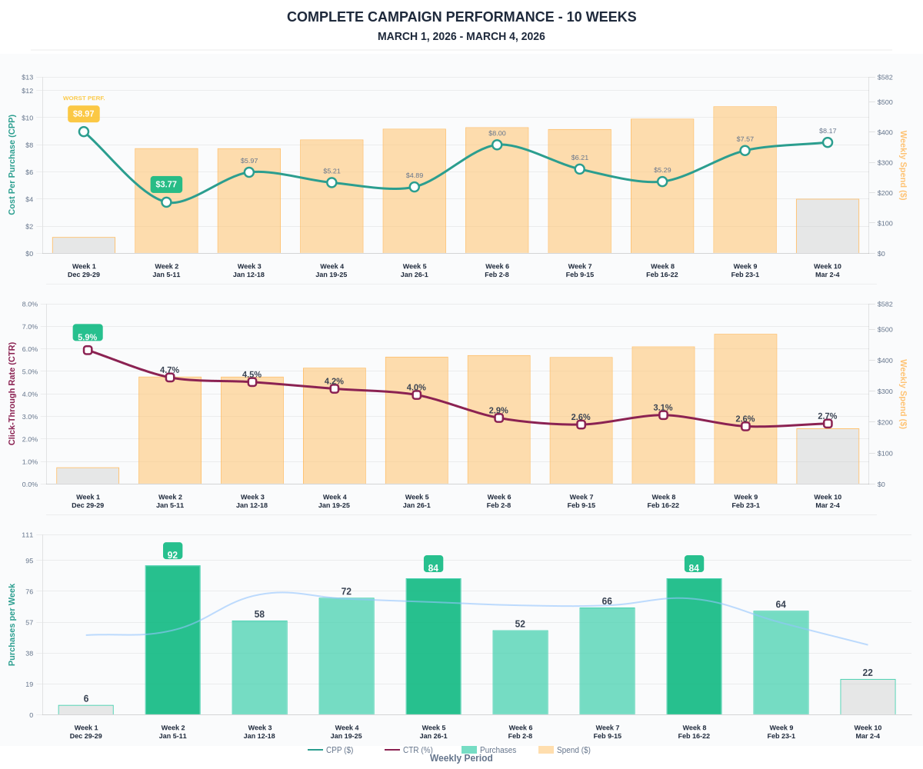

Questions? Let's chat about scaling these results.

