

Meta Ads Performance Audit
Client: NeedleFree (Comfort-In)
Campaign: PA - Sales - LP - All - CBO - 17.1
Period: 2 March 2026 – 8 March 2026

Executive Summary
The NeedleFree (Comfort-In) campaign is delivering solid results with a blended CPP of $19.02 across 26 purchases. Total ad spend for the period was $494.63 with an average CTR of 2.47%. The top performer achieved a CPP of $0.25 ((22-12-2025) - (5)). CTR is within healthy range for e-commerce campaigns.

Key Metrics
Period | Spend | Purchases | CPP | CTR
This Week | $494.63 | 26 | $19.02 | 2.47%
This Month | $1,954.32 | 141 | $13.86 | 2.71%
Since Starting | $5,472.36 | 450 | $12.16 | 3.89%

Latest Batch — Top Metrics
# | Release Lot | Spend | CPM | CTR | Ad ID | Preview
🔥 | Feb-28 | $14.67 | $16.03 | 2.73% | ...736857971 | 
2 | Feb-28 | $6.30 | $24.14 | 4.60% | ...749584571 | 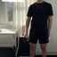
⭐ | Feb-28 | $5.38 | $24.79 | 1.38% | ...749577771 | 
4 | Feb-28 | $1.90 | $20.21 | 2.13% | ...749607571 | 
5 | Feb-28 | $1.71 | $15.55 | 0.91% | ...749525771 | 

Top 5 Performers by CPP — All Time
# | Release Lot | CPP | Purchases | CTR | Ad ID | Preview
🔥 | Dec-22 | $0.25 | 22 | 2.45% | ...434619171 | 
2 | Feb-10 | $0.25 | 4 | 1.67% | ...790733571 | 
⭐ | Jan-7 | $0.56 | 4 | 2.40% | ...925871771 | 
4 | Feb-10 | $0.57 | 6 | 1.19% | ...790733771 | 
5 | Jan-20 | $0.58 | 4 | 0.71% | ...245221971 | 
🔥 = Top performer | ⭐ = Volume star | Sorted by cost per conversion (lowest first)

Release Lot Performance
• Dec-22 Release: 22 conversions from 1 ad(s) – Best cost: $0.25
• Feb-10 Release: 10 conversions from 2 ad(s) – Best cost: $0.25
• Jan-07 Release: 4 conversions from 1 ad(s) – Best cost: $0.56
• Jan-20 Release: 4 conversions from 1 ad(s) – Best cost: $0.58

Creative Insights
Top Performer:
(22-12-2025) - (5) – 22 conversions at $0.25 cost, 2.45% CTR
Runner Up:
(10-02-2026) - (2) – 4 conversions at $0.25 cost, 1.67% CTR

Demographic Sweet Spot
• Male 35-44: 22 purchases, $8.79 CPP, 2.56% CTR
• Male 45-54: 10 purchases, $8.41 CPP, 3.20% CTR
• Female 25-34: 6 purchases, $1.29 CPP, 3.76% CTR

Key Insights
What's Working:
✓ Strong overall purchase volume with 26 conversions at an efficient $19.02 cost per purchase, indicating effective targeting and ad relevance
✓ Healthy CTR of 2.47% showing above-average ad engagement and compelling creative performance
✓ Ad set (22-12-2025) - (5) demonstrating exceptional efficiency with 22 purchases at just $0.25 cost per result

Opportunities:
→ Significant performance variance between top and lower-performing ad sets suggests room for budget optimisation
→ Potential to scale successful ad sets given the strong cost per purchase metrics
→ Room to improve conversion rates from clicks to purchases (26 purchases from 942 clicks indicates potential landing page optimisation needs)

Recommended Next Steps
▸ Reallocate budget from lower-performing ad sets to the top performer (22-12-2025) - (5) to maximise ROI
▸ Create lookalike audiences based on purchasers from the best-performing ad set to expand reach while maintaining efficiency
▸ Analyse landing page metrics and implement A/B testing to improve the 2.76% click-to-purchase conversion rate

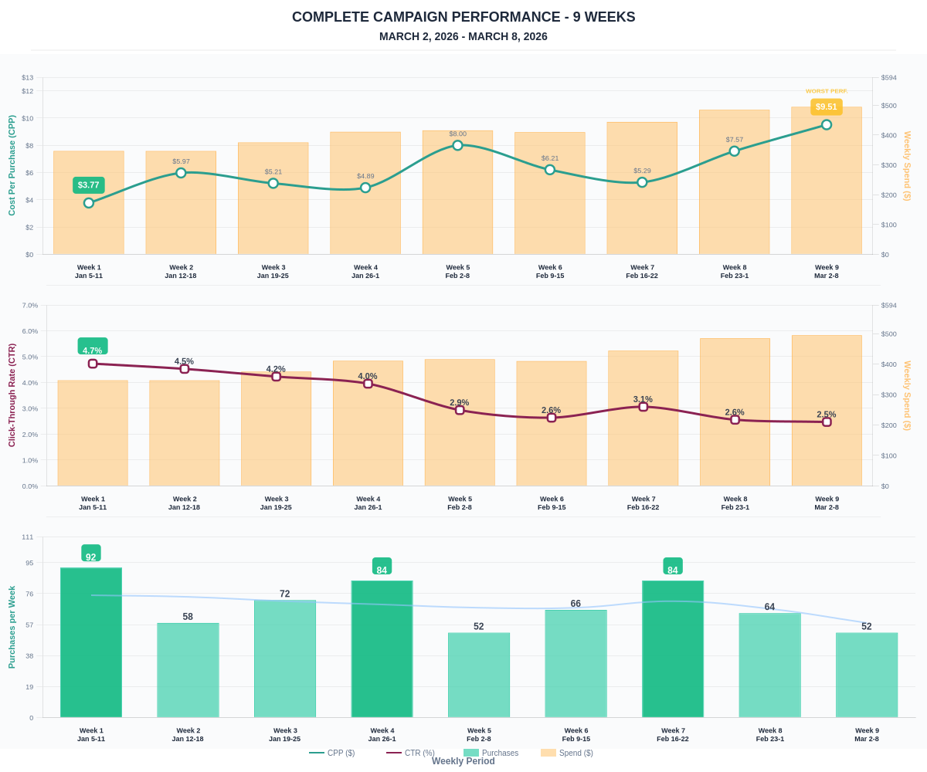

Questions? Let's chat about scaling these results.

