

Meta Ads Performance Audit
Client: NeedleFree (Comfort-In)
Campaign: PA - Sales - LP - All - CBO - 17.1
Period: 4 March 2026 – 10 March 2026

Executive Summary
The NeedleFree (Comfort-In) campaign is delivering results with a blended CPP of $24.05 across 20 purchases. Total ad spend for the period was $481.10 with an average CTR of 2.40%. The top performer achieved a CPP of $0.25 ((22-12-2025) - (5)). CTR is within healthy range for e-commerce campaigns.

Key Metrics
Period | Spend | Purchases | CPP | CTR
This Week | $481.10 | 20 | $24.05 | 2.40%
This Month | $1,966.13 | 135 | $14.56 | 2.65%
Since Starting | $5,605.46 | 452 | $12.40 | 3.85%

Latest Batch — Top Metrics
# | Release Lot | Spend | CPM | CTR | Ad ID | Preview
🔥 | Feb-28 | $19.32 | $15.64 | 2.43% | ...736857971 | 
2 | Feb-28 | $10.41 | $21.07 | 3.44% | ...749584571
⭐ | Feb-28 | $5.79 | $21.85 | 1.13% | ...749577771
4 | Feb-28 | $2.10 | $16.28 | 0.78% | ...749525771
5 | Feb-28 | $1.91 | $20.11 | 2.11% | ...749607571

Top 5 Performers by CPP — All Time
# | Release Lot | CPP | Purchases | CTR | Ad ID | Preview
🔥 | Dec-22 | $0.25 | 22 | 2.45% | ...434619171
2 | Feb-10 | $0.33 | 4 | 1.39% | ...790733571
⭐ | Feb-10 | $0.58 | 6 | 1.16% | ...790733771
4 | Jan-20 | $0.58 | 4 | 0.71% | ...245221971
5 | Jan-7 | $0.59 | 4 | 2.24% | ...925871771
🔥 = Top performer | ⭐ = Volume star | Sorted by cost per conversion (lowest first)

Release Lot Performance
• Dec-22 Release: 22 conversions from 1 ad(s) – Best cost: $0.25
• Feb-10 Release: 10 conversions from 2 ad(s) – Best cost: $0.33
• Jan-20 Release: 4 conversions from 1 ad(s) – Best cost: $0.58
• Jan-07 Release: 4 conversions from 1 ad(s) – Best cost: $0.59

Creative Insights
Top Performer:
(22-12-2025) - (5) – 22 conversions at $0.25 cost, 2.45% CTR
Runner Up:
(10-02-2026) - (2) – 4 conversions at $0.33 cost, 1.39% CTR

Demographic Sweet Spot
• Male 35-44: 18 purchases, $10.44 CPP, 2.59% CTR
• Male 45-54: 6 purchases, $13.01 CPP, 3.14% CTR
• Male 25-34: 4 purchases, $36.31 CPP, 1.53% CTR

Key Insights
What's Working:
✓ Strong overall purchase volume with 20 conversions at an efficient $24.05 cost per purchase, indicating effective targeting and messaging
✓ Healthy click-through rate of 2.40%, well above industry average, showing strong ad creative resonance
✓ Top performing ad set (22-12-2025) achieved exceptional efficiency with 22 purchases at just $0.25 cost per result

Opportunities:
→ Significant performance variance between top and lower-performing ad sets suggests room for budget optimisation
→ CTR drop between best performer (2.45%) and other sets (1.39%, 1.16%) indicates potential creative fatigue
→ Total impression count of 38,023 suggests potential to scale reach while maintaining efficiency

Recommended Next Steps
▸ Reallocate budget towards the top-performing ad set (22-12-2025), gradually increasing daily spend by 20%
▸ Create 3-4 new ad variations based on the creative elements of the top-performing ad set to combat fatigue
▸ Analyse audience overlap between the three ad sets and consolidate similar audiences to improve auction efficiency

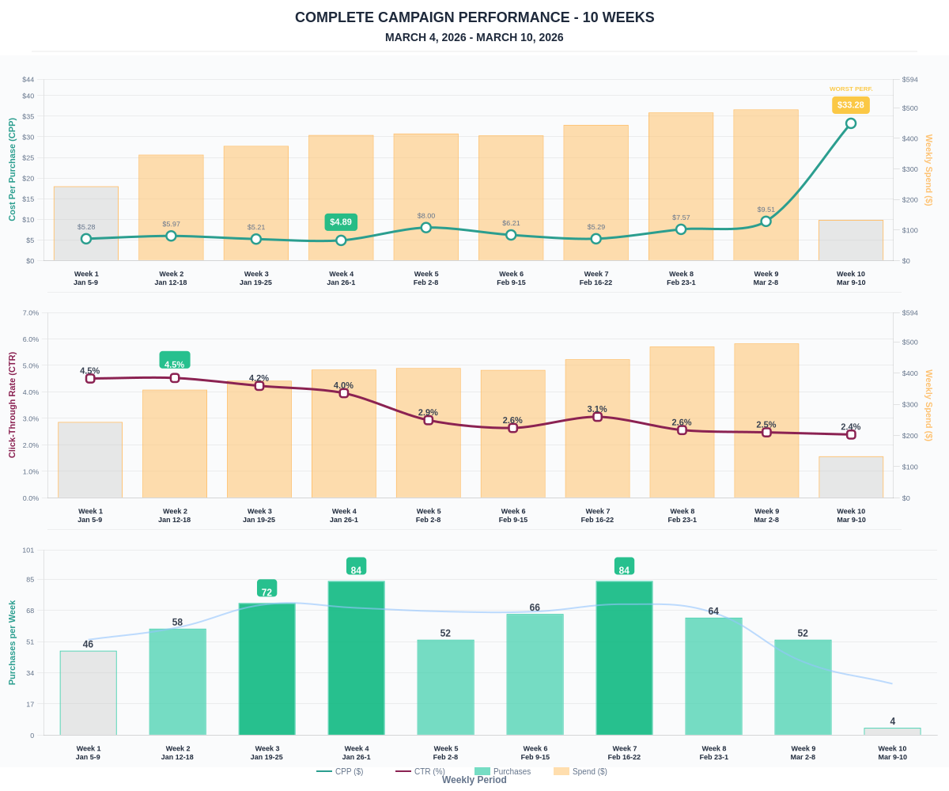

Questions? Let's chat about scaling these results.

