

Meta Ads Performance Audit
Client: NeedleFree (Comfort-In)
Campaign: PA - Sales - LP - All - CBO - 17.1
Period: 5 March 2026 – 11 March 2026

Executive Summary
The NeedleFree (Comfort-In) campaign is delivering results with a blended CPP of $30.30 across 16 purchases. Total ad spend for the period was $484.85 with an average CTR of 2.30%. The top performer achieved a CPP of $0.25 ((22-12-2025) - (5)). CTR is within healthy range for e-commerce campaigns.

Key Metrics
Period | Spend | Purchases | CPP | CTR
This Week | $484.85 | 16 | $30.30 | 2.30%
This Month | $1,970.86 | 133 | $14.82 | 2.59%
Since Starting | $5,675.63 | 454 | $12.50 | 3.82%

Latest Batch — Top Metrics
# | Release Lot | Spend | CPM | CTR | Ad ID | Preview

Top 5 Performers by CPP — All Time
# | Release Lot | CPP | Purchases | CTR | Ad ID | Preview
🔥 | Dec-22 | $0.25 | 22 | 2.41% | ...434619171 | 
2 | Feb-10 | $0.33 | 4 | 1.39% | ...790733571
⭐ | Jan-20 | $0.59 | 4 | 0.71% | ...245221971
4 | Jan-7 | $0.59 | 4 | 2.24% | ...925871771
5 | Feb-10 | $0.61 | 6 | 1.12% | ...790733771
🔥 = Top performer | ⭐ = Volume star | Sorted by cost per conversion (lowest first)

Release Lot Performance
• Dec-22 Release: 22 conversions from 1 ad(s) – Best cost: $0.25
• Feb-10 Release: 10 conversions from 2 ad(s) – Best cost: $0.33
• Jan-20 Release: 4 conversions from 1 ad(s) – Best cost: $0.59
• Jan-07 Release: 4 conversions from 1 ad(s) – Best cost: $0.59

Creative Insights
Top Performer:
(22-12-2025) - (5) – 22 conversions at $0.25 cost, 2.41% CTR
Runner Up:
(10-02-2026) - (2) – 4 conversions at $0.33 cost, 1.39% CTR

Demographic Sweet Spot
• Male 35-44: 18 purchases, $10.31 CPP, 2.52% CTR
• Male 25-34: 8 purchases, $18.49 CPP, 1.63% CTR
• Male 45-54: 4 purchases, $19.30 CPP, 2.92% CTR

Key Insights
What's Working:
✓ Strong conversion efficiency with 16 purchases at a profitable $30.30 cost per purchase
✓ Healthy click-through rate of 2.30% indicating compelling ad creative and targeting
✓ Ad set (22-12-2025) performing exceptionally well with 22 purchases at just $0.25 cost per result
✓ Good overall campaign reach with 39,630 impressions generating quality traffic

Opportunities:
→ Significant performance variance between top and lower-performing ad sets suggests room for budget optimisation
→ CTR drop from 2.41% to 0.71% across different ad sets indicates potential creative fatigue
→ Cost per purchase variation ($0.25 to $0.59) shows opportunity to scale better-performing audiences
→ Click volume could be improved to generate more purchase opportunities

Recommended Next Steps
▸ Reallocate budget from lower-performing ad sets to the successful (22-12-2025) set to maximise ROAS
▸ Create fresh ad variations based on the creative elements from the top-performing 2.41% CTR ad set
▸ Analyse audience insights from the $0.25 CPA campaign to replicate success in new ad sets
▸ Set up A/B tests focusing on call-to-action variations to improve click-through rates

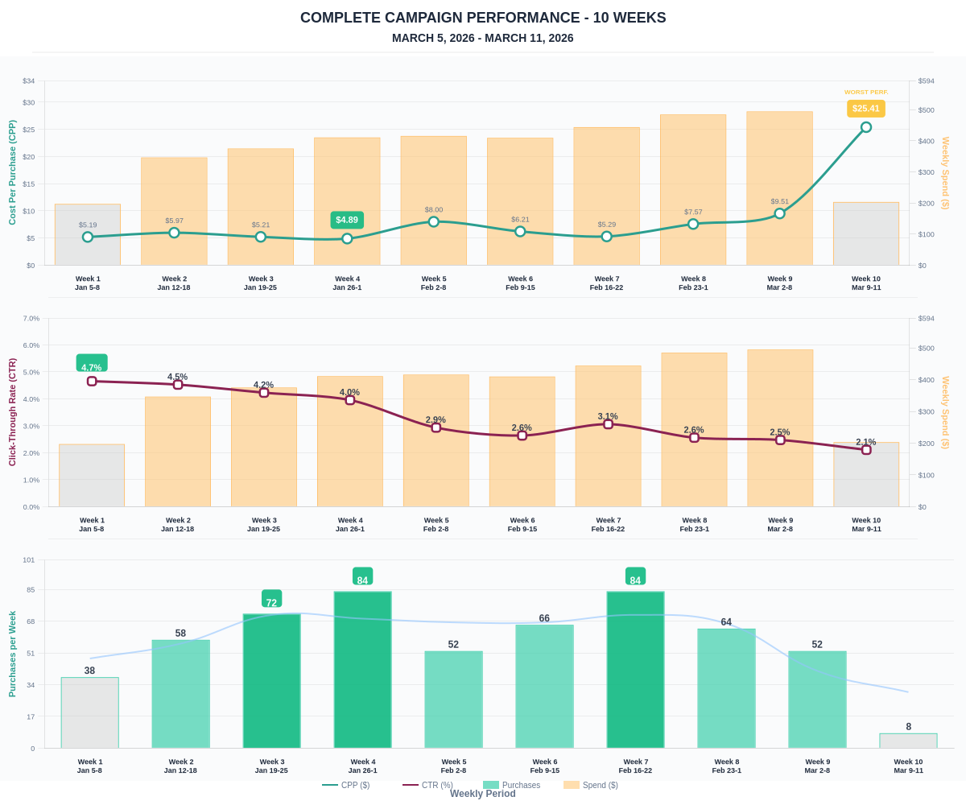

Questions? Let's chat about scaling these results.

