

Meta Ads Performance Audit
Client: NeedleFree (Comfort-In)
Campaign: PA - Sales - LP - All - CBO - 17.1
Period: 6 March 2026 – 12 March 2026

Executive Summary
The NeedleFree (Comfort-In) campaign is delivering results with a blended CPP of $34.44 across 14 purchases. Total ad spend for the period was $482.15 with an average CTR of 2.33%. The top performer achieved a CPP of $0.25 ((22-12-2025) - (5)). CTR is within healthy range for e-commerce campaigns.

Key Metrics
Period | Spend | Purchases | CPP | CTR
This Week | $482.15 | 14 | $34.44 | 2.33%
This Month | $1,979.42 | 131 | $15.11 | 2.61%
Since Starting | $5,741.82 | 454 | $12.65 | 3.80%

Latest Batch — Top Metrics
# | Release Lot | Spend | CPM | CTR | Ad ID | Preview
🔥 | Mar-12 | $1.17 | $24.37 | 0.00% | ...675711571 | 
2 | Mar-12 | $0.69 | $18.16 | 2.63% | ...675335171 | 
⭐ | Mar-12 | $0.61 | $23.46 | 0.00% | ...673354571 | 
4 | Mar-12 | $0.60 | $12.77 | 6.38% | ...680445171 | 
5 | Mar-12 | $0.47 | $14.69 | 3.13% | ...675519971 | 

Top 5 Performers by CPP — All Time
# | Release Lot | CPP | Purchases | CTR | Ad ID | Preview
🔥 | Dec-22 | $0.25 | 22 | 2.41% | ...434619171 | 
2 | Feb-10 | $0.34 | 4 | 1.37% | ...790733571 | 
⭐ | Jan-20 | $0.59 | 4 | 0.71% | ...245221971 | 
4 | Feb-10 | $0.61 | 6 | 1.12% | ...790733771 | 
5 | Jan-7 | $0.62 | 4 | 2.16% | ...925871771 | 
🔥 = Top performer | ⭐ = Volume star | Sorted by cost per conversion (lowest first)

Release Lot Performance
• Dec-22 Release: 22 conversions from 1 ad(s) – Best cost: $0.25
• Feb-10 Release: 10 conversions from 2 ad(s) – Best cost: $0.34
• Jan-20 Release: 4 conversions from 1 ad(s) – Best cost: $0.59
• Jan-07 Release: 4 conversions from 1 ad(s) – Best cost: $0.62

Creative Insights
Top Performer:
(22-12-2025) - (5) – 22 conversions at $0.25 cost, 2.41% CTR
Runner Up:
(10-02-2026) - (2) – 4 conversions at $0.34 cost, 1.37% CTR

Demographic Sweet Spot
• Male 35-44: 14 purchases, $12.81 CPP, 2.65% CTR
• Male 25-34: 8 purchases, $18.80 CPP, 1.81% CTR
• Male 45-54: 4 purchases, $18.07 CPP, 2.96% CTR

Key Insights
What's Working:
✓ Strong overall CTR of 2.33% indicates compelling ad creative and targeting resonating with the audience
✓ Consistent conversion pattern with 14 purchases achieved at a sustainable cost per purchase of $34.44
✓ Top performing ad set (22-12-2025) shows excellent efficiency with high purchase volume and CTR

Opportunities:
→ Significant performance variance between top and lower-performing ad sets suggests room for budget optimisation
→ CTR drop in newer ad sets (1.37% and 0.71%) indicates potential creative fatigue or targeting issues
→ Cost per purchase varies widely across ad sets, suggesting opportunity to standardise performance

Recommended Next Steps
▸ Reallocate budget towards the top-performing ad set (22-12-2025), gradually increasing spend by 20%
▸ Create fresh ad variations based on the successful creative elements from the top-performing ad set
▸ Analyse audience overlap between ad sets and consolidate similar performing audiences to reduce competition

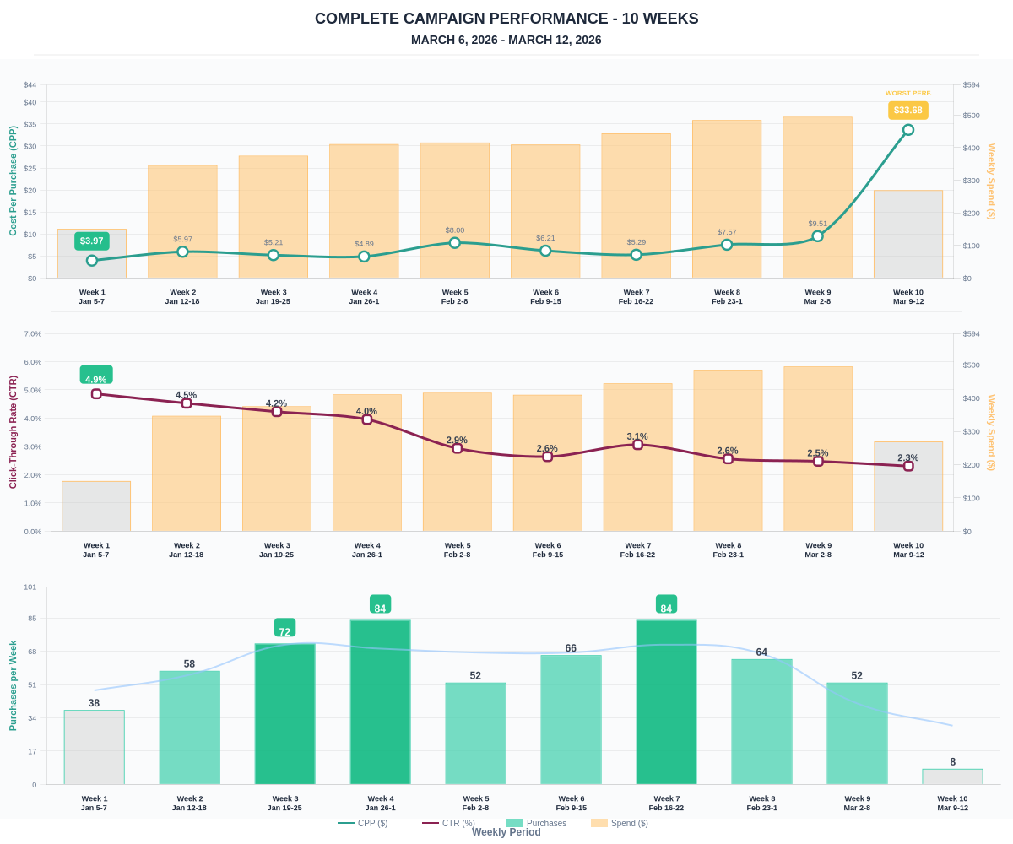

Questions? Let's chat about scaling these results.

