

Meta Ads Performance Audit
Client: NeedleFree (Comfort-In)
Campaign: PA - Sales - LP - All - CBO - 17.1
Period: 7 March 2026 – 13 March 2026

Executive Summary
The NeedleFree (Comfort-In) campaign is delivering results with a blended CPP of $39.59 across 12 purchases. Total ad spend for the period was $475.12 with an average CTR of 2.51%. The top performer achieved a CPP of $0.25 ((22-12-2025) - (5)). CTR is within healthy range for e-commerce campaigns.

Key Metrics
Period | Spend | Purchases | CPP | CTR
This Week | $475.12 | 12 | $39.59 | 2.51%
This Month | $1,985.74 | 127 | $15.64 | 2.66%
Since Starting | $5,805.64 | 454 | $12.79 | 3.80%

Latest Batch — Top Metrics
# | Release Lot | Spend | CPM | CTR | Ad ID | Preview
🔥 | Mar-12 | $1.17 | $24.37 | 0.00% | ...675711571 | 
2 | Mar-12 | $0.91 | $21.67 | 0.00% | ...675398571 | 
⭐ | Mar-12 | $0.69 | $18.16 | 2.63% | ...675335171 | 
4 | Mar-12 | $0.65 | $22.41 | 0.00% | ...673354571 | 
5 | Mar-12 | $0.60 | $12.77 | 6.38% | ...680445171 | 

Top 5 Performers by CPP — All Time
# | Release Lot | CPP | Purchases | CTR | Ad ID | Preview
🔥 | Dec-22 | $0.25 | 22 | 2.40% | ...434619171 | 
2 | Feb-10 | $0.34 | 4 | 1.37% | ...790733571 | 
⭐ | Jan-20 | $0.59 | 4 | 0.71% | ...245221971 | 
4 | Feb-10 | $0.61 | 6 | 1.11% | ...790733771 | 
5 | Jan-7 | $0.62 | 4 | 2.16% | ...925871771 | 
🔥 = Top performer | ⭐ = Volume star | Sorted by cost per conversion (lowest first)

Release Lot Performance
• Dec-22 Release: 22 conversions from 1 ad(s) – Best cost: $0.25
• Feb-10 Release: 10 conversions from 2 ad(s) – Best cost: $0.34
• Jan-20 Release: 4 conversions from 1 ad(s) – Best cost: $0.59
• Jan-07 Release: 4 conversions from 1 ad(s) – Best cost: $0.62

Creative Insights
Top Performer:
(22-12-2025) - (5) – 22 conversions at $0.25 cost, 2.40% CTR
Runner Up:
(10-02-2026) - (2) – 4 conversions at $0.34 cost, 1.37% CTR

Demographic Sweet Spot
• Male 35-44: 10 purchases, $17.99 CPP, 2.94% CTR
• Male 25-34: 8 purchases, $18.32 CPP, 1.92% CTR
• Male 45-54: 4 purchases, $17.55 CPP, 3.14% CTR

Key Insights
What's Working:
✓ Strong overall CTR of 2.51% indicates compelling ad creative and targeting resonating with audience
✓ Top performing ad set (22-12-2025) achieved excellent cost efficiency with 22 purchases at just $0.25 per result
✓ Campaign maintained consistent purchase volume with 12 conversions over 7 days
✓ High impression volume (39,854) suggests good audience reach and campaign visibility

Opportunities:
→ Large variance in cost per purchase across ad sets ($0.25 to $0.59) indicates room for optimisation
→ Lower performing ad sets (2 & 3) show declining CTR, suggesting audience fatigue or targeting issues
→ Click-to-purchase conversion rate could be improved to reduce overall acquisition costs
→ Significant drop in performance between top ad set and others suggests need for creative refresh

Recommended Next Steps
▸ Analyse top performing ad set's audience characteristics and replicate targeting approach across other sets
▸ Conduct A/B testing of new creative variations based on best performing ad's messaging and visuals
▸ Optimise campaign budget allocation to favour the best performing ad set while testing improvements to others
▸ Review landing page experience for lower performing ads to identify conversion rate optimisation opportunities

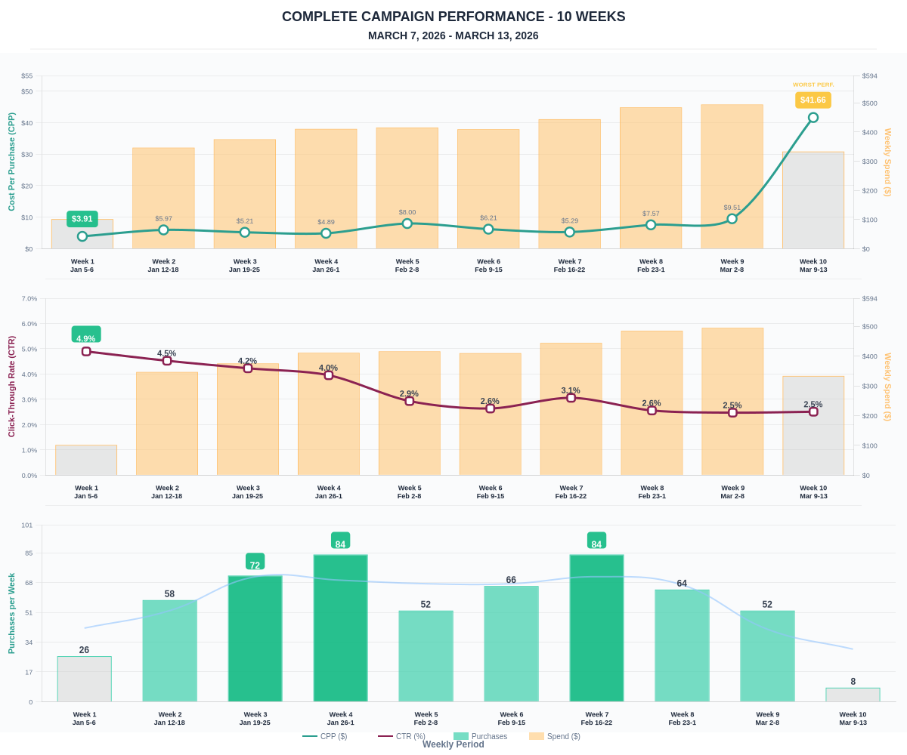

Questions? Let's chat about scaling these results.

