

Meta Ads Performance Audit
Client: NeedleFree (Comfort-In)
Campaign: PA - Sales - LP - All - CBO - 17.1
Period: 8 March 2026 – 14 March 2026

Executive Summary
The NeedleFree (Comfort-In) campaign is delivering results with a blended CPP of $68.59 across 7 purchases. Total ad spend for the period was $480.13 with an average CTR of 2.72%. The top performer achieved a CPP of $0.25 ((22-12-2025) - (5)). CTR is within healthy range for e-commerce campaigns.

Key Metrics
Period | Spend | Purchases | CPP | CTR
This Week | $480.13 | 7 | $68.59 | 2.72%
This Month | $1,994.57 | 121 | $16.48 | 2.71%
Since Starting | $5,877.03 | 454 | $12.95 | 3.80%

Latest Batch — Top Metrics
# | Release Lot | Spend | CPM | CTR | Ad ID | Preview
🔥 | Mar-12 | $1.71 | $24.43 | 0.00% | ...675398571 | 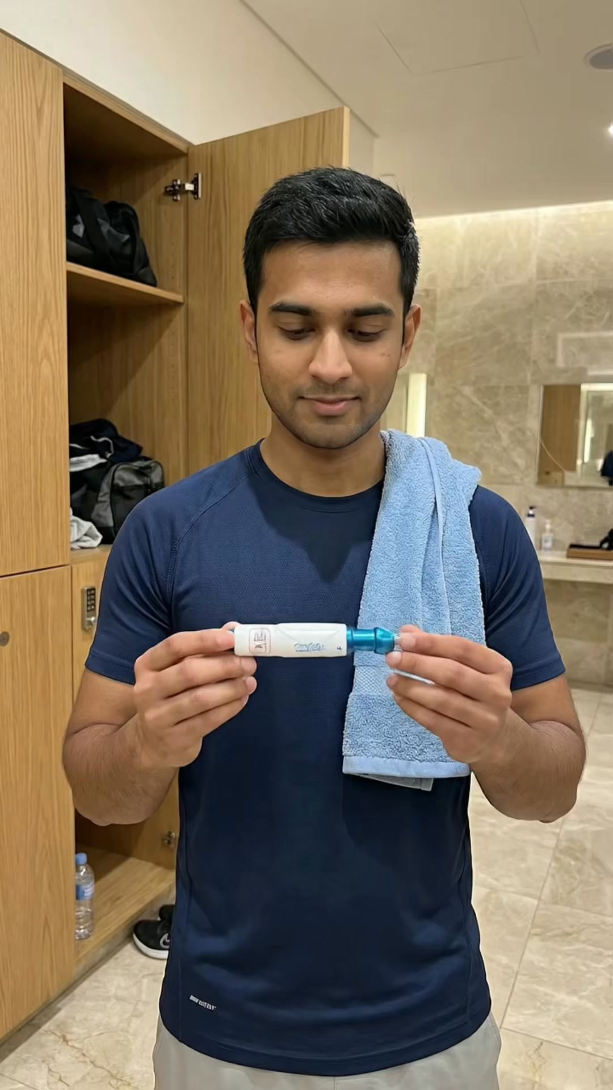
2 | Mar-12 | $1.61 | $26.83 | 1.67% | ...675711571 | 
⭐ | Mar-12 | $1.55 | $18.45 | 4.76% | ...680445171 | 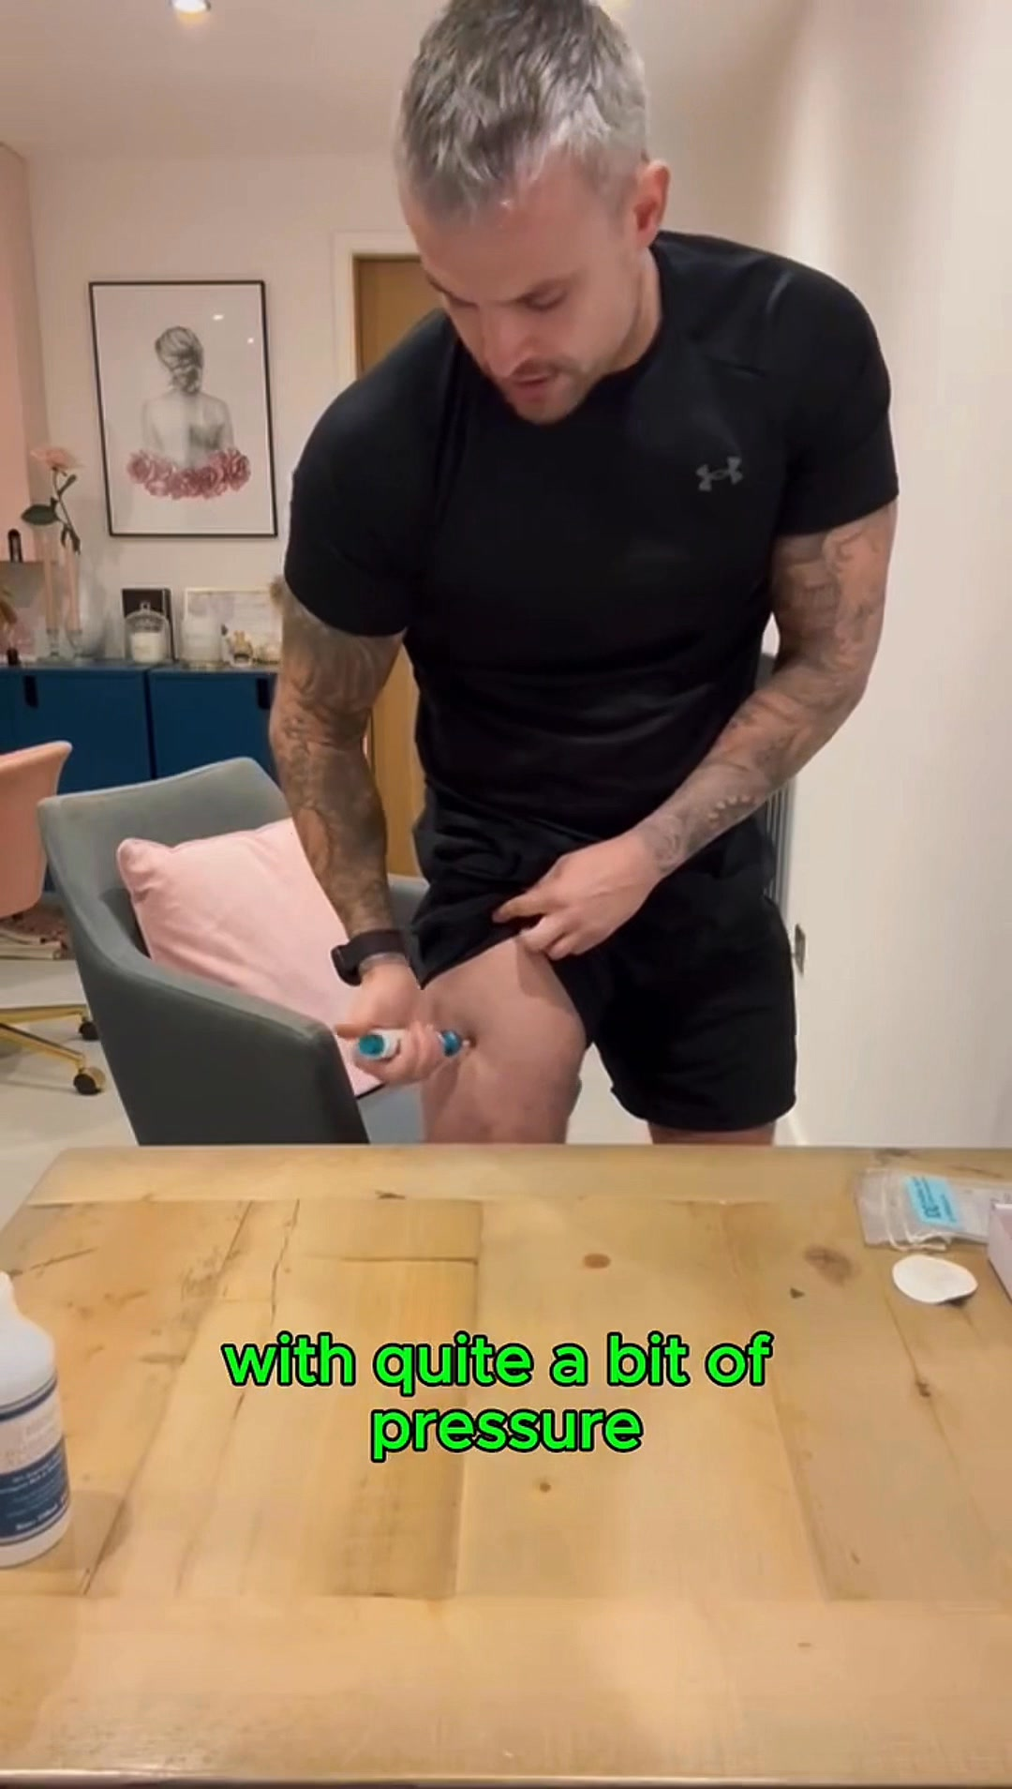
4 | Mar-12 | $0.95 | $27.14 | 0.00% | ...674206971 | 
5 | Mar-12 | $0.94 | $21.36 | 2.27% | ...675335171 | 

Top 5 Performers by CPP — All Time
# | Release Lot | CPP | Purchases | CTR | Ad ID | Preview
🔥 | Dec-22 | $0.25 | 22 | 2.40% | ...434619171 | 
2 | Feb-10 | $0.34 | 4 | 1.37% | ...790733571 | 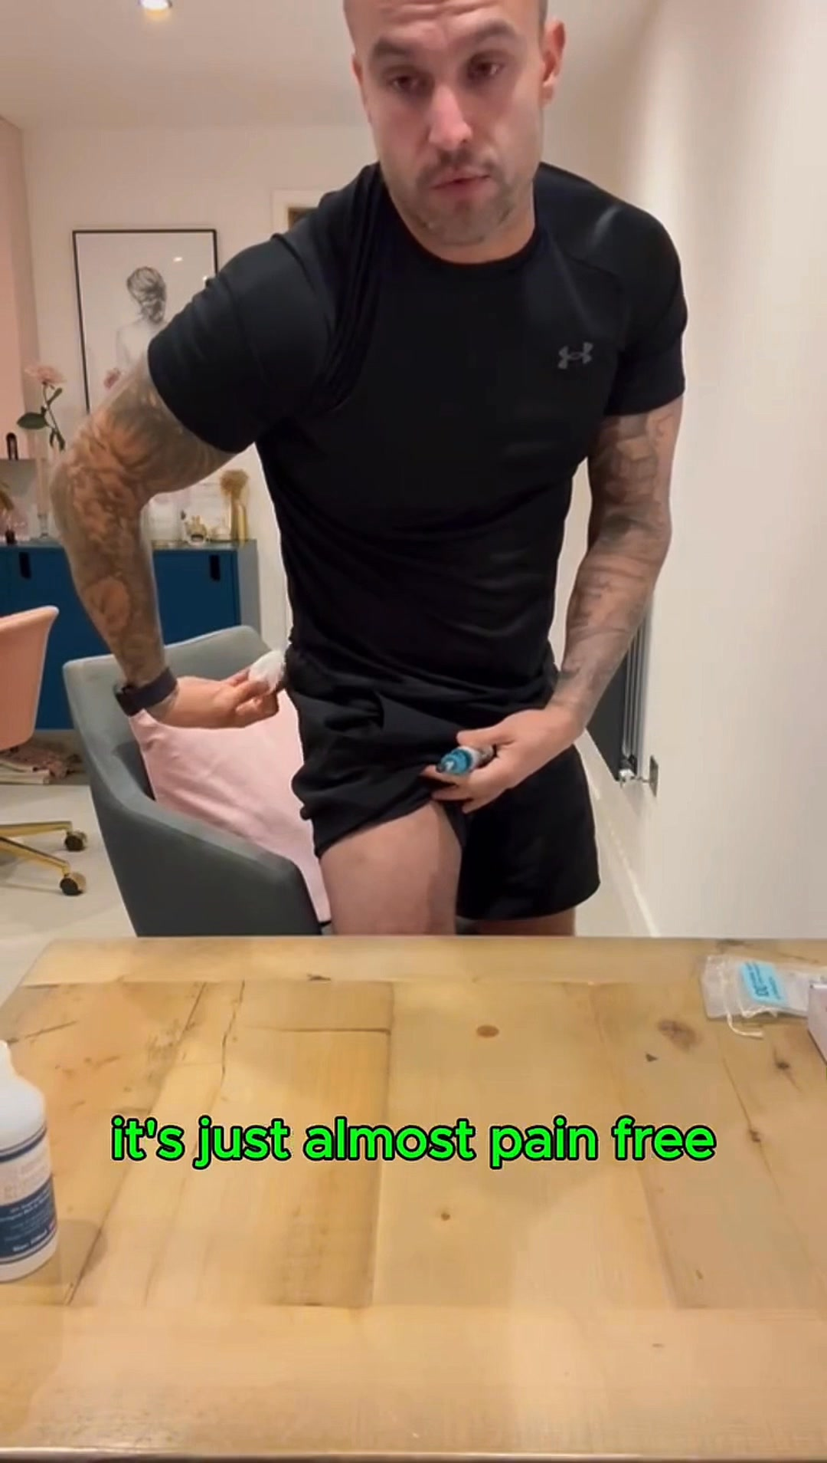
⭐ | Jan-20 | $0.59 | 4 | 0.71% | ...245221971 | 
4 | Feb-10 | $0.61 | 6 | 1.11% | ...790733771 | 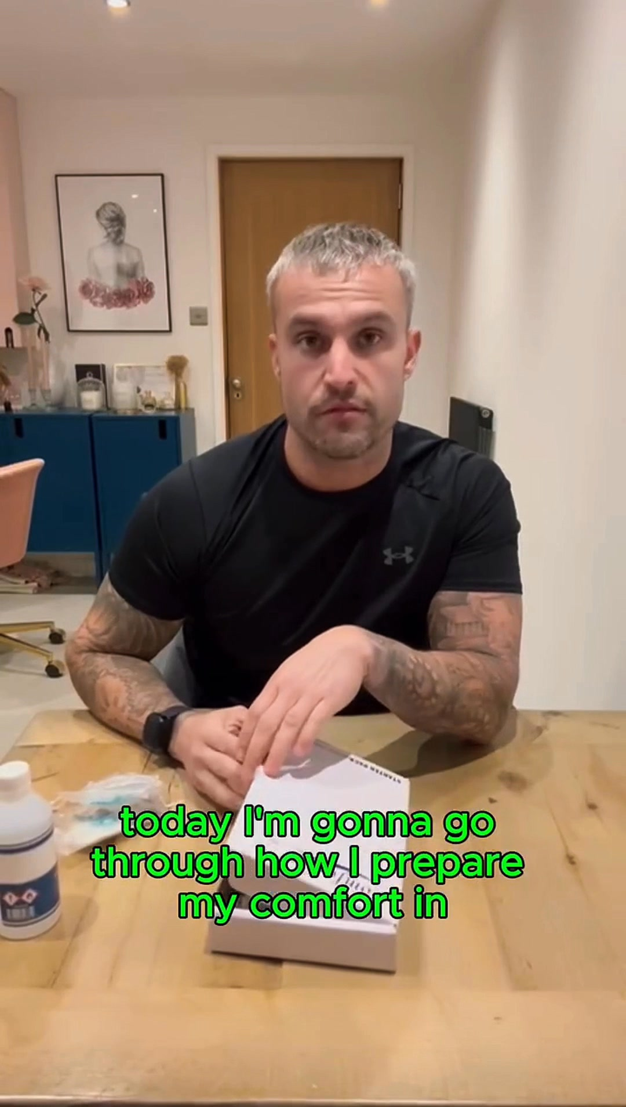
5 | Jan-7 | $0.69 | 4 | 2.55% | ...925871771 | 
🔥 = Top performer | ⭐ = Volume star | Sorted by cost per conversion (lowest first)

Release Lot Performance
• Dec-22 Release: 22 conversions from 1 ad(s) – Best cost: $0.25
• Feb-10 Release: 10 conversions from 2 ad(s) – Best cost: $0.34
• Jan-20 Release: 4 conversions from 1 ad(s) – Best cost: $0.59
• Jan-07 Release: 4 conversions from 1 ad(s) – Best cost: $0.69

Creative Insights
Top Performer:
(22-12-2025) - (5) – 22 conversions at $0.25 cost, 2.40% CTR
Runner Up:
(10-02-2026) - (2) – 4 conversions at $0.34 cost, 1.37% CTR

Demographic Sweet Spot
• Male 25-34: 8 purchases, $18.72 CPP, 2.12% CTR
• Male 35-44: 6 purchases, $30.54 CPP, 3.20% CTR

Key Insights
What's Working:
✓ Strong CTR of 2.72% indicates compelling ad creative and messaging resonating with target audience
✓ Consistent purchase activity with 7 conversions demonstrating product market fit
✓ Top performing ad set (22-12-2025) achieved excellent cost efficiency with 22 purchases at just $0.25 cost per result

Opportunities:
→ High cost per purchase variance between ad sets ($0.25 to $68.59) suggests room for budget optimisation
→ Lower performing ad sets showing CTR below 1.5% indicate potential audience targeting improvements
→ Large impression to purchase ratio suggests conversion rate optimisation potential in the funnel

Recommended Next Steps
▸ Reallocate budget towards the top-performing ad set (22-12-2025) and analyse its audience characteristics for scaling
▸ Create new ad variations based on the creative elements from the highest CTR performers
▸ Implement dynamic creative testing focusing on purchase-intent audiences to improve conversion rates

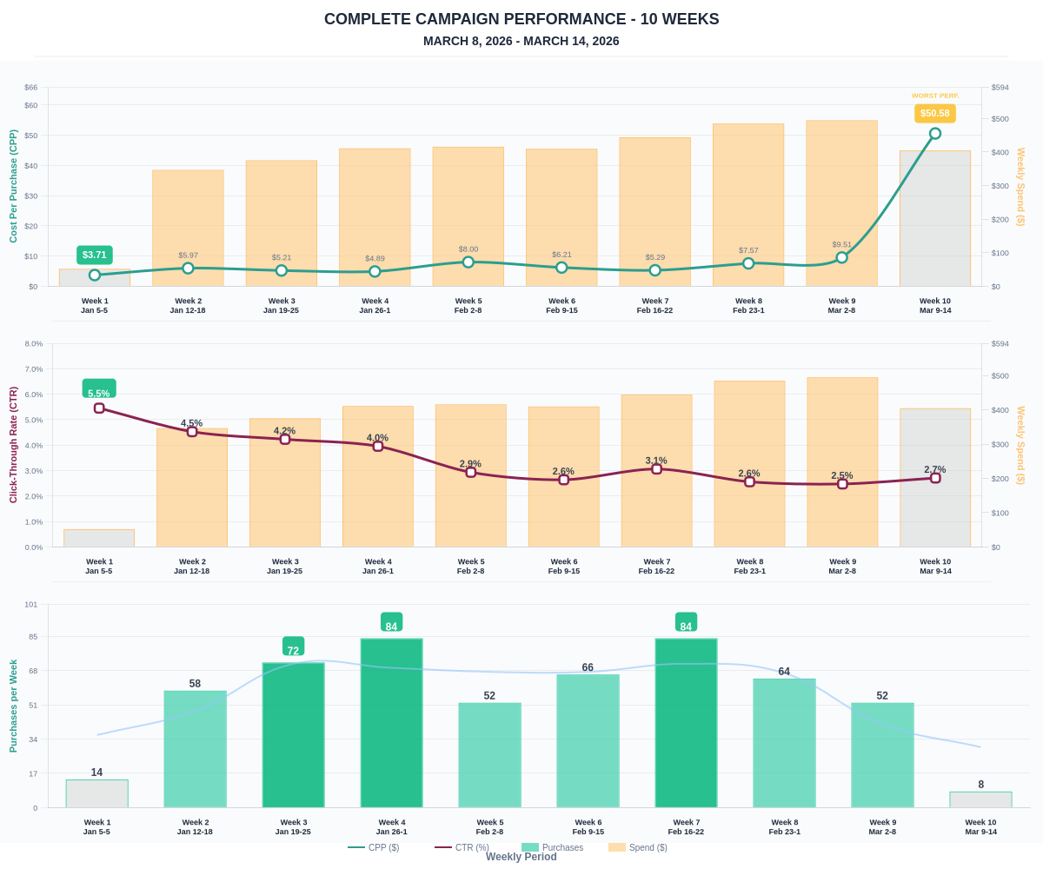

Questions? Let's chat about scaling these results.

