

Meta Ads Performance Audit
Client: NeedleFree (Comfort-In)
Campaign: PA - Sales - LP - All - CBO - 17.1
Period: 9 March 2026 – 15 March 2026

Executive Summary
The NeedleFree (Comfort-In) campaign is delivering results with a blended CPP of $37.36 across 13 purchases. Total ad spend for the period was $485.65 with an average CTR of 2.69%. The top performer achieved a CPP of $0.23 ((Feb-28-26) - (26) A4884). CTR is within healthy range for e-commerce campaigns.

Key Metrics
Period | Spend | Purchases | CPP | CTR
This Week | $485.65 | 13 | $37.36 | 2.69%
This Month | $2,019.06 | 124 | $16.28 | 2.71%
Since Starting | $5,958.01 | 463 | $12.87 | 3.79%

Latest Batch — Top Performers
# | Release Lot | CPP | Purchases | CTR | Ad ID | Preview
🔥 | Mar-12 | $0.23 | 4 | 2.27% | ...675335171 | 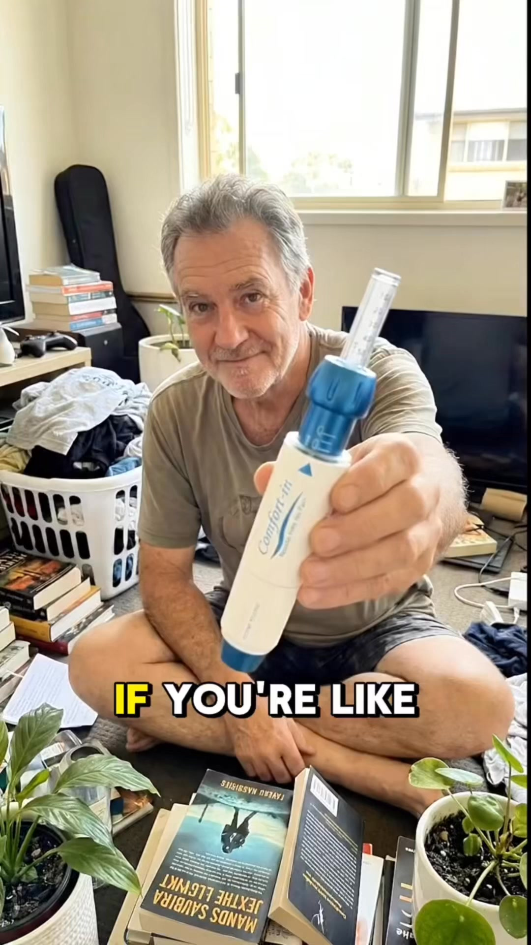

Top 5 Performers by CPP — All Time
# | Release Lot | CPP | Purchases | CTR | Ad ID | Preview
🔥 | Mar-12 | $0.23 | 4 | 2.27% | ...675335171
2 | Dec-22 | $0.25 | 22 | 2.40% | ...434619171 | 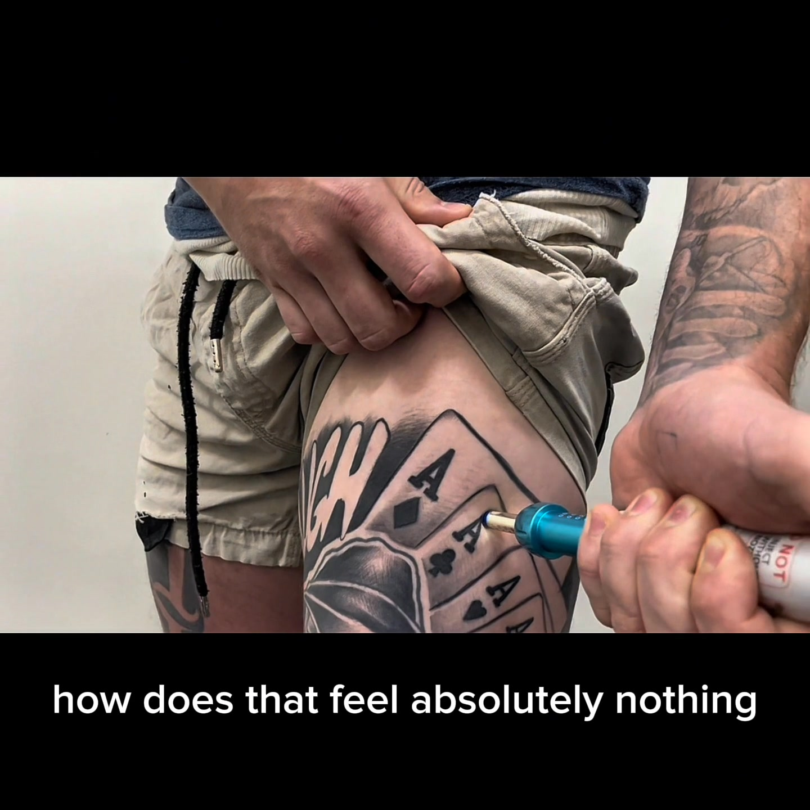
⭐ | Feb-10 | $0.34 | 4 | 1.30% | ...790733571 | 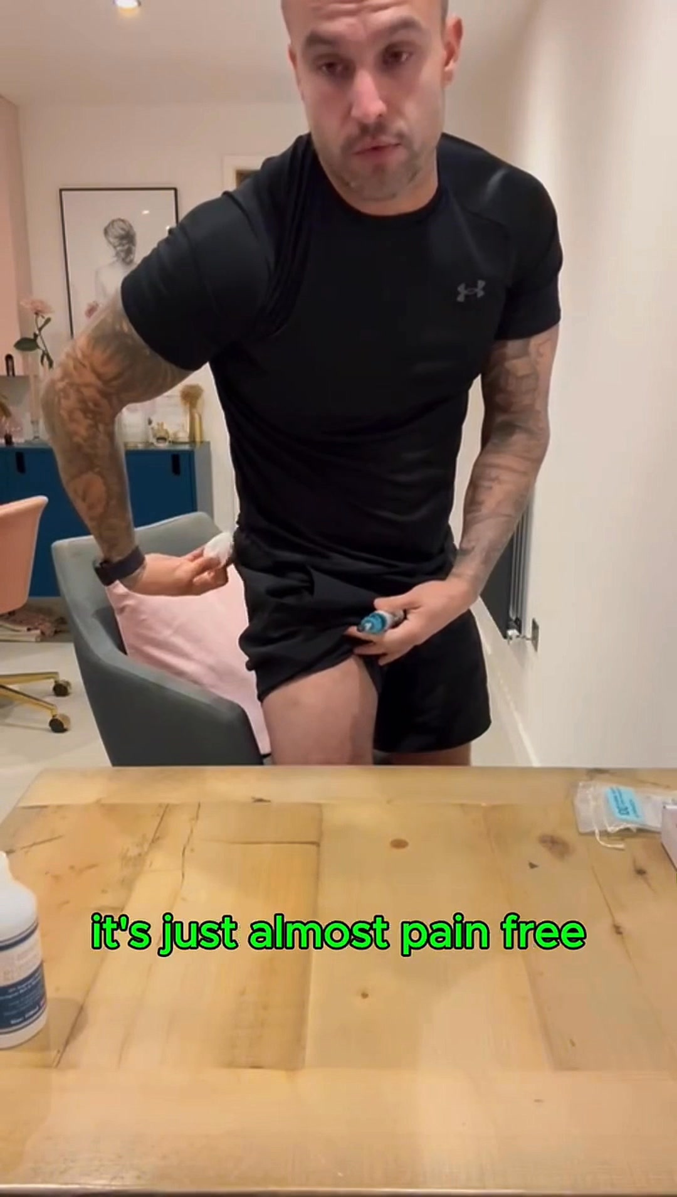
4 | Jan-20 | $0.59 | 4 | 0.71% | ...245221971 | 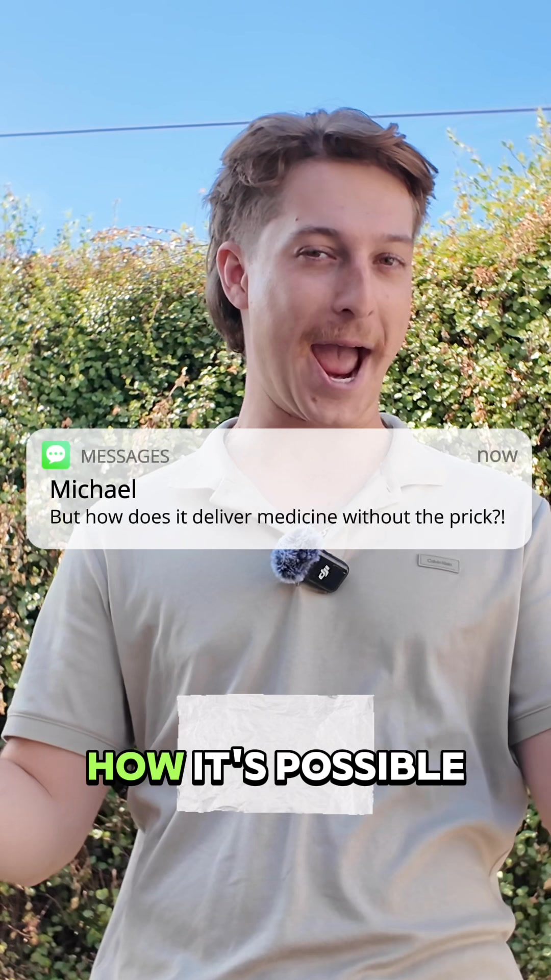
5 | Feb-10 | $0.61 | 6 | 1.11% | ...790733771 | 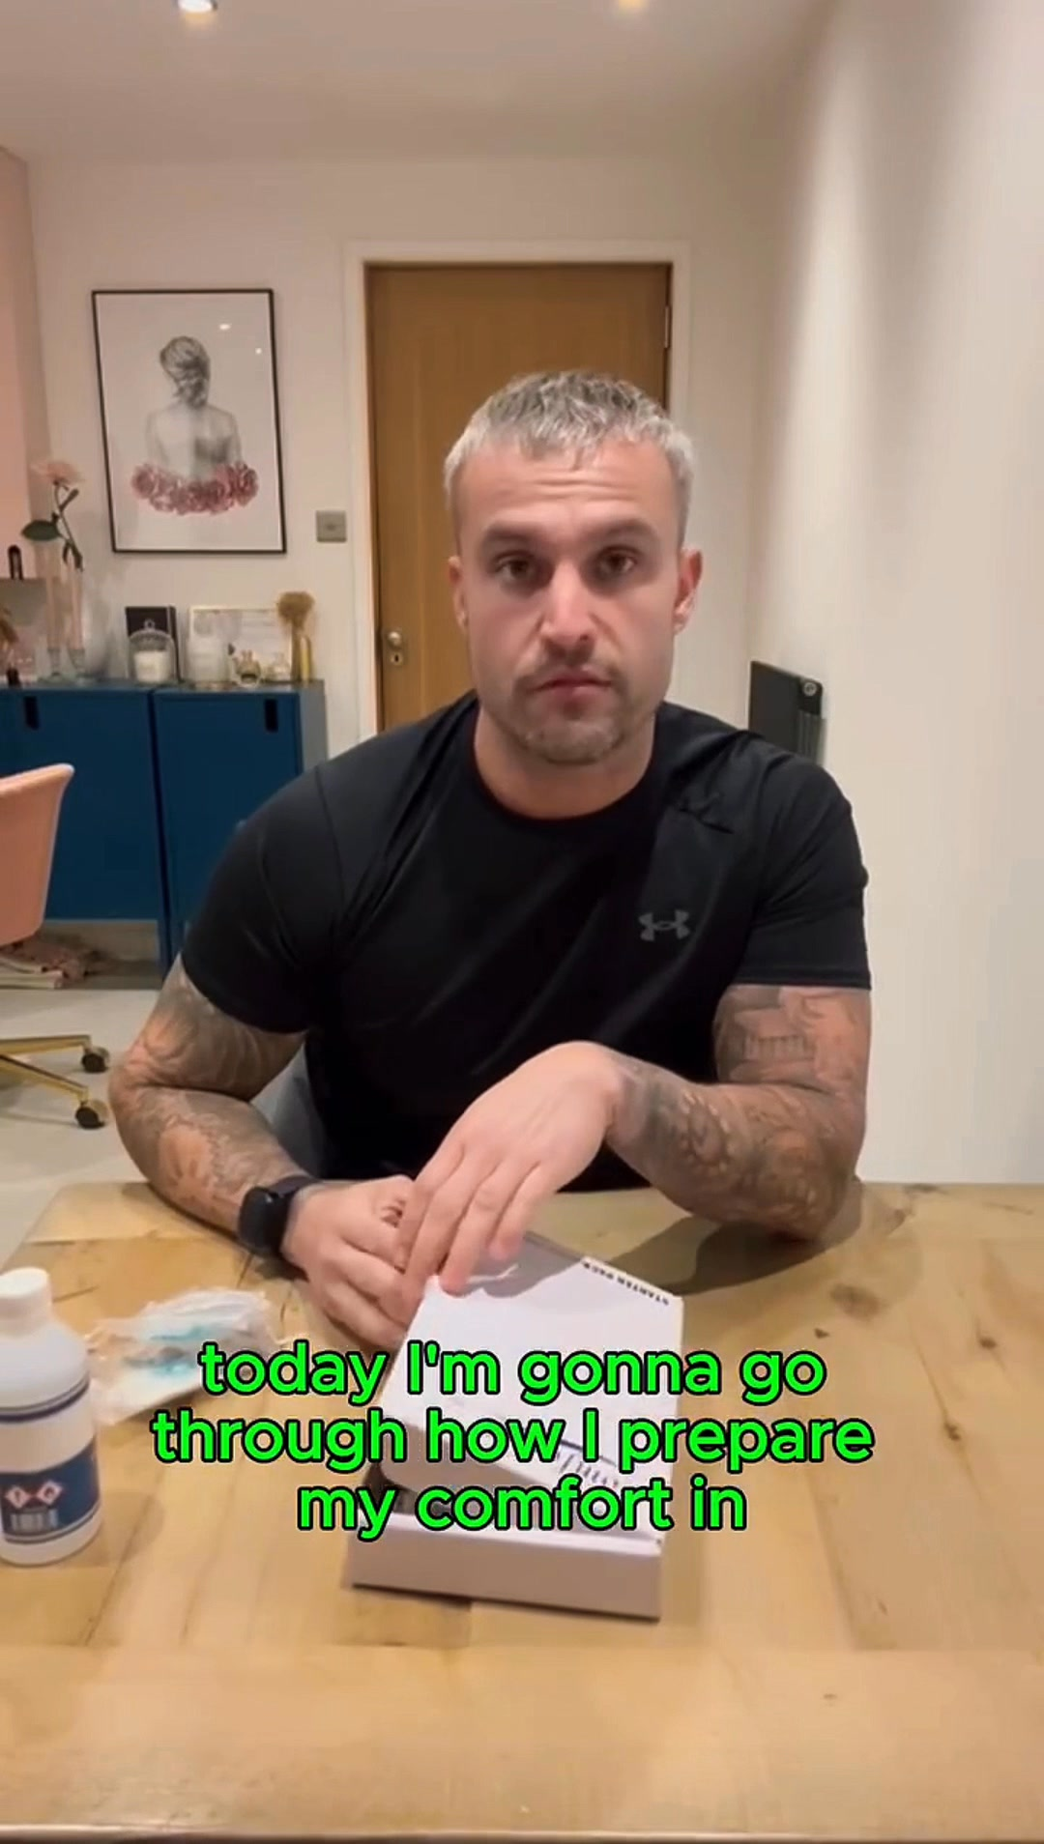
🔥 = Top performer | ⭐ = Volume star | Sorted by cost per conversion (lowest first)

Release Lot Performance
• Feb-28 Release: 4 conversions from 1 ad(s) – Best cost: $0.23
• Dec-22 Release: 22 conversions from 1 ad(s) – Best cost: $0.25
• Feb-10 Release: 10 conversions from 2 ad(s) – Best cost: $0.34
• Jan-20 Release: 4 conversions from 1 ad(s) – Best cost: $0.59

Creative Insights
Top Performer:
(Feb-28-26) - (26) A4884 – 4 conversions at $0.23 cost, 2.27% CTR
Runner Up:
(22-12-2025) - (5) – 22 conversions at $0.25 cost, 2.40% CTR

Demographic Sweet Spot
• Male 35-44: 14 purchases, $13.31 CPP, 3.10% CTR
• Male 45-54: 8 purchases, $8.71 CPP, 3.36% CTR
• Male 25-34: 4 purchases, $38.76 CPP, 2.23% CTR

Key Insights
What's Working:
✓ Campaign is running with 13 conversions

Opportunities:
→ Continue optimising campaign performance

Recommended Next Steps
▸ Monitor performance and adjust as needed

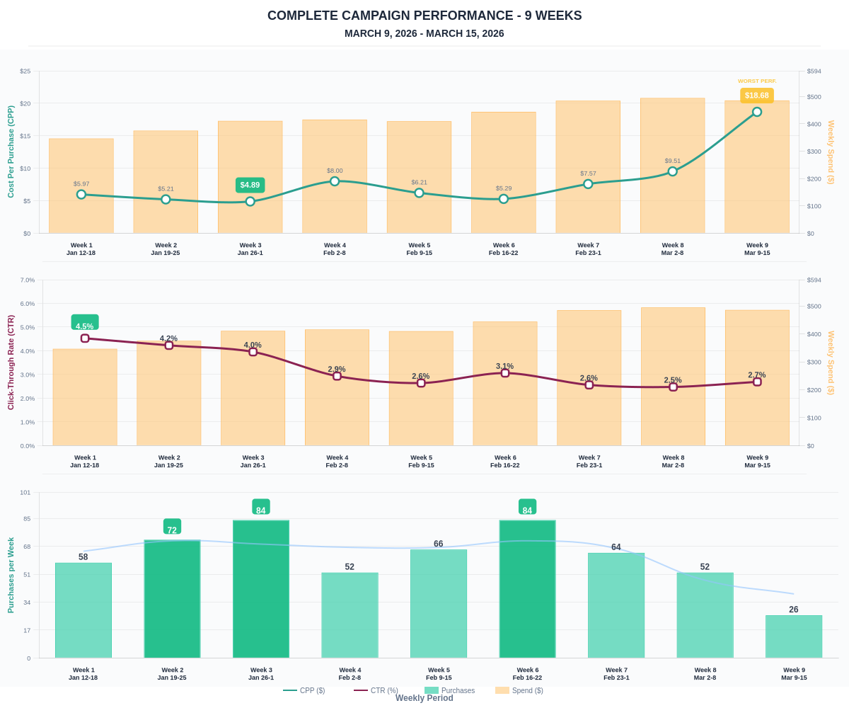

Questions? Let's chat about scaling these results.

