

Meta Ads Performance Audit
Client: NeedleFree (Comfort-In)
Campaign: PA - Sales - LP - All - CBO - 17.1
Period: 16 March 2026 – 22 March 2026

Executive Summary
The NeedleFree (Comfort-In) campaign is delivering results with a blended CPP of $29.10 across 5 purchases. Total ad spend for the period was $145.50 with an average CTR of 2.93%. The top performer achieved a CPP of $0.25 ((22-12-2025) - (5)). CTR is within healthy range for e-commerce campaigns.

Key Metrics
Period | Spend | Purchases | CPP | CTR
This Week | $145.50 | 5 | $29.10 | 2.93%
This Month | $1,742.63 | 78 | $22.34 | 2.66%
Since Starting | $6,103.52 | 468 | $13.04 | 3.77%

Latest Batch — Top Performers
# | Release Lot | CPP | Purchases | CTR | Ad ID | Preview
🔥 | Mar-12 | $0.42 | 4 | 2.33% | ...675335171 | 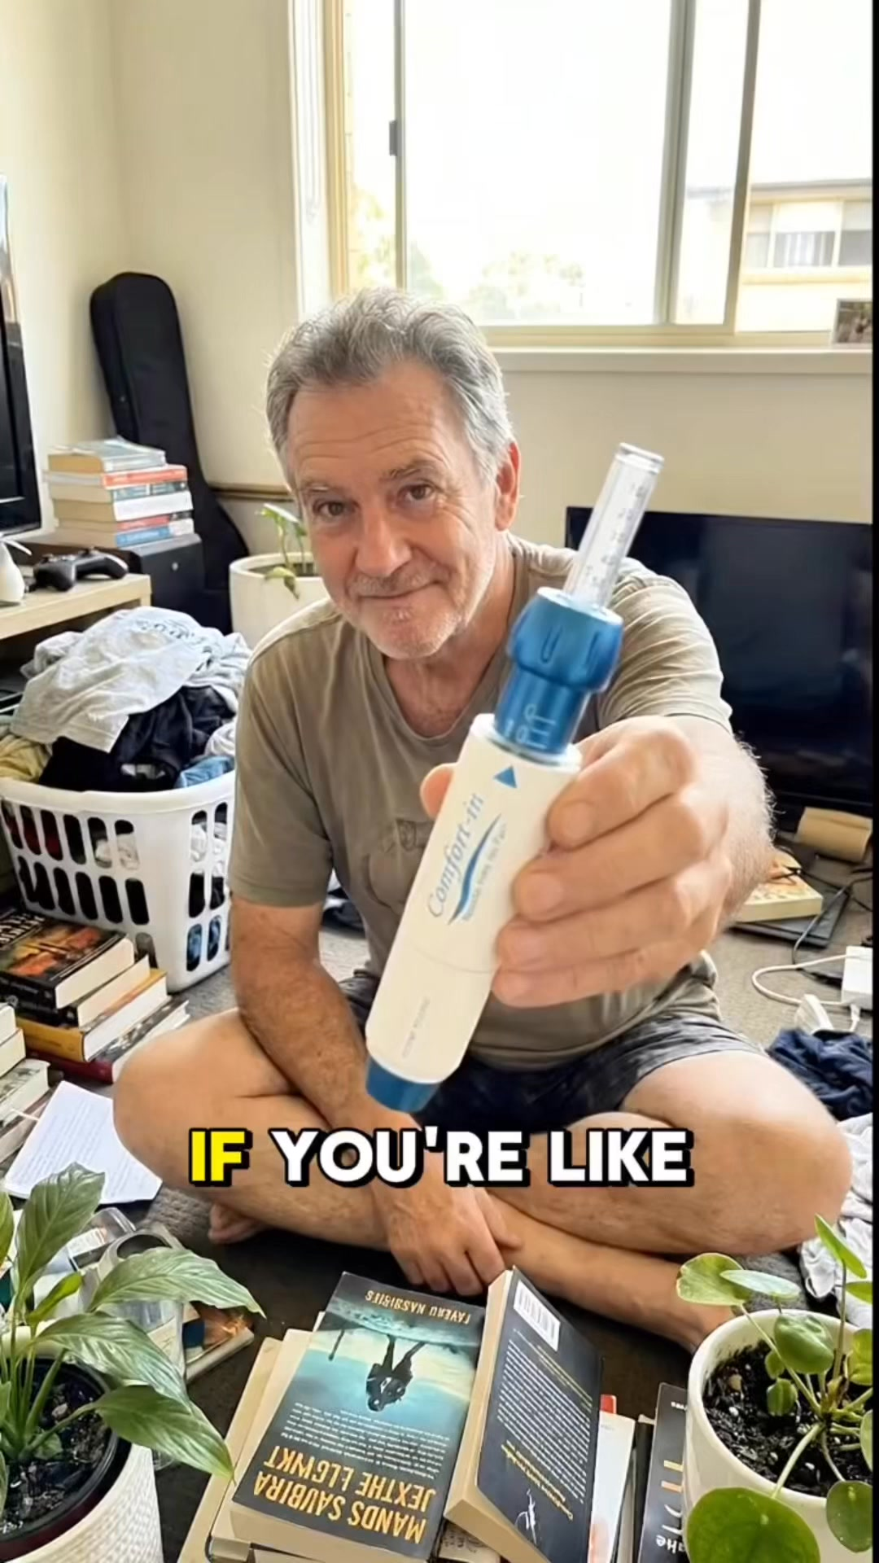

Top 5 Performers by CPP — All Time
# | Release Lot | CPP | Purchases | CTR | Ad ID | Preview
🔥 | Dec-22 | $0.25 | 22 | 2.65% | ...434619171 | 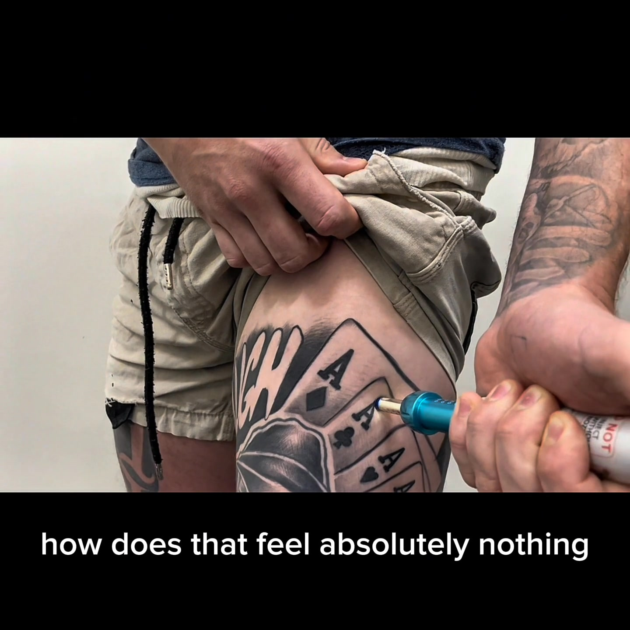
2 | Feb-10 | $0.34 | 4 | 1.30% | ...790733571 | 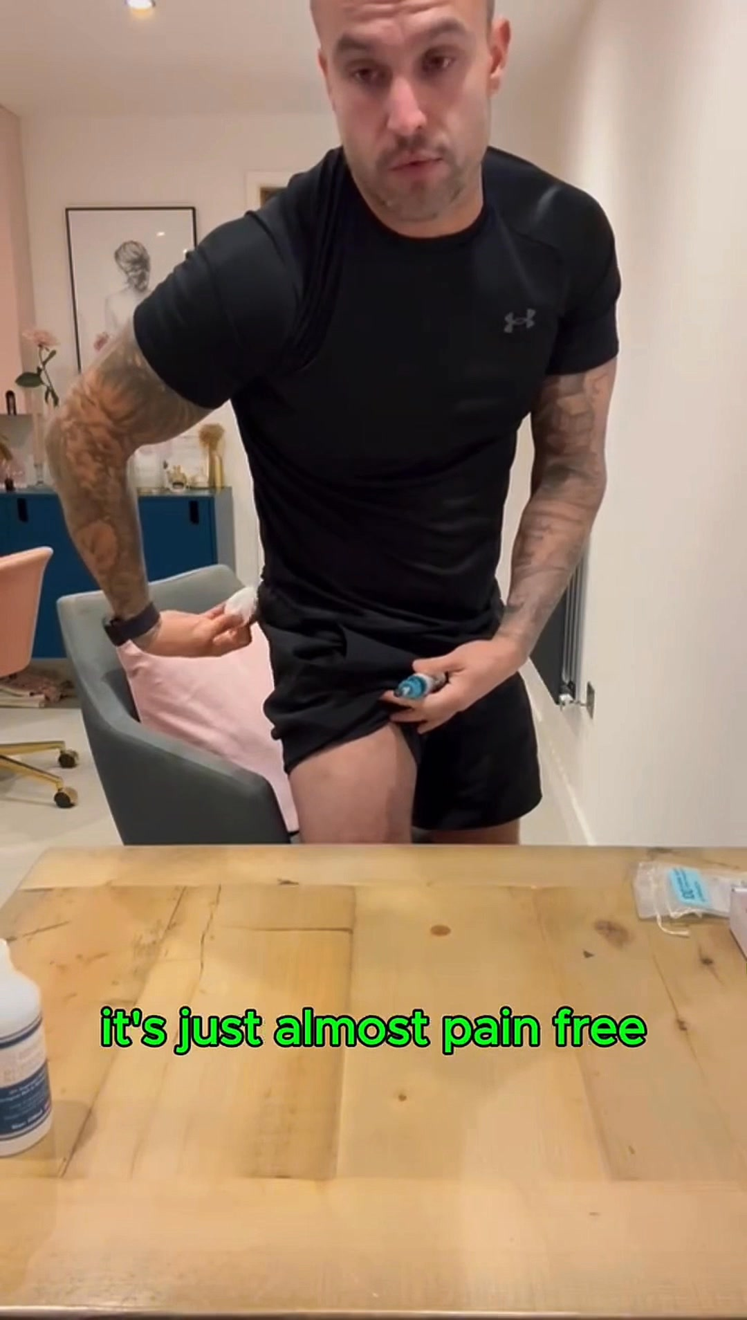
⭐ | Mar-12 | $0.42 | 4 | 2.33% | ...675335171
4 | Jan-20 | $0.62 | 4 | 0.69% | ...245221971 | 
5 | Feb-10 | $0.74 | 6 | 0.94% | ...790733771 | 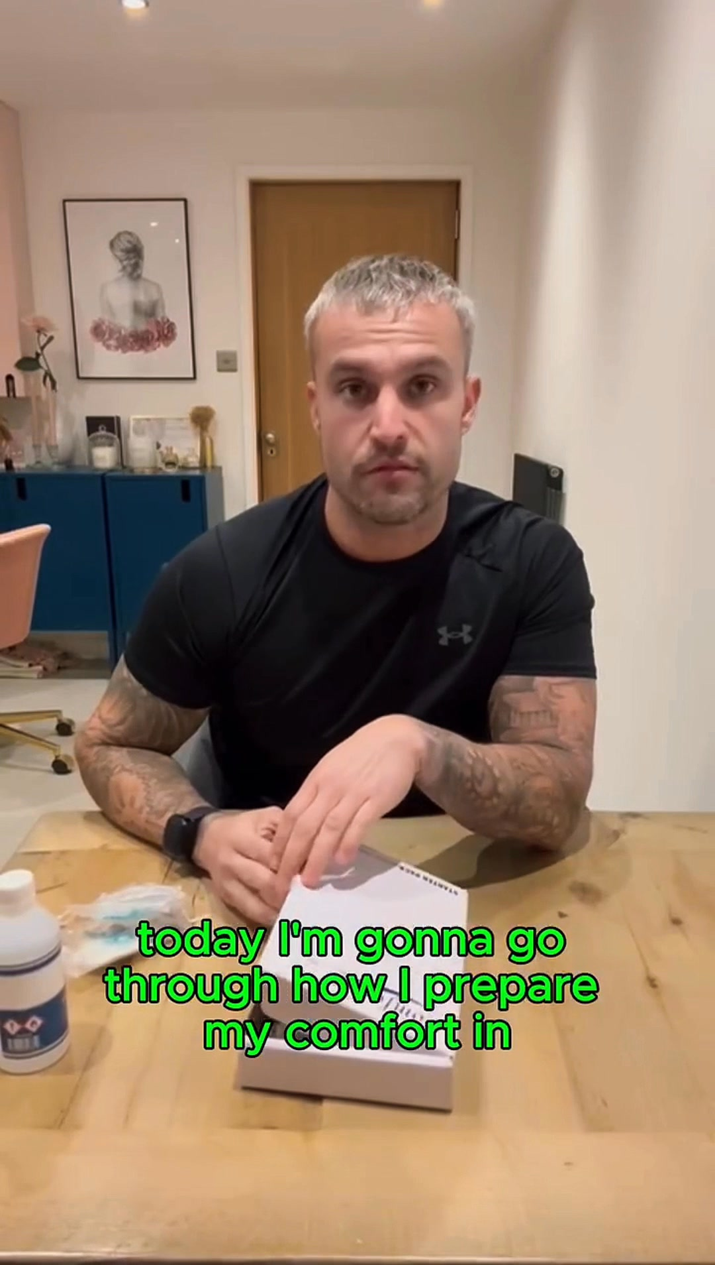
🔥 = Top performer | ⭐ = Volume star | Sorted by cost per conversion (lowest first)

Release Lot Performance
• Dec-22 Release: 22 conversions from 1 ad(s) – Best cost: $0.25
• Feb-10 Release: 10 conversions from 2 ad(s) – Best cost: $0.34
• Feb-28 Release: 4 conversions from 1 ad(s) – Best cost: $0.42
• Jan-20 Release: 4 conversions from 1 ad(s) – Best cost: $0.62

Creative Insights
Top Performer:
(22-12-2025) - (5) – 22 conversions at $0.25 cost, 2.65% CTR
Runner Up:
(10-02-2026) - (2) – 4 conversions at $0.34 cost, 1.30% CTR

Demographic Sweet Spot
• Male 35-44: 6 purchases, $10.29 CPP, 3.32% CTR
• Male 45-54: 4 purchases, $4.89 CPP, 3.59% CTR

Key Insights
What's Working:
✓ Campaign is running with 5 conversions

Opportunities:
→ Continue optimising campaign performance

Recommended Next Steps
▸ Monitor performance and adjust as needed

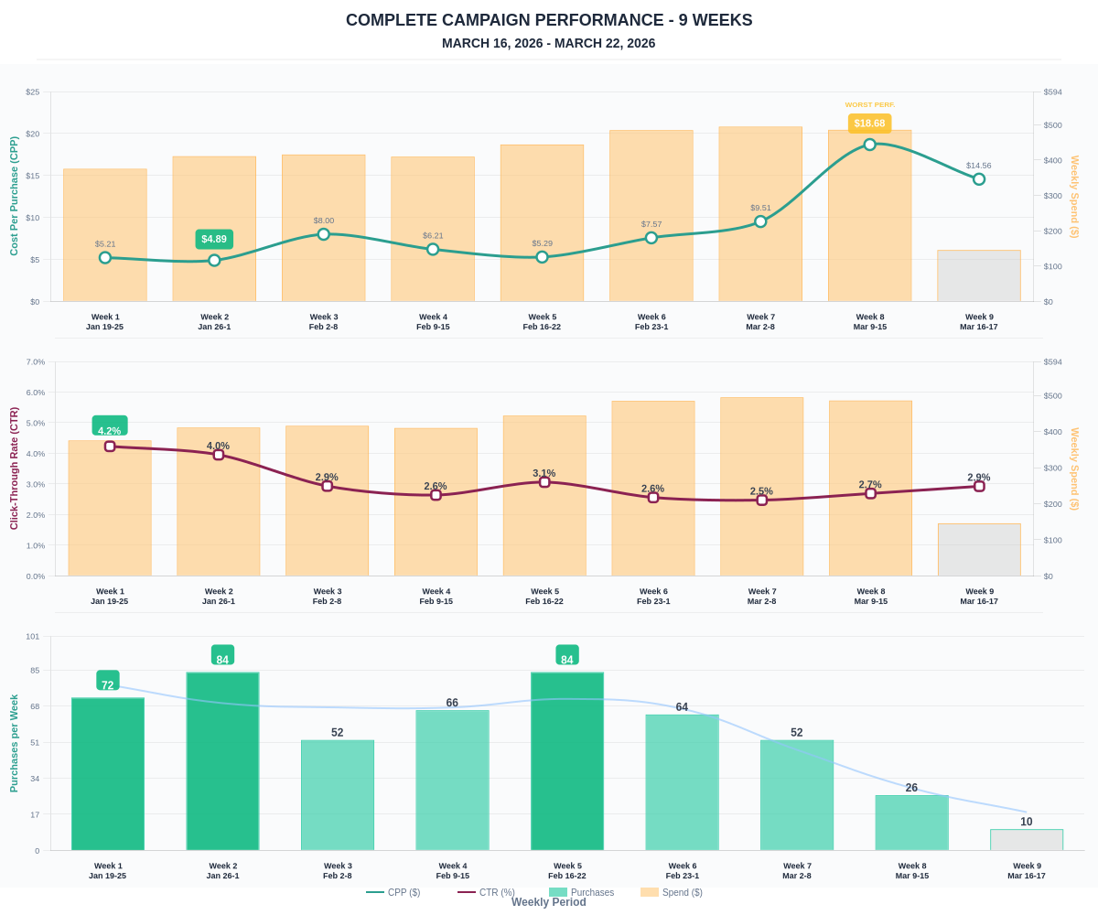

Questions? Let's chat about scaling these results.

