

Meta Ads Performance Audit
Client: NeedleFree (Comfort-In)
Campaign: PA - Sales - LP - All - CBO - 17.1
Period: 11 March 2026 – 17 March 2026

Executive Summary
The NeedleFree (Comfort-In) campaign is delivering results with a blended CPP of $31.76 across 16 purchases. Total ad spend for the period was $508.14 with an average CTR of 2.86%. The top performer achieved a CPP of $0.25 ((22-12-2025) - (5)). CTR is within healthy range for e-commerce campaigns.

Key Metrics
Period | Spend | Purchases | CPP | CTR
This Week | $508.14 | 16 | $31.76 | 2.86%
This Month | $2,064.55 | 118 | $17.50 | 2.71%
Since Starting | $6,113.60 | 468 | $13.06 | 3.77%

Latest Batch — Top Performers
# | Release Lot | CPP | Purchases | CTR | Ad ID | Preview
🔥 | Mar-12 | $0.42 | 4 | 2.33% | ...675335171 | 

Top 5 Performers by CPP — All Time
# | Release Lot | CPP | Purchases | CTR | Ad ID | Preview
🔥 | Dec-22 | $0.25 | 22 | 2.65% | ...434619171 | 
2 | Feb-10 | $0.34 | 4 | 1.30% | ...790733571 | 
⭐ | Mar-12 | $0.42 | 4 | 2.33% | ...675335171
4 | Jan-20 | $0.62 | 4 | 0.69% | ...245221971 | 
5 | Feb-10 | $0.74 | 6 | 0.94% | ...790733771 | 
🔥 = Top performer | ⭐ = Volume star | Sorted by cost per conversion (lowest first)

Release Lot Performance
• Dec-22 Release: 22 conversions from 1 ad(s) – Best cost: $0.25
• Feb-10 Release: 10 conversions from 2 ad(s) – Best cost: $0.34
• Feb-28 Release: 4 conversions from 1 ad(s) – Best cost: $0.42
• Jan-20 Release: 4 conversions from 1 ad(s) – Best cost: $0.62

Creative Insights
Top Performer:
(22-12-2025) - (5) – 22 conversions at $0.25 cost, 2.65% CTR
Runner Up:
(10-02-2026) - (2) – 4 conversions at $0.34 cost, 1.30% CTR

Demographic Sweet Spot
• Male 35-44: 16 purchases, $12.63 CPP, 3.26% CTR
• Male 45-54: 12 purchases, $5.92 CPP, 3.59% CTR
• Male 25-34: 4 purchases, $41.72 CPP, 2.48% CTR

Key Insights
What's Working:
✓ Strong overall CTR of 2.86% indicates compelling ad creative and targeting resonating with audience
✓ Consistent conversion pattern with 16 purchases achieved at a sustainable cost per purchase of $31.76
✓ Top performing ad set (22-12-2025) shows excellent efficiency with low-cost purchases and high CTR of 2.65%

Opportunities:
→ Significant variation in purchase costs across ad sets suggests room for budget optimisation
→ Some ad sets showing lower CTR (e.g., 1.30%) indicate potential targeting or creative improvements needed
→ Total impression count suggests potential to scale successful ad sets for broader reach

Recommended Next Steps
▸ Reallocate budget towards the top-performing ad set (22-12-2025) to maximise efficient conversions
▸ Create new ad variations based on the creative elements from the highest CTR performers
▸ Analyse audience overlap between high and low-performing ad sets to refine targeting strategy

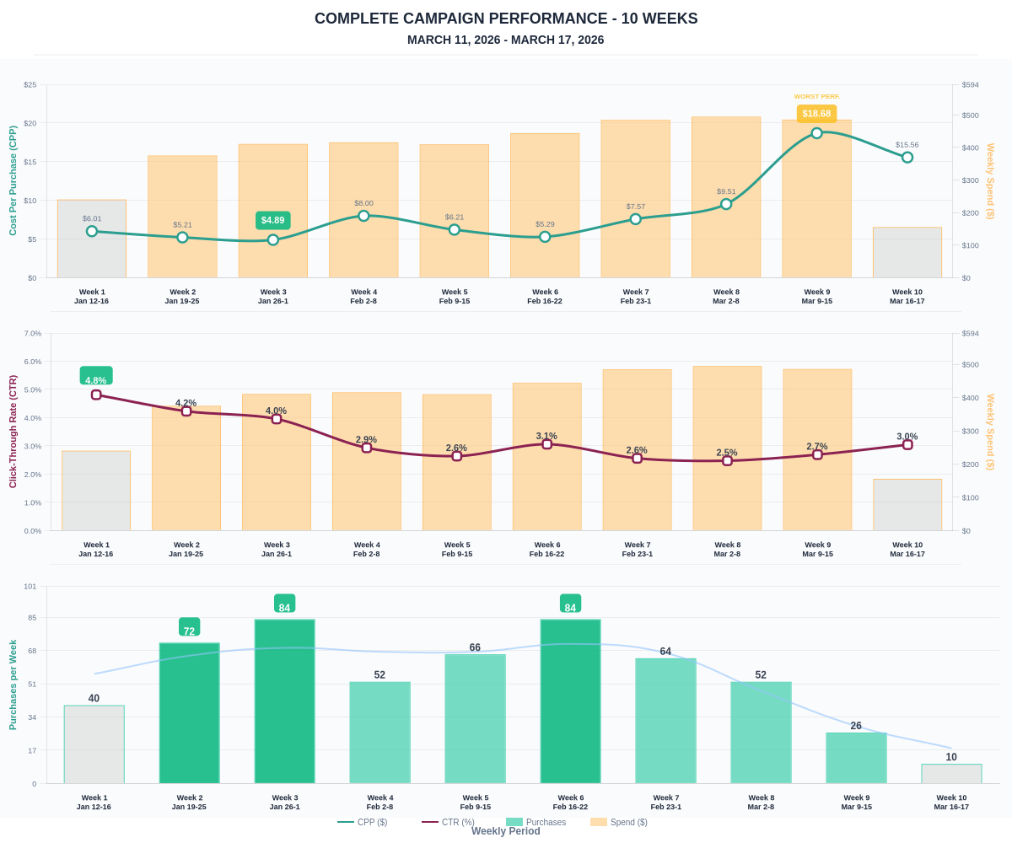

Questions? Let's chat about scaling these results.

