

Meta Ads Performance Audit
Client: NeedleFree (Comfort-In)
Campaign: PA - Sales - LP - All - CBO - 17.1
Period: 15 March 2026 – 21 March 2026

Executive Summary
The NeedleFree (Comfort-In) campaign is delivering solid results with a blended CPP of $18.90 across 20 purchases. Total ad spend for the period was $377.99 with an average CTR of 2.70%. The top performer achieved a CPP of $0.26 ((22-12-2025) - (5)). CTR is within healthy range for e-commerce campaigns.

Key Metrics
Period | Spend | Purchases | CPP | CTR
This Week | $377.99 | 20 | $18.90 | 2.70%
This Month | $1,970.91 | 93 | $21.19 | 2.67%
Since Starting | $6,255.02 | 474 | $13.20 | 3.74%

Latest Batch — Top Performers
# | Release Lot | CPP | Purchases | CTR | Ad ID | Preview
🔥 | Mar-12 | $0.62 | 4 | 4.26% | ...675335171 | 

Top 5 Performers by CPP — All Time
# | Release Lot | CPP | Purchases | CTR | Ad ID | Preview
🔥 | Dec-22 | $0.26 | 22 | 2.62% | ...434619171 | 
2 | Feb-10 | $0.36 | 4 | 1.11% | ...790733571 | 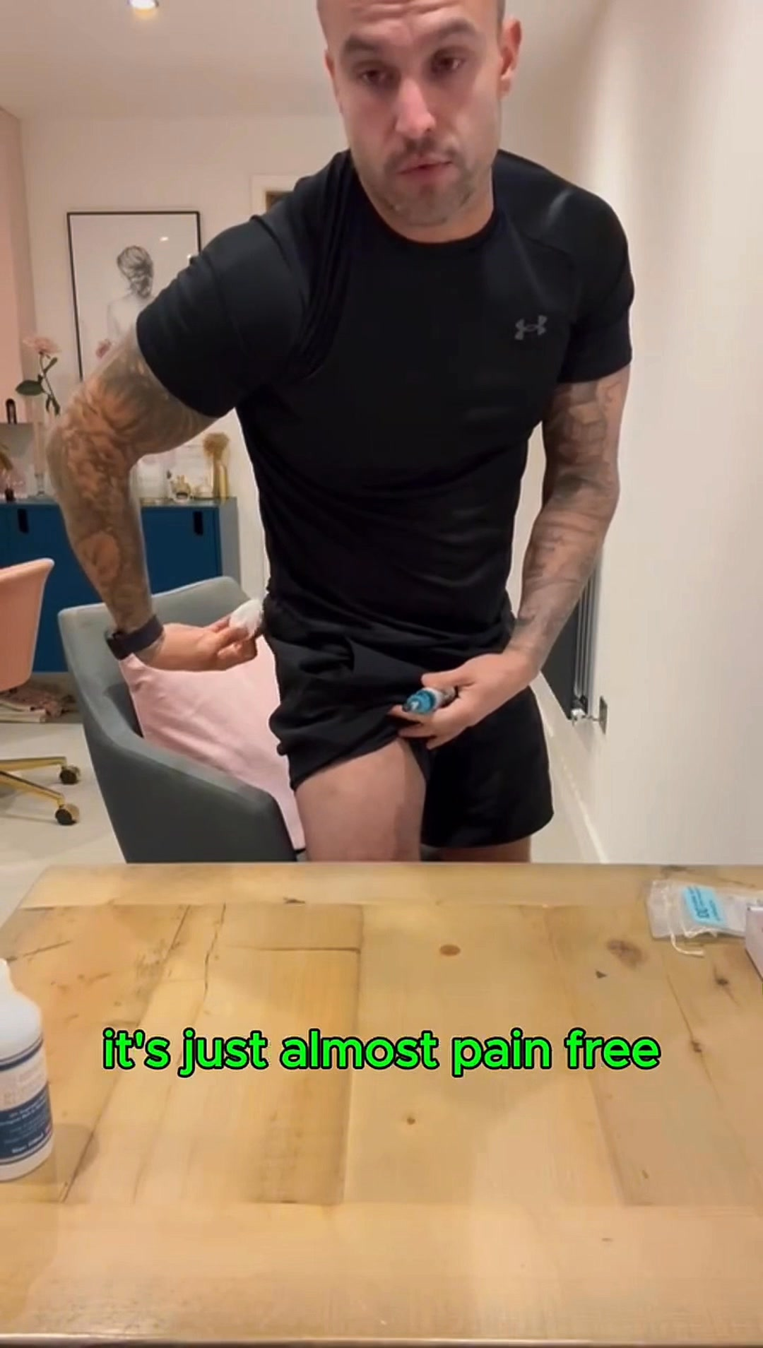
⭐ | Mar-12 | $0.62 | 4 | 4.26% | ...675335171
4 | Jan-20 | $0.70 | 4 | 1.26% | ...245221971 | 
5 | Feb-10 | $0.74 | 6 | 0.93% | ...790733771 | 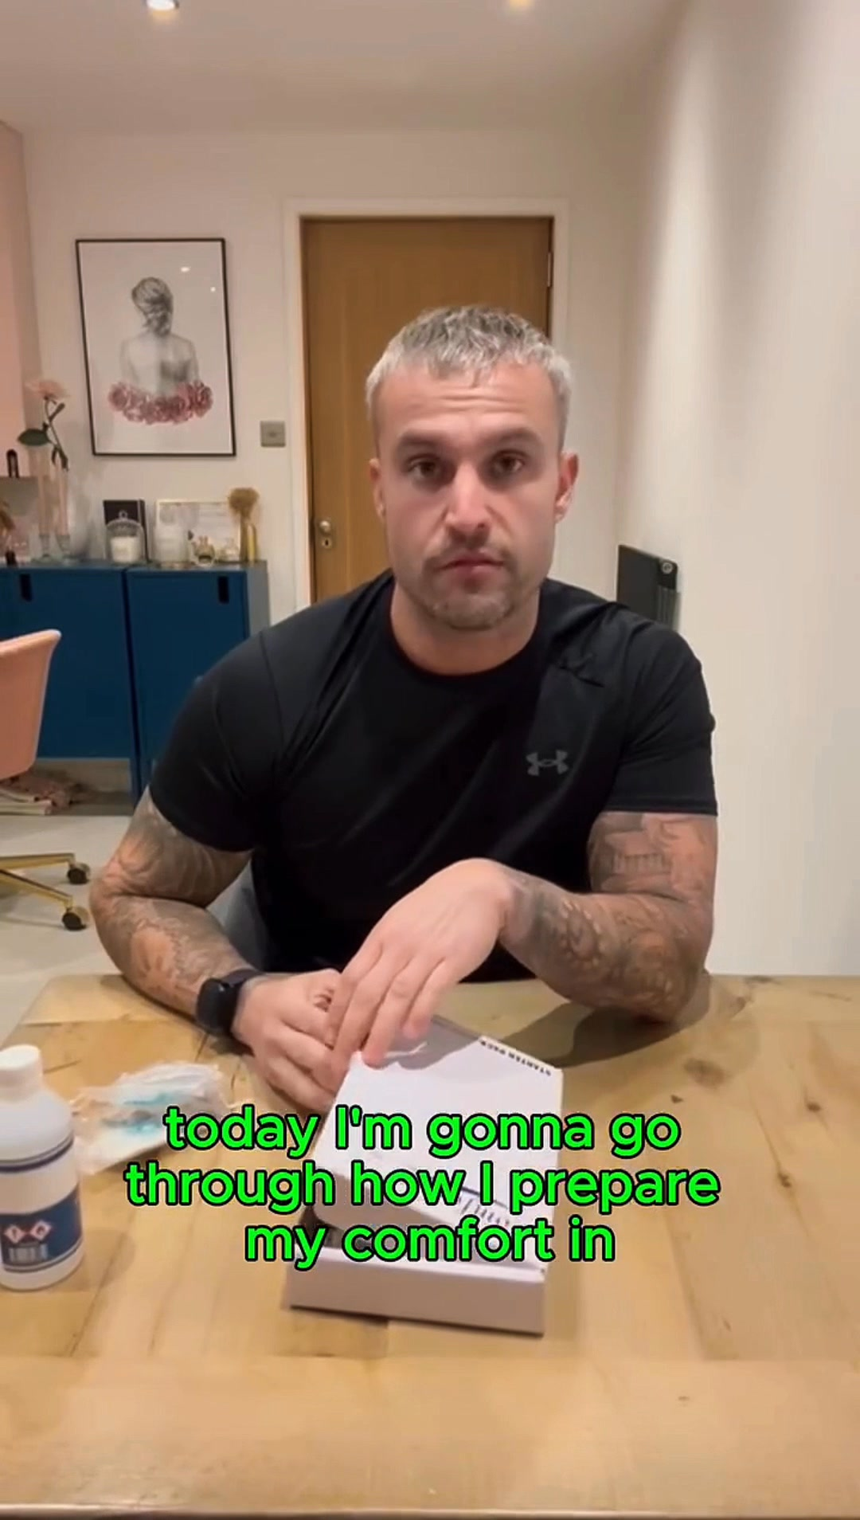
🔥 = Top performer | ⭐ = Volume star | Sorted by cost per conversion (lowest first)

Release Lot Performance
• Dec-22 Release: 22 conversions from 1 ad(s) – Best cost: $0.26
• Feb-10 Release: 10 conversions from 2 ad(s) – Best cost: $0.36
• Feb-28 Release: 4 conversions from 1 ad(s) – Best cost: $0.62
• Jan-20 Release: 4 conversions from 1 ad(s) – Best cost: $0.70

Creative Insights
Top Performer:
(22-12-2025) - (5) – 22 conversions at $0.26 cost, 2.62% CTR
Runner Up:
(10-02-2026) - (2) – 4 conversions at $0.36 cost, 1.11% CTR

Demographic Sweet Spot
• Male 35-44: 16 purchases, $9.75 CPP, 2.80% CTR
• Male 45-54: 16 purchases, $4.05 CPP, 3.28% CTR
• Male 25-34: 8 purchases, $15.13 CPP, 2.30% CTR

Key Insights
What's Working:
✓ Strong overall conversion rate with 20 purchases achieved at an efficient cost per purchase of $18.90
✓ Healthy CTR of 2.70% indicates compelling ad creative and targeting resonating with audience
✓ Top performing ad set from 22-12-2025 delivered exceptional efficiency with 22 purchases at just $0.26 cost per purchase
✓ Ad set A4884 achieved impressive 4.26% CTR, showing strong audience engagement

Opportunities:
→ Significant performance variance between top and lower performing ad sets suggests room for budget optimisation
→ CTR ranges from 1.11% to 4.26% across ad sets, indicating potential to improve lower performing creative
→ Cost per purchase variation ($0.26 to $0.62) suggests opportunity to scale best performing targeting parameters
→ Total impression count suggests potential to expand reach while maintaining efficiency

Recommended Next Steps
▸ Reallocate budget towards the successful 22-12-2025 ad set targeting parameters and creative elements
▸ Analyse creative elements from A4884 (4.26% CTR) to replicate high-engagement features in new ad variations
▸ Create lookalike audiences based on purchasers from top-performing ad sets to expand reach
▸ Pause lowest performing ad sets and reinvest budget into top 3 performers for improved ROAS

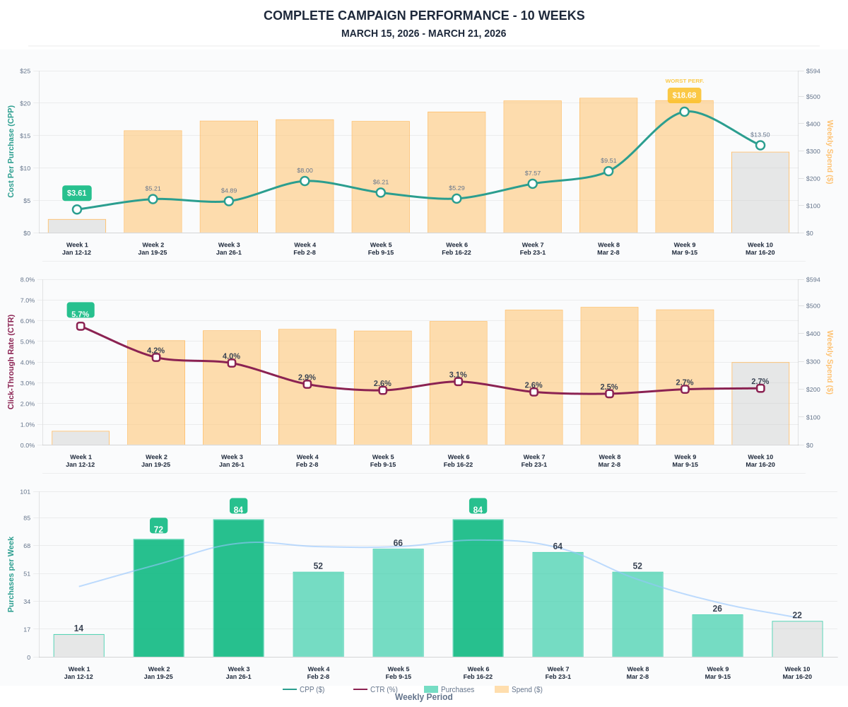

Questions? Let's chat about scaling these results.

