

Meta Ads Performance Audit
Client: NeedleFree (Comfort-In)
Campaign: PA - Sales - LP - All - CBO - 17.1
Period: 16 March 2026 – 22 March 2026

Executive Summary
The NeedleFree (Comfort-In) campaign is delivering results with a blended CPP of $36.04 across 14 purchases. Total ad spend for the period was $504.51 with an average CTR of 2.85%. The top performer achieved a CPP of $0.26 ((22-12-2025) - (5)). CTR is within healthy range for e-commerce campaigns.

Key Metrics
Period | Spend | Purchases | CPP | CTR
This Week | $504.51 | 14 | $36.04 | 2.85%
This Month | $2,101.64 | 87 | $24.16 | 2.68%
Since Starting | $6,462.53 | 477 | $13.55 | 3.73%

Latest Batch — Top Performers
# | Release Lot | CPP | Purchases | CTR | Ad ID | Preview
🔥 | Mar-12 | $0.69 | 4 | 3.54% | ...675335171 | 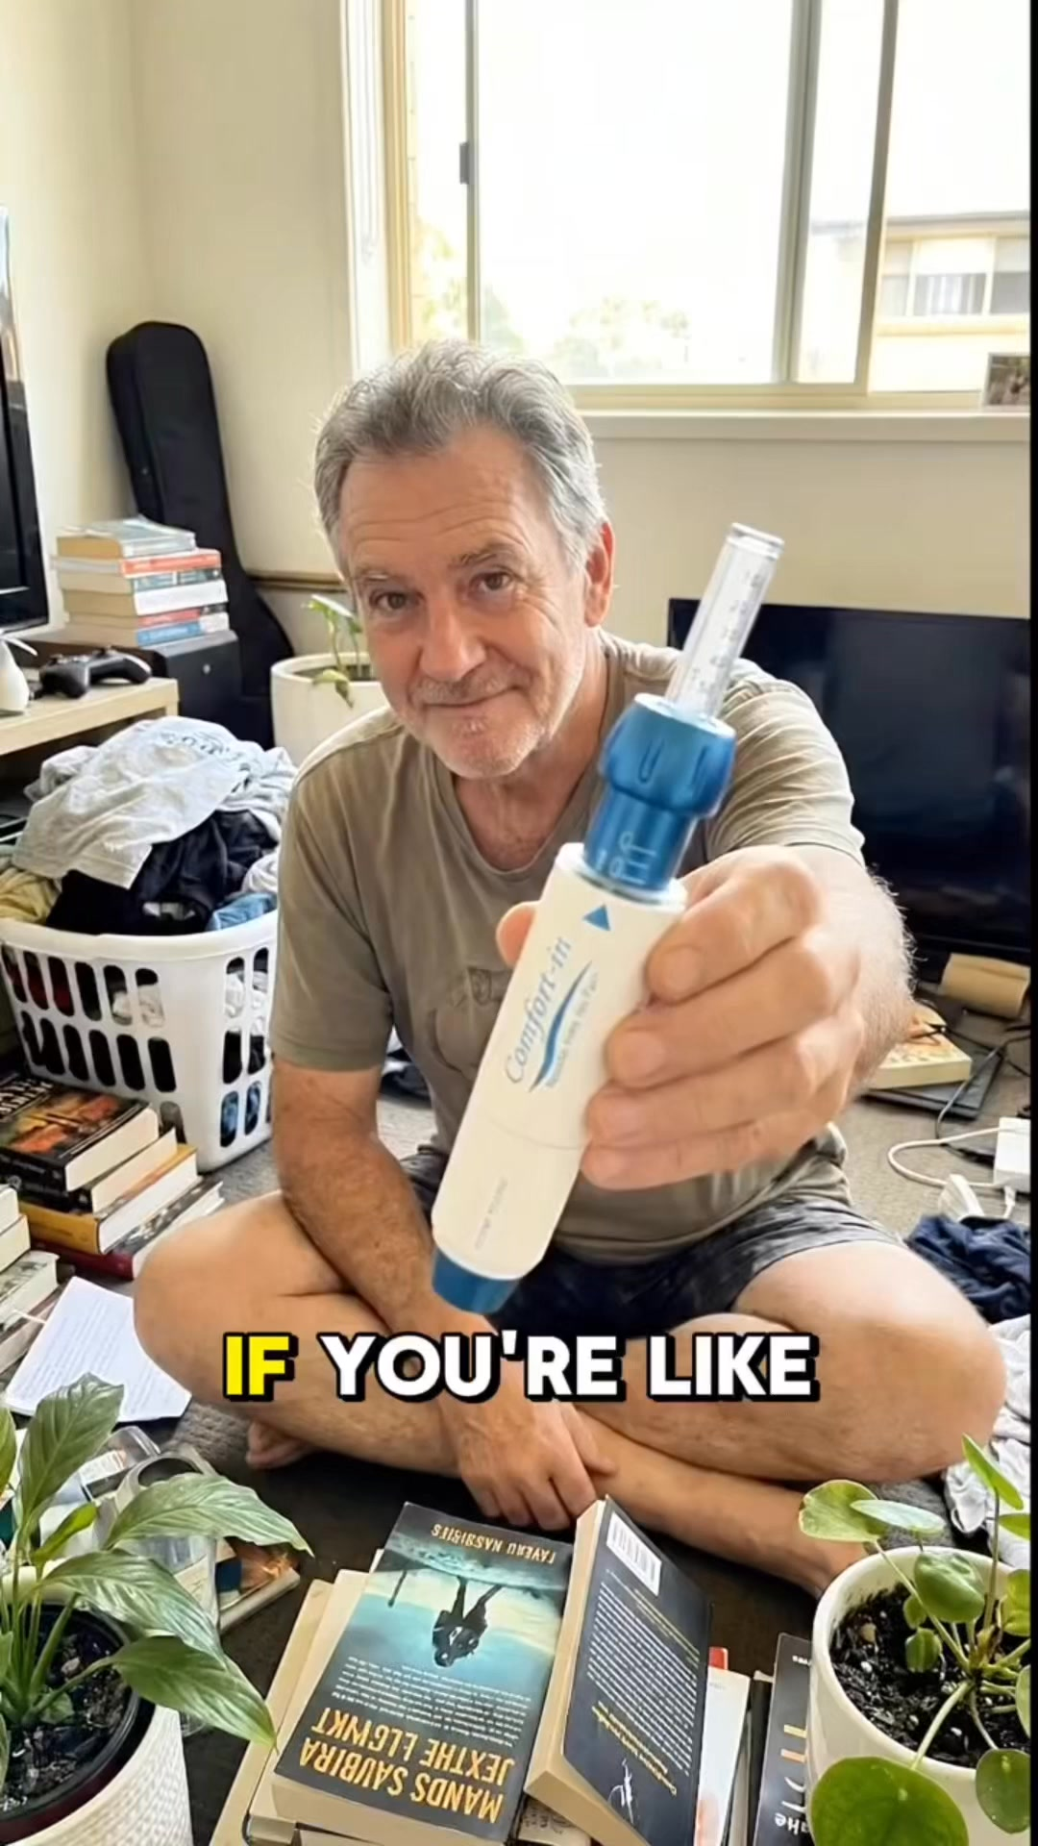

Top 5 Performers by CPP — All Time
# | Release Lot | CPP | Purchases | CTR | Ad ID | Preview
🔥 | Dec-22 | $0.26 | 22 | 2.62% | ...434619171 | 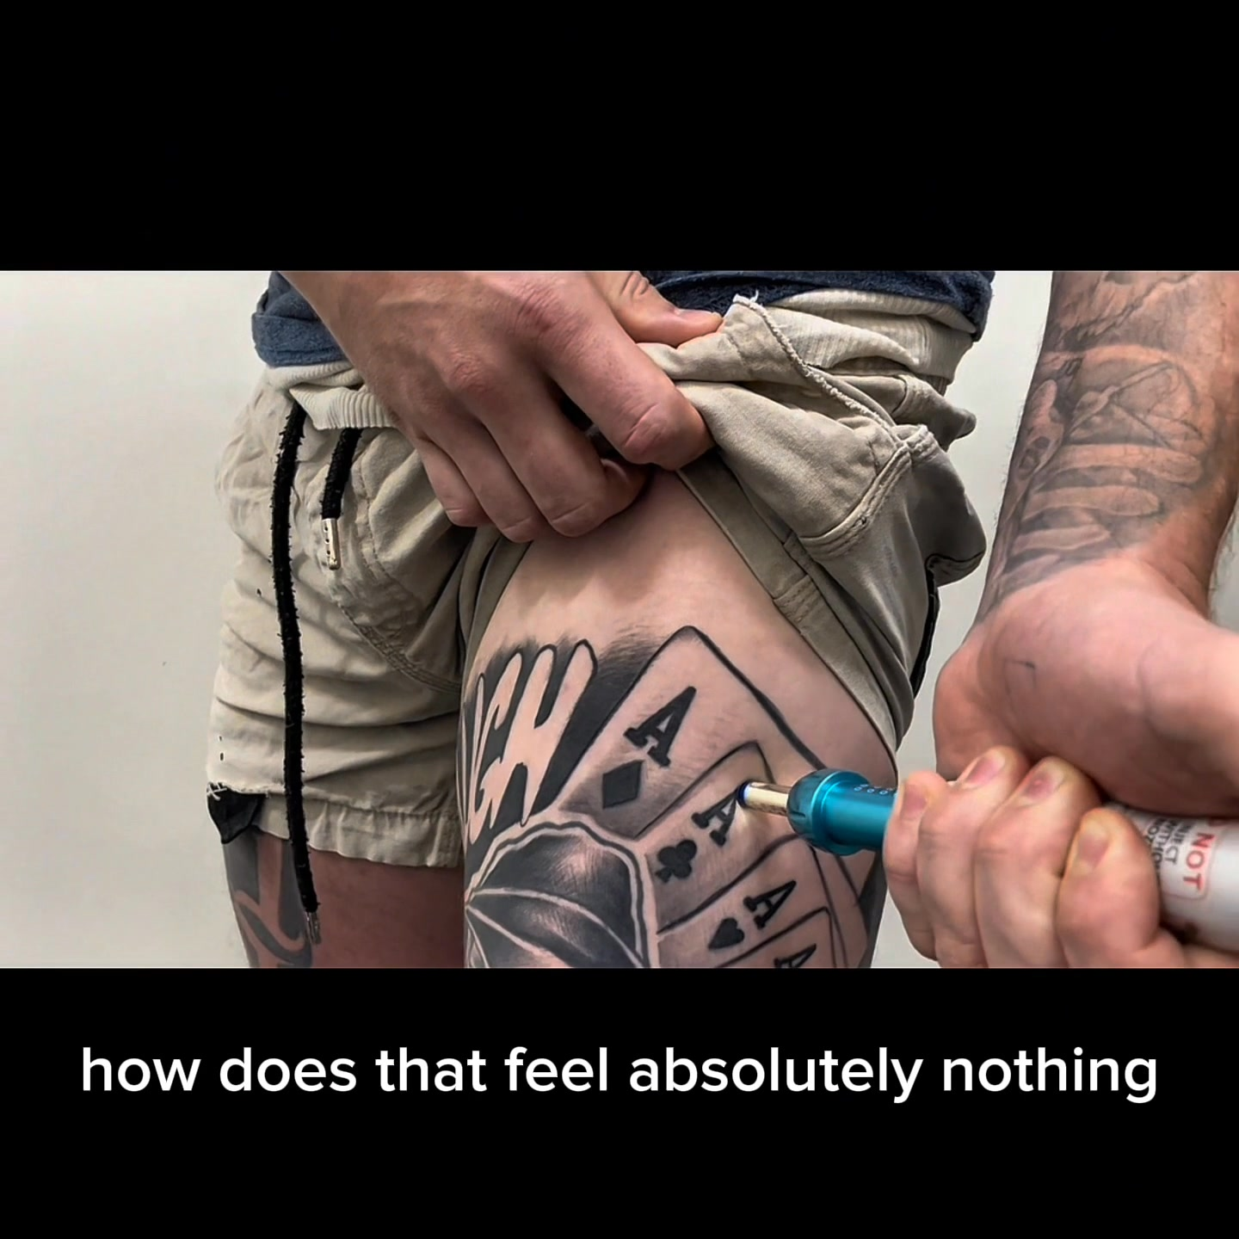
2 | Feb-10 | $0.45 | 4 | 0.92% | ...790733571 | 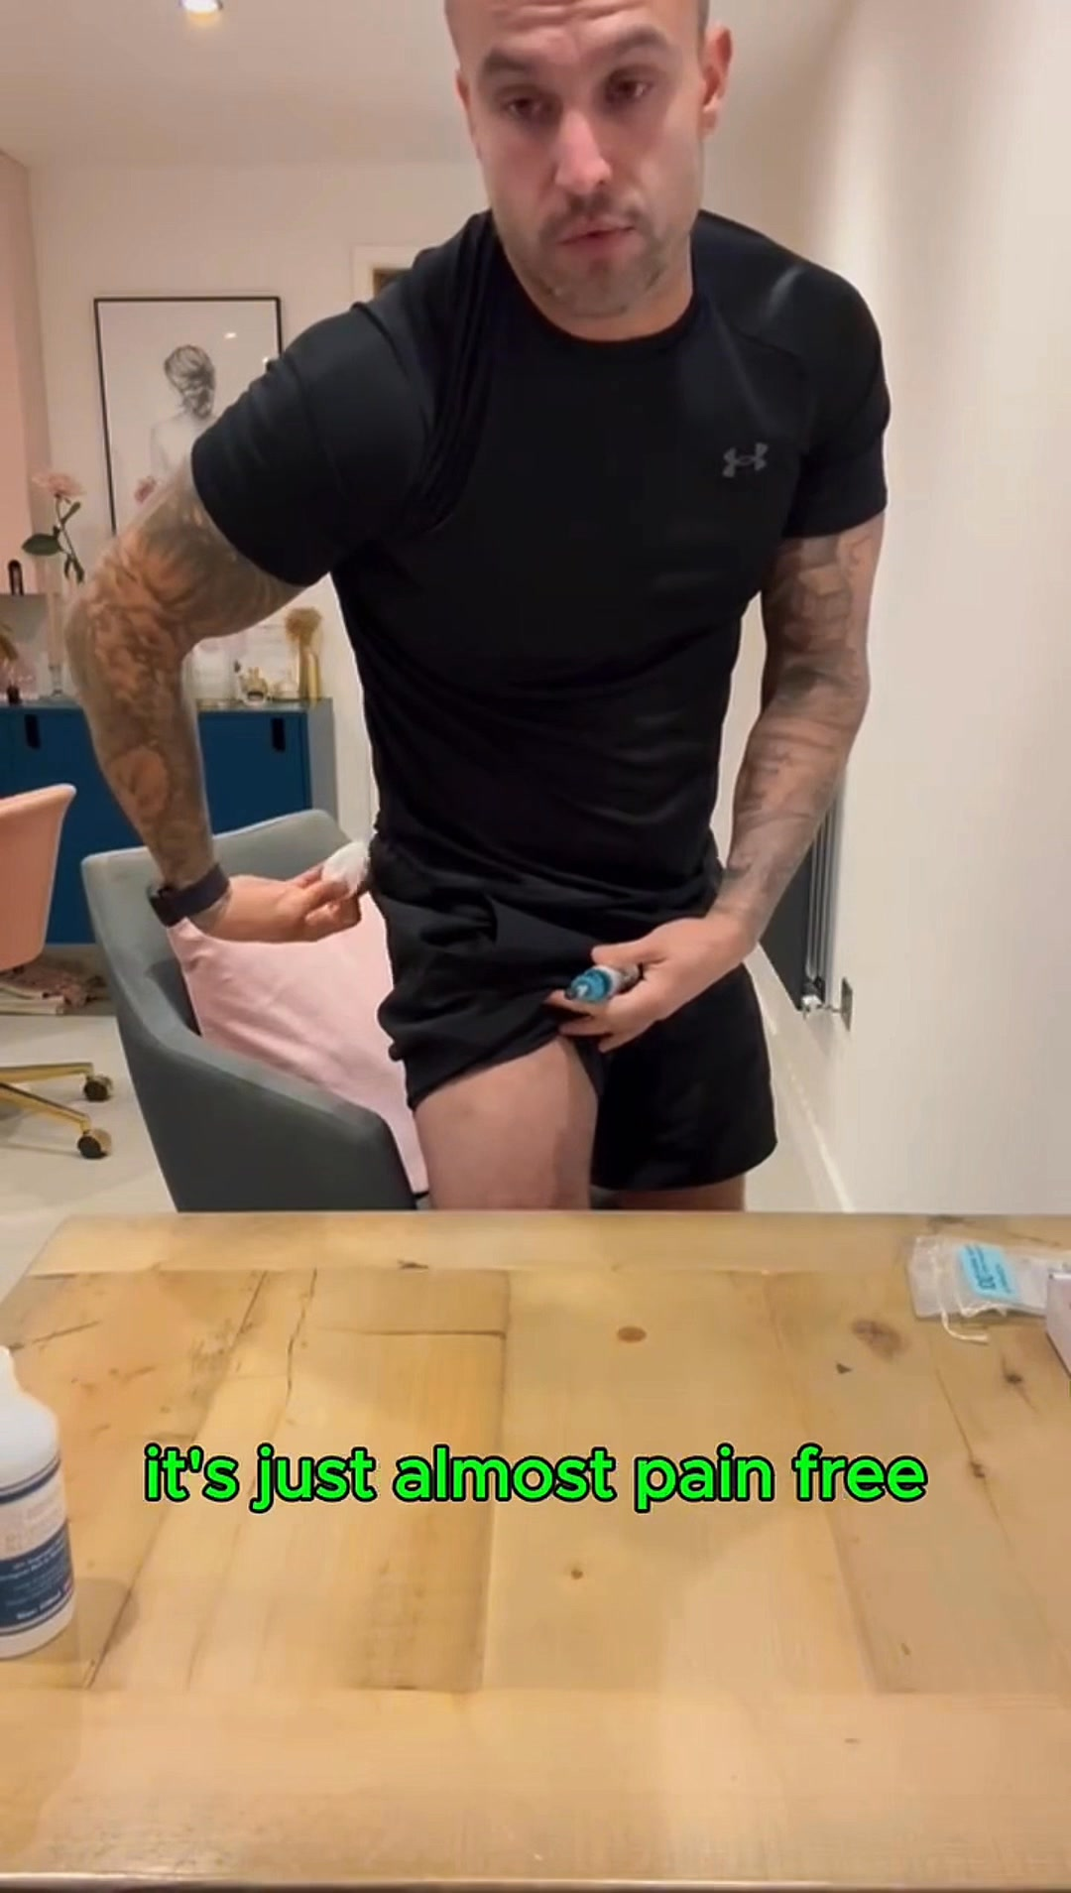
⭐ | Mar-12 | $0.69 | 4 | 3.54% | ...675335171
4 | Jan-20 | $0.70 | 4 | 1.26% | ...245221971 | 
5 | Jan-7 | $0.82 | 4 | 2.21% | ...925871771 | 
🔥 = Top performer | ⭐ = Volume star | Sorted by cost per conversion (lowest first)

Release Lot Performance
• Dec-22 Release: 22 conversions from 1 ad(s) – Best cost: $0.26
• Feb-10 Release: 4 conversions from 1 ad(s) – Best cost: $0.45
• Feb-28 Release: 4 conversions from 1 ad(s) – Best cost: $0.69
• Jan-20 Release: 4 conversions from 1 ad(s) – Best cost: $0.70
• Jan-07 Release: 4 conversions from 1 ad(s) – Best cost: $0.82

Creative Insights
Top Performer:
(22-12-2025) - (5) – 22 conversions at $0.26 cost, 2.62% CTR
Runner Up:
(10-02-2026) - (2) – 4 conversions at $0.45 cost, 0.92% CTR

Demographic Sweet Spot
• Male 35-44: 10 purchases, $21.17 CPP, 2.93% CTR
• Male 45-54: 10 purchases, $9.08 CPP, 3.20% CTR
• Male 25-34: 8 purchases, $19.75 CPP, 2.48% CTR

Key Insights
What's Working:
✓ Campaign is running with 14 conversions

Opportunities:
→ Continue optimising campaign performance

Recommended Next Steps
▸ Monitor performance and adjust as needed

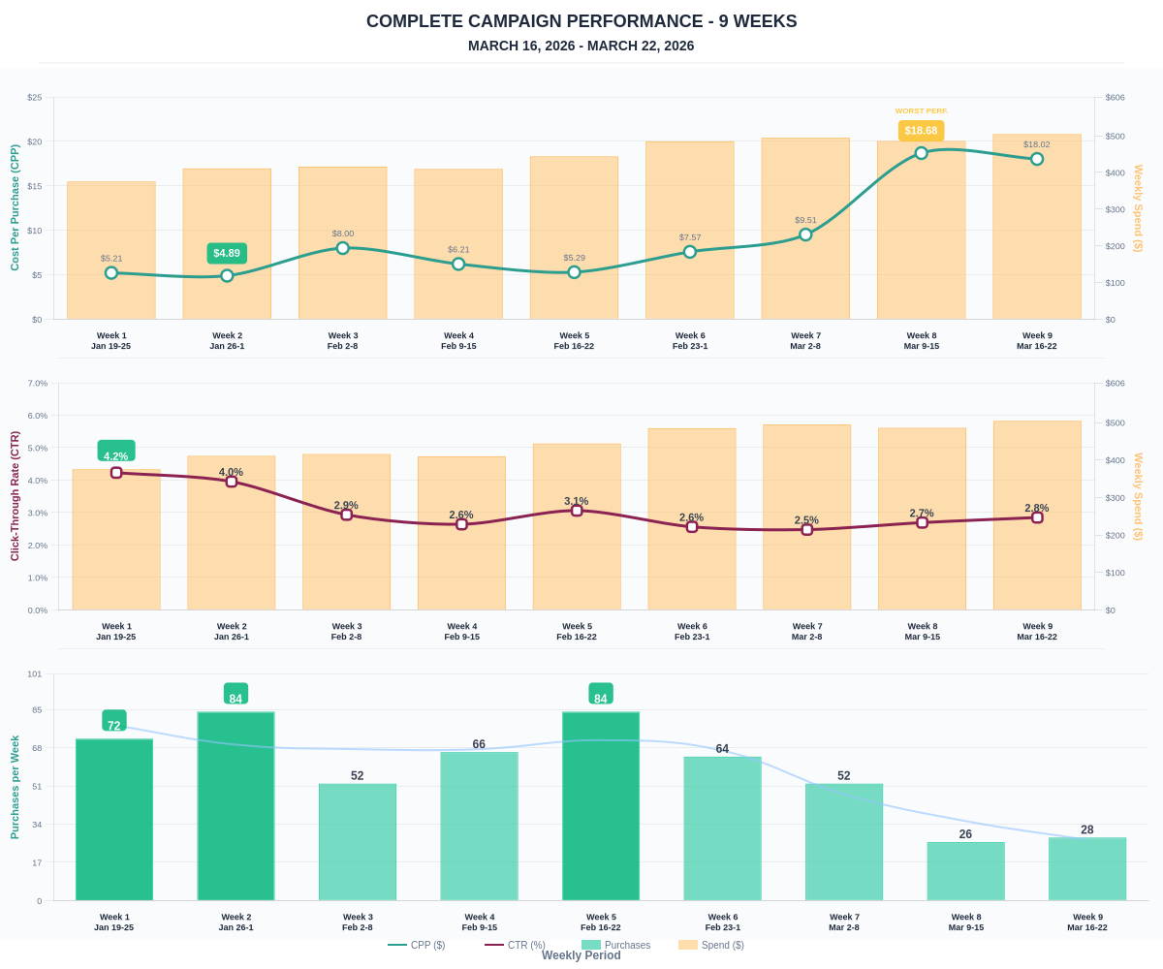

Questions? Let's chat about scaling these results.

