

Meta Ads Performance Audit
Client: NeedleFree (Comfort-In)
Campaign: PA - Sales - LP - All - CBO - 17.1
Period: 23 March 2026 – 2 April 2026

Executive Summary
The NeedleFree (Comfort-In) campaign is delivering results with a blended CPP of $33.92 across 25 purchases. Total ad spend for the period was $847.90 with an average CTR of 3.51%. The top performer achieved a CPP of $0.39 ((22-12-2025) - (5)). CTR is within healthy range for e-commerce campaigns.

Key Metrics
Period | Spend | Purchases | CPP | CTR
This Week | $847.90 | 25 | $33.92 | 3.51%
This Month | $2,186.10 | 70 | $31.23 | 2.99%
Since Starting | $7,310.46 | 502 | $14.56 | 3.70%

Latest Batch — Top Metrics
# | Release Lot | Spend | CPM | CTR | Ad ID | Preview
🔥 | Mar-28 | $2.38 | $23.56 | 0.99% | ...860842171 | 

Top 5 Performers by CPP — All Time
# | Release Lot | CPP | Purchases | CTR | Ad ID | Preview
🔥 | Dec-22 | $0.39 | 22 | 2.65% | ...434619171 | 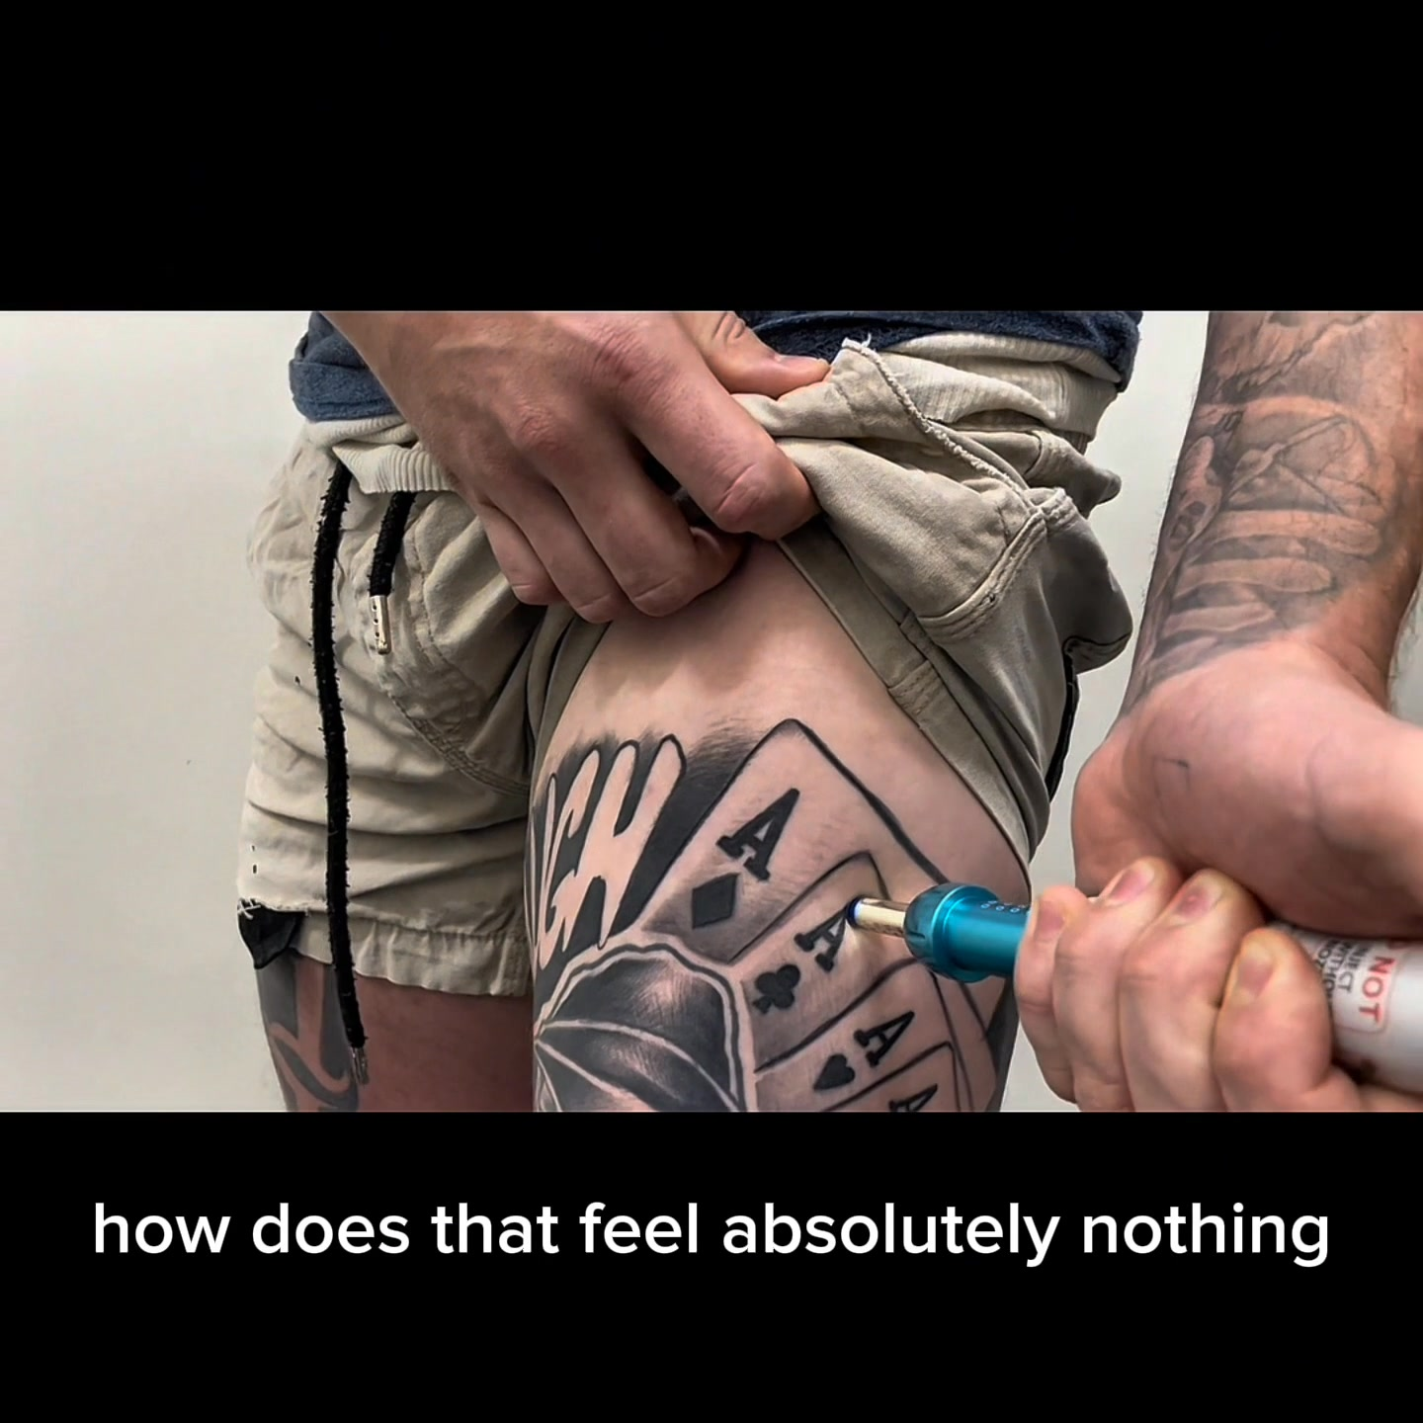
2 | Jan-20 | $0.76 | 4 | 1.13% | ...245221971 | 
⭐ | Feb-10 | $0.88 | 6 | 0.85% | ...790733771 | 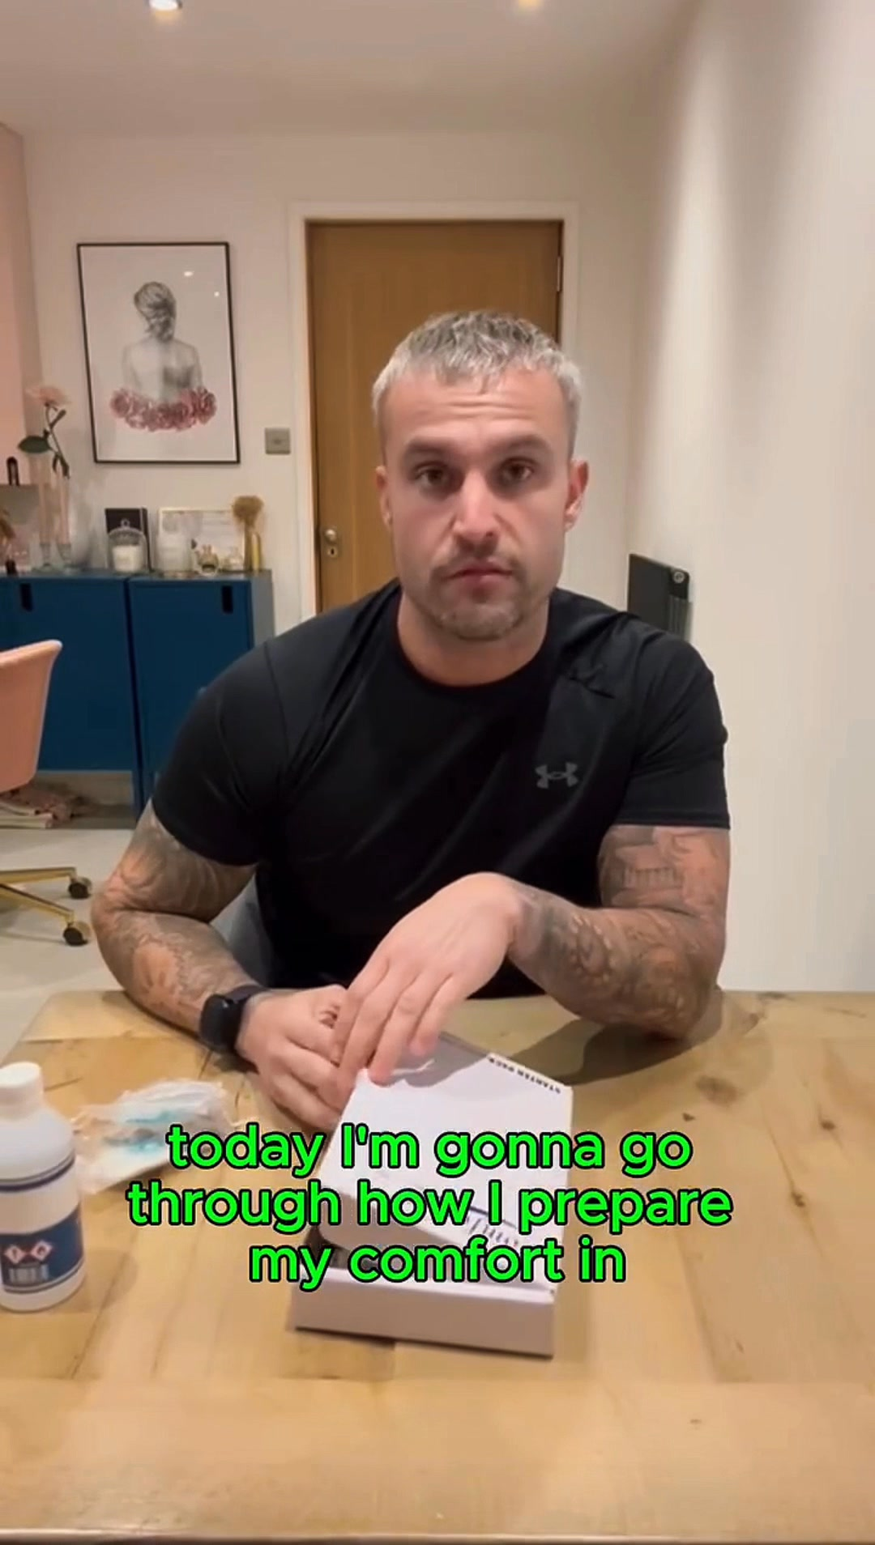
4 | Jan-7 | $1.00 | 4 | 1.83% | ...925871771 | 
5 | Mar-12 | $1.26 | 4 | 2.70% | ...675335171 | 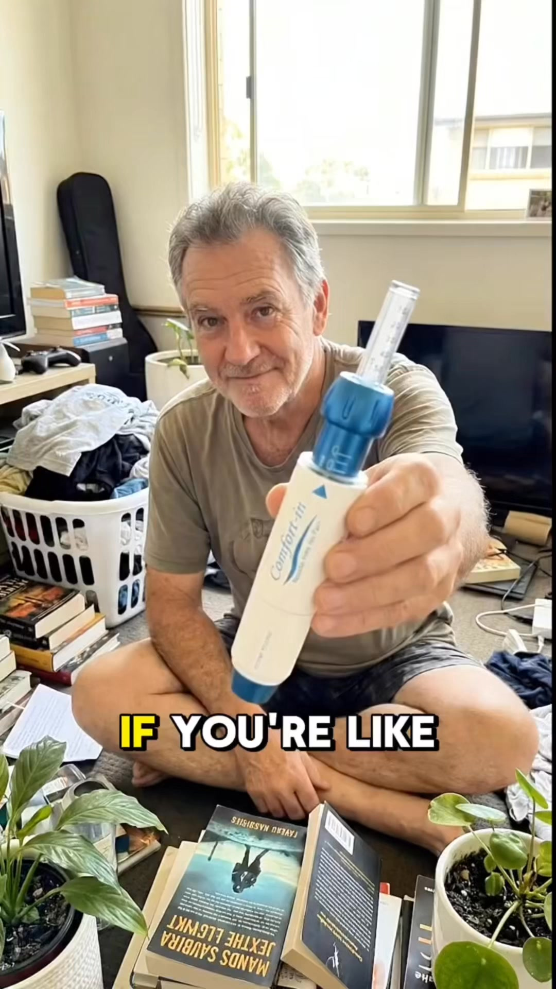
🔥 = Top performer | ⭐ = Volume star | Sorted by cost per conversion (lowest first)

Release Lot Performance
• Dec-22 Release: 22 conversions from 1 ad(s) – Best cost: $0.39
• Jan-20 Release: 4 conversions from 1 ad(s) – Best cost: $0.76
• Feb-10 Release: 6 conversions from 1 ad(s) – Best cost: $0.88
• Jan-07 Release: 4 conversions from 1 ad(s) – Best cost: $1.00
• Feb-28 Release: 4 conversions from 1 ad(s) – Best cost: $1.26

Creative Insights
Top Performer:
(22-12-2025) - (5) – 22 conversions at $0.39 cost, 2.65% CTR
Runner Up:
(20-01-2026) - (3) – 4 conversions at $0.76 cost, 1.13% CTR

Demographic Sweet Spot
• Male 25-34: 22 purchases, $12.47 CPP, 3.20% CTR
• Male 35-44: 12 purchases, $29.40 CPP, 3.51% CTR
• Male 45-54: 12 purchases, $11.26 CPP, 4.14% CTR

Key Insights
What's Working:
✓ Campaign is running with 25 conversions

Opportunities:
→ Continue optimising campaign performance

Recommended Next Steps
▸ Monitor performance and adjust as needed

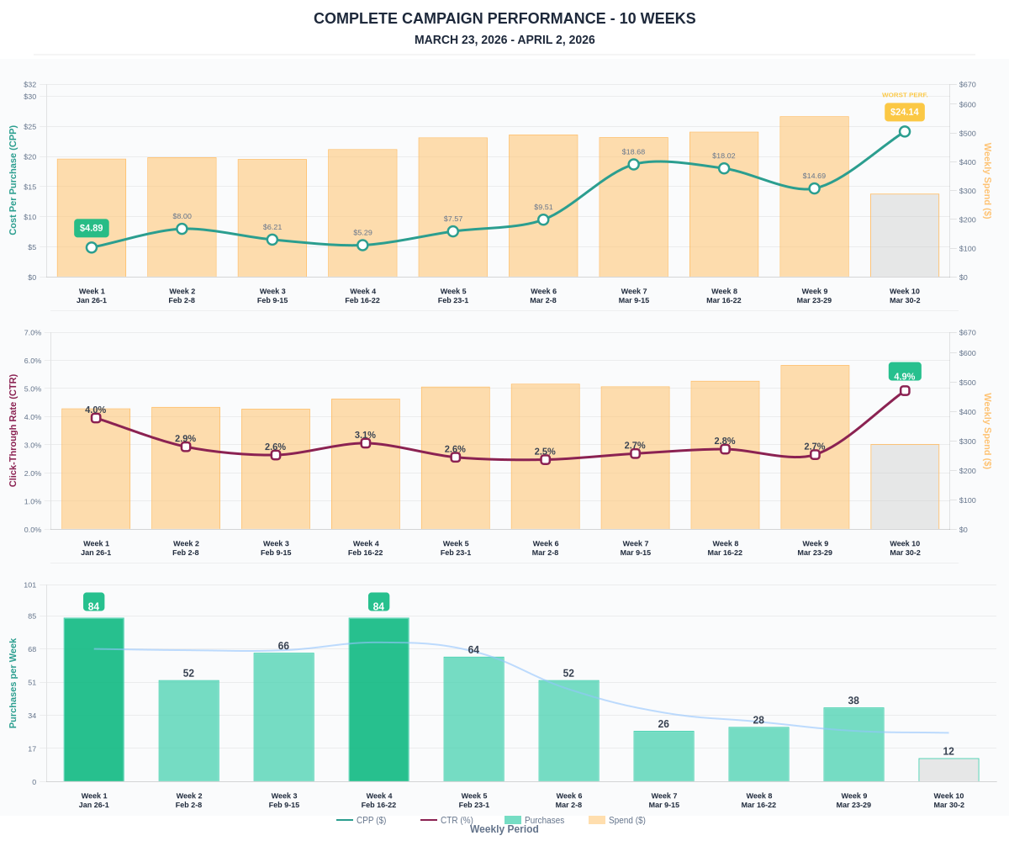

Questions? Let's chat about scaling these results.

