

Meta Ads Performance Audit
Client: NeedleFree (Comfort-In)
Campaign: PA - Sales - LP - All - CBO - 17.1
Period: 30 March 2026 – 5 April 2026

Executive Summary
The NeedleFree (Comfort-In) campaign is delivering results with a blended CPP of $23.08 across 24 purchases. Total ad spend for the period was $553.86 with an average CTR of 5.41%. The top performer achieved a CPP of $0.39 ((22-12-2025) - (5)). High CTR indicates strong creative-audience fit.

Key Metrics
Period | Spend | Purchases | CPP | CTR
This Week | $553.86 | 24 | $23.08 | 5.41%
This Month | $2,315.07 | 80 | $28.94 | 3.38%
Since Starting | $7,574.74 | 520 | $14.57 | 3.78%

Latest Batch — Top Performers
# | Release Lot | CPP | Purchases | CTR | Ad ID | Preview
🔥 | Nov-23 | $9.25 | 74 | 0.96% | ...051358971 | 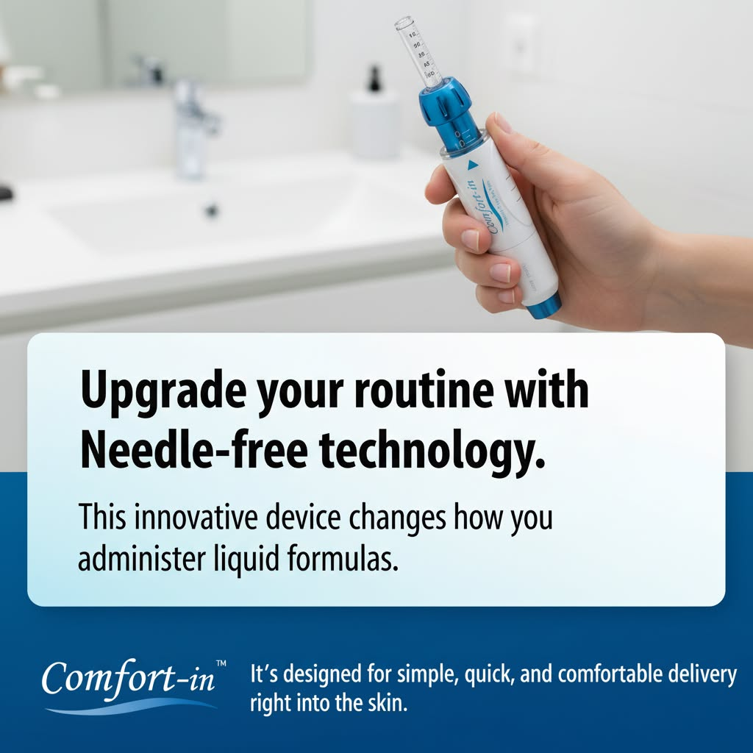
2 | Nov-23 | $14.39 | 66 | 1.12% | ...051360371 | 

Top 5 Performers by CPP — All Time
# | Release Lot | CPP | Purchases | CTR | Ad ID | Preview
🔥 | Dec-22 | $0.39 | 22 | 2.65% | ...434619171 | 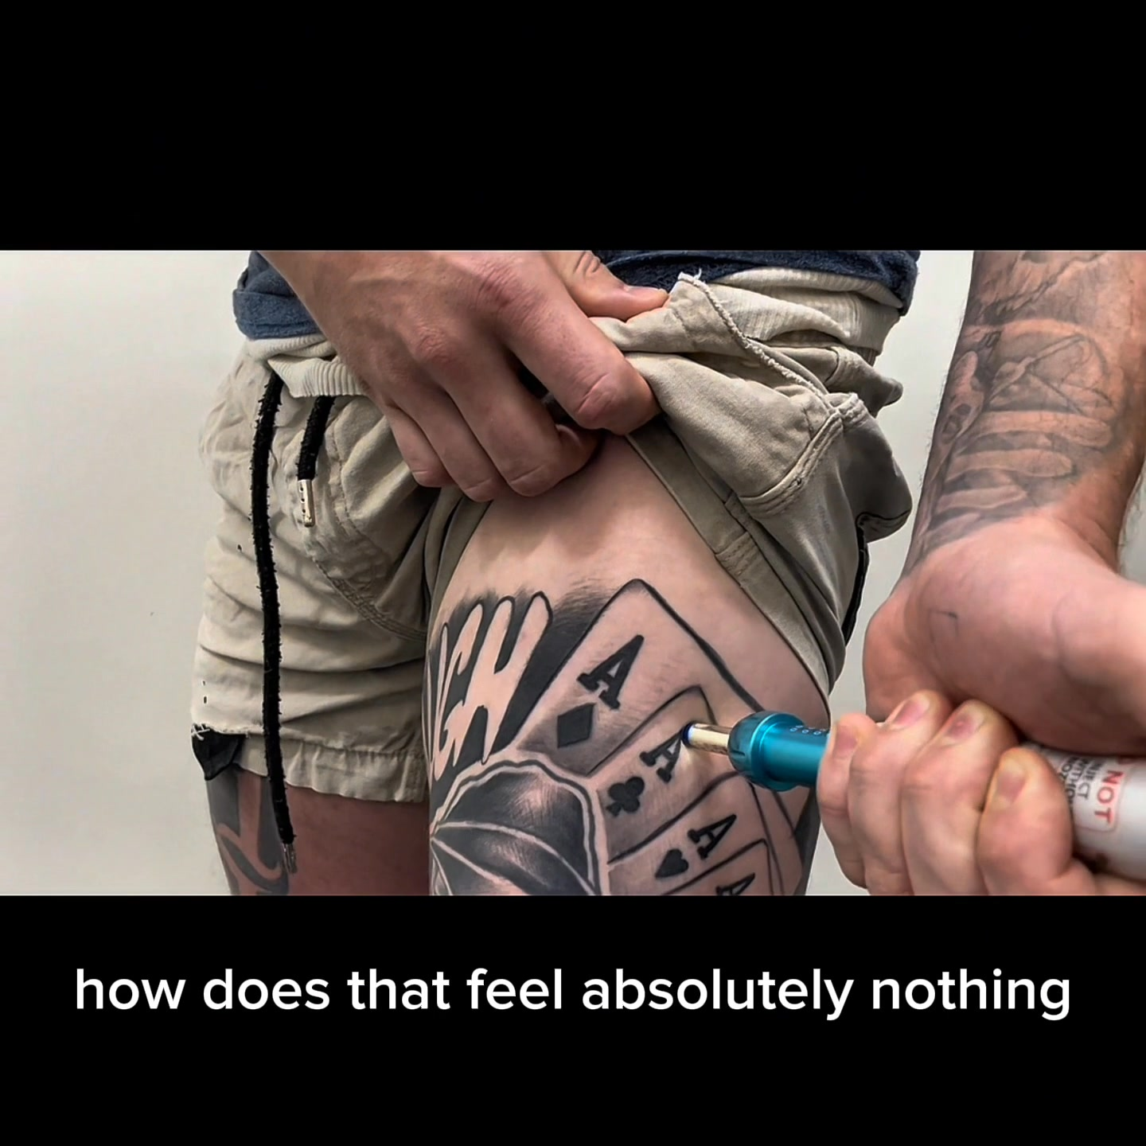
2 | Jan-20 | $0.76 | 4 | 1.13% | ...245221971 | 
⭐ | Jan-7 | $0.87 | 6 | 2.32% | ...925871771 | 
4 | Feb-10 | $0.88 | 6 | 0.85% | ...790733771 | 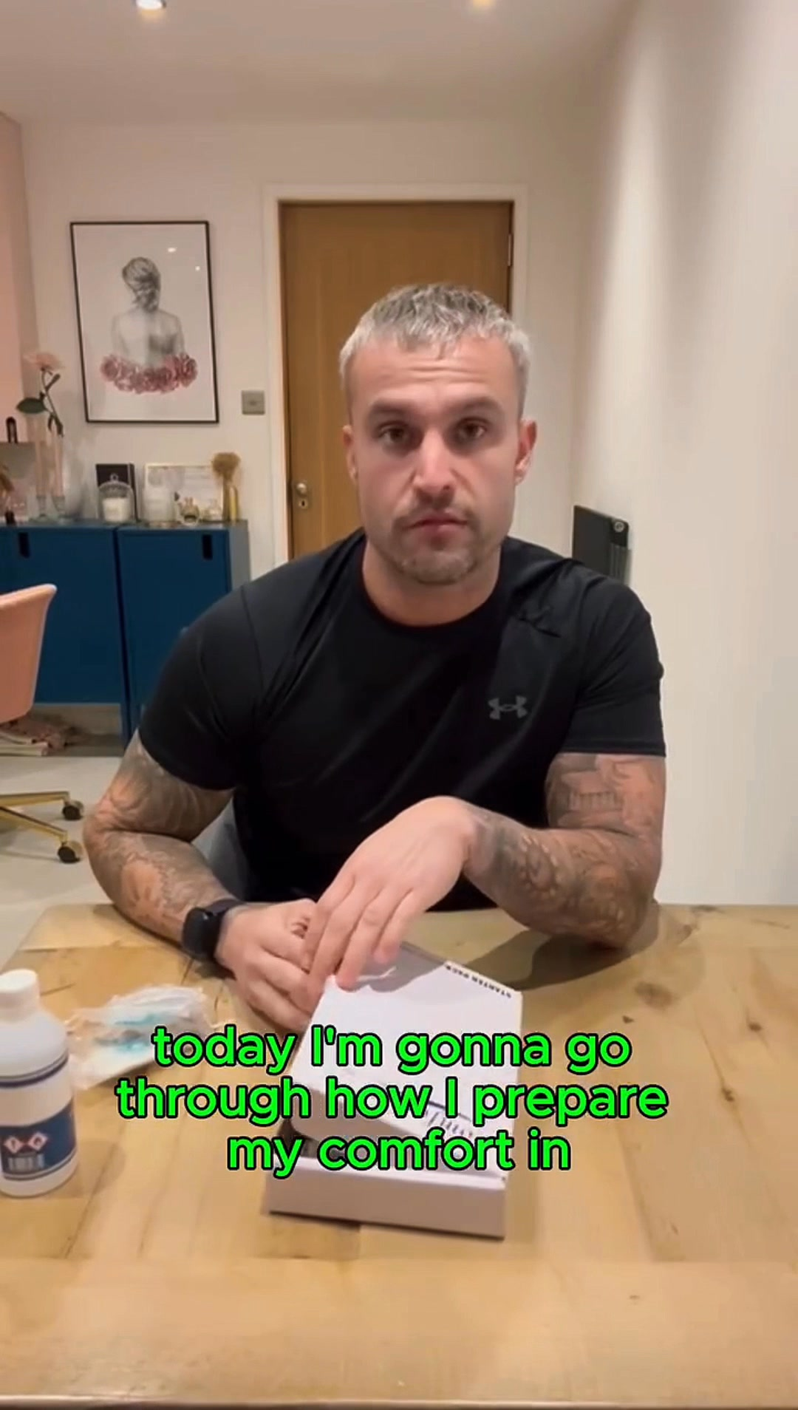
5 | Mar-12 | $1.26 | 4 | 2.70% | ...675335171 | 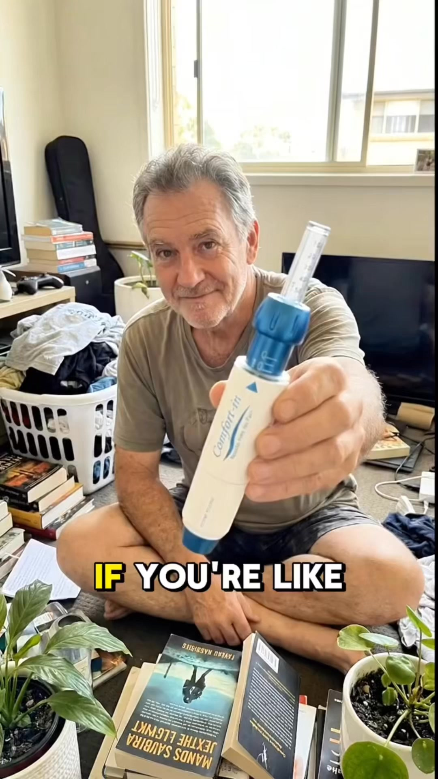
🔥 = Top performer | ⭐ = Volume star | Sorted by cost per conversion (lowest first)

Release Lot Performance
• Dec-22 Release: 22 conversions from 1 ad(s) – Best cost: $0.39
• Jan-20 Release: 4 conversions from 1 ad(s) – Best cost: $0.76
• Jan-07 Release: 6 conversions from 1 ad(s) – Best cost: $0.87
• Feb-10 Release: 6 conversions from 1 ad(s) – Best cost: $0.88
• Feb-28 Release: 4 conversions from 1 ad(s) – Best cost: $1.26

Creative Insights
Top Performer:
(22-12-2025) - (5) – 22 conversions at $0.39 cost, 2.65% CTR
Runner Up:
(20-01-2026) - (3) – 4 conversions at $0.76 cost, 1.13% CTR

Demographic Sweet Spot
• Male 35-44: 24 purchases, $9.28 CPP, 5.63% CTR
• Male 25-34: 14 purchases, $13.10 CPP, 4.78% CTR
• Male 45-54: 6 purchases, $14.79 CPP, 5.83% CTR

Key Insights
What's Working:
✓ Campaign is running with 24 conversions

Opportunities:
→ Continue optimising campaign performance

Recommended Next Steps
▸ Monitor performance and adjust as needed

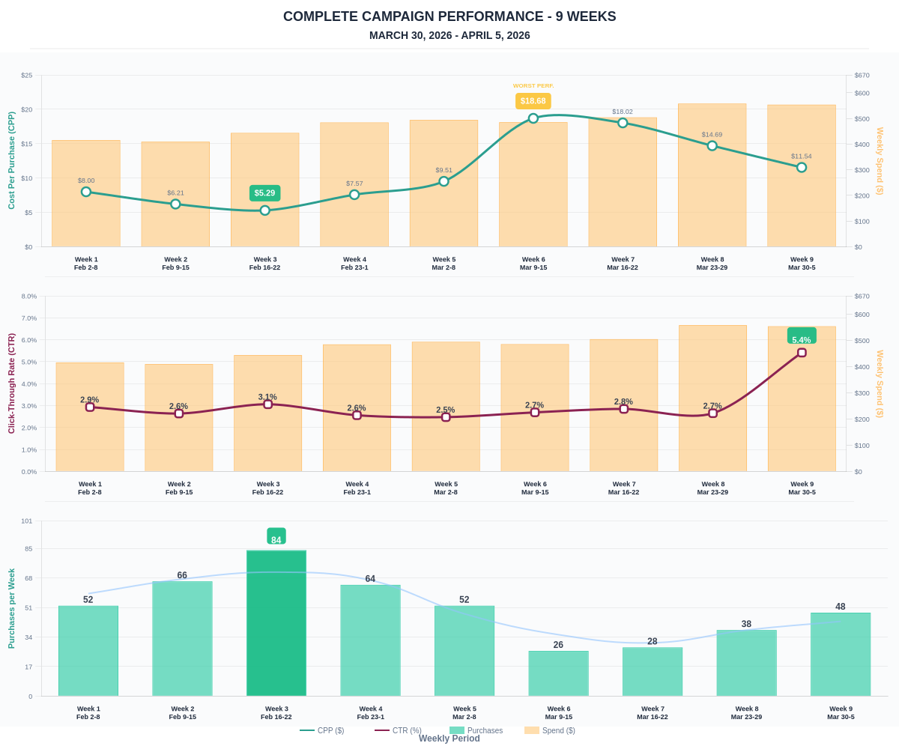

Questions? Let's chat about scaling these results.

