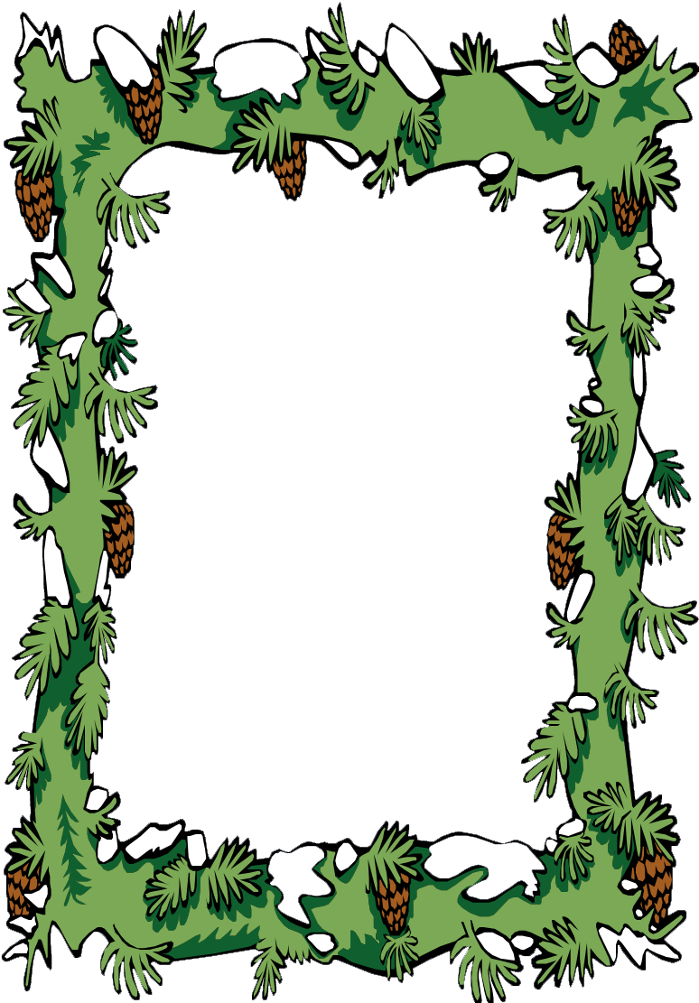

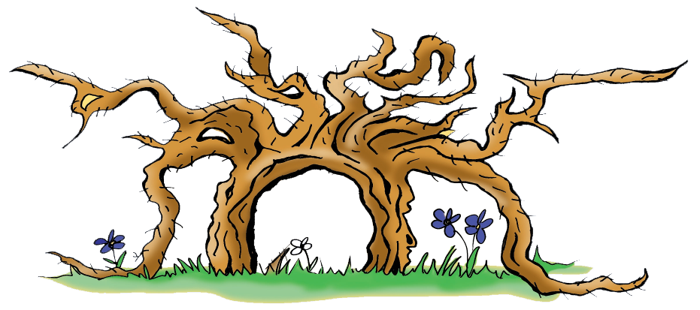

Certificate

for

${name}

Congratulations!

You’ve finished the quiz rally with

laudable

success.

Awarded by the team of Wurzelpark.

Arriach, June 27, 2017