Agenda-W2W

- Talk about lab today
- Assignment for Monday
  - 1-2 page essay
  - Read ESP from some other source
  - Entry ticket: 1 sentence written out telling something new you learned about ESP (or something new you learned that people believe about ESP)
- Debate time
  - Internalist vs externalist
  - Judging
    - Decide on rules
    - Elect judges
  - Choose teams
  - We’ll structure the debate into rounds of
    - Define your side
    - Explain why your side is right
    - Respond to other side
  - Judging
- Pro-con caveat grid for winner
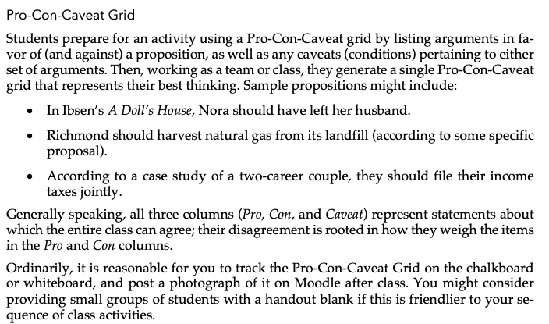
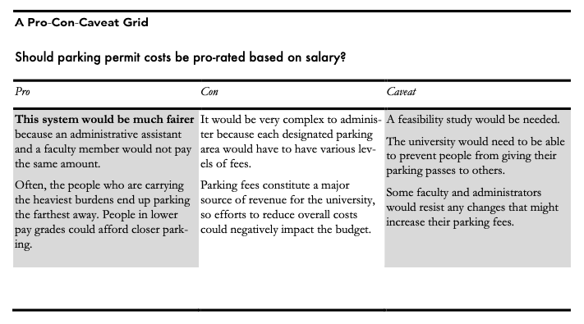

REMIND ABOUT LAB TODAY
- Don’t be late
- Meet here at 2:30. Take attendance, walk over.

Make sure can have a copy of Sagan a week from Monday.
Exit ticket:
- Three most important Problems in Scientific Thinking and why.
  - You can reference them by number if you wish
  - You must explain why

