Agenda-W3D2
Ice breaker
- What music artist reminds you of home (however you define it)
Coin flips demo
What was the point of the Zener cards? What did you learn from it?
Graphical Organizer: what are the characteristics of a witch hunt?
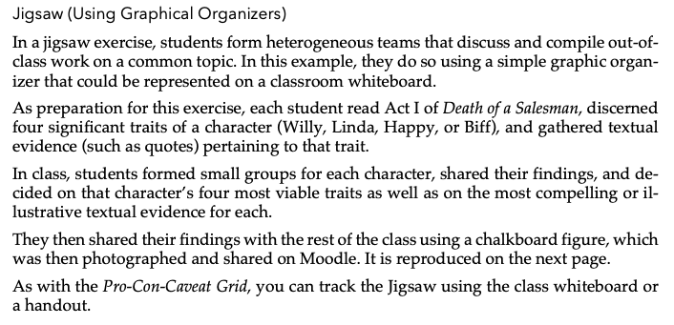
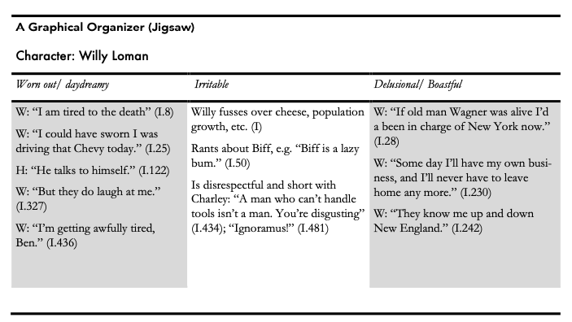
Brief discussion of “confronting creationists”
- Form pairs from across the room, pick the most interesting argument, tell me how you’d apply that argument to something else.

Syllabus things
- A couple of people didn’t turn in reflection #2 and asked for extension. I really like the “no late work” policy combined with the “24 hour extension” policy, because a real part of the ESem is getting you used to handling workload/timing on your own. Meanwhile, I understand that it’s trickier at the beginning. So, slight change
  - Was going to be 5 reflection papers (drop 1) and 4 longer papers (drop 2). I’m going to bump that up to 6-7 reflections (so closer to one per week), but I’ll drop 2.
Exit ticket:
- I’ve avoided evolution vs creation in the past because I know that religion can be a deeply personal topic … and that a discussion that goes a bit sideways can turn into a deeply personal attack. Meanwhile, I’ve talked about it in the past when I thought we could do so reasonably. For your exit ticket, let me know your thoughts. In particular, I want to know if you think we should avoid it.

