EvoDots is a computer program that simulates a population of dots. You, the user, will act as a “predator” who tries to capture the moving dots (your “prey”). We will use the EvoDots program to explore the conditions necessary for evolution by natural selection to operate in populations.

**Downloading and Opening EvoDots**

To obtain EvoDots, navigate to this link in your browser: <http://faculty.washington.edu/herronjc/SoftwareFolder/EvoDots.html> .

1. If you are using a Mac, click the link that says “EvoDots for Mac.” If you using a PC, click the link that says “EvoDots for Windows.” Clicking this link will download EvoDots onto your computer. Follow the instructions depending on your computer system.
2. **Opening EvoDots on Windows**
   1. Once download is complete, you will see a new folder in your computer (most likely in the “Downloads” folder, depending on your personal browser preferences) called “evodots.” **Do not attempt to move to change any contents of this folder! If you change or move contents, EvoDots will NOT work properly.**
   2. Inside this folder is a file called “EvoDots.exe”. Double-click this file to launch EvoDots.
3. **Opening EvoDots on a Mac**
   1. Once download is complete, you will see a new folder in your computer (most likely in the “Downloads” folder, depending on your personal browser preferences) called “EvoDotsApp.”
   2. Inside this folder is a file, denoted with the EvoDots icon, called “EvoDots.” Double-click this file to launch EvoDots.
   3. The first time you try to open EvoDots you will probably get a message that says “**Evodots.app can’t be opened because it is from an unidentified developer.”** This is NORMAL!! Click “ok”, then go to your computers “System Preferences” 🡪 “Security & Privacy.” There will be a button there to click that says “Open Anyway.” Now you’re good to go.
      1. At this point there will be yet another warning, “**Evodots.app is from an unidentified developer. Are you sure you want to open it?”** Again, it’s ok – click Open!

**Getting Started with EvoDots**

When you open EvoDots, you will see a window like this:

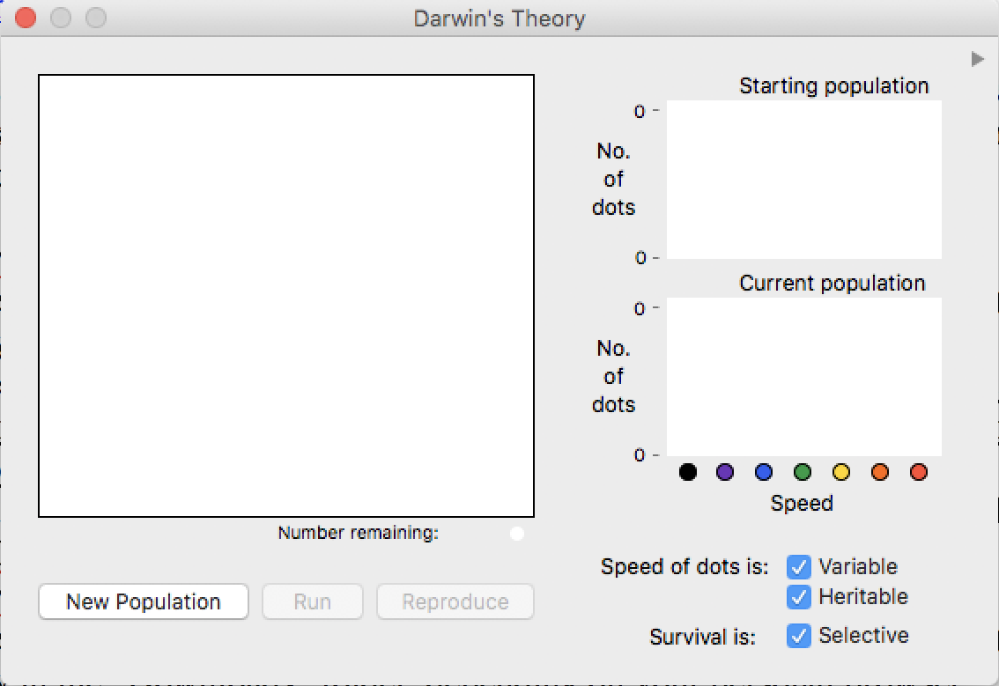

The large screen on the left is where your population of dots will live. The screens on the right will show *bar plots* of how many different colors of dots are in i) the starting population (top right), and ii) the current population (bottom right).

To see this information, we’ll need a population of dots! Click the button “New Population” to create your very own first population of dots (your dots will look different from this picture). For now, do NOT click any other button.

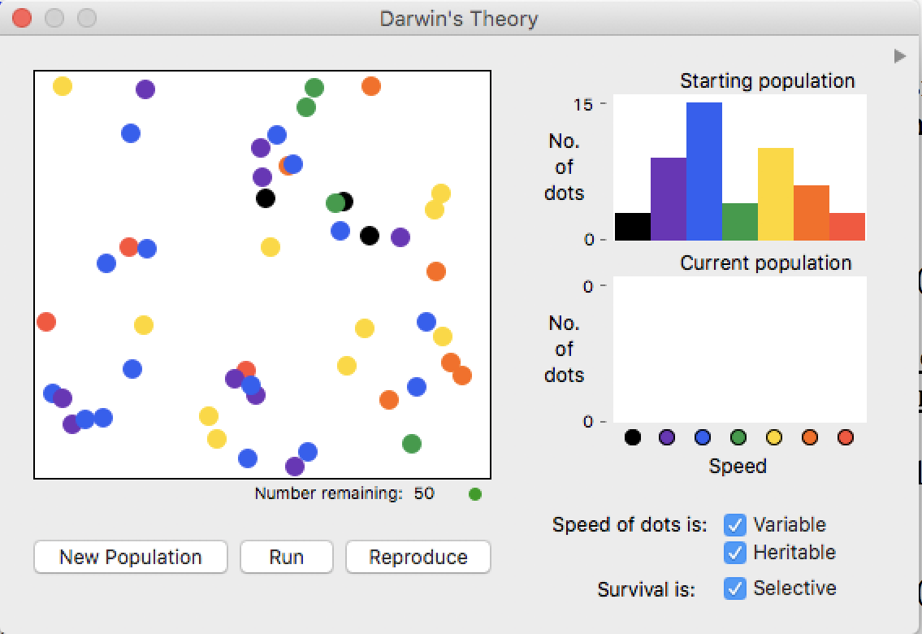

You will now see **50 dots** (note the caption “Number remaining: 50”) in the population box on the left, and a bar plot showing the different color counts on the top right.

**Complete the following tasks along with the class to get acquainted with EvoDots.**

[An important note before we proceed: Sometimes when you click away from the EvoDots window, your dot population will seem to disappear. Don’t worry – it’s still there!! Re-engaging with EvoDots buttons will make your population return to normal!]

1. Understand the relationship between the dots themselves and the “Starting Population” bar plot. To do this, pick a color and count the number of dots on the left. You should observe that the height of each color bar matches the number of those dots.
2. Click the “Run” button (but nothing else!) and you will see the dots begin to move. While they are moving, make some observations about the behavior of the dots. Once you have completed your observations, press the “Stop” bottom to halt dot movement.
3. You will now see a second bar plot appear in the “Current Population” box. How does this bar plot compare to the “Starting Population” bar plot? Understand why these two bar plots look similar or different.
4. At the top right corner of the EvoDots screen, you will see a small gray arrow. Click this arrow to reveal a table called “History.” Can you determine what information this table contains? *Hint: The column “g” stands for “generation.”*
5. Now, let’s examine the three checkboxes at the bottom right of the screen. These boxes provide information about *natural selection for dot speed*. Make sure these boxes are checked! The boxes are…
   1. **Speed of dots is variable.** When checked, the different colors of dots vary in their speed of movement, with red dots moving the fastest and black moving slowest. When unchecked, all the dots move at the same speed regardless of color.
   2. **Speed of dots is heritable.** When checked the speed of a “parent” dot is passed on to its offspring after “reproduction,” so children will inherit the exact same dot speed their parent had. When unchecked, the newly produced dots move at a randomly chosen speed.
   3. **Survival is selective.** When checked, dots are removed from the population when you, the predator, directly click them. When unchecked, a random dot is removed each time you click on the dot population. *In other words*, this checkbox determines whether dot speed affects fitness (here, fitness = surviving a predator attack aka a click).
6. Let’s practice being predators and capture some dots. Again, click the “Run” button and try to click as many dots as you can for **5—10 seconds**. Then, click the “Stop” button. Examine your population and the new bar plot resulting after your predation examine your population.
7. Finally, let’s practice reproducing. Click the “Reproduce” button and examine the new generation of dots.
8. Now that you are acquainted with the different features of EvoDots, work with your group to conduct and record data for the **five exercises** below. The goal of these exercises is to understand how and why natural selection acts on populations, and under which conditions natural selection and/or evolution does and does not act.

*HINT!!* Throughout this exercise, remember that there is a difference between *evolution* and *natural selection*. Natural selection is only *one way* that populations can evolve, and sometimes a population can evolve even when there is no natural selection acting.

For each exercise, you will prey on a population of dots for ***five generations*** (or until the population has no more variation, whichever comes first) and record the number of dots in each generation as you go. To accomplish this, you will, for each exercise, i) initialize a new population, ii) run the population and prey on it, iii) allow the population to reproduce, and repeat.

**EXERCISE 1**

1. For this exercise, we will examine the (potential) actions of natural selection when all three checkboxes are checked: the three boxes Speed of dots is variable, Speed of dots is heritable, and Survival is selective should all be checked.
2. Initialize a new population of 50 dots by clicking the “New Population” button. Record the number of dots of each color in your spreadsheet at the row *Generation 1/Before Predation*.
3. **Predict how the population will look, in terms of dot phenotype frequencies, after five generations of predation and reproduction.** In other words, will most dots be slow? most dots be fasts? equal amounts of dots of different speeds? random amounts of dots with each speed? etc. **Record your prediction on the Exercise #1 section of the EvoDots Answer Sheet.**
4. Prey on the population until only **25 dots remain**. (Hint: use the counter on the bottom left of the dot populations to see how many dots are left.) Record the number of dots of each color in your spreadsheet at the row *Generation 1/After Predation*.
5. “Reproduce” the population of dots, which will return the population size back to 50. Again, record the number of dots of each color in *Generation 2/Before Predation*. Again, click “Run” and prey until only 25 dots remain, and record the resulting number of dots in *Generation 2/After Predation.***Repeat this task for a total of** **six generations, OR until there is no more color variation left in your dot population (whichever comes first)**.
6. **Answer the remaining Exercise #1 questions on the EvoDots Answer Sheet.**

**EXERCISE 2**

1. For this exercise, we will examine the (potential) actions of natural selection when **only two** checkboxes are checked:
   1. **UNCHECK** Speed of dots is variable
   2. **CHECK** Speed of dots is heritable and Survival is selective
2. Follow the same tasks as you did for Exercise 1, recording your hypotheses, results, and conclusions as you go.

**EXERCISE 3**

1. For this exercise, we will examine the (potential) actions of natural selection when **only two** checkboxes are checked:
   1. **UNCHECK** Speed of dots is heritable
   2. **CHECK** Speed of dots is variable and Survival is selective
2. Follow the same tasks as you did for Exercise 1, recording your hypotheses, results, and conclusions as you go.

**EXERCISE 4**

1. For this exercise, we will examine the (potential) actions of natural selection when **only two** checkboxes are checked:
   1. **UNCHECK** Survival is selective
   2. **CHECK** Speed of dots is heritable and Speed of dots is variable
2. Follow the same tasks as you did for Exercise 1, recording your hypotheses, results, and conclusions as you go.