**Your name:____________________________________**

**Names of any students you worked with:**

**Please answer all questions in a different color!**

**Question 1**

Neonicotinoids are a type of pesticide widely used in agriculture. Researchers studied the extent to which exposure to clothianidin, a commonly used neonicotinoid, affects development of the bee pollinator species, *Osmia bicornis* (10.7717/peerj.3417).

To examine this question, researchers allowed randomly-chosen females to lay eggs under the same conditions. A total of 161 eggs were randomly collected from these females, and researchers randomly assigned these eggs into four experimental groups. Each group was exposed to a different dosage of clothianidin: 0 ppb (parts per billion), 1 ppb, 3 ppb, and 10 ppb. These clothianidin levels match the range of clothianidin levels found in *Osmia bicornis'* natural habitat. Researchers waited for all eggs to hatch and develop into adults. Researchers then measured the weight of each adult bee in milligrams (mg). Results are shown in the figure below, where dots represent the mean mass and lines represent the standard deviation of mass, for each experimental group. To account for sexual dimorphism in their analysis, researchers measured male and female mass separately. *When interpreting this figure, assume that if standard deviations overlap across treatments, they are NOT significantly different from each other.*

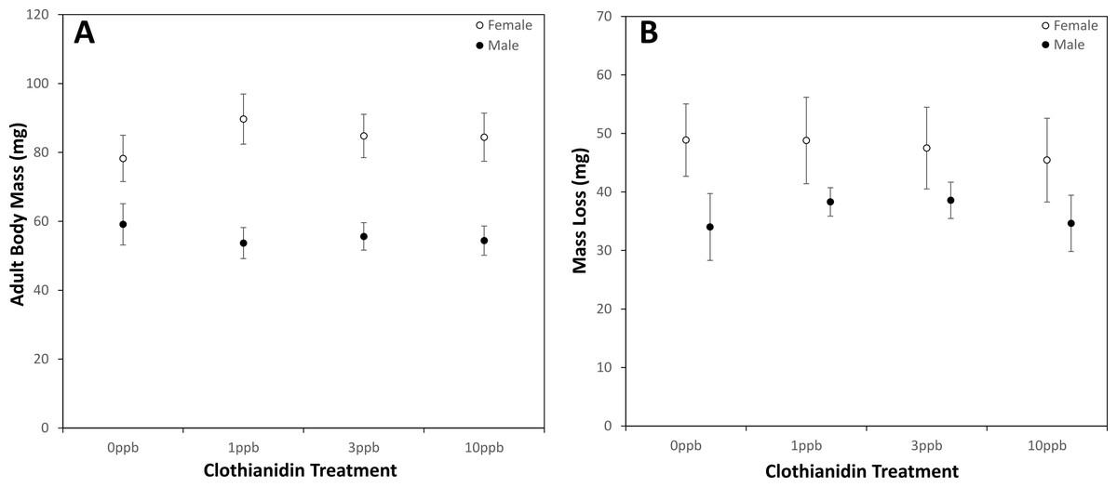

* 1. What are the null and alternative hypotheses for this experiment?
     1. Null:
     2. Alternative:

1. **State** the independent and dependent variable(s) in this experiment, and the type of variable (either categorical, quantitative discrete, or quantitative continuous. Additionally name one confounding variable that the researchers accounted for in their analysis. No explanation is needed.
   1. Independent:
   2. Dependent:
   3. Confounding:
2. Explain whether this experiment includes i) a control group, ii) replication, and iii) randomization. Based only on these components, can we rely on the results of the experiment? You may write this answer in bullet point/list form.
3. Do the researchers' results provide evidence for the alternative and reject the null, or do they fail to provide evidence for the alternative? Explain your reasoning, in 1-2 sentences. (5 points)

1. Compare the mean and standard deviation of measured masses for males vs. females as depicted in the figure in 1-2 sentences. Specifically, do males or females have a larger average mass? Larger standard deviation? This should be an overall comparison, i.e. not for a specific treatment group.

**Question 2**

This figure shows results researchers obtained while studying the trait of *head length* in a population of seahorses over time. In each panel of the plot, the indicated “G = ....” stands for *generations* – this means researchers took measurements at generation 0 (start of the study), and then every 20 generations until 60 generations later. Assume that head length is a heritable trait in seahorses.

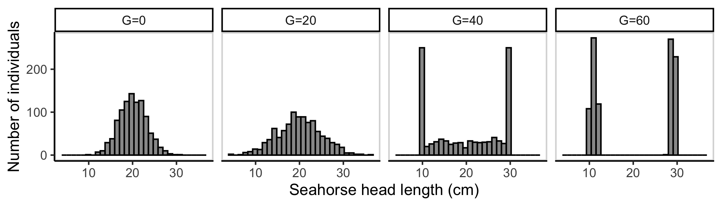

1. What type of plot is each panel? Answer in a single word below.
2. Do these plots provide evidence that head length is evolving in this population of seahorses? Explain your reasoning in 1-2 sentences.
3. Assume that head length is evolving under natural selection. What *mode* of natural selection best describes the observed trends in head length over time? Explain in 1-2 sentences.

**Question 3**

Two islands lie some miles apart. Grasshoppers of the same species lives on each island. An examination of variation in genes of these two populations provided the following results:

|  |  |  |
| --- | --- | --- |
|  | **Frequency of the same allele** | |
| **Gene** | **Island A** | **Island B** |
| 1 | 0.65 | 0.63 |
| 2 | 0.22 | 0.21 |
| 3 | 0.58 | 0.57 |
| 4 | 0.66 | 0.67 |
| 5 | 1.00 | 0.98 |

Do these results provide evidence *for* or *against* migration of grasshoppers back and forth between these islands? Explain your reasoning in 1-2 sentences.

**Question 4**

Researchers are studying male reproductive success in a species of flatworm to determine which physical traits might affect how many offspring males can have. One trait they study is testes size, as shown in their results figure below (doi:10.1111/evo.12861). In this figure, the X-axis indicates "normalized testis size," where a value of 0 indicates the average testis size of all individuals examined, positive values indicate larger-than-average testes, and negative values indicate smaller-than-average testes. The Y-axis indicates reproductive success, such that larger values mean more offspring for that male. The line of best fit is also shown.

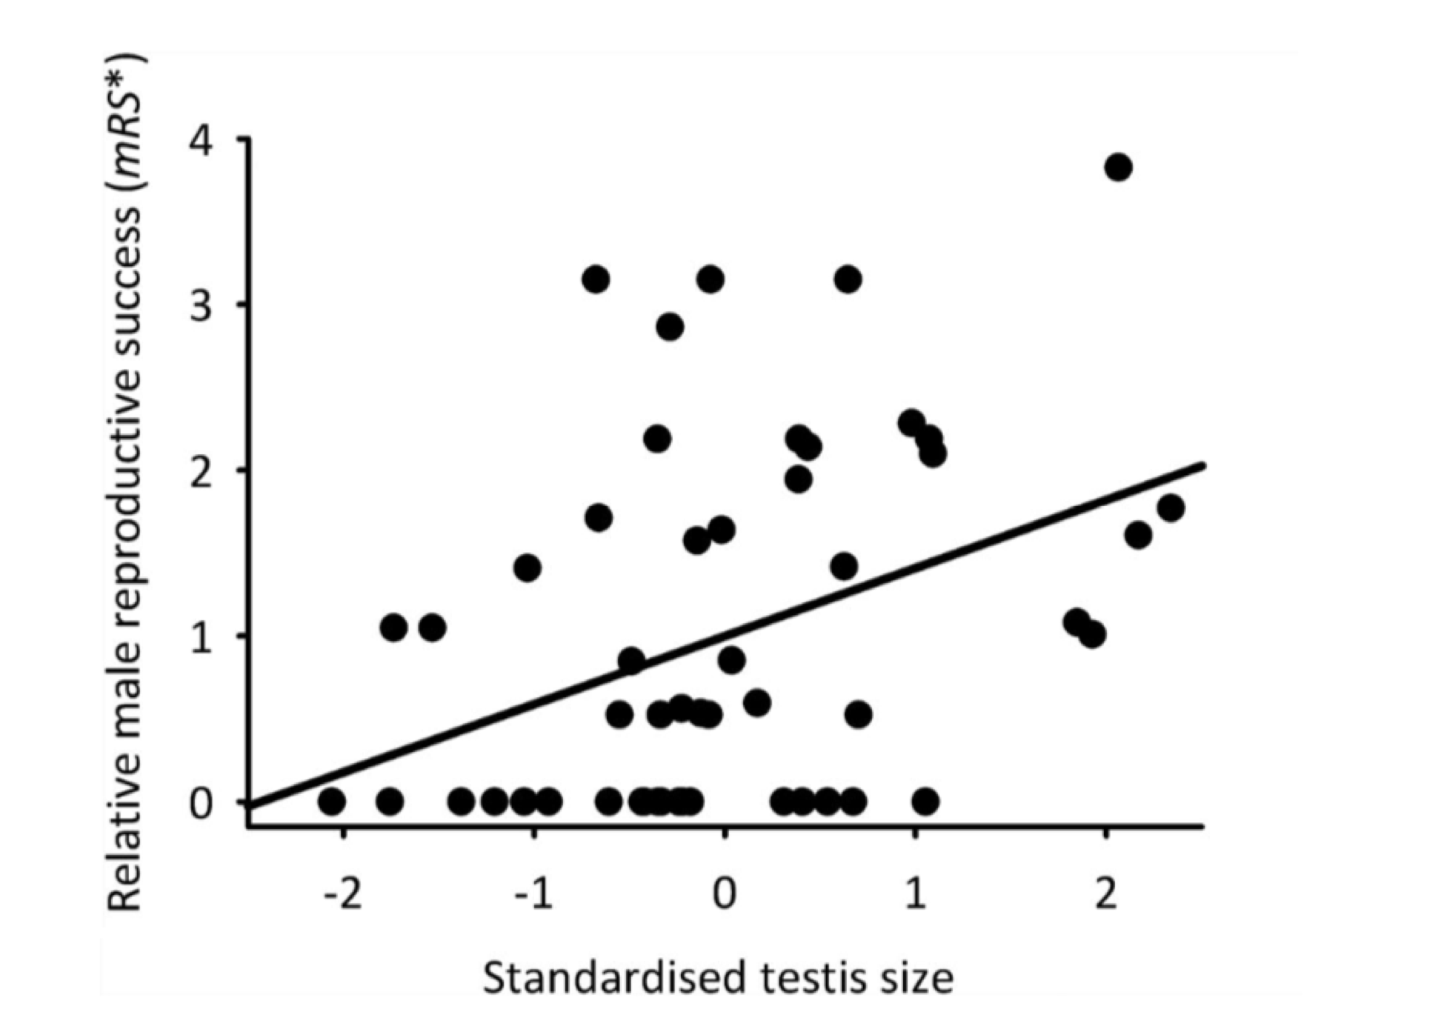

1. State the direction and magnitude of the correlation in this plot: Is it positive or negative? Weak, moderate, or strong?
2. Assume sexual selection (i.e., natural selection on a reproductive trait!) is acting on testis size. Based only on the information given (don't invent other scenarios!!), predict whether, over time, testis size will evolve in the population to be larger, smaller, or stay the same size. Justify your answer in 1-2 sentences.
3. Assume the average testes size as depicted is 0.25 mm. Further assume that you have now discovered several flatworms with much larger than average testes, specifically 0.35 mm and greater. You find that, in spite of their larger testes, these males have a dramatically reduced reproductive success and have almost no offspring. You suspect a trade-off of some kind is the cause of this strange observation for large testes. Explain the most likely source of this trade-off and why it causes this observation, in 2-5 sentences (hint! we really did discuss something very specific in class about this!).