**Speciation and Phylogenetics Assignment**

**Name: ______________________________**

**Names of any students you completed assignment with:**

Answer all questions in your own words, using a different color please!

**Part One. Consider the following scenario for questions 1-5:**

You are studying two types of frogs, *P. feriarum* (black dots) and *P. nigrita* (white dots) who have lived in allopatry for millions of years. Recently, the frogs have begun to again live sympatry ("secondary contact" - where the grey dots are shown in the image) after all these millions of years of separation. Researchers are now investigating the dynamics occurring in the secondary contact area by analyzing the hybrid frogs, i.e. frogs which have one *P. nigrita* parent and one *P. feriarum* parent (F1 hybrid below).

Specifically, they analyzed the mating calls that each type of frog makes by considering both the pulse rate (how many vocal pulses per minute, as recorded at 14°C). This data is shown in the middle section of the figure below, where each dot represents a measurement taken from either a *P. feriarum* (black dots) or *P. nigrita* (white dots) individual living at that latitude where the point is shown. Researchers also analyzed the specific acoustic signals that each of the three types of frogs studied makes in either sympatry or allopatry, as shown on the right section of the figure below.

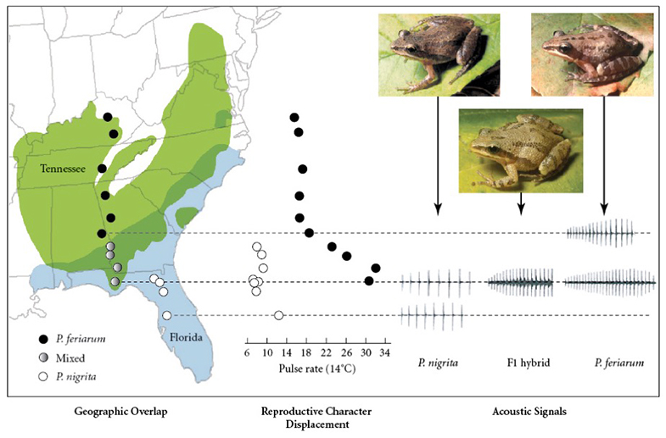

1. Based only on the description of *P. feriarum* and *P. nigrita* given above, do believe that these two types of frogs are separate species according to the biological species concept? Explain your reasoning in 1-3 sentences.
2. You also collected DNA sequences from 50 different *P. nigrita* and *P. feriarum* frogs each, and made a phylogeny of showing the relationships among these *P. nigrita* and *P. feriarum*, shown below. All *P. feriarum* individuals are shown as red, and all *P. nigrita* individuals are shown as blue. The scale bar below the tree indicates the genetic distance scale for branch lengths.

Based only on this phylogeny, do believe that these two types of frogs are separate species according to the phylogenetic species concept? Explain your reasoning in 1-3 sentences.

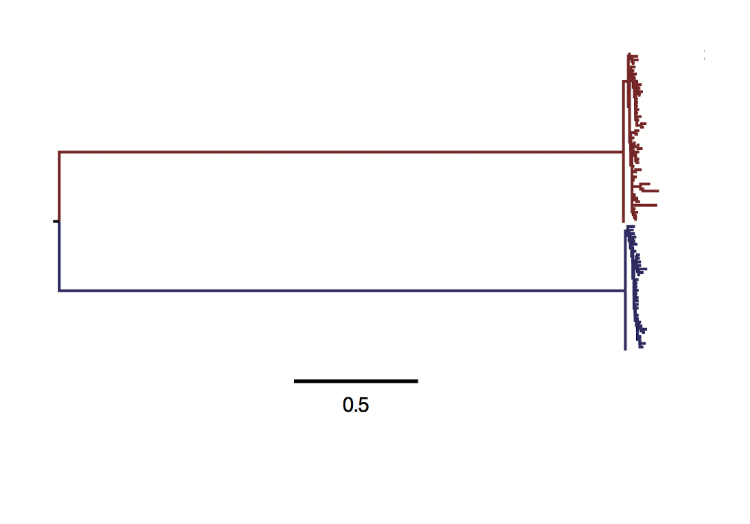

1. Compare the pulse rates (not the acoustic signals!) for *P. feriarum* and *P. nigrita*. Which species exhibits stronger reproductive character displacement in sympatry? Explain your reasoning in 1-3 sentences.
2. Researchers additionally measured the fitness of the hybrid frogs compared to *P. feriarum* frogs using several measurements for fitness. They obtained the following results, as shown in a table below. The top row shows the parents of the frogs who were studied. Answer the following questions based on this table:

|  |  |  |  |
| --- | --- | --- | --- |
|  | **P. feriarum** (both parents P. feriarum) | **F1 hybrid**  (one parent P. feriarum, one parent P. nigrita) | **F2 hybrid** (Both parents hybrid) |
| **Percentage surviving to adulthood** | 75% | 72% | 76% |
| **Male success at attracting a female** | 60% | 14% | 12% |
| **Percentage of matings which result in viable offspring** | 92% | 6% | 7% |

* + Considering **only percentage surviving to adulthood**, does this data provide evidence that reinforcement of speciation is occurring in the secondary contact zone between *P. feriarum* and *P. nigrita*? Explain in 1-3 sentences.
  + Considering **only male success at attracting a female**, does this data provide evidence that reinforcement of speciation is occurring in the secondary contact zone between *P. feriarum* and *P. nigrita*? Explain in 1-3 sentences.
  + Considering **only percentage of matings which result in viable offspring**, does this data provide evidence that reinforcement of speciation is occurring in the secondary contact zone between *P. feriarum* and *P. nigrita*? Explain in 1-3 sentences.

1. Considering both pulse rate and measurements shown in question #4, which SINGLE option of those given below do you predict will eventually be the "ultimate" outcome of secondary contact between *P. feriarum* and *P. nigrita*? Explain your reasoning in 2-4 sentences. Options include...
   * **Reticulation**: *P. feriarum* and *P. nigrita* will have "re-merged" into a single species
   * **Complete speciation:** *P. feriarum* and *P. nigrita* will have become true separate species
   * **Stable hybrid zone:** *P. feriarum* and *P. nigrita* will continue to stably produce hybrid offspring
   * **Hybrid speciation:** *P. feriarum* and *P. nigrita* will have become true separate species *and* their hybrids have become a third species in addition.

**Part Two: Consider the following scenario for questions 6-8:**

The ability to sense light (vision!!) varies widely across animals. A group of genes called "opsins" control vision, but different animal species have evolved different opsins to use in vision. The phylogeny for different types of vision across the animal tree of life is shown on the next page. Answer the following questions about vision evolution in animals considering the most parsimonious explanation for each question. Single word/number answers are fine for question 6-7, but a bit more is needed for question 8!

1. Assume the (not shown) ancestor of all animals did *not* have any opsin genes and could not see. How many times was vision itself (not the different types - just vision generally) *gained* in animals? How many times was vision itself *lost* in animals? Note that a lack of vision would be represented in the tree as “no opsin-based light detection”.
   * # Gains:
   * # Losses:
2. For each type of vision, state i) how many times it was gained, ii) how many times it was lost, iii) whether it is forms a monophyletic, paraphyletic, or polyphyletic group:
   * **Class I (blue)**
     1. # Gains:
     2. # Losses:
     3. Group type:
   * **Class II (green)**
     1. # Gains:
     2. # Losses:
     3. Group type:
   * **Class IIb (purple)**
     1. # Gains:
     2. # Losses:
     3. Group type:
   * **Class III (yellow)**
     1. # Gains:
     2. # Losses:
     3. Group type:
   * **Class IV (red)**
     1. # Gains:
     2. # Losses:
     3. Group type:
3. In which clade of Bilaterian animals as labeled on internal nodes (Deuterostomia, Lophotrochozoa, or Ecdysozoa) did vision evolve the *most quickly?* For this question, explain in 1-2 sentences.

***IMPORTANT NOTE!***

**When interpreting this tree, rely primarily on the TIP COLORS, NOT the internal branch colors (these are the "assumed" phenotypes, but the only known vision phenotypes are from living organisms shown as tips)!!**

**In particular, IGNORE the little green blip leading to the Cnidaria tip - assume it just goes straight from blue -> yellow.**

