**Gupshup Bot SDK**

**(Version 1.0)**

1. **Capabilities**
2. **JSON based configuration**
3. **Pre-configured components like display, poll, menu, input.**
4. **Configurable Auto execution of components.**
5. **State Management**
6. **Main JSON Structure**

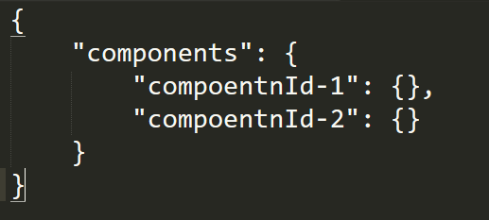

1. **Different Types of Components**

**Display Type - Done**

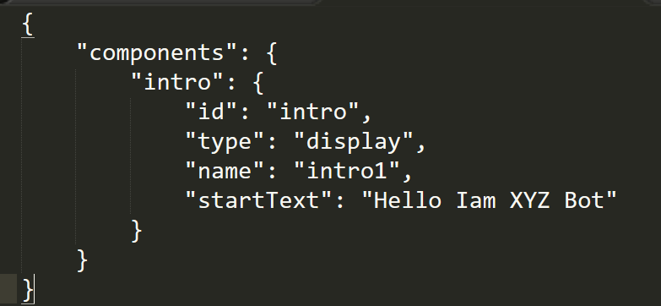

**POLL TYPE – In Progress**

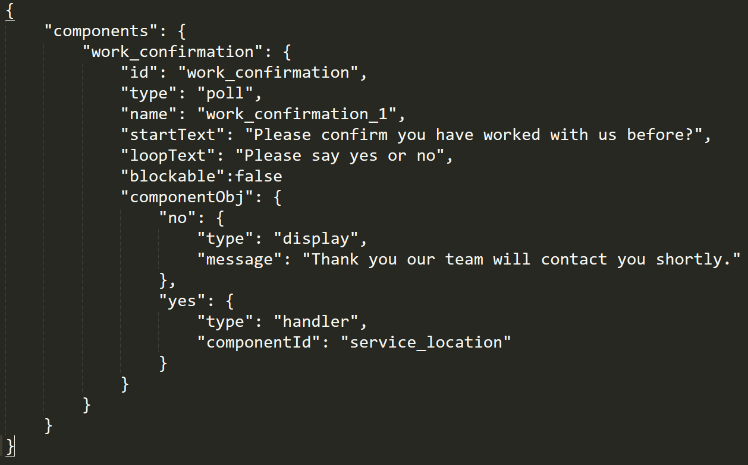

**loopText: GupshupBotSDK’s Parsing Engine will try to match all yes/no type’s statements, if unmatched uses message to prompt user.**

**blockable : true/false :**