Lab 02
Deadline of Submission: Saturday Midnight
Submission: Submit your file on LMS
In this lab, you will create multiple simple pages and create links between them. The hyperlinks will be as follows:
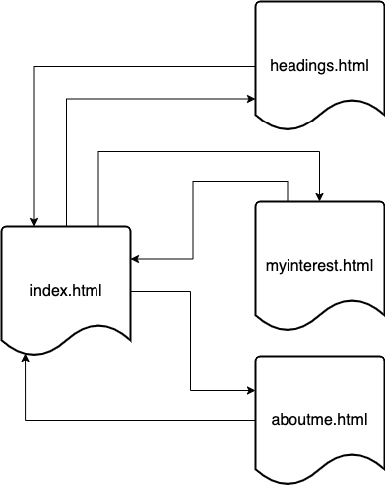
Figure 1. Pages and Hyperlinks
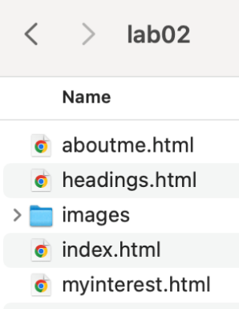
- Create a new folder in your computer named Lab02 and create four html pages in it. Name these pages as shown above in the Figure 1.
- Also create another folder in the above folder and name it as “images”. You will save all the images that you will use in the pages here.
Your folder will look like the following:
Containing the html files and one folder for the images.

index.html
- Open index.html and edit it as follows:
  - Using SHIFT + 1, generate basic code for html file.
Note that your HTML file will look like the following:
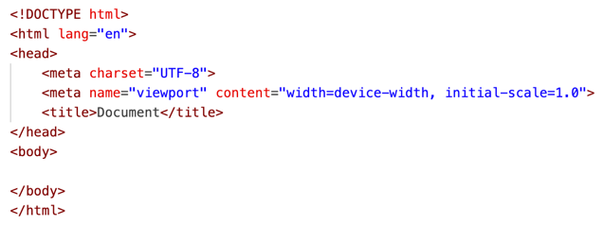
Figure 2 Generated HTML Code
  - Change the title from “Document” to “Lab 02 – Hyperlinks”.
  - Within the <body> element, first add a <header> tag. In the header tag, add a <h1> element and add “Lab 02 – Hyperlinks” as content of this new <h1> element.
  - After the <h1> tag, add <h2> tag and add “Your Full Name” as its content.
  - After the <header> tag, add a <section> tag and add <h1> tag in it with “Hyperlinks Practice” as its content.
  - After the <h1> tag, add <p> tag and write what you have learnt so far in this week.
  - Add another <p> tag and write your opinion about this course so far.
  - Now add another <section> tag, below the previous one and add an <h1> tag with heading as “HyperLinks”.
  - After the <h1> tag, add four <a> tags and create links to each page as follows:
<a href = “headings.html”><h2>Headings Page</h2></a>
Do the same for each page. Note that <h1> tag is the content of <a> hyperlink tag.
  - Now open index.html in the web browser and click on the links created in the previous step and check that relevant pages are opening or not.
Your page will look like the following:
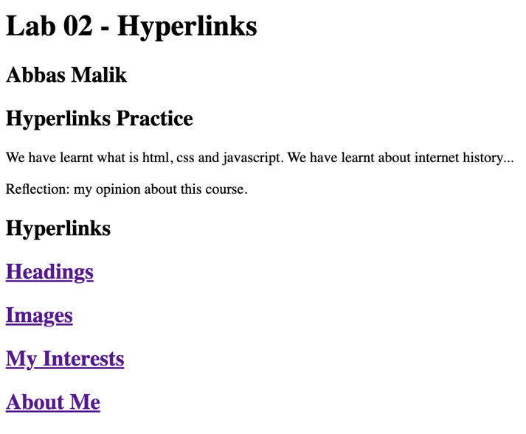
Figure 3. index.html Page
headings.html
For this page, you will choose a topic/thing/place etc. of your interest. For example, I choose Saudi Arabia. Create a section tag and put Saudi Arabi as H1 in this section. Write basic information about the country in a <p> tag. Also find some important information about the Saudi Arabia and organize this information in the page.
Here is a sample html page for Saudi Arabia.
<!DOCTYPE html>
<html lang="en">
<head>
<meta charset="UTF-8">
<meta name="viewport" content="width=device-width, initial-scale=1.0">
<title>Headings</title>
</head>
<body>
<header>
<h1>Saudi Arabia</h1>
<p>Kingdom of Saudi Arabia is the official name.</p>
</header>
<section>
<h2>Regions</h2>
<p>Saudi Arabia is divided into different reagions.</p>
</section>
<section>
<h2>Government</h2>
<p>Government is headed by King Sulman bin Abdulaziz Al-Saud...</p>
</section>
<section>
<h2>Economy</h2>
<h3>Oil Ecomony</h3>
<p>Oil is the main contributor of the Saudi Arabian ecomonoy.</p>
<h3>Tourism Economy</h3>
<p>Tourism is the 2nd main contributor towards the Saudi Arabian economy. Religious tourism is one the main reason for this sector. Makkah and Madina are the main destinations for the religious tourits.</p>
</section>
<footer>
<a href="index.html">Back to Main</a>
</footer>
</body>
</html>
- Open headings.html page. Generate html code and change its title to ‘Headings’.
- Choose a topic of your interest and create page for this. You can also include images to make the page more interesting and good looking. Please remember to save all images in the images folder. Use sections to organize your contents in semantic tags like section, header, footer, etc.
- In the footer tag, add a hyperlink to the index.html.

myinterst.html
In this page, you will choose one your hobby and write details about it. You must use at least 3 images in it and organize your information in sematic tags.
- Open myinterest.html and generate the basic code.
- Change the title based on your hobby.
- Edit the html file to include at least 3 images and information about your hobby.
- In the footer tag, add a hyperlink to the index.html.

aboutme.html
Last week, you have created a page about yourself.
- Improve the page using the semantic tags and include images in it, at least 2.
- In the footer tag, add a hyperlink to the index.html.

Practice 2
- Create another file and name it practice.html
- Implement all the following exercises in this single file.
- Use comments to separate each section/tag
<!DOCTYPE html>
<html lang="en">
<head>
<meta charset="UTF-8">
<meta name="viewport" content="width=device-width, initial-scale=1.0">
<title>HTML Tags Practice Lab</title>
</head>
<body>
<!-- HEADING TAGS SECTION -->
<h1>This is Heading Level 1 (h1)</h1>
<h2>This is Heading Level 2 (h2)</h2>
<h3>This is Heading Level 3 (h3)</h3>
<h4>This is Heading Level 4 (h4)</h4>
<h5>This is Heading Level 5 (h5)</h5>
<h6>This is Heading Level 6 (h6)</h6>

<!-- PARAGRAPH AND LINE BREAKS SECTION -->
<p>This is a paragraph (p) tag. It's used for blocks of text.</p>

<p>This paragraph shows how the br (line break) tag works.<br>
The text continues on the next line, but within the same paragraph.</p>

<!-- HORIZONTAL RULE -->
<hr>
<p>The hr tag above creates a horizontal rule (line) across the page to separate content.</p>
<hr>

<!-- LINKS SECTION -->
<h2>Working with Links (a tag)</h2>
<p>This is a link to <a href="https://www.google.com">Google</a>.</p>
<p>This link opens in a new tab: <a href="https://www.wikipedia.org" target="_blank">Wikipedia</a></p>

<!-- IMAGES SECTION -->
<h2>Working with Images (img tag)</h2>
<p>Here's an image from an online source:</p>
<img src="https://www.w3schools.com/html/pic_trulli.jpg" alt="Example image of Trulli houses" width="300">

<p>Here's an image with broken source to show alt text:</p>
<img src="nonexistent.jpg" alt="This text appears when the image can't load">

<!-- COMBINING ELEMENTS -->
<h2>Combining Elements</h2>
<p>You can combine tags. For example, put an image inside a link:</p>
<a href="https://www.example.com">
<img src="https://www.w3schools.com/html/img_girl.jpg" alt="Clickable image" width="200">
</a>

<!-- COMMENTS SECTION -->
<h2>HTML Comments</h2>
<p>Comments are not displayed in the browser, but they help document your code.</p>
<!-- This is a comment that won't be visible on the webpage -->
<p>View the page source to see the comments in the HTML code.</p>

<!-- END OF PRACTICE LAB -->
</body>
</html>

More Practice Exercises:
After completing the basic implementation above, try these additional exercises:
- Headings Challenge: Create a document outline with headings that represent a book chapter structure
- Link Target: Create a link that points to the headings section of this page using an ID
- Image Gallery: Add 3 more images with proper alt text and arrange them horizontally
- Mixed Content: Create a paragraph that contains a link and an image within the text flow
- Accessibility: Improve all images with more descriptive alt text
- Comments: Add comments explaining each section of your code

