Secure Communities Deportations: Trends and Implications

#### Mary Mills

#### 10 May 2019

# Background/Importance

Questions of effective immigration policy and how the U.S. should manage unauthorized immigrants are some of the most divisive we are currently facing as a country. It seems like comprehensive immigration policy reform to address shortcomings is currently unattainable, which is increasingly troubling as more and more vulnerable populations are seeking entry into the U.S. Piecemeal efforts by government agencies to address the changing trends in immigrant numbers and demographics have been visible and controversial, with asylum seekers dying due to inhumane conditions in immigration detention not uncommon[1].

Secure Communities (SC) is one such tool government is currently using to try to curb illegal immigration. First introduced in 2008, Secure Communities is a program administered by Immigrations and Customs Enforcement (ICE) whose purpose is to identify and remove non-citizens who have been put in jail for serious crimes[2]. Secure Communities was halted in 2014 amidst concerns about how the program was potentially affecting autonomy of the state and local law enforcement agencies that were required to share biometric information about booked inmates with ICE. The questions arose of how to regulate Secure Communities, and what the program’s mission actually was: to prevent dangerous criminals from remaining in the country, or arresting immigrants mainly for their illegal status.

Secure Communities was reinstated in 2017 under executive order[3], as one part of president Trump’s strong arsenal in the fight against what he deems is a crisis at the southern border. The program’s mission and reach were already under question before the start of his administration, and some fear that this lack of clarity will allow for enforcement overreaches as Secure Communities continues.

# Research Questions

In my study I will seek to answer the overarching question of what social, political, and demographic shifts since Secure Communities’ full operationalization in 20132 have impacted arrests through the program. Firstly, I will analyze Secure Communities arrest data since 2013, available via ICE’s FOIA library[4] to identify some potential trends:

1. **Is there a “Trump Effect” in SC arrests overall? -** To answer this question, I will test whether overall arrest numbers are statistically higher or lower before and after November 8, 2016, the day Donald Trump was elected president.
2. **What nationalities are being deported the most, and for what offenses? -** Secure Communities data gives each deported individual’s nationality. I will determine what nationalities have been deported in the highest numbers year-to-year. Then, I will see if these individuals are being arrested and deported primarily for migration-related offenses or other criminal offenses.
3. **Do border states deport more individuals through SC than interior states? -** I will compare states that share a border with either Canada or Mexico to those that do not to see whether SC arrests and deportations are higher in states where illegal border crossings happen.
4. **Is the number of state SC arrests correlated with the state’s Hispanic population? -** I will compare each state’s population of Hispanic-origin individuals with its number of Secure Communities arrests to see whether the state’s ethnic composition is tied to the number of arrests through SC.
5. **What variables are correlated with SC deportations and how? -** I will run a simple linear regression model with several variables I think may be correlated with the number of SC deportations during this period: border state status, county-level Hispanic population, county-level political stance (as measured by 2016 presidential election results), and state-level population of incarcerated non-citizens.

# Data Sources and Methodology

The data I have collected for my analysis is mainly government-published data, either published yearly by the respective government agencies or released via Freedom of Information Act (FOIA) request.

The main source of data I will draw from is deportation data from the Secure Communities program, released by ICE. This dataset is extensive, listing de-identified data on every individual deported through SC from fiscal year 2015 through March 2017. The individual-level data includes information such as state in which the deportee was arrested, country they were deported to, country of citizenship, dates of arrest and deportation, and data on the specific crime committed. It is important for me to only use individual-level data after January 22nd, 2013, when Secure Communities was fully operationalized in all U.S. jurisdictions. This will eliminate any perceived increase in arrests due to the program scaling up its operability nation-wide before this time. Additionally, although SC was halted in 2014, deportations of individuals identified through SC continued. This dataset is available through ICE’s FOIA library, but I initially discovered it through the Center for Immigration Studies’ Immigration Data Portal[5].

I will also employ datasets created through the U.S. Census Website’s American FactFinder tool[6]. I will mainly use this to calculate each U.S. county’s Hispanic population percentage which I will use to answer my fourth research question. The Census reports very detailed national-level, state-level and county-level data on the ethnic origin of Americans reporting their Hispanic background. I will collapse all specific ethnic data to arrive at the overall Hispanic population per county. I will create a separate dataset to gather total county population numbers. I will draw both datasets from the American Community Survey’s 5-Year Estimates data from 2016.

Two additional variables I use in Question 5 are county-level political stance and each state’s number of incarcerated non-citizens. The first of these two variables I drew from Tony McGovern’s work on scraping Townhall.com county-level 2016 election data, that is publicly available to use on his GitHub[7]. The second variable I took from the Bureau of Justice Statistics’ Annual Survey of Jails data from 2016. Unlike BJS’s Jail Census, the Annual Survey of Jails is conducted yearly. However, it does not contain data from all U.S. jail jurisdictions, like the Census does. All this data is jail-level and includes overall demographic inmate data.

# Measures

In all my research questions, I will use the total number of observations in the Secure Communities Deportations dataset, manipulated in different ways. Other variables I will use from this dataset are Arrest State, Departed Date, Most Serious Criminal Conviction and Citizenship Country. In the second part of Question 2, I will break down the “Most Serious Criminal Conviction” variable into two categories: “Migration-related” and “Other”. In doing so I will seek to answer whether deportees entering the U.S. from the top 5 source countries are being deported mainly on charges purely tied to their illegal entry, or for more dangerous crimes.

An additional variable I will use to answer Questions 3 and 5 is the “Border” variable, which will be a dichotomous variable to identify whether a U.S. state shares a land border with either Canada or Mexico. I will create this variable, which will exclude states that only have a water border with either country, and states that share water borders with other countries such as Cuba (Florida). As such, my border state list includes the following states: Texas, Arizona, New Mexico, California, Alaska, Maine, New Hampshire, Vermont, Michigan, Minnesota, North Dakota, Montana, Idaho, Washington, and New York[8].

To answer Questions 4 and 5, I will create a “%_Hispanic” variable which will give each county’s Hispanic population in 2016 as a percentage. I will do this by importing the total population and Hispanic population for each county from the American FactFinder data as columns, divide the Hispanic by the overall population, and multiply this by 100.

From the Annual Survey of Jails data, I will pull the variable “NONCITZ”, or the jail population of noncitizen inmates, collapsed by state. Because this annual survey does not represent every U.S. county, I am using state-level population, instead of county-level like most of my other variables.

The 2016 voting data collected by Tony McGovern gives a complete overview of every U.S. county, borough and parish’s number of votes for the Democratic and Republican presidential candidates, as well as percentages. I will use the variable “per_gop” as a proxy for political stance. I believe this is a fitting variable given then-candidate Trump’s vocal opinions and policies on immigration reform.

# Analytic Strategy

**Q1: Trump Effect -** To measure any potential spike in deportations that may have come with expectations of Trump’s future policies affecting immigration into the U.S., I will organize total deportations by Month-Year, and compare to see if the level of deportations in November 2016 (when Trump won the election) are significantly different than other months.

**Q2: Targeted Nationalities -** This question will be answered by descriptive statistical analysis to see what nationalities were deported in the highest numbers between 2015 and 2017. Once I determine the top 5 source countries, I will count these unique deportations by the reason they entered ICE custody (“Most Serious Criminal Conviction”). Through this I will determine whether most deportees were found eligible for deportation because of violent crimes (which is the stated purpose of the Secure Communities program) or purely on the illegal nature of their entry (which would suggest that Secure Communities indiscriminately targets asylum seekers).

**Q3: Border vs. Interior Apprehensions -** After labeling every deportation as the result of an arrest in a border/interior state, I will find the mean number of arrests by state for both categories. Then, I will apply a t-test to these two means to determine whether the mean deportations are significantly significant depending on whether arrests occur in a border or non-border state.

**Q4: Effect of Hispanic Population -** Once I merge each U.S. county’s deportation number with its respective Hispanic population percentage, I will perform a simple linear regression to see if deportation number is correlated with the Hispanic population of the county in which the arrest occurred.

**Q5: Interaction of Variables –** This analysis will build upon Q4 by adding variables for border, state noncitizen jail population, and political stance into a multiple regression model to determine whether any of the demographic variables I hypothesize are correlated with the number of deported noncitizens actually are.

# Results

**Q1: Trump Effect**

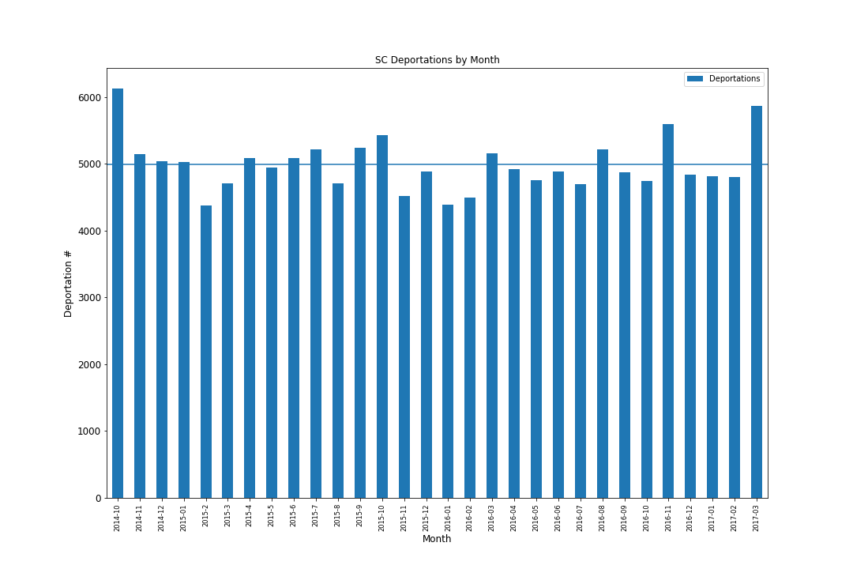

**Mean Monthly Deportations: 4986.73**

**November 2016 Deportations: 5591**

The number of deportations that occurred through Secure Communities in the month that Trump was elected president (November 2016) was 5591, which was approximately 604 higher than the average number of monthly deportations during the entire period.

**Q2: Targeted Nationalities**

|  |  |
| --- | --- |
| **Citizenship Country** | **Deportation Number (2015-2017)** |
| Mexico | 113697 |
| Honduras | 9086 |
| Guatemala | 8610 |
| El Salvador | 6859 |
| Jamaica | 871 |

**Total Deportations: 149,607**

The four highest origin countries of deported individuals through SC are Mexico and the “Northern Triangle” countries just below it, Honduras, Guatemala and El Salvador. This is congruent with the fact that individuals from these countries are seeking asylum at the U.S.-Mexico border in higher numbers now than ever before[9]. Arrests and deportations from the top five origin countries dwarf the remainder; only 7% of all arrests during the 2015-2017 period came from countries other than those included above.

|  |  |  |
| --- | --- | --- |
| Citizenship Country | Migration-Related Deportation | Other Deportation |
| Mexico | 15671 | 92586 |
| Honduras | 1160 | 7075 |
| Guatemala | 1119 | 6492 |
| El Salvador | 594 | 5707 |
| Jamaica | 11 | 834 |

When breaking down the charges under which SC deportees from the top five origin countries were initially detained, the data reflect that most individuals from all five countries were arrested for criminal offenses other than illegal entry or re-entry. It is important to note in this case that only in recent years has illegal entry into the U.S. been seen as a criminal (as opposed to a civil) offense. Critics of SC argue that the program is aiding in the criminalization of illegal entry by deporting large numbers of migrants with illegal entry as their only offense. While this data does show that large numbers of individuals who have committed no crime other than illegal entry are being deported through SC, they do not represent most deportations. This would seem to be aligned with the stated purpose of SC, but there is no knowing how many deportations go unreported, and what types of crimes are associated with them.

**Q3: Border vs. Interior Apprehensions**

|  |  |  |
| --- | --- | --- |
| **Border State?** | **Mean Arrest Number** |  |
| No | 1178.1 |  |
| Yes | 6831.8 |  |

**T-Statistic: 2.44, P-Value: 0.018**

As expected, the mean number of arrests and deportations is much higher in border states than interior states. This may be because most individuals who illegal cross into the U.S. settle in the state into which they crossed initially, or nearby. A t-test of the mean arrests between border and interior state shows that the difference between these two means is statistically significant.

**Q4: Effect of Hispanic Population**

This scatter plot of the data tells an interesting story. Most counties in the U.S. had low levels of arrests during the 2015-2017 period. However, there are a significant number of counties that arrested and deported several times the number of noncitizens in the country illegally than the majority. No counties with a Hispanic population less than around 30% arrested and deported more than 2000 individuals during this period, and the best-fit line generally slopes upward as this percentage increases. The highest-deporting counties (6000 individuals and above) are likely located in border states.

|  |  |
| --- | --- |
|  | arrest_number |
| percent_hispanic | 8.446 |
|  | (14.65)** |
| _cons | -24.540 |
|  | (2.24)* |
| *R*2 | 0.10 |
| *N* | 2,043 |

* *p*<0.05; ** *p*<0.01

A linear regression of the data shows that a county’s Hispanic percentage is significant at a 99% confidence interval. However, an r-squared of 0.10 suggests that this association is not very strong.

**Q5: Regression**

|  |  |
| --- | --- |
|  | arrest_number |
| percent_hispanic | 7.276 |
|  | (9.10)** |
| per_gop | -476.975 |
|  | (6.56)** |
| incarceration_number | 1.051 |
|  | (2.07)* |
| border | 5.062 |
|  | (0.18) |
| _cons | 252.254 |
|  | (5.12)** |
| *N* | 1,482 |

* *p*<0.05; ** *p*<0.01

At a 95% confidence interval, the variable “incarceration_number”, representing state-level jail population of noncitizens, is significant. Variables “percent_hispanic” and “per_gop” are significant at a 99% confidence interval. This analysis suggests that a state’s number of incarcerated noncitizens, the Hispanic composition of a county, and the political stance of a county are all correlated with the number of deportations resulting from arrests in those 1482 counties.

One surprising finding from this regression model is that the coefficient for per_gop is negative. This would either mean that more conservative counties are less likely to be associated with higher levels of SC arrests and deportations, or my choice to represent political attitude by 2016 voting data was not very accurate.

# Data Validation

Validating the data used in this research is fairly difficult for two main reasons. Firstly, the main Secure Communities dataset upon which all my analysis is based was published by ICE through a FOIA request from the Immigrant Legal Resource Center in 2017[10]. Meaning that this data was not publicly available before the request. So finding similar data to compare the ICE dataset to is not a possibility. Secondly, many of the U.S. federal agencies from which I draw data (Bureau of Justice Statistics, U.S. Census, etc.) are the main authorities on data collection for the respective measures I use. For example, although Pew Hispanic Center publishes a lot of data on Hispanic population through tables, maps and other visuals, most of the information they gather through Census and American Community Survey data.

After some search, I have found the TRAC Immigration website[11] to be a rich source of data on immigration in the U.S. They report their own data on Secure Communities arrests, although it is not available to download as datasets. However, I wanted to use this resource to at least spot-validate the dataset published by ICE if I could.

Firstly, I looked to see if the overall number of deportations was similar for years in which I have a full year’s worth of data for, namely fiscal years 2015 and 2016. TRAC Immigration’s Removals under the Secure Communities Program interactive data tool allows you to filter deportations by several variables. Their total arrests for 2015 and 2016 versus the figures for my Secure Communities set are given below:

|  |  |  |
| --- | --- | --- |
| Source | TRAC Immigration | ICE Dataset |
| 2015 Deportations | 60,105 | 59,242 |
| 2016 Deportations | 57,242 | 58,572 |

In both years, the arrest numbers between datasets are within about 1,000 of one another.

To partially validate my data for “Most Serious Criminal Conviction” used in Question 5, I sorted the TRAC Immigration data by years 2015 and 2016, and then added up the total deportations where the most serious criminal conviction was Illegal Entry or Re-Entry. I subtracted this number from the total number of deportations that year to get the “Other Convictions” for that year. To find these numbers in the ICE dataset, I performed a groupby for each year and category (“migration-related” and “other) and included those figures below.

|  |  |  |
| --- | --- | --- |
| Source | TRAC Immigration | ICE Dataset |
| 2015 Migration-Related | 7,833 | 7,778 |
| 2015 Other Convictions | 52,272 | 51,464 |
| 2016 Migration-Related | 7,119 | 7,326 |
| 2016 Other Convictions | 50,123 | 51,246 |

All these figures are within 1,000 deportations of the other dataset.

Finally, I used two other TRAC resources to validate my data; these can be found in appendices 2 and 3. Appendix 2 lists the top Most Serious Criminal Convictions recorded. Because the ICE dataset only contains complete data for 2015 and 2016, I did not think it would be useful to compare the numbers exactly. I did want to compare general trends in the TRAC conviction data versus what I found in Question 2. My analysis generally found that migration-related deportations are not the most common compared to other convictions; this is true for the TRAC data as well (Illegal Entry is the 5th most common conviction). Appendix 3 is a bar graph showing the countries whose proportion of asylum petitions to the U.S. increased the most in recent years. I used this graph to validate my findings in Question 2, that Mexico and the Northern Triangle represented the highest sending countries of deportees through Secure Communities.

# Limitations

One main limitation of my analysis is that I rely heavily on the use of government-reported data, especially from ICE. While I believe the Secure Communities dataset to be a robust source of information about the program, there is always the risk that the year-to-year data is not complete or collected in a way that I would not expect. Especially with the extent of “bad press” that ICE frequently receives regarding its policies, it may not be in their best interest to provide extensive data that may potentially be used against the agency.

Regarding the validity of my data, another limitation is that I draw from several different sources (ICE, BJS, Census, independent researchers) that may collect data in different ways.

Limitations in my research design reflect my novice-level understanding of analytical methods. In Question 3, the number of interior states (35) far outweighs the number of border states (15) that I compared. There may have been a more meaningful way for me to compare arrests and deportations between the two groups. My regression analysis in Question 5 also presented some problems that may have affected the strength of my results. One was my sample size; there are 3,142 counties in the U.S., but only 2196 were represented in the Secure Communities dataset after I merged on State/County. This means that either 946 U.S. counties did not arrest anyone through Secure Communities who was deported between 2015 and 2017, or my attempt to prevent county-level arrests from merging on county name alone (e.g. arrests from all eight counties named “Orange” in the U.S. merging together) was unsuccessful. This number dropped to 1,481 counties after merging all my variables together, so my findings may not be generalizable to the entire U.S.

My choice of using 2016 county-level voting data as a measure of county-wide political stance was made after a fruitless search of finding other research-based methods for measuring where on the political spectrum voters in a county stand year to year. The measure I chose was recommended to me by a colleague, and the data is organized well, both in the datasets themselves and in the researcher’s GitHub repository. The original data was scraped using beautifulsoup from Townhall.com’s reporting of the 2016 presidential election, so the burden of accuracy lies with that organization[12]. However, my unexpected finding that per_gop (the percentage of each county’s voters that picked Trump in the 2016 election) was significantly negatively correlated with county-level arrests and deportations leads me to believe that it may not have been the best proxy for what extent President Trump’s anti-immigrant rhetoric resonated with a county’s voters.

# Conclusion

My research only begins to scratch the surface of how the Secure Communities program, and changes in the program, interact with demographic trends in different parts of the country. My findings arrive at several conclusions. Firstly, Mexico and the countries of the Northern Triangle of El Salvador, Honduras and Guatemala compose most arrests and deportations through Secure Communities, but most of these individuals are being deported for reasons other than simply entry or reentry. Secondly, states that share a land border with Mexico or Canada see the bulk of Secure Communities activity. Monitoring trends in arrests and deportations in these states will be important in future research. Thirdly, my analysis found a slight positive correlation between a county’s Hispanic population and the amount of arrests and deportations. However, this could merely reflect the fact that the states with the highest population percentages of residents of Hispanic origin are all located on the U.S-Mexico border[13]. And lastly, my regression model showed that political stance and the incarcerated noncitizen population are correlated with the number of arrests and deportations in a county. Although my findings are not very strong, they can serve as a starting point to pursue further research with more robust models. This analysis can also be strengthened if additional Secure Communities data is released in the future.

Further research on the program and how it affects detention and deportation of migrants into the U.S. is vital to making the American immigration and border security systems fair ones that limit humanitarian abuses and abide by existing immigration law. With the revitalization of Secure Communities under President Trump in the midst of an unprecedented wave of asylum applications from Central America, it is even more important to ensure that this program is not being used as a tool merely to keep migrants out, but a tool to target only those undocumented individuals that pose a threat to others.

# Supplemental Materials

**Appendix 1: Data Management Plan**

All data I have downloaded onto my personal computer is not accessible via any cloud or external storage such as DropBox or iCloud. Within the folder I have dedicated to this class, I house my collected raw data in a specific subfolder called “Data”. Within this folder, I have another for raw data, and one for copies of the original datasets, that can be linked to the originals by file name; I keep the file names of the original datasets, but append “_copy” to copies I have pushed to GitHub for my analysis. At the time of writing, my GitHub repository is up to date with all files used and produced in my analysis. It can be found here: https://github.com/mgmills93/AEM_Spring_2019/tree/master/SecureCommunities_FinalProject . I plan on leaving the repository containing all my research up in my GitHub for the next two years.

To safeguard all my computer’s files, including my data, I back up to an external hard drive on the last day of every month. I plan to continue to back up my school-related files for a year after I graduate from LBJ in case I need to refer to anything within that time frame. My external hard drive is stored in a secure location in my apartment and will have a dedicated storage location in my new living situation when I move.

**Appendix 2: TRAC Immigration Top Criminal Offense Table[14]**

I used this table from TRAC Immigration to both categorize criminal offenses in part two of Question 2 and validate my findings that showed that most individuals deported through SC committed crimes other than illegal entry or re-entry.

**Table 2. The Most Serious Criminal Conviction for Individuals with ICE Detainers**

|  |  |  |  |
| --- | --- | --- | --- |
| **Top 25 Offenses Recorded\*** | **Number** | **Percent** | **Rank** |
| **All detainers** | **347,691** | **100.0%** |  |
| **None** | **165,769** | **47.7%** | **1** |
| **Driving Under Influence Liquor** | **33,342** | **9.6%** | **2** |
| **Traffic Offense** | **20,997** | **6.0%** | **3** |
| **Marijuana - Possession** | **6,940** | **2.0%** | **4** |
| **Illegal Entry (INA SEC.101(a)(43)(O), 8USC1325 only)** | **6,746** | **1.9%** | **5** |
| **Dangerous Drugs** | **6,724** | **1.9%** | **6** |
| **Cocaine - Possession** | **6,644** | **1.9%** | **7** |
| **Assault** | **6,234** | **1.8%** | **8** |
| **Larceny** | **4,891** | **1.4%** | **9** |
| **Cocaine - Sell** | **4,314** | **1.2%** | **10** |
| **Robbery** | **3,480** | **1.0%** | **11** |
| **Burglary** | **3,414** | **1.0%** | **12** |
| **Marijuana - Sell** | **3,335** | **1.0%** | **13** |
| **Public Order Crimes** | **3,129** | **0.9%** | **14** |
| **Drug Possession** | **2,773** | **0.8%** | **15** |
| **Disorderly Conduct** | **2,758** | **0.8%** | **16** |
| **Drug Trafficking** | **2,109** | **0.6%** | **17** |
| **Sex Assault** | **2,100** | **0.6%** | **18** |
| **Amphetamine - Possession** | **2,008** | **0.6%** | **19** |
| **Domestic Violence** | **1,940** | **0.6%** | **20** |
| **Battery** | **1,919** | **0.6%** | **21** |
| **Amphetamine - Sell** | **1,826** | **0.5%** | **22** |
| **Trespassing** | **1,647** | **0.5%** | **23** |
| **Fraud** | **1,599** | **0.5%** | **24** |
| **Forgery** | **1,539** | **0.4%** | **25** |

**Appendix 3: TRAC Immigration Asylum-Seeker Trends Chart[15]**

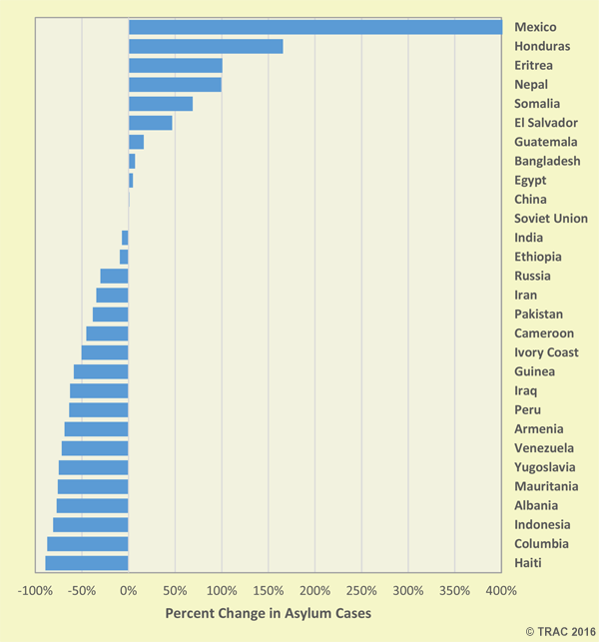

This chart from TRAC shows the percentage increase in asylum cases in the U.S. from the period fiscal year 2005 to 2010 to the period spanning fiscal year 2011 to 2016. Although TRAC claims that the overall volume of asylum cases dropped 18% during this period, asylum cases from Mexico, Guatemala, Honduras and EL Salvador are in the top seven that increased during this time period. This is generally consistent with my findings in Question 2.

**Appendix 4: Border States Map**

**Green: Shares land border**

**Blue: Shares water border only (excluded from analysis)**

**Appendix 5: Research Workflow**

1. "22 Immigrants Died in ICE Detention Centers during the past 2 Years." NBCNews.com. Accessed April 02, 2019. https://www.nbcnews.com/politics/immigration/22-immigrants-died-ice-detention-centers-during-past-2-years-n954781.
2. "Secure Communities." ICE. Accessed April 02, 2019. https://www.ice.gov/secure-communities.
3. Groetzinger, Kate, and Kate Groetzinger. "Trump's Temporary Immigration Ban Was Cover for His Order to Defund Sanctuary Cities." Quartz. February 02, 2017. Accessed April 03, 2019. https://qz.com/899563/trump-executive-order-reinstates-bushs-secure-communities-policy-which-may-have-serious-impact-on-immigrants-in-sanctuary-cities/.
4. "FOIA Library." ICE. Accessed April 03, 2019. https://www.ice.gov/foia/library.
5. "Immigration Data Portal." CIS.org. Accessed April 07, 2019. https://cis.org/Immigration-Statistics-Data-Portal.
6. Data Access and Dissemination Systems (DADS). "American FactFinder." American FactFinder. October 05, 2010. Accessed April 07, 2019. https://factfinder.census.gov/faces/nav/jsf/pages/index.xhtml.
7. https://github.com/tonmcg/US_County_Level_Election_Results_08-16
8. Revolvy, LLC. ""International Border States of the United States" on Revolvy.com." Revolvy. Accessed April 07, 2019. https://www.revolvy.com/page/International-border-states-of-the-United-States.
9. Wola. "Fact Sheet: U.S. Immigration and Central American Asylum Seekers." WOLA. Accessed May 08, 2019. https://www.wola.org/analysis/fact-sheet-united-states-immigration-central-american-asylum-seekers/.
10. "ICE Detention Facilities: Population and Facility Statistics - Dataset by Rivardreport." Data.world. July 31, 2018. Accessed May 10, 2019. https://data.world/rivardreport/ice-detention-facilities-population-and-facility-statistics.
11. TRAC Immigration - Comprehensive, Independent, and Nonpartisan Information about Immigration Enforcement. Accessed May 10, 2019. https://trac.syr.edu/immigration/.
12. "Election 2016 Results Map and Key Races for the President Elections - View the Latest Election Results, News, Polls and Conservative Election Commentary." Townhall. Accessed May 08, 2019. https://townhall.com/election/2016/president/.
13. Wee, Rolando Y. "States With the Largest Latino and Hispanic Populations." WorldAtlas. March 14, 2016. Accessed May 10, 2019. https://www.worldatlas.com/articles/us-states-with-the-largest-relative-hispanic-and-latino-populations.html.
14. Transactional Records Access Clearinghouse (TRAC) - Comprehensive, Independent, and Nonpartisan Information on Federal Enforcement, Staffing and Funding. Accessed May 08, 2019. https://trac.syr.edu/immigration/reports/330/.
15. Transactional Records Access Clearinghouse (TRAC) - Comprehensive, Independent, and Nonpartisan Information on Federal Enforcement, Staffing and Funding. Accessed May 09, 2019. https://trac.syr.edu/immigration/reports/448/.