Proof of Funds
Company Director / Business Owner

Applicant
Full name | James Wong
Nationality | Irish
Date prepared | 1 March 2026

Section A — Personal Funds
I hold personal funds totalling $24,420.00 as at 31 January 2026:
Account | Institution | Balance
Instant-access savings | HSBC | $18,070.00
Current account | HSBC | $6,350.00
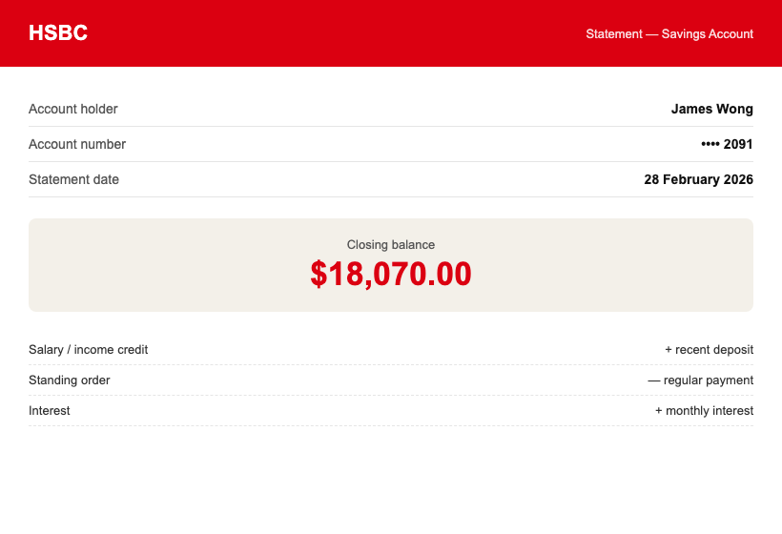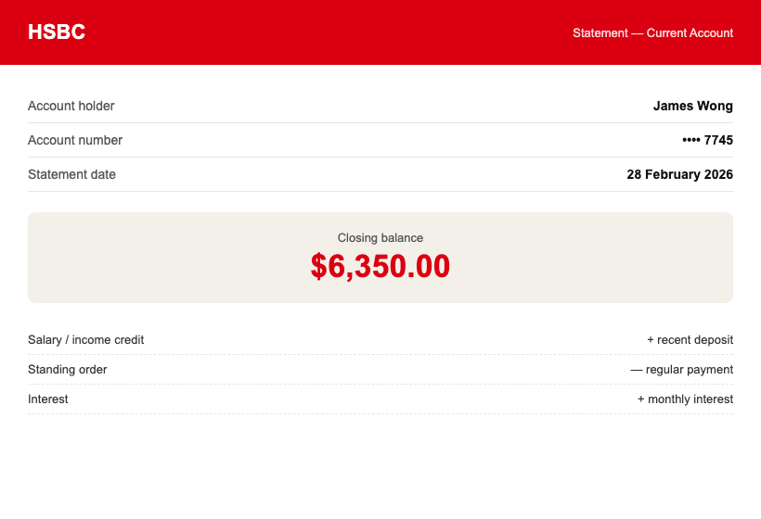

Section B — Director Income
I am paid by my company through payroll and dividends: salary $1,350.00/month plus dividends of $45,500.00 (declared June 2025 and February 2026). See payslips, dividend declarations, and the Salary & Tax Confirmation Letter.

Section C — Company Financial Position
Company | Company No. | Account balance | Statement date
Wong Media Productions Ltd | 14512789 | $103,200.00 (Capital on Tap savings) | 31 Jan 2026
— | — | — | —
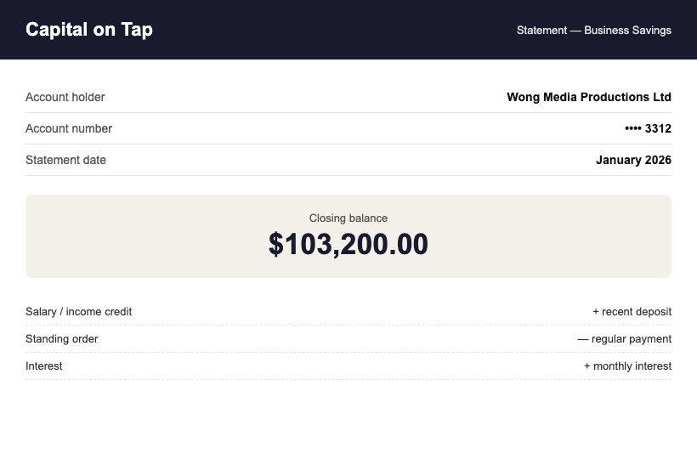

Funds Summary
Source | Amount | THB equivalent
HSBC savings + current account | $24,420.00 | THB 842,490
Business savings (Capital on Tap) | $103,200.00 | THB 3,560,400
Exchange rate: 1 USD = 34.50 THB (mid-market, 1 March 2026) — personal funds alone exceed the THB 500,000 DTV requirement.

Appendices
- Appendix A: personal bank statements, September 2025 – February 2026
- Appendix B: payslips and dividend declarations
- Appendix C: company/business account statements — Wong Media Ltd and Bright Loop Ltd

Declaration
I declare that the funds and income presented above are genuinely held by me (or by companies I direct, where stated), that the attached statements are unaltered originals, and that all figures match those statements exactly.
_______________________________
James Wong — printed name
Date: 1 March 2026
WORKED EXAMPLE — modelled on a real, approved DTV application. All names and figures are fictional; the structure and level of detail are what got approved. Do not copy any details.

