Proof of Funds
Content Creator / Influencer

Applicant
Full name | Emma Larsen
Nationality | Danish
Date prepared | 1 March 2026

Section A — Personal Funds
I hold personal funds totalling $31,100.00 as at 28 February 2026:
Account | Institution | Balance
Savings | Danske Bank | $31,100.00
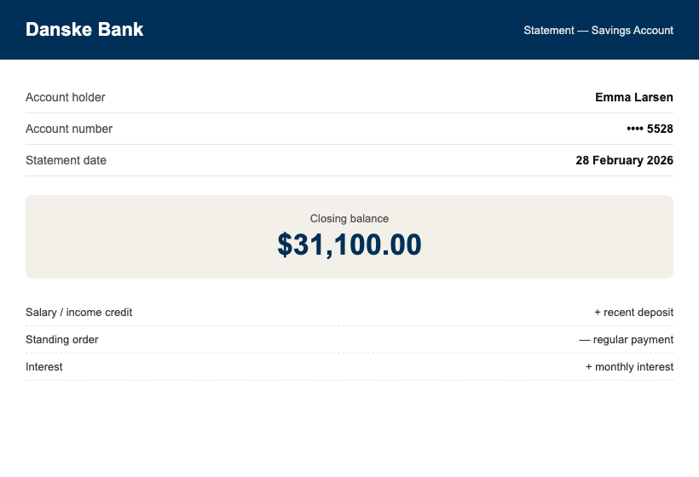

Section B — Creator Income
My income comes from platform revenue and brand partnerships, all from entities outside Thailand:
Source | Period | Amount | Evidence
YouTube (AdSense) | Dec 2025–Feb 2026 | $9,750.00 | AdSense statements + bank credits
Nordic Outdoor Co. | Jan 2026 | $12,300.00 | Contract + invoice + deposit 11 Jan
Skyline Luggage retainer | Oct 2025–present | $2,150.00/month | Contract + monthly deposits
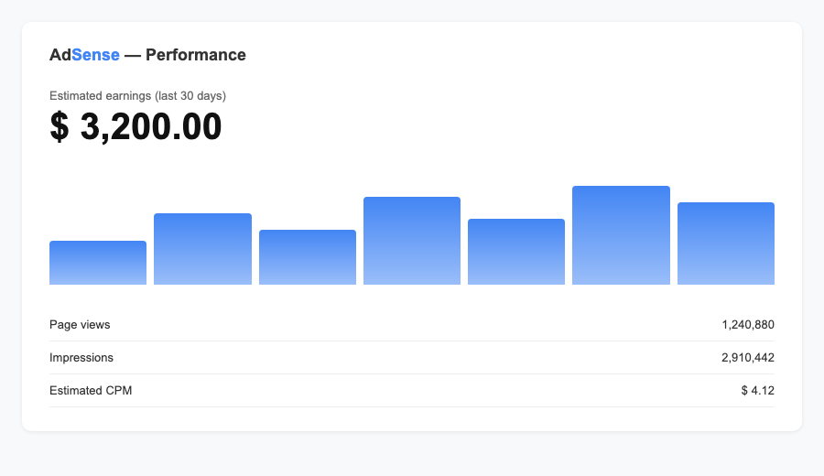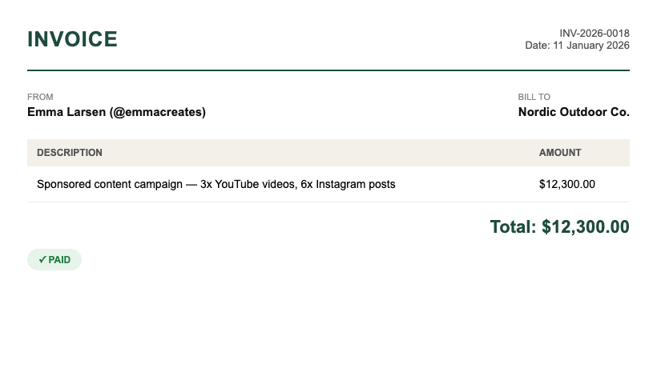

Funds Summary
Source | Amount | THB equivalent
Danske Bank savings | $31,100.00 | THB 1,072,950
PERSONAL TOTAL | $31,100.00 | THB 1,072,950
Exchange rate: 1 USD = 34.50 THB (mid-market, 1 March 2026) — personal funds alone exceed the THB 500,000 DTV requirement.

Appendices
- Appendix A: personal bank statements, September 2025 – February 2026
- Appendix B: AdSense and platform revenue statements
- Appendix C: brand partner contracts and invoices

Declaration
I declare that the funds and income presented above are genuinely held by me (or by companies I direct, where stated), that the attached statements are unaltered originals, and that all figures match those statements exactly.
_______________________________
Emma Larsen — printed name
Date: 1 March 2026
WORKED EXAMPLE — fictional persona and figures for format reference only. Do not copy any details.

