Proof of Funds
Employed (Full-Time)

Applicant
Full name | Sarah Jane Mitchell
Nationality | British
Date prepared | 1 March 2026

Section A — Personal Funds
I hold personal funds totalling $29,740.00 as at 28 February 2026, held as follows:
Account | Institution | Balance
Instant-access savings | First Direct | $23,150.00
Fixed-term saver | Barclays | $6,590.00
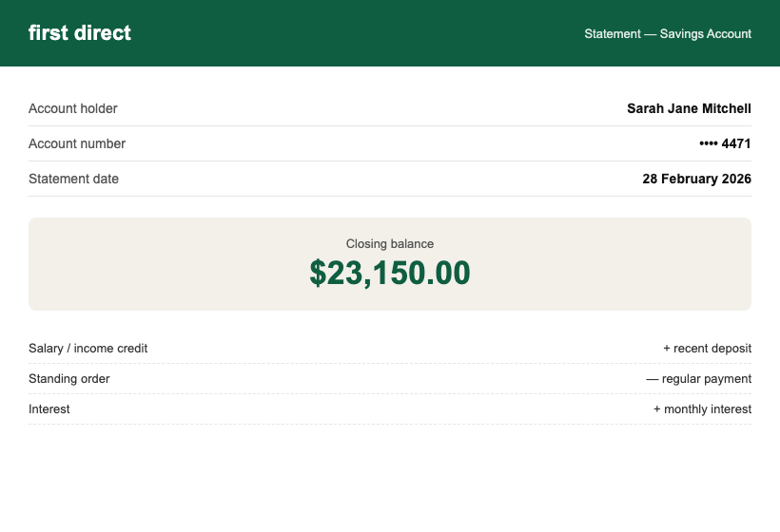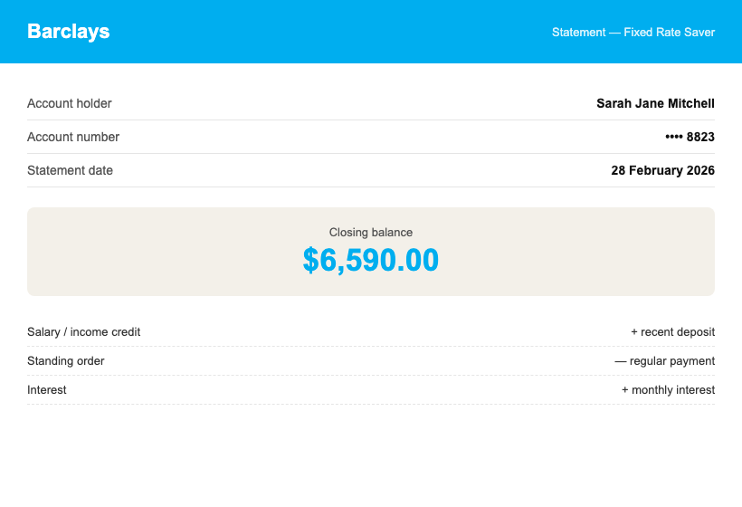

Section B — Regular Income
I receive a gross monthly salary of $5,500.00 from Northgate Insights Ltd, paid into my current account. See attached payslips and the Salary & Tax Confirmation Letter.
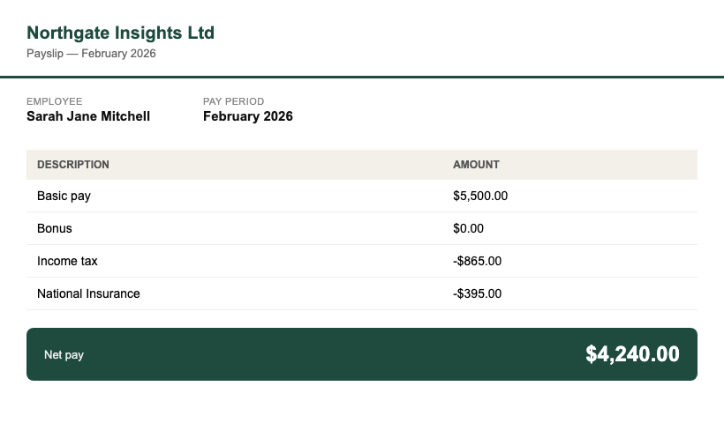

Funds Summary
Source | Amount | THB equivalent
First Direct savings | $23,150.00 | THB 798,675
Barclays fixed saver | $6,590.00 | THB 227,355
PERSONAL TOTAL | $29,740.00 | THB 1,026,030
Exchange rate: 1 USD = 34.50 THB (mid-market, 1 March 2026) — personal funds alone exceed the THB 500,000 DTV requirement.

Appendices
- Appendix A: personal bank statements, September 2025 – February 2026
- Appendix B: payslips, February 2026

Declaration
I declare that the funds and income presented above are genuinely held by me (or by companies I direct, where stated), that the attached statements are unaltered originals, and that all figures match those statements exactly.
_______________________________
Sarah Jane Mitchell — printed name
Date: 1 March 2026
WORKED EXAMPLE — fictional persona and figures for format reference only. Do not copy any details.

