Proof of Funds
Self-Employed (Sole Trader / Freelancer)

Applicant
Full name | David Okafor
Nationality | British
Date prepared | 1 March 2026

Section A — Personal Funds
I hold personal funds totalling $27,740.00 as at 28 February 2026:
Account | Institution | Balance
Personal savings | Nationwide | $27,740.00
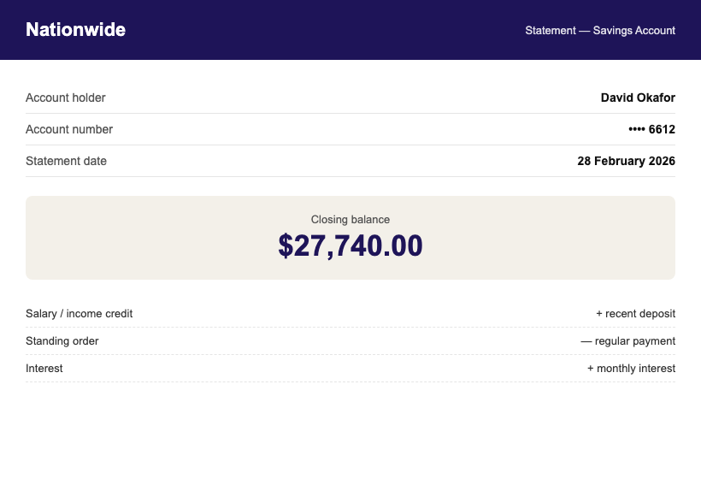

Section B — Business Income
As a self-employed web designer trading as Okafor Digital, my business income for the last tax year was $77,700.00 (net profit $60,750.00) per my tax return.
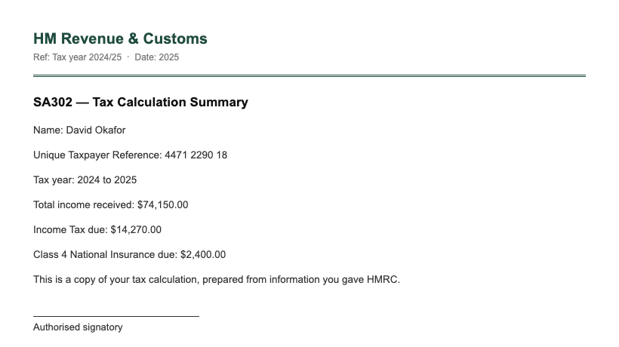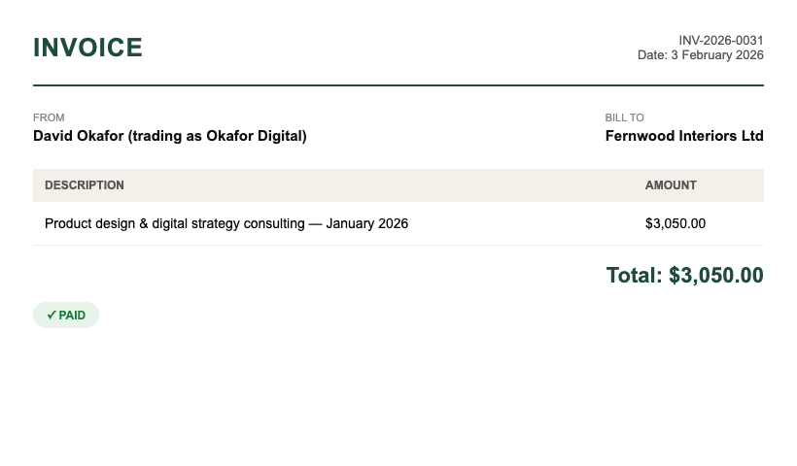

Funds Summary
Source | Amount | THB equivalent
Nationwide savings | $27,740.00 | THB 956,530
PERSONAL TOTAL | $27,740.00 | THB 956,530
Business current — Starling | $11,820.00 | THB 407,790
Exchange rate: 1 USD = 34.50 THB (mid-market, 1 March 2026) — personal funds alone exceed the THB 500,000 DTV requirement.

Appendices
- Appendix A: personal bank statements, September 2025 – February 2026
- Appendix B: invoices and SA302 tax calculation
- Appendix C: business account statements — Okafor Digital (Starling)

Declaration
I declare that the funds and income presented above are genuinely held by me (or by companies I direct, where stated), that the attached statements are unaltered originals, and that all figures match those statements exactly.
_______________________________
David Okafor — printed name
Date: 1 March 2026
WORKED EXAMPLE — fictional persona and figures for format reference only. Do not copy any details.

