EEG Hybrid Brain-Computer Interfaces: a scoping review seeking techniques and protocols feasible for children

# Introduction

Children with very limited motor abilities may benefit from the use of brain-computer interfaces (BCI) to access play and learning activities, but there is very little research in the area. BCI are devices that use brain signals processed via computational operations to control machines for various purposes, from rehabilitation to gaming. Despite the long list of interfaces created to this day, most traditional BCI still face challenges to achieve the desired performance that would allow them to become an assistive-technology for controlling devices. Hybrid brain-computer interfaces (hBCI) are becoming a desirable option in the face of the traditional BCI limitations (cite Kinney-Lang 2020, Orlandi 2021). The main goal of hBCI is to improve BCI performance (effectiveness and efficiency) through multi-modal signal inputs, e.g. combinations of different brain signals, BCI paradigms and/or other external devices (cite Wolpaw 2012).

In general, studies with traditional and hybrid-BCI have mainly been with adults. BCI for children is harder to implement than for adults. That is due to physiological and developmental reasons. There might be difficulties in identifying signal features (E. Mikołajewska, 2014), recognizing oscillatory brain signals (J. Ehlers, 2012), and instructing young participants to perform the desired self-regulating mental task (J. Z. Zhang, 2019). During experiments, external factors such as lab environment or the care-giver can distract children and negatively influence the recorded signal (cite Gavin and Davis 2009, de Haan 2009 and Richards 2003).

The purpose of this review was to …

The papers are presented according tothe taxonomy proposed by Choi et al. (2017). The taxonomy considers how the paradigms, processing, equipment and experiments were organized to achieve hybridization. Categories used are: 1) diversity of input signal, 2) role of operation, 3) mode of operation, 4) mental strategy, 5) brain signal signature, and 6) stimulus modality. ~~This structure of categorization helped to group interfaces that worked alike so the performances could be contrasted more easily.~~ A brief description of the categories is provided here:

* **Diversity of Input** - categorized as homogeneous or heterogeneous, depending on whether the input types are brain signals only or brain signals combined with other inputs, respectively. Homogeneous inputs can have a single-brain signal approach (EEG only) or a multi-brain signal approach (e.g., EEG and fNIRS). Heterogeneous inputs combine multi-physiological signals (e.g., EEG and EMG) or external inputs (e.g., EEG and Eye Tracker).
* **Mental Strategy** - categorized as either selective attention or operant conditioning. Selective attention strategies rely on external stimuli to generate expected brain responses, while operant conditioning strategies (also known as slow cortical potentials) rely on the self-regulation of the subject to generate distinguishable brain responses.
* **Brain Signal Signature** - This is defined by the mental paradigm used for the interface, and is directly associated with the mental strategy. For selective attention, the steady-state evoked potential (SSEP), transient event-related potentials (ERP) and motion-onset evoked potential (mVEP) are possible signatures. For operant conditioning, slow cortical potentials (SCP) can be modulated via movement related efforts (sensory-motor rhythms - SMR) or attention levels (µ-rhythm). Other mental tasks involving music and speech imagery were also classified as SCP.
* **Stimulus Modality** - is the pathway through which the subject is stimulated so that the brain can elicit predictable signals. The pathway can be sensorial such as visual, tactile or auditory, or self induced in the case of operant conditioning, defined as the operant pathway. A further classification can be made in terms of diversity of stimulus modalities within the interface. Single modality uses the same sensor pathway for all inputs and paradigms, and multi-modality uses different sensory pathways for the same brain signature (e.g., SSVEP and SSSEP).
* **Role of operation** - refers to the role of each system and how they are chronologically bound together. The role can be simultaneous, where both systems work concurrently in either the same or in different parts of the task. It can also be a sequential-switch, where one system initiates the other system, or a sequential-selector, where one system partially completes the task and the other system confirms or rejects the selection.
* **Mode of operation** - is the mode with which the experiment is paced. For synchronous experiments, stimuli are presented within a specific timeframe and cues are used. Asynchronous interfaces are self-paced by the subject, with more flexible timeframes.

Effectiveness and efficiency were the two main performance metrics considered. As most of the BCI community uses accuracy (or other parameters that allow for accuracy assessment) to indicate effectiveness, we usedaccuracy as our metric for effectiveness. On the other hand, efficiency is measured in a variety of different ways. Most papers that do present efficiency metrics, use information transfer rate (ITR), but execution time or commands per minute are also recurrent. It is important to notice that our main interest was in the metrics referring to the system’s classification and not to the task accomplishments.

The purpose of this paper was to review the literature around hBCI and explore what has been developed thus far regarding hBCI geared towards clinical applications, especially applied to control and communication. All the papers were analysed having the peadiatric population in mind. We categorized the level of difficulty of the task based on how many steps would be required for achieving the goal, how many activities would be happening at once, the number of devices participants had to focus on, and the type of feedback. We also analysed if the performance levels were acceptable, according to the known requirements of patients with SCI (Huggins, 2011).

# Review Objectives

This review was conducted in order to analyze the current state-of-the-art of hBCI, considering the hBCI taxonomy proposed by Choi et. al. Categorizing each system according to the taxonomy allows for a perspective of the most used methods currently developed for hBCI. We also proposed a classification system for features that play a central role on system complexity based on factors related to the interface, display and other taxonomic categories should it be used by a child. One of the problems that might be faced by the peadiatric population when using hBCI is system complexity. To achieve this, two main questions guided this study:

**Q1. What are the existing solutions for hybridization of BCI systems focused on control that could be used in a clinical setup?**

From the systems gathered from the literature, the ones clinically applicable (i.e, suitable for people with disabilities) were included, following the exclusion criteria discussed below. We focused on systems with clinical potential as most children would have their first contact with brain-controlled systems in a clinical setting. Preference was given to interfaces designed for the control of other devices.

**~~Q2. What are the hBCI solutions that could be more relevant for children?~~**

**Q2. What are the least complex and most efficient solutions available?**

The combination of some of the taxonomic features with design aspects of a system, such as the target design and the number of steps to accomplish the task can weigh on the complexity of a hBCI. From the gathered articles, we determined features of the interface design that can allow engineers and therapists to predict the complexity of a system. From the features, we tried to extract the most and least complex settings from the children’s perspective.

# Search Methodology

The keyword search consisted of four parts: the hybrid modality of the system, using (*Hybrid* OR Multiinput* OR Multi-Sensor* OR Multi-Device* OR Multimodal);*the system *(“brain computer interface” OR BCI* OR hBCI OR “human machine interface” or HMI);*the application type *(Activit* OR Task* OR Step* OR Assignment* OR Exercise OR Test* OR Execut*); and* the main acquisition source *((EEG) OR (electroencephalogra*)) OR (non-invasive)*.

*The keyword search consisted of four parts to specify the hybrid modality, the BCI system, the application type and the acquisition source: (Hybrid* OR Multiinput* OR Multi-Sensor* OR Multi-Device* OR Multimodal) AND (“brain computer interface” OR BCI* OR hBCI OR “human machine interface” OR HMI) AND (Activit* OR Task* OR Step* OR Assignment* OR Exercise OR Test* OR Execut*) AND (((EEG) OR (electroencephalogra*)) OR (non-invasive)).*

As the definition of a hybrid BCI (hBCI) can be broad, to narrow down our scope, we defined some minimal requirements for a hBCI system to be considered valid for our analysis. **Firstly**, we only considered systems that included signal acquisition via EEG. EEG-based BCI are by far the most popular system compared to other non-invasive methods (such as NIRS, fNIRS or MEG) and they have the highest information transfer rates (ITR), which puts them in an advantageous position in terms of performance compared to other methods. **Secondly**, in heterogeneous systems, the BCI component must have had a primary role in the overall system. Counterexamples of this requirement would be hBCI that used brain signals only for target selection confirmation or hBCI that used brain signals only as a mechanism to switch between non-BCI input modes. **Thirdly**, the multiplicity of inputs or paradigms had to work synergistically to achieve improved results. ~~This review focuses especially on the performance of different hBCI systems.~~ Our main interest was in systems that combine different paradigms, inputs or sensory pathways attempting to improve traditional BCI. Systems that implemented two paradigms to execute completely unrelated tasks, although they happen to be accessed through the same interface, were not considered for this review. The considered systems had to present a higher level of integration than merely combining two BCI paradigms and a switch mechanism to perform separate tasks. For example, a system that used one BCI to move a wheelchair and another to select items on a shelf were rejected. Likewise, systems that claimed to be hybrid purely because of the integration of an on/off switch mechanism to a previously standalone BCI were also rejected. Even though such systems used valid paradigms or secondary inputs, they were not included in this review as we understood that they did not significantly contribute to the improvement of the system’s performance but rather with its controllability and asynchronous capabilities.

In this study, the scoping review methodology proposed by (cite Arksey and O’Malley (2005)) was implemented. Articles from Web of Science, PubMed, Scopus and IEEE Xplore databases were extracted as they focus on medical and engineering topics. The criteria for inclusion and exclusion were delimited per filtering phase, following the scoping review methodology. The exclusion criteria of the previous phases were kept for the next phases, in case the article did not explicitly mention an exclusive term in the previous phase. All databases were searched on February 23rd of 2021, and articles published before that date were included. Patents, reviews, ~~//conference papers//~~ and other formats of publication that were not articles and conference papers were not included. ~~//Journal articles were the one format of publication included as they have a rigid protocol of peer review before publication.//~~

**Title inclusion/exclusion criteria.** Article titles to be **included** had to (1) contain “hybrid BCI” or other terms that indicated hybridization such as multi-input, multi-modality or multiple paradigms, signal acquisition methods or devices. It also had to (2) make reference to control terms (selection, interaction, classification, etc.) or devices (speller, robotic arm, wheelchair, etc.). The titles that were **excluded** were the ones indicating that the paper focused on (1) non-hBCI systems (e.g., single-input BCI, multi-input devices), (2) estimation applications (e.g., motion trajectory prediction, group decision making), (3) assessment applications (learning performance, affective/emotion state, mental/psychological state, facial expressions or fatigue), (4) imaging and detection applications (e.g., neuroimaging, algorithms to localize best EEG sources, studies on brain signal detection, cortical reorganization, epilepsy detection), (5) other EEG-related algorithms, (e.g., artifact removal algorithms, algorithm for EEG signal simulation), (6) rehabilitation or therapeutic applications, (7) systems including functional electrical stimulation, (8) invasive technologies, and (9) pure headset development.

**Abstract exclusion criteria.** At this stage, the title-included articles were filtered based on their abstracts. Papers were excluded if they were oriented towards (1) BCI as a complementary input in a multi-modal system, (2) the study of hybrid classifiers for a single BCI input, (3) optimal channel selection algorithms, (4) development of a method or framework for experimentation, (5) signal identification during other activities or (6) if they had no participants (i.e., only used datasets for validation).

**Full article exclusion criteria.** The final filter allowed a more in-depth analysis of each article, avoiding the inclusion of articles with misleading titles or abstracts. At this phase, articles were excluded if they (1) proposed an invalid hBCI (i.e., brain signal was a secondary function, any of the inputs in a two-system input was only used to keep/turn the system on/off, paradigms or inputs did not work in synergy), (2) did not have a valid performance measurement (accuracy or true positives, true negatives, false positives and false negatives, or any indication of the number of correct trials versus the total) of the paradigms’ efficiency (opposed to the task accomplishment, which was not the main interest), (3) had online trials but only provided offline performance measurements, (4) did not include performance measurements for the relevant system role of operation, either for each of the inputs or their combination, (5) proposed a system that was not suitable for control applications, (6) had insufficient information for experiment replicability (i.e., lacked information such as but not limited to number of trials, number of participants, number of sessions, number of analyzed samples, number of training/validation datasets, or clarity about experiment protocol).

# Search Results

When all the filters were applied, 45 articles were selected for this scoping review. Initially, the search on all databases yielded 1585 publications, 617 from Web of Science, 225 from PubMed, 489 from Scopus, and 244 from IEEE Xplore. The number of duplicates was 1214 that, when removed, resulted in 771 unique articles. From those, 302 were included after title-filtering, 149 after abstract-filtering and 45 after article-filtering. No conference papers remained among the 45 final articles, although we did not set a strict exclusion criteria for conference papers.

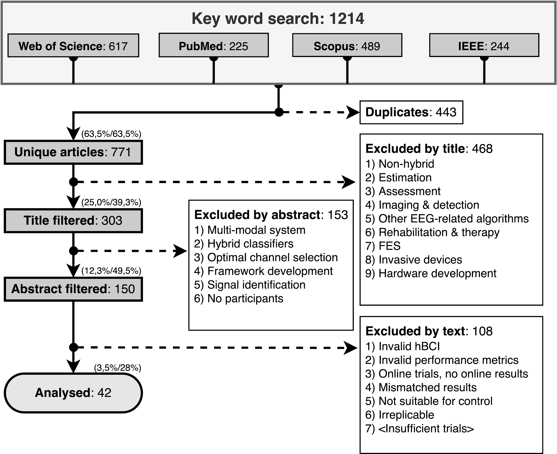

Figure XI shows how many articles were published per year. The transparent bars correspond to all the articles included by abstract. The solid bars correspond to the articles included for the final analysis. For both groups, the overall number of articles per year has been growing, reaching its peak in 2015. There were more articles published in 2020 that met our inclusion and exclusion criteria than other years. The average number of written articles from 2014 to 2019, was 4.16. In 2020, 14 articles were written, 3.4 times more articles than the previous average and 56% of the total number of articles written in the six years prior to 2020.

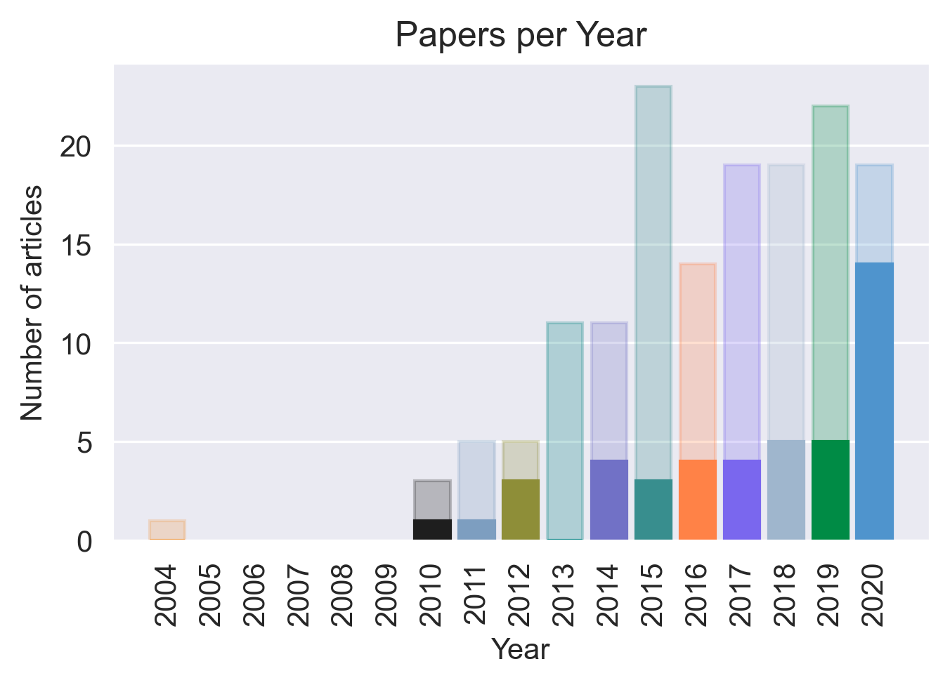

No studies included child participants. One study had a participant aged18 y.o., (Kaongoen & Jo, 2017), but most papers had at least one participant within the range of 20 to 30 y.o. (except for Nann et al. 2020 experiment with tetraplegic participants). Only two papers included participants above 40 years of age (Brennan et al., 2020 and Nann et al., 2020). Figure YYa correlates the age range of participants in each study with the achieved accuracy and Figure YYb shows the age range overlap among the papers.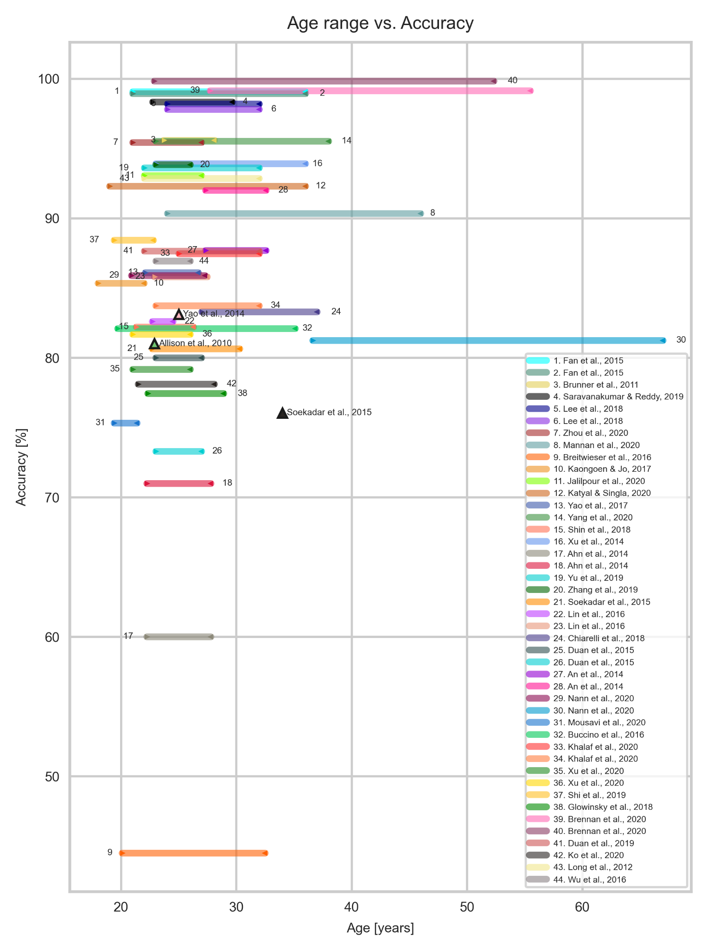

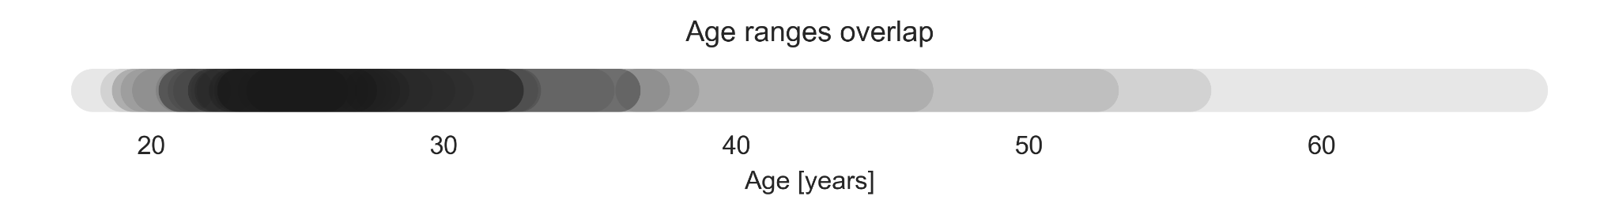

Only three studies included participants with disabilities. Soekadar et al. (2015) tested the system with one participant with flaccid hand paralysis, a 34 year-old male. The study reported that he was able to control a robotic hand via MI, even though his accuracy was slightly lower than the average of the other healthy participants (76.03% compared to 80.65%). Brennan et al. (2020) included 14 participants with brain injury (although only nine completed the hBCI trials) with an average age range of 41.6±13.9 years. Participants underwent trials with both an SSVEP BCI and an SSVEP-Eye Tracker hBCI for comparison. The hBCI trials had higher accuracy than the BCI, with 99.14% compared to 80.26%. Participants with brain injury only did one session of experiments, while healthy participants did two. Nann et al. (2020) had four participants with tetraplegia, average ages of 51.8±15.2. The study tested an EEG-BCI and an hBCI combining EEG with HOV, increasing the accuracy from 58.68 ± 10.62% to 81.25 ± 5.84%. All participants with tetraplegia rated the system as user-friendly and reliable.

The average population size was 11±5.27 participants, ranging from 1 to 30 participants. The most common population size was ten participants (21.3%), followed by eleven participants (10.6%), as seen in Figure N.

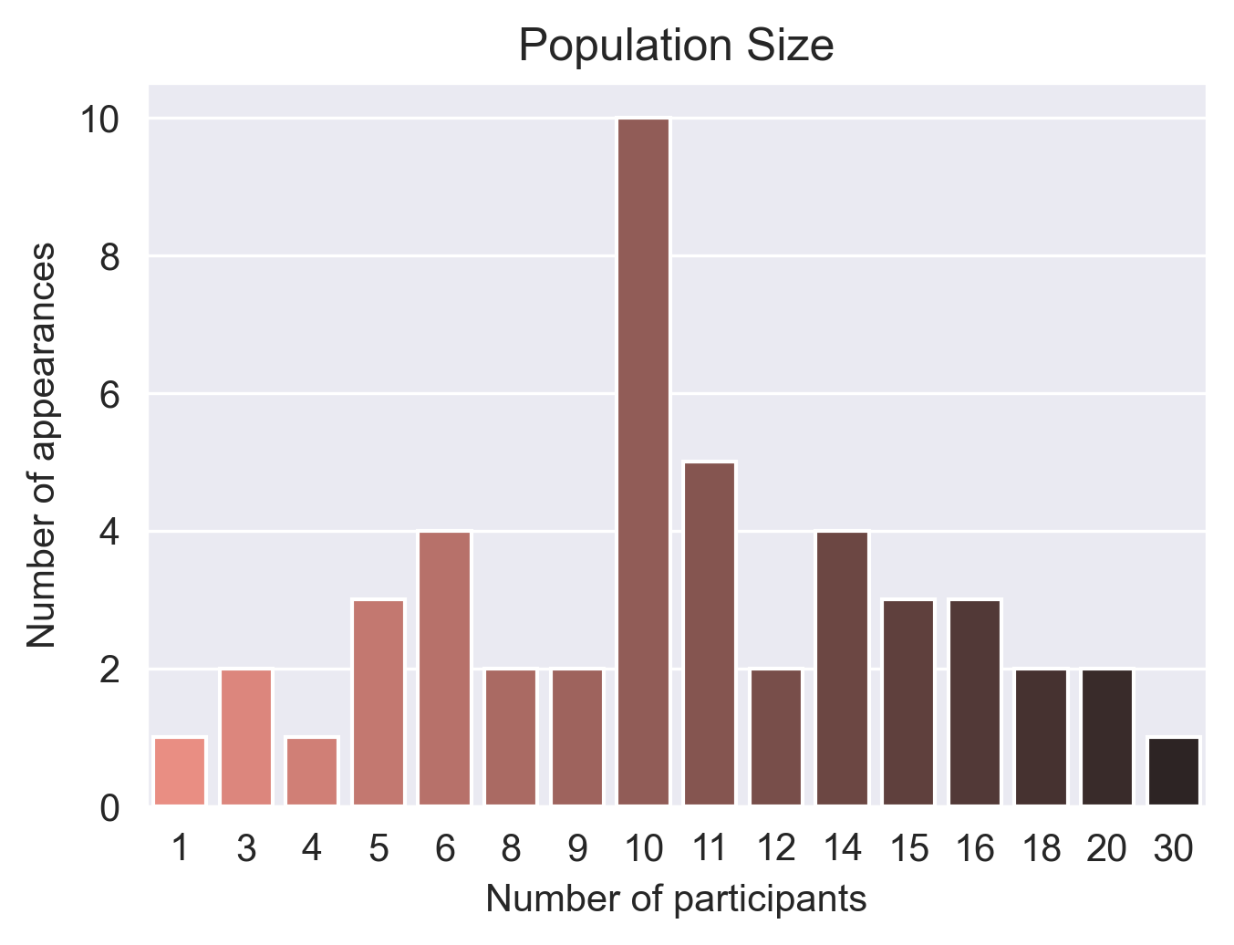

One quarter of systems used the g.USBamp. Most of the papers reported using a fabric cap with Ag/AgCl electrodes or golden cups. The only system that that used a headset style instead was the Cognionics system. Articles that combined multiple input caps (e.g. EEG and NIRS) were Buccino et al. (2016), Khalaf et al.(2020), Chiarelli et al. (2018), Shin et al.(2018) and Glowinsky et al. (2018). <<add more info later>>

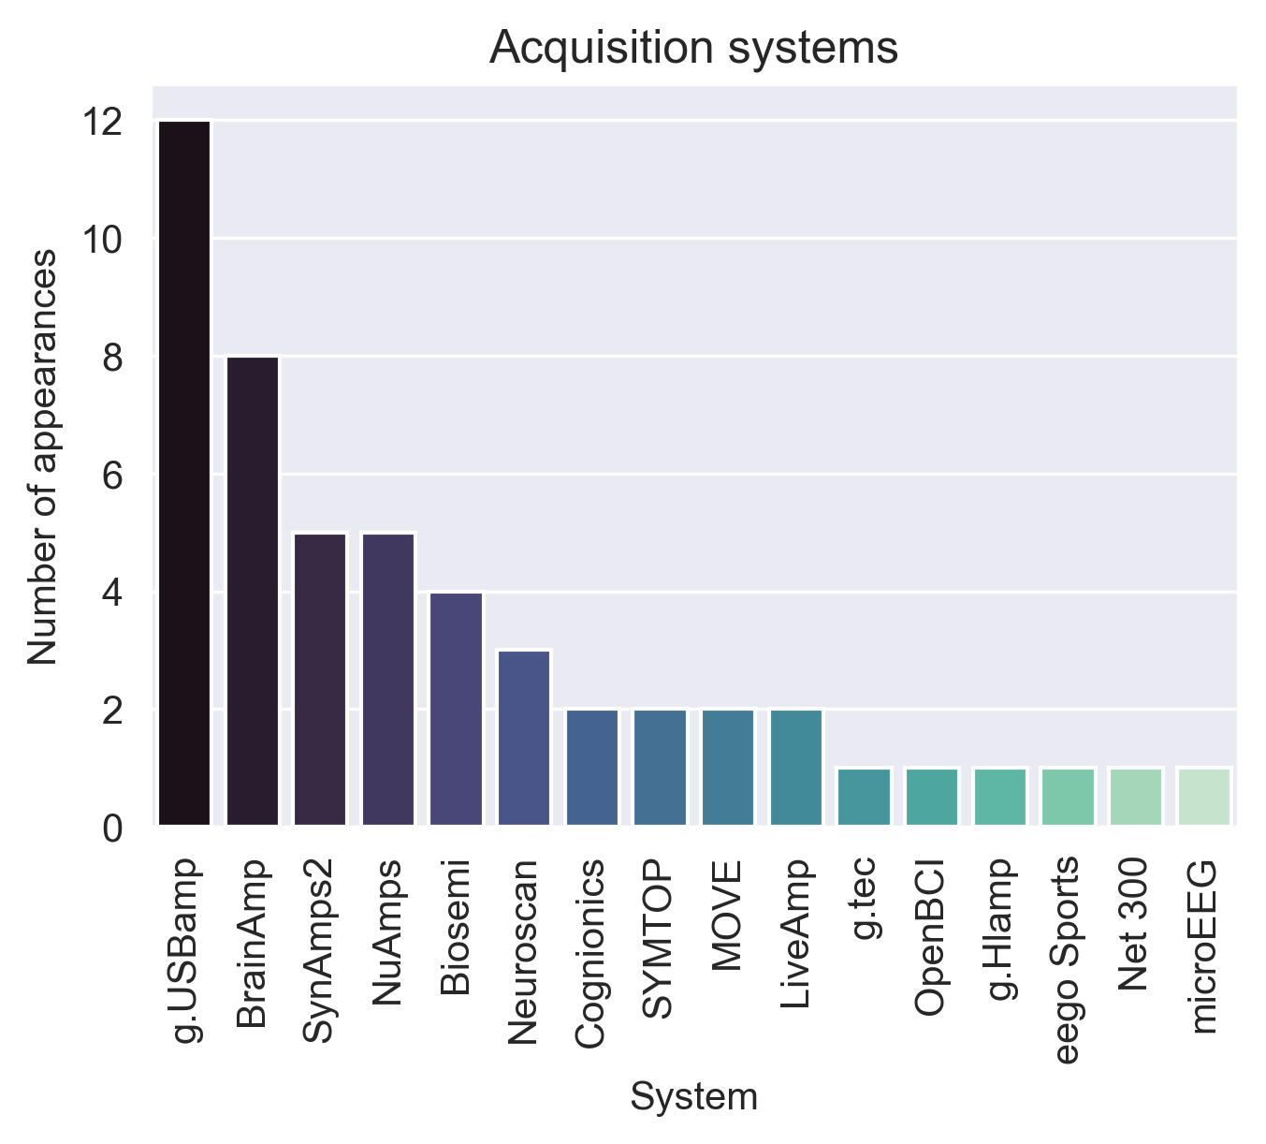

## Complexity analysis

From the analysed articles, we found some features that might play an important role on the complexity of a system:

* Number of Brain Signatures
* Role of Operation: Sequential, Simultaneous
* Type of targets: still, strobe, goal/spatial, off-screen
* Number of targets
* Stimulus Modality: Visual, Tactile, Operant, Auditory or multiple
* Number of Stimulus Modalities
* Built-in correction/confirmation capabilities
* Number of actions before selection
* Includes external inputs

The list was separated in interface presentation and user interaction features. The presentation played the biggest role on the user acceptance of the system. It could improve user experience, and reduce mental overload. The user interaction indicated which tools were offered so that the user could have more reliable communication with the hBCI. It had a greater impact on the efficiency of the system. Although there are no studies with children using hBCI, the descriptions and ordering of elements below were elaborated based on how we would expect children to react to certain settings. We also hinted at some of the performance results from the selected papers and common sense. The deductions below can serve as a guideline for future researchers that are developing hBCI for children.

**Number of Brain Signatures** - brain signatures define the regime of operation the brain will be operating throughout the experiment. The interface (or the participant) induces a particular brain operation for the duration of one or more trials. Switching between brain signatures or performing multiple brain signatures simultaneously can increase the complexity of the system, especially if the brain signatures belong to different mental strategies. For example, Duan et al. (2015) utilized SSVEP to move a robot, mu-rhythms to switch modes and MI for grasping. It was the only system with more than two Brain Signals for control. Due to its complexity, the accuracy was lower than the average (85.64%) with 73.3%. Similarly, but in a simultaneous role of operation, Alisson et al. (2012) developed a system where a ball could be moved in a 2D space utilizing SSVEP and MI for horizontal and vertical movement, respectively. The average accuracy was 60%.

**Role of Operation** - multi-tasking generally decreases processing speed and increases the amount of information needed to make a decision (cite Howard et al. 2020). Using multiple brain signals simultaneously can decrease participant’s focus hability or increase mental fatigue. Ahn et al. (2014) designed two experiments combining MI and tactile selective attention, with sequential and simultaneous roles of operation. The results with the sequential experiment yielded 71% accuracy, while the simultaneous reached 60%.

**Type of targets** - the stimuli that happen on the screen can either elicit a certain brain response or indicate to the participant what self-regulating action to take. Certain types of targets can cause more fatigue in users, while other types of targets place all the stimulus responsability on the participant. Based on required effort and likely fatigue caused by the stimulus, we ordered the existing types of target (from the selected papers) from least to most complex.

The *still targets* flash periodically (usually with less than 6 Hz) with a certain inter-stimuli interval and are usually associated with P300 paradigms and spellers. Those targets generally require counting and focus on a single desired target. The *strobic targets* have flashing with higher frequencies (usually above 6 Hz) incorporated onto them. They are mosly used in SSEP or RSVP paradigms and can change in intensity, color, shape, visuals or position, and targets usually have different frequencies. *Goal or spatial targets* stimulate users to displace objects, cursors or other elements through time by sustaining certain threshold of intensity. They are mostly used in SCP paradigms.

Then we have the off-screen targets, which require greater focus and mental training as they do not present stimuli, nor feedback in some cases. These include *motor/tactile targets*, which require focus on certain motor imageries or tactile stimulations. This approach could be an alternative for people with severe visual impairments. The *mental tasks* utilize the blood flow generated in the brain when arithmetic operations, mental gemoetric manipulation or word formation are performed by the participant. They are usually associated with NIRS and fNIRS inputs. Children could have difficulties with this type of target since it involves not only focus, but also a task that might not be playful. Finally, *sound cues* are targets that rely on sound for selection. These targets can be difficult to distinguish and even when the audio tracks are substantially manipulated as in Glowinsky et al. (2018) or An et al. (2014), they yield lower accuracies and have higher workload for mental demand and effort compared to visual stimuli.

*<possibly include an illustration of the types of targets?>*

**Number of targets** - Some authors have attempted to increase the number of targets to increase the ITR. Although it might be a good strategy that can give the user more flexibility and a faster system, a greater number of targets could make a user distracted or overwhelmed with many options. A greater number of targets was mostly seen in spellers. For example, Xu et al. (2020) developed a speller with 108 targets. Twelve 3x3 character matrices were presented to participants at once and they underwent a synchronous and asynchronous session. Although they had some of the highest ITR (172.5 bits/min for synchronous and 164.7 bits/min for asynchronous) they had the lowest accuracies (81.67% for synchronous and 79.17% for asynchronous) compared to the group, with average of 90.32%.

**Stimulus Modality** - most papers chose visual pathways to stimulate the brain. Visual stimulation is the most mainstream, but it is also the least complex modality. Figure K shows the relationship between accuracy and each Stimulus Modality. Although not all modalities had the same sample size, we can see a trend where systems using visual pathways have higher accuracies than the others. We hypothesize that there would be different levels of complexity associated with each stimulus modality, especially for children. From the easiest to the hardest, *visual*, *operant*, *auditory* and *tactile*. Non-invasive BCI can read stronger signals from the outermost layers of the brain. *Visual* paradigms, in general, elicit clear signals on the Occipital and Parietal regions, especially when using SSVEP and P300. On the other hand, *operant* modalities require a certain level of training and focus from the participant to generate distinguishable signals (cite Yuan and He, 2014). The *auditory* modality was considered more complex than the operant modality because it requires more attention and has a steeper learning curve (cite Nijboer et al., 2008). Lastly, *tactile* modalities require a body awareness, which might not be well developed in most children, and can become confusing with multiple targets (cite Brouwer and van Erp, 2010).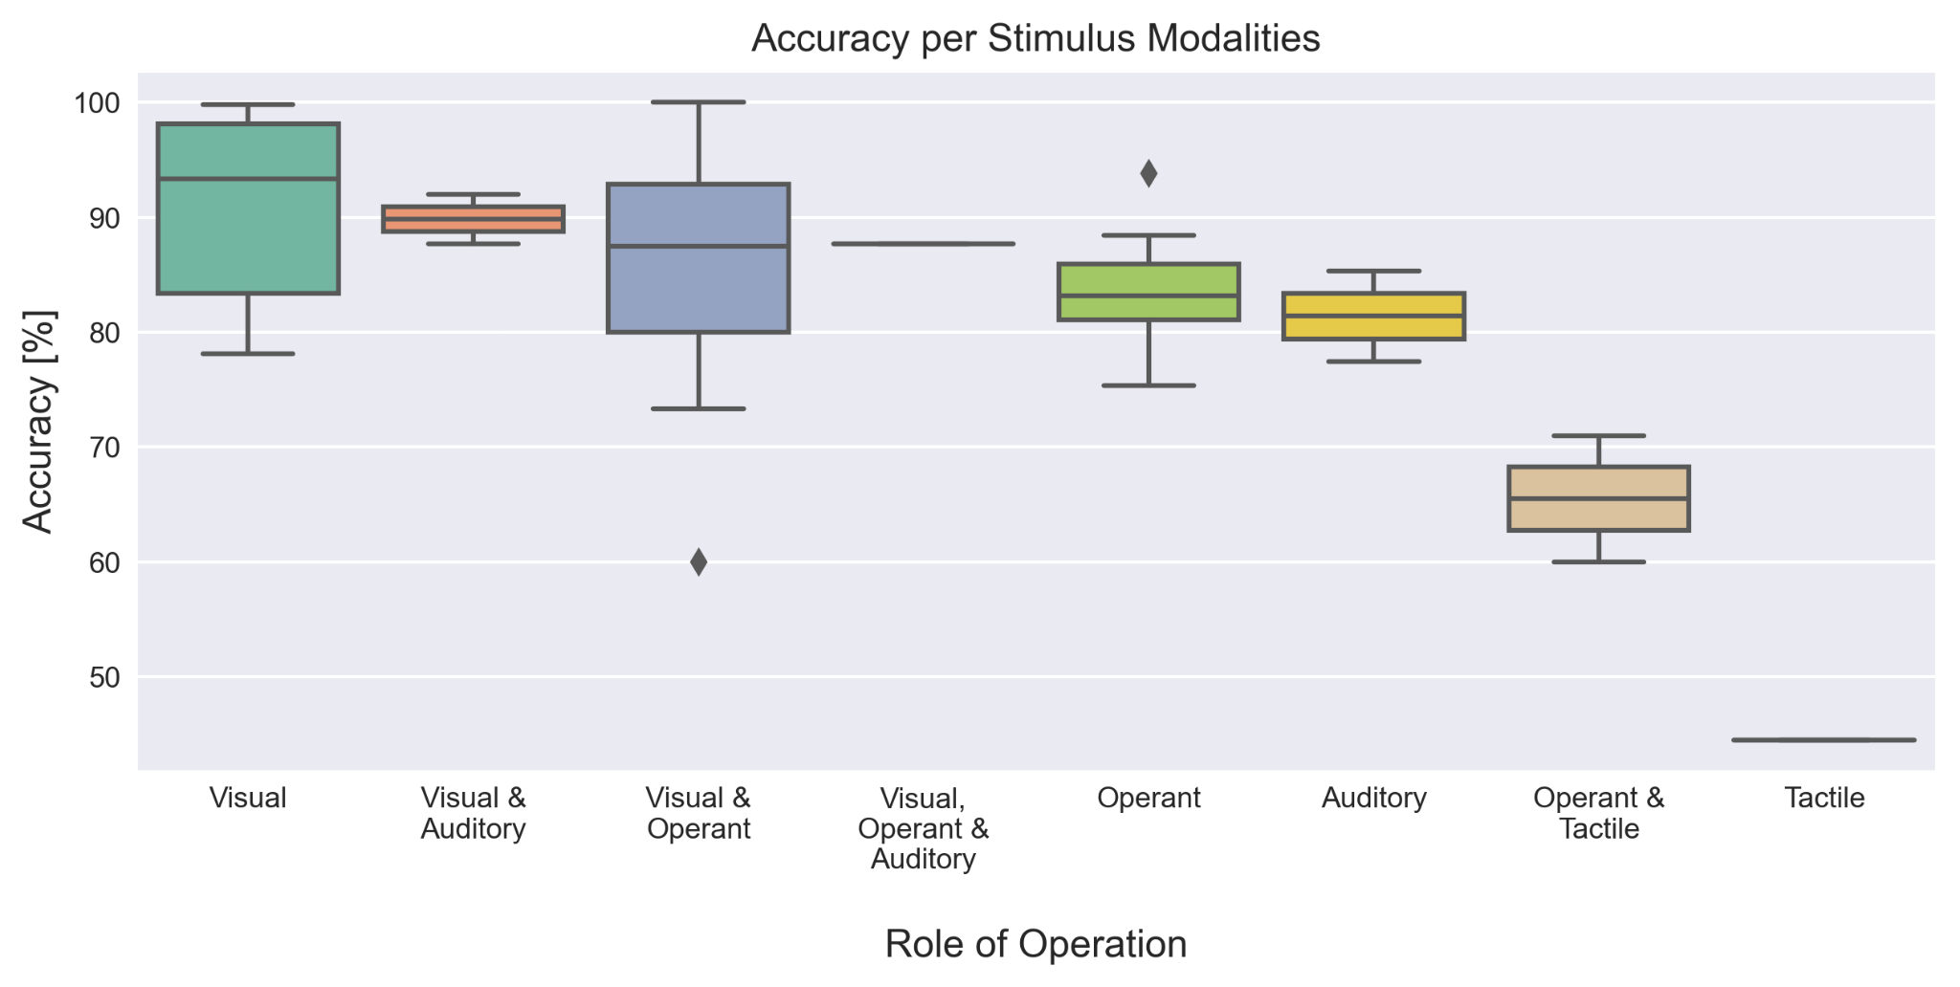

**Number of Stimulus Modalities** - switching between stimulus modalities or having to simultaneously focus on more than one sense might also increase the system’s complexity, especially if the different stimulus modalities refer to a different target. An et al. (2014) experimented with two roles of operation. In the sequential mode, where stimuli alternated between visual and auditory repeatedly with different sequences, participants reported vthat the modality had a considerably higher workload than the simultaneous mode or the individual stimulus modalities.

**Built-in correction/confirmation capabilities** - having mechanisms to amend or confirm selections can increase performance. Mousavi et al. (2020) utilized ErrP to correct MI misclassification and the system had an improvement in accuracy. Similarly, Soekadar et al. (2015) implemented a task correction with EOG which resulted in a more intentional operation of the system. Fan et al. (2015) implemented confirmation mechanisms before the final selection utilizing SSVEP, resulting in one of the highest evaluated accuracies (99.07%).

**Number of actions before selection** - some systems required multiple sub-tasks before the final selection was completed (i.e., multiple input commands and classifications to make a final selection). Although it appears that having multiple sub-tasks can add to the robustness of the system, it could also increase its complexity. Most systems in the literature had two sub-tasks, at maximum, as seen in Figure Xx. Seven systems utilized three sub-tasks and Zhang et al. (2019) was the only one with four sub-tasks. Their system utilized EEG, EOG and EMG modes, each with specific commands. EOG blinking switched modes and a participant could need up to four commands to cycle through all the modes and then make a selection. 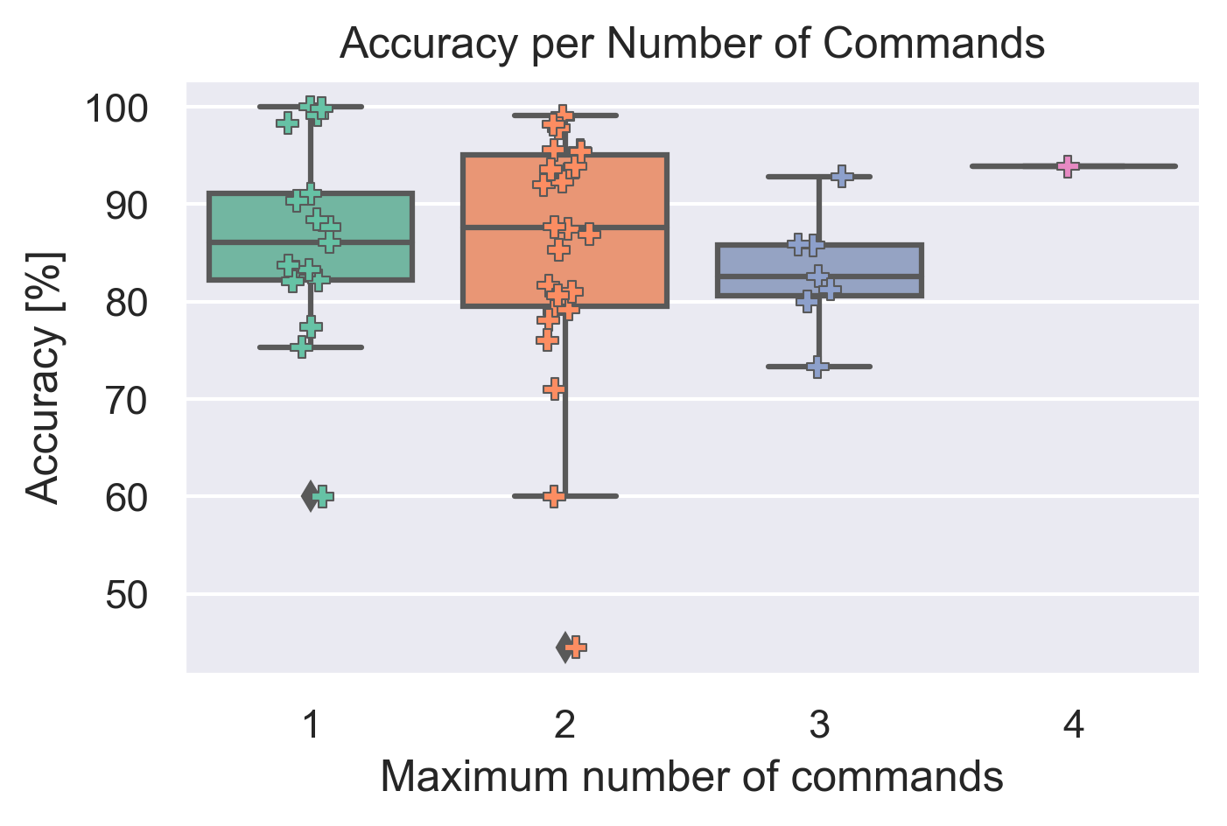

**Includes external inputs** - having an external input can facilitate selection if the participant does not have severe impairments. Inputs such as eye trackers, joysticks and buttons add reliability to the system and therefore increase its performance. Three of the selected papers used external inputs, Mannan et al. (2020) and Brennan et al. (2020) used an eye tracker and Saravanakumar & Reddy (2019) utilized a vision-based eye tracker. Their accuracy results were among the highest (average 96.92%), even when utilized by the nine participants with brain injury from Brennan et al. (2020) (accuracy of 99.14%).

## Taxonomy report

Some papers presented more than one variation of system. In the 42 papers, 47 systems were presented. Khalaf et al. (2020) presented two systems with different brain signals, one using SMR and one combining SSEP and SCP. Other papers presented synchronous and asynchronous experiments using spellers for cue-based experiments and free-spelling (Lee et al., 2018, Lin et al., 2016 & Xu et al., 2020), and others varied the role of operation (An et al., 2014 & Ahn et al., 2014).

### Diversity of Input

Considering the diversity of input, 36 (76.6%) systems were homogeneous and 11 (23.4%) heterogeneous, as show in figure X. Thirty of the homogeneous systems used EEG only and the reminder used a multi-brain input approach: two combining EEG and fNIRS, two combining EEG and NIRS, and two combining EEG and fTCD. All the multi-brain input systems only presented offline results. Eleven were heterogeneous, with eight multi-physiological and three making use of external input. The multi-physiological were mostly EEG and EOG, but Lin et al. (2016) combined EEG and EMG and Zhang et al. (2019) combined EEG, EOG and EMG. As for the ones with external input, Mannan et al. (2020) and Brennan et al. (2020) used an eye tracker and Saravanakumar & Reddy (2019) used EOG combined with VET.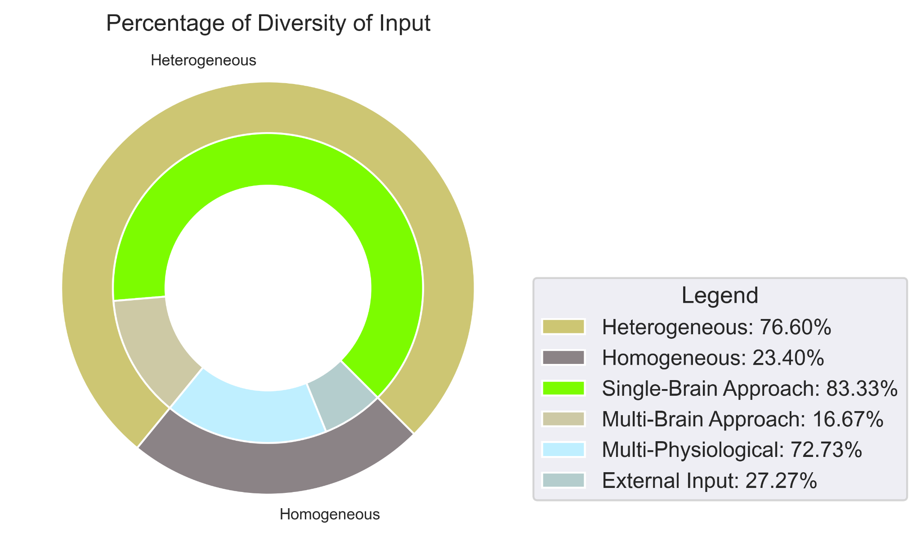

### Mental Strategy & Brain signal signature

Almost half of the systems used selective attention (23 systems, 48.9%), more than a quarter operant conditioning (13 systems, 27.7%) and the reminder combined both (11 systems, 23.4%). The selective attention systems were equally divided in terms of paradigms: six used only SSEP, six only ERP and eleven combined both. As for the operant conditioning, all used SMR. Most were exclusively SMR (10 systems), two combined SMR with µ-rhythms, and one used SMR combined with SCP. The systems with multiple mental strategies mostly used SSEP: six with SMR, one with SMR and µ-rhythm and one with SCP. The other three combined ERP and SMR.

Figure Y shows the percentage of brain signatures that were used. The total number for each brain signal signature is represented by the outermost ring, and the combinations made with each signature are represented by the innermost ring. In total, SSEP was the most used, followed by SMR, ERP, µ-rhythms and finally SCP. The signature most largely used by itself was SMR (9 systems), followed by ERP (6 systems) and SSEP (5 systems). The other brain signatures were always combined with other signatures. All the systems using µ-rhythms had SMR as well, therefore, the SMR combination is not represented in the figure.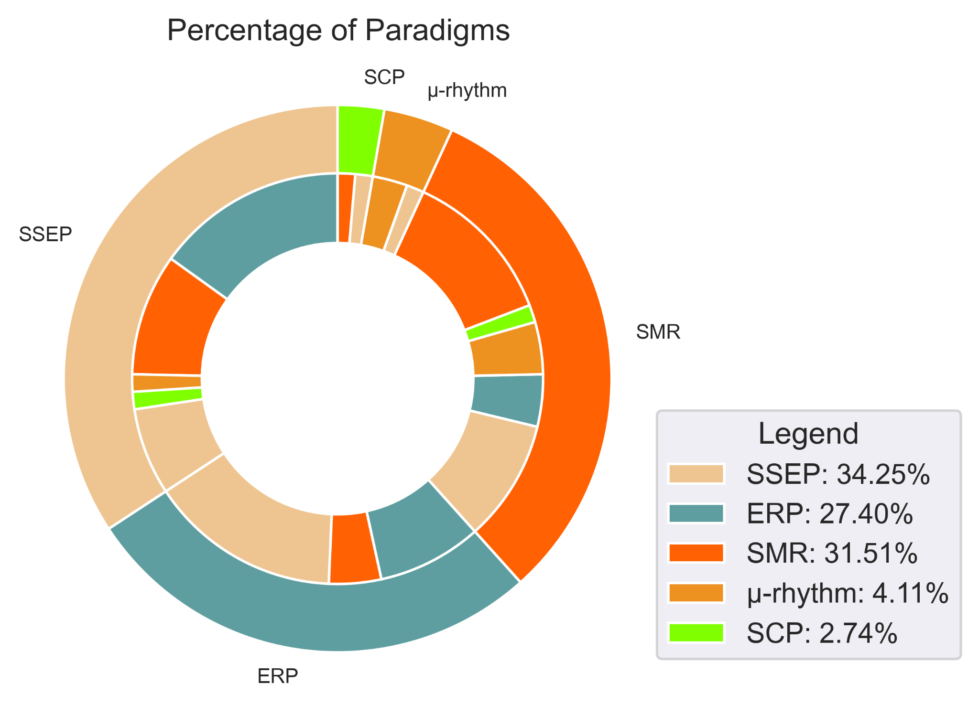

### Stimulus modality

Figure AA shows how the stimulus modalities were distributed for the considered systems. The two most utilized stimulus modalities were visual and operant. Twenty of the 47 systems were purely visual, and 51.6% of the total had visual stimulus combinations. Ten systems were based on operant stimuli and 35.5% of systems included operant stimuli. The combination of both visual and operant was also popular, totaling nine systems using this modality. Only five systems included auditory stimuli (two purely auditory, two combined with visual and one combined with visual and operant stimuli) and three systems included tactile stimuli (one purely tactile and two combined with operant stimulus).

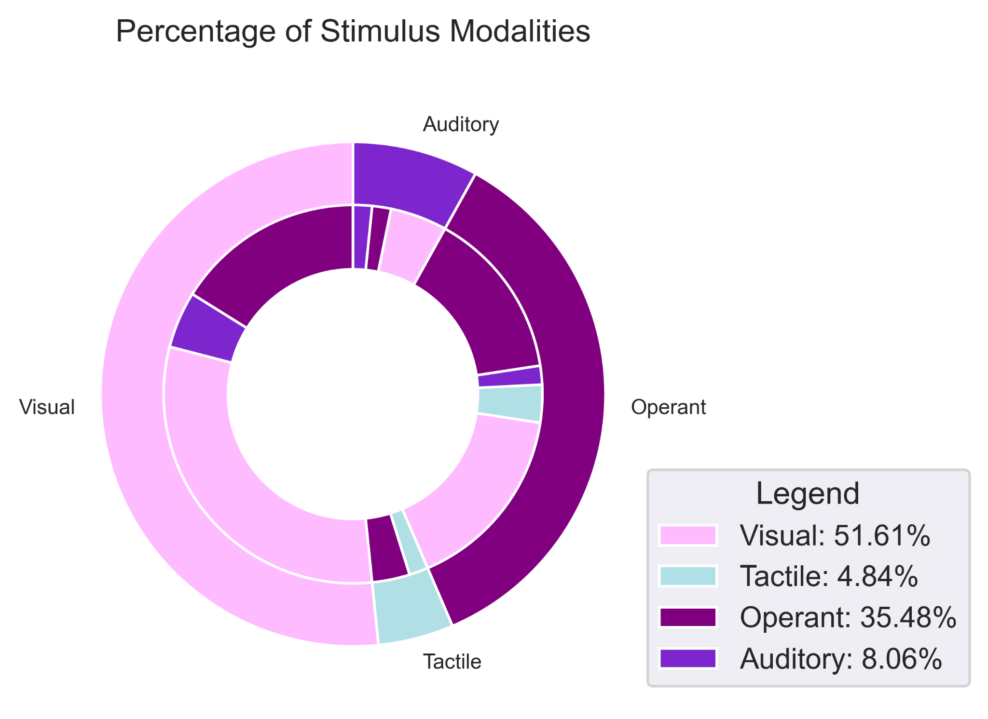

### Role of operation

Almost 60% of systems were simultaneous in their role of operation, totaling 29 systems. Eighteen were sequential, including five sequential-selectors (Lee et al. 2018, Yang et al. 2020, Fan et al. 2015, Ko et al. 2020 and Long et al. 2012) and two sequential-switching systems (Li et al. 2018 and Yu et al. 2017), as shown in Figure BB.

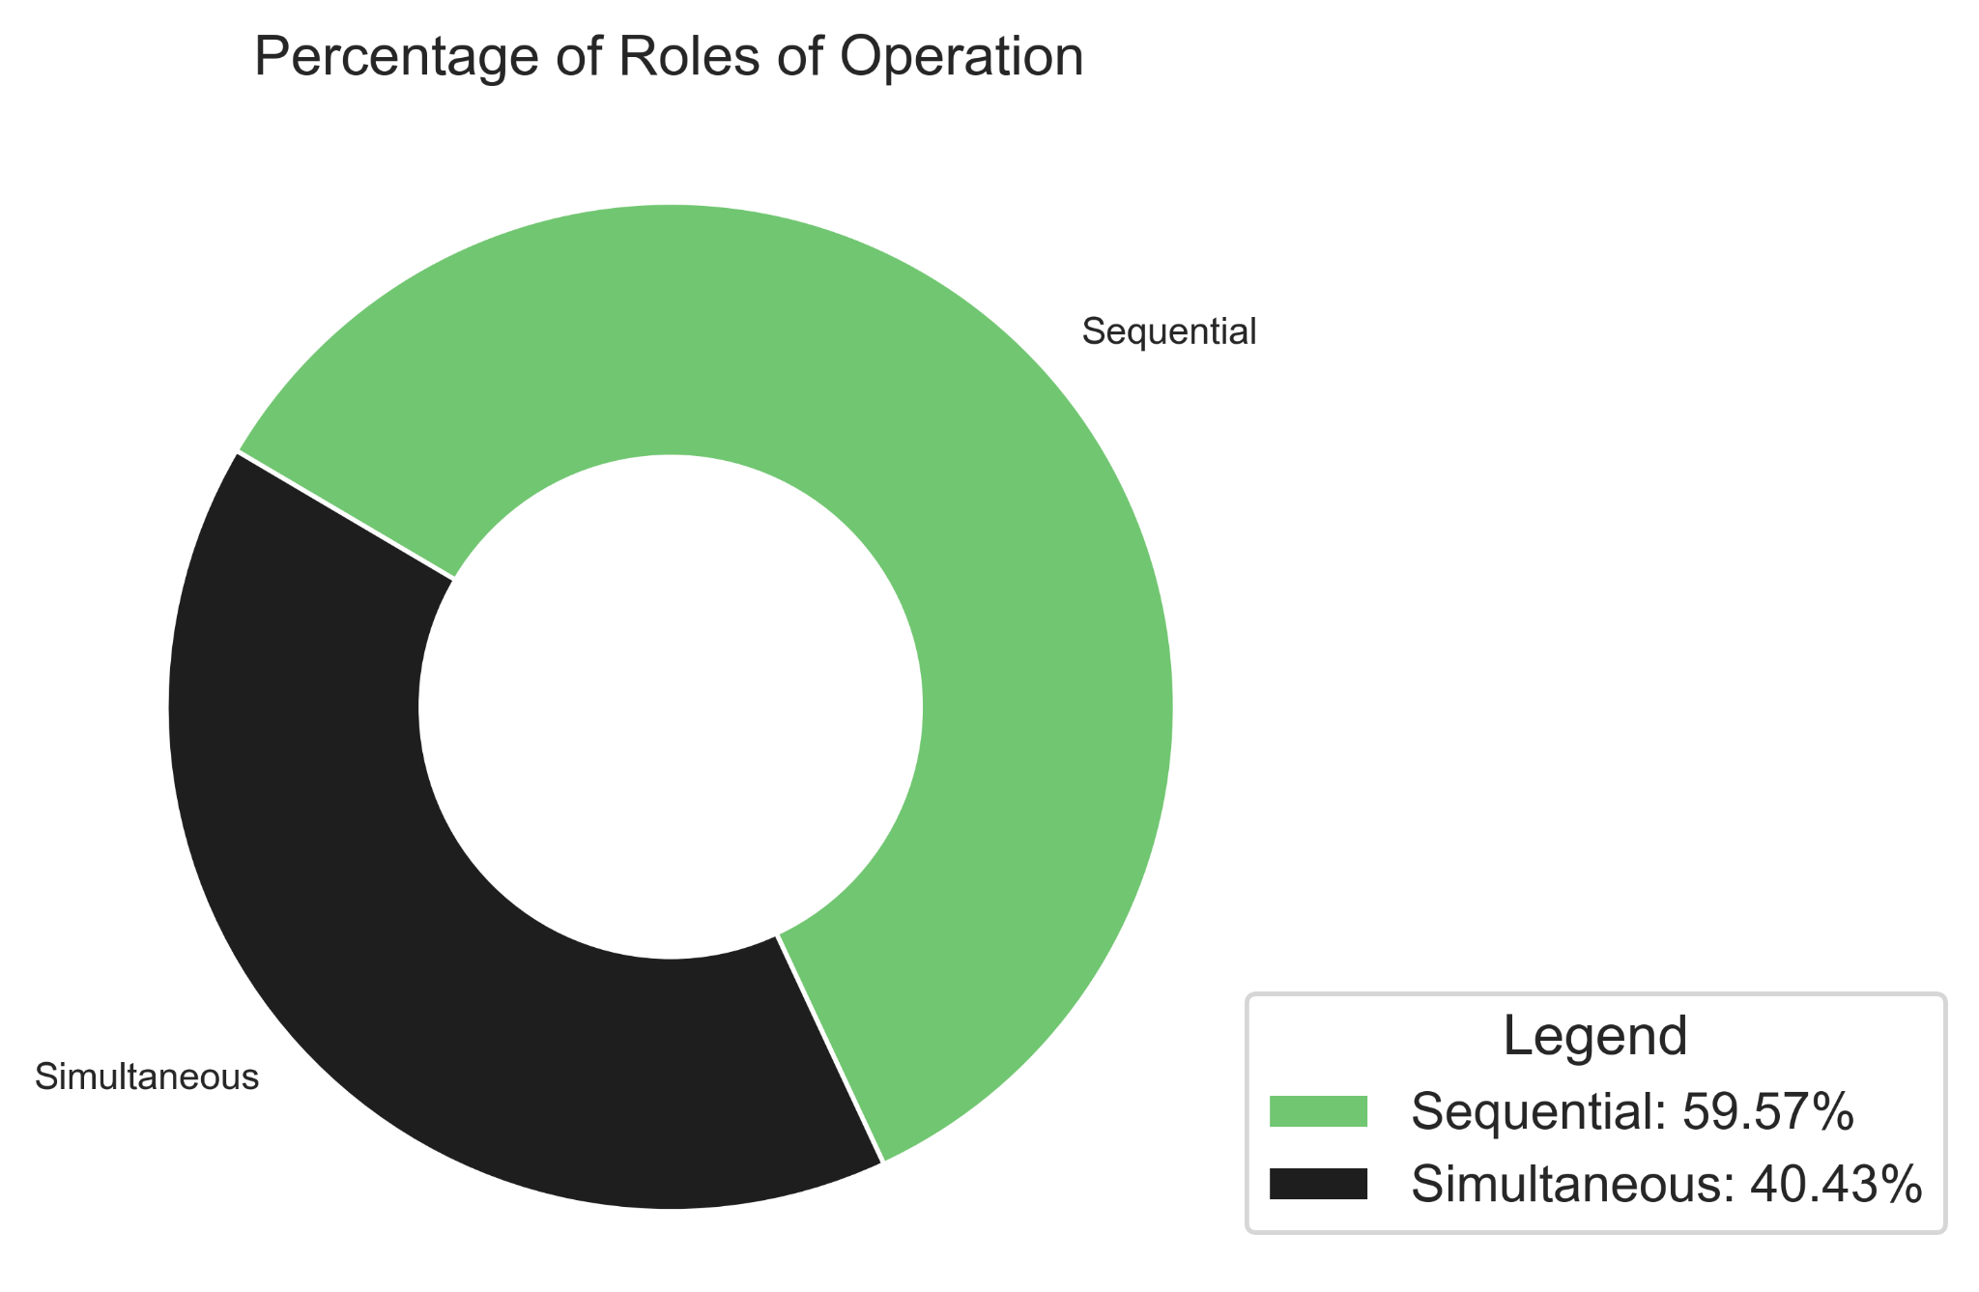

### Mode of operation

Most experiments relied on cues, using the synchronous mode of operation. Ten had asynchronous modalities, where the participant could self-pace his selections. Zhang et al. (2019) was the only experiment to utlize both synchronous and asynchronous. Due to its multi-intput nature, Zhang and colleagues allowed the EOG and EMG to operate asynchronously, and when switched to EEG mode, the system alternated to synchronous.

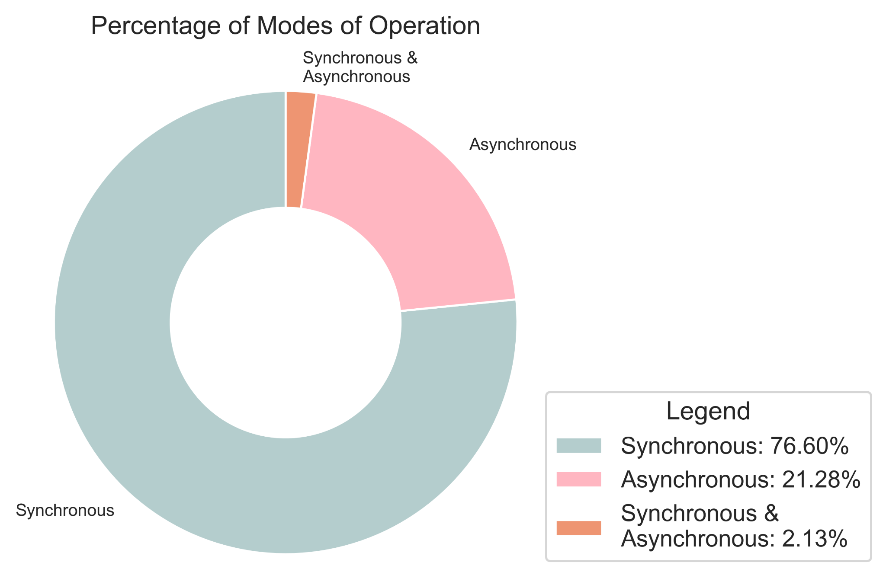

### Task Categories

It is very common in the BCI field to have systems that only test the paradigm and its classification without any application. For the selected hBCI, 38.3% of systems did not control any device or external task. The most common application was for spellers with thirteen systems attempting to improve its performance. Six articles controlled devices that were displaced such as drones, wheelchairs and other vehicles (physical or simulated). Four implemented cursors or games, four controlled robotic devices and two developed home automation systems.

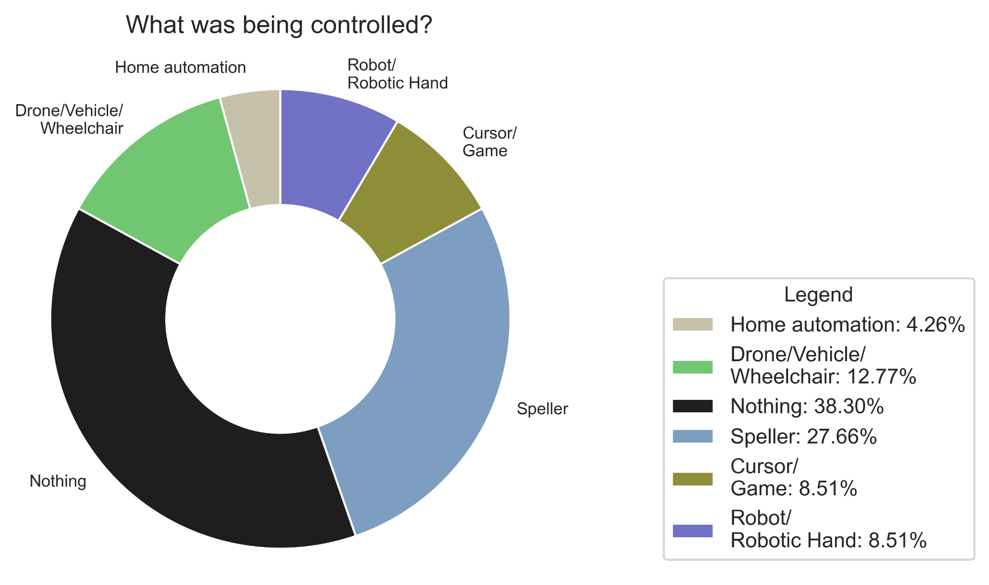

Things about kids to pay attention to:

~~- System complexity of use:~~

~~- number of commands~~

~~- number of steps to perform a command~~

~~- number of diverging systems used~~

~~- add pie graphs for each taxonomy item~~

~~- acquisition system - uncomfortable?~~

- if use with kids at home, then plug and play is NB

~~Look up children reviews and see what they say something that could give a framework for what would be good for kids:~~

~~- Mikołajewska (2014)~~

~~- Beraldo (2020)~~

~~- Sarah house and Chau one (2021)~~

~~- games?~~

<<TABLE WITH ALL THE ATICLES>> <<HERE OR IN SUPPLEMENTARY MATERIAL?>>

# Discussion

# Conclusion

# Limitations

We only looked at EEG-based systems

Sample sizes for accuracy are small

Not using real criteria for what might be important considerations for using with children.

# References

(Scoping Studies: Towards a Methodological Framework, Hilary Arksey & Lisa O’Malley (2002))