DEMONS WHIP - NOVO - ENEMIES
MODEL 3D • Volume 2 de 2

Assets neste volume: 29
Origem: NOVO
Gerado em: 2026-08-17T19:04:21+00:00

NOV-005173 • veiled_doe [ERROR]

ID | NOV-005173
Origem | Asset novo
Pack/Fonte | Assets Organizados - Enemies
Categoria | Enemies / Veiled Doe.Glb
Arquivo | veiled_doe.glb
Caminho | 01_Assets_Organizados/Enemies/veiled_doe.glb
Formato | GLB
Tamanho | 329.28 KB
SHA-256 | ee0dd9450b96d58215b3…
Status técnico | ERROR
Licença | MISSING_REVIEW_REQUIRED — sem evidência localizada
Objetos / meshes | N/D / N/D
Vértices | N/D
Faces / triângulos | N/D / N/D
Materiais | N/D —
UV sets / vertex colors | N/D / N/D
Dimensões XYZ | N/D
Rig / armatures / bones | N/D / N/D / N/D
Skinned meshes | N/D
Animações | N/D —
Duração total clips | N/D
Root motion detectado | N/D
LODs / colliders | Nenhum / Nenhum
Texturas vinculadas | N/D (0 ausentes)
Alertas | Licença/fonte não localizada automaticamente; revisão legal necessária. | Duplicado exato: grupo DUP-00747 (2 cópias).
Notas | Falha na inspeção 3D: RuntimeError: Error: Python: Traceback (most recent call last):  File "/usr/share/blender/scripts/addons/io_scene_gltf2/__init__.py", line 1064, in execute  return self.import_gltf2(context)  File "/usr/share/blender/scripts/addons/io_scene_gltf2/__init__.py", line 1083, in import_gltf2  return self.unit_import(self.filepath, import_settings)  File "/usr/share/blender/scripts/addons/io_scene_gltf2/__init__.py", line 1088, in unit_import  from .blender.imp.gltf2_blender_gltf import BlenderGlTF  File "/usr/share/blender/scripts/addons/io_scene_gltf2/blender/imp/gltf2_blender_gltf.py", line 17, in <module>  from .gltf2_blender_scene import BlenderScene  File "/usr/share/blender/scripts/addons/io_scene_gltf2/blender/imp/gltf2_blender_scene.py", line 17, in <module>  from .gltf2_blender_node import BlenderNode  File "/usr/share/blender/scripts/addons/io_scene_gltf2/blender/imp/gltf2_blender_node.py", line 18, in <module>  from .gltf2_blender_mesh import BlenderMesh  File "/usr/share/blender/scripts/addons/io_scene_gltf2/blender/imp/gltf2_blender_mesh.py", line 17, in <module>  import numpy as np  ModuleNotFoundError: No module named 'numpy'  location: /usr/share/blender/scripts/modules/bpy/ops.py:132  Traceback (most recent call last):  File "/home/runner/work/PSX_demons_whip/PSX_demons_whip/workspace/demons/tools/asset_catalog/blender_batch.py", line 427, in inspect_task  import_model(path)  File "/home/runner/work/PSX_demons_whip/PSX_demons_whip/workspace/demons/tools/asset_catalog/blender_batch.py", line 52, in import_model  bpy.ops.import_scene.gltf(filepath=str(path))  File "/usr/share/blender/scripts/modules/bpy/ops.py", line 132, in __call__  ret = _op_call(self.idname_py(), None, kw)  RuntimeError: Error: Python: Traceback (most recent call last):  File "/usr/share/blender/scripts/addons/io_scene_gltf2/__init__.py", line 1064, in execute  return self.import_gltf2(context)  File "/usr/share/blender/scripts/addons/io_scene_gltf2/__init__.py", line 1083, in import_gltf2  return self.unit_import(self.filepath, import_settings)  File "/usr/share/blender/scripts/addons/io_scene_gltf2/__init__.py", line 1088, in unit_import  from .blender.imp.gltf2_blender_gltf import BlenderGlTF  File "/usr/share/blender/scripts/addons/io_scene_gltf2/blender/imp/gltf2_blender_gltf.py", line 17, in <module>  from .gltf2_blender_scene import BlenderScene  File "/usr/share/blender/scripts/addons/io_scene_gltf2/blender/imp/gltf2_blender_scene.py", line 17, in <module>  from .gltf2_blender_node import BlenderNode  File "/usr/share/blender/scripts/addons/io_scene_gltf2/blender/imp/gltf2_blender_node.py", line 18, in <module>  from .gltf2_blender_mesh import BlenderMesh  File "/usr/share/blender/scripts/addons/io_scene_gltf2/blender/imp/gltf2_blender_mesh.py", line 17, in <module>  import numpy as np  ModuleNotFoundError: No module named 'numpy'  location: /usr/share/blender/scripts/modules/bpy/ops.py:132  | Metadados 3D reutilizados do duplicado idêntico TEM-001986.

NOV-005225 • veiled_stag [ERROR]
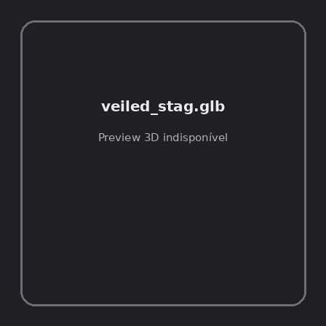
ID | NOV-005225
Origem | Asset novo
Pack/Fonte | Assets Organizados - Enemies
Categoria | Enemies / Veiled Stag.Glb
Arquivo | veiled_stag.glb
Caminho | 01_Assets_Organizados/Enemies/veiled_stag.glb
Formato | GLB
Tamanho | 329.75 KB
SHA-256 | 4854cf2afd697a68be4c…
Status técnico | ERROR
Licença | MISSING_REVIEW_REQUIRED — sem evidência localizada
Objetos / meshes | N/D / N/D
Vértices | N/D
Faces / triângulos | N/D / N/D
Materiais | N/D —
UV sets / vertex colors | N/D / N/D
Dimensões XYZ | N/D
Rig / armatures / bones | N/D / N/D / N/D
Skinned meshes | N/D
Animações | N/D —
Duração total clips | N/D
Root motion detectado | N/D
LODs / colliders | Nenhum / Nenhum
Texturas vinculadas | N/D (0 ausentes)
Alertas | Licença/fonte não localizada automaticamente; revisão legal necessária. | Duplicado exato: grupo DUP-00769 (2 cópias).
Notas | Falha na inspeção 3D: RuntimeError: Error: Python: Traceback (most recent call last):  File "/usr/share/blender/scripts/addons/io_scene_gltf2/__init__.py", line 1064, in execute  return self.import_gltf2(context)  File "/usr/share/blender/scripts/addons/io_scene_gltf2/__init__.py", line 1083, in import_gltf2  return self.unit_import(self.filepath, import_settings)  File "/usr/share/blender/scripts/addons/io_scene_gltf2/__init__.py", line 1088, in unit_import  from .blender.imp.gltf2_blender_gltf import BlenderGlTF  File "/usr/share/blender/scripts/addons/io_scene_gltf2/blender/imp/gltf2_blender_gltf.py", line 17, in <module>  from .gltf2_blender_scene import BlenderScene  File "/usr/share/blender/scripts/addons/io_scene_gltf2/blender/imp/gltf2_blender_scene.py", line 17, in <module>  from .gltf2_blender_node import BlenderNode  File "/usr/share/blender/scripts/addons/io_scene_gltf2/blender/imp/gltf2_blender_node.py", line 18, in <module>  from .gltf2_blender_mesh import BlenderMesh  File "/usr/share/blender/scripts/addons/io_scene_gltf2/blender/imp/gltf2_blender_mesh.py", line 17, in <module>  import numpy as np  ModuleNotFoundError: No module named 'numpy'  location: /usr/share/blender/scripts/modules/bpy/ops.py:132  Traceback (most recent call last):  File "/home/runner/work/PSX_demons_whip/PSX_demons_whip/workspace/demons/tools/asset_catalog/blender_batch.py", line 427, in inspect_task  import_model(path)  File "/home/runner/work/PSX_demons_whip/PSX_demons_whip/workspace/demons/tools/asset_catalog/blender_batch.py", line 52, in import_model  bpy.ops.import_scene.gltf(filepath=str(path))  File "/usr/share/blender/scripts/modules/bpy/ops.py", line 132, in __call__  ret = _op_call(self.idname_py(), None, kw)  RuntimeError: Error: Python: Traceback (most recent call last):  File "/usr/share/blender/scripts/addons/io_scene_gltf2/__init__.py", line 1064, in execute  return self.import_gltf2(context)  File "/usr/share/blender/scripts/addons/io_scene_gltf2/__init__.py", line 1083, in import_gltf2  return self.unit_import(self.filepath, import_settings)  File "/usr/share/blender/scripts/addons/io_scene_gltf2/__init__.py", line 1088, in unit_import  from .blender.imp.gltf2_blender_gltf import BlenderGlTF  File "/usr/share/blender/scripts/addons/io_scene_gltf2/blender/imp/gltf2_blender_gltf.py", line 17, in <module>  from .gltf2_blender_scene import BlenderScene  File "/usr/share/blender/scripts/addons/io_scene_gltf2/blender/imp/gltf2_blender_scene.py", line 17, in <module>  from .gltf2_blender_node import BlenderNode  File "/usr/share/blender/scripts/addons/io_scene_gltf2/blender/imp/gltf2_blender_node.py", line 18, in <module>  from .gltf2_blender_mesh import BlenderMesh  File "/usr/share/blender/scripts/addons/io_scene_gltf2/blender/imp/gltf2_blender_mesh.py", line 17, in <module>  import numpy as np  ModuleNotFoundError: No module named 'numpy'  location: /usr/share/blender/scripts/modules/bpy/ops.py:132  | Metadados 3D reutilizados do duplicado idêntico TEM-002008.

NOV-005227 • velociraptor [ERROR]
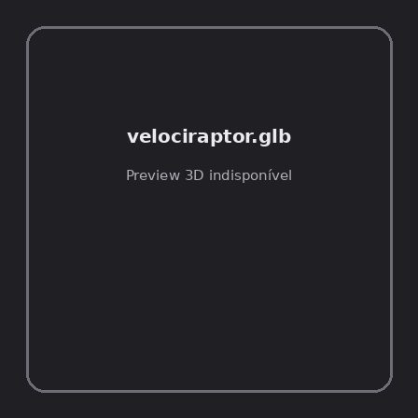
ID | NOV-005227
Origem | Asset novo
Pack/Fonte | Assets Organizados - Enemies
Categoria | Enemies / Velociraptor.Glb
Arquivo | velociraptor.glb
Caminho | 01_Assets_Organizados/Enemies/velociraptor.glb
Formato | GLB
Tamanho | 108.44 KB
SHA-256 | 3385fbba757a7d923a98…
Status técnico | ERROR
Licença | MISSING_REVIEW_REQUIRED — sem evidência localizada
Objetos / meshes | N/D / N/D
Vértices | N/D
Faces / triângulos | N/D / N/D
Materiais | N/D —
UV sets / vertex colors | N/D / N/D
Dimensões XYZ | N/D
Rig / armatures / bones | N/D / N/D / N/D
Skinned meshes | N/D
Animações | N/D —
Duração total clips | N/D
Root motion detectado | N/D
LODs / colliders | Nenhum / Nenhum
Texturas vinculadas | N/D (0 ausentes)
Alertas | Licença/fonte não localizada automaticamente; revisão legal necessária. | Duplicado exato: grupo DUP-00771 (2 cópias).
Notas | Falha na inspeção 3D: RuntimeError: Error: Python: Traceback (most recent call last):  File "/usr/share/blender/scripts/addons/io_scene_gltf2/__init__.py", line 1064, in execute  return self.import_gltf2(context)  File "/usr/share/blender/scripts/addons/io_scene_gltf2/__init__.py", line 1083, in import_gltf2  return self.unit_import(self.filepath, import_settings)  File "/usr/share/blender/scripts/addons/io_scene_gltf2/__init__.py", line 1088, in unit_import  from .blender.imp.gltf2_blender_gltf import BlenderGlTF  File "/usr/share/blender/scripts/addons/io_scene_gltf2/blender/imp/gltf2_blender_gltf.py", line 17, in <module>  from .gltf2_blender_scene import BlenderScene  File "/usr/share/blender/scripts/addons/io_scene_gltf2/blender/imp/gltf2_blender_scene.py", line 17, in <module>  from .gltf2_blender_node import BlenderNode  File "/usr/share/blender/scripts/addons/io_scene_gltf2/blender/imp/gltf2_blender_node.py", line 18, in <module>  from .gltf2_blender_mesh import BlenderMesh  File "/usr/share/blender/scripts/addons/io_scene_gltf2/blender/imp/gltf2_blender_mesh.py", line 17, in <module>  import numpy as np  ModuleNotFoundError: No module named 'numpy'  location: /usr/share/blender/scripts/modules/bpy/ops.py:132  Traceback (most recent call last):  File "/home/runner/work/PSX_demons_whip/PSX_demons_whip/workspace/demons/tools/asset_catalog/blender_batch.py", line 427, in inspect_task  import_model(path)  File "/home/runner/work/PSX_demons_whip/PSX_demons_whip/workspace/demons/tools/asset_catalog/blender_batch.py", line 52, in import_model  bpy.ops.import_scene.gltf(filepath=str(path))  File "/usr/share/blender/scripts/modules/bpy/ops.py", line 132, in __call__  ret = _op_call(self.idname_py(), None, kw)  RuntimeError: Error: Python: Traceback (most recent call last):  File "/usr/share/blender/scripts/addons/io_scene_gltf2/__init__.py", line 1064, in execute  return self.import_gltf2(context)  File "/usr/share/blender/scripts/addons/io_scene_gltf2/__init__.py", line 1083, in import_gltf2  return self.unit_import(self.filepath, import_settings)  File "/usr/share/blender/scripts/addons/io_scene_gltf2/__init__.py", line 1088, in unit_import  from .blender.imp.gltf2_blender_gltf import BlenderGlTF  File "/usr/share/blender/scripts/addons/io_scene_gltf2/blender/imp/gltf2_blender_gltf.py", line 17, in <module>  from .gltf2_blender_scene import BlenderScene  File "/usr/share/blender/scripts/addons/io_scene_gltf2/blender/imp/gltf2_blender_scene.py", line 17, in <module>  from .gltf2_blender_node import BlenderNode  File "/usr/share/blender/scripts/addons/io_scene_gltf2/blender/imp/gltf2_blender_node.py", line 18, in <module>  from .gltf2_blender_mesh import BlenderMesh  File "/usr/share/blender/scripts/addons/io_scene_gltf2/blender/imp/gltf2_blender_mesh.py", line 17, in <module>  import numpy as np  ModuleNotFoundError: No module named 'numpy'  location: /usr/share/blender/scripts/modules/bpy/ops.py:132  | Metadados 3D reutilizados do duplicado idêntico TEM-002010.

NOV-005191 • water_elemental [ERROR]

ID | NOV-005191
Origem | Asset novo
Pack/Fonte | Assets Organizados - Enemies
Categoria | Enemies / Water Elemental.Glb
Arquivo | water_elemental.glb
Caminho | 01_Assets_Organizados/Enemies/water_elemental.glb
Formato | GLB
Tamanho | 249.31 KB
SHA-256 | 8b02b114d81492d66d4f…
Status técnico | ERROR
Licença | MISSING_REVIEW_REQUIRED — sem evidência localizada
Objetos / meshes | N/D / N/D
Vértices | N/D
Faces / triângulos | N/D / N/D
Materiais | N/D —
UV sets / vertex colors | N/D / N/D
Dimensões XYZ | N/D
Rig / armatures / bones | N/D / N/D / N/D
Skinned meshes | N/D
Animações | N/D —
Duração total clips | N/D
Root motion detectado | N/D
LODs / colliders | Nenhum / Nenhum
Texturas vinculadas | N/D (0 ausentes)
Alertas | Licença/fonte não localizada automaticamente; revisão legal necessária. | Duplicado exato: grupo DUP-00757 (2 cópias).
Notas | Falha na inspeção 3D: RuntimeError: Error: Python: Traceback (most recent call last):  File "/usr/share/blender/scripts/addons/io_scene_gltf2/__init__.py", line 1064, in execute  return self.import_gltf2(context)  File "/usr/share/blender/scripts/addons/io_scene_gltf2/__init__.py", line 1083, in import_gltf2  return self.unit_import(self.filepath, import_settings)  File "/usr/share/blender/scripts/addons/io_scene_gltf2/__init__.py", line 1088, in unit_import  from .blender.imp.gltf2_blender_gltf import BlenderGlTF  File "/usr/share/blender/scripts/addons/io_scene_gltf2/blender/imp/gltf2_blender_gltf.py", line 17, in <module>  from .gltf2_blender_scene import BlenderScene  File "/usr/share/blender/scripts/addons/io_scene_gltf2/blender/imp/gltf2_blender_scene.py", line 17, in <module>  from .gltf2_blender_node import BlenderNode  File "/usr/share/blender/scripts/addons/io_scene_gltf2/blender/imp/gltf2_blender_node.py", line 18, in <module>  from .gltf2_blender_mesh import BlenderMesh  File "/usr/share/blender/scripts/addons/io_scene_gltf2/blender/imp/gltf2_blender_mesh.py", line 17, in <module>  import numpy as np  ModuleNotFoundError: No module named 'numpy'  location: /usr/share/blender/scripts/modules/bpy/ops.py:132  Traceback (most recent call last):  File "/home/runner/work/PSX_demons_whip/PSX_demons_whip/workspace/demons/tools/asset_catalog/blender_batch.py", line 427, in inspect_task  import_model(path)  File "/home/runner/work/PSX_demons_whip/PSX_demons_whip/workspace/demons/tools/asset_catalog/blender_batch.py", line 52, in import_model  bpy.ops.import_scene.gltf(filepath=str(path))  File "/usr/share/blender/scripts/modules/bpy/ops.py", line 132, in __call__  ret = _op_call(self.idname_py(), None, kw)  RuntimeError: Error: Python: Traceback (most recent call last):  File "/usr/share/blender/scripts/addons/io_scene_gltf2/__init__.py", line 1064, in execute  return self.import_gltf2(context)  File "/usr/share/blender/scripts/addons/io_scene_gltf2/__init__.py", line 1083, in import_gltf2  return self.unit_import(self.filepath, import_settings)  File "/usr/share/blender/scripts/addons/io_scene_gltf2/__init__.py", line 1088, in unit_import  from .blender.imp.gltf2_blender_gltf import BlenderGlTF  File "/usr/share/blender/scripts/addons/io_scene_gltf2/blender/imp/gltf2_blender_gltf.py", line 17, in <module>  from .gltf2_blender_scene import BlenderScene  File "/usr/share/blender/scripts/addons/io_scene_gltf2/blender/imp/gltf2_blender_scene.py", line 17, in <module>  from .gltf2_blender_node import BlenderNode  File "/usr/share/blender/scripts/addons/io_scene_gltf2/blender/imp/gltf2_blender_node.py", line 18, in <module>  from .gltf2_blender_mesh import BlenderMesh  File "/usr/share/blender/scripts/addons/io_scene_gltf2/blender/imp/gltf2_blender_mesh.py", line 17, in <module>  import numpy as np  ModuleNotFoundError: No module named 'numpy'  location: /usr/share/blender/scripts/modules/bpy/ops.py:132  | Metadados 3D reutilizados do duplicado idêntico TEM-001996.

NOV-005172 • wild_boar [ERROR]

ID | NOV-005172
Origem | Asset novo
Pack/Fonte | Assets Organizados - Enemies
Categoria | Enemies / Wild Boar.Glb
Arquivo | wild_boar.glb
Caminho | 01_Assets_Organizados/Enemies/wild_boar.glb
Formato | GLB
Tamanho | 311.14 KB
SHA-256 | de4e128ddd963b580456…
Status técnico | ERROR
Licença | MISSING_REVIEW_REQUIRED — sem evidência localizada
Objetos / meshes | N/D / N/D
Vértices | N/D
Faces / triângulos | N/D / N/D
Materiais | N/D —
UV sets / vertex colors | N/D / N/D
Dimensões XYZ | N/D
Rig / armatures / bones | N/D / N/D / N/D
Skinned meshes | N/D
Animações | N/D —
Duração total clips | N/D
Root motion detectado | N/D
LODs / colliders | Nenhum / Nenhum
Texturas vinculadas | N/D (0 ausentes)
Alertas | Licença/fonte não localizada automaticamente; revisão legal necessária. | Duplicado exato: grupo DUP-00746 (2 cópias).
Notas | Falha na inspeção 3D: RuntimeError: Error: Python: Traceback (most recent call last):  File "/usr/share/blender/scripts/addons/io_scene_gltf2/__init__.py", line 1064, in execute  return self.import_gltf2(context)  File "/usr/share/blender/scripts/addons/io_scene_gltf2/__init__.py", line 1083, in import_gltf2  return self.unit_import(self.filepath, import_settings)  File "/usr/share/blender/scripts/addons/io_scene_gltf2/__init__.py", line 1088, in unit_import  from .blender.imp.gltf2_blender_gltf import BlenderGlTF  File "/usr/share/blender/scripts/addons/io_scene_gltf2/blender/imp/gltf2_blender_gltf.py", line 17, in <module>  from .gltf2_blender_scene import BlenderScene  File "/usr/share/blender/scripts/addons/io_scene_gltf2/blender/imp/gltf2_blender_scene.py", line 17, in <module>  from .gltf2_blender_node import BlenderNode  File "/usr/share/blender/scripts/addons/io_scene_gltf2/blender/imp/gltf2_blender_node.py", line 18, in <module>  from .gltf2_blender_mesh import BlenderMesh  File "/usr/share/blender/scripts/addons/io_scene_gltf2/blender/imp/gltf2_blender_mesh.py", line 17, in <module>  import numpy as np  ModuleNotFoundError: No module named 'numpy'  location: /usr/share/blender/scripts/modules/bpy/ops.py:132  Traceback (most recent call last):  File "/home/runner/work/PSX_demons_whip/PSX_demons_whip/workspace/demons/tools/asset_catalog/blender_batch.py", line 427, in inspect_task  import_model(path)  File "/home/runner/work/PSX_demons_whip/PSX_demons_whip/workspace/demons/tools/asset_catalog/blender_batch.py", line 52, in import_model  bpy.ops.import_scene.gltf(filepath=str(path))  File "/usr/share/blender/scripts/modules/bpy/ops.py", line 132, in __call__  ret = _op_call(self.idname_py(), None, kw)  RuntimeError: Error: Python: Traceback (most recent call last):  File "/usr/share/blender/scripts/addons/io_scene_gltf2/__init__.py", line 1064, in execute  return self.import_gltf2(context)  File "/usr/share/blender/scripts/addons/io_scene_gltf2/__init__.py", line 1083, in import_gltf2  return self.unit_import(self.filepath, import_settings)  File "/usr/share/blender/scripts/addons/io_scene_gltf2/__init__.py", line 1088, in unit_import  from .blender.imp.gltf2_blender_gltf import BlenderGlTF  File "/usr/share/blender/scripts/addons/io_scene_gltf2/blender/imp/gltf2_blender_gltf.py", line 17, in <module>  from .gltf2_blender_scene import BlenderScene  File "/usr/share/blender/scripts/addons/io_scene_gltf2/blender/imp/gltf2_blender_scene.py", line 17, in <module>  from .gltf2_blender_node import BlenderNode  File "/usr/share/blender/scripts/addons/io_scene_gltf2/blender/imp/gltf2_blender_node.py", line 18, in <module>  from .gltf2_blender_mesh import BlenderMesh  File "/usr/share/blender/scripts/addons/io_scene_gltf2/blender/imp/gltf2_blender_mesh.py", line 17, in <module>  import numpy as np  ModuleNotFoundError: No module named 'numpy'  location: /usr/share/blender/scripts/modules/bpy/ops.py:132  | Metadados 3D reutilizados do duplicado idêntico TEM-001985.

NOV-005138 • wildheart_beastmaster [ERROR]
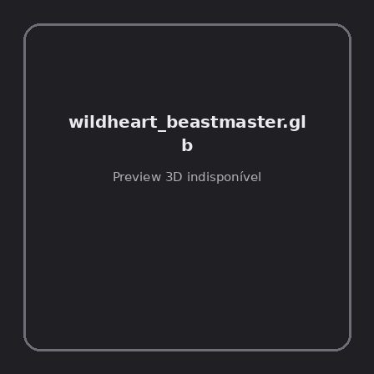
ID | NOV-005138
Origem | Asset novo
Pack/Fonte | Assets Organizados - Enemies
Categoria | Enemies / Wildheart Beastmaster.Glb
Arquivo | wildheart_beastmaster.glb
Caminho | 01_Assets_Organizados/Enemies/wildheart_beastmaster.glb
Formato | GLB
Tamanho | 1.28 MB
SHA-256 | 399c39ab6c959dfe8c55…
Status técnico | ERROR
Licença | MISSING_REVIEW_REQUIRED — sem evidência localizada
Objetos / meshes | N/D / N/D
Vértices | N/D
Faces / triângulos | N/D / N/D
Materiais | N/D —
UV sets / vertex colors | N/D / N/D
Dimensões XYZ | N/D
Rig / armatures / bones | N/D / N/D / N/D
Skinned meshes | N/D
Animações | N/D —
Duração total clips | N/D
Root motion detectado | N/D
LODs / colliders | Nenhum / Nenhum
Texturas vinculadas | N/D (0 ausentes)
Alertas | Licença/fonte não localizada automaticamente; revisão legal necessária. | Duplicado exato: grupo DUP-00727 (2 cópias).
Notas | Falha na inspeção 3D: RuntimeError: Error: Python: Traceback (most recent call last):  File "/usr/share/blender/scripts/addons/io_scene_gltf2/__init__.py", line 1064, in execute  return self.import_gltf2(context)  File "/usr/share/blender/scripts/addons/io_scene_gltf2/__init__.py", line 1083, in import_gltf2  return self.unit_import(self.filepath, import_settings)  File "/usr/share/blender/scripts/addons/io_scene_gltf2/__init__.py", line 1088, in unit_import  from .blender.imp.gltf2_blender_gltf import BlenderGlTF  File "/usr/share/blender/scripts/addons/io_scene_gltf2/blender/imp/gltf2_blender_gltf.py", line 17, in <module>  from .gltf2_blender_scene import BlenderScene  File "/usr/share/blender/scripts/addons/io_scene_gltf2/blender/imp/gltf2_blender_scene.py", line 17, in <module>  from .gltf2_blender_node import BlenderNode  File "/usr/share/blender/scripts/addons/io_scene_gltf2/blender/imp/gltf2_blender_node.py", line 18, in <module>  from .gltf2_blender_mesh import BlenderMesh  File "/usr/share/blender/scripts/addons/io_scene_gltf2/blender/imp/gltf2_blender_mesh.py", line 17, in <module>  import numpy as np  ModuleNotFoundError: No module named 'numpy'  location: /usr/share/blender/scripts/modules/bpy/ops.py:132  Traceback (most recent call last):  File "/home/runner/work/PSX_demons_whip/PSX_demons_whip/workspace/demons/tools/asset_catalog/blender_batch.py", line 427, in inspect_task  import_model(path)  File "/home/runner/work/PSX_demons_whip/PSX_demons_whip/workspace/demons/tools/asset_catalog/blender_batch.py", line 52, in import_model  bpy.ops.import_scene.gltf(filepath=str(path))  File "/usr/share/blender/scripts/modules/bpy/ops.py", line 132, in __call__  ret = _op_call(self.idname_py(), None, kw)  RuntimeError: Error: Python: Traceback (most recent call last):  File "/usr/share/blender/scripts/addons/io_scene_gltf2/__init__.py", line 1064, in execute  return self.import_gltf2(context)  File "/usr/share/blender/scripts/addons/io_scene_gltf2/__init__.py", line 1083, in import_gltf2  return self.unit_import(self.filepath, import_settings)  File "/usr/share/blender/scripts/addons/io_scene_gltf2/__init__.py", line 1088, in unit_import  from .blender.imp.gltf2_blender_gltf import BlenderGlTF  File "/usr/share/blender/scripts/addons/io_scene_gltf2/blender/imp/gltf2_blender_gltf.py", line 17, in <module>  from .gltf2_blender_scene import BlenderScene  File "/usr/share/blender/scripts/addons/io_scene_gltf2/blender/imp/gltf2_blender_scene.py", line 17, in <module>  from .gltf2_blender_node import BlenderNode  File "/usr/share/blender/scripts/addons/io_scene_gltf2/blender/imp/gltf2_blender_node.py", line 18, in <module>  from .gltf2_blender_mesh import BlenderMesh  File "/usr/share/blender/scripts/addons/io_scene_gltf2/blender/imp/gltf2_blender_mesh.py", line 17, in <module>  import numpy as np  ModuleNotFoundError: No module named 'numpy'  location: /usr/share/blender/scripts/modules/bpy/ops.py:132  | Metadados 3D reutilizados do duplicado idêntico TEM-001966.

NOV-005207 • wildheart_beastmaster_hit_variety_anims [ERROR]
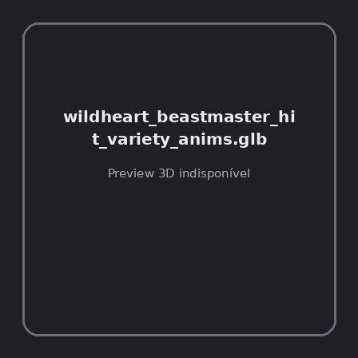
ID | NOV-005207
Origem | Asset novo
Pack/Fonte | Assets Organizados - Enemies
Categoria | Enemies / Wildheart Beastmaster Hit Variety Anims.Glb
Arquivo | wildheart_beastmaster_hit_variety_anims.glb
Caminho | 01_Assets_Organizados/Enemies/wildheart_beastmaster_hit_variety_anims.glb
Formato | GLB
Tamanho | 28.81 KB
SHA-256 | 3fe1bb737abd603b6404…
Status técnico | ERROR
Licença | MISSING_REVIEW_REQUIRED — sem evidência localizada
Objetos / meshes | N/D / N/D
Vértices | N/D
Faces / triângulos | N/D / N/D
Materiais | N/D —
UV sets / vertex colors | N/D / N/D
Dimensões XYZ | N/D
Rig / armatures / bones | N/D / N/D / N/D
Skinned meshes | N/D
Animações | N/D —
Duração total clips | N/D
Root motion detectado | N/D
LODs / colliders | Nenhum / Nenhum
Texturas vinculadas | N/D (0 ausentes)
Alertas | Licença/fonte não localizada automaticamente; revisão legal necessária.
Notas | Falha na inspeção 3D: RuntimeError: Error: Python: Traceback (most recent call last):  File "/usr/share/blender/scripts/addons/io_scene_gltf2/__init__.py", line 1064, in execute  return self.import_gltf2(context)  File "/usr/share/blender/scripts/addons/io_scene_gltf2/__init__.py", line 1083, in import_gltf2  return self.unit_import(self.filepath, import_settings)  File "/usr/share/blender/scripts/addons/io_scene_gltf2/__init__.py", line 1088, in unit_import  from .blender.imp.gltf2_blender_gltf import BlenderGlTF  File "/usr/share/blender/scripts/addons/io_scene_gltf2/blender/imp/gltf2_blender_gltf.py", line 17, in <module>  from .gltf2_blender_scene import BlenderScene  File "/usr/share/blender/scripts/addons/io_scene_gltf2/blender/imp/gltf2_blender_scene.py", line 17, in <module>  from .gltf2_blender_node import BlenderNode  File "/usr/share/blender/scripts/addons/io_scene_gltf2/blender/imp/gltf2_blender_node.py", line 18, in <module>  from .gltf2_blender_mesh import BlenderMesh  File "/usr/share/blender/scripts/addons/io_scene_gltf2/blender/imp/gltf2_blender_mesh.py", line 17, in <module>  import numpy as np  ModuleNotFoundError: No module named 'numpy'  location: /usr/share/blender/scripts/modules/bpy/ops.py:132  Traceback (most recent call last):  File "/home/runner/work/PSX_demons_whip/PSX_demons_whip/workspace/demons/tools/asset_catalog/blender_batch.py", line 427, in inspect_task  import_model(path)  File "/home/runner/work/PSX_demons_whip/PSX_demons_whip/workspace/demons/tools/asset_catalog/blender_batch.py", line 52, in import_model  bpy.ops.import_scene.gltf(filepath=str(path))  File "/usr/share/blender/scripts/modules/bpy/ops.py", line 132, in __call__  ret = _op_call(self.idname_py(), None, kw)  RuntimeError: Error: Python: Traceback (most recent call last):  File "/usr/share/blender/scripts/addons/io_scene_gltf2/__init__.py", line 1064, in execute  return self.import_gltf2(context)  File "/usr/share/blender/scripts/addons/io_scene_gltf2/__init__.py", line 1083, in import_gltf2  return self.unit_import(self.filepath, import_settings)  File "/usr/share/blender/scripts/addons/io_scene_gltf2/__init__.py", line 1088, in unit_import  from .blender.imp.gltf2_blender_gltf import BlenderGlTF  File "/usr/share/blender/scripts/addons/io_scene_gltf2/blender/imp/gltf2_blender_gltf.py", line 17, in <module>  from .gltf2_blender_scene import BlenderScene  File "/usr/share/blender/scripts/addons/io_scene_gltf2/blender/imp/gltf2_blender_scene.py", line 17, in <module>  from .gltf2_blender_node import BlenderNode  File "/usr/share/blender/scripts/addons/io_scene_gltf2/blender/imp/gltf2_blender_node.py", line 18, in <module>  from .gltf2_blender_mesh import BlenderMesh  File "/usr/share/blender/scripts/addons/io_scene_gltf2/blender/imp/gltf2_blender_mesh.py", line 17, in <module>  import numpy as np  ModuleNotFoundError: No module named 'numpy'  location: /usr/share/blender/scripts/modules/bpy/ops.py:132

NOV-005163 • wildheart_hexcaller [ERROR]
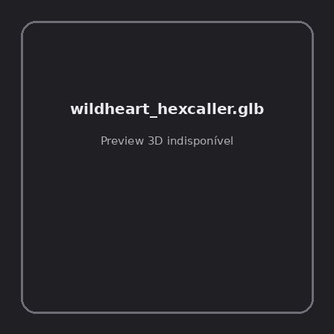
ID | NOV-005163
Origem | Asset novo
Pack/Fonte | Assets Organizados - Enemies
Categoria | Enemies / Wildheart Hexcaller.Glb
Arquivo | wildheart_hexcaller.glb
Caminho | 01_Assets_Organizados/Enemies/wildheart_hexcaller.glb
Formato | GLB
Tamanho | 1.01 MB
SHA-256 | f25e9ea2acad458b9761…
Status técnico | ERROR
Licença | MISSING_REVIEW_REQUIRED — sem evidência localizada
Objetos / meshes | N/D / N/D
Vértices | N/D
Faces / triângulos | N/D / N/D
Materiais | N/D —
UV sets / vertex colors | N/D / N/D
Dimensões XYZ | N/D
Rig / armatures / bones | N/D / N/D / N/D
Skinned meshes | N/D
Animações | N/D —
Duração total clips | N/D
Root motion detectado | N/D
LODs / colliders | Nenhum / Nenhum
Texturas vinculadas | N/D (0 ausentes)
Alertas | Licença/fonte não localizada automaticamente; revisão legal necessária. | Duplicado exato: grupo DUP-00741 (2 cópias).
Notas | Falha na inspeção 3D: RuntimeError: Error: Python: Traceback (most recent call last):  File "/usr/share/blender/scripts/addons/io_scene_gltf2/__init__.py", line 1064, in execute  return self.import_gltf2(context)  File "/usr/share/blender/scripts/addons/io_scene_gltf2/__init__.py", line 1083, in import_gltf2  return self.unit_import(self.filepath, import_settings)  File "/usr/share/blender/scripts/addons/io_scene_gltf2/__init__.py", line 1088, in unit_import  from .blender.imp.gltf2_blender_gltf import BlenderGlTF  File "/usr/share/blender/scripts/addons/io_scene_gltf2/blender/imp/gltf2_blender_gltf.py", line 17, in <module>  from .gltf2_blender_scene import BlenderScene  File "/usr/share/blender/scripts/addons/io_scene_gltf2/blender/imp/gltf2_blender_scene.py", line 17, in <module>  from .gltf2_blender_node import BlenderNode  File "/usr/share/blender/scripts/addons/io_scene_gltf2/blender/imp/gltf2_blender_node.py", line 18, in <module>  from .gltf2_blender_mesh import BlenderMesh  File "/usr/share/blender/scripts/addons/io_scene_gltf2/blender/imp/gltf2_blender_mesh.py", line 17, in <module>  import numpy as np  ModuleNotFoundError: No module named 'numpy'  location: /usr/share/blender/scripts/modules/bpy/ops.py:132  Traceback (most recent call last):  File "/home/runner/work/PSX_demons_whip/PSX_demons_whip/workspace/demons/tools/asset_catalog/blender_batch.py", line 427, in inspect_task  import_model(path)  File "/home/runner/work/PSX_demons_whip/PSX_demons_whip/workspace/demons/tools/asset_catalog/blender_batch.py", line 52, in import_model  bpy.ops.import_scene.gltf(filepath=str(path))  File "/usr/share/blender/scripts/modules/bpy/ops.py", line 132, in __call__  ret = _op_call(self.idname_py(), None, kw)  RuntimeError: Error: Python: Traceback (most recent call last):  File "/usr/share/blender/scripts/addons/io_scene_gltf2/__init__.py", line 1064, in execute  return self.import_gltf2(context)  File "/usr/share/blender/scripts/addons/io_scene_gltf2/__init__.py", line 1083, in import_gltf2  return self.unit_import(self.filepath, import_settings)  File "/usr/share/blender/scripts/addons/io_scene_gltf2/__init__.py", line 1088, in unit_import  from .blender.imp.gltf2_blender_gltf import BlenderGlTF  File "/usr/share/blender/scripts/addons/io_scene_gltf2/blender/imp/gltf2_blender_gltf.py", line 17, in <module>  from .gltf2_blender_scene import BlenderScene  File "/usr/share/blender/scripts/addons/io_scene_gltf2/blender/imp/gltf2_blender_scene.py", line 17, in <module>  from .gltf2_blender_node import BlenderNode  File "/usr/share/blender/scripts/addons/io_scene_gltf2/blender/imp/gltf2_blender_node.py", line 18, in <module>  from .gltf2_blender_mesh import BlenderMesh  File "/usr/share/blender/scripts/addons/io_scene_gltf2/blender/imp/gltf2_blender_mesh.py", line 17, in <module>  import numpy as np  ModuleNotFoundError: No module named 'numpy'  location: /usr/share/blender/scripts/modules/bpy/ops.py:132  | Metadados 3D reutilizados do duplicado idêntico TEM-001980.

NOV-005216 • wildheart_hexcaller_ability_anims [ERROR]
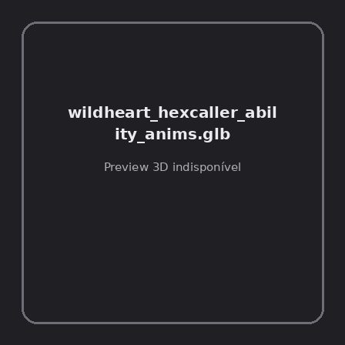
ID | NOV-005216
Origem | Asset novo
Pack/Fonte | Assets Organizados - Enemies
Categoria | Enemies / Wildheart Hexcaller Ability Anims.Glb
Arquivo | wildheart_hexcaller_ability_anims.glb
Caminho | 01_Assets_Organizados/Enemies/wildheart_hexcaller_ability_anims.glb
Formato | GLB
Tamanho | 27.60 KB
SHA-256 | e9771819f8f1f71e3b57…
Status técnico | ERROR
Licença | MISSING_REVIEW_REQUIRED — sem evidência localizada
Objetos / meshes | N/D / N/D
Vértices | N/D
Faces / triângulos | N/D / N/D
Materiais | N/D —
UV sets / vertex colors | N/D / N/D
Dimensões XYZ | N/D
Rig / armatures / bones | N/D / N/D / N/D
Skinned meshes | N/D
Animações | N/D —
Duração total clips | N/D
Root motion detectado | N/D
LODs / colliders | Nenhum / Nenhum
Texturas vinculadas | N/D (0 ausentes)
Alertas | Licença/fonte não localizada automaticamente; revisão legal necessária.
Notas | Falha na inspeção 3D: RuntimeError: Error: Python: Traceback (most recent call last):  File "/usr/share/blender/scripts/addons/io_scene_gltf2/__init__.py", line 1064, in execute  return self.import_gltf2(context)  File "/usr/share/blender/scripts/addons/io_scene_gltf2/__init__.py", line 1083, in import_gltf2  return self.unit_import(self.filepath, import_settings)  File "/usr/share/blender/scripts/addons/io_scene_gltf2/__init__.py", line 1088, in unit_import  from .blender.imp.gltf2_blender_gltf import BlenderGlTF  File "/usr/share/blender/scripts/addons/io_scene_gltf2/blender/imp/gltf2_blender_gltf.py", line 17, in <module>  from .gltf2_blender_scene import BlenderScene  File "/usr/share/blender/scripts/addons/io_scene_gltf2/blender/imp/gltf2_blender_scene.py", line 17, in <module>  from .gltf2_blender_node import BlenderNode  File "/usr/share/blender/scripts/addons/io_scene_gltf2/blender/imp/gltf2_blender_node.py", line 18, in <module>  from .gltf2_blender_mesh import BlenderMesh  File "/usr/share/blender/scripts/addons/io_scene_gltf2/blender/imp/gltf2_blender_mesh.py", line 17, in <module>  import numpy as np  ModuleNotFoundError: No module named 'numpy'  location: /usr/share/blender/scripts/modules/bpy/ops.py:132  Traceback (most recent call last):  File "/home/runner/work/PSX_demons_whip/PSX_demons_whip/workspace/demons/tools/asset_catalog/blender_batch.py", line 427, in inspect_task  import_model(path)  File "/home/runner/work/PSX_demons_whip/PSX_demons_whip/workspace/demons/tools/asset_catalog/blender_batch.py", line 52, in import_model  bpy.ops.import_scene.gltf(filepath=str(path))  File "/usr/share/blender/scripts/modules/bpy/ops.py", line 132, in __call__  ret = _op_call(self.idname_py(), None, kw)  RuntimeError: Error: Python: Traceback (most recent call last):  File "/usr/share/blender/scripts/addons/io_scene_gltf2/__init__.py", line 1064, in execute  return self.import_gltf2(context)  File "/usr/share/blender/scripts/addons/io_scene_gltf2/__init__.py", line 1083, in import_gltf2  return self.unit_import(self.filepath, import_settings)  File "/usr/share/blender/scripts/addons/io_scene_gltf2/__init__.py", line 1088, in unit_import  from .blender.imp.gltf2_blender_gltf import BlenderGlTF  File "/usr/share/blender/scripts/addons/io_scene_gltf2/blender/imp/gltf2_blender_gltf.py", line 17, in <module>  from .gltf2_blender_scene import BlenderScene  File "/usr/share/blender/scripts/addons/io_scene_gltf2/blender/imp/gltf2_blender_scene.py", line 17, in <module>  from .gltf2_blender_node import BlenderNode  File "/usr/share/blender/scripts/addons/io_scene_gltf2/blender/imp/gltf2_blender_node.py", line 18, in <module>  from .gltf2_blender_mesh import BlenderMesh  File "/usr/share/blender/scripts/addons/io_scene_gltf2/blender/imp/gltf2_blender_mesh.py", line 17, in <module>  import numpy as np  ModuleNotFoundError: No module named 'numpy'  location: /usr/share/blender/scripts/modules/bpy/ops.py:132

NOV-005159 • wildheart_hexcaller_hit_variety_anims [ERROR]
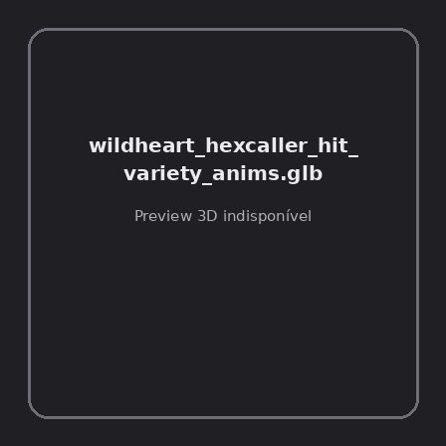
ID | NOV-005159
Origem | Asset novo
Pack/Fonte | Assets Organizados - Enemies
Categoria | Enemies / Wildheart Hexcaller Hit Variety Anims.Glb
Arquivo | wildheart_hexcaller_hit_variety_anims.glb
Caminho | 01_Assets_Organizados/Enemies/wildheart_hexcaller_hit_variety_anims.glb
Formato | GLB
Tamanho | 28.86 KB
SHA-256 | 48abda8e3815a93b67ec…
Status técnico | ERROR
Licença | MISSING_REVIEW_REQUIRED — sem evidência localizada
Objetos / meshes | N/D / N/D
Vértices | N/D
Faces / triângulos | N/D / N/D
Materiais | N/D —
UV sets / vertex colors | N/D / N/D
Dimensões XYZ | N/D
Rig / armatures / bones | N/D / N/D / N/D
Skinned meshes | N/D
Animações | N/D —
Duração total clips | N/D
Root motion detectado | N/D
LODs / colliders | Nenhum / Nenhum
Texturas vinculadas | N/D (0 ausentes)
Alertas | Licença/fonte não localizada automaticamente; revisão legal necessária.
Notas | Falha na inspeção 3D: RuntimeError: Error: Python: Traceback (most recent call last):  File "/usr/share/blender/scripts/addons/io_scene_gltf2/__init__.py", line 1064, in execute  return self.import_gltf2(context)  File "/usr/share/blender/scripts/addons/io_scene_gltf2/__init__.py", line 1083, in import_gltf2  return self.unit_import(self.filepath, import_settings)  File "/usr/share/blender/scripts/addons/io_scene_gltf2/__init__.py", line 1088, in unit_import  from .blender.imp.gltf2_blender_gltf import BlenderGlTF  File "/usr/share/blender/scripts/addons/io_scene_gltf2/blender/imp/gltf2_blender_gltf.py", line 17, in <module>  from .gltf2_blender_scene import BlenderScene  File "/usr/share/blender/scripts/addons/io_scene_gltf2/blender/imp/gltf2_blender_scene.py", line 17, in <module>  from .gltf2_blender_node import BlenderNode  File "/usr/share/blender/scripts/addons/io_scene_gltf2/blender/imp/gltf2_blender_node.py", line 18, in <module>  from .gltf2_blender_mesh import BlenderMesh  File "/usr/share/blender/scripts/addons/io_scene_gltf2/blender/imp/gltf2_blender_mesh.py", line 17, in <module>  import numpy as np  ModuleNotFoundError: No module named 'numpy'  location: /usr/share/blender/scripts/modules/bpy/ops.py:132  Traceback (most recent call last):  File "/home/runner/work/PSX_demons_whip/PSX_demons_whip/workspace/demons/tools/asset_catalog/blender_batch.py", line 427, in inspect_task  import_model(path)  File "/home/runner/work/PSX_demons_whip/PSX_demons_whip/workspace/demons/tools/asset_catalog/blender_batch.py", line 52, in import_model  bpy.ops.import_scene.gltf(filepath=str(path))  File "/usr/share/blender/scripts/modules/bpy/ops.py", line 132, in __call__  ret = _op_call(self.idname_py(), None, kw)  RuntimeError: Error: Python: Traceback (most recent call last):  File "/usr/share/blender/scripts/addons/io_scene_gltf2/__init__.py", line 1064, in execute  return self.import_gltf2(context)  File "/usr/share/blender/scripts/addons/io_scene_gltf2/__init__.py", line 1083, in import_gltf2  return self.unit_import(self.filepath, import_settings)  File "/usr/share/blender/scripts/addons/io_scene_gltf2/__init__.py", line 1088, in unit_import  from .blender.imp.gltf2_blender_gltf import BlenderGlTF  File "/usr/share/blender/scripts/addons/io_scene_gltf2/blender/imp/gltf2_blender_gltf.py", line 17, in <module>  from .gltf2_blender_scene import BlenderScene  File "/usr/share/blender/scripts/addons/io_scene_gltf2/blender/imp/gltf2_blender_scene.py", line 17, in <module>  from .gltf2_blender_node import BlenderNode  File "/usr/share/blender/scripts/addons/io_scene_gltf2/blender/imp/gltf2_blender_node.py", line 18, in <module>  from .gltf2_blender_mesh import BlenderMesh  File "/usr/share/blender/scripts/addons/io_scene_gltf2/blender/imp/gltf2_blender_mesh.py", line 17, in <module>  import numpy as np  ModuleNotFoundError: No module named 'numpy'  location: /usr/share/blender/scripts/modules/bpy/ops.py:132

NOV-005152 • wildheart_high_priest [ERROR]
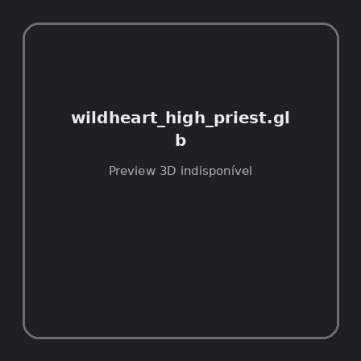
ID | NOV-005152
Origem | Asset novo
Pack/Fonte | Assets Organizados - Enemies
Categoria | Enemies / Wildheart High Priest.Glb
Arquivo | wildheart_high_priest.glb
Caminho | 01_Assets_Organizados/Enemies/wildheart_high_priest.glb
Formato | GLB
Tamanho | 1.20 MB
SHA-256 | a43393cb43b91cecb5e4…
Status técnico | ERROR
Licença | MISSING_REVIEW_REQUIRED — sem evidência localizada
Objetos / meshes | N/D / N/D
Vértices | N/D
Faces / triângulos | N/D / N/D
Materiais | N/D —
UV sets / vertex colors | N/D / N/D
Dimensões XYZ | N/D
Rig / armatures / bones | N/D / N/D / N/D
Skinned meshes | N/D
Animações | N/D —
Duração total clips | N/D
Root motion detectado | N/D
LODs / colliders | Nenhum / Nenhum
Texturas vinculadas | N/D (0 ausentes)
Alertas | Licença/fonte não localizada automaticamente; revisão legal necessária. | Duplicado exato: grupo DUP-00733 (2 cópias).
Notas | Falha na inspeção 3D: RuntimeError: Error: Python: Traceback (most recent call last):  File "/usr/share/blender/scripts/addons/io_scene_gltf2/__init__.py", line 1064, in execute  return self.import_gltf2(context)  File "/usr/share/blender/scripts/addons/io_scene_gltf2/__init__.py", line 1083, in import_gltf2  return self.unit_import(self.filepath, import_settings)  File "/usr/share/blender/scripts/addons/io_scene_gltf2/__init__.py", line 1088, in unit_import  from .blender.imp.gltf2_blender_gltf import BlenderGlTF  File "/usr/share/blender/scripts/addons/io_scene_gltf2/blender/imp/gltf2_blender_gltf.py", line 17, in <module>  from .gltf2_blender_scene import BlenderScene  File "/usr/share/blender/scripts/addons/io_scene_gltf2/blender/imp/gltf2_blender_scene.py", line 17, in <module>  from .gltf2_blender_node import BlenderNode  File "/usr/share/blender/scripts/addons/io_scene_gltf2/blender/imp/gltf2_blender_node.py", line 18, in <module>  from .gltf2_blender_mesh import BlenderMesh  File "/usr/share/blender/scripts/addons/io_scene_gltf2/blender/imp/gltf2_blender_mesh.py", line 17, in <module>  import numpy as np  ModuleNotFoundError: No module named 'numpy'  location: /usr/share/blender/scripts/modules/bpy/ops.py:132  Traceback (most recent call last):  File "/home/runner/work/PSX_demons_whip/PSX_demons_whip/workspace/demons/tools/asset_catalog/blender_batch.py", line 427, in inspect_task  import_model(path)  File "/home/runner/work/PSX_demons_whip/PSX_demons_whip/workspace/demons/tools/asset_catalog/blender_batch.py", line 52, in import_model  bpy.ops.import_scene.gltf(filepath=str(path))  File "/usr/share/blender/scripts/modules/bpy/ops.py", line 132, in __call__  ret = _op_call(self.idname_py(), None, kw)  RuntimeError: Error: Python: Traceback (most recent call last):  File "/usr/share/blender/scripts/addons/io_scene_gltf2/__init__.py", line 1064, in execute  return self.import_gltf2(context)  File "/usr/share/blender/scripts/addons/io_scene_gltf2/__init__.py", line 1083, in import_gltf2  return self.unit_import(self.filepath, import_settings)  File "/usr/share/blender/scripts/addons/io_scene_gltf2/__init__.py", line 1088, in unit_import  from .blender.imp.gltf2_blender_gltf import BlenderGlTF  File "/usr/share/blender/scripts/addons/io_scene_gltf2/blender/imp/gltf2_blender_gltf.py", line 17, in <module>  from .gltf2_blender_scene import BlenderScene  File "/usr/share/blender/scripts/addons/io_scene_gltf2/blender/imp/gltf2_blender_scene.py", line 17, in <module>  from .gltf2_blender_node import BlenderNode  File "/usr/share/blender/scripts/addons/io_scene_gltf2/blender/imp/gltf2_blender_node.py", line 18, in <module>  from .gltf2_blender_mesh import BlenderMesh  File "/usr/share/blender/scripts/addons/io_scene_gltf2/blender/imp/gltf2_blender_mesh.py", line 17, in <module>  import numpy as np  ModuleNotFoundError: No module named 'numpy'  location: /usr/share/blender/scripts/modules/bpy/ops.py:132  | Metadados 3D reutilizados do duplicado idêntico TEM-001972.

NOV-005217 • wildheart_high_priest_ability_anims [ERROR]
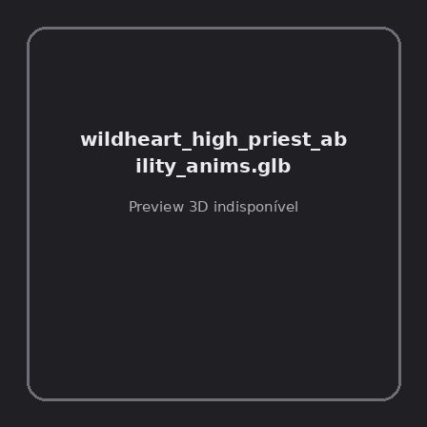
ID | NOV-005217
Origem | Asset novo
Pack/Fonte | Assets Organizados - Enemies
Categoria | Enemies / Wildheart High Priest Ability Anims.Glb
Arquivo | wildheart_high_priest_ability_anims.glb
Caminho | 01_Assets_Organizados/Enemies/wildheart_high_priest_ability_anims.glb
Formato | GLB
Tamanho | 32.18 KB
SHA-256 | 38c2c1788e40c79262c0…
Status técnico | ERROR
Licença | MISSING_REVIEW_REQUIRED — sem evidência localizada
Objetos / meshes | N/D / N/D
Vértices | N/D
Faces / triângulos | N/D / N/D
Materiais | N/D —
UV sets / vertex colors | N/D / N/D
Dimensões XYZ | N/D
Rig / armatures / bones | N/D / N/D / N/D
Skinned meshes | N/D
Animações | N/D —
Duração total clips | N/D
Root motion detectado | N/D
LODs / colliders | Nenhum / Nenhum
Texturas vinculadas | N/D (0 ausentes)
Alertas | Licença/fonte não localizada automaticamente; revisão legal necessária.
Notas | Falha na inspeção 3D: RuntimeError: Error: Python: Traceback (most recent call last):  File "/usr/share/blender/scripts/addons/io_scene_gltf2/__init__.py", line 1064, in execute  return self.import_gltf2(context)  File "/usr/share/blender/scripts/addons/io_scene_gltf2/__init__.py", line 1083, in import_gltf2  return self.unit_import(self.filepath, import_settings)  File "/usr/share/blender/scripts/addons/io_scene_gltf2/__init__.py", line 1088, in unit_import  from .blender.imp.gltf2_blender_gltf import BlenderGlTF  File "/usr/share/blender/scripts/addons/io_scene_gltf2/blender/imp/gltf2_blender_gltf.py", line 17, in <module>  from .gltf2_blender_scene import BlenderScene  File "/usr/share/blender/scripts/addons/io_scene_gltf2/blender/imp/gltf2_blender_scene.py", line 17, in <module>  from .gltf2_blender_node import BlenderNode  File "/usr/share/blender/scripts/addons/io_scene_gltf2/blender/imp/gltf2_blender_node.py", line 18, in <module>  from .gltf2_blender_mesh import BlenderMesh  File "/usr/share/blender/scripts/addons/io_scene_gltf2/blender/imp/gltf2_blender_mesh.py", line 17, in <module>  import numpy as np  ModuleNotFoundError: No module named 'numpy'  location: /usr/share/blender/scripts/modules/bpy/ops.py:132  Traceback (most recent call last):  File "/home/runner/work/PSX_demons_whip/PSX_demons_whip/workspace/demons/tools/asset_catalog/blender_batch.py", line 427, in inspect_task  import_model(path)  File "/home/runner/work/PSX_demons_whip/PSX_demons_whip/workspace/demons/tools/asset_catalog/blender_batch.py", line 52, in import_model  bpy.ops.import_scene.gltf(filepath=str(path))  File "/usr/share/blender/scripts/modules/bpy/ops.py", line 132, in __call__  ret = _op_call(self.idname_py(), None, kw)  RuntimeError: Error: Python: Traceback (most recent call last):  File "/usr/share/blender/scripts/addons/io_scene_gltf2/__init__.py", line 1064, in execute  return self.import_gltf2(context)  File "/usr/share/blender/scripts/addons/io_scene_gltf2/__init__.py", line 1083, in import_gltf2  return self.unit_import(self.filepath, import_settings)  File "/usr/share/blender/scripts/addons/io_scene_gltf2/__init__.py", line 1088, in unit_import  from .blender.imp.gltf2_blender_gltf import BlenderGlTF  File "/usr/share/blender/scripts/addons/io_scene_gltf2/blender/imp/gltf2_blender_gltf.py", line 17, in <module>  from .gltf2_blender_scene import BlenderScene  File "/usr/share/blender/scripts/addons/io_scene_gltf2/blender/imp/gltf2_blender_scene.py", line 17, in <module>  from .gltf2_blender_node import BlenderNode  File "/usr/share/blender/scripts/addons/io_scene_gltf2/blender/imp/gltf2_blender_node.py", line 18, in <module>  from .gltf2_blender_mesh import BlenderMesh  File "/usr/share/blender/scripts/addons/io_scene_gltf2/blender/imp/gltf2_blender_mesh.py", line 17, in <module>  import numpy as np  ModuleNotFoundError: No module named 'numpy'  location: /usr/share/blender/scripts/modules/bpy/ops.py:132

NOV-005205 • wildheart_high_priest_hit_variety_anims [ERROR]
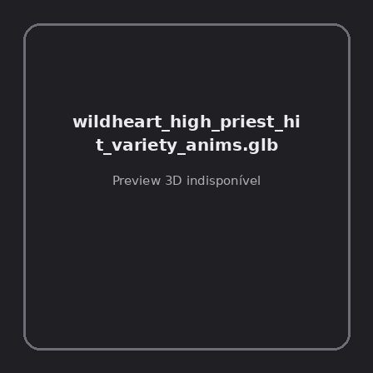
ID | NOV-005205
Origem | Asset novo
Pack/Fonte | Assets Organizados - Enemies
Categoria | Enemies / Wildheart High Priest Hit Variety Anims.Glb
Arquivo | wildheart_high_priest_hit_variety_anims.glb
Caminho | 01_Assets_Organizados/Enemies/wildheart_high_priest_hit_variety_anims.glb
Formato | GLB
Tamanho | 28.95 KB
SHA-256 | 00fd573d03a71a55853f…
Status técnico | ERROR
Licença | MISSING_REVIEW_REQUIRED — sem evidência localizada
Objetos / meshes | N/D / N/D
Vértices | N/D
Faces / triângulos | N/D / N/D
Materiais | N/D —
UV sets / vertex colors | N/D / N/D
Dimensões XYZ | N/D
Rig / armatures / bones | N/D / N/D / N/D
Skinned meshes | N/D
Animações | N/D —
Duração total clips | N/D
Root motion detectado | N/D
LODs / colliders | Nenhum / Nenhum
Texturas vinculadas | N/D (0 ausentes)
Alertas | Licença/fonte não localizada automaticamente; revisão legal necessária.
Notas | Falha na inspeção 3D: RuntimeError: Error: Python: Traceback (most recent call last):  File "/usr/share/blender/scripts/addons/io_scene_gltf2/__init__.py", line 1064, in execute  return self.import_gltf2(context)  File "/usr/share/blender/scripts/addons/io_scene_gltf2/__init__.py", line 1083, in import_gltf2  return self.unit_import(self.filepath, import_settings)  File "/usr/share/blender/scripts/addons/io_scene_gltf2/__init__.py", line 1088, in unit_import  from .blender.imp.gltf2_blender_gltf import BlenderGlTF  File "/usr/share/blender/scripts/addons/io_scene_gltf2/blender/imp/gltf2_blender_gltf.py", line 17, in <module>  from .gltf2_blender_scene import BlenderScene  File "/usr/share/blender/scripts/addons/io_scene_gltf2/blender/imp/gltf2_blender_scene.py", line 17, in <module>  from .gltf2_blender_node import BlenderNode  File "/usr/share/blender/scripts/addons/io_scene_gltf2/blender/imp/gltf2_blender_node.py", line 18, in <module>  from .gltf2_blender_mesh import BlenderMesh  File "/usr/share/blender/scripts/addons/io_scene_gltf2/blender/imp/gltf2_blender_mesh.py", line 17, in <module>  import numpy as np  ModuleNotFoundError: No module named 'numpy'  location: /usr/share/blender/scripts/modules/bpy/ops.py:132  Traceback (most recent call last):  File "/home/runner/work/PSX_demons_whip/PSX_demons_whip/workspace/demons/tools/asset_catalog/blender_batch.py", line 427, in inspect_task  import_model(path)  File "/home/runner/work/PSX_demons_whip/PSX_demons_whip/workspace/demons/tools/asset_catalog/blender_batch.py", line 52, in import_model  bpy.ops.import_scene.gltf(filepath=str(path))  File "/usr/share/blender/scripts/modules/bpy/ops.py", line 132, in __call__  ret = _op_call(self.idname_py(), None, kw)  RuntimeError: Error: Python: Traceback (most recent call last):  File "/usr/share/blender/scripts/addons/io_scene_gltf2/__init__.py", line 1064, in execute  return self.import_gltf2(context)  File "/usr/share/blender/scripts/addons/io_scene_gltf2/__init__.py", line 1083, in import_gltf2  return self.unit_import(self.filepath, import_settings)  File "/usr/share/blender/scripts/addons/io_scene_gltf2/__init__.py", line 1088, in unit_import  from .blender.imp.gltf2_blender_gltf import BlenderGlTF  File "/usr/share/blender/scripts/addons/io_scene_gltf2/blender/imp/gltf2_blender_gltf.py", line 17, in <module>  from .gltf2_blender_scene import BlenderScene  File "/usr/share/blender/scripts/addons/io_scene_gltf2/blender/imp/gltf2_blender_scene.py", line 17, in <module>  from .gltf2_blender_node import BlenderNode  File "/usr/share/blender/scripts/addons/io_scene_gltf2/blender/imp/gltf2_blender_node.py", line 18, in <module>  from .gltf2_blender_mesh import BlenderMesh  File "/usr/share/blender/scripts/addons/io_scene_gltf2/blender/imp/gltf2_blender_mesh.py", line 17, in <module>  import numpy as np  ModuleNotFoundError: No module named 'numpy'  location: /usr/share/blender/scripts/modules/bpy/ops.py:132

NOV-005161 • wildheart_ravager [ERROR]
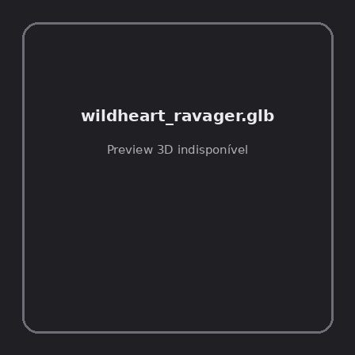
ID | NOV-005161
Origem | Asset novo
Pack/Fonte | Assets Organizados - Enemies
Categoria | Enemies / Wildheart Ravager.Glb
Arquivo | wildheart_ravager.glb
Caminho | 01_Assets_Organizados/Enemies/wildheart_ravager.glb
Formato | GLB
Tamanho | 1.20 MB
SHA-256 | 1d07968792a6a60f8b0f…
Status técnico | ERROR
Licença | MISSING_REVIEW_REQUIRED — sem evidência localizada
Objetos / meshes | N/D / N/D
Vértices | N/D
Faces / triângulos | N/D / N/D
Materiais | N/D —
UV sets / vertex colors | N/D / N/D
Dimensões XYZ | N/D
Rig / armatures / bones | N/D / N/D / N/D
Skinned meshes | N/D
Animações | N/D —
Duração total clips | N/D
Root motion detectado | N/D
LODs / colliders | Nenhum / Nenhum
Texturas vinculadas | N/D (0 ausentes)
Alertas | Licença/fonte não localizada automaticamente; revisão legal necessária. | Duplicado exato: grupo DUP-00739 (2 cópias).
Notas | Falha na inspeção 3D: RuntimeError: Error: Python: Traceback (most recent call last):  File "/usr/share/blender/scripts/addons/io_scene_gltf2/__init__.py", line 1064, in execute  return self.import_gltf2(context)  File "/usr/share/blender/scripts/addons/io_scene_gltf2/__init__.py", line 1083, in import_gltf2  return self.unit_import(self.filepath, import_settings)  File "/usr/share/blender/scripts/addons/io_scene_gltf2/__init__.py", line 1088, in unit_import  from .blender.imp.gltf2_blender_gltf import BlenderGlTF  File "/usr/share/blender/scripts/addons/io_scene_gltf2/blender/imp/gltf2_blender_gltf.py", line 17, in <module>  from .gltf2_blender_scene import BlenderScene  File "/usr/share/blender/scripts/addons/io_scene_gltf2/blender/imp/gltf2_blender_scene.py", line 17, in <module>  from .gltf2_blender_node import BlenderNode  File "/usr/share/blender/scripts/addons/io_scene_gltf2/blender/imp/gltf2_blender_node.py", line 18, in <module>  from .gltf2_blender_mesh import BlenderMesh  File "/usr/share/blender/scripts/addons/io_scene_gltf2/blender/imp/gltf2_blender_mesh.py", line 17, in <module>  import numpy as np  ModuleNotFoundError: No module named 'numpy'  location: /usr/share/blender/scripts/modules/bpy/ops.py:132  Traceback (most recent call last):  File "/home/runner/work/PSX_demons_whip/PSX_demons_whip/workspace/demons/tools/asset_catalog/blender_batch.py", line 427, in inspect_task  import_model(path)  File "/home/runner/work/PSX_demons_whip/PSX_demons_whip/workspace/demons/tools/asset_catalog/blender_batch.py", line 52, in import_model  bpy.ops.import_scene.gltf(filepath=str(path))  File "/usr/share/blender/scripts/modules/bpy/ops.py", line 132, in __call__  ret = _op_call(self.idname_py(), None, kw)  RuntimeError: Error: Python: Traceback (most recent call last):  File "/usr/share/blender/scripts/addons/io_scene_gltf2/__init__.py", line 1064, in execute  return self.import_gltf2(context)  File "/usr/share/blender/scripts/addons/io_scene_gltf2/__init__.py", line 1083, in import_gltf2  return self.unit_import(self.filepath, import_settings)  File "/usr/share/blender/scripts/addons/io_scene_gltf2/__init__.py", line 1088, in unit_import  from .blender.imp.gltf2_blender_gltf import BlenderGlTF  File "/usr/share/blender/scripts/addons/io_scene_gltf2/blender/imp/gltf2_blender_gltf.py", line 17, in <module>  from .gltf2_blender_scene import BlenderScene  File "/usr/share/blender/scripts/addons/io_scene_gltf2/blender/imp/gltf2_blender_scene.py", line 17, in <module>  from .gltf2_blender_node import BlenderNode  File "/usr/share/blender/scripts/addons/io_scene_gltf2/blender/imp/gltf2_blender_node.py", line 18, in <module>  from .gltf2_blender_mesh import BlenderMesh  File "/usr/share/blender/scripts/addons/io_scene_gltf2/blender/imp/gltf2_blender_mesh.py", line 17, in <module>  import numpy as np  ModuleNotFoundError: No module named 'numpy'  location: /usr/share/blender/scripts/modules/bpy/ops.py:132  | Metadados 3D reutilizados do duplicado idêntico TEM-001978.

NOV-005186 • wildheart_ravager_ability_anims [ERROR]
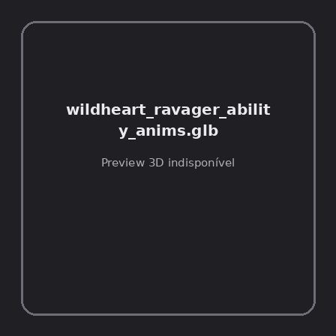
ID | NOV-005186
Origem | Asset novo
Pack/Fonte | Assets Organizados - Enemies
Categoria | Enemies / Wildheart Ravager Ability Anims.Glb
Arquivo | wildheart_ravager_ability_anims.glb
Caminho | 01_Assets_Organizados/Enemies/wildheart_ravager_ability_anims.glb
Formato | GLB
Tamanho | 30.68 KB
SHA-256 | bc278ac1148ecf7dd076…
Status técnico | ERROR
Licença | MISSING_REVIEW_REQUIRED — sem evidência localizada
Objetos / meshes | N/D / N/D
Vértices | N/D
Faces / triângulos | N/D / N/D
Materiais | N/D —
UV sets / vertex colors | N/D / N/D
Dimensões XYZ | N/D
Rig / armatures / bones | N/D / N/D / N/D
Skinned meshes | N/D
Animações | N/D —
Duração total clips | N/D
Root motion detectado | N/D
LODs / colliders | Nenhum / Nenhum
Texturas vinculadas | N/D (0 ausentes)
Alertas | Licença/fonte não localizada automaticamente; revisão legal necessária.
Notas | Falha na inspeção 3D: RuntimeError: Error: Python: Traceback (most recent call last):  File "/usr/share/blender/scripts/addons/io_scene_gltf2/__init__.py", line 1064, in execute  return self.import_gltf2(context)  File "/usr/share/blender/scripts/addons/io_scene_gltf2/__init__.py", line 1083, in import_gltf2  return self.unit_import(self.filepath, import_settings)  File "/usr/share/blender/scripts/addons/io_scene_gltf2/__init__.py", line 1088, in unit_import  from .blender.imp.gltf2_blender_gltf import BlenderGlTF  File "/usr/share/blender/scripts/addons/io_scene_gltf2/blender/imp/gltf2_blender_gltf.py", line 17, in <module>  from .gltf2_blender_scene import BlenderScene  File "/usr/share/blender/scripts/addons/io_scene_gltf2/blender/imp/gltf2_blender_scene.py", line 17, in <module>  from .gltf2_blender_node import BlenderNode  File "/usr/share/blender/scripts/addons/io_scene_gltf2/blender/imp/gltf2_blender_node.py", line 18, in <module>  from .gltf2_blender_mesh import BlenderMesh  File "/usr/share/blender/scripts/addons/io_scene_gltf2/blender/imp/gltf2_blender_mesh.py", line 17, in <module>  import numpy as np  ModuleNotFoundError: No module named 'numpy'  location: /usr/share/blender/scripts/modules/bpy/ops.py:132  Traceback (most recent call last):  File "/home/runner/work/PSX_demons_whip/PSX_demons_whip/workspace/demons/tools/asset_catalog/blender_batch.py", line 427, in inspect_task  import_model(path)  File "/home/runner/work/PSX_demons_whip/PSX_demons_whip/workspace/demons/tools/asset_catalog/blender_batch.py", line 52, in import_model  bpy.ops.import_scene.gltf(filepath=str(path))  File "/usr/share/blender/scripts/modules/bpy/ops.py", line 132, in __call__  ret = _op_call(self.idname_py(), None, kw)  RuntimeError: Error: Python: Traceback (most recent call last):  File "/usr/share/blender/scripts/addons/io_scene_gltf2/__init__.py", line 1064, in execute  return self.import_gltf2(context)  File "/usr/share/blender/scripts/addons/io_scene_gltf2/__init__.py", line 1083, in import_gltf2  return self.unit_import(self.filepath, import_settings)  File "/usr/share/blender/scripts/addons/io_scene_gltf2/__init__.py", line 1088, in unit_import  from .blender.imp.gltf2_blender_gltf import BlenderGlTF  File "/usr/share/blender/scripts/addons/io_scene_gltf2/blender/imp/gltf2_blender_gltf.py", line 17, in <module>  from .gltf2_blender_scene import BlenderScene  File "/usr/share/blender/scripts/addons/io_scene_gltf2/blender/imp/gltf2_blender_scene.py", line 17, in <module>  from .gltf2_blender_node import BlenderNode  File "/usr/share/blender/scripts/addons/io_scene_gltf2/blender/imp/gltf2_blender_node.py", line 18, in <module>  from .gltf2_blender_mesh import BlenderMesh  File "/usr/share/blender/scripts/addons/io_scene_gltf2/blender/imp/gltf2_blender_mesh.py", line 17, in <module>  import numpy as np  ModuleNotFoundError: No module named 'numpy'  location: /usr/share/blender/scripts/modules/bpy/ops.py:132

NOV-005211 • wildheart_ravager_hit_variety_anims [ERROR]
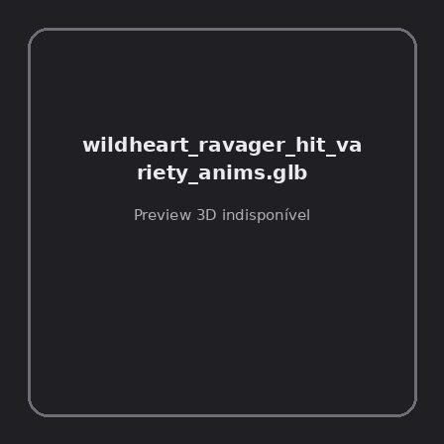
ID | NOV-005211
Origem | Asset novo
Pack/Fonte | Assets Organizados - Enemies
Categoria | Enemies / Wildheart Ravager Hit Variety Anims.Glb
Arquivo | wildheart_ravager_hit_variety_anims.glb
Caminho | 01_Assets_Organizados/Enemies/wildheart_ravager_hit_variety_anims.glb
Formato | GLB
Tamanho | 28.88 KB
SHA-256 | edb6cc284005ae76566e…
Status técnico | ERROR
Licença | MISSING_REVIEW_REQUIRED — sem evidência localizada
Objetos / meshes | N/D / N/D
Vértices | N/D
Faces / triângulos | N/D / N/D
Materiais | N/D —
UV sets / vertex colors | N/D / N/D
Dimensões XYZ | N/D
Rig / armatures / bones | N/D / N/D / N/D
Skinned meshes | N/D
Animações | N/D —
Duração total clips | N/D
Root motion detectado | N/D
LODs / colliders | Nenhum / Nenhum
Texturas vinculadas | N/D (0 ausentes)
Alertas | Licença/fonte não localizada automaticamente; revisão legal necessária.
Notas | Falha na inspeção 3D: RuntimeError: Error: Python: Traceback (most recent call last):  File "/usr/share/blender/scripts/addons/io_scene_gltf2/__init__.py", line 1064, in execute  return self.import_gltf2(context)  File "/usr/share/blender/scripts/addons/io_scene_gltf2/__init__.py", line 1083, in import_gltf2  return self.unit_import(self.filepath, import_settings)  File "/usr/share/blender/scripts/addons/io_scene_gltf2/__init__.py", line 1088, in unit_import  from .blender.imp.gltf2_blender_gltf import BlenderGlTF  File "/usr/share/blender/scripts/addons/io_scene_gltf2/blender/imp/gltf2_blender_gltf.py", line 17, in <module>  from .gltf2_blender_scene import BlenderScene  File "/usr/share/blender/scripts/addons/io_scene_gltf2/blender/imp/gltf2_blender_scene.py", line 17, in <module>  from .gltf2_blender_node import BlenderNode  File "/usr/share/blender/scripts/addons/io_scene_gltf2/blender/imp/gltf2_blender_node.py", line 18, in <module>  from .gltf2_blender_mesh import BlenderMesh  File "/usr/share/blender/scripts/addons/io_scene_gltf2/blender/imp/gltf2_blender_mesh.py", line 17, in <module>  import numpy as np  ModuleNotFoundError: No module named 'numpy'  location: /usr/share/blender/scripts/modules/bpy/ops.py:132  Traceback (most recent call last):  File "/home/runner/work/PSX_demons_whip/PSX_demons_whip/workspace/demons/tools/asset_catalog/blender_batch.py", line 427, in inspect_task  import_model(path)  File "/home/runner/work/PSX_demons_whip/PSX_demons_whip/workspace/demons/tools/asset_catalog/blender_batch.py", line 52, in import_model  bpy.ops.import_scene.gltf(filepath=str(path))  File "/usr/share/blender/scripts/modules/bpy/ops.py", line 132, in __call__  ret = _op_call(self.idname_py(), None, kw)  RuntimeError: Error: Python: Traceback (most recent call last):  File "/usr/share/blender/scripts/addons/io_scene_gltf2/__init__.py", line 1064, in execute  return self.import_gltf2(context)  File "/usr/share/blender/scripts/addons/io_scene_gltf2/__init__.py", line 1083, in import_gltf2  return self.unit_import(self.filepath, import_settings)  File "/usr/share/blender/scripts/addons/io_scene_gltf2/__init__.py", line 1088, in unit_import  from .blender.imp.gltf2_blender_gltf import BlenderGlTF  File "/usr/share/blender/scripts/addons/io_scene_gltf2/blender/imp/gltf2_blender_gltf.py", line 17, in <module>  from .gltf2_blender_scene import BlenderScene  File "/usr/share/blender/scripts/addons/io_scene_gltf2/blender/imp/gltf2_blender_scene.py", line 17, in <module>  from .gltf2_blender_node import BlenderNode  File "/usr/share/blender/scripts/addons/io_scene_gltf2/blender/imp/gltf2_blender_node.py", line 18, in <module>  from .gltf2_blender_mesh import BlenderMesh  File "/usr/share/blender/scripts/addons/io_scene_gltf2/blender/imp/gltf2_blender_mesh.py", line 17, in <module>  import numpy as np  ModuleNotFoundError: No module named 'numpy'  location: /usr/share/blender/scripts/modules/bpy/ops.py:132

NOV-005174 • wildheart_stalker [ERROR]
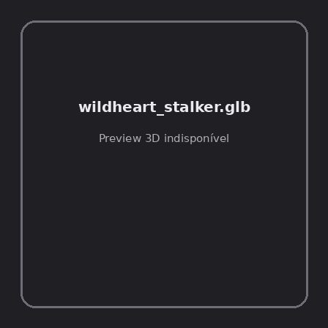
ID | NOV-005174
Origem | Asset novo
Pack/Fonte | Assets Organizados - Enemies
Categoria | Enemies / Wildheart Stalker.Glb
Arquivo | wildheart_stalker.glb
Caminho | 01_Assets_Organizados/Enemies/wildheart_stalker.glb
Formato | GLB
Tamanho | 1.14 MB
SHA-256 | 7b999b51c99b55cc128a…
Status técnico | ERROR
Licença | MISSING_REVIEW_REQUIRED — sem evidência localizada
Objetos / meshes | N/D / N/D
Vértices | N/D
Faces / triângulos | N/D / N/D
Materiais | N/D —
UV sets / vertex colors | N/D / N/D
Dimensões XYZ | N/D
Rig / armatures / bones | N/D / N/D / N/D
Skinned meshes | N/D
Animações | N/D —
Duração total clips | N/D
Root motion detectado | N/D
LODs / colliders | Nenhum / Nenhum
Texturas vinculadas | N/D (0 ausentes)
Alertas | Licença/fonte não localizada automaticamente; revisão legal necessária. | Duplicado exato: grupo DUP-00748 (2 cópias).
Notas | Falha na inspeção 3D: RuntimeError: Error: Python: Traceback (most recent call last):  File "/usr/share/blender/scripts/addons/io_scene_gltf2/__init__.py", line 1064, in execute  return self.import_gltf2(context)  File "/usr/share/blender/scripts/addons/io_scene_gltf2/__init__.py", line 1083, in import_gltf2  return self.unit_import(self.filepath, import_settings)  File "/usr/share/blender/scripts/addons/io_scene_gltf2/__init__.py", line 1088, in unit_import  from .blender.imp.gltf2_blender_gltf import BlenderGlTF  File "/usr/share/blender/scripts/addons/io_scene_gltf2/blender/imp/gltf2_blender_gltf.py", line 17, in <module>  from .gltf2_blender_scene import BlenderScene  File "/usr/share/blender/scripts/addons/io_scene_gltf2/blender/imp/gltf2_blender_scene.py", line 17, in <module>  from .gltf2_blender_node import BlenderNode  File "/usr/share/blender/scripts/addons/io_scene_gltf2/blender/imp/gltf2_blender_node.py", line 18, in <module>  from .gltf2_blender_mesh import BlenderMesh  File "/usr/share/blender/scripts/addons/io_scene_gltf2/blender/imp/gltf2_blender_mesh.py", line 17, in <module>  import numpy as np  ModuleNotFoundError: No module named 'numpy'  location: /usr/share/blender/scripts/modules/bpy/ops.py:132  Traceback (most recent call last):  File "/home/runner/work/PSX_demons_whip/PSX_demons_whip/workspace/demons/tools/asset_catalog/blender_batch.py", line 427, in inspect_task  import_model(path)  File "/home/runner/work/PSX_demons_whip/PSX_demons_whip/workspace/demons/tools/asset_catalog/blender_batch.py", line 52, in import_model  bpy.ops.import_scene.gltf(filepath=str(path))  File "/usr/share/blender/scripts/modules/bpy/ops.py", line 132, in __call__  ret = _op_call(self.idname_py(), None, kw)  RuntimeError: Error: Python: Traceback (most recent call last):  File "/usr/share/blender/scripts/addons/io_scene_gltf2/__init__.py", line 1064, in execute  return self.import_gltf2(context)  File "/usr/share/blender/scripts/addons/io_scene_gltf2/__init__.py", line 1083, in import_gltf2  return self.unit_import(self.filepath, import_settings)  File "/usr/share/blender/scripts/addons/io_scene_gltf2/__init__.py", line 1088, in unit_import  from .blender.imp.gltf2_blender_gltf import BlenderGlTF  File "/usr/share/blender/scripts/addons/io_scene_gltf2/blender/imp/gltf2_blender_gltf.py", line 17, in <module>  from .gltf2_blender_scene import BlenderScene  File "/usr/share/blender/scripts/addons/io_scene_gltf2/blender/imp/gltf2_blender_scene.py", line 17, in <module>  from .gltf2_blender_node import BlenderNode  File "/usr/share/blender/scripts/addons/io_scene_gltf2/blender/imp/gltf2_blender_node.py", line 18, in <module>  from .gltf2_blender_mesh import BlenderMesh  File "/usr/share/blender/scripts/addons/io_scene_gltf2/blender/imp/gltf2_blender_mesh.py", line 17, in <module>  import numpy as np  ModuleNotFoundError: No module named 'numpy'  location: /usr/share/blender/scripts/modules/bpy/ops.py:132  | Metadados 3D reutilizados do duplicado idêntico TEM-001987.

NOV-005143 • wildheart_stalker_ability_anims [ERROR]
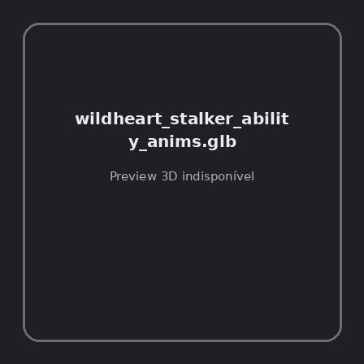
ID | NOV-005143
Origem | Asset novo
Pack/Fonte | Assets Organizados - Enemies
Categoria | Enemies / Wildheart Stalker Ability Anims.Glb
Arquivo | wildheart_stalker_ability_anims.glb
Caminho | 01_Assets_Organizados/Enemies/wildheart_stalker_ability_anims.glb
Formato | GLB
Tamanho | 23.06 KB
SHA-256 | 00aa5fcf9966177b96fe…
Status técnico | ERROR
Licença | MISSING_REVIEW_REQUIRED — sem evidência localizada
Objetos / meshes | N/D / N/D
Vértices | N/D
Faces / triângulos | N/D / N/D
Materiais | N/D —
UV sets / vertex colors | N/D / N/D
Dimensões XYZ | N/D
Rig / armatures / bones | N/D / N/D / N/D
Skinned meshes | N/D
Animações | N/D —
Duração total clips | N/D
Root motion detectado | N/D
LODs / colliders | Nenhum / Nenhum
Texturas vinculadas | N/D (0 ausentes)
Alertas | Licença/fonte não localizada automaticamente; revisão legal necessária.
Notas | Falha na inspeção 3D: RuntimeError: Error: Python: Traceback (most recent call last):  File "/usr/share/blender/scripts/addons/io_scene_gltf2/__init__.py", line 1064, in execute  return self.import_gltf2(context)  File "/usr/share/blender/scripts/addons/io_scene_gltf2/__init__.py", line 1083, in import_gltf2  return self.unit_import(self.filepath, import_settings)  File "/usr/share/blender/scripts/addons/io_scene_gltf2/__init__.py", line 1088, in unit_import  from .blender.imp.gltf2_blender_gltf import BlenderGlTF  File "/usr/share/blender/scripts/addons/io_scene_gltf2/blender/imp/gltf2_blender_gltf.py", line 17, in <module>  from .gltf2_blender_scene import BlenderScene  File "/usr/share/blender/scripts/addons/io_scene_gltf2/blender/imp/gltf2_blender_scene.py", line 17, in <module>  from .gltf2_blender_node import BlenderNode  File "/usr/share/blender/scripts/addons/io_scene_gltf2/blender/imp/gltf2_blender_node.py", line 18, in <module>  from .gltf2_blender_mesh import BlenderMesh  File "/usr/share/blender/scripts/addons/io_scene_gltf2/blender/imp/gltf2_blender_mesh.py", line 17, in <module>  import numpy as np  ModuleNotFoundError: No module named 'numpy'  location: /usr/share/blender/scripts/modules/bpy/ops.py:132  Traceback (most recent call last):  File "/home/runner/work/PSX_demons_whip/PSX_demons_whip/workspace/demons/tools/asset_catalog/blender_batch.py", line 427, in inspect_task  import_model(path)  File "/home/runner/work/PSX_demons_whip/PSX_demons_whip/workspace/demons/tools/asset_catalog/blender_batch.py", line 52, in import_model  bpy.ops.import_scene.gltf(filepath=str(path))  File "/usr/share/blender/scripts/modules/bpy/ops.py", line 132, in __call__  ret = _op_call(self.idname_py(), None, kw)  RuntimeError: Error: Python: Traceback (most recent call last):  File "/usr/share/blender/scripts/addons/io_scene_gltf2/__init__.py", line 1064, in execute  return self.import_gltf2(context)  File "/usr/share/blender/scripts/addons/io_scene_gltf2/__init__.py", line 1083, in import_gltf2  return self.unit_import(self.filepath, import_settings)  File "/usr/share/blender/scripts/addons/io_scene_gltf2/__init__.py", line 1088, in unit_import  from .blender.imp.gltf2_blender_gltf import BlenderGlTF  File "/usr/share/blender/scripts/addons/io_scene_gltf2/blender/imp/gltf2_blender_gltf.py", line 17, in <module>  from .gltf2_blender_scene import BlenderScene  File "/usr/share/blender/scripts/addons/io_scene_gltf2/blender/imp/gltf2_blender_scene.py", line 17, in <module>  from .gltf2_blender_node import BlenderNode  File "/usr/share/blender/scripts/addons/io_scene_gltf2/blender/imp/gltf2_blender_node.py", line 18, in <module>  from .gltf2_blender_mesh import BlenderMesh  File "/usr/share/blender/scripts/addons/io_scene_gltf2/blender/imp/gltf2_blender_mesh.py", line 17, in <module>  import numpy as np  ModuleNotFoundError: No module named 'numpy'  location: /usr/share/blender/scripts/modules/bpy/ops.py:132

NOV-005202 • wildheart_stalker_hit_variety_anims [ERROR]
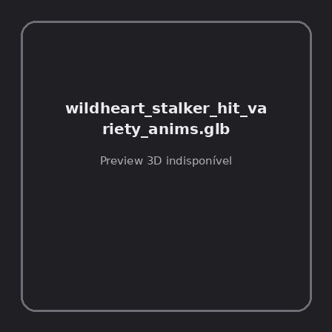
ID | NOV-005202
Origem | Asset novo
Pack/Fonte | Assets Organizados - Enemies
Categoria | Enemies / Wildheart Stalker Hit Variety Anims.Glb
Arquivo | wildheart_stalker_hit_variety_anims.glb
Caminho | 01_Assets_Organizados/Enemies/wildheart_stalker_hit_variety_anims.glb
Formato | GLB
Tamanho | 28.83 KB
SHA-256 | 8c8e61caf62f729f8183…
Status técnico | ERROR
Licença | MISSING_REVIEW_REQUIRED — sem evidência localizada
Objetos / meshes | N/D / N/D
Vértices | N/D
Faces / triângulos | N/D / N/D
Materiais | N/D —
UV sets / vertex colors | N/D / N/D
Dimensões XYZ | N/D
Rig / armatures / bones | N/D / N/D / N/D
Skinned meshes | N/D
Animações | N/D —
Duração total clips | N/D
Root motion detectado | N/D
LODs / colliders | Nenhum / Nenhum
Texturas vinculadas | N/D (0 ausentes)
Alertas | Licença/fonte não localizada automaticamente; revisão legal necessária.
Notas | Falha na inspeção 3D: RuntimeError: Error: Python: Traceback (most recent call last):  File "/usr/share/blender/scripts/addons/io_scene_gltf2/__init__.py", line 1064, in execute  return self.import_gltf2(context)  File "/usr/share/blender/scripts/addons/io_scene_gltf2/__init__.py", line 1083, in import_gltf2  return self.unit_import(self.filepath, import_settings)  File "/usr/share/blender/scripts/addons/io_scene_gltf2/__init__.py", line 1088, in unit_import  from .blender.imp.gltf2_blender_gltf import BlenderGlTF  File "/usr/share/blender/scripts/addons/io_scene_gltf2/blender/imp/gltf2_blender_gltf.py", line 17, in <module>  from .gltf2_blender_scene import BlenderScene  File "/usr/share/blender/scripts/addons/io_scene_gltf2/blender/imp/gltf2_blender_scene.py", line 17, in <module>  from .gltf2_blender_node import BlenderNode  File "/usr/share/blender/scripts/addons/io_scene_gltf2/blender/imp/gltf2_blender_node.py", line 18, in <module>  from .gltf2_blender_mesh import BlenderMesh  File "/usr/share/blender/scripts/addons/io_scene_gltf2/blender/imp/gltf2_blender_mesh.py", line 17, in <module>  import numpy as np  ModuleNotFoundError: No module named 'numpy'  location: /usr/share/blender/scripts/modules/bpy/ops.py:132  Traceback (most recent call last):  File "/home/runner/work/PSX_demons_whip/PSX_demons_whip/workspace/demons/tools/asset_catalog/blender_batch.py", line 427, in inspect_task  import_model(path)  File "/home/runner/work/PSX_demons_whip/PSX_demons_whip/workspace/demons/tools/asset_catalog/blender_batch.py", line 52, in import_model  bpy.ops.import_scene.gltf(filepath=str(path))  File "/usr/share/blender/scripts/modules/bpy/ops.py", line 132, in __call__  ret = _op_call(self.idname_py(), None, kw)  RuntimeError: Error: Python: Traceback (most recent call last):  File "/usr/share/blender/scripts/addons/io_scene_gltf2/__init__.py", line 1064, in execute  return self.import_gltf2(context)  File "/usr/share/blender/scripts/addons/io_scene_gltf2/__init__.py", line 1083, in import_gltf2  return self.unit_import(self.filepath, import_settings)  File "/usr/share/blender/scripts/addons/io_scene_gltf2/__init__.py", line 1088, in unit_import  from .blender.imp.gltf2_blender_gltf import BlenderGlTF  File "/usr/share/blender/scripts/addons/io_scene_gltf2/blender/imp/gltf2_blender_gltf.py", line 17, in <module>  from .gltf2_blender_scene import BlenderScene  File "/usr/share/blender/scripts/addons/io_scene_gltf2/blender/imp/gltf2_blender_scene.py", line 17, in <module>  from .gltf2_blender_node import BlenderNode  File "/usr/share/blender/scripts/addons/io_scene_gltf2/blender/imp/gltf2_blender_node.py", line 18, in <module>  from .gltf2_blender_mesh import BlenderMesh  File "/usr/share/blender/scripts/addons/io_scene_gltf2/blender/imp/gltf2_blender_mesh.py", line 17, in <module>  import numpy as np  ModuleNotFoundError: No module named 'numpy'  location: /usr/share/blender/scripts/modules/bpy/ops.py:132

NOV-005184 • wolf [ERROR]
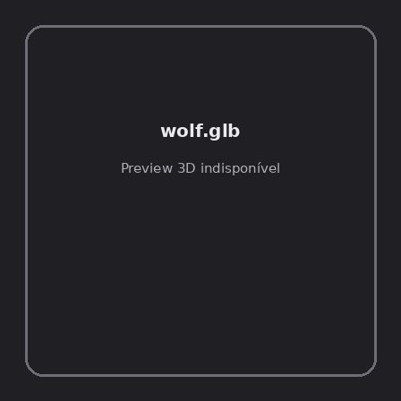
ID | NOV-005184
Origem | Asset novo
Pack/Fonte | Assets Organizados - Enemies
Categoria | Enemies / Wolf.Glb
Arquivo | wolf.glb
Caminho | 01_Assets_Organizados/Enemies/wolf.glb
Formato | GLB
Tamanho | 328.57 KB
SHA-256 | 9ae2ad8b2ab23a1aa650…
Status técnico | ERROR
Licença | MISSING_REVIEW_REQUIRED — sem evidência localizada
Objetos / meshes | N/D / N/D
Vértices | N/D
Faces / triângulos | N/D / N/D
Materiais | N/D —
UV sets / vertex colors | N/D / N/D
Dimensões XYZ | N/D
Rig / armatures / bones | N/D / N/D / N/D
Skinned meshes | N/D
Animações | N/D —
Duração total clips | N/D
Root motion detectado | N/D
LODs / colliders | Nenhum / Nenhum
Texturas vinculadas | N/D (0 ausentes)
Alertas | Licença/fonte não localizada automaticamente; revisão legal necessária. | Duplicado exato: grupo DUP-00752 (2 cópias).
Notas | Falha na inspeção 3D: RuntimeError: Error: Python: Traceback (most recent call last):  File "/usr/share/blender/scripts/addons/io_scene_gltf2/__init__.py", line 1064, in execute  return self.import_gltf2(context)  File "/usr/share/blender/scripts/addons/io_scene_gltf2/__init__.py", line 1083, in import_gltf2  return self.unit_import(self.filepath, import_settings)  File "/usr/share/blender/scripts/addons/io_scene_gltf2/__init__.py", line 1088, in unit_import  from .blender.imp.gltf2_blender_gltf import BlenderGlTF  File "/usr/share/blender/scripts/addons/io_scene_gltf2/blender/imp/gltf2_blender_gltf.py", line 17, in <module>  from .gltf2_blender_scene import BlenderScene  File "/usr/share/blender/scripts/addons/io_scene_gltf2/blender/imp/gltf2_blender_scene.py", line 17, in <module>  from .gltf2_blender_node import BlenderNode  File "/usr/share/blender/scripts/addons/io_scene_gltf2/blender/imp/gltf2_blender_node.py", line 18, in <module>  from .gltf2_blender_mesh import BlenderMesh  File "/usr/share/blender/scripts/addons/io_scene_gltf2/blender/imp/gltf2_blender_mesh.py", line 17, in <module>  import numpy as np  ModuleNotFoundError: No module named 'numpy'  location: /usr/share/blender/scripts/modules/bpy/ops.py:132  Traceback (most recent call last):  File "/home/runner/work/PSX_demons_whip/PSX_demons_whip/workspace/demons/tools/asset_catalog/blender_batch.py", line 427, in inspect_task  import_model(path)  File "/home/runner/work/PSX_demons_whip/PSX_demons_whip/workspace/demons/tools/asset_catalog/blender_batch.py", line 52, in import_model  bpy.ops.import_scene.gltf(filepath=str(path))  File "/usr/share/blender/scripts/modules/bpy/ops.py", line 132, in __call__  ret = _op_call(self.idname_py(), None, kw)  RuntimeError: Error: Python: Traceback (most recent call last):  File "/usr/share/blender/scripts/addons/io_scene_gltf2/__init__.py", line 1064, in execute  return self.import_gltf2(context)  File "/usr/share/blender/scripts/addons/io_scene_gltf2/__init__.py", line 1083, in import_gltf2  return self.unit_import(self.filepath, import_settings)  File "/usr/share/blender/scripts/addons/io_scene_gltf2/__init__.py", line 1088, in unit_import  from .blender.imp.gltf2_blender_gltf import BlenderGlTF  File "/usr/share/blender/scripts/addons/io_scene_gltf2/blender/imp/gltf2_blender_gltf.py", line 17, in <module>  from .gltf2_blender_scene import BlenderScene  File "/usr/share/blender/scripts/addons/io_scene_gltf2/blender/imp/gltf2_blender_scene.py", line 17, in <module>  from .gltf2_blender_node import BlenderNode  File "/usr/share/blender/scripts/addons/io_scene_gltf2/blender/imp/gltf2_blender_node.py", line 18, in <module>  from .gltf2_blender_mesh import BlenderMesh  File "/usr/share/blender/scripts/addons/io_scene_gltf2/blender/imp/gltf2_blender_mesh.py", line 17, in <module>  import numpy as np  ModuleNotFoundError: No module named 'numpy'  location: /usr/share/blender/scripts/modules/bpy/ops.py:132  | Metadados 3D reutilizados do duplicado idêntico TEM-001991.

NOV-005193 • wolf_basic [ERROR]
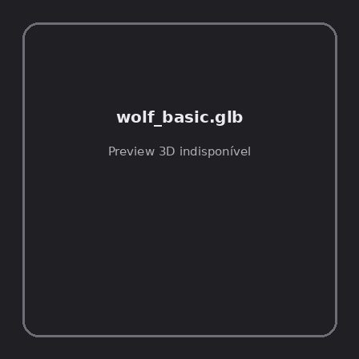
ID | NOV-005193
Origem | Asset novo
Pack/Fonte | Assets Organizados - Enemies
Categoria | Enemies / Wolf Basic.Glb
Arquivo | wolf_basic.glb
Caminho | 01_Assets_Organizados/Enemies/wolf_basic.glb
Formato | GLB
Tamanho | 327.04 KB
SHA-256 | 0edf50b21a051f79c412…
Status técnico | ERROR
Licença | MISSING_REVIEW_REQUIRED — sem evidência localizada
Objetos / meshes | N/D / N/D
Vértices | N/D
Faces / triângulos | N/D / N/D
Materiais | N/D —
UV sets / vertex colors | N/D / N/D
Dimensões XYZ | N/D
Rig / armatures / bones | N/D / N/D / N/D
Skinned meshes | N/D
Animações | N/D —
Duração total clips | N/D
Root motion detectado | N/D
LODs / colliders | Nenhum / Nenhum
Texturas vinculadas | N/D (0 ausentes)
Alertas | Licença/fonte não localizada automaticamente; revisão legal necessária. | Duplicado exato: grupo DUP-00758 (2 cópias).
Notas | Falha na inspeção 3D: RuntimeError: Error: Python: Traceback (most recent call last):  File "/usr/share/blender/scripts/addons/io_scene_gltf2/__init__.py", line 1064, in execute  return self.import_gltf2(context)  File "/usr/share/blender/scripts/addons/io_scene_gltf2/__init__.py", line 1083, in import_gltf2  return self.unit_import(self.filepath, import_settings)  File "/usr/share/blender/scripts/addons/io_scene_gltf2/__init__.py", line 1088, in unit_import  from .blender.imp.gltf2_blender_gltf import BlenderGlTF  File "/usr/share/blender/scripts/addons/io_scene_gltf2/blender/imp/gltf2_blender_gltf.py", line 17, in <module>  from .gltf2_blender_scene import BlenderScene  File "/usr/share/blender/scripts/addons/io_scene_gltf2/blender/imp/gltf2_blender_scene.py", line 17, in <module>  from .gltf2_blender_node import BlenderNode  File "/usr/share/blender/scripts/addons/io_scene_gltf2/blender/imp/gltf2_blender_node.py", line 18, in <module>  from .gltf2_blender_mesh import BlenderMesh  File "/usr/share/blender/scripts/addons/io_scene_gltf2/blender/imp/gltf2_blender_mesh.py", line 17, in <module>  import numpy as np  ModuleNotFoundError: No module named 'numpy'  location: /usr/share/blender/scripts/modules/bpy/ops.py:132  Traceback (most recent call last):  File "/home/runner/work/PSX_demons_whip/PSX_demons_whip/workspace/demons/tools/asset_catalog/blender_batch.py", line 427, in inspect_task  import_model(path)  File "/home/runner/work/PSX_demons_whip/PSX_demons_whip/workspace/demons/tools/asset_catalog/blender_batch.py", line 52, in import_model  bpy.ops.import_scene.gltf(filepath=str(path))  File "/usr/share/blender/scripts/modules/bpy/ops.py", line 132, in __call__  ret = _op_call(self.idname_py(), None, kw)  RuntimeError: Error: Python: Traceback (most recent call last):  File "/usr/share/blender/scripts/addons/io_scene_gltf2/__init__.py", line 1064, in execute  return self.import_gltf2(context)  File "/usr/share/blender/scripts/addons/io_scene_gltf2/__init__.py", line 1083, in import_gltf2  return self.unit_import(self.filepath, import_settings)  File "/usr/share/blender/scripts/addons/io_scene_gltf2/__init__.py", line 1088, in unit_import  from .blender.imp.gltf2_blender_gltf import BlenderGlTF  File "/usr/share/blender/scripts/addons/io_scene_gltf2/blender/imp/gltf2_blender_gltf.py", line 17, in <module>  from .gltf2_blender_scene import BlenderScene  File "/usr/share/blender/scripts/addons/io_scene_gltf2/blender/imp/gltf2_blender_scene.py", line 17, in <module>  from .gltf2_blender_node import BlenderNode  File "/usr/share/blender/scripts/addons/io_scene_gltf2/blender/imp/gltf2_blender_node.py", line 18, in <module>  from .gltf2_blender_mesh import BlenderMesh  File "/usr/share/blender/scripts/addons/io_scene_gltf2/blender/imp/gltf2_blender_mesh.py", line 17, in <module>  import numpy as np  ModuleNotFoundError: No module named 'numpy'  location: /usr/share/blender/scripts/modules/bpy/ops.py:132  | Metadados 3D reutilizados do duplicado idêntico TEM-001997.

NOV-005230 • yeti [ERROR]
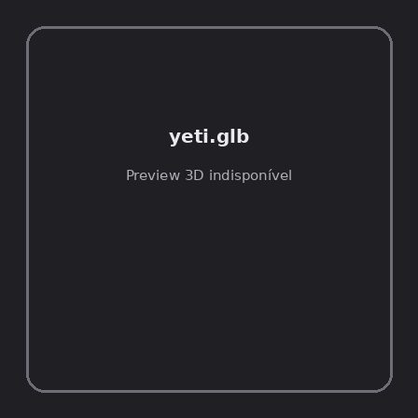
ID | NOV-005230
Origem | Asset novo
Pack/Fonte | Assets Organizados - Enemies
Categoria | Enemies / Yeti.Glb
Arquivo | yeti.glb
Caminho | 01_Assets_Organizados/Enemies/yeti.glb
Formato | GLB
Tamanho | 40.18 KB
SHA-256 | acbf79f899d21a5e611e…
Status técnico | ERROR
Licença | MISSING_REVIEW_REQUIRED — sem evidência localizada
Objetos / meshes | N/D / N/D
Vértices | N/D
Faces / triângulos | N/D / N/D
Materiais | N/D —
UV sets / vertex colors | N/D / N/D
Dimensões XYZ | N/D
Rig / armatures / bones | N/D / N/D / N/D
Skinned meshes | N/D
Animações | N/D —
Duração total clips | N/D
Root motion detectado | N/D
LODs / colliders | Nenhum / Nenhum
Texturas vinculadas | N/D (0 ausentes)
Alertas | Licença/fonte não localizada automaticamente; revisão legal necessária. | Duplicado exato: grupo DUP-00774 (2 cópias).
Notas | Falha na inspeção 3D: RuntimeError: Error: Python: Traceback (most recent call last):  File "/usr/share/blender/scripts/addons/io_scene_gltf2/__init__.py", line 1064, in execute  return self.import_gltf2(context)  File "/usr/share/blender/scripts/addons/io_scene_gltf2/__init__.py", line 1083, in import_gltf2  return self.unit_import(self.filepath, import_settings)  File "/usr/share/blender/scripts/addons/io_scene_gltf2/__init__.py", line 1088, in unit_import  from .blender.imp.gltf2_blender_gltf import BlenderGlTF  File "/usr/share/blender/scripts/addons/io_scene_gltf2/blender/imp/gltf2_blender_gltf.py", line 17, in <module>  from .gltf2_blender_scene import BlenderScene  File "/usr/share/blender/scripts/addons/io_scene_gltf2/blender/imp/gltf2_blender_scene.py", line 17, in <module>  from .gltf2_blender_node import BlenderNode  File "/usr/share/blender/scripts/addons/io_scene_gltf2/blender/imp/gltf2_blender_node.py", line 18, in <module>  from .gltf2_blender_mesh import BlenderMesh  File "/usr/share/blender/scripts/addons/io_scene_gltf2/blender/imp/gltf2_blender_mesh.py", line 17, in <module>  import numpy as np  ModuleNotFoundError: No module named 'numpy'  location: /usr/share/blender/scripts/modules/bpy/ops.py:132  Traceback (most recent call last):  File "/home/runner/work/PSX_demons_whip/PSX_demons_whip/workspace/demons/tools/asset_catalog/blender_batch.py", line 427, in inspect_task  import_model(path)  File "/home/runner/work/PSX_demons_whip/PSX_demons_whip/workspace/demons/tools/asset_catalog/blender_batch.py", line 52, in import_model  bpy.ops.import_scene.gltf(filepath=str(path))  File "/usr/share/blender/scripts/modules/bpy/ops.py", line 132, in __call__  ret = _op_call(self.idname_py(), None, kw)  RuntimeError: Error: Python: Traceback (most recent call last):  File "/usr/share/blender/scripts/addons/io_scene_gltf2/__init__.py", line 1064, in execute  return self.import_gltf2(context)  File "/usr/share/blender/scripts/addons/io_scene_gltf2/__init__.py", line 1083, in import_gltf2  return self.unit_import(self.filepath, import_settings)  File "/usr/share/blender/scripts/addons/io_scene_gltf2/__init__.py", line 1088, in unit_import  from .blender.imp.gltf2_blender_gltf import BlenderGlTF  File "/usr/share/blender/scripts/addons/io_scene_gltf2/blender/imp/gltf2_blender_gltf.py", line 17, in <module>  from .gltf2_blender_scene import BlenderScene  File "/usr/share/blender/scripts/addons/io_scene_gltf2/blender/imp/gltf2_blender_scene.py", line 17, in <module>  from .gltf2_blender_node import BlenderNode  File "/usr/share/blender/scripts/addons/io_scene_gltf2/blender/imp/gltf2_blender_node.py", line 18, in <module>  from .gltf2_blender_mesh import BlenderMesh  File "/usr/share/blender/scripts/addons/io_scene_gltf2/blender/imp/gltf2_blender_mesh.py", line 17, in <module>  import numpy as np  ModuleNotFoundError: No module named 'numpy'  location: /usr/share/blender/scripts/modules/bpy/ops.py:132  | Metadados 3D reutilizados do duplicado idêntico TEM-002013.

NOV-005145 • yeti_ability_anims [ERROR]
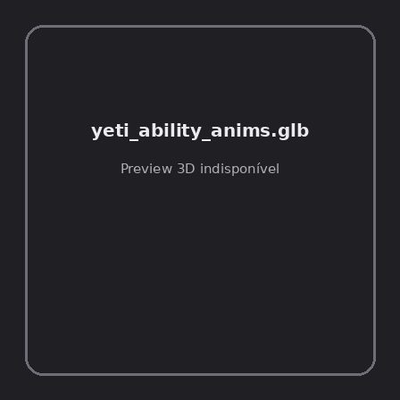
ID | NOV-005145
Origem | Asset novo
Pack/Fonte | Assets Organizados - Enemies
Categoria | Enemies / Yeti Ability Anims.Glb
Arquivo | yeti_ability_anims.glb
Caminho | 01_Assets_Organizados/Enemies/yeti_ability_anims.glb
Formato | GLB
Tamanho | 21.16 KB
SHA-256 | 0a0b7f08832069399450…
Status técnico | ERROR
Licença | MISSING_REVIEW_REQUIRED — sem evidência localizada
Objetos / meshes | N/D / N/D
Vértices | N/D
Faces / triângulos | N/D / N/D
Materiais | N/D —
UV sets / vertex colors | N/D / N/D
Dimensões XYZ | N/D
Rig / armatures / bones | N/D / N/D / N/D
Skinned meshes | N/D
Animações | N/D —
Duração total clips | N/D
Root motion detectado | N/D
LODs / colliders | Nenhum / Nenhum
Texturas vinculadas | N/D (0 ausentes)
Alertas | Licença/fonte não localizada automaticamente; revisão legal necessária.
Notas | Falha na inspeção 3D: RuntimeError: Error: Python: Traceback (most recent call last):  File "/usr/share/blender/scripts/addons/io_scene_gltf2/__init__.py", line 1064, in execute  return self.import_gltf2(context)  File "/usr/share/blender/scripts/addons/io_scene_gltf2/__init__.py", line 1083, in import_gltf2  return self.unit_import(self.filepath, import_settings)  File "/usr/share/blender/scripts/addons/io_scene_gltf2/__init__.py", line 1088, in unit_import  from .blender.imp.gltf2_blender_gltf import BlenderGlTF  File "/usr/share/blender/scripts/addons/io_scene_gltf2/blender/imp/gltf2_blender_gltf.py", line 17, in <module>  from .gltf2_blender_scene import BlenderScene  File "/usr/share/blender/scripts/addons/io_scene_gltf2/blender/imp/gltf2_blender_scene.py", line 17, in <module>  from .gltf2_blender_node import BlenderNode  File "/usr/share/blender/scripts/addons/io_scene_gltf2/blender/imp/gltf2_blender_node.py", line 18, in <module>  from .gltf2_blender_mesh import BlenderMesh  File "/usr/share/blender/scripts/addons/io_scene_gltf2/blender/imp/gltf2_blender_mesh.py", line 17, in <module>  import numpy as np  ModuleNotFoundError: No module named 'numpy'  location: /usr/share/blender/scripts/modules/bpy/ops.py:132  Traceback (most recent call last):  File "/home/runner/work/PSX_demons_whip/PSX_demons_whip/workspace/demons/tools/asset_catalog/blender_batch.py", line 427, in inspect_task  import_model(path)  File "/home/runner/work/PSX_demons_whip/PSX_demons_whip/workspace/demons/tools/asset_catalog/blender_batch.py", line 52, in import_model  bpy.ops.import_scene.gltf(filepath=str(path))  File "/usr/share/blender/scripts/modules/bpy/ops.py", line 132, in __call__  ret = _op_call(self.idname_py(), None, kw)  RuntimeError: Error: Python: Traceback (most recent call last):  File "/usr/share/blender/scripts/addons/io_scene_gltf2/__init__.py", line 1064, in execute  return self.import_gltf2(context)  File "/usr/share/blender/scripts/addons/io_scene_gltf2/__init__.py", line 1083, in import_gltf2  return self.unit_import(self.filepath, import_settings)  File "/usr/share/blender/scripts/addons/io_scene_gltf2/__init__.py", line 1088, in unit_import  from .blender.imp.gltf2_blender_gltf import BlenderGlTF  File "/usr/share/blender/scripts/addons/io_scene_gltf2/blender/imp/gltf2_blender_gltf.py", line 17, in <module>  from .gltf2_blender_scene import BlenderScene  File "/usr/share/blender/scripts/addons/io_scene_gltf2/blender/imp/gltf2_blender_scene.py", line 17, in <module>  from .gltf2_blender_node import BlenderNode  File "/usr/share/blender/scripts/addons/io_scene_gltf2/blender/imp/gltf2_blender_node.py", line 18, in <module>  from .gltf2_blender_mesh import BlenderMesh  File "/usr/share/blender/scripts/addons/io_scene_gltf2/blender/imp/gltf2_blender_mesh.py", line 17, in <module>  import numpy as np  ModuleNotFoundError: No module named 'numpy'  location: /usr/share/blender/scripts/modules/bpy/ops.py:132

NOV-005203 • yeti_hit_variety_anims [ERROR]
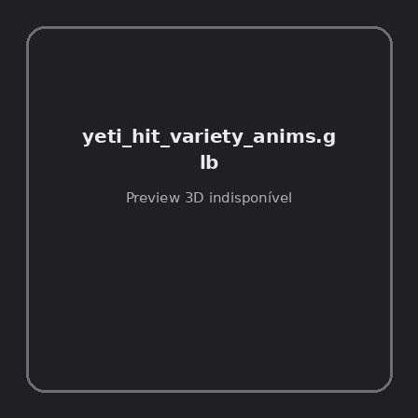
ID | NOV-005203
Origem | Asset novo
Pack/Fonte | Assets Organizados - Enemies
Categoria | Enemies / Yeti Hit Variety Anims.Glb
Arquivo | yeti_hit_variety_anims.glb
Caminho | 01_Assets_Organizados/Enemies/yeti_hit_variety_anims.glb
Formato | GLB
Tamanho | 3.80 KB
SHA-256 | 6302c53235ce97b19530…
Status técnico | ERROR
Licença | MISSING_REVIEW_REQUIRED — sem evidência localizada
Objetos / meshes | N/D / N/D
Vértices | N/D
Faces / triângulos | N/D / N/D
Materiais | N/D —
UV sets / vertex colors | N/D / N/D
Dimensões XYZ | N/D
Rig / armatures / bones | N/D / N/D / N/D
Skinned meshes | N/D
Animações | N/D —
Duração total clips | N/D
Root motion detectado | N/D
LODs / colliders | Nenhum / Nenhum
Texturas vinculadas | N/D (0 ausentes)
Alertas | Licença/fonte não localizada automaticamente; revisão legal necessária.
Notas | Falha na inspeção 3D: RuntimeError: Error: Python: Traceback (most recent call last):  File "/usr/share/blender/scripts/addons/io_scene_gltf2/__init__.py", line 1064, in execute  return self.import_gltf2(context)  File "/usr/share/blender/scripts/addons/io_scene_gltf2/__init__.py", line 1083, in import_gltf2  return self.unit_import(self.filepath, import_settings)  File "/usr/share/blender/scripts/addons/io_scene_gltf2/__init__.py", line 1088, in unit_import  from .blender.imp.gltf2_blender_gltf import BlenderGlTF  File "/usr/share/blender/scripts/addons/io_scene_gltf2/blender/imp/gltf2_blender_gltf.py", line 17, in <module>  from .gltf2_blender_scene import BlenderScene  File "/usr/share/blender/scripts/addons/io_scene_gltf2/blender/imp/gltf2_blender_scene.py", line 17, in <module>  from .gltf2_blender_node import BlenderNode  File "/usr/share/blender/scripts/addons/io_scene_gltf2/blender/imp/gltf2_blender_node.py", line 18, in <module>  from .gltf2_blender_mesh import BlenderMesh  File "/usr/share/blender/scripts/addons/io_scene_gltf2/blender/imp/gltf2_blender_mesh.py", line 17, in <module>  import numpy as np  ModuleNotFoundError: No module named 'numpy'  location: /usr/share/blender/scripts/modules/bpy/ops.py:132  Traceback (most recent call last):  File "/home/runner/work/PSX_demons_whip/PSX_demons_whip/workspace/demons/tools/asset_catalog/blender_batch.py", line 427, in inspect_task  import_model(path)  File "/home/runner/work/PSX_demons_whip/PSX_demons_whip/workspace/demons/tools/asset_catalog/blender_batch.py", line 52, in import_model  bpy.ops.import_scene.gltf(filepath=str(path))  File "/usr/share/blender/scripts/modules/bpy/ops.py", line 132, in __call__  ret = _op_call(self.idname_py(), None, kw)  RuntimeError: Error: Python: Traceback (most recent call last):  File "/usr/share/blender/scripts/addons/io_scene_gltf2/__init__.py", line 1064, in execute  return self.import_gltf2(context)  File "/usr/share/blender/scripts/addons/io_scene_gltf2/__init__.py", line 1083, in import_gltf2  return self.unit_import(self.filepath, import_settings)  File "/usr/share/blender/scripts/addons/io_scene_gltf2/__init__.py", line 1088, in unit_import  from .blender.imp.gltf2_blender_gltf import BlenderGlTF  File "/usr/share/blender/scripts/addons/io_scene_gltf2/blender/imp/gltf2_blender_gltf.py", line 17, in <module>  from .gltf2_blender_scene import BlenderScene  File "/usr/share/blender/scripts/addons/io_scene_gltf2/blender/imp/gltf2_blender_scene.py", line 17, in <module>  from .gltf2_blender_node import BlenderNode  File "/usr/share/blender/scripts/addons/io_scene_gltf2/blender/imp/gltf2_blender_node.py", line 18, in <module>  from .gltf2_blender_mesh import BlenderMesh  File "/usr/share/blender/scripts/addons/io_scene_gltf2/blender/imp/gltf2_blender_mesh.py", line 17, in <module>  import numpy as np  ModuleNotFoundError: No module named 'numpy'  location: /usr/share/blender/scripts/modules/bpy/ops.py:132

NOV-005168 • yetialt [ERROR]
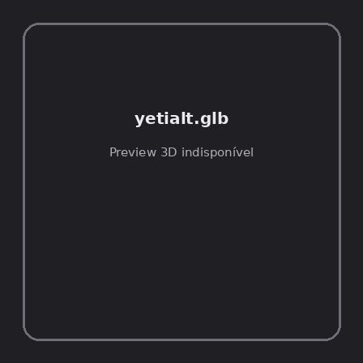
ID | NOV-005168
Origem | Asset novo
Pack/Fonte | Assets Organizados - Enemies
Categoria | Enemies / Yetialt.Glb
Arquivo | yetialt.glb
Caminho | 01_Assets_Organizados/Enemies/yetialt.glb
Formato | GLB
Tamanho | 146.27 KB
SHA-256 | 6c14f370c2aff231186a…
Status técnico | ERROR
Licença | MISSING_REVIEW_REQUIRED — sem evidência localizada
Objetos / meshes | N/D / N/D
Vértices | N/D
Faces / triângulos | N/D / N/D
Materiais | N/D —
UV sets / vertex colors | N/D / N/D
Dimensões XYZ | N/D
Rig / armatures / bones | N/D / N/D / N/D
Skinned meshes | N/D
Animações | N/D —
Duração total clips | N/D
Root motion detectado | N/D
LODs / colliders | Nenhum / Nenhum
Texturas vinculadas | N/D (0 ausentes)
Alertas | Licença/fonte não localizada automaticamente; revisão legal necessária. | Duplicado exato: grupo DUP-00744 (2 cópias).
Notas | Falha na inspeção 3D: RuntimeError: Error: Python: Traceback (most recent call last):  File "/usr/share/blender/scripts/addons/io_scene_gltf2/__init__.py", line 1064, in execute  return self.import_gltf2(context)  File "/usr/share/blender/scripts/addons/io_scene_gltf2/__init__.py", line 1083, in import_gltf2  return self.unit_import(self.filepath, import_settings)  File "/usr/share/blender/scripts/addons/io_scene_gltf2/__init__.py", line 1088, in unit_import  from .blender.imp.gltf2_blender_gltf import BlenderGlTF  File "/usr/share/blender/scripts/addons/io_scene_gltf2/blender/imp/gltf2_blender_gltf.py", line 17, in <module>  from .gltf2_blender_scene import BlenderScene  File "/usr/share/blender/scripts/addons/io_scene_gltf2/blender/imp/gltf2_blender_scene.py", line 17, in <module>  from .gltf2_blender_node import BlenderNode  File "/usr/share/blender/scripts/addons/io_scene_gltf2/blender/imp/gltf2_blender_node.py", line 18, in <module>  from .gltf2_blender_mesh import BlenderMesh  File "/usr/share/blender/scripts/addons/io_scene_gltf2/blender/imp/gltf2_blender_mesh.py", line 17, in <module>  import numpy as np  ModuleNotFoundError: No module named 'numpy'  location: /usr/share/blender/scripts/modules/bpy/ops.py:132  Traceback (most recent call last):  File "/home/runner/work/PSX_demons_whip/PSX_demons_whip/workspace/demons/tools/asset_catalog/blender_batch.py", line 427, in inspect_task  import_model(path)  File "/home/runner/work/PSX_demons_whip/PSX_demons_whip/workspace/demons/tools/asset_catalog/blender_batch.py", line 52, in import_model  bpy.ops.import_scene.gltf(filepath=str(path))  File "/usr/share/blender/scripts/modules/bpy/ops.py", line 132, in __call__  ret = _op_call(self.idname_py(), None, kw)  RuntimeError: Error: Python: Traceback (most recent call last):  File "/usr/share/blender/scripts/addons/io_scene_gltf2/__init__.py", line 1064, in execute  return self.import_gltf2(context)  File "/usr/share/blender/scripts/addons/io_scene_gltf2/__init__.py", line 1083, in import_gltf2  return self.unit_import(self.filepath, import_settings)  File "/usr/share/blender/scripts/addons/io_scene_gltf2/__init__.py", line 1088, in unit_import  from .blender.imp.gltf2_blender_gltf import BlenderGlTF  File "/usr/share/blender/scripts/addons/io_scene_gltf2/blender/imp/gltf2_blender_gltf.py", line 17, in <module>  from .gltf2_blender_scene import BlenderScene  File "/usr/share/blender/scripts/addons/io_scene_gltf2/blender/imp/gltf2_blender_scene.py", line 17, in <module>  from .gltf2_blender_node import BlenderNode  File "/usr/share/blender/scripts/addons/io_scene_gltf2/blender/imp/gltf2_blender_node.py", line 18, in <module>  from .gltf2_blender_mesh import BlenderMesh  File "/usr/share/blender/scripts/addons/io_scene_gltf2/blender/imp/gltf2_blender_mesh.py", line 17, in <module>  import numpy as np  ModuleNotFoundError: No module named 'numpy'  location: /usr/share/blender/scripts/modules/bpy/ops.py:132  | Metadados 3D reutilizados do duplicado idêntico TEM-001983.

NOV-005192 • yetialt_hit_variety_anims [ERROR]
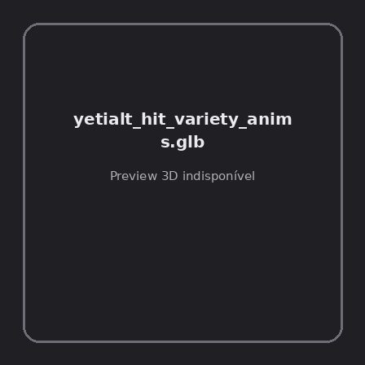
ID | NOV-005192
Origem | Asset novo
Pack/Fonte | Assets Organizados - Enemies
Categoria | Enemies / Yetialt Hit Variety Anims.Glb
Arquivo | yetialt_hit_variety_anims.glb
Caminho | 01_Assets_Organizados/Enemies/yetialt_hit_variety_anims.glb
Formato | GLB
Tamanho | 11.82 KB
SHA-256 | 9b88410ce042f3a96483…
Status técnico | ERROR
Licença | MISSING_REVIEW_REQUIRED — sem evidência localizada
Objetos / meshes | N/D / N/D
Vértices | N/D
Faces / triângulos | N/D / N/D
Materiais | N/D —
UV sets / vertex colors | N/D / N/D
Dimensões XYZ | N/D
Rig / armatures / bones | N/D / N/D / N/D
Skinned meshes | N/D
Animações | N/D —
Duração total clips | N/D
Root motion detectado | N/D
LODs / colliders | Nenhum / Nenhum
Texturas vinculadas | N/D (0 ausentes)
Alertas | Licença/fonte não localizada automaticamente; revisão legal necessária.
Notas | Falha na inspeção 3D: RuntimeError: Error: Python: Traceback (most recent call last):  File "/usr/share/blender/scripts/addons/io_scene_gltf2/__init__.py", line 1064, in execute  return self.import_gltf2(context)  File "/usr/share/blender/scripts/addons/io_scene_gltf2/__init__.py", line 1083, in import_gltf2  return self.unit_import(self.filepath, import_settings)  File "/usr/share/blender/scripts/addons/io_scene_gltf2/__init__.py", line 1088, in unit_import  from .blender.imp.gltf2_blender_gltf import BlenderGlTF  File "/usr/share/blender/scripts/addons/io_scene_gltf2/blender/imp/gltf2_blender_gltf.py", line 17, in <module>  from .gltf2_blender_scene import BlenderScene  File "/usr/share/blender/scripts/addons/io_scene_gltf2/blender/imp/gltf2_blender_scene.py", line 17, in <module>  from .gltf2_blender_node import BlenderNode  File "/usr/share/blender/scripts/addons/io_scene_gltf2/blender/imp/gltf2_blender_node.py", line 18, in <module>  from .gltf2_blender_mesh import BlenderMesh  File "/usr/share/blender/scripts/addons/io_scene_gltf2/blender/imp/gltf2_blender_mesh.py", line 17, in <module>  import numpy as np  ModuleNotFoundError: No module named 'numpy'  location: /usr/share/blender/scripts/modules/bpy/ops.py:132  Traceback (most recent call last):  File "/home/runner/work/PSX_demons_whip/PSX_demons_whip/workspace/demons/tools/asset_catalog/blender_batch.py", line 427, in inspect_task  import_model(path)  File "/home/runner/work/PSX_demons_whip/PSX_demons_whip/workspace/demons/tools/asset_catalog/blender_batch.py", line 52, in import_model  bpy.ops.import_scene.gltf(filepath=str(path))  File "/usr/share/blender/scripts/modules/bpy/ops.py", line 132, in __call__  ret = _op_call(self.idname_py(), None, kw)  RuntimeError: Error: Python: Traceback (most recent call last):  File "/usr/share/blender/scripts/addons/io_scene_gltf2/__init__.py", line 1064, in execute  return self.import_gltf2(context)  File "/usr/share/blender/scripts/addons/io_scene_gltf2/__init__.py", line 1083, in import_gltf2  return self.unit_import(self.filepath, import_settings)  File "/usr/share/blender/scripts/addons/io_scene_gltf2/__init__.py", line 1088, in unit_import  from .blender.imp.gltf2_blender_gltf import BlenderGlTF  File "/usr/share/blender/scripts/addons/io_scene_gltf2/blender/imp/gltf2_blender_gltf.py", line 17, in <module>  from .gltf2_blender_scene import BlenderScene  File "/usr/share/blender/scripts/addons/io_scene_gltf2/blender/imp/gltf2_blender_scene.py", line 17, in <module>  from .gltf2_blender_node import BlenderNode  File "/usr/share/blender/scripts/addons/io_scene_gltf2/blender/imp/gltf2_blender_node.py", line 18, in <module>  from .gltf2_blender_mesh import BlenderMesh  File "/usr/share/blender/scripts/addons/io_scene_gltf2/blender/imp/gltf2_blender_mesh.py", line 17, in <module>  import numpy as np  ModuleNotFoundError: No module named 'numpy'  location: /usr/share/blender/scripts/modules/bpy/ops.py:132

NOV-005200 • yumi_cat [ERROR]

ID | NOV-005200
Origem | Asset novo
Pack/Fonte | Assets Organizados - Enemies
Categoria | Enemies / Yumi Cat.Glb
Arquivo | yumi_cat.glb
Caminho | 01_Assets_Organizados/Enemies/yumi_cat.glb
Formato | GLB
Tamanho | 420.28 KB
SHA-256 | 7583712c2d3c08fbf7a2…
Status técnico | ERROR
Licença | MISSING_REVIEW_REQUIRED — sem evidência localizada
Objetos / meshes | N/D / N/D
Vértices | N/D
Faces / triângulos | N/D / N/D
Materiais | N/D —
UV sets / vertex colors | N/D / N/D
Dimensões XYZ | N/D
Rig / armatures / bones | N/D / N/D / N/D
Skinned meshes | N/D
Animações | N/D —
Duração total clips | N/D
Root motion detectado | N/D
LODs / colliders | Nenhum / Nenhum
Texturas vinculadas | N/D (0 ausentes)
Alertas | Licença/fonte não localizada automaticamente; revisão legal necessária. | Duplicado exato: grupo DUP-00763 (2 cópias).
Notas | Falha na inspeção 3D: RuntimeError: Error: Python: Traceback (most recent call last):  File "/usr/share/blender/scripts/addons/io_scene_gltf2/__init__.py", line 1064, in execute  return self.import_gltf2(context)  File "/usr/share/blender/scripts/addons/io_scene_gltf2/__init__.py", line 1083, in import_gltf2  return self.unit_import(self.filepath, import_settings)  File "/usr/share/blender/scripts/addons/io_scene_gltf2/__init__.py", line 1088, in unit_import  from .blender.imp.gltf2_blender_gltf import BlenderGlTF  File "/usr/share/blender/scripts/addons/io_scene_gltf2/blender/imp/gltf2_blender_gltf.py", line 17, in <module>  from .gltf2_blender_scene import BlenderScene  File "/usr/share/blender/scripts/addons/io_scene_gltf2/blender/imp/gltf2_blender_scene.py", line 17, in <module>  from .gltf2_blender_node import BlenderNode  File "/usr/share/blender/scripts/addons/io_scene_gltf2/blender/imp/gltf2_blender_node.py", line 18, in <module>  from .gltf2_blender_mesh import BlenderMesh  File "/usr/share/blender/scripts/addons/io_scene_gltf2/blender/imp/gltf2_blender_mesh.py", line 17, in <module>  import numpy as np  ModuleNotFoundError: No module named 'numpy'  location: /usr/share/blender/scripts/modules/bpy/ops.py:132  Traceback (most recent call last):  File "/home/runner/work/PSX_demons_whip/PSX_demons_whip/workspace/demons/tools/asset_catalog/blender_batch.py", line 427, in inspect_task  import_model(path)  File "/home/runner/work/PSX_demons_whip/PSX_demons_whip/workspace/demons/tools/asset_catalog/blender_batch.py", line 52, in import_model  bpy.ops.import_scene.gltf(filepath=str(path))  File "/usr/share/blender/scripts/modules/bpy/ops.py", line 132, in __call__  ret = _op_call(self.idname_py(), None, kw)  RuntimeError: Error: Python: Traceback (most recent call last):  File "/usr/share/blender/scripts/addons/io_scene_gltf2/__init__.py", line 1064, in execute  return self.import_gltf2(context)  File "/usr/share/blender/scripts/addons/io_scene_gltf2/__init__.py", line 1083, in import_gltf2  return self.unit_import(self.filepath, import_settings)  File "/usr/share/blender/scripts/addons/io_scene_gltf2/__init__.py", line 1088, in unit_import  from .blender.imp.gltf2_blender_gltf import BlenderGlTF  File "/usr/share/blender/scripts/addons/io_scene_gltf2/blender/imp/gltf2_blender_gltf.py", line 17, in <module>  from .gltf2_blender_scene import BlenderScene  File "/usr/share/blender/scripts/addons/io_scene_gltf2/blender/imp/gltf2_blender_scene.py", line 17, in <module>  from .gltf2_blender_node import BlenderNode  File "/usr/share/blender/scripts/addons/io_scene_gltf2/blender/imp/gltf2_blender_node.py", line 18, in <module>  from .gltf2_blender_mesh import BlenderMesh  File "/usr/share/blender/scripts/addons/io_scene_gltf2/blender/imp/gltf2_blender_mesh.py", line 17, in <module>  import numpy as np  ModuleNotFoundError: No module named 'numpy'  location: /usr/share/blender/scripts/modules/bpy/ops.py:132  | Metadados 3D reutilizados do duplicado idêntico TEM-002002.

NOV-004607 • anomalyfbx [ERROR]
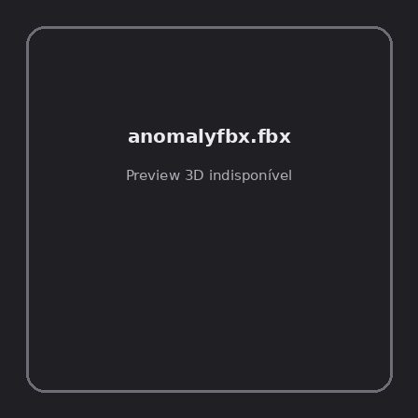
ID | NOV-004607
Origem | Asset novo
Pack/Fonte | PSX Horror-Fantasy Megapack
Categoria | Enemies / Anomalymonster
Arquivo | anomalyfbx.fbx
Caminho | 00_Packs_Raw/PSX Horror-Fantasy Megapack/AnomalyMonster/anomalyfbx.fbx
Formato | FBX
Tamanho | 904.73 KB
SHA-256 | 1980177bfc0b903cb92f…
Status técnico | ERROR
Licença | MISSING_REVIEW_REQUIRED — sem evidência localizada
Objetos / meshes | N/D / N/D
Vértices | N/D
Faces / triângulos | N/D / N/D
Materiais | N/D —
UV sets / vertex colors | N/D / N/D
Dimensões XYZ | N/D
Rig / armatures / bones | N/D / N/D / N/D
Skinned meshes | N/D
Animações | N/D —
Duração total clips | N/D
Root motion detectado | N/D
LODs / colliders | Nenhum / Nenhum
Texturas vinculadas | N/D (0 ausentes)
Alertas | Licença/fonte não localizada automaticamente; revisão legal necessária.
Notas | Falha na inspeção 3D: Unable to open a display

NOV-004609 • anomalygodot [ERROR]
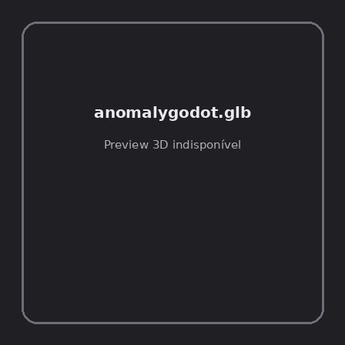
ID | NOV-004609
Origem | Asset novo
Pack/Fonte | PSX Horror-Fantasy Megapack
Categoria | Enemies / Anomalymonster
Arquivo | anomalygodot.glb
Caminho | 00_Packs_Raw/PSX Horror-Fantasy Megapack/AnomalyMonster/anomalygodot.glb
Formato | GLB
Tamanho | 271.85 KB
SHA-256 | 1ca3e41a9c3da14dd413…
Status técnico | ERROR
Licença | MISSING_REVIEW_REQUIRED — sem evidência localizada
Objetos / meshes | N/D / N/D
Vértices | N/D
Faces / triângulos | N/D / N/D
Materiais | N/D —
UV sets / vertex colors | N/D / N/D
Dimensões XYZ | N/D
Rig / armatures / bones | N/D / N/D / N/D
Skinned meshes | N/D
Animações | N/D —
Duração total clips | N/D
Root motion detectado | N/D
LODs / colliders | Nenhum / Nenhum
Texturas vinculadas | N/D (0 ausentes)
Alertas | Licença/fonte não localizada automaticamente; revisão legal necessária.
Notas | Falha na inspeção 3D: RuntimeError: Error: Python: Traceback (most recent call last):  File "/usr/share/blender/scripts/addons/io_scene_gltf2/__init__.py", line 1064, in execute  return self.import_gltf2(context)  File "/usr/share/blender/scripts/addons/io_scene_gltf2/__init__.py", line 1083, in import_gltf2  return self.unit_import(self.filepath, import_settings)  File "/usr/share/blender/scripts/addons/io_scene_gltf2/__init__.py", line 1088, in unit_import  from .blender.imp.gltf2_blender_gltf import BlenderGlTF  File "/usr/share/blender/scripts/addons/io_scene_gltf2/blender/imp/gltf2_blender_gltf.py", line 17, in <module>  from .gltf2_blender_scene import BlenderScene  File "/usr/share/blender/scripts/addons/io_scene_gltf2/blender/imp/gltf2_blender_scene.py", line 17, in <module>  from .gltf2_blender_node import BlenderNode  File "/usr/share/blender/scripts/addons/io_scene_gltf2/blender/imp/gltf2_blender_node.py", line 18, in <module>  from .gltf2_blender_mesh import BlenderMesh  File "/usr/share/blender/scripts/addons/io_scene_gltf2/blender/imp/gltf2_blender_mesh.py", line 17, in <module>  import numpy as np  ModuleNotFoundError: No module named 'numpy'  location: /usr/share/blender/scripts/modules/bpy/ops.py:132  Traceback (most recent call last):  File "/home/runner/work/PSX_demons_whip/PSX_demons_whip/workspace/demons/tools/asset_catalog/blender_batch.py", line 427, in inspect_task  import_model(path)  File "/home/runner/work/PSX_demons_whip/PSX_demons_whip/workspace/demons/tools/asset_catalog/blender_batch.py", line 52, in import_model  bpy.ops.import_scene.gltf(filepath=str(path))  File "/usr/share/blender/scripts/modules/bpy/ops.py", line 132, in __call__  ret = _op_call(self.idname_py(), None, kw)  RuntimeError: Error: Python: Traceback (most recent call last):  File "/usr/share/blender/scripts/addons/io_scene_gltf2/__init__.py", line 1064, in execute  return self.import_gltf2(context)  File "/usr/share/blender/scripts/addons/io_scene_gltf2/__init__.py", line 1083, in import_gltf2  return self.unit_import(self.filepath, import_settings)  File "/usr/share/blender/scripts/addons/io_scene_gltf2/__init__.py", line 1088, in unit_import  from .blender.imp.gltf2_blender_gltf import BlenderGlTF  File "/usr/share/blender/scripts/addons/io_scene_gltf2/blender/imp/gltf2_blender_gltf.py", line 17, in <module>  from .gltf2_blender_scene import BlenderScene  File "/usr/share/blender/scripts/addons/io_scene_gltf2/blender/imp/gltf2_blender_scene.py", line 17, in <module>  from .gltf2_blender_node import BlenderNode  File "/usr/share/blender/scripts/addons/io_scene_gltf2/blender/imp/gltf2_blender_node.py", line 18, in <module>  from .gltf2_blender_mesh import BlenderMesh  File "/usr/share/blender/scripts/addons/io_scene_gltf2/blender/imp/gltf2_blender_mesh.py", line 17, in <module>  import numpy as np  ModuleNotFoundError: No module named 'numpy'  location: /usr/share/blender/scripts/modules/bpy/ops.py:132

