DEMONS WHIP - NOVO - MOUNTS
MODEL 3D • Volume 1 de 1

Assets neste volume: 9
Origem: NOVO
Gerado em: 2026-08-17T19:04:26+00:00

NOV-005546 • aether_hover_cycle [ERROR]
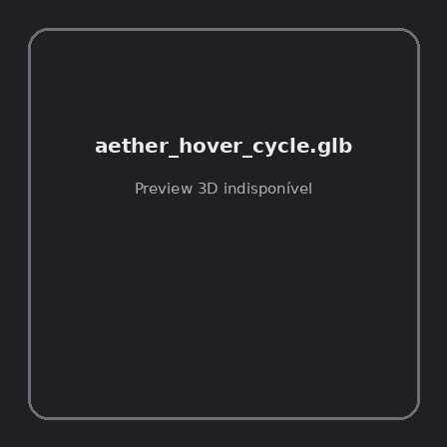
ID | NOV-005546
Origem | Asset novo
Pack/Fonte | Assets Organizados - Mounts
Categoria | Mounts / Aether Hover Cycle.Glb
Arquivo | aether_hover_cycle.glb
Caminho | 01_Assets_Organizados/Mounts/aether_hover_cycle.glb
Formato | GLB
Tamanho | 276.32 KB
SHA-256 | 10935b02e1d848735958…
Status técnico | ERROR
Licença | MISSING_REVIEW_REQUIRED — sem evidência localizada
Objetos / meshes | N/D / N/D
Vértices | N/D
Faces / triângulos | N/D / N/D
Materiais | N/D —
UV sets / vertex colors | N/D / N/D
Dimensões XYZ | N/D
Rig / armatures / bones | N/D / N/D / N/D
Skinned meshes | N/D
Animações | N/D —
Duração total clips | N/D
Root motion detectado | N/D
LODs / colliders | Nenhum / Nenhum
Texturas vinculadas | N/D (0 ausentes)
Alertas | Licença/fonte não localizada automaticamente; revisão legal necessária. | Duplicado exato: grupo DUP-00718 (2 cópias).
Notas | Falha na inspeção 3D: RuntimeError: Error: Python: Traceback (most recent call last):  File "/usr/share/blender/scripts/addons/io_scene_gltf2/__init__.py", line 1064, in execute  return self.import_gltf2(context)  File "/usr/share/blender/scripts/addons/io_scene_gltf2/__init__.py", line 1083, in import_gltf2  return self.unit_import(self.filepath, import_settings)  File "/usr/share/blender/scripts/addons/io_scene_gltf2/__init__.py", line 1088, in unit_import  from .blender.imp.gltf2_blender_gltf import BlenderGlTF  File "/usr/share/blender/scripts/addons/io_scene_gltf2/blender/imp/gltf2_blender_gltf.py", line 17, in <module>  from .gltf2_blender_scene import BlenderScene  File "/usr/share/blender/scripts/addons/io_scene_gltf2/blender/imp/gltf2_blender_scene.py", line 17, in <module>  from .gltf2_blender_node import BlenderNode  File "/usr/share/blender/scripts/addons/io_scene_gltf2/blender/imp/gltf2_blender_node.py", line 18, in <module>  from .gltf2_blender_mesh import BlenderMesh  File "/usr/share/blender/scripts/addons/io_scene_gltf2/blender/imp/gltf2_blender_mesh.py", line 17, in <module>  import numpy as np  ModuleNotFoundError: No module named 'numpy'  location: /usr/share/blender/scripts/modules/bpy/ops.py:132  Traceback (most recent call last):  File "/home/runner/work/PSX_demons_whip/PSX_demons_whip/workspace/demons/tools/asset_catalog/blender_batch.py", line 427, in inspect_task  import_model(path)  File "/home/runner/work/PSX_demons_whip/PSX_demons_whip/workspace/demons/tools/asset_catalog/blender_batch.py", line 52, in import_model  bpy.ops.import_scene.gltf(filepath=str(path))  File "/usr/share/blender/scripts/modules/bpy/ops.py", line 132, in __call__  ret = _op_call(self.idname_py(), None, kw)  RuntimeError: Error: Python: Traceback (most recent call last):  File "/usr/share/blender/scripts/addons/io_scene_gltf2/__init__.py", line 1064, in execute  return self.import_gltf2(context)  File "/usr/share/blender/scripts/addons/io_scene_gltf2/__init__.py", line 1083, in import_gltf2  return self.unit_import(self.filepath, import_settings)  File "/usr/share/blender/scripts/addons/io_scene_gltf2/__init__.py", line 1088, in unit_import  from .blender.imp.gltf2_blender_gltf import BlenderGlTF  File "/usr/share/blender/scripts/addons/io_scene_gltf2/blender/imp/gltf2_blender_gltf.py", line 17, in <module>  from .gltf2_blender_scene import BlenderScene  File "/usr/share/blender/scripts/addons/io_scene_gltf2/blender/imp/gltf2_blender_scene.py", line 17, in <module>  from .gltf2_blender_node import BlenderNode  File "/usr/share/blender/scripts/addons/io_scene_gltf2/blender/imp/gltf2_blender_node.py", line 18, in <module>  from .gltf2_blender_mesh import BlenderMesh  File "/usr/share/blender/scripts/addons/io_scene_gltf2/blender/imp/gltf2_blender_mesh.py", line 17, in <module>  import numpy as np  ModuleNotFoundError: No module named 'numpy'  location: /usr/share/blender/scripts/modules/bpy/ops.py:132  | Metadados 3D reutilizados do duplicado idêntico TEM-001957.

NOV-005544 • drakemaw_raptor [ERROR]
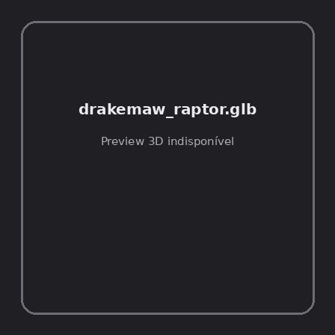
ID | NOV-005544
Origem | Asset novo
Pack/Fonte | Assets Organizados - Mounts
Categoria | Mounts / Drakemaw Raptor.Glb
Arquivo | drakemaw_raptor.glb
Caminho | 01_Assets_Organizados/Mounts/drakemaw_raptor.glb
Formato | GLB
Tamanho | 344.02 KB
SHA-256 | 44d00a10e3486711b90a…
Status técnico | ERROR
Licença | MISSING_REVIEW_REQUIRED — sem evidência localizada
Objetos / meshes | N/D / N/D
Vértices | N/D
Faces / triângulos | N/D / N/D
Materiais | N/D —
UV sets / vertex colors | N/D / N/D
Dimensões XYZ | N/D
Rig / armatures / bones | N/D / N/D / N/D
Skinned meshes | N/D
Animações | N/D —
Duração total clips | N/D
Root motion detectado | N/D
LODs / colliders | Nenhum / Nenhum
Texturas vinculadas | N/D (0 ausentes)
Alertas | Licença/fonte não localizada automaticamente; revisão legal necessária. | Duplicado exato: grupo DUP-00716 (2 cópias).
Notas | Falha na inspeção 3D: RuntimeError: Error: Python: Traceback (most recent call last):  File "/usr/share/blender/scripts/addons/io_scene_gltf2/__init__.py", line 1064, in execute  return self.import_gltf2(context)  File "/usr/share/blender/scripts/addons/io_scene_gltf2/__init__.py", line 1083, in import_gltf2  return self.unit_import(self.filepath, import_settings)  File "/usr/share/blender/scripts/addons/io_scene_gltf2/__init__.py", line 1088, in unit_import  from .blender.imp.gltf2_blender_gltf import BlenderGlTF  File "/usr/share/blender/scripts/addons/io_scene_gltf2/blender/imp/gltf2_blender_gltf.py", line 17, in <module>  from .gltf2_blender_scene import BlenderScene  File "/usr/share/blender/scripts/addons/io_scene_gltf2/blender/imp/gltf2_blender_scene.py", line 17, in <module>  from .gltf2_blender_node import BlenderNode  File "/usr/share/blender/scripts/addons/io_scene_gltf2/blender/imp/gltf2_blender_node.py", line 18, in <module>  from .gltf2_blender_mesh import BlenderMesh  File "/usr/share/blender/scripts/addons/io_scene_gltf2/blender/imp/gltf2_blender_mesh.py", line 17, in <module>  import numpy as np  ModuleNotFoundError: No module named 'numpy'  location: /usr/share/blender/scripts/modules/bpy/ops.py:132  Traceback (most recent call last):  File "/home/runner/work/PSX_demons_whip/PSX_demons_whip/workspace/demons/tools/asset_catalog/blender_batch.py", line 427, in inspect_task  import_model(path)  File "/home/runner/work/PSX_demons_whip/PSX_demons_whip/workspace/demons/tools/asset_catalog/blender_batch.py", line 52, in import_model  bpy.ops.import_scene.gltf(filepath=str(path))  File "/usr/share/blender/scripts/modules/bpy/ops.py", line 132, in __call__  ret = _op_call(self.idname_py(), None, kw)  RuntimeError: Error: Python: Traceback (most recent call last):  File "/usr/share/blender/scripts/addons/io_scene_gltf2/__init__.py", line 1064, in execute  return self.import_gltf2(context)  File "/usr/share/blender/scripts/addons/io_scene_gltf2/__init__.py", line 1083, in import_gltf2  return self.unit_import(self.filepath, import_settings)  File "/usr/share/blender/scripts/addons/io_scene_gltf2/__init__.py", line 1088, in unit_import  from .blender.imp.gltf2_blender_gltf import BlenderGlTF  File "/usr/share/blender/scripts/addons/io_scene_gltf2/blender/imp/gltf2_blender_gltf.py", line 17, in <module>  from .gltf2_blender_scene import BlenderScene  File "/usr/share/blender/scripts/addons/io_scene_gltf2/blender/imp/gltf2_blender_scene.py", line 17, in <module>  from .gltf2_blender_node import BlenderNode  File "/usr/share/blender/scripts/addons/io_scene_gltf2/blender/imp/gltf2_blender_node.py", line 18, in <module>  from .gltf2_blender_mesh import BlenderMesh  File "/usr/share/blender/scripts/addons/io_scene_gltf2/blender/imp/gltf2_blender_mesh.py", line 17, in <module>  import numpy as np  ModuleNotFoundError: No module named 'numpy'  location: /usr/share/blender/scripts/modules/bpy/ops.py:132  | Metadados 3D reutilizados do duplicado idêntico TEM-001955.

NOV-005548 • grag_bear [ERROR]

ID | NOV-005548
Origem | Asset novo
Pack/Fonte | Assets Organizados - Mounts
Categoria | Mounts / Grag Bear.Glb
Arquivo | grag_bear.glb
Caminho | 01_Assets_Organizados/Mounts/grag_bear.glb
Formato | GLB
Tamanho | 635.94 KB
SHA-256 | 767ddb38445d7f8656cb…
Status técnico | ERROR
Licença | MISSING_REVIEW_REQUIRED — sem evidência localizada
Objetos / meshes | N/D / N/D
Vértices | N/D
Faces / triângulos | N/D / N/D
Materiais | N/D —
UV sets / vertex colors | N/D / N/D
Dimensões XYZ | N/D
Rig / armatures / bones | N/D / N/D / N/D
Skinned meshes | N/D
Animações | N/D —
Duração total clips | N/D
Root motion detectado | N/D
LODs / colliders | Nenhum / Nenhum
Texturas vinculadas | N/D (0 ausentes)
Alertas | Licença/fonte não localizada automaticamente; revisão legal necessária. | Duplicado exato: grupo DUP-00720 (2 cópias).
Notas | Falha na inspeção 3D: RuntimeError: Error: Python: Traceback (most recent call last):  File "/usr/share/blender/scripts/addons/io_scene_gltf2/__init__.py", line 1064, in execute  return self.import_gltf2(context)  File "/usr/share/blender/scripts/addons/io_scene_gltf2/__init__.py", line 1083, in import_gltf2  return self.unit_import(self.filepath, import_settings)  File "/usr/share/blender/scripts/addons/io_scene_gltf2/__init__.py", line 1088, in unit_import  from .blender.imp.gltf2_blender_gltf import BlenderGlTF  File "/usr/share/blender/scripts/addons/io_scene_gltf2/blender/imp/gltf2_blender_gltf.py", line 17, in <module>  from .gltf2_blender_scene import BlenderScene  File "/usr/share/blender/scripts/addons/io_scene_gltf2/blender/imp/gltf2_blender_scene.py", line 17, in <module>  from .gltf2_blender_node import BlenderNode  File "/usr/share/blender/scripts/addons/io_scene_gltf2/blender/imp/gltf2_blender_node.py", line 18, in <module>  from .gltf2_blender_mesh import BlenderMesh  File "/usr/share/blender/scripts/addons/io_scene_gltf2/blender/imp/gltf2_blender_mesh.py", line 17, in <module>  import numpy as np  ModuleNotFoundError: No module named 'numpy'  location: /usr/share/blender/scripts/modules/bpy/ops.py:132  Traceback (most recent call last):  File "/home/runner/work/PSX_demons_whip/PSX_demons_whip/workspace/demons/tools/asset_catalog/blender_batch.py", line 427, in inspect_task  import_model(path)  File "/home/runner/work/PSX_demons_whip/PSX_demons_whip/workspace/demons/tools/asset_catalog/blender_batch.py", line 52, in import_model  bpy.ops.import_scene.gltf(filepath=str(path))  File "/usr/share/blender/scripts/modules/bpy/ops.py", line 132, in __call__  ret = _op_call(self.idname_py(), None, kw)  RuntimeError: Error: Python: Traceback (most recent call last):  File "/usr/share/blender/scripts/addons/io_scene_gltf2/__init__.py", line 1064, in execute  return self.import_gltf2(context)  File "/usr/share/blender/scripts/addons/io_scene_gltf2/__init__.py", line 1083, in import_gltf2  return self.unit_import(self.filepath, import_settings)  File "/usr/share/blender/scripts/addons/io_scene_gltf2/__init__.py", line 1088, in unit_import  from .blender.imp.gltf2_blender_gltf import BlenderGlTF  File "/usr/share/blender/scripts/addons/io_scene_gltf2/blender/imp/gltf2_blender_gltf.py", line 17, in <module>  from .gltf2_blender_scene import BlenderScene  File "/usr/share/blender/scripts/addons/io_scene_gltf2/blender/imp/gltf2_blender_scene.py", line 17, in <module>  from .gltf2_blender_node import BlenderNode  File "/usr/share/blender/scripts/addons/io_scene_gltf2/blender/imp/gltf2_blender_node.py", line 18, in <module>  from .gltf2_blender_mesh import BlenderMesh  File "/usr/share/blender/scripts/addons/io_scene_gltf2/blender/imp/gltf2_blender_mesh.py", line 17, in <module>  import numpy as np  ModuleNotFoundError: No module named 'numpy'  location: /usr/share/blender/scripts/modules/bpy/ops.py:132  | Metadados 3D reutilizados do duplicado idêntico TEM-001959.

NOV-005547 • shadowjump_toad [ERROR]
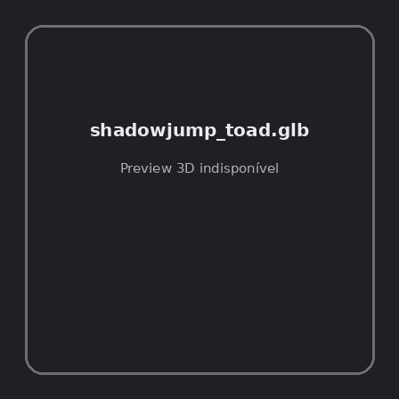
ID | NOV-005547
Origem | Asset novo
Pack/Fonte | Assets Organizados - Mounts
Categoria | Mounts / Shadowjump Toad.Glb
Arquivo | shadowjump_toad.glb
Caminho | 01_Assets_Organizados/Mounts/shadowjump_toad.glb
Formato | GLB
Tamanho | 623.26 KB
SHA-256 | 2811f4fadfda99d70ffa…
Status técnico | ERROR
Licença | MISSING_REVIEW_REQUIRED — sem evidência localizada
Objetos / meshes | N/D / N/D
Vértices | N/D
Faces / triângulos | N/D / N/D
Materiais | N/D —
UV sets / vertex colors | N/D / N/D
Dimensões XYZ | N/D
Rig / armatures / bones | N/D / N/D / N/D
Skinned meshes | N/D
Animações | N/D —
Duração total clips | N/D
Root motion detectado | N/D
LODs / colliders | Nenhum / Nenhum
Texturas vinculadas | N/D (0 ausentes)
Alertas | Licença/fonte não localizada automaticamente; revisão legal necessária. | Duplicado exato: grupo DUP-00719 (2 cópias).
Notas | Falha na inspeção 3D: RuntimeError: Error: Python: Traceback (most recent call last):  File "/usr/share/blender/scripts/addons/io_scene_gltf2/__init__.py", line 1064, in execute  return self.import_gltf2(context)  File "/usr/share/blender/scripts/addons/io_scene_gltf2/__init__.py", line 1083, in import_gltf2  return self.unit_import(self.filepath, import_settings)  File "/usr/share/blender/scripts/addons/io_scene_gltf2/__init__.py", line 1088, in unit_import  from .blender.imp.gltf2_blender_gltf import BlenderGlTF  File "/usr/share/blender/scripts/addons/io_scene_gltf2/blender/imp/gltf2_blender_gltf.py", line 17, in <module>  from .gltf2_blender_scene import BlenderScene  File "/usr/share/blender/scripts/addons/io_scene_gltf2/blender/imp/gltf2_blender_scene.py", line 17, in <module>  from .gltf2_blender_node import BlenderNode  File "/usr/share/blender/scripts/addons/io_scene_gltf2/blender/imp/gltf2_blender_node.py", line 18, in <module>  from .gltf2_blender_mesh import BlenderMesh  File "/usr/share/blender/scripts/addons/io_scene_gltf2/blender/imp/gltf2_blender_mesh.py", line 17, in <module>  import numpy as np  ModuleNotFoundError: No module named 'numpy'  location: /usr/share/blender/scripts/modules/bpy/ops.py:132  Traceback (most recent call last):  File "/home/runner/work/PSX_demons_whip/PSX_demons_whip/workspace/demons/tools/asset_catalog/blender_batch.py", line 427, in inspect_task  import_model(path)  File "/home/runner/work/PSX_demons_whip/PSX_demons_whip/workspace/demons/tools/asset_catalog/blender_batch.py", line 52, in import_model  bpy.ops.import_scene.gltf(filepath=str(path))  File "/usr/share/blender/scripts/modules/bpy/ops.py", line 132, in __call__  ret = _op_call(self.idname_py(), None, kw)  RuntimeError: Error: Python: Traceback (most recent call last):  File "/usr/share/blender/scripts/addons/io_scene_gltf2/__init__.py", line 1064, in execute  return self.import_gltf2(context)  File "/usr/share/blender/scripts/addons/io_scene_gltf2/__init__.py", line 1083, in import_gltf2  return self.unit_import(self.filepath, import_settings)  File "/usr/share/blender/scripts/addons/io_scene_gltf2/__init__.py", line 1088, in unit_import  from .blender.imp.gltf2_blender_gltf import BlenderGlTF  File "/usr/share/blender/scripts/addons/io_scene_gltf2/blender/imp/gltf2_blender_gltf.py", line 17, in <module>  from .gltf2_blender_scene import BlenderScene  File "/usr/share/blender/scripts/addons/io_scene_gltf2/blender/imp/gltf2_blender_scene.py", line 17, in <module>  from .gltf2_blender_node import BlenderNode  File "/usr/share/blender/scripts/addons/io_scene_gltf2/blender/imp/gltf2_blender_node.py", line 18, in <module>  from .gltf2_blender_mesh import BlenderMesh  File "/usr/share/blender/scripts/addons/io_scene_gltf2/blender/imp/gltf2_blender_mesh.py", line 17, in <module>  import numpy as np  ModuleNotFoundError: No module named 'numpy'  location: /usr/share/blender/scripts/modules/bpy/ops.py:132  | Metadados 3D reutilizados do duplicado idêntico TEM-001958.

NOV-005550 • stalkglider_snail [ERROR]
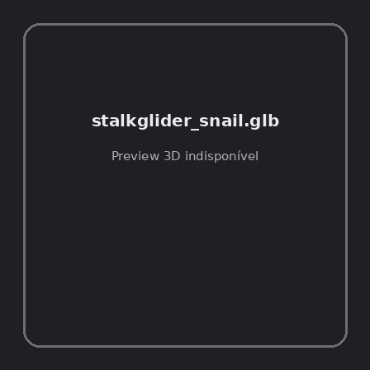
ID | NOV-005550
Origem | Asset novo
Pack/Fonte | Assets Organizados - Mounts
Categoria | Mounts / Stalkglider Snail.Glb
Arquivo | stalkglider_snail.glb
Caminho | 01_Assets_Organizados/Mounts/stalkglider_snail.glb
Formato | GLB
Tamanho | 203.23 KB
SHA-256 | 418aa794d44f0e99a681…
Status técnico | ERROR
Licença | MISSING_REVIEW_REQUIRED — sem evidência localizada
Objetos / meshes | N/D / N/D
Vértices | N/D
Faces / triângulos | N/D / N/D
Materiais | N/D —
UV sets / vertex colors | N/D / N/D
Dimensões XYZ | N/D
Rig / armatures / bones | N/D / N/D / N/D
Skinned meshes | N/D
Animações | N/D —
Duração total clips | N/D
Root motion detectado | N/D
LODs / colliders | Nenhum / Nenhum
Texturas vinculadas | N/D (0 ausentes)
Alertas | Licença/fonte não localizada automaticamente; revisão legal necessária. | Duplicado exato: grupo DUP-00722 (2 cópias).
Notas | Falha na inspeção 3D: RuntimeError: Error: Python: Traceback (most recent call last):  File "/usr/share/blender/scripts/addons/io_scene_gltf2/__init__.py", line 1064, in execute  return self.import_gltf2(context)  File "/usr/share/blender/scripts/addons/io_scene_gltf2/__init__.py", line 1083, in import_gltf2  return self.unit_import(self.filepath, import_settings)  File "/usr/share/blender/scripts/addons/io_scene_gltf2/__init__.py", line 1088, in unit_import  from .blender.imp.gltf2_blender_gltf import BlenderGlTF  File "/usr/share/blender/scripts/addons/io_scene_gltf2/blender/imp/gltf2_blender_gltf.py", line 17, in <module>  from .gltf2_blender_scene import BlenderScene  File "/usr/share/blender/scripts/addons/io_scene_gltf2/blender/imp/gltf2_blender_scene.py", line 17, in <module>  from .gltf2_blender_node import BlenderNode  File "/usr/share/blender/scripts/addons/io_scene_gltf2/blender/imp/gltf2_blender_node.py", line 18, in <module>  from .gltf2_blender_mesh import BlenderMesh  File "/usr/share/blender/scripts/addons/io_scene_gltf2/blender/imp/gltf2_blender_mesh.py", line 17, in <module>  import numpy as np  ModuleNotFoundError: No module named 'numpy'  location: /usr/share/blender/scripts/modules/bpy/ops.py:132  Traceback (most recent call last):  File "/home/runner/work/PSX_demons_whip/PSX_demons_whip/workspace/demons/tools/asset_catalog/blender_batch.py", line 427, in inspect_task  import_model(path)  File "/home/runner/work/PSX_demons_whip/PSX_demons_whip/workspace/demons/tools/asset_catalog/blender_batch.py", line 52, in import_model  bpy.ops.import_scene.gltf(filepath=str(path))  File "/usr/share/blender/scripts/modules/bpy/ops.py", line 132, in __call__  ret = _op_call(self.idname_py(), None, kw)  RuntimeError: Error: Python: Traceback (most recent call last):  File "/usr/share/blender/scripts/addons/io_scene_gltf2/__init__.py", line 1064, in execute  return self.import_gltf2(context)  File "/usr/share/blender/scripts/addons/io_scene_gltf2/__init__.py", line 1083, in import_gltf2  return self.unit_import(self.filepath, import_settings)  File "/usr/share/blender/scripts/addons/io_scene_gltf2/__init__.py", line 1088, in unit_import  from .blender.imp.gltf2_blender_gltf import BlenderGlTF  File "/usr/share/blender/scripts/addons/io_scene_gltf2/blender/imp/gltf2_blender_gltf.py", line 17, in <module>  from .gltf2_blender_scene import BlenderScene  File "/usr/share/blender/scripts/addons/io_scene_gltf2/blender/imp/gltf2_blender_scene.py", line 17, in <module>  from .gltf2_blender_node import BlenderNode  File "/usr/share/blender/scripts/addons/io_scene_gltf2/blender/imp/gltf2_blender_node.py", line 18, in <module>  from .gltf2_blender_mesh import BlenderMesh  File "/usr/share/blender/scripts/addons/io_scene_gltf2/blender/imp/gltf2_blender_mesh.py", line 17, in <module>  import numpy as np  ModuleNotFoundError: No module named 'numpy'  location: /usr/share/blender/scripts/modules/bpy/ops.py:132  | Metadados 3D reutilizados do duplicado idêntico TEM-001961.

NOV-005549 • stormfeather_griffin [ERROR]
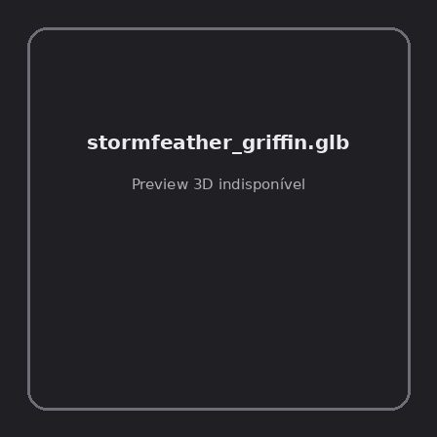
ID | NOV-005549
Origem | Asset novo
Pack/Fonte | Assets Organizados - Mounts
Categoria | Mounts / Stormfeather Griffin.Glb
Arquivo | stormfeather_griffin.glb
Caminho | 01_Assets_Organizados/Mounts/stormfeather_griffin.glb
Formato | GLB
Tamanho | 255.47 KB
SHA-256 | 32a487152ca276b4365d…
Status técnico | ERROR
Licença | MISSING_REVIEW_REQUIRED — sem evidência localizada
Objetos / meshes | N/D / N/D
Vértices | N/D
Faces / triângulos | N/D / N/D
Materiais | N/D —
UV sets / vertex colors | N/D / N/D
Dimensões XYZ | N/D
Rig / armatures / bones | N/D / N/D / N/D
Skinned meshes | N/D
Animações | N/D —
Duração total clips | N/D
Root motion detectado | N/D
LODs / colliders | Nenhum / Nenhum
Texturas vinculadas | N/D (0 ausentes)
Alertas | Licença/fonte não localizada automaticamente; revisão legal necessária. | Duplicado exato: grupo DUP-00721 (2 cópias).
Notas | Falha na inspeção 3D: RuntimeError: Error: Python: Traceback (most recent call last):  File "/usr/share/blender/scripts/addons/io_scene_gltf2/__init__.py", line 1064, in execute  return self.import_gltf2(context)  File "/usr/share/blender/scripts/addons/io_scene_gltf2/__init__.py", line 1083, in import_gltf2  return self.unit_import(self.filepath, import_settings)  File "/usr/share/blender/scripts/addons/io_scene_gltf2/__init__.py", line 1088, in unit_import  from .blender.imp.gltf2_blender_gltf import BlenderGlTF  File "/usr/share/blender/scripts/addons/io_scene_gltf2/blender/imp/gltf2_blender_gltf.py", line 17, in <module>  from .gltf2_blender_scene import BlenderScene  File "/usr/share/blender/scripts/addons/io_scene_gltf2/blender/imp/gltf2_blender_scene.py", line 17, in <module>  from .gltf2_blender_node import BlenderNode  File "/usr/share/blender/scripts/addons/io_scene_gltf2/blender/imp/gltf2_blender_node.py", line 18, in <module>  from .gltf2_blender_mesh import BlenderMesh  File "/usr/share/blender/scripts/addons/io_scene_gltf2/blender/imp/gltf2_blender_mesh.py", line 17, in <module>  import numpy as np  ModuleNotFoundError: No module named 'numpy'  location: /usr/share/blender/scripts/modules/bpy/ops.py:132  Traceback (most recent call last):  File "/home/runner/work/PSX_demons_whip/PSX_demons_whip/workspace/demons/tools/asset_catalog/blender_batch.py", line 427, in inspect_task  import_model(path)  File "/home/runner/work/PSX_demons_whip/PSX_demons_whip/workspace/demons/tools/asset_catalog/blender_batch.py", line 52, in import_model  bpy.ops.import_scene.gltf(filepath=str(path))  File "/usr/share/blender/scripts/modules/bpy/ops.py", line 132, in __call__  ret = _op_call(self.idname_py(), None, kw)  RuntimeError: Error: Python: Traceback (most recent call last):  File "/usr/share/blender/scripts/addons/io_scene_gltf2/__init__.py", line 1064, in execute  return self.import_gltf2(context)  File "/usr/share/blender/scripts/addons/io_scene_gltf2/__init__.py", line 1083, in import_gltf2  return self.unit_import(self.filepath, import_settings)  File "/usr/share/blender/scripts/addons/io_scene_gltf2/__init__.py", line 1088, in unit_import  from .blender.imp.gltf2_blender_gltf import BlenderGlTF  File "/usr/share/blender/scripts/addons/io_scene_gltf2/blender/imp/gltf2_blender_gltf.py", line 17, in <module>  from .gltf2_blender_scene import BlenderScene  File "/usr/share/blender/scripts/addons/io_scene_gltf2/blender/imp/gltf2_blender_scene.py", line 17, in <module>  from .gltf2_blender_node import BlenderNode  File "/usr/share/blender/scripts/addons/io_scene_gltf2/blender/imp/gltf2_blender_node.py", line 18, in <module>  from .gltf2_blender_mesh import BlenderMesh  File "/usr/share/blender/scripts/addons/io_scene_gltf2/blender/imp/gltf2_blender_mesh.py", line 17, in <module>  import numpy as np  ModuleNotFoundError: No module named 'numpy'  location: /usr/share/blender/scripts/modules/bpy/ops.py:132  | Metadados 3D reutilizados do duplicado idêntico TEM-001960.

NOV-005543 • terrorspark_groundshaker [ERROR]
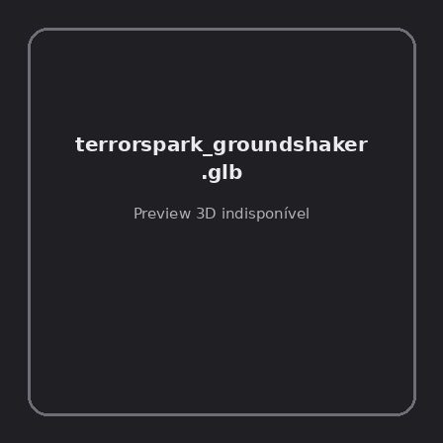
ID | NOV-005543
Origem | Asset novo
Pack/Fonte | Assets Organizados - Mounts
Categoria | Mounts / Terrorspark Groundshaker.Glb
Arquivo | terrorspark_groundshaker.glb
Caminho | 01_Assets_Organizados/Mounts/terrorspark_groundshaker.glb
Formato | GLB
Tamanho | 1.11 MB
SHA-256 | 2f42879b885debe52bf7…
Status técnico | ERROR
Licença | MISSING_REVIEW_REQUIRED — sem evidência localizada
Objetos / meshes | N/D / N/D
Vértices | N/D
Faces / triângulos | N/D / N/D
Materiais | N/D —
UV sets / vertex colors | N/D / N/D
Dimensões XYZ | N/D
Rig / armatures / bones | N/D / N/D / N/D
Skinned meshes | N/D
Animações | N/D —
Duração total clips | N/D
Root motion detectado | N/D
LODs / colliders | Nenhum / Nenhum
Texturas vinculadas | N/D (0 ausentes)
Alertas | Licença/fonte não localizada automaticamente; revisão legal necessária.
Notas | Falha na inspeção 3D: RuntimeError: Error: Python: Traceback (most recent call last):  File "/usr/share/blender/scripts/addons/io_scene_gltf2/__init__.py", line 1064, in execute  return self.import_gltf2(context)  File "/usr/share/blender/scripts/addons/io_scene_gltf2/__init__.py", line 1083, in import_gltf2  return self.unit_import(self.filepath, import_settings)  File "/usr/share/blender/scripts/addons/io_scene_gltf2/__init__.py", line 1088, in unit_import  from .blender.imp.gltf2_blender_gltf import BlenderGlTF  File "/usr/share/blender/scripts/addons/io_scene_gltf2/blender/imp/gltf2_blender_gltf.py", line 17, in <module>  from .gltf2_blender_scene import BlenderScene  File "/usr/share/blender/scripts/addons/io_scene_gltf2/blender/imp/gltf2_blender_scene.py", line 17, in <module>  from .gltf2_blender_node import BlenderNode  File "/usr/share/blender/scripts/addons/io_scene_gltf2/blender/imp/gltf2_blender_node.py", line 18, in <module>  from .gltf2_blender_mesh import BlenderMesh  File "/usr/share/blender/scripts/addons/io_scene_gltf2/blender/imp/gltf2_blender_mesh.py", line 17, in <module>  import numpy as np  ModuleNotFoundError: No module named 'numpy'  location: /usr/share/blender/scripts/modules/bpy/ops.py:132  Traceback (most recent call last):  File "/home/runner/work/PSX_demons_whip/PSX_demons_whip/workspace/demons/tools/asset_catalog/blender_batch.py", line 427, in inspect_task  import_model(path)  File "/home/runner/work/PSX_demons_whip/PSX_demons_whip/workspace/demons/tools/asset_catalog/blender_batch.py", line 52, in import_model  bpy.ops.import_scene.gltf(filepath=str(path))  File "/usr/share/blender/scripts/modules/bpy/ops.py", line 132, in __call__  ret = _op_call(self.idname_py(), None, kw)  RuntimeError: Error: Python: Traceback (most recent call last):  File "/usr/share/blender/scripts/addons/io_scene_gltf2/__init__.py", line 1064, in execute  return self.import_gltf2(context)  File "/usr/share/blender/scripts/addons/io_scene_gltf2/__init__.py", line 1083, in import_gltf2  return self.unit_import(self.filepath, import_settings)  File "/usr/share/blender/scripts/addons/io_scene_gltf2/__init__.py", line 1088, in unit_import  from .blender.imp.gltf2_blender_gltf import BlenderGlTF  File "/usr/share/blender/scripts/addons/io_scene_gltf2/blender/imp/gltf2_blender_gltf.py", line 17, in <module>  from .gltf2_blender_scene import BlenderScene  File "/usr/share/blender/scripts/addons/io_scene_gltf2/blender/imp/gltf2_blender_scene.py", line 17, in <module>  from .gltf2_blender_node import BlenderNode  File "/usr/share/blender/scripts/addons/io_scene_gltf2/blender/imp/gltf2_blender_node.py", line 18, in <module>  from .gltf2_blender_mesh import BlenderMesh  File "/usr/share/blender/scripts/addons/io_scene_gltf2/blender/imp/gltf2_blender_mesh.py", line 17, in <module>  import numpy as np  ModuleNotFoundError: No module named 'numpy'  location: /usr/share/blender/scripts/modules/bpy/ops.py:132

NOV-005551 • thunderstrut_gobbler [ERROR]
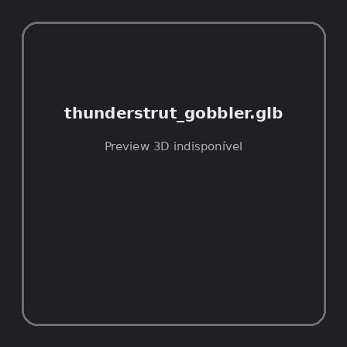
ID | NOV-005551
Origem | Asset novo
Pack/Fonte | Assets Organizados - Mounts
Categoria | Mounts / Thunderstrut Gobbler.Glb
Arquivo | thunderstrut_gobbler.glb
Caminho | 01_Assets_Organizados/Mounts/thunderstrut_gobbler.glb
Formato | GLB
Tamanho | 346.24 KB
SHA-256 | 14c562c1e2d9530a51d4…
Status técnico | ERROR
Licença | MISSING_REVIEW_REQUIRED — sem evidência localizada
Objetos / meshes | N/D / N/D
Vértices | N/D
Faces / triângulos | N/D / N/D
Materiais | N/D —
UV sets / vertex colors | N/D / N/D
Dimensões XYZ | N/D
Rig / armatures / bones | N/D / N/D / N/D
Skinned meshes | N/D
Animações | N/D —
Duração total clips | N/D
Root motion detectado | N/D
LODs / colliders | Nenhum / Nenhum
Texturas vinculadas | N/D (0 ausentes)
Alertas | Licença/fonte não localizada automaticamente; revisão legal necessária. | Duplicado exato: grupo DUP-00723 (2 cópias).
Notas | Falha na inspeção 3D: RuntimeError: Error: Python: Traceback (most recent call last):  File "/usr/share/blender/scripts/addons/io_scene_gltf2/__init__.py", line 1064, in execute  return self.import_gltf2(context)  File "/usr/share/blender/scripts/addons/io_scene_gltf2/__init__.py", line 1083, in import_gltf2  return self.unit_import(self.filepath, import_settings)  File "/usr/share/blender/scripts/addons/io_scene_gltf2/__init__.py", line 1088, in unit_import  from .blender.imp.gltf2_blender_gltf import BlenderGlTF  File "/usr/share/blender/scripts/addons/io_scene_gltf2/blender/imp/gltf2_blender_gltf.py", line 17, in <module>  from .gltf2_blender_scene import BlenderScene  File "/usr/share/blender/scripts/addons/io_scene_gltf2/blender/imp/gltf2_blender_scene.py", line 17, in <module>  from .gltf2_blender_node import BlenderNode  File "/usr/share/blender/scripts/addons/io_scene_gltf2/blender/imp/gltf2_blender_node.py", line 18, in <module>  from .gltf2_blender_mesh import BlenderMesh  File "/usr/share/blender/scripts/addons/io_scene_gltf2/blender/imp/gltf2_blender_mesh.py", line 17, in <module>  import numpy as np  ModuleNotFoundError: No module named 'numpy'  location: /usr/share/blender/scripts/modules/bpy/ops.py:132  Traceback (most recent call last):  File "/home/runner/work/PSX_demons_whip/PSX_demons_whip/workspace/demons/tools/asset_catalog/blender_batch.py", line 427, in inspect_task  import_model(path)  File "/home/runner/work/PSX_demons_whip/PSX_demons_whip/workspace/demons/tools/asset_catalog/blender_batch.py", line 52, in import_model  bpy.ops.import_scene.gltf(filepath=str(path))  File "/usr/share/blender/scripts/modules/bpy/ops.py", line 132, in __call__  ret = _op_call(self.idname_py(), None, kw)  RuntimeError: Error: Python: Traceback (most recent call last):  File "/usr/share/blender/scripts/addons/io_scene_gltf2/__init__.py", line 1064, in execute  return self.import_gltf2(context)  File "/usr/share/blender/scripts/addons/io_scene_gltf2/__init__.py", line 1083, in import_gltf2  return self.unit_import(self.filepath, import_settings)  File "/usr/share/blender/scripts/addons/io_scene_gltf2/__init__.py", line 1088, in unit_import  from .blender.imp.gltf2_blender_gltf import BlenderGlTF  File "/usr/share/blender/scripts/addons/io_scene_gltf2/blender/imp/gltf2_blender_gltf.py", line 17, in <module>  from .gltf2_blender_scene import BlenderScene  File "/usr/share/blender/scripts/addons/io_scene_gltf2/blender/imp/gltf2_blender_scene.py", line 17, in <module>  from .gltf2_blender_node import BlenderNode  File "/usr/share/blender/scripts/addons/io_scene_gltf2/blender/imp/gltf2_blender_node.py", line 18, in <module>  from .gltf2_blender_mesh import BlenderMesh  File "/usr/share/blender/scripts/addons/io_scene_gltf2/blender/imp/gltf2_blender_mesh.py", line 17, in <module>  import numpy as np  ModuleNotFoundError: No module named 'numpy'  location: /usr/share/blender/scripts/modules/bpy/ops.py:132  | Metadados 3D reutilizados do duplicado idêntico TEM-001962.

NOV-005545 • valorsteed [ERROR]
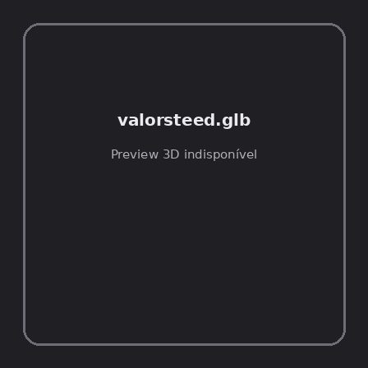
ID | NOV-005545
Origem | Asset novo
Pack/Fonte | Assets Organizados - Mounts
Categoria | Mounts / Valorsteed.Glb
Arquivo | valorsteed.glb
Caminho | 01_Assets_Organizados/Mounts/valorsteed.glb
Formato | GLB
Tamanho | 561.73 KB
SHA-256 | d63c2617a0900f8cb9fc…
Status técnico | ERROR
Licença | MISSING_REVIEW_REQUIRED — sem evidência localizada
Objetos / meshes | N/D / N/D
Vértices | N/D
Faces / triângulos | N/D / N/D
Materiais | N/D —
UV sets / vertex colors | N/D / N/D
Dimensões XYZ | N/D
Rig / armatures / bones | N/D / N/D / N/D
Skinned meshes | N/D
Animações | N/D —
Duração total clips | N/D
Root motion detectado | N/D
LODs / colliders | Nenhum / Nenhum
Texturas vinculadas | N/D (0 ausentes)
Alertas | Licença/fonte não localizada automaticamente; revisão legal necessária. | Duplicado exato: grupo DUP-00717 (2 cópias).
Notas | Falha na inspeção 3D: RuntimeError: Error: Python: Traceback (most recent call last):  File "/usr/share/blender/scripts/addons/io_scene_gltf2/__init__.py", line 1064, in execute  return self.import_gltf2(context)  File "/usr/share/blender/scripts/addons/io_scene_gltf2/__init__.py", line 1083, in import_gltf2  return self.unit_import(self.filepath, import_settings)  File "/usr/share/blender/scripts/addons/io_scene_gltf2/__init__.py", line 1088, in unit_import  from .blender.imp.gltf2_blender_gltf import BlenderGlTF  File "/usr/share/blender/scripts/addons/io_scene_gltf2/blender/imp/gltf2_blender_gltf.py", line 17, in <module>  from .gltf2_blender_scene import BlenderScene  File "/usr/share/blender/scripts/addons/io_scene_gltf2/blender/imp/gltf2_blender_scene.py", line 17, in <module>  from .gltf2_blender_node import BlenderNode  File "/usr/share/blender/scripts/addons/io_scene_gltf2/blender/imp/gltf2_blender_node.py", line 18, in <module>  from .gltf2_blender_mesh import BlenderMesh  File "/usr/share/blender/scripts/addons/io_scene_gltf2/blender/imp/gltf2_blender_mesh.py", line 17, in <module>  import numpy as np  ModuleNotFoundError: No module named 'numpy'  location: /usr/share/blender/scripts/modules/bpy/ops.py:132  Traceback (most recent call last):  File "/home/runner/work/PSX_demons_whip/PSX_demons_whip/workspace/demons/tools/asset_catalog/blender_batch.py", line 427, in inspect_task  import_model(path)  File "/home/runner/work/PSX_demons_whip/PSX_demons_whip/workspace/demons/tools/asset_catalog/blender_batch.py", line 52, in import_model  bpy.ops.import_scene.gltf(filepath=str(path))  File "/usr/share/blender/scripts/modules/bpy/ops.py", line 132, in __call__  ret = _op_call(self.idname_py(), None, kw)  RuntimeError: Error: Python: Traceback (most recent call last):  File "/usr/share/blender/scripts/addons/io_scene_gltf2/__init__.py", line 1064, in execute  return self.import_gltf2(context)  File "/usr/share/blender/scripts/addons/io_scene_gltf2/__init__.py", line 1083, in import_gltf2  return self.unit_import(self.filepath, import_settings)  File "/usr/share/blender/scripts/addons/io_scene_gltf2/__init__.py", line 1088, in unit_import  from .blender.imp.gltf2_blender_gltf import BlenderGlTF  File "/usr/share/blender/scripts/addons/io_scene_gltf2/blender/imp/gltf2_blender_gltf.py", line 17, in <module>  from .gltf2_blender_scene import BlenderScene  File "/usr/share/blender/scripts/addons/io_scene_gltf2/blender/imp/gltf2_blender_scene.py", line 17, in <module>  from .gltf2_blender_node import BlenderNode  File "/usr/share/blender/scripts/addons/io_scene_gltf2/blender/imp/gltf2_blender_node.py", line 18, in <module>  from .gltf2_blender_mesh import BlenderMesh  File "/usr/share/blender/scripts/addons/io_scene_gltf2/blender/imp/gltf2_blender_mesh.py", line 17, in <module>  import numpy as np  ModuleNotFoundError: No module named 'numpy'  location: /usr/share/blender/scripts/modules/bpy/ops.py:132  | Metadados 3D reutilizados do duplicado idêntico TEM-001956.

