DEMONS WHIP - NOVO - NATURE
MODEL 3D • Volume 4 de 5

Assets neste volume: 70
Origem: NOVO
Gerado em: 2026-08-17T19:04:35+00:00

NOV-004571 • bush03 [ERROR]
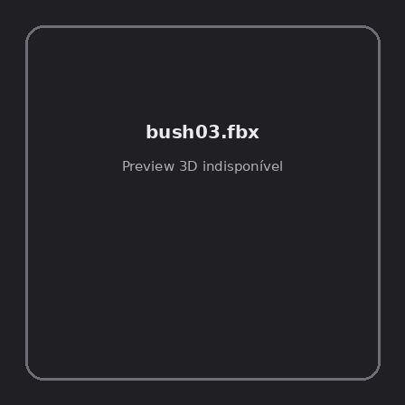
ID | NOV-004571
Origem | Asset novo
Pack/Fonte | retro_nature_pack
Categoria | Nature / Models
Arquivo | bush03.fbx
Caminho | 00_Packs_Raw/retro_nature_pack/models/FBX/bushes/bush03.fbx
Formato | FBX
Tamanho | 22.81 KB
SHA-256 | 89b99d1d065d517a7ac0…
Status técnico | ERROR
Licença | MISSING_REVIEW_REQUIRED — sem evidência localizada
Objetos / meshes | N/D / N/D
Vértices | N/D
Faces / triângulos | N/D / N/D
Materiais | N/D —
UV sets / vertex colors | N/D / N/D
Dimensões XYZ | N/D
Rig / armatures / bones | N/D / N/D / N/D
Skinned meshes | N/D
Animações | N/D —
Duração total clips | N/D
Root motion detectado | N/D
LODs / colliders | Nenhum / Nenhum
Texturas vinculadas | N/D (0 ausentes)
Alertas | Licença/fonte não localizada automaticamente; revisão legal necessária.
Notas | Falha na inspeção 3D: Unable to open a display

NOV-004567 • bush03_winter [ERROR]
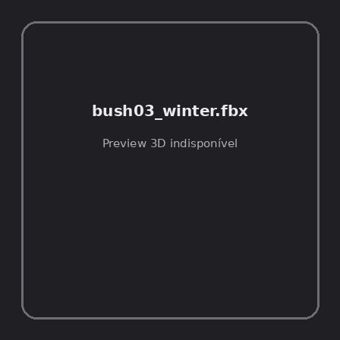
ID | NOV-004567
Origem | Asset novo
Pack/Fonte | retro_nature_pack
Categoria | Nature / Models
Arquivo | bush03_winter.fbx
Caminho | 00_Packs_Raw/retro_nature_pack/models/FBX/bushes/bush03_winter.fbx
Formato | FBX
Tamanho | 15.53 KB
SHA-256 | cd3f451b7b62e0e5ddf1…
Status técnico | ERROR
Licença | MISSING_REVIEW_REQUIRED — sem evidência localizada
Objetos / meshes | N/D / N/D
Vértices | N/D
Faces / triângulos | N/D / N/D
Materiais | N/D —
UV sets / vertex colors | N/D / N/D
Dimensões XYZ | N/D
Rig / armatures / bones | N/D / N/D / N/D
Skinned meshes | N/D
Animações | N/D —
Duração total clips | N/D
Root motion detectado | N/D
LODs / colliders | Nenhum / Nenhum
Texturas vinculadas | N/D (0 ausentes)
Alertas | Licença/fonte não localizada automaticamente; revisão legal necessária.
Notas | Falha na inspeção 3D: Unable to open a display

NOV-004562 • bush04 [ERROR]
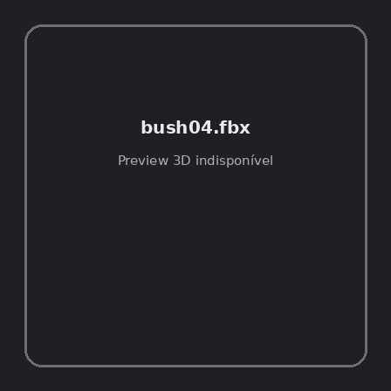
ID | NOV-004562
Origem | Asset novo
Pack/Fonte | retro_nature_pack
Categoria | Nature / Models
Arquivo | bush04.fbx
Caminho | 00_Packs_Raw/retro_nature_pack/models/FBX/bushes/bush04.fbx
Formato | FBX
Tamanho | 23.79 KB
SHA-256 | 4d528b56c04590fa2b08…
Status técnico | ERROR
Licença | MISSING_REVIEW_REQUIRED — sem evidência localizada
Objetos / meshes | N/D / N/D
Vértices | N/D
Faces / triângulos | N/D / N/D
Materiais | N/D —
UV sets / vertex colors | N/D / N/D
Dimensões XYZ | N/D
Rig / armatures / bones | N/D / N/D / N/D
Skinned meshes | N/D
Animações | N/D —
Duração total clips | N/D
Root motion detectado | N/D
LODs / colliders | Nenhum / Nenhum
Texturas vinculadas | N/D (0 ausentes)
Alertas | Licença/fonte não localizada automaticamente; revisão legal necessária.
Notas | Falha na inspeção 3D: Unable to open a display

NOV-004561 • bush04_winter [ERROR]
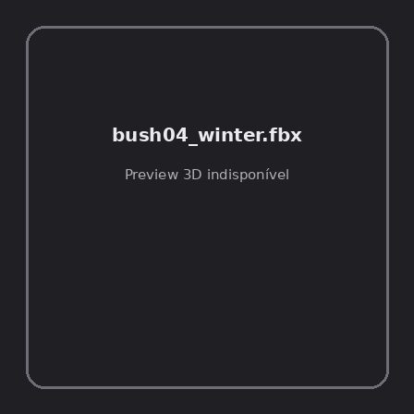
ID | NOV-004561
Origem | Asset novo
Pack/Fonte | retro_nature_pack
Categoria | Nature / Models
Arquivo | bush04_winter.fbx
Caminho | 00_Packs_Raw/retro_nature_pack/models/FBX/bushes/bush04_winter.fbx
Formato | FBX
Tamanho | 15.43 KB
SHA-256 | d3fd162a4c4eb9e17ca2…
Status técnico | ERROR
Licença | MISSING_REVIEW_REQUIRED — sem evidência localizada
Objetos / meshes | N/D / N/D
Vértices | N/D
Faces / triângulos | N/D / N/D
Materiais | N/D —
UV sets / vertex colors | N/D / N/D
Dimensões XYZ | N/D
Rig / armatures / bones | N/D / N/D / N/D
Skinned meshes | N/D
Animações | N/D —
Duração total clips | N/D
Root motion detectado | N/D
LODs / colliders | Nenhum / Nenhum
Texturas vinculadas | N/D (0 ausentes)
Alertas | Licença/fonte não localizada automaticamente; revisão legal necessária.
Notas | Falha na inspeção 3D: Unable to open a display

NOV-004564 • bush05 [ERROR]
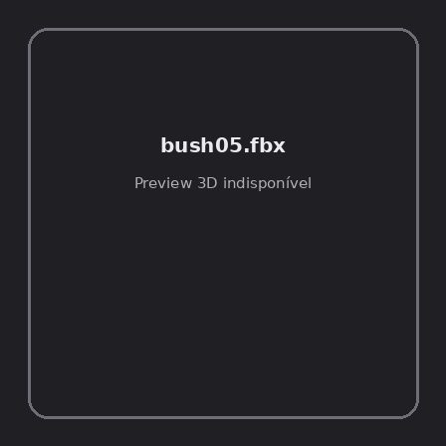
ID | NOV-004564
Origem | Asset novo
Pack/Fonte | retro_nature_pack
Categoria | Nature / Models
Arquivo | bush05.fbx
Caminho | 00_Packs_Raw/retro_nature_pack/models/FBX/bushes/bush05.fbx
Formato | FBX
Tamanho | 24.15 KB
SHA-256 | 71df8254a35a51ecfba1…
Status técnico | ERROR
Licença | MISSING_REVIEW_REQUIRED — sem evidência localizada
Objetos / meshes | N/D / N/D
Vértices | N/D
Faces / triângulos | N/D / N/D
Materiais | N/D —
UV sets / vertex colors | N/D / N/D
Dimensões XYZ | N/D
Rig / armatures / bones | N/D / N/D / N/D
Skinned meshes | N/D
Animações | N/D —
Duração total clips | N/D
Root motion detectado | N/D
LODs / colliders | Nenhum / Nenhum
Texturas vinculadas | N/D (0 ausentes)
Alertas | Licença/fonte não localizada automaticamente; revisão legal necessária.
Notas | Falha na inspeção 3D: Unable to open a display

NOV-004569 • bush05_winter [ERROR]
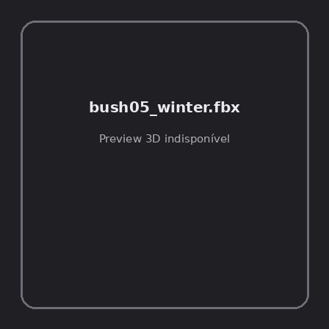
ID | NOV-004569
Origem | Asset novo
Pack/Fonte | retro_nature_pack
Categoria | Nature / Models
Arquivo | bush05_winter.fbx
Caminho | 00_Packs_Raw/retro_nature_pack/models/FBX/bushes/bush05_winter.fbx
Formato | FBX
Tamanho | 15.98 KB
SHA-256 | 63f0ef30f0626b094c91…
Status técnico | ERROR
Licença | MISSING_REVIEW_REQUIRED — sem evidência localizada
Objetos / meshes | N/D / N/D
Vértices | N/D
Faces / triângulos | N/D / N/D
Materiais | N/D —
UV sets / vertex colors | N/D / N/D
Dimensões XYZ | N/D
Rig / armatures / bones | N/D / N/D / N/D
Skinned meshes | N/D
Animações | N/D —
Duração total clips | N/D
Root motion detectado | N/D
LODs / colliders | Nenhum / Nenhum
Texturas vinculadas | N/D (0 ausentes)
Alertas | Licença/fonte não localizada automaticamente; revisão legal necessária.
Notas | Falha na inspeção 3D: Unable to open a display

NOV-004563 • bush06 [ERROR]
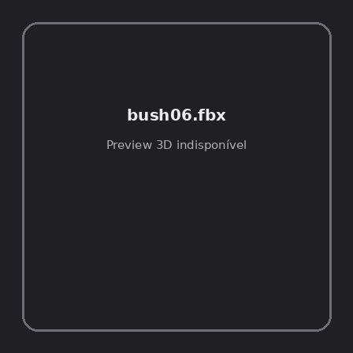
ID | NOV-004563
Origem | Asset novo
Pack/Fonte | retro_nature_pack
Categoria | Nature / Models
Arquivo | bush06.fbx
Caminho | 00_Packs_Raw/retro_nature_pack/models/FBX/bushes/bush06.fbx
Formato | FBX
Tamanho | 24.25 KB
SHA-256 | 981a368bc684bc3f01d8…
Status técnico | ERROR
Licença | MISSING_REVIEW_REQUIRED — sem evidência localizada
Objetos / meshes | N/D / N/D
Vértices | N/D
Faces / triângulos | N/D / N/D
Materiais | N/D —
UV sets / vertex colors | N/D / N/D
Dimensões XYZ | N/D
Rig / armatures / bones | N/D / N/D / N/D
Skinned meshes | N/D
Animações | N/D —
Duração total clips | N/D
Root motion detectado | N/D
LODs / colliders | Nenhum / Nenhum
Texturas vinculadas | N/D (0 ausentes)
Alertas | Licença/fonte não localizada automaticamente; revisão legal necessária.
Notas | Falha na inspeção 3D: Unable to open a display

NOV-004559 • bush06_winter [ERROR]
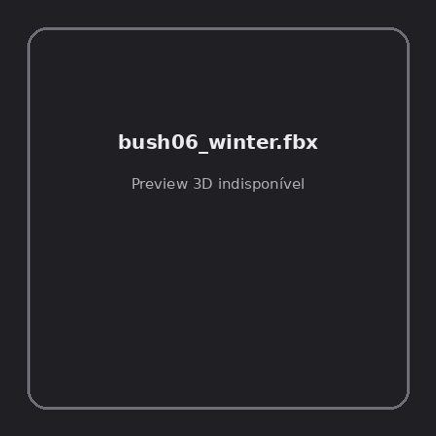
ID | NOV-004559
Origem | Asset novo
Pack/Fonte | retro_nature_pack
Categoria | Nature / Models
Arquivo | bush06_winter.fbx
Caminho | 00_Packs_Raw/retro_nature_pack/models/FBX/bushes/bush06_winter.fbx
Formato | FBX
Tamanho | 15.40 KB
SHA-256 | e49e83d890385c84f9d7…
Status técnico | ERROR
Licença | MISSING_REVIEW_REQUIRED — sem evidência localizada
Objetos / meshes | N/D / N/D
Vértices | N/D
Faces / triângulos | N/D / N/D
Materiais | N/D —
UV sets / vertex colors | N/D / N/D
Dimensões XYZ | N/D
Rig / armatures / bones | N/D / N/D / N/D
Skinned meshes | N/D
Animações | N/D —
Duração total clips | N/D
Root motion detectado | N/D
LODs / colliders | Nenhum / Nenhum
Texturas vinculadas | N/D (0 ausentes)
Alertas | Licença/fonte não localizada automaticamente; revisão legal necessária.
Notas | Falha na inspeção 3D: Unable to open a display

NOV-004570 • bush07 [ERROR]
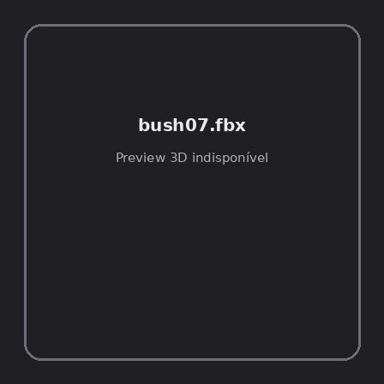
ID | NOV-004570
Origem | Asset novo
Pack/Fonte | retro_nature_pack
Categoria | Nature / Models
Arquivo | bush07.fbx
Caminho | 00_Packs_Raw/retro_nature_pack/models/FBX/bushes/bush07.fbx
Formato | FBX
Tamanho | 24.17 KB
SHA-256 | c6d00b66cb3338a93977…
Status técnico | ERROR
Licença | MISSING_REVIEW_REQUIRED — sem evidência localizada
Objetos / meshes | N/D / N/D
Vértices | N/D
Faces / triângulos | N/D / N/D
Materiais | N/D —
UV sets / vertex colors | N/D / N/D
Dimensões XYZ | N/D
Rig / armatures / bones | N/D / N/D / N/D
Skinned meshes | N/D
Animações | N/D —
Duração total clips | N/D
Root motion detectado | N/D
LODs / colliders | Nenhum / Nenhum
Texturas vinculadas | N/D (0 ausentes)
Alertas | Licença/fonte não localizada automaticamente; revisão legal necessária.
Notas | Falha na inspeção 3D: Unable to open a display

NOV-004560 • bush08 [ERROR]
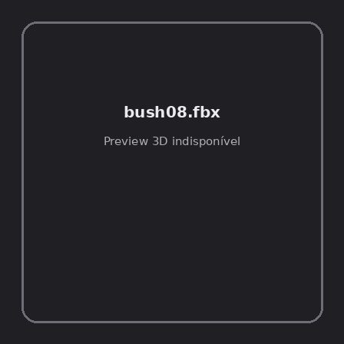
ID | NOV-004560
Origem | Asset novo
Pack/Fonte | retro_nature_pack
Categoria | Nature / Models
Arquivo | bush08.fbx
Caminho | 00_Packs_Raw/retro_nature_pack/models/FBX/bushes/bush08.fbx
Formato | FBX
Tamanho | 25.32 KB
SHA-256 | 0da6f51e9a6ed54cbc00…
Status técnico | ERROR
Licença | MISSING_REVIEW_REQUIRED — sem evidência localizada
Objetos / meshes | N/D / N/D
Vértices | N/D
Faces / triângulos | N/D / N/D
Materiais | N/D —
UV sets / vertex colors | N/D / N/D
Dimensões XYZ | N/D
Rig / armatures / bones | N/D / N/D / N/D
Skinned meshes | N/D
Animações | N/D —
Duração total clips | N/D
Root motion detectado | N/D
LODs / colliders | Nenhum / Nenhum
Texturas vinculadas | N/D (0 ausentes)
Alertas | Licença/fonte não localizada automaticamente; revisão legal necessária.
Notas | Falha na inspeção 3D: Unable to open a display

NOV-004596 • grass01 [ERROR]
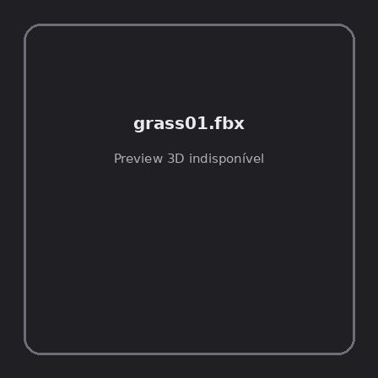
ID | NOV-004596
Origem | Asset novo
Pack/Fonte | retro_nature_pack
Categoria | Nature / Models
Arquivo | grass01.fbx
Caminho | 00_Packs_Raw/retro_nature_pack/models/FBX/grass/grass01.fbx
Formato | FBX
Tamanho | 14.53 KB
SHA-256 | 01767ffb0ae034c0db3f…
Status técnico | ERROR
Licença | MISSING_REVIEW_REQUIRED — sem evidência localizada
Objetos / meshes | N/D / N/D
Vértices | N/D
Faces / triângulos | N/D / N/D
Materiais | N/D —
UV sets / vertex colors | N/D / N/D
Dimensões XYZ | N/D
Rig / armatures / bones | N/D / N/D / N/D
Skinned meshes | N/D
Animações | N/D —
Duração total clips | N/D
Root motion detectado | N/D
LODs / colliders | Nenhum / Nenhum
Texturas vinculadas | N/D (0 ausentes)
Alertas | Licença/fonte não localizada automaticamente; revisão legal necessária.
Notas | Falha na inspeção 3D: Unable to open a display

NOV-004597 • grass02 [ERROR]
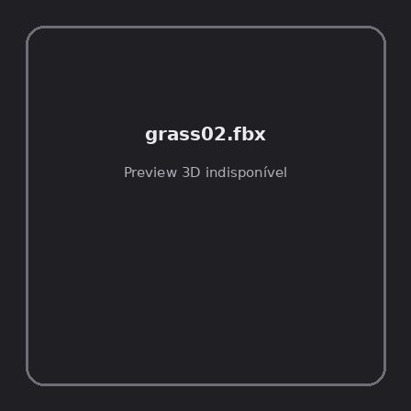
ID | NOV-004597
Origem | Asset novo
Pack/Fonte | retro_nature_pack
Categoria | Nature / Models
Arquivo | grass02.fbx
Caminho | 00_Packs_Raw/retro_nature_pack/models/FBX/grass/grass02.fbx
Formato | FBX
Tamanho | 15.12 KB
SHA-256 | 2a81cf5561457d8bd4dd…
Status técnico | ERROR
Licença | MISSING_REVIEW_REQUIRED — sem evidência localizada
Objetos / meshes | N/D / N/D
Vértices | N/D
Faces / triângulos | N/D / N/D
Materiais | N/D —
UV sets / vertex colors | N/D / N/D
Dimensões XYZ | N/D
Rig / armatures / bones | N/D / N/D / N/D
Skinned meshes | N/D
Animações | N/D —
Duração total clips | N/D
Root motion detectado | N/D
LODs / colliders | Nenhum / Nenhum
Texturas vinculadas | N/D (0 ausentes)
Alertas | Licença/fonte não localizada automaticamente; revisão legal necessária.
Notas | Falha na inspeção 3D: Unable to open a display

NOV-004598 • grass03 [ERROR]
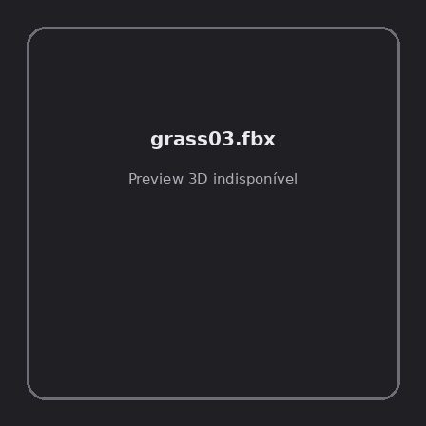
ID | NOV-004598
Origem | Asset novo
Pack/Fonte | retro_nature_pack
Categoria | Nature / Models
Arquivo | grass03.fbx
Caminho | 00_Packs_Raw/retro_nature_pack/models/FBX/grass/grass03.fbx
Formato | FBX
Tamanho | 15.11 KB
SHA-256 | 05a85eab483e03821463…
Status técnico | ERROR
Licença | MISSING_REVIEW_REQUIRED — sem evidência localizada
Objetos / meshes | N/D / N/D
Vértices | N/D
Faces / triângulos | N/D / N/D
Materiais | N/D —
UV sets / vertex colors | N/D / N/D
Dimensões XYZ | N/D
Rig / armatures / bones | N/D / N/D / N/D
Skinned meshes | N/D
Animações | N/D —
Duração total clips | N/D
Root motion detectado | N/D
LODs / colliders | Nenhum / Nenhum
Texturas vinculadas | N/D (0 ausentes)
Alertas | Licença/fonte não localizada automaticamente; revisão legal necessária.
Notas | Falha na inspeção 3D: Unable to open a display

NOV-004591 • grass04 [ERROR]
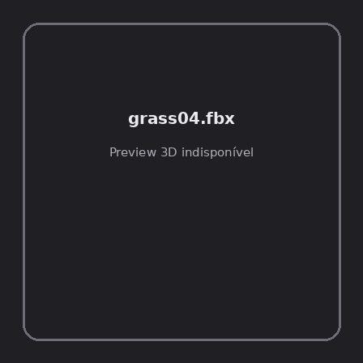
ID | NOV-004591
Origem | Asset novo
Pack/Fonte | retro_nature_pack
Categoria | Nature / Models
Arquivo | grass04.fbx
Caminho | 00_Packs_Raw/retro_nature_pack/models/FBX/grass/grass04.fbx
Formato | FBX
Tamanho | 15.14 KB
SHA-256 | feceddbc6966234d7b84…
Status técnico | ERROR
Licença | MISSING_REVIEW_REQUIRED — sem evidência localizada
Objetos / meshes | N/D / N/D
Vértices | N/D
Faces / triângulos | N/D / N/D
Materiais | N/D —
UV sets / vertex colors | N/D / N/D
Dimensões XYZ | N/D
Rig / armatures / bones | N/D / N/D / N/D
Skinned meshes | N/D
Animações | N/D —
Duração total clips | N/D
Root motion detectado | N/D
LODs / colliders | Nenhum / Nenhum
Texturas vinculadas | N/D (0 ausentes)
Alertas | Licença/fonte não localizada automaticamente; revisão legal necessária.
Notas | Falha na inspeção 3D: Unable to open a display

NOV-004589 • grass05 [ERROR]
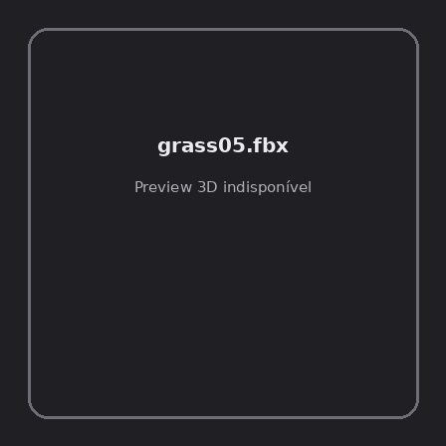
ID | NOV-004589
Origem | Asset novo
Pack/Fonte | retro_nature_pack
Categoria | Nature / Models
Arquivo | grass05.fbx
Caminho | 00_Packs_Raw/retro_nature_pack/models/FBX/grass/grass05.fbx
Formato | FBX
Tamanho | 15.12 KB
SHA-256 | 5b01f566a3ff17fa9bd7…
Status técnico | ERROR
Licença | MISSING_REVIEW_REQUIRED — sem evidência localizada
Objetos / meshes | N/D / N/D
Vértices | N/D
Faces / triângulos | N/D / N/D
Materiais | N/D —
UV sets / vertex colors | N/D / N/D
Dimensões XYZ | N/D
Rig / armatures / bones | N/D / N/D / N/D
Skinned meshes | N/D
Animações | N/D —
Duração total clips | N/D
Root motion detectado | N/D
LODs / colliders | Nenhum / Nenhum
Texturas vinculadas | N/D (0 ausentes)
Alertas | Licença/fonte não localizada automaticamente; revisão legal necessária.
Notas | Falha na inspeção 3D: Unable to open a display

NOV-004595 • grass06 [ERROR]
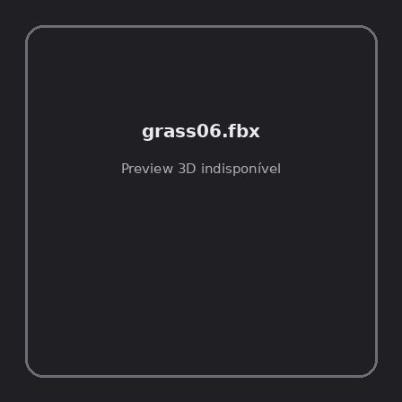
ID | NOV-004595
Origem | Asset novo
Pack/Fonte | retro_nature_pack
Categoria | Nature / Models
Arquivo | grass06.fbx
Caminho | 00_Packs_Raw/retro_nature_pack/models/FBX/grass/grass06.fbx
Formato | FBX
Tamanho | 15.17 KB
SHA-256 | ac7bffcf7b71dde01b70…
Status técnico | ERROR
Licença | MISSING_REVIEW_REQUIRED — sem evidência localizada
Objetos / meshes | N/D / N/D
Vértices | N/D
Faces / triângulos | N/D / N/D
Materiais | N/D —
UV sets / vertex colors | N/D / N/D
Dimensões XYZ | N/D
Rig / armatures / bones | N/D / N/D / N/D
Skinned meshes | N/D
Animações | N/D —
Duração total clips | N/D
Root motion detectado | N/D
LODs / colliders | Nenhum / Nenhum
Texturas vinculadas | N/D (0 ausentes)
Alertas | Licença/fonte não localizada automaticamente; revisão legal necessária.
Notas | Falha na inspeção 3D: Unable to open a display

NOV-004588 • grass07 [ERROR]
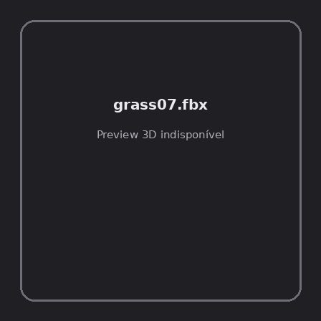
ID | NOV-004588
Origem | Asset novo
Pack/Fonte | retro_nature_pack
Categoria | Nature / Models
Arquivo | grass07.fbx
Caminho | 00_Packs_Raw/retro_nature_pack/models/FBX/grass/grass07.fbx
Formato | FBX
Tamanho | 15.12 KB
SHA-256 | 13ece1d15d2f94bcf3d5…
Status técnico | ERROR
Licença | MISSING_REVIEW_REQUIRED — sem evidência localizada
Objetos / meshes | N/D / N/D
Vértices | N/D
Faces / triângulos | N/D / N/D
Materiais | N/D —
UV sets / vertex colors | N/D / N/D
Dimensões XYZ | N/D
Rig / armatures / bones | N/D / N/D / N/D
Skinned meshes | N/D
Animações | N/D —
Duração total clips | N/D
Root motion detectado | N/D
LODs / colliders | Nenhum / Nenhum
Texturas vinculadas | N/D (0 ausentes)
Alertas | Licença/fonte não localizada automaticamente; revisão legal necessária.
Notas | Falha na inspeção 3D: Unable to open a display

NOV-004593 • grass08 [ERROR]
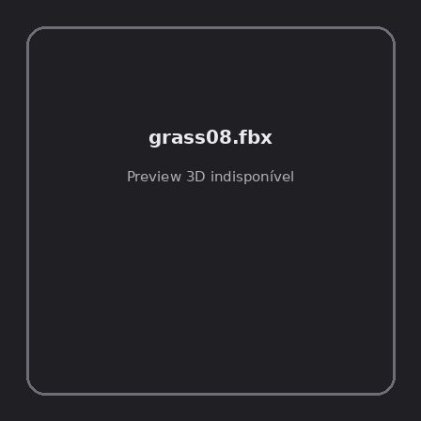
ID | NOV-004593
Origem | Asset novo
Pack/Fonte | retro_nature_pack
Categoria | Nature / Models
Arquivo | grass08.fbx
Caminho | 00_Packs_Raw/retro_nature_pack/models/FBX/grass/grass08.fbx
Formato | FBX
Tamanho | 15.14 KB
SHA-256 | e679f6dc45aba8011c23…
Status técnico | ERROR
Licença | MISSING_REVIEW_REQUIRED — sem evidência localizada
Objetos / meshes | N/D / N/D
Vértices | N/D
Faces / triângulos | N/D / N/D
Materiais | N/D —
UV sets / vertex colors | N/D / N/D
Dimensões XYZ | N/D
Rig / armatures / bones | N/D / N/D / N/D
Skinned meshes | N/D
Animações | N/D —
Duração total clips | N/D
Root motion detectado | N/D
LODs / colliders | Nenhum / Nenhum
Texturas vinculadas | N/D (0 ausentes)
Alertas | Licença/fonte não localizada automaticamente; revisão legal necessária.
Notas | Falha na inspeção 3D: Unable to open a display

NOV-004594 • grass09 [ERROR]
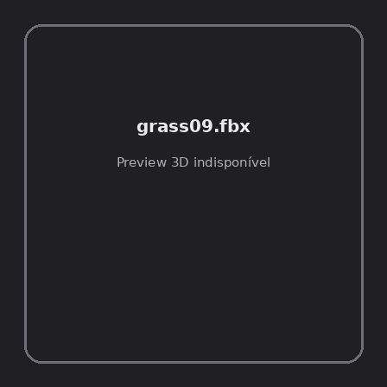
ID | NOV-004594
Origem | Asset novo
Pack/Fonte | retro_nature_pack
Categoria | Nature / Models
Arquivo | grass09.fbx
Caminho | 00_Packs_Raw/retro_nature_pack/models/FBX/grass/grass09.fbx
Formato | FBX
Tamanho | 14.98 KB
SHA-256 | 7c5697c2953a5ae8b7bb…
Status técnico | ERROR
Licença | MISSING_REVIEW_REQUIRED — sem evidência localizada
Objetos / meshes | N/D / N/D
Vértices | N/D
Faces / triângulos | N/D / N/D
Materiais | N/D —
UV sets / vertex colors | N/D / N/D
Dimensões XYZ | N/D
Rig / armatures / bones | N/D / N/D / N/D
Skinned meshes | N/D
Animações | N/D —
Duração total clips | N/D
Root motion detectado | N/D
LODs / colliders | Nenhum / Nenhum
Texturas vinculadas | N/D (0 ausentes)
Alertas | Licença/fonte não localizada automaticamente; revisão legal necessária.
Notas | Falha na inspeção 3D: Unable to open a display

NOV-004587 • grass_bush [ERROR]
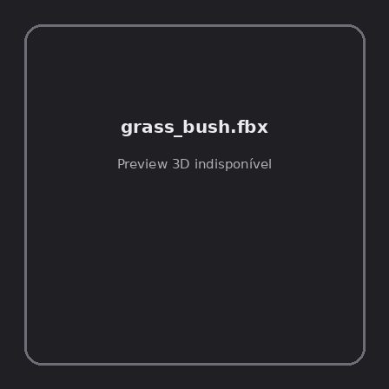
ID | NOV-004587
Origem | Asset novo
Pack/Fonte | retro_nature_pack
Categoria | Nature / Models
Arquivo | grass_bush.fbx
Caminho | 00_Packs_Raw/retro_nature_pack/models/FBX/grass/grass_bush.fbx
Formato | FBX
Tamanho | 15.89 KB
SHA-256 | 435649b8a7ff7c72228b…
Status técnico | ERROR
Licença | MISSING_REVIEW_REQUIRED — sem evidência localizada
Objetos / meshes | N/D / N/D
Vértices | N/D
Faces / triângulos | N/D / N/D
Materiais | N/D —
UV sets / vertex colors | N/D / N/D
Dimensões XYZ | N/D
Rig / armatures / bones | N/D / N/D / N/D
Skinned meshes | N/D
Animações | N/D —
Duração total clips | N/D
Root motion detectado | N/D
LODs / colliders | Nenhum / Nenhum
Texturas vinculadas | N/D (0 ausentes)
Alertas | Licença/fonte não localizada automaticamente; revisão legal necessária.
Notas | Falha na inspeção 3D: Unable to open a display

NOV-004592 • grass_patch [ERROR]
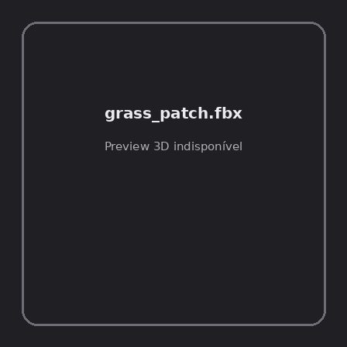
ID | NOV-004592
Origem | Asset novo
Pack/Fonte | retro_nature_pack
Categoria | Nature / Models
Arquivo | grass_patch.fbx
Caminho | 00_Packs_Raw/retro_nature_pack/models/FBX/grass/grass_patch.fbx
Formato | FBX
Tamanho | 24.51 KB
SHA-256 | 506bb6e17fbcd84de587…
Status técnico | ERROR
Licença | MISSING_REVIEW_REQUIRED — sem evidência localizada
Objetos / meshes | N/D / N/D
Vértices | N/D
Faces / triângulos | N/D / N/D
Materiais | N/D —
UV sets / vertex colors | N/D / N/D
Dimensões XYZ | N/D
Rig / armatures / bones | N/D / N/D / N/D
Skinned meshes | N/D
Animações | N/D —
Duração total clips | N/D
Root motion detectado | N/D
LODs / colliders | Nenhum / Nenhum
Texturas vinculadas | N/D (0 ausentes)
Alertas | Licença/fonte não localizada automaticamente; revisão legal necessária.
Notas | Falha na inspeção 3D: Unable to open a display

NOV-004590 • grass_patch_corner [ERROR]
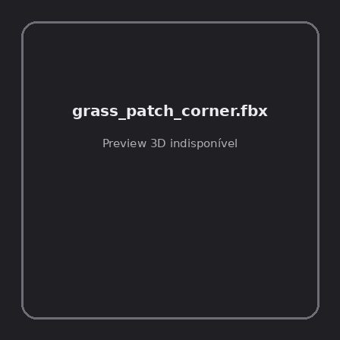
ID | NOV-004590
Origem | Asset novo
Pack/Fonte | retro_nature_pack
Categoria | Nature / Models
Arquivo | grass_patch_corner.fbx
Caminho | 00_Packs_Raw/retro_nature_pack/models/FBX/grass/grass_patch_corner.fbx
Formato | FBX
Tamanho | 26.42 KB
SHA-256 | 51d849e2f923654aff37…
Status técnico | ERROR
Licença | MISSING_REVIEW_REQUIRED — sem evidência localizada
Objetos / meshes | N/D / N/D
Vértices | N/D
Faces / triângulos | N/D / N/D
Materiais | N/D —
UV sets / vertex colors | N/D / N/D
Dimensões XYZ | N/D
Rig / armatures / bones | N/D / N/D / N/D
Skinned meshes | N/D
Animações | N/D —
Duração total clips | N/D
Root motion detectado | N/D
LODs / colliders | Nenhum / Nenhum
Texturas vinculadas | N/D (0 ausentes)
Alertas | Licença/fonte não localizada automaticamente; revisão legal necessária.
Notas | Falha na inspeção 3D: Unable to open a display

NOV-004581 • tree01 [ERROR]
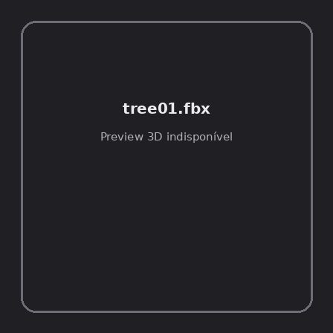
ID | NOV-004581
Origem | Asset novo
Pack/Fonte | retro_nature_pack
Categoria | Nature / Models
Arquivo | tree01.fbx
Caminho | 00_Packs_Raw/retro_nature_pack/models/FBX/trees/tree01.fbx
Formato | FBX
Tamanho | 28.62 KB
SHA-256 | 66ad96e96a811c8af28b…
Status técnico | ERROR
Licença | MISSING_REVIEW_REQUIRED — sem evidência localizada
Objetos / meshes | N/D / N/D
Vértices | N/D
Faces / triângulos | N/D / N/D
Materiais | N/D —
UV sets / vertex colors | N/D / N/D
Dimensões XYZ | N/D
Rig / armatures / bones | N/D / N/D / N/D
Skinned meshes | N/D
Animações | N/D —
Duração total clips | N/D
Root motion detectado | N/D
LODs / colliders | Nenhum / Nenhum
Texturas vinculadas | N/D (0 ausentes)
Alertas | Licença/fonte não localizada automaticamente; revisão legal necessária.
Notas | Falha na inspeção 3D: Unable to open a display

NOV-004585 • tree01_winter [ERROR]
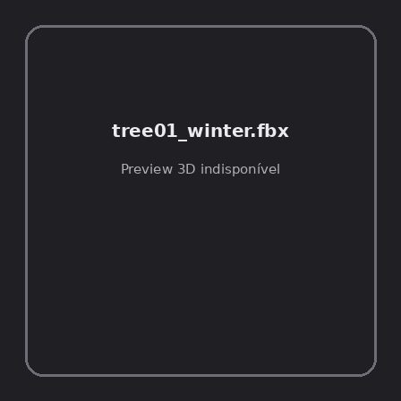
ID | NOV-004585
Origem | Asset novo
Pack/Fonte | retro_nature_pack
Categoria | Nature / Models
Arquivo | tree01_winter.fbx
Caminho | 00_Packs_Raw/retro_nature_pack/models/FBX/trees/tree01_winter.fbx
Formato | FBX
Tamanho | 20.54 KB
SHA-256 | 908317b81f79726922ec…
Status técnico | ERROR
Licença | MISSING_REVIEW_REQUIRED — sem evidência localizada
Objetos / meshes | N/D / N/D
Vértices | N/D
Faces / triângulos | N/D / N/D
Materiais | N/D —
UV sets / vertex colors | N/D / N/D
Dimensões XYZ | N/D
Rig / armatures / bones | N/D / N/D / N/D
Skinned meshes | N/D
Animações | N/D —
Duração total clips | N/D
Root motion detectado | N/D
LODs / colliders | Nenhum / Nenhum
Texturas vinculadas | N/D (0 ausentes)
Alertas | Licença/fonte não localizada automaticamente; revisão legal necessária.
Notas | Falha na inspeção 3D: Unable to open a display

NOV-004586 • tree02 [ERROR]
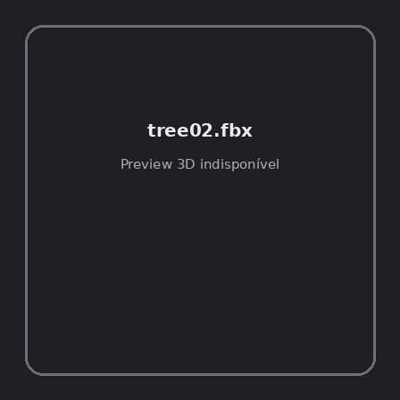
ID | NOV-004586
Origem | Asset novo
Pack/Fonte | retro_nature_pack
Categoria | Nature / Models
Arquivo | tree02.fbx
Caminho | 00_Packs_Raw/retro_nature_pack/models/FBX/trees/tree02.fbx
Formato | FBX
Tamanho | 27.48 KB
SHA-256 | 209aeb73e41ec1026590…
Status técnico | ERROR
Licença | MISSING_REVIEW_REQUIRED — sem evidência localizada
Objetos / meshes | N/D / N/D
Vértices | N/D
Faces / triângulos | N/D / N/D
Materiais | N/D —
UV sets / vertex colors | N/D / N/D
Dimensões XYZ | N/D
Rig / armatures / bones | N/D / N/D / N/D
Skinned meshes | N/D
Animações | N/D —
Duração total clips | N/D
Root motion detectado | N/D
LODs / colliders | Nenhum / Nenhum
Texturas vinculadas | N/D (0 ausentes)
Alertas | Licença/fonte não localizada automaticamente; revisão legal necessária.
Notas | Falha na inspeção 3D: Unable to open a display

NOV-004580 • tree02_winter [ERROR]
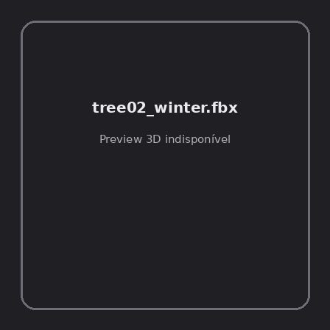
ID | NOV-004580
Origem | Asset novo
Pack/Fonte | retro_nature_pack
Categoria | Nature / Models
Arquivo | tree02_winter.fbx
Caminho | 00_Packs_Raw/retro_nature_pack/models/FBX/trees/tree02_winter.fbx
Formato | FBX
Tamanho | 4.01 KB
SHA-256 | 2fa53491d37781dcce31…
Status técnico | ERROR
Licença | MISSING_REVIEW_REQUIRED — sem evidência localizada
Objetos / meshes | N/D / N/D
Vértices | N/D
Faces / triângulos | N/D / N/D
Materiais | N/D —
UV sets / vertex colors | N/D / N/D
Dimensões XYZ | N/D
Rig / armatures / bones | N/D / N/D / N/D
Skinned meshes | N/D
Animações | N/D —
Duração total clips | N/D
Root motion detectado | N/D
LODs / colliders | Nenhum / Nenhum
Texturas vinculadas | N/D (0 ausentes)
Alertas | Licença/fonte não localizada automaticamente; revisão legal necessária.
Notas | Falha na inspeção 3D: Unable to open a display

NOV-004578 • tree03 [ERROR]
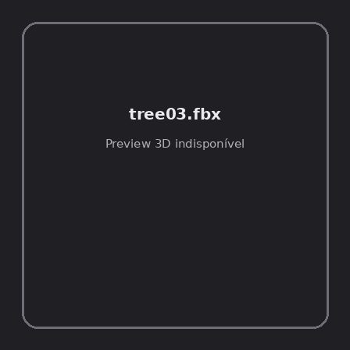
ID | NOV-004578
Origem | Asset novo
Pack/Fonte | retro_nature_pack
Categoria | Nature / Models
Arquivo | tree03.fbx
Caminho | 00_Packs_Raw/retro_nature_pack/models/FBX/trees/tree03.fbx
Formato | FBX
Tamanho | 38.28 KB
SHA-256 | 4d43918b85627c006ef0…
Status técnico | ERROR
Licença | MISSING_REVIEW_REQUIRED — sem evidência localizada
Objetos / meshes | N/D / N/D
Vértices | N/D
Faces / triângulos | N/D / N/D
Materiais | N/D —
UV sets / vertex colors | N/D / N/D
Dimensões XYZ | N/D
Rig / armatures / bones | N/D / N/D / N/D
Skinned meshes | N/D
Animações | N/D —
Duração total clips | N/D
Root motion detectado | N/D
LODs / colliders | Nenhum / Nenhum
Texturas vinculadas | N/D (0 ausentes)
Alertas | Licença/fonte não localizada automaticamente; revisão legal necessária.
Notas | Falha na inspeção 3D: Unable to open a display

NOV-004573 • tree03_winter [ERROR]
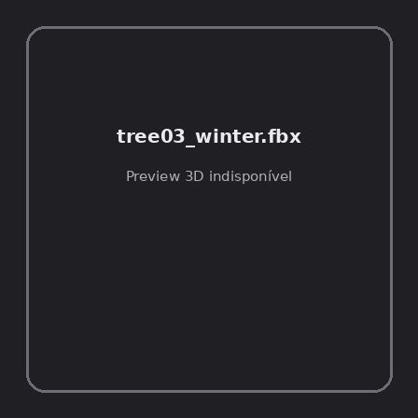
ID | NOV-004573
Origem | Asset novo
Pack/Fonte | retro_nature_pack
Categoria | Nature / Models
Arquivo | tree03_winter.fbx
Caminho | 00_Packs_Raw/retro_nature_pack/models/FBX/trees/tree03_winter.fbx
Formato | FBX
Tamanho | 28.09 KB
SHA-256 | f7410c9803f5724bbe06…
Status técnico | ERROR
Licença | MISSING_REVIEW_REQUIRED — sem evidência localizada
Objetos / meshes | N/D / N/D
Vértices | N/D
Faces / triângulos | N/D / N/D
Materiais | N/D —
UV sets / vertex colors | N/D / N/D
Dimensões XYZ | N/D
Rig / armatures / bones | N/D / N/D / N/D
Skinned meshes | N/D
Animações | N/D —
Duração total clips | N/D
Root motion detectado | N/D
LODs / colliders | Nenhum / Nenhum
Texturas vinculadas | N/D (0 ausentes)
Alertas | Licença/fonte não localizada automaticamente; revisão legal necessária.
Notas | Falha na inspeção 3D: Unable to open a display

NOV-004574 • tree04 [ERROR]
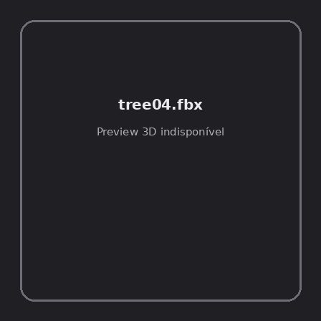
ID | NOV-004574
Origem | Asset novo
Pack/Fonte | retro_nature_pack
Categoria | Nature / Models
Arquivo | tree04.fbx
Caminho | 00_Packs_Raw/retro_nature_pack/models/FBX/trees/tree04.fbx
Formato | FBX
Tamanho | 43.48 KB
SHA-256 | fe6ce29a2863343a3a9c…
Status técnico | ERROR
Licença | MISSING_REVIEW_REQUIRED — sem evidência localizada
Objetos / meshes | N/D / N/D
Vértices | N/D
Faces / triângulos | N/D / N/D
Materiais | N/D —
UV sets / vertex colors | N/D / N/D
Dimensões XYZ | N/D
Rig / armatures / bones | N/D / N/D / N/D
Skinned meshes | N/D
Animações | N/D —
Duração total clips | N/D
Root motion detectado | N/D
LODs / colliders | Nenhum / Nenhum
Texturas vinculadas | N/D (0 ausentes)
Alertas | Licença/fonte não localizada automaticamente; revisão legal necessária.
Notas | Falha na inspeção 3D: Unable to open a display

NOV-004576 • tree04_winter [ERROR]
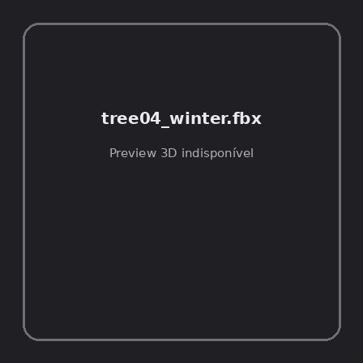
ID | NOV-004576
Origem | Asset novo
Pack/Fonte | retro_nature_pack
Categoria | Nature / Models
Arquivo | tree04_winter.fbx
Caminho | 00_Packs_Raw/retro_nature_pack/models/FBX/trees/tree04_winter.fbx
Formato | FBX
Tamanho | 33.17 KB
SHA-256 | b8fef3a4feeecd8cc755…
Status técnico | ERROR
Licença | MISSING_REVIEW_REQUIRED — sem evidência localizada
Objetos / meshes | N/D / N/D
Vértices | N/D
Faces / triângulos | N/D / N/D
Materiais | N/D —
UV sets / vertex colors | N/D / N/D
Dimensões XYZ | N/D
Rig / armatures / bones | N/D / N/D / N/D
Skinned meshes | N/D
Animações | N/D —
Duração total clips | N/D
Root motion detectado | N/D
LODs / colliders | Nenhum / Nenhum
Texturas vinculadas | N/D (0 ausentes)
Alertas | Licença/fonte não localizada automaticamente; revisão legal necessária.
Notas | Falha na inspeção 3D: Unable to open a display

NOV-004577 • tree05 [ERROR]
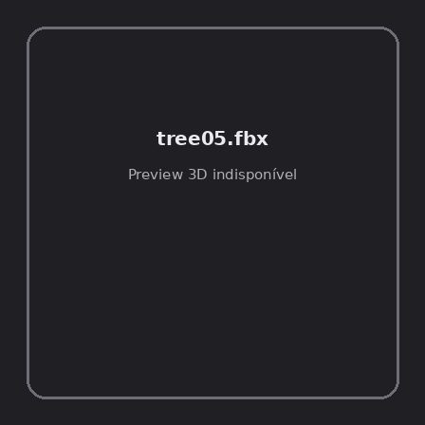
ID | NOV-004577
Origem | Asset novo
Pack/Fonte | retro_nature_pack
Categoria | Nature / Models
Arquivo | tree05.fbx
Caminho | 00_Packs_Raw/retro_nature_pack/models/FBX/trees/tree05.fbx
Formato | FBX
Tamanho | 32.15 KB
SHA-256 | 663eb69df8c378e94076…
Status técnico | ERROR
Licença | MISSING_REVIEW_REQUIRED — sem evidência localizada
Objetos / meshes | N/D / N/D
Vértices | N/D
Faces / triângulos | N/D / N/D
Materiais | N/D —
UV sets / vertex colors | N/D / N/D
Dimensões XYZ | N/D
Rig / armatures / bones | N/D / N/D / N/D
Skinned meshes | N/D
Animações | N/D —
Duração total clips | N/D
Root motion detectado | N/D
LODs / colliders | Nenhum / Nenhum
Texturas vinculadas | N/D (0 ausentes)
Alertas | Licença/fonte não localizada automaticamente; revisão legal necessária.
Notas | Falha na inspeção 3D: Unable to open a display

NOV-004579 • tree05_winter [ERROR]
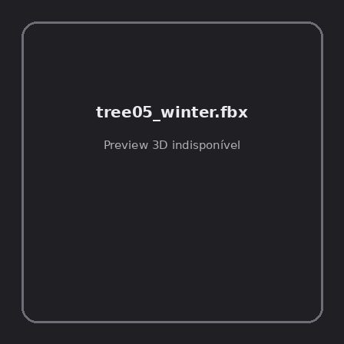
ID | NOV-004579
Origem | Asset novo
Pack/Fonte | retro_nature_pack
Categoria | Nature / Models
Arquivo | tree05_winter.fbx
Caminho | 00_Packs_Raw/retro_nature_pack/models/FBX/trees/tree05_winter.fbx
Formato | FBX
Tamanho | 21.28 KB
SHA-256 | aab2e1e4b52b633a2e5f…
Status técnico | ERROR
Licença | MISSING_REVIEW_REQUIRED — sem evidência localizada
Objetos / meshes | N/D / N/D
Vértices | N/D
Faces / triângulos | N/D / N/D
Materiais | N/D —
UV sets / vertex colors | N/D / N/D
Dimensões XYZ | N/D
Rig / armatures / bones | N/D / N/D / N/D
Skinned meshes | N/D
Animações | N/D —
Duração total clips | N/D
Root motion detectado | N/D
LODs / colliders | Nenhum / Nenhum
Texturas vinculadas | N/D (0 ausentes)
Alertas | Licença/fonte não localizada automaticamente; revisão legal necessária.
Notas | Falha na inspeção 3D: Unable to open a display

NOV-004584 • tree06 [ERROR]
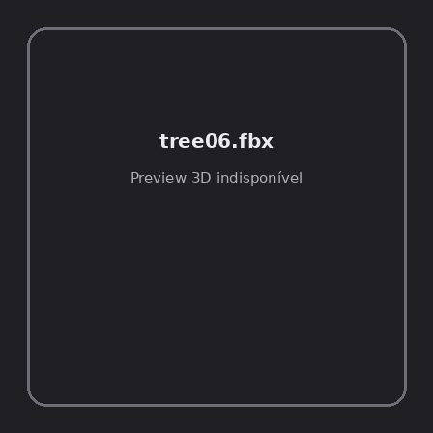
ID | NOV-004584
Origem | Asset novo
Pack/Fonte | retro_nature_pack
Categoria | Nature / Models
Arquivo | tree06.fbx
Caminho | 00_Packs_Raw/retro_nature_pack/models/FBX/trees/tree06.fbx
Formato | FBX
Tamanho | 30.09 KB
SHA-256 | 9c638c9c3a2813e8a3c3…
Status técnico | ERROR
Licença | MISSING_REVIEW_REQUIRED — sem evidência localizada
Objetos / meshes | N/D / N/D
Vértices | N/D
Faces / triângulos | N/D / N/D
Materiais | N/D —
UV sets / vertex colors | N/D / N/D
Dimensões XYZ | N/D
Rig / armatures / bones | N/D / N/D / N/D
Skinned meshes | N/D
Animações | N/D —
Duração total clips | N/D
Root motion detectado | N/D
LODs / colliders | Nenhum / Nenhum
Texturas vinculadas | N/D (0 ausentes)
Alertas | Licença/fonte não localizada automaticamente; revisão legal necessária.
Notas | Falha na inspeção 3D: Unable to open a display

NOV-004583 • tree06_winter [ERROR]
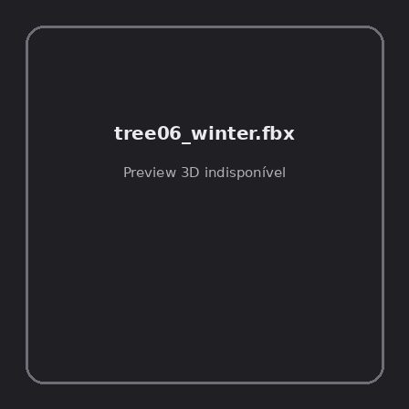
ID | NOV-004583
Origem | Asset novo
Pack/Fonte | retro_nature_pack
Categoria | Nature / Models
Arquivo | tree06_winter.fbx
Caminho | 00_Packs_Raw/retro_nature_pack/models/FBX/trees/tree06_winter.fbx
Formato | FBX
Tamanho | 20.92 KB
SHA-256 | 3117cafeec4c1920da91…
Status técnico | ERROR
Licença | MISSING_REVIEW_REQUIRED — sem evidência localizada
Objetos / meshes | N/D / N/D
Vértices | N/D
Faces / triângulos | N/D / N/D
Materiais | N/D —
UV sets / vertex colors | N/D / N/D
Dimensões XYZ | N/D
Rig / armatures / bones | N/D / N/D / N/D
Skinned meshes | N/D
Animações | N/D —
Duração total clips | N/D
Root motion detectado | N/D
LODs / colliders | Nenhum / Nenhum
Texturas vinculadas | N/D (0 ausentes)
Alertas | Licença/fonte não localizada automaticamente; revisão legal necessária.
Notas | Falha na inspeção 3D: Unable to open a display

NOV-004582 • tree07 [ERROR]
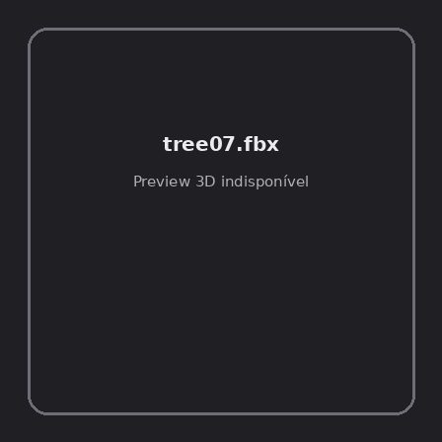
ID | NOV-004582
Origem | Asset novo
Pack/Fonte | retro_nature_pack
Categoria | Nature / Models
Arquivo | tree07.fbx
Caminho | 00_Packs_Raw/retro_nature_pack/models/FBX/trees/tree07.fbx
Formato | FBX
Tamanho | 29.36 KB
SHA-256 | c9e49f7e3b1492899fcc…
Status técnico | ERROR
Licença | MISSING_REVIEW_REQUIRED — sem evidência localizada
Objetos / meshes | N/D / N/D
Vértices | N/D
Faces / triângulos | N/D / N/D
Materiais | N/D —
UV sets / vertex colors | N/D / N/D
Dimensões XYZ | N/D
Rig / armatures / bones | N/D / N/D / N/D
Skinned meshes | N/D
Animações | N/D —
Duração total clips | N/D
Root motion detectado | N/D
LODs / colliders | Nenhum / Nenhum
Texturas vinculadas | N/D (0 ausentes)
Alertas | Licença/fonte não localizada automaticamente; revisão legal necessária.
Notas | Falha na inspeção 3D: Unable to open a display

NOV-004575 • tree08 [ERROR]
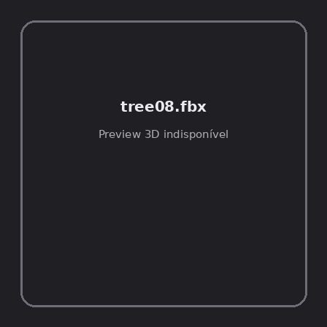
ID | NOV-004575
Origem | Asset novo
Pack/Fonte | retro_nature_pack
Categoria | Nature / Models
Arquivo | tree08.fbx
Caminho | 00_Packs_Raw/retro_nature_pack/models/FBX/trees/tree08.fbx
Formato | FBX
Tamanho | 27.36 KB
SHA-256 | be95d5cea288dca35719…
Status técnico | ERROR
Licença | MISSING_REVIEW_REQUIRED — sem evidência localizada
Objetos / meshes | N/D / N/D
Vértices | N/D
Faces / triângulos | N/D / N/D
Materiais | N/D —
UV sets / vertex colors | N/D / N/D
Dimensões XYZ | N/D
Rig / armatures / bones | N/D / N/D / N/D
Skinned meshes | N/D
Animações | N/D —
Duração total clips | N/D
Root motion detectado | N/D
LODs / colliders | Nenhum / Nenhum
Texturas vinculadas | N/D (0 ausentes)
Alertas | Licença/fonte não localizada automaticamente; revisão legal necessária.
Notas | Falha na inspeção 3D: Unable to open a display

NOV-004487 • bush01 [ERROR]
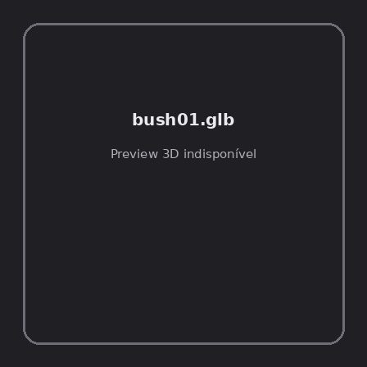
ID | NOV-004487
Origem | Asset novo
Pack/Fonte | retro_nature_pack
Categoria | Nature / Models
Arquivo | bush01.glb
Caminho | 00_Packs_Raw/retro_nature_pack/models/glTF/bushes/bush01.glb
Formato | GLB
Tamanho | 20.75 KB
SHA-256 | ea15b60383d33f5cea44…
Status técnico | ERROR
Licença | MISSING_REVIEW_REQUIRED — sem evidência localizada
Objetos / meshes | N/D / N/D
Vértices | N/D
Faces / triângulos | N/D / N/D
Materiais | N/D —
UV sets / vertex colors | N/D / N/D
Dimensões XYZ | N/D
Rig / armatures / bones | N/D / N/D / N/D
Skinned meshes | N/D
Animações | N/D —
Duração total clips | N/D
Root motion detectado | N/D
LODs / colliders | Nenhum / Nenhum
Texturas vinculadas | N/D (0 ausentes)
Alertas | Licença/fonte não localizada automaticamente; revisão legal necessária.
Notas | Falha na inspeção 3D: RuntimeError: Error: Python: Traceback (most recent call last):  File "/usr/share/blender/scripts/addons/io_scene_gltf2/__init__.py", line 1064, in execute  return self.import_gltf2(context)  File "/usr/share/blender/scripts/addons/io_scene_gltf2/__init__.py", line 1083, in import_gltf2  return self.unit_import(self.filepath, import_settings)  File "/usr/share/blender/scripts/addons/io_scene_gltf2/__init__.py", line 1088, in unit_import  from .blender.imp.gltf2_blender_gltf import BlenderGlTF  File "/usr/share/blender/scripts/addons/io_scene_gltf2/blender/imp/gltf2_blender_gltf.py", line 17, in <module>  from .gltf2_blender_scene import BlenderScene  File "/usr/share/blender/scripts/addons/io_scene_gltf2/blender/imp/gltf2_blender_scene.py", line 17, in <module>  from .gltf2_blender_node import BlenderNode  File "/usr/share/blender/scripts/addons/io_scene_gltf2/blender/imp/gltf2_blender_node.py", line 18, in <module>  from .gltf2_blender_mesh import BlenderMesh  File "/usr/share/blender/scripts/addons/io_scene_gltf2/blender/imp/gltf2_blender_mesh.py", line 17, in <module>  import numpy as np  ModuleNotFoundError: No module named 'numpy'  location: /usr/share/blender/scripts/modules/bpy/ops.py:132  Traceback (most recent call last):  File "/home/runner/work/PSX_demons_whip/PSX_demons_whip/workspace/demons/tools/asset_catalog/blender_batch.py", line 427, in inspect_task  import_model(path)  File "/home/runner/work/PSX_demons_whip/PSX_demons_whip/workspace/demons/tools/asset_catalog/blender_batch.py", line 52, in import_model  bpy.ops.import_scene.gltf(filepath=str(path))  File "/usr/share/blender/scripts/modules/bpy/ops.py", line 132, in __call__  ret = _op_call(self.idname_py(), None, kw)  RuntimeError: Error: Python: Traceback (most recent call last):  File "/usr/share/blender/scripts/addons/io_scene_gltf2/__init__.py", line 1064, in execute  return self.import_gltf2(context)  File "/usr/share/blender/scripts/addons/io_scene_gltf2/__init__.py", line 1083, in import_gltf2  return self.unit_import(self.filepath, import_settings)  File "/usr/share/blender/scripts/addons/io_scene_gltf2/__init__.py", line 1088, in unit_import  from .blender.imp.gltf2_blender_gltf import BlenderGlTF  File "/usr/share/blender/scripts/addons/io_scene_gltf2/blender/imp/gltf2_blender_gltf.py", line 17, in <module>  from .gltf2_blender_scene import BlenderScene  File "/usr/share/blender/scripts/addons/io_scene_gltf2/blender/imp/gltf2_blender_scene.py", line 17, in <module>  from .gltf2_blender_node import BlenderNode  File "/usr/share/blender/scripts/addons/io_scene_gltf2/blender/imp/gltf2_blender_node.py", line 18, in <module>  from .gltf2_blender_mesh import BlenderMesh  File "/usr/share/blender/scripts/addons/io_scene_gltf2/blender/imp/gltf2_blender_mesh.py", line 17, in <module>  import numpy as np  ModuleNotFoundError: No module named 'numpy'  location: /usr/share/blender/scripts/modules/bpy/ops.py:132

NOV-004483 • bush01_winter [ERROR]
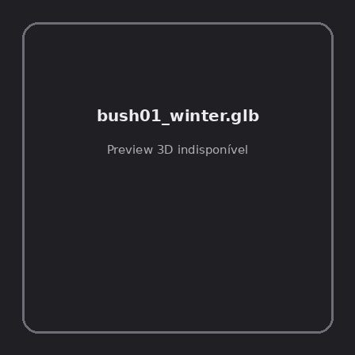
ID | NOV-004483
Origem | Asset novo
Pack/Fonte | retro_nature_pack
Categoria | Nature / Models
Arquivo | bush01_winter.glb
Caminho | 00_Packs_Raw/retro_nature_pack/models/glTF/bushes/bush01_winter.glb
Formato | GLB
Tamanho | 5.00 KB
SHA-256 | 90461d972adbda8b7669…
Status técnico | ERROR
Licença | MISSING_REVIEW_REQUIRED — sem evidência localizada
Objetos / meshes | N/D / N/D
Vértices | N/D
Faces / triângulos | N/D / N/D
Materiais | N/D —
UV sets / vertex colors | N/D / N/D
Dimensões XYZ | N/D
Rig / armatures / bones | N/D / N/D / N/D
Skinned meshes | N/D
Animações | N/D —
Duração total clips | N/D
Root motion detectado | N/D
LODs / colliders | Nenhum / Nenhum
Texturas vinculadas | N/D (0 ausentes)
Alertas | Licença/fonte não localizada automaticamente; revisão legal necessária.
Notas | Falha na inspeção 3D: RuntimeError: Error: Python: Traceback (most recent call last):  File "/usr/share/blender/scripts/addons/io_scene_gltf2/__init__.py", line 1064, in execute  return self.import_gltf2(context)  File "/usr/share/blender/scripts/addons/io_scene_gltf2/__init__.py", line 1083, in import_gltf2  return self.unit_import(self.filepath, import_settings)  File "/usr/share/blender/scripts/addons/io_scene_gltf2/__init__.py", line 1088, in unit_import  from .blender.imp.gltf2_blender_gltf import BlenderGlTF  File "/usr/share/blender/scripts/addons/io_scene_gltf2/blender/imp/gltf2_blender_gltf.py", line 17, in <module>  from .gltf2_blender_scene import BlenderScene  File "/usr/share/blender/scripts/addons/io_scene_gltf2/blender/imp/gltf2_blender_scene.py", line 17, in <module>  from .gltf2_blender_node import BlenderNode  File "/usr/share/blender/scripts/addons/io_scene_gltf2/blender/imp/gltf2_blender_node.py", line 18, in <module>  from .gltf2_blender_mesh import BlenderMesh  File "/usr/share/blender/scripts/addons/io_scene_gltf2/blender/imp/gltf2_blender_mesh.py", line 17, in <module>  import numpy as np  ModuleNotFoundError: No module named 'numpy'  location: /usr/share/blender/scripts/modules/bpy/ops.py:132  Traceback (most recent call last):  File "/home/runner/work/PSX_demons_whip/PSX_demons_whip/workspace/demons/tools/asset_catalog/blender_batch.py", line 427, in inspect_task  import_model(path)  File "/home/runner/work/PSX_demons_whip/PSX_demons_whip/workspace/demons/tools/asset_catalog/blender_batch.py", line 52, in import_model  bpy.ops.import_scene.gltf(filepath=str(path))  File "/usr/share/blender/scripts/modules/bpy/ops.py", line 132, in __call__  ret = _op_call(self.idname_py(), None, kw)  RuntimeError: Error: Python: Traceback (most recent call last):  File "/usr/share/blender/scripts/addons/io_scene_gltf2/__init__.py", line 1064, in execute  return self.import_gltf2(context)  File "/usr/share/blender/scripts/addons/io_scene_gltf2/__init__.py", line 1083, in import_gltf2  return self.unit_import(self.filepath, import_settings)  File "/usr/share/blender/scripts/addons/io_scene_gltf2/__init__.py", line 1088, in unit_import  from .blender.imp.gltf2_blender_gltf import BlenderGlTF  File "/usr/share/blender/scripts/addons/io_scene_gltf2/blender/imp/gltf2_blender_gltf.py", line 17, in <module>  from .gltf2_blender_scene import BlenderScene  File "/usr/share/blender/scripts/addons/io_scene_gltf2/blender/imp/gltf2_blender_scene.py", line 17, in <module>  from .gltf2_blender_node import BlenderNode  File "/usr/share/blender/scripts/addons/io_scene_gltf2/blender/imp/gltf2_blender_node.py", line 18, in <module>  from .gltf2_blender_mesh import BlenderMesh  File "/usr/share/blender/scripts/addons/io_scene_gltf2/blender/imp/gltf2_blender_mesh.py", line 17, in <module>  import numpy as np  ModuleNotFoundError: No module named 'numpy'  location: /usr/share/blender/scripts/modules/bpy/ops.py:132

NOV-004484 • bush02 [ERROR]
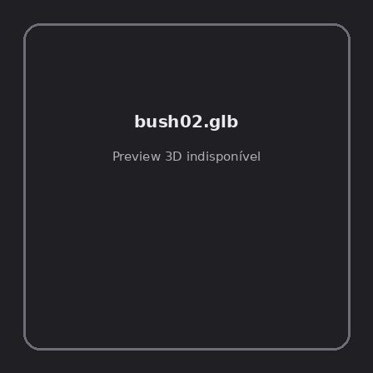
ID | NOV-004484
Origem | Asset novo
Pack/Fonte | retro_nature_pack
Categoria | Nature / Models
Arquivo | bush02.glb
Caminho | 00_Packs_Raw/retro_nature_pack/models/glTF/bushes/bush02.glb
Formato | GLB
Tamanho | 31.01 KB
SHA-256 | 549f7029f4ee48f00d65…
Status técnico | ERROR
Licença | MISSING_REVIEW_REQUIRED — sem evidência localizada
Objetos / meshes | N/D / N/D
Vértices | N/D
Faces / triângulos | N/D / N/D
Materiais | N/D —
UV sets / vertex colors | N/D / N/D
Dimensões XYZ | N/D
Rig / armatures / bones | N/D / N/D / N/D
Skinned meshes | N/D
Animações | N/D —
Duração total clips | N/D
Root motion detectado | N/D
LODs / colliders | Nenhum / Nenhum
Texturas vinculadas | N/D (0 ausentes)
Alertas | Licença/fonte não localizada automaticamente; revisão legal necessária.
Notas | Falha na inspeção 3D: RuntimeError: Error: Python: Traceback (most recent call last):  File "/usr/share/blender/scripts/addons/io_scene_gltf2/__init__.py", line 1064, in execute  return self.import_gltf2(context)  File "/usr/share/blender/scripts/addons/io_scene_gltf2/__init__.py", line 1083, in import_gltf2  return self.unit_import(self.filepath, import_settings)  File "/usr/share/blender/scripts/addons/io_scene_gltf2/__init__.py", line 1088, in unit_import  from .blender.imp.gltf2_blender_gltf import BlenderGlTF  File "/usr/share/blender/scripts/addons/io_scene_gltf2/blender/imp/gltf2_blender_gltf.py", line 17, in <module>  from .gltf2_blender_scene import BlenderScene  File "/usr/share/blender/scripts/addons/io_scene_gltf2/blender/imp/gltf2_blender_scene.py", line 17, in <module>  from .gltf2_blender_node import BlenderNode  File "/usr/share/blender/scripts/addons/io_scene_gltf2/blender/imp/gltf2_blender_node.py", line 18, in <module>  from .gltf2_blender_mesh import BlenderMesh  File "/usr/share/blender/scripts/addons/io_scene_gltf2/blender/imp/gltf2_blender_mesh.py", line 17, in <module>  import numpy as np  ModuleNotFoundError: No module named 'numpy'  location: /usr/share/blender/scripts/modules/bpy/ops.py:132  Traceback (most recent call last):  File "/home/runner/work/PSX_demons_whip/PSX_demons_whip/workspace/demons/tools/asset_catalog/blender_batch.py", line 427, in inspect_task  import_model(path)  File "/home/runner/work/PSX_demons_whip/PSX_demons_whip/workspace/demons/tools/asset_catalog/blender_batch.py", line 52, in import_model  bpy.ops.import_scene.gltf(filepath=str(path))  File "/usr/share/blender/scripts/modules/bpy/ops.py", line 132, in __call__  ret = _op_call(self.idname_py(), None, kw)  RuntimeError: Error: Python: Traceback (most recent call last):  File "/usr/share/blender/scripts/addons/io_scene_gltf2/__init__.py", line 1064, in execute  return self.import_gltf2(context)  File "/usr/share/blender/scripts/addons/io_scene_gltf2/__init__.py", line 1083, in import_gltf2  return self.unit_import(self.filepath, import_settings)  File "/usr/share/blender/scripts/addons/io_scene_gltf2/__init__.py", line 1088, in unit_import  from .blender.imp.gltf2_blender_gltf import BlenderGlTF  File "/usr/share/blender/scripts/addons/io_scene_gltf2/blender/imp/gltf2_blender_gltf.py", line 17, in <module>  from .gltf2_blender_scene import BlenderScene  File "/usr/share/blender/scripts/addons/io_scene_gltf2/blender/imp/gltf2_blender_scene.py", line 17, in <module>  from .gltf2_blender_node import BlenderNode  File "/usr/share/blender/scripts/addons/io_scene_gltf2/blender/imp/gltf2_blender_node.py", line 18, in <module>  from .gltf2_blender_mesh import BlenderMesh  File "/usr/share/blender/scripts/addons/io_scene_gltf2/blender/imp/gltf2_blender_mesh.py", line 17, in <module>  import numpy as np  ModuleNotFoundError: No module named 'numpy'  location: /usr/share/blender/scripts/modules/bpy/ops.py:132

NOV-004480 • bush02_winter [ERROR]
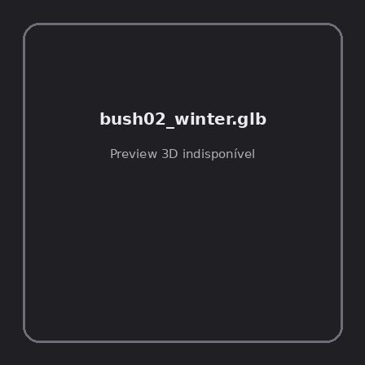
ID | NOV-004480
Origem | Asset novo
Pack/Fonte | retro_nature_pack
Categoria | Nature / Models
Arquivo | bush02_winter.glb
Caminho | 00_Packs_Raw/retro_nature_pack/models/glTF/bushes/bush02_winter.glb
Formato | GLB
Tamanho | 3.44 KB
SHA-256 | ff4fd175a269256d5e7b…
Status técnico | ERROR
Licença | MISSING_REVIEW_REQUIRED — sem evidência localizada
Objetos / meshes | N/D / N/D
Vértices | N/D
Faces / triângulos | N/D / N/D
Materiais | N/D —
UV sets / vertex colors | N/D / N/D
Dimensões XYZ | N/D
Rig / armatures / bones | N/D / N/D / N/D
Skinned meshes | N/D
Animações | N/D —
Duração total clips | N/D
Root motion detectado | N/D
LODs / colliders | Nenhum / Nenhum
Texturas vinculadas | N/D (0 ausentes)
Alertas | Licença/fonte não localizada automaticamente; revisão legal necessária.
Notas | Falha na inspeção 3D: RuntimeError: Error: Python: Traceback (most recent call last):  File "/usr/share/blender/scripts/addons/io_scene_gltf2/__init__.py", line 1064, in execute  return self.import_gltf2(context)  File "/usr/share/blender/scripts/addons/io_scene_gltf2/__init__.py", line 1083, in import_gltf2  return self.unit_import(self.filepath, import_settings)  File "/usr/share/blender/scripts/addons/io_scene_gltf2/__init__.py", line 1088, in unit_import  from .blender.imp.gltf2_blender_gltf import BlenderGlTF  File "/usr/share/blender/scripts/addons/io_scene_gltf2/blender/imp/gltf2_blender_gltf.py", line 17, in <module>  from .gltf2_blender_scene import BlenderScene  File "/usr/share/blender/scripts/addons/io_scene_gltf2/blender/imp/gltf2_blender_scene.py", line 17, in <module>  from .gltf2_blender_node import BlenderNode  File "/usr/share/blender/scripts/addons/io_scene_gltf2/blender/imp/gltf2_blender_node.py", line 18, in <module>  from .gltf2_blender_mesh import BlenderMesh  File "/usr/share/blender/scripts/addons/io_scene_gltf2/blender/imp/gltf2_blender_mesh.py", line 17, in <module>  import numpy as np  ModuleNotFoundError: No module named 'numpy'  location: /usr/share/blender/scripts/modules/bpy/ops.py:132  Traceback (most recent call last):  File "/home/runner/work/PSX_demons_whip/PSX_demons_whip/workspace/demons/tools/asset_catalog/blender_batch.py", line 427, in inspect_task  import_model(path)  File "/home/runner/work/PSX_demons_whip/PSX_demons_whip/workspace/demons/tools/asset_catalog/blender_batch.py", line 52, in import_model  bpy.ops.import_scene.gltf(filepath=str(path))  File "/usr/share/blender/scripts/modules/bpy/ops.py", line 132, in __call__  ret = _op_call(self.idname_py(), None, kw)  RuntimeError: Error: Python: Traceback (most recent call last):  File "/usr/share/blender/scripts/addons/io_scene_gltf2/__init__.py", line 1064, in execute  return self.import_gltf2(context)  File "/usr/share/blender/scripts/addons/io_scene_gltf2/__init__.py", line 1083, in import_gltf2  return self.unit_import(self.filepath, import_settings)  File "/usr/share/blender/scripts/addons/io_scene_gltf2/__init__.py", line 1088, in unit_import  from .blender.imp.gltf2_blender_gltf import BlenderGlTF  File "/usr/share/blender/scripts/addons/io_scene_gltf2/blender/imp/gltf2_blender_gltf.py", line 17, in <module>  from .gltf2_blender_scene import BlenderScene  File "/usr/share/blender/scripts/addons/io_scene_gltf2/blender/imp/gltf2_blender_scene.py", line 17, in <module>  from .gltf2_blender_node import BlenderNode  File "/usr/share/blender/scripts/addons/io_scene_gltf2/blender/imp/gltf2_blender_node.py", line 18, in <module>  from .gltf2_blender_mesh import BlenderMesh  File "/usr/share/blender/scripts/addons/io_scene_gltf2/blender/imp/gltf2_blender_mesh.py", line 17, in <module>  import numpy as np  ModuleNotFoundError: No module named 'numpy'  location: /usr/share/blender/scripts/modules/bpy/ops.py:132

NOV-004482 • bush03 [ERROR]
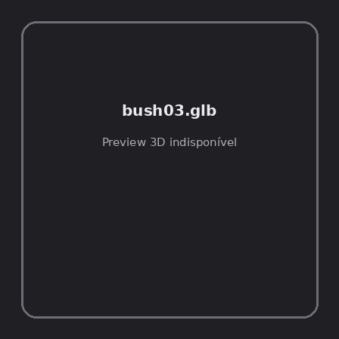
ID | NOV-004482
Origem | Asset novo
Pack/Fonte | retro_nature_pack
Categoria | Nature / Models
Arquivo | bush03.glb
Caminho | 00_Packs_Raw/retro_nature_pack/models/glTF/bushes/bush03.glb
Formato | GLB
Tamanho | 25.13 KB
SHA-256 | 6ea00571c2bdbbeb7ca8…
Status técnico | ERROR
Licença | MISSING_REVIEW_REQUIRED — sem evidência localizada
Objetos / meshes | N/D / N/D
Vértices | N/D
Faces / triângulos | N/D / N/D
Materiais | N/D —
UV sets / vertex colors | N/D / N/D
Dimensões XYZ | N/D
Rig / armatures / bones | N/D / N/D / N/D
Skinned meshes | N/D
Animações | N/D —
Duração total clips | N/D
Root motion detectado | N/D
LODs / colliders | Nenhum / Nenhum
Texturas vinculadas | N/D (0 ausentes)
Alertas | Licença/fonte não localizada automaticamente; revisão legal necessária.
Notas | Falha na inspeção 3D: RuntimeError: Error: Python: Traceback (most recent call last):  File "/usr/share/blender/scripts/addons/io_scene_gltf2/__init__.py", line 1064, in execute  return self.import_gltf2(context)  File "/usr/share/blender/scripts/addons/io_scene_gltf2/__init__.py", line 1083, in import_gltf2  return self.unit_import(self.filepath, import_settings)  File "/usr/share/blender/scripts/addons/io_scene_gltf2/__init__.py", line 1088, in unit_import  from .blender.imp.gltf2_blender_gltf import BlenderGlTF  File "/usr/share/blender/scripts/addons/io_scene_gltf2/blender/imp/gltf2_blender_gltf.py", line 17, in <module>  from .gltf2_blender_scene import BlenderScene  File "/usr/share/blender/scripts/addons/io_scene_gltf2/blender/imp/gltf2_blender_scene.py", line 17, in <module>  from .gltf2_blender_node import BlenderNode  File "/usr/share/blender/scripts/addons/io_scene_gltf2/blender/imp/gltf2_blender_node.py", line 18, in <module>  from .gltf2_blender_mesh import BlenderMesh  File "/usr/share/blender/scripts/addons/io_scene_gltf2/blender/imp/gltf2_blender_mesh.py", line 17, in <module>  import numpy as np  ModuleNotFoundError: No module named 'numpy'  location: /usr/share/blender/scripts/modules/bpy/ops.py:132  Traceback (most recent call last):  File "/home/runner/work/PSX_demons_whip/PSX_demons_whip/workspace/demons/tools/asset_catalog/blender_batch.py", line 427, in inspect_task  import_model(path)  File "/home/runner/work/PSX_demons_whip/PSX_demons_whip/workspace/demons/tools/asset_catalog/blender_batch.py", line 52, in import_model  bpy.ops.import_scene.gltf(filepath=str(path))  File "/usr/share/blender/scripts/modules/bpy/ops.py", line 132, in __call__  ret = _op_call(self.idname_py(), None, kw)  RuntimeError: Error: Python: Traceback (most recent call last):  File "/usr/share/blender/scripts/addons/io_scene_gltf2/__init__.py", line 1064, in execute  return self.import_gltf2(context)  File "/usr/share/blender/scripts/addons/io_scene_gltf2/__init__.py", line 1083, in import_gltf2  return self.unit_import(self.filepath, import_settings)  File "/usr/share/blender/scripts/addons/io_scene_gltf2/__init__.py", line 1088, in unit_import  from .blender.imp.gltf2_blender_gltf import BlenderGlTF  File "/usr/share/blender/scripts/addons/io_scene_gltf2/blender/imp/gltf2_blender_gltf.py", line 17, in <module>  from .gltf2_blender_scene import BlenderScene  File "/usr/share/blender/scripts/addons/io_scene_gltf2/blender/imp/gltf2_blender_scene.py", line 17, in <module>  from .gltf2_blender_node import BlenderNode  File "/usr/share/blender/scripts/addons/io_scene_gltf2/blender/imp/gltf2_blender_node.py", line 18, in <module>  from .gltf2_blender_mesh import BlenderMesh  File "/usr/share/blender/scripts/addons/io_scene_gltf2/blender/imp/gltf2_blender_mesh.py", line 17, in <module>  import numpy as np  ModuleNotFoundError: No module named 'numpy'  location: /usr/share/blender/scripts/modules/bpy/ops.py:132

NOV-004489 • bush03_winter [ERROR]
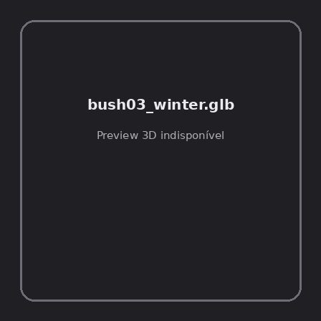
ID | NOV-004489
Origem | Asset novo
Pack/Fonte | retro_nature_pack
Categoria | Nature / Models
Arquivo | bush03_winter.glb
Caminho | 00_Packs_Raw/retro_nature_pack/models/glTF/bushes/bush03_winter.glb
Formato | GLB
Tamanho | 2.34 KB
SHA-256 | d02cf053a35c4f59e179…
Status técnico | ERROR
Licença | MISSING_REVIEW_REQUIRED — sem evidência localizada
Objetos / meshes | N/D / N/D
Vértices | N/D
Faces / triângulos | N/D / N/D
Materiais | N/D —
UV sets / vertex colors | N/D / N/D
Dimensões XYZ | N/D
Rig / armatures / bones | N/D / N/D / N/D
Skinned meshes | N/D
Animações | N/D —
Duração total clips | N/D
Root motion detectado | N/D
LODs / colliders | Nenhum / Nenhum
Texturas vinculadas | N/D (0 ausentes)
Alertas | Licença/fonte não localizada automaticamente; revisão legal necessária.
Notas | Falha na inspeção 3D: RuntimeError: Error: Python: Traceback (most recent call last):  File "/usr/share/blender/scripts/addons/io_scene_gltf2/__init__.py", line 1064, in execute  return self.import_gltf2(context)  File "/usr/share/blender/scripts/addons/io_scene_gltf2/__init__.py", line 1083, in import_gltf2  return self.unit_import(self.filepath, import_settings)  File "/usr/share/blender/scripts/addons/io_scene_gltf2/__init__.py", line 1088, in unit_import  from .blender.imp.gltf2_blender_gltf import BlenderGlTF  File "/usr/share/blender/scripts/addons/io_scene_gltf2/blender/imp/gltf2_blender_gltf.py", line 17, in <module>  from .gltf2_blender_scene import BlenderScene  File "/usr/share/blender/scripts/addons/io_scene_gltf2/blender/imp/gltf2_blender_scene.py", line 17, in <module>  from .gltf2_blender_node import BlenderNode  File "/usr/share/blender/scripts/addons/io_scene_gltf2/blender/imp/gltf2_blender_node.py", line 18, in <module>  from .gltf2_blender_mesh import BlenderMesh  File "/usr/share/blender/scripts/addons/io_scene_gltf2/blender/imp/gltf2_blender_mesh.py", line 17, in <module>  import numpy as np  ModuleNotFoundError: No module named 'numpy'  location: /usr/share/blender/scripts/modules/bpy/ops.py:132  Traceback (most recent call last):  File "/home/runner/work/PSX_demons_whip/PSX_demons_whip/workspace/demons/tools/asset_catalog/blender_batch.py", line 427, in inspect_task  import_model(path)  File "/home/runner/work/PSX_demons_whip/PSX_demons_whip/workspace/demons/tools/asset_catalog/blender_batch.py", line 52, in import_model  bpy.ops.import_scene.gltf(filepath=str(path))  File "/usr/share/blender/scripts/modules/bpy/ops.py", line 132, in __call__  ret = _op_call(self.idname_py(), None, kw)  RuntimeError: Error: Python: Traceback (most recent call last):  File "/usr/share/blender/scripts/addons/io_scene_gltf2/__init__.py", line 1064, in execute  return self.import_gltf2(context)  File "/usr/share/blender/scripts/addons/io_scene_gltf2/__init__.py", line 1083, in import_gltf2  return self.unit_import(self.filepath, import_settings)  File "/usr/share/blender/scripts/addons/io_scene_gltf2/__init__.py", line 1088, in unit_import  from .blender.imp.gltf2_blender_gltf import BlenderGlTF  File "/usr/share/blender/scripts/addons/io_scene_gltf2/blender/imp/gltf2_blender_gltf.py", line 17, in <module>  from .gltf2_blender_scene import BlenderScene  File "/usr/share/blender/scripts/addons/io_scene_gltf2/blender/imp/gltf2_blender_scene.py", line 17, in <module>  from .gltf2_blender_node import BlenderNode  File "/usr/share/blender/scripts/addons/io_scene_gltf2/blender/imp/gltf2_blender_node.py", line 18, in <module>  from .gltf2_blender_mesh import BlenderMesh  File "/usr/share/blender/scripts/addons/io_scene_gltf2/blender/imp/gltf2_blender_mesh.py", line 17, in <module>  import numpy as np  ModuleNotFoundError: No module named 'numpy'  location: /usr/share/blender/scripts/modules/bpy/ops.py:132

NOV-004492 • bush04 [ERROR]
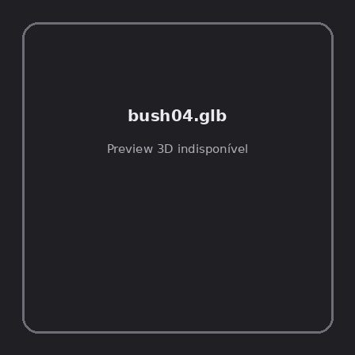
ID | NOV-004492
Origem | Asset novo
Pack/Fonte | retro_nature_pack
Categoria | Nature / Models
Arquivo | bush04.glb
Caminho | 00_Packs_Raw/retro_nature_pack/models/glTF/bushes/bush04.glb
Formato | GLB
Tamanho | 30.85 KB
SHA-256 | 14e9f2f37d1f58c71051…
Status técnico | ERROR
Licença | MISSING_REVIEW_REQUIRED — sem evidência localizada
Objetos / meshes | N/D / N/D
Vértices | N/D
Faces / triângulos | N/D / N/D
Materiais | N/D —
UV sets / vertex colors | N/D / N/D
Dimensões XYZ | N/D
Rig / armatures / bones | N/D / N/D / N/D
Skinned meshes | N/D
Animações | N/D —
Duração total clips | N/D
Root motion detectado | N/D
LODs / colliders | Nenhum / Nenhum
Texturas vinculadas | N/D (0 ausentes)
Alertas | Licença/fonte não localizada automaticamente; revisão legal necessária.
Notas | Falha na inspeção 3D: RuntimeError: Error: Python: Traceback (most recent call last):  File "/usr/share/blender/scripts/addons/io_scene_gltf2/__init__.py", line 1064, in execute  return self.import_gltf2(context)  File "/usr/share/blender/scripts/addons/io_scene_gltf2/__init__.py", line 1083, in import_gltf2  return self.unit_import(self.filepath, import_settings)  File "/usr/share/blender/scripts/addons/io_scene_gltf2/__init__.py", line 1088, in unit_import  from .blender.imp.gltf2_blender_gltf import BlenderGlTF  File "/usr/share/blender/scripts/addons/io_scene_gltf2/blender/imp/gltf2_blender_gltf.py", line 17, in <module>  from .gltf2_blender_scene import BlenderScene  File "/usr/share/blender/scripts/addons/io_scene_gltf2/blender/imp/gltf2_blender_scene.py", line 17, in <module>  from .gltf2_blender_node import BlenderNode  File "/usr/share/blender/scripts/addons/io_scene_gltf2/blender/imp/gltf2_blender_node.py", line 18, in <module>  from .gltf2_blender_mesh import BlenderMesh  File "/usr/share/blender/scripts/addons/io_scene_gltf2/blender/imp/gltf2_blender_mesh.py", line 17, in <module>  import numpy as np  ModuleNotFoundError: No module named 'numpy'  location: /usr/share/blender/scripts/modules/bpy/ops.py:132  Traceback (most recent call last):  File "/home/runner/work/PSX_demons_whip/PSX_demons_whip/workspace/demons/tools/asset_catalog/blender_batch.py", line 427, in inspect_task  import_model(path)  File "/home/runner/work/PSX_demons_whip/PSX_demons_whip/workspace/demons/tools/asset_catalog/blender_batch.py", line 52, in import_model  bpy.ops.import_scene.gltf(filepath=str(path))  File "/usr/share/blender/scripts/modules/bpy/ops.py", line 132, in __call__  ret = _op_call(self.idname_py(), None, kw)  RuntimeError: Error: Python: Traceback (most recent call last):  File "/usr/share/blender/scripts/addons/io_scene_gltf2/__init__.py", line 1064, in execute  return self.import_gltf2(context)  File "/usr/share/blender/scripts/addons/io_scene_gltf2/__init__.py", line 1083, in import_gltf2  return self.unit_import(self.filepath, import_settings)  File "/usr/share/blender/scripts/addons/io_scene_gltf2/__init__.py", line 1088, in unit_import  from .blender.imp.gltf2_blender_gltf import BlenderGlTF  File "/usr/share/blender/scripts/addons/io_scene_gltf2/blender/imp/gltf2_blender_gltf.py", line 17, in <module>  from .gltf2_blender_scene import BlenderScene  File "/usr/share/blender/scripts/addons/io_scene_gltf2/blender/imp/gltf2_blender_scene.py", line 17, in <module>  from .gltf2_blender_node import BlenderNode  File "/usr/share/blender/scripts/addons/io_scene_gltf2/blender/imp/gltf2_blender_node.py", line 18, in <module>  from .gltf2_blender_mesh import BlenderMesh  File "/usr/share/blender/scripts/addons/io_scene_gltf2/blender/imp/gltf2_blender_mesh.py", line 17, in <module>  import numpy as np  ModuleNotFoundError: No module named 'numpy'  location: /usr/share/blender/scripts/modules/bpy/ops.py:132

NOV-004479 • bush04_winter [ERROR]
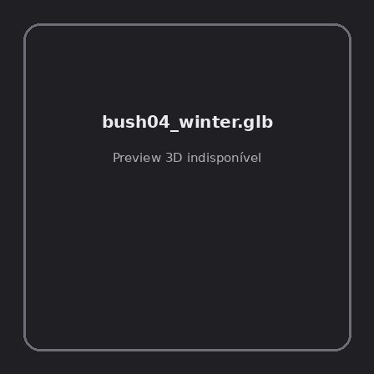
ID | NOV-004479
Origem | Asset novo
Pack/Fonte | retro_nature_pack
Categoria | Nature / Models
Arquivo | bush04_winter.glb
Caminho | 00_Packs_Raw/retro_nature_pack/models/glTF/bushes/bush04_winter.glb
Formato | GLB
Tamanho | 2.83 KB
SHA-256 | f983ecd0f43cdbfc541f…
Status técnico | ERROR
Licença | MISSING_REVIEW_REQUIRED — sem evidência localizada
Objetos / meshes | N/D / N/D
Vértices | N/D
Faces / triângulos | N/D / N/D
Materiais | N/D —
UV sets / vertex colors | N/D / N/D
Dimensões XYZ | N/D
Rig / armatures / bones | N/D / N/D / N/D
Skinned meshes | N/D
Animações | N/D —
Duração total clips | N/D
Root motion detectado | N/D
LODs / colliders | Nenhum / Nenhum
Texturas vinculadas | N/D (0 ausentes)
Alertas | Licença/fonte não localizada automaticamente; revisão legal necessária.
Notas | Falha na inspeção 3D: RuntimeError: Error: Python: Traceback (most recent call last):  File "/usr/share/blender/scripts/addons/io_scene_gltf2/__init__.py", line 1064, in execute  return self.import_gltf2(context)  File "/usr/share/blender/scripts/addons/io_scene_gltf2/__init__.py", line 1083, in import_gltf2  return self.unit_import(self.filepath, import_settings)  File "/usr/share/blender/scripts/addons/io_scene_gltf2/__init__.py", line 1088, in unit_import  from .blender.imp.gltf2_blender_gltf import BlenderGlTF  File "/usr/share/blender/scripts/addons/io_scene_gltf2/blender/imp/gltf2_blender_gltf.py", line 17, in <module>  from .gltf2_blender_scene import BlenderScene  File "/usr/share/blender/scripts/addons/io_scene_gltf2/blender/imp/gltf2_blender_scene.py", line 17, in <module>  from .gltf2_blender_node import BlenderNode  File "/usr/share/blender/scripts/addons/io_scene_gltf2/blender/imp/gltf2_blender_node.py", line 18, in <module>  from .gltf2_blender_mesh import BlenderMesh  File "/usr/share/blender/scripts/addons/io_scene_gltf2/blender/imp/gltf2_blender_mesh.py", line 17, in <module>  import numpy as np  ModuleNotFoundError: No module named 'numpy'  location: /usr/share/blender/scripts/modules/bpy/ops.py:132  Traceback (most recent call last):  File "/home/runner/work/PSX_demons_whip/PSX_demons_whip/workspace/demons/tools/asset_catalog/blender_batch.py", line 427, in inspect_task  import_model(path)  File "/home/runner/work/PSX_demons_whip/PSX_demons_whip/workspace/demons/tools/asset_catalog/blender_batch.py", line 52, in import_model  bpy.ops.import_scene.gltf(filepath=str(path))  File "/usr/share/blender/scripts/modules/bpy/ops.py", line 132, in __call__  ret = _op_call(self.idname_py(), None, kw)  RuntimeError: Error: Python: Traceback (most recent call last):  File "/usr/share/blender/scripts/addons/io_scene_gltf2/__init__.py", line 1064, in execute  return self.import_gltf2(context)  File "/usr/share/blender/scripts/addons/io_scene_gltf2/__init__.py", line 1083, in import_gltf2  return self.unit_import(self.filepath, import_settings)  File "/usr/share/blender/scripts/addons/io_scene_gltf2/__init__.py", line 1088, in unit_import  from .blender.imp.gltf2_blender_gltf import BlenderGlTF  File "/usr/share/blender/scripts/addons/io_scene_gltf2/blender/imp/gltf2_blender_gltf.py", line 17, in <module>  from .gltf2_blender_scene import BlenderScene  File "/usr/share/blender/scripts/addons/io_scene_gltf2/blender/imp/gltf2_blender_scene.py", line 17, in <module>  from .gltf2_blender_node import BlenderNode  File "/usr/share/blender/scripts/addons/io_scene_gltf2/blender/imp/gltf2_blender_node.py", line 18, in <module>  from .gltf2_blender_mesh import BlenderMesh  File "/usr/share/blender/scripts/addons/io_scene_gltf2/blender/imp/gltf2_blender_mesh.py", line 17, in <module>  import numpy as np  ModuleNotFoundError: No module named 'numpy'  location: /usr/share/blender/scripts/modules/bpy/ops.py:132

NOV-004481 • bush05 [ERROR]
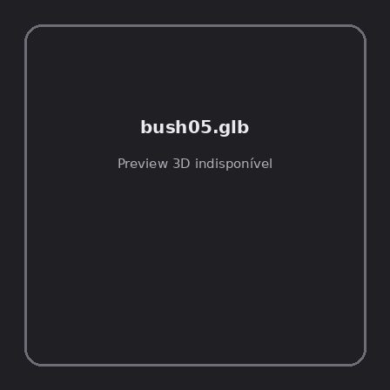
ID | NOV-004481
Origem | Asset novo
Pack/Fonte | retro_nature_pack
Categoria | Nature / Models
Arquivo | bush05.glb
Caminho | 00_Packs_Raw/retro_nature_pack/models/glTF/bushes/bush05.glb
Formato | GLB
Tamanho | 32.29 KB
SHA-256 | b274cb9173fad5f201af…
Status técnico | ERROR
Licença | MISSING_REVIEW_REQUIRED — sem evidência localizada
Objetos / meshes | N/D / N/D
Vértices | N/D
Faces / triângulos | N/D / N/D
Materiais | N/D —
UV sets / vertex colors | N/D / N/D
Dimensões XYZ | N/D
Rig / armatures / bones | N/D / N/D / N/D
Skinned meshes | N/D
Animações | N/D —
Duração total clips | N/D
Root motion detectado | N/D
LODs / colliders | Nenhum / Nenhum
Texturas vinculadas | N/D (0 ausentes)
Alertas | Licença/fonte não localizada automaticamente; revisão legal necessária.
Notas | Falha na inspeção 3D: RuntimeError: Error: Python: Traceback (most recent call last):  File "/usr/share/blender/scripts/addons/io_scene_gltf2/__init__.py", line 1064, in execute  return self.import_gltf2(context)  File "/usr/share/blender/scripts/addons/io_scene_gltf2/__init__.py", line 1083, in import_gltf2  return self.unit_import(self.filepath, import_settings)  File "/usr/share/blender/scripts/addons/io_scene_gltf2/__init__.py", line 1088, in unit_import  from .blender.imp.gltf2_blender_gltf import BlenderGlTF  File "/usr/share/blender/scripts/addons/io_scene_gltf2/blender/imp/gltf2_blender_gltf.py", line 17, in <module>  from .gltf2_blender_scene import BlenderScene  File "/usr/share/blender/scripts/addons/io_scene_gltf2/blender/imp/gltf2_blender_scene.py", line 17, in <module>  from .gltf2_blender_node import BlenderNode  File "/usr/share/blender/scripts/addons/io_scene_gltf2/blender/imp/gltf2_blender_node.py", line 18, in <module>  from .gltf2_blender_mesh import BlenderMesh  File "/usr/share/blender/scripts/addons/io_scene_gltf2/blender/imp/gltf2_blender_mesh.py", line 17, in <module>  import numpy as np  ModuleNotFoundError: No module named 'numpy'  location: /usr/share/blender/scripts/modules/bpy/ops.py:132  Traceback (most recent call last):  File "/home/runner/work/PSX_demons_whip/PSX_demons_whip/workspace/demons/tools/asset_catalog/blender_batch.py", line 427, in inspect_task  import_model(path)  File "/home/runner/work/PSX_demons_whip/PSX_demons_whip/workspace/demons/tools/asset_catalog/blender_batch.py", line 52, in import_model  bpy.ops.import_scene.gltf(filepath=str(path))  File "/usr/share/blender/scripts/modules/bpy/ops.py", line 132, in __call__  ret = _op_call(self.idname_py(), None, kw)  RuntimeError: Error: Python: Traceback (most recent call last):  File "/usr/share/blender/scripts/addons/io_scene_gltf2/__init__.py", line 1064, in execute  return self.import_gltf2(context)  File "/usr/share/blender/scripts/addons/io_scene_gltf2/__init__.py", line 1083, in import_gltf2  return self.unit_import(self.filepath, import_settings)  File "/usr/share/blender/scripts/addons/io_scene_gltf2/__init__.py", line 1088, in unit_import  from .blender.imp.gltf2_blender_gltf import BlenderGlTF  File "/usr/share/blender/scripts/addons/io_scene_gltf2/blender/imp/gltf2_blender_gltf.py", line 17, in <module>  from .gltf2_blender_scene import BlenderScene  File "/usr/share/blender/scripts/addons/io_scene_gltf2/blender/imp/gltf2_blender_scene.py", line 17, in <module>  from .gltf2_blender_node import BlenderNode  File "/usr/share/blender/scripts/addons/io_scene_gltf2/blender/imp/gltf2_blender_node.py", line 18, in <module>  from .gltf2_blender_mesh import BlenderMesh  File "/usr/share/blender/scripts/addons/io_scene_gltf2/blender/imp/gltf2_blender_mesh.py", line 17, in <module>  import numpy as np  ModuleNotFoundError: No module named 'numpy'  location: /usr/share/blender/scripts/modules/bpy/ops.py:132

NOV-004485 • bush05_winter [ERROR]
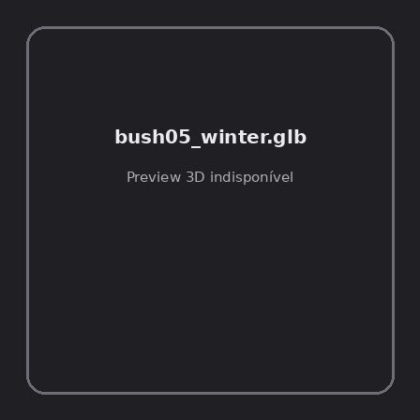
ID | NOV-004485
Origem | Asset novo
Pack/Fonte | retro_nature_pack
Categoria | Nature / Models
Arquivo | bush05_winter.glb
Caminho | 00_Packs_Raw/retro_nature_pack/models/glTF/bushes/bush05_winter.glb
Formato | GLB
Tamanho | 4.80 KB
SHA-256 | 12004c3dd330a613dc3b…
Status técnico | ERROR
Licença | MISSING_REVIEW_REQUIRED — sem evidência localizada
Objetos / meshes | N/D / N/D
Vértices | N/D
Faces / triângulos | N/D / N/D
Materiais | N/D —
UV sets / vertex colors | N/D / N/D
Dimensões XYZ | N/D
Rig / armatures / bones | N/D / N/D / N/D
Skinned meshes | N/D
Animações | N/D —
Duração total clips | N/D
Root motion detectado | N/D
LODs / colliders | Nenhum / Nenhum
Texturas vinculadas | N/D (0 ausentes)
Alertas | Licença/fonte não localizada automaticamente; revisão legal necessária.
Notas | Falha na inspeção 3D: RuntimeError: Error: Python: Traceback (most recent call last):  File "/usr/share/blender/scripts/addons/io_scene_gltf2/__init__.py", line 1064, in execute  return self.import_gltf2(context)  File "/usr/share/blender/scripts/addons/io_scene_gltf2/__init__.py", line 1083, in import_gltf2  return self.unit_import(self.filepath, import_settings)  File "/usr/share/blender/scripts/addons/io_scene_gltf2/__init__.py", line 1088, in unit_import  from .blender.imp.gltf2_blender_gltf import BlenderGlTF  File "/usr/share/blender/scripts/addons/io_scene_gltf2/blender/imp/gltf2_blender_gltf.py", line 17, in <module>  from .gltf2_blender_scene import BlenderScene  File "/usr/share/blender/scripts/addons/io_scene_gltf2/blender/imp/gltf2_blender_scene.py", line 17, in <module>  from .gltf2_blender_node import BlenderNode  File "/usr/share/blender/scripts/addons/io_scene_gltf2/blender/imp/gltf2_blender_node.py", line 18, in <module>  from .gltf2_blender_mesh import BlenderMesh  File "/usr/share/blender/scripts/addons/io_scene_gltf2/blender/imp/gltf2_blender_mesh.py", line 17, in <module>  import numpy as np  ModuleNotFoundError: No module named 'numpy'  location: /usr/share/blender/scripts/modules/bpy/ops.py:132  Traceback (most recent call last):  File "/home/runner/work/PSX_demons_whip/PSX_demons_whip/workspace/demons/tools/asset_catalog/blender_batch.py", line 427, in inspect_task  import_model(path)  File "/home/runner/work/PSX_demons_whip/PSX_demons_whip/workspace/demons/tools/asset_catalog/blender_batch.py", line 52, in import_model  bpy.ops.import_scene.gltf(filepath=str(path))  File "/usr/share/blender/scripts/modules/bpy/ops.py", line 132, in __call__  ret = _op_call(self.idname_py(), None, kw)  RuntimeError: Error: Python: Traceback (most recent call last):  File "/usr/share/blender/scripts/addons/io_scene_gltf2/__init__.py", line 1064, in execute  return self.import_gltf2(context)  File "/usr/share/blender/scripts/addons/io_scene_gltf2/__init__.py", line 1083, in import_gltf2  return self.unit_import(self.filepath, import_settings)  File "/usr/share/blender/scripts/addons/io_scene_gltf2/__init__.py", line 1088, in unit_import  from .blender.imp.gltf2_blender_gltf import BlenderGlTF  File "/usr/share/blender/scripts/addons/io_scene_gltf2/blender/imp/gltf2_blender_gltf.py", line 17, in <module>  from .gltf2_blender_scene import BlenderScene  File "/usr/share/blender/scripts/addons/io_scene_gltf2/blender/imp/gltf2_blender_scene.py", line 17, in <module>  from .gltf2_blender_node import BlenderNode  File "/usr/share/blender/scripts/addons/io_scene_gltf2/blender/imp/gltf2_blender_node.py", line 18, in <module>  from .gltf2_blender_mesh import BlenderMesh  File "/usr/share/blender/scripts/addons/io_scene_gltf2/blender/imp/gltf2_blender_mesh.py", line 17, in <module>  import numpy as np  ModuleNotFoundError: No module named 'numpy'  location: /usr/share/blender/scripts/modules/bpy/ops.py:132

NOV-004488 • bush06 [ERROR]
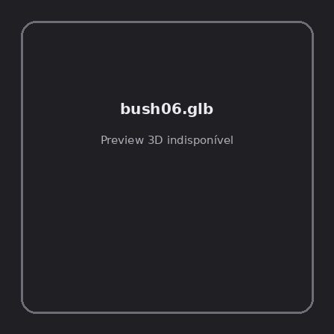
ID | NOV-004488
Origem | Asset novo
Pack/Fonte | retro_nature_pack
Categoria | Nature / Models
Arquivo | bush06.glb
Caminho | 00_Packs_Raw/retro_nature_pack/models/glTF/bushes/bush06.glb
Formato | GLB
Tamanho | 33.14 KB
SHA-256 | 43ae55137e8dbe376141…
Status técnico | ERROR
Licença | MISSING_REVIEW_REQUIRED — sem evidência localizada
Objetos / meshes | N/D / N/D
Vértices | N/D
Faces / triângulos | N/D / N/D
Materiais | N/D —
UV sets / vertex colors | N/D / N/D
Dimensões XYZ | N/D
Rig / armatures / bones | N/D / N/D / N/D
Skinned meshes | N/D
Animações | N/D —
Duração total clips | N/D
Root motion detectado | N/D
LODs / colliders | Nenhum / Nenhum
Texturas vinculadas | N/D (0 ausentes)
Alertas | Licença/fonte não localizada automaticamente; revisão legal necessária.
Notas | Falha na inspeção 3D: RuntimeError: Error: Python: Traceback (most recent call last):  File "/usr/share/blender/scripts/addons/io_scene_gltf2/__init__.py", line 1064, in execute  return self.import_gltf2(context)  File "/usr/share/blender/scripts/addons/io_scene_gltf2/__init__.py", line 1083, in import_gltf2  return self.unit_import(self.filepath, import_settings)  File "/usr/share/blender/scripts/addons/io_scene_gltf2/__init__.py", line 1088, in unit_import  from .blender.imp.gltf2_blender_gltf import BlenderGlTF  File "/usr/share/blender/scripts/addons/io_scene_gltf2/blender/imp/gltf2_blender_gltf.py", line 17, in <module>  from .gltf2_blender_scene import BlenderScene  File "/usr/share/blender/scripts/addons/io_scene_gltf2/blender/imp/gltf2_blender_scene.py", line 17, in <module>  from .gltf2_blender_node import BlenderNode  File "/usr/share/blender/scripts/addons/io_scene_gltf2/blender/imp/gltf2_blender_node.py", line 18, in <module>  from .gltf2_blender_mesh import BlenderMesh  File "/usr/share/blender/scripts/addons/io_scene_gltf2/blender/imp/gltf2_blender_mesh.py", line 17, in <module>  import numpy as np  ModuleNotFoundError: No module named 'numpy'  location: /usr/share/blender/scripts/modules/bpy/ops.py:132  Traceback (most recent call last):  File "/home/runner/work/PSX_demons_whip/PSX_demons_whip/workspace/demons/tools/asset_catalog/blender_batch.py", line 427, in inspect_task  import_model(path)  File "/home/runner/work/PSX_demons_whip/PSX_demons_whip/workspace/demons/tools/asset_catalog/blender_batch.py", line 52, in import_model  bpy.ops.import_scene.gltf(filepath=str(path))  File "/usr/share/blender/scripts/modules/bpy/ops.py", line 132, in __call__  ret = _op_call(self.idname_py(), None, kw)  RuntimeError: Error: Python: Traceback (most recent call last):  File "/usr/share/blender/scripts/addons/io_scene_gltf2/__init__.py", line 1064, in execute  return self.import_gltf2(context)  File "/usr/share/blender/scripts/addons/io_scene_gltf2/__init__.py", line 1083, in import_gltf2  return self.unit_import(self.filepath, import_settings)  File "/usr/share/blender/scripts/addons/io_scene_gltf2/__init__.py", line 1088, in unit_import  from .blender.imp.gltf2_blender_gltf import BlenderGlTF  File "/usr/share/blender/scripts/addons/io_scene_gltf2/blender/imp/gltf2_blender_gltf.py", line 17, in <module>  from .gltf2_blender_scene import BlenderScene  File "/usr/share/blender/scripts/addons/io_scene_gltf2/blender/imp/gltf2_blender_scene.py", line 17, in <module>  from .gltf2_blender_node import BlenderNode  File "/usr/share/blender/scripts/addons/io_scene_gltf2/blender/imp/gltf2_blender_node.py", line 18, in <module>  from .gltf2_blender_mesh import BlenderMesh  File "/usr/share/blender/scripts/addons/io_scene_gltf2/blender/imp/gltf2_blender_mesh.py", line 17, in <module>  import numpy as np  ModuleNotFoundError: No module named 'numpy'  location: /usr/share/blender/scripts/modules/bpy/ops.py:132

NOV-004490 • bush06_winter [ERROR]
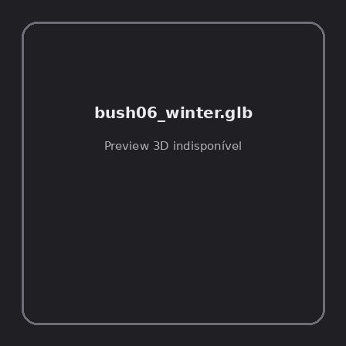
ID | NOV-004490
Origem | Asset novo
Pack/Fonte | retro_nature_pack
Categoria | Nature / Models
Arquivo | bush06_winter.glb
Caminho | 00_Packs_Raw/retro_nature_pack/models/glTF/bushes/bush06_winter.glb
Formato | GLB
Tamanho | 2.84 KB
SHA-256 | 02abee25d91e2eb7d7b9…
Status técnico | ERROR
Licença | MISSING_REVIEW_REQUIRED — sem evidência localizada
Objetos / meshes | N/D / N/D
Vértices | N/D
Faces / triângulos | N/D / N/D
Materiais | N/D —
UV sets / vertex colors | N/D / N/D
Dimensões XYZ | N/D
Rig / armatures / bones | N/D / N/D / N/D
Skinned meshes | N/D
Animações | N/D —
Duração total clips | N/D
Root motion detectado | N/D
LODs / colliders | Nenhum / Nenhum
Texturas vinculadas | N/D (0 ausentes)
Alertas | Licença/fonte não localizada automaticamente; revisão legal necessária.
Notas | Falha na inspeção 3D: RuntimeError: Error: Python: Traceback (most recent call last):  File "/usr/share/blender/scripts/addons/io_scene_gltf2/__init__.py", line 1064, in execute  return self.import_gltf2(context)  File "/usr/share/blender/scripts/addons/io_scene_gltf2/__init__.py", line 1083, in import_gltf2  return self.unit_import(self.filepath, import_settings)  File "/usr/share/blender/scripts/addons/io_scene_gltf2/__init__.py", line 1088, in unit_import  from .blender.imp.gltf2_blender_gltf import BlenderGlTF  File "/usr/share/blender/scripts/addons/io_scene_gltf2/blender/imp/gltf2_blender_gltf.py", line 17, in <module>  from .gltf2_blender_scene import BlenderScene  File "/usr/share/blender/scripts/addons/io_scene_gltf2/blender/imp/gltf2_blender_scene.py", line 17, in <module>  from .gltf2_blender_node import BlenderNode  File "/usr/share/blender/scripts/addons/io_scene_gltf2/blender/imp/gltf2_blender_node.py", line 18, in <module>  from .gltf2_blender_mesh import BlenderMesh  File "/usr/share/blender/scripts/addons/io_scene_gltf2/blender/imp/gltf2_blender_mesh.py", line 17, in <module>  import numpy as np  ModuleNotFoundError: No module named 'numpy'  location: /usr/share/blender/scripts/modules/bpy/ops.py:132  Traceback (most recent call last):  File "/home/runner/work/PSX_demons_whip/PSX_demons_whip/workspace/demons/tools/asset_catalog/blender_batch.py", line 427, in inspect_task  import_model(path)  File "/home/runner/work/PSX_demons_whip/PSX_demons_whip/workspace/demons/tools/asset_catalog/blender_batch.py", line 52, in import_model  bpy.ops.import_scene.gltf(filepath=str(path))  File "/usr/share/blender/scripts/modules/bpy/ops.py", line 132, in __call__  ret = _op_call(self.idname_py(), None, kw)  RuntimeError: Error: Python: Traceback (most recent call last):  File "/usr/share/blender/scripts/addons/io_scene_gltf2/__init__.py", line 1064, in execute  return self.import_gltf2(context)  File "/usr/share/blender/scripts/addons/io_scene_gltf2/__init__.py", line 1083, in import_gltf2  return self.unit_import(self.filepath, import_settings)  File "/usr/share/blender/scripts/addons/io_scene_gltf2/__init__.py", line 1088, in unit_import  from .blender.imp.gltf2_blender_gltf import BlenderGlTF  File "/usr/share/blender/scripts/addons/io_scene_gltf2/blender/imp/gltf2_blender_gltf.py", line 17, in <module>  from .gltf2_blender_scene import BlenderScene  File "/usr/share/blender/scripts/addons/io_scene_gltf2/blender/imp/gltf2_blender_scene.py", line 17, in <module>  from .gltf2_blender_node import BlenderNode  File "/usr/share/blender/scripts/addons/io_scene_gltf2/blender/imp/gltf2_blender_node.py", line 18, in <module>  from .gltf2_blender_mesh import BlenderMesh  File "/usr/share/blender/scripts/addons/io_scene_gltf2/blender/imp/gltf2_blender_mesh.py", line 17, in <module>  import numpy as np  ModuleNotFoundError: No module named 'numpy'  location: /usr/share/blender/scripts/modules/bpy/ops.py:132

NOV-004491 • bush07 [ERROR]
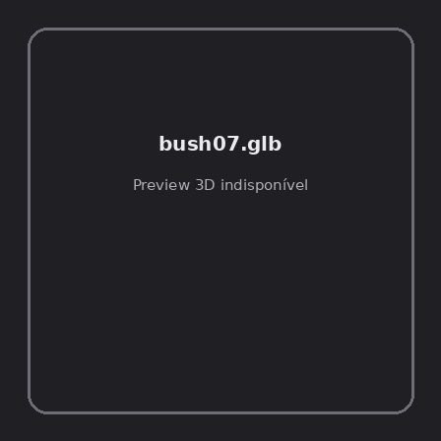
ID | NOV-004491
Origem | Asset novo
Pack/Fonte | retro_nature_pack
Categoria | Nature / Models
Arquivo | bush07.glb
Caminho | 00_Packs_Raw/retro_nature_pack/models/glTF/bushes/bush07.glb
Formato | GLB
Tamanho | 31.99 KB
SHA-256 | 4bb4877308cc07f263bd…
Status técnico | ERROR
Licença | MISSING_REVIEW_REQUIRED — sem evidência localizada
Objetos / meshes | N/D / N/D
Vértices | N/D
Faces / triângulos | N/D / N/D
Materiais | N/D —
UV sets / vertex colors | N/D / N/D
Dimensões XYZ | N/D
Rig / armatures / bones | N/D / N/D / N/D
Skinned meshes | N/D
Animações | N/D —
Duração total clips | N/D
Root motion detectado | N/D
LODs / colliders | Nenhum / Nenhum
Texturas vinculadas | N/D (0 ausentes)
Alertas | Licença/fonte não localizada automaticamente; revisão legal necessária.
Notas | Falha na inspeção 3D: RuntimeError: Error: Python: Traceback (most recent call last):  File "/usr/share/blender/scripts/addons/io_scene_gltf2/__init__.py", line 1064, in execute  return self.import_gltf2(context)  File "/usr/share/blender/scripts/addons/io_scene_gltf2/__init__.py", line 1083, in import_gltf2  return self.unit_import(self.filepath, import_settings)  File "/usr/share/blender/scripts/addons/io_scene_gltf2/__init__.py", line 1088, in unit_import  from .blender.imp.gltf2_blender_gltf import BlenderGlTF  File "/usr/share/blender/scripts/addons/io_scene_gltf2/blender/imp/gltf2_blender_gltf.py", line 17, in <module>  from .gltf2_blender_scene import BlenderScene  File "/usr/share/blender/scripts/addons/io_scene_gltf2/blender/imp/gltf2_blender_scene.py", line 17, in <module>  from .gltf2_blender_node import BlenderNode  File "/usr/share/blender/scripts/addons/io_scene_gltf2/blender/imp/gltf2_blender_node.py", line 18, in <module>  from .gltf2_blender_mesh import BlenderMesh  File "/usr/share/blender/scripts/addons/io_scene_gltf2/blender/imp/gltf2_blender_mesh.py", line 17, in <module>  import numpy as np  ModuleNotFoundError: No module named 'numpy'  location: /usr/share/blender/scripts/modules/bpy/ops.py:132  Traceback (most recent call last):  File "/home/runner/work/PSX_demons_whip/PSX_demons_whip/workspace/demons/tools/asset_catalog/blender_batch.py", line 427, in inspect_task  import_model(path)  File "/home/runner/work/PSX_demons_whip/PSX_demons_whip/workspace/demons/tools/asset_catalog/blender_batch.py", line 52, in import_model  bpy.ops.import_scene.gltf(filepath=str(path))  File "/usr/share/blender/scripts/modules/bpy/ops.py", line 132, in __call__  ret = _op_call(self.idname_py(), None, kw)  RuntimeError: Error: Python: Traceback (most recent call last):  File "/usr/share/blender/scripts/addons/io_scene_gltf2/__init__.py", line 1064, in execute  return self.import_gltf2(context)  File "/usr/share/blender/scripts/addons/io_scene_gltf2/__init__.py", line 1083, in import_gltf2  return self.unit_import(self.filepath, import_settings)  File "/usr/share/blender/scripts/addons/io_scene_gltf2/__init__.py", line 1088, in unit_import  from .blender.imp.gltf2_blender_gltf import BlenderGlTF  File "/usr/share/blender/scripts/addons/io_scene_gltf2/blender/imp/gltf2_blender_gltf.py", line 17, in <module>  from .gltf2_blender_scene import BlenderScene  File "/usr/share/blender/scripts/addons/io_scene_gltf2/blender/imp/gltf2_blender_scene.py", line 17, in <module>  from .gltf2_blender_node import BlenderNode  File "/usr/share/blender/scripts/addons/io_scene_gltf2/blender/imp/gltf2_blender_node.py", line 18, in <module>  from .gltf2_blender_mesh import BlenderMesh  File "/usr/share/blender/scripts/addons/io_scene_gltf2/blender/imp/gltf2_blender_mesh.py", line 17, in <module>  import numpy as np  ModuleNotFoundError: No module named 'numpy'  location: /usr/share/blender/scripts/modules/bpy/ops.py:132

NOV-004486 • bush08 [ERROR]
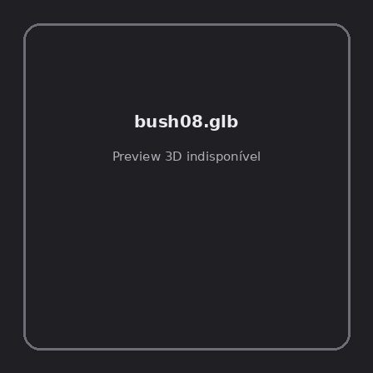
ID | NOV-004486
Origem | Asset novo
Pack/Fonte | retro_nature_pack
Categoria | Nature / Models
Arquivo | bush08.glb
Caminho | 00_Packs_Raw/retro_nature_pack/models/glTF/bushes/bush08.glb
Formato | GLB
Tamanho | 34.79 KB
SHA-256 | 306e77fa7c0cb7c813a0…
Status técnico | ERROR
Licença | MISSING_REVIEW_REQUIRED — sem evidência localizada
Objetos / meshes | N/D / N/D
Vértices | N/D
Faces / triângulos | N/D / N/D
Materiais | N/D —
UV sets / vertex colors | N/D / N/D
Dimensões XYZ | N/D
Rig / armatures / bones | N/D / N/D / N/D
Skinned meshes | N/D
Animações | N/D —
Duração total clips | N/D
Root motion detectado | N/D
LODs / colliders | Nenhum / Nenhum
Texturas vinculadas | N/D (0 ausentes)
Alertas | Licença/fonte não localizada automaticamente; revisão legal necessária.
Notas | Falha na inspeção 3D: RuntimeError: Error: Python: Traceback (most recent call last):  File "/usr/share/blender/scripts/addons/io_scene_gltf2/__init__.py", line 1064, in execute  return self.import_gltf2(context)  File "/usr/share/blender/scripts/addons/io_scene_gltf2/__init__.py", line 1083, in import_gltf2  return self.unit_import(self.filepath, import_settings)  File "/usr/share/blender/scripts/addons/io_scene_gltf2/__init__.py", line 1088, in unit_import  from .blender.imp.gltf2_blender_gltf import BlenderGlTF  File "/usr/share/blender/scripts/addons/io_scene_gltf2/blender/imp/gltf2_blender_gltf.py", line 17, in <module>  from .gltf2_blender_scene import BlenderScene  File "/usr/share/blender/scripts/addons/io_scene_gltf2/blender/imp/gltf2_blender_scene.py", line 17, in <module>  from .gltf2_blender_node import BlenderNode  File "/usr/share/blender/scripts/addons/io_scene_gltf2/blender/imp/gltf2_blender_node.py", line 18, in <module>  from .gltf2_blender_mesh import BlenderMesh  File "/usr/share/blender/scripts/addons/io_scene_gltf2/blender/imp/gltf2_blender_mesh.py", line 17, in <module>  import numpy as np  ModuleNotFoundError: No module named 'numpy'  location: /usr/share/blender/scripts/modules/bpy/ops.py:132  Traceback (most recent call last):  File "/home/runner/work/PSX_demons_whip/PSX_demons_whip/workspace/demons/tools/asset_catalog/blender_batch.py", line 427, in inspect_task  import_model(path)  File "/home/runner/work/PSX_demons_whip/PSX_demons_whip/workspace/demons/tools/asset_catalog/blender_batch.py", line 52, in import_model  bpy.ops.import_scene.gltf(filepath=str(path))  File "/usr/share/blender/scripts/modules/bpy/ops.py", line 132, in __call__  ret = _op_call(self.idname_py(), None, kw)  RuntimeError: Error: Python: Traceback (most recent call last):  File "/usr/share/blender/scripts/addons/io_scene_gltf2/__init__.py", line 1064, in execute  return self.import_gltf2(context)  File "/usr/share/blender/scripts/addons/io_scene_gltf2/__init__.py", line 1083, in import_gltf2  return self.unit_import(self.filepath, import_settings)  File "/usr/share/blender/scripts/addons/io_scene_gltf2/__init__.py", line 1088, in unit_import  from .blender.imp.gltf2_blender_gltf import BlenderGlTF  File "/usr/share/blender/scripts/addons/io_scene_gltf2/blender/imp/gltf2_blender_gltf.py", line 17, in <module>  from .gltf2_blender_scene import BlenderScene  File "/usr/share/blender/scripts/addons/io_scene_gltf2/blender/imp/gltf2_blender_scene.py", line 17, in <module>  from .gltf2_blender_node import BlenderNode  File "/usr/share/blender/scripts/addons/io_scene_gltf2/blender/imp/gltf2_blender_node.py", line 18, in <module>  from .gltf2_blender_mesh import BlenderMesh  File "/usr/share/blender/scripts/addons/io_scene_gltf2/blender/imp/gltf2_blender_mesh.py", line 17, in <module>  import numpy as np  ModuleNotFoundError: No module named 'numpy'  location: /usr/share/blender/scripts/modules/bpy/ops.py:132

NOV-004516 • grass01 [ERROR]
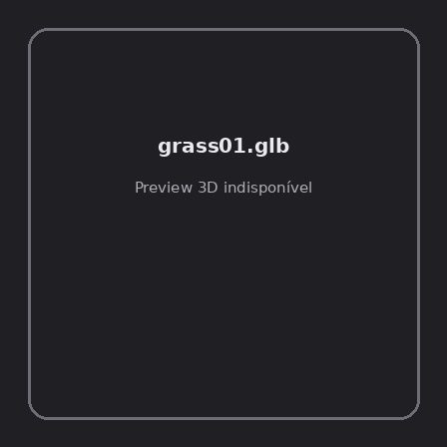
ID | NOV-004516
Origem | Asset novo
Pack/Fonte | retro_nature_pack
Categoria | Nature / Models
Arquivo | grass01.glb
Caminho | 00_Packs_Raw/retro_nature_pack/models/glTF/grass/grass01.glb
Formato | GLB
Tamanho | 1.43 KB
SHA-256 | 4079b9c106bffd69a35c…
Status técnico | ERROR
Licença | MISSING_REVIEW_REQUIRED — sem evidência localizada
Objetos / meshes | N/D / N/D
Vértices | N/D
Faces / triângulos | N/D / N/D
Materiais | N/D —
UV sets / vertex colors | N/D / N/D
Dimensões XYZ | N/D
Rig / armatures / bones | N/D / N/D / N/D
Skinned meshes | N/D
Animações | N/D —
Duração total clips | N/D
Root motion detectado | N/D
LODs / colliders | Nenhum / Nenhum
Texturas vinculadas | N/D (0 ausentes)
Alertas | Licença/fonte não localizada automaticamente; revisão legal necessária.
Notas | Falha na inspeção 3D: RuntimeError: Error: Python: Traceback (most recent call last):  File "/usr/share/blender/scripts/addons/io_scene_gltf2/__init__.py", line 1064, in execute  return self.import_gltf2(context)  File "/usr/share/blender/scripts/addons/io_scene_gltf2/__init__.py", line 1083, in import_gltf2  return self.unit_import(self.filepath, import_settings)  File "/usr/share/blender/scripts/addons/io_scene_gltf2/__init__.py", line 1088, in unit_import  from .blender.imp.gltf2_blender_gltf import BlenderGlTF  File "/usr/share/blender/scripts/addons/io_scene_gltf2/blender/imp/gltf2_blender_gltf.py", line 17, in <module>  from .gltf2_blender_scene import BlenderScene  File "/usr/share/blender/scripts/addons/io_scene_gltf2/blender/imp/gltf2_blender_scene.py", line 17, in <module>  from .gltf2_blender_node import BlenderNode  File "/usr/share/blender/scripts/addons/io_scene_gltf2/blender/imp/gltf2_blender_node.py", line 18, in <module>  from .gltf2_blender_mesh import BlenderMesh  File "/usr/share/blender/scripts/addons/io_scene_gltf2/blender/imp/gltf2_blender_mesh.py", line 17, in <module>  import numpy as np  ModuleNotFoundError: No module named 'numpy'  location: /usr/share/blender/scripts/modules/bpy/ops.py:132  Traceback (most recent call last):  File "/home/runner/work/PSX_demons_whip/PSX_demons_whip/workspace/demons/tools/asset_catalog/blender_batch.py", line 427, in inspect_task  import_model(path)  File "/home/runner/work/PSX_demons_whip/PSX_demons_whip/workspace/demons/tools/asset_catalog/blender_batch.py", line 52, in import_model  bpy.ops.import_scene.gltf(filepath=str(path))  File "/usr/share/blender/scripts/modules/bpy/ops.py", line 132, in __call__  ret = _op_call(self.idname_py(), None, kw)  RuntimeError: Error: Python: Traceback (most recent call last):  File "/usr/share/blender/scripts/addons/io_scene_gltf2/__init__.py", line 1064, in execute  return self.import_gltf2(context)  File "/usr/share/blender/scripts/addons/io_scene_gltf2/__init__.py", line 1083, in import_gltf2  return self.unit_import(self.filepath, import_settings)  File "/usr/share/blender/scripts/addons/io_scene_gltf2/__init__.py", line 1088, in unit_import  from .blender.imp.gltf2_blender_gltf import BlenderGlTF  File "/usr/share/blender/scripts/addons/io_scene_gltf2/blender/imp/gltf2_blender_gltf.py", line 17, in <module>  from .gltf2_blender_scene import BlenderScene  File "/usr/share/blender/scripts/addons/io_scene_gltf2/blender/imp/gltf2_blender_scene.py", line 17, in <module>  from .gltf2_blender_node import BlenderNode  File "/usr/share/blender/scripts/addons/io_scene_gltf2/blender/imp/gltf2_blender_node.py", line 18, in <module>  from .gltf2_blender_mesh import BlenderMesh  File "/usr/share/blender/scripts/addons/io_scene_gltf2/blender/imp/gltf2_blender_mesh.py", line 17, in <module>  import numpy as np  ModuleNotFoundError: No module named 'numpy'  location: /usr/share/blender/scripts/modules/bpy/ops.py:132

NOV-004514 • grass02 [ERROR]
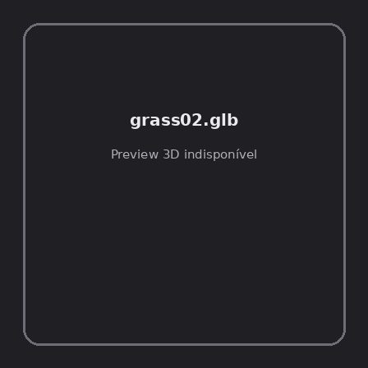
ID | NOV-004514
Origem | Asset novo
Pack/Fonte | retro_nature_pack
Categoria | Nature / Models
Arquivo | grass02.glb
Caminho | 00_Packs_Raw/retro_nature_pack/models/glTF/grass/grass02.glb
Formato | GLB
Tamanho | 1.83 KB
SHA-256 | 7c2020c7cc9ce0ab54c8…
Status técnico | ERROR
Licença | MISSING_REVIEW_REQUIRED — sem evidência localizada
Objetos / meshes | N/D / N/D
Vértices | N/D
Faces / triângulos | N/D / N/D
Materiais | N/D —
UV sets / vertex colors | N/D / N/D
Dimensões XYZ | N/D
Rig / armatures / bones | N/D / N/D / N/D
Skinned meshes | N/D
Animações | N/D —
Duração total clips | N/D
Root motion detectado | N/D
LODs / colliders | Nenhum / Nenhum
Texturas vinculadas | N/D (0 ausentes)
Alertas | Licença/fonte não localizada automaticamente; revisão legal necessária.
Notas | Falha na inspeção 3D: RuntimeError: Error: Python: Traceback (most recent call last):  File "/usr/share/blender/scripts/addons/io_scene_gltf2/__init__.py", line 1064, in execute  return self.import_gltf2(context)  File "/usr/share/blender/scripts/addons/io_scene_gltf2/__init__.py", line 1083, in import_gltf2  return self.unit_import(self.filepath, import_settings)  File "/usr/share/blender/scripts/addons/io_scene_gltf2/__init__.py", line 1088, in unit_import  from .blender.imp.gltf2_blender_gltf import BlenderGlTF  File "/usr/share/blender/scripts/addons/io_scene_gltf2/blender/imp/gltf2_blender_gltf.py", line 17, in <module>  from .gltf2_blender_scene import BlenderScene  File "/usr/share/blender/scripts/addons/io_scene_gltf2/blender/imp/gltf2_blender_scene.py", line 17, in <module>  from .gltf2_blender_node import BlenderNode  File "/usr/share/blender/scripts/addons/io_scene_gltf2/blender/imp/gltf2_blender_node.py", line 18, in <module>  from .gltf2_blender_mesh import BlenderMesh  File "/usr/share/blender/scripts/addons/io_scene_gltf2/blender/imp/gltf2_blender_mesh.py", line 17, in <module>  import numpy as np  ModuleNotFoundError: No module named 'numpy'  location: /usr/share/blender/scripts/modules/bpy/ops.py:132  Traceback (most recent call last):  File "/home/runner/work/PSX_demons_whip/PSX_demons_whip/workspace/demons/tools/asset_catalog/blender_batch.py", line 427, in inspect_task  import_model(path)  File "/home/runner/work/PSX_demons_whip/PSX_demons_whip/workspace/demons/tools/asset_catalog/blender_batch.py", line 52, in import_model  bpy.ops.import_scene.gltf(filepath=str(path))  File "/usr/share/blender/scripts/modules/bpy/ops.py", line 132, in __call__  ret = _op_call(self.idname_py(), None, kw)  RuntimeError: Error: Python: Traceback (most recent call last):  File "/usr/share/blender/scripts/addons/io_scene_gltf2/__init__.py", line 1064, in execute  return self.import_gltf2(context)  File "/usr/share/blender/scripts/addons/io_scene_gltf2/__init__.py", line 1083, in import_gltf2  return self.unit_import(self.filepath, import_settings)  File "/usr/share/blender/scripts/addons/io_scene_gltf2/__init__.py", line 1088, in unit_import  from .blender.imp.gltf2_blender_gltf import BlenderGlTF  File "/usr/share/blender/scripts/addons/io_scene_gltf2/blender/imp/gltf2_blender_gltf.py", line 17, in <module>  from .gltf2_blender_scene import BlenderScene  File "/usr/share/blender/scripts/addons/io_scene_gltf2/blender/imp/gltf2_blender_scene.py", line 17, in <module>  from .gltf2_blender_node import BlenderNode  File "/usr/share/blender/scripts/addons/io_scene_gltf2/blender/imp/gltf2_blender_node.py", line 18, in <module>  from .gltf2_blender_mesh import BlenderMesh  File "/usr/share/blender/scripts/addons/io_scene_gltf2/blender/imp/gltf2_blender_mesh.py", line 17, in <module>  import numpy as np  ModuleNotFoundError: No module named 'numpy'  location: /usr/share/blender/scripts/modules/bpy/ops.py:132

NOV-004513 • grass03 [ERROR]
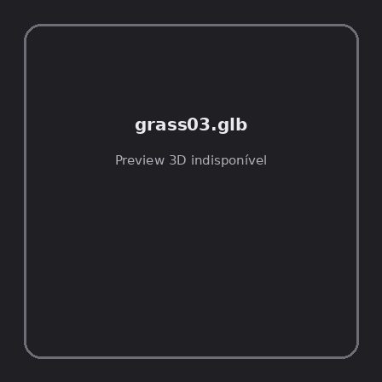
ID | NOV-004513
Origem | Asset novo
Pack/Fonte | retro_nature_pack
Categoria | Nature / Models
Arquivo | grass03.glb
Caminho | 00_Packs_Raw/retro_nature_pack/models/glTF/grass/grass03.glb
Formato | GLB
Tamanho | 2.01 KB
SHA-256 | 707896a7950fd27a4dfb…
Status técnico | ERROR
Licença | MISSING_REVIEW_REQUIRED — sem evidência localizada
Objetos / meshes | N/D / N/D
Vértices | N/D
Faces / triângulos | N/D / N/D
Materiais | N/D —
UV sets / vertex colors | N/D / N/D
Dimensões XYZ | N/D
Rig / armatures / bones | N/D / N/D / N/D
Skinned meshes | N/D
Animações | N/D —
Duração total clips | N/D
Root motion detectado | N/D
LODs / colliders | Nenhum / Nenhum
Texturas vinculadas | N/D (0 ausentes)
Alertas | Licença/fonte não localizada automaticamente; revisão legal necessária.
Notas | Falha na inspeção 3D: RuntimeError: Error: Python: Traceback (most recent call last):  File "/usr/share/blender/scripts/addons/io_scene_gltf2/__init__.py", line 1064, in execute  return self.import_gltf2(context)  File "/usr/share/blender/scripts/addons/io_scene_gltf2/__init__.py", line 1083, in import_gltf2  return self.unit_import(self.filepath, import_settings)  File "/usr/share/blender/scripts/addons/io_scene_gltf2/__init__.py", line 1088, in unit_import  from .blender.imp.gltf2_blender_gltf import BlenderGlTF  File "/usr/share/blender/scripts/addons/io_scene_gltf2/blender/imp/gltf2_blender_gltf.py", line 17, in <module>  from .gltf2_blender_scene import BlenderScene  File "/usr/share/blender/scripts/addons/io_scene_gltf2/blender/imp/gltf2_blender_scene.py", line 17, in <module>  from .gltf2_blender_node import BlenderNode  File "/usr/share/blender/scripts/addons/io_scene_gltf2/blender/imp/gltf2_blender_node.py", line 18, in <module>  from .gltf2_blender_mesh import BlenderMesh  File "/usr/share/blender/scripts/addons/io_scene_gltf2/blender/imp/gltf2_blender_mesh.py", line 17, in <module>  import numpy as np  ModuleNotFoundError: No module named 'numpy'  location: /usr/share/blender/scripts/modules/bpy/ops.py:132  Traceback (most recent call last):  File "/home/runner/work/PSX_demons_whip/PSX_demons_whip/workspace/demons/tools/asset_catalog/blender_batch.py", line 427, in inspect_task  import_model(path)  File "/home/runner/work/PSX_demons_whip/PSX_demons_whip/workspace/demons/tools/asset_catalog/blender_batch.py", line 52, in import_model  bpy.ops.import_scene.gltf(filepath=str(path))  File "/usr/share/blender/scripts/modules/bpy/ops.py", line 132, in __call__  ret = _op_call(self.idname_py(), None, kw)  RuntimeError: Error: Python: Traceback (most recent call last):  File "/usr/share/blender/scripts/addons/io_scene_gltf2/__init__.py", line 1064, in execute  return self.import_gltf2(context)  File "/usr/share/blender/scripts/addons/io_scene_gltf2/__init__.py", line 1083, in import_gltf2  return self.unit_import(self.filepath, import_settings)  File "/usr/share/blender/scripts/addons/io_scene_gltf2/__init__.py", line 1088, in unit_import  from .blender.imp.gltf2_blender_gltf import BlenderGlTF  File "/usr/share/blender/scripts/addons/io_scene_gltf2/blender/imp/gltf2_blender_gltf.py", line 17, in <module>  from .gltf2_blender_scene import BlenderScene  File "/usr/share/blender/scripts/addons/io_scene_gltf2/blender/imp/gltf2_blender_scene.py", line 17, in <module>  from .gltf2_blender_node import BlenderNode  File "/usr/share/blender/scripts/addons/io_scene_gltf2/blender/imp/gltf2_blender_node.py", line 18, in <module>  from .gltf2_blender_mesh import BlenderMesh  File "/usr/share/blender/scripts/addons/io_scene_gltf2/blender/imp/gltf2_blender_mesh.py", line 17, in <module>  import numpy as np  ModuleNotFoundError: No module named 'numpy'  location: /usr/share/blender/scripts/modules/bpy/ops.py:132

NOV-004511 • grass04 [ERROR]
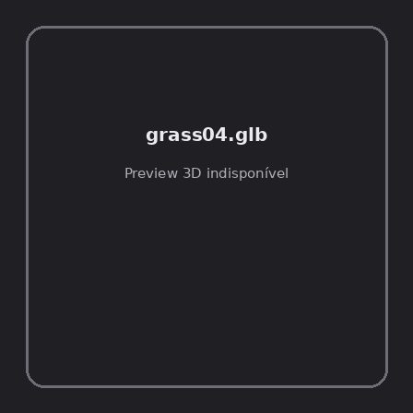
ID | NOV-004511
Origem | Asset novo
Pack/Fonte | retro_nature_pack
Categoria | Nature / Models
Arquivo | grass04.glb
Caminho | 00_Packs_Raw/retro_nature_pack/models/glTF/grass/grass04.glb
Formato | GLB
Tamanho | 1.79 KB
SHA-256 | ed9ed024217e92e74588…
Status técnico | ERROR
Licença | MISSING_REVIEW_REQUIRED — sem evidência localizada
Objetos / meshes | N/D / N/D
Vértices | N/D
Faces / triângulos | N/D / N/D
Materiais | N/D —
UV sets / vertex colors | N/D / N/D
Dimensões XYZ | N/D
Rig / armatures / bones | N/D / N/D / N/D
Skinned meshes | N/D
Animações | N/D —
Duração total clips | N/D
Root motion detectado | N/D
LODs / colliders | Nenhum / Nenhum
Texturas vinculadas | N/D (0 ausentes)
Alertas | Licença/fonte não localizada automaticamente; revisão legal necessária.
Notas | Falha na inspeção 3D: RuntimeError: Error: Python: Traceback (most recent call last):  File "/usr/share/blender/scripts/addons/io_scene_gltf2/__init__.py", line 1064, in execute  return self.import_gltf2(context)  File "/usr/share/blender/scripts/addons/io_scene_gltf2/__init__.py", line 1083, in import_gltf2  return self.unit_import(self.filepath, import_settings)  File "/usr/share/blender/scripts/addons/io_scene_gltf2/__init__.py", line 1088, in unit_import  from .blender.imp.gltf2_blender_gltf import BlenderGlTF  File "/usr/share/blender/scripts/addons/io_scene_gltf2/blender/imp/gltf2_blender_gltf.py", line 17, in <module>  from .gltf2_blender_scene import BlenderScene  File "/usr/share/blender/scripts/addons/io_scene_gltf2/blender/imp/gltf2_blender_scene.py", line 17, in <module>  from .gltf2_blender_node import BlenderNode  File "/usr/share/blender/scripts/addons/io_scene_gltf2/blender/imp/gltf2_blender_node.py", line 18, in <module>  from .gltf2_blender_mesh import BlenderMesh  File "/usr/share/blender/scripts/addons/io_scene_gltf2/blender/imp/gltf2_blender_mesh.py", line 17, in <module>  import numpy as np  ModuleNotFoundError: No module named 'numpy'  location: /usr/share/blender/scripts/modules/bpy/ops.py:132  Traceback (most recent call last):  File "/home/runner/work/PSX_demons_whip/PSX_demons_whip/workspace/demons/tools/asset_catalog/blender_batch.py", line 427, in inspect_task  import_model(path)  File "/home/runner/work/PSX_demons_whip/PSX_demons_whip/workspace/demons/tools/asset_catalog/blender_batch.py", line 52, in import_model  bpy.ops.import_scene.gltf(filepath=str(path))  File "/usr/share/blender/scripts/modules/bpy/ops.py", line 132, in __call__  ret = _op_call(self.idname_py(), None, kw)  RuntimeError: Error: Python: Traceback (most recent call last):  File "/usr/share/blender/scripts/addons/io_scene_gltf2/__init__.py", line 1064, in execute  return self.import_gltf2(context)  File "/usr/share/blender/scripts/addons/io_scene_gltf2/__init__.py", line 1083, in import_gltf2  return self.unit_import(self.filepath, import_settings)  File "/usr/share/blender/scripts/addons/io_scene_gltf2/__init__.py", line 1088, in unit_import  from .blender.imp.gltf2_blender_gltf import BlenderGlTF  File "/usr/share/blender/scripts/addons/io_scene_gltf2/blender/imp/gltf2_blender_gltf.py", line 17, in <module>  from .gltf2_blender_scene import BlenderScene  File "/usr/share/blender/scripts/addons/io_scene_gltf2/blender/imp/gltf2_blender_scene.py", line 17, in <module>  from .gltf2_blender_node import BlenderNode  File "/usr/share/blender/scripts/addons/io_scene_gltf2/blender/imp/gltf2_blender_node.py", line 18, in <module>  from .gltf2_blender_mesh import BlenderMesh  File "/usr/share/blender/scripts/addons/io_scene_gltf2/blender/imp/gltf2_blender_mesh.py", line 17, in <module>  import numpy as np  ModuleNotFoundError: No module named 'numpy'  location: /usr/share/blender/scripts/modules/bpy/ops.py:132

NOV-004508 • grass05 [ERROR]
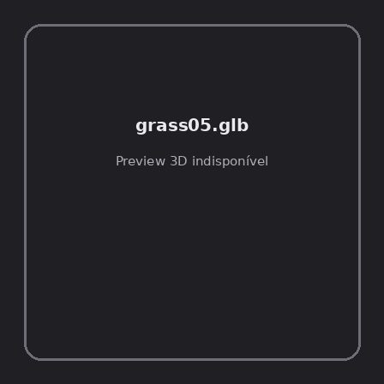
ID | NOV-004508
Origem | Asset novo
Pack/Fonte | retro_nature_pack
Categoria | Nature / Models
Arquivo | grass05.glb
Caminho | 00_Packs_Raw/retro_nature_pack/models/glTF/grass/grass05.glb
Formato | GLB
Tamanho | 1.84 KB
SHA-256 | 868b37a094220d0e4b05…
Status técnico | ERROR
Licença | MISSING_REVIEW_REQUIRED — sem evidência localizada
Objetos / meshes | N/D / N/D
Vértices | N/D
Faces / triângulos | N/D / N/D
Materiais | N/D —
UV sets / vertex colors | N/D / N/D
Dimensões XYZ | N/D
Rig / armatures / bones | N/D / N/D / N/D
Skinned meshes | N/D
Animações | N/D —
Duração total clips | N/D
Root motion detectado | N/D
LODs / colliders | Nenhum / Nenhum
Texturas vinculadas | N/D (0 ausentes)
Alertas | Licença/fonte não localizada automaticamente; revisão legal necessária.
Notas | Falha na inspeção 3D: RuntimeError: Error: Python: Traceback (most recent call last):  File "/usr/share/blender/scripts/addons/io_scene_gltf2/__init__.py", line 1064, in execute  return self.import_gltf2(context)  File "/usr/share/blender/scripts/addons/io_scene_gltf2/__init__.py", line 1083, in import_gltf2  return self.unit_import(self.filepath, import_settings)  File "/usr/share/blender/scripts/addons/io_scene_gltf2/__init__.py", line 1088, in unit_import  from .blender.imp.gltf2_blender_gltf import BlenderGlTF  File "/usr/share/blender/scripts/addons/io_scene_gltf2/blender/imp/gltf2_blender_gltf.py", line 17, in <module>  from .gltf2_blender_scene import BlenderScene  File "/usr/share/blender/scripts/addons/io_scene_gltf2/blender/imp/gltf2_blender_scene.py", line 17, in <module>  from .gltf2_blender_node import BlenderNode  File "/usr/share/blender/scripts/addons/io_scene_gltf2/blender/imp/gltf2_blender_node.py", line 18, in <module>  from .gltf2_blender_mesh import BlenderMesh  File "/usr/share/blender/scripts/addons/io_scene_gltf2/blender/imp/gltf2_blender_mesh.py", line 17, in <module>  import numpy as np  ModuleNotFoundError: No module named 'numpy'  location: /usr/share/blender/scripts/modules/bpy/ops.py:132  Traceback (most recent call last):  File "/home/runner/work/PSX_demons_whip/PSX_demons_whip/workspace/demons/tools/asset_catalog/blender_batch.py", line 427, in inspect_task  import_model(path)  File "/home/runner/work/PSX_demons_whip/PSX_demons_whip/workspace/demons/tools/asset_catalog/blender_batch.py", line 52, in import_model  bpy.ops.import_scene.gltf(filepath=str(path))  File "/usr/share/blender/scripts/modules/bpy/ops.py", line 132, in __call__  ret = _op_call(self.idname_py(), None, kw)  RuntimeError: Error: Python: Traceback (most recent call last):  File "/usr/share/blender/scripts/addons/io_scene_gltf2/__init__.py", line 1064, in execute  return self.import_gltf2(context)  File "/usr/share/blender/scripts/addons/io_scene_gltf2/__init__.py", line 1083, in import_gltf2  return self.unit_import(self.filepath, import_settings)  File "/usr/share/blender/scripts/addons/io_scene_gltf2/__init__.py", line 1088, in unit_import  from .blender.imp.gltf2_blender_gltf import BlenderGlTF  File "/usr/share/blender/scripts/addons/io_scene_gltf2/blender/imp/gltf2_blender_gltf.py", line 17, in <module>  from .gltf2_blender_scene import BlenderScene  File "/usr/share/blender/scripts/addons/io_scene_gltf2/blender/imp/gltf2_blender_scene.py", line 17, in <module>  from .gltf2_blender_node import BlenderNode  File "/usr/share/blender/scripts/addons/io_scene_gltf2/blender/imp/gltf2_blender_node.py", line 18, in <module>  from .gltf2_blender_mesh import BlenderMesh  File "/usr/share/blender/scripts/addons/io_scene_gltf2/blender/imp/gltf2_blender_mesh.py", line 17, in <module>  import numpy as np  ModuleNotFoundError: No module named 'numpy'  location: /usr/share/blender/scripts/modules/bpy/ops.py:132

NOV-004518 • grass06 [ERROR]
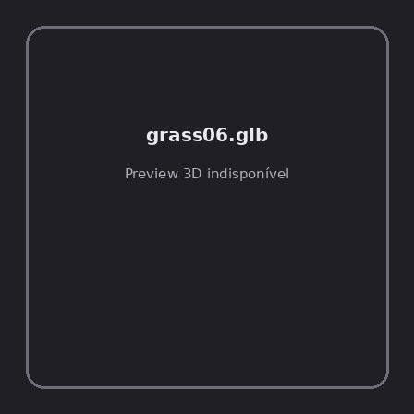
ID | NOV-004518
Origem | Asset novo
Pack/Fonte | retro_nature_pack
Categoria | Nature / Models
Arquivo | grass06.glb
Caminho | 00_Packs_Raw/retro_nature_pack/models/glTF/grass/grass06.glb
Formato | GLB
Tamanho | 1.98 KB
SHA-256 | d232c5e5976313ab1b9d…
Status técnico | ERROR
Licença | MISSING_REVIEW_REQUIRED — sem evidência localizada
Objetos / meshes | N/D / N/D
Vértices | N/D
Faces / triângulos | N/D / N/D
Materiais | N/D —
UV sets / vertex colors | N/D / N/D
Dimensões XYZ | N/D
Rig / armatures / bones | N/D / N/D / N/D
Skinned meshes | N/D
Animações | N/D —
Duração total clips | N/D
Root motion detectado | N/D
LODs / colliders | Nenhum / Nenhum
Texturas vinculadas | N/D (0 ausentes)
Alertas | Licença/fonte não localizada automaticamente; revisão legal necessária.
Notas | Falha na inspeção 3D: RuntimeError: Error: Python: Traceback (most recent call last):  File "/usr/share/blender/scripts/addons/io_scene_gltf2/__init__.py", line 1064, in execute  return self.import_gltf2(context)  File "/usr/share/blender/scripts/addons/io_scene_gltf2/__init__.py", line 1083, in import_gltf2  return self.unit_import(self.filepath, import_settings)  File "/usr/share/blender/scripts/addons/io_scene_gltf2/__init__.py", line 1088, in unit_import  from .blender.imp.gltf2_blender_gltf import BlenderGlTF  File "/usr/share/blender/scripts/addons/io_scene_gltf2/blender/imp/gltf2_blender_gltf.py", line 17, in <module>  from .gltf2_blender_scene import BlenderScene  File "/usr/share/blender/scripts/addons/io_scene_gltf2/blender/imp/gltf2_blender_scene.py", line 17, in <module>  from .gltf2_blender_node import BlenderNode  File "/usr/share/blender/scripts/addons/io_scene_gltf2/blender/imp/gltf2_blender_node.py", line 18, in <module>  from .gltf2_blender_mesh import BlenderMesh  File "/usr/share/blender/scripts/addons/io_scene_gltf2/blender/imp/gltf2_blender_mesh.py", line 17, in <module>  import numpy as np  ModuleNotFoundError: No module named 'numpy'  location: /usr/share/blender/scripts/modules/bpy/ops.py:132  Traceback (most recent call last):  File "/home/runner/work/PSX_demons_whip/PSX_demons_whip/workspace/demons/tools/asset_catalog/blender_batch.py", line 427, in inspect_task  import_model(path)  File "/home/runner/work/PSX_demons_whip/PSX_demons_whip/workspace/demons/tools/asset_catalog/blender_batch.py", line 52, in import_model  bpy.ops.import_scene.gltf(filepath=str(path))  File "/usr/share/blender/scripts/modules/bpy/ops.py", line 132, in __call__  ret = _op_call(self.idname_py(), None, kw)  RuntimeError: Error: Python: Traceback (most recent call last):  File "/usr/share/blender/scripts/addons/io_scene_gltf2/__init__.py", line 1064, in execute  return self.import_gltf2(context)  File "/usr/share/blender/scripts/addons/io_scene_gltf2/__init__.py", line 1083, in import_gltf2  return self.unit_import(self.filepath, import_settings)  File "/usr/share/blender/scripts/addons/io_scene_gltf2/__init__.py", line 1088, in unit_import  from .blender.imp.gltf2_blender_gltf import BlenderGlTF  File "/usr/share/blender/scripts/addons/io_scene_gltf2/blender/imp/gltf2_blender_gltf.py", line 17, in <module>  from .gltf2_blender_scene import BlenderScene  File "/usr/share/blender/scripts/addons/io_scene_gltf2/blender/imp/gltf2_blender_scene.py", line 17, in <module>  from .gltf2_blender_node import BlenderNode  File "/usr/share/blender/scripts/addons/io_scene_gltf2/blender/imp/gltf2_blender_node.py", line 18, in <module>  from .gltf2_blender_mesh import BlenderMesh  File "/usr/share/blender/scripts/addons/io_scene_gltf2/blender/imp/gltf2_blender_mesh.py", line 17, in <module>  import numpy as np  ModuleNotFoundError: No module named 'numpy'  location: /usr/share/blender/scripts/modules/bpy/ops.py:132

NOV-004510 • grass07 [ERROR]
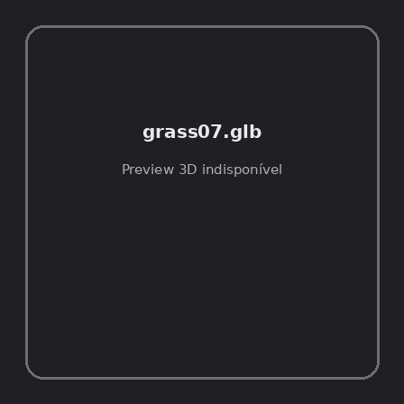
ID | NOV-004510
Origem | Asset novo
Pack/Fonte | retro_nature_pack
Categoria | Nature / Models
Arquivo | grass07.glb
Caminho | 00_Packs_Raw/retro_nature_pack/models/glTF/grass/grass07.glb
Formato | GLB
Tamanho | 1.78 KB
SHA-256 | cfa7fd5fab5a37db5b4e…
Status técnico | ERROR
Licença | MISSING_REVIEW_REQUIRED — sem evidência localizada
Objetos / meshes | N/D / N/D
Vértices | N/D
Faces / triângulos | N/D / N/D
Materiais | N/D —
UV sets / vertex colors | N/D / N/D
Dimensões XYZ | N/D
Rig / armatures / bones | N/D / N/D / N/D
Skinned meshes | N/D
Animações | N/D —
Duração total clips | N/D
Root motion detectado | N/D
LODs / colliders | Nenhum / Nenhum
Texturas vinculadas | N/D (0 ausentes)
Alertas | Licença/fonte não localizada automaticamente; revisão legal necessária.
Notas | Falha na inspeção 3D: RuntimeError: Error: Python: Traceback (most recent call last):  File "/usr/share/blender/scripts/addons/io_scene_gltf2/__init__.py", line 1064, in execute  return self.import_gltf2(context)  File "/usr/share/blender/scripts/addons/io_scene_gltf2/__init__.py", line 1083, in import_gltf2  return self.unit_import(self.filepath, import_settings)  File "/usr/share/blender/scripts/addons/io_scene_gltf2/__init__.py", line 1088, in unit_import  from .blender.imp.gltf2_blender_gltf import BlenderGlTF  File "/usr/share/blender/scripts/addons/io_scene_gltf2/blender/imp/gltf2_blender_gltf.py", line 17, in <module>  from .gltf2_blender_scene import BlenderScene  File "/usr/share/blender/scripts/addons/io_scene_gltf2/blender/imp/gltf2_blender_scene.py", line 17, in <module>  from .gltf2_blender_node import BlenderNode  File "/usr/share/blender/scripts/addons/io_scene_gltf2/blender/imp/gltf2_blender_node.py", line 18, in <module>  from .gltf2_blender_mesh import BlenderMesh  File "/usr/share/blender/scripts/addons/io_scene_gltf2/blender/imp/gltf2_blender_mesh.py", line 17, in <module>  import numpy as np  ModuleNotFoundError: No module named 'numpy'  location: /usr/share/blender/scripts/modules/bpy/ops.py:132  Traceback (most recent call last):  File "/home/runner/work/PSX_demons_whip/PSX_demons_whip/workspace/demons/tools/asset_catalog/blender_batch.py", line 427, in inspect_task  import_model(path)  File "/home/runner/work/PSX_demons_whip/PSX_demons_whip/workspace/demons/tools/asset_catalog/blender_batch.py", line 52, in import_model  bpy.ops.import_scene.gltf(filepath=str(path))  File "/usr/share/blender/scripts/modules/bpy/ops.py", line 132, in __call__  ret = _op_call(self.idname_py(), None, kw)  RuntimeError: Error: Python: Traceback (most recent call last):  File "/usr/share/blender/scripts/addons/io_scene_gltf2/__init__.py", line 1064, in execute  return self.import_gltf2(context)  File "/usr/share/blender/scripts/addons/io_scene_gltf2/__init__.py", line 1083, in import_gltf2  return self.unit_import(self.filepath, import_settings)  File "/usr/share/blender/scripts/addons/io_scene_gltf2/__init__.py", line 1088, in unit_import  from .blender.imp.gltf2_blender_gltf import BlenderGlTF  File "/usr/share/blender/scripts/addons/io_scene_gltf2/blender/imp/gltf2_blender_gltf.py", line 17, in <module>  from .gltf2_blender_scene import BlenderScene  File "/usr/share/blender/scripts/addons/io_scene_gltf2/blender/imp/gltf2_blender_scene.py", line 17, in <module>  from .gltf2_blender_node import BlenderNode  File "/usr/share/blender/scripts/addons/io_scene_gltf2/blender/imp/gltf2_blender_node.py", line 18, in <module>  from .gltf2_blender_mesh import BlenderMesh  File "/usr/share/blender/scripts/addons/io_scene_gltf2/blender/imp/gltf2_blender_mesh.py", line 17, in <module>  import numpy as np  ModuleNotFoundError: No module named 'numpy'  location: /usr/share/blender/scripts/modules/bpy/ops.py:132

NOV-004507 • grass08 [ERROR]
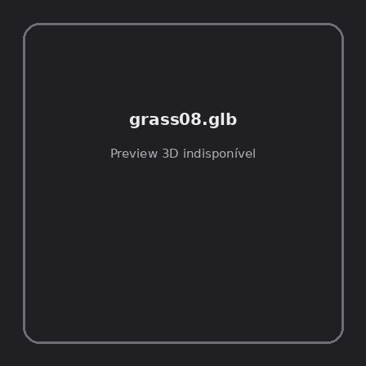
ID | NOV-004507
Origem | Asset novo
Pack/Fonte | retro_nature_pack
Categoria | Nature / Models
Arquivo | grass08.glb
Caminho | 00_Packs_Raw/retro_nature_pack/models/glTF/grass/grass08.glb
Formato | GLB
Tamanho | 1.78 KB
SHA-256 | a45a2905c817e4f1d249…
Status técnico | ERROR
Licença | MISSING_REVIEW_REQUIRED — sem evidência localizada
Objetos / meshes | N/D / N/D
Vértices | N/D
Faces / triângulos | N/D / N/D
Materiais | N/D —
UV sets / vertex colors | N/D / N/D
Dimensões XYZ | N/D
Rig / armatures / bones | N/D / N/D / N/D
Skinned meshes | N/D
Animações | N/D —
Duração total clips | N/D
Root motion detectado | N/D
LODs / colliders | Nenhum / Nenhum
Texturas vinculadas | N/D (0 ausentes)
Alertas | Licença/fonte não localizada automaticamente; revisão legal necessária.
Notas | Falha na inspeção 3D: RuntimeError: Error: Python: Traceback (most recent call last):  File "/usr/share/blender/scripts/addons/io_scene_gltf2/__init__.py", line 1064, in execute  return self.import_gltf2(context)  File "/usr/share/blender/scripts/addons/io_scene_gltf2/__init__.py", line 1083, in import_gltf2  return self.unit_import(self.filepath, import_settings)  File "/usr/share/blender/scripts/addons/io_scene_gltf2/__init__.py", line 1088, in unit_import  from .blender.imp.gltf2_blender_gltf import BlenderGlTF  File "/usr/share/blender/scripts/addons/io_scene_gltf2/blender/imp/gltf2_blender_gltf.py", line 17, in <module>  from .gltf2_blender_scene import BlenderScene  File "/usr/share/blender/scripts/addons/io_scene_gltf2/blender/imp/gltf2_blender_scene.py", line 17, in <module>  from .gltf2_blender_node import BlenderNode  File "/usr/share/blender/scripts/addons/io_scene_gltf2/blender/imp/gltf2_blender_node.py", line 18, in <module>  from .gltf2_blender_mesh import BlenderMesh  File "/usr/share/blender/scripts/addons/io_scene_gltf2/blender/imp/gltf2_blender_mesh.py", line 17, in <module>  import numpy as np  ModuleNotFoundError: No module named 'numpy'  location: /usr/share/blender/scripts/modules/bpy/ops.py:132  Traceback (most recent call last):  File "/home/runner/work/PSX_demons_whip/PSX_demons_whip/workspace/demons/tools/asset_catalog/blender_batch.py", line 427, in inspect_task  import_model(path)  File "/home/runner/work/PSX_demons_whip/PSX_demons_whip/workspace/demons/tools/asset_catalog/blender_batch.py", line 52, in import_model  bpy.ops.import_scene.gltf(filepath=str(path))  File "/usr/share/blender/scripts/modules/bpy/ops.py", line 132, in __call__  ret = _op_call(self.idname_py(), None, kw)  RuntimeError: Error: Python: Traceback (most recent call last):  File "/usr/share/blender/scripts/addons/io_scene_gltf2/__init__.py", line 1064, in execute  return self.import_gltf2(context)  File "/usr/share/blender/scripts/addons/io_scene_gltf2/__init__.py", line 1083, in import_gltf2  return self.unit_import(self.filepath, import_settings)  File "/usr/share/blender/scripts/addons/io_scene_gltf2/__init__.py", line 1088, in unit_import  from .blender.imp.gltf2_blender_gltf import BlenderGlTF  File "/usr/share/blender/scripts/addons/io_scene_gltf2/blender/imp/gltf2_blender_gltf.py", line 17, in <module>  from .gltf2_blender_scene import BlenderScene  File "/usr/share/blender/scripts/addons/io_scene_gltf2/blender/imp/gltf2_blender_scene.py", line 17, in <module>  from .gltf2_blender_node import BlenderNode  File "/usr/share/blender/scripts/addons/io_scene_gltf2/blender/imp/gltf2_blender_node.py", line 18, in <module>  from .gltf2_blender_mesh import BlenderMesh  File "/usr/share/blender/scripts/addons/io_scene_gltf2/blender/imp/gltf2_blender_mesh.py", line 17, in <module>  import numpy as np  ModuleNotFoundError: No module named 'numpy'  location: /usr/share/blender/scripts/modules/bpy/ops.py:132

NOV-004517 • grass09 [ERROR]
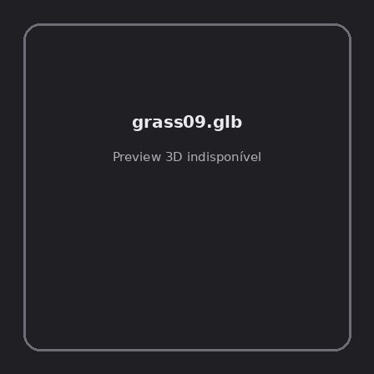
ID | NOV-004517
Origem | Asset novo
Pack/Fonte | retro_nature_pack
Categoria | Nature / Models
Arquivo | grass09.glb
Caminho | 00_Packs_Raw/retro_nature_pack/models/glTF/grass/grass09.glb
Formato | GLB
Tamanho | 1.62 KB
SHA-256 | 40cdce7dece46432dcc0…
Status técnico | ERROR
Licença | MISSING_REVIEW_REQUIRED — sem evidência localizada
Objetos / meshes | N/D / N/D
Vértices | N/D
Faces / triângulos | N/D / N/D
Materiais | N/D —
UV sets / vertex colors | N/D / N/D
Dimensões XYZ | N/D
Rig / armatures / bones | N/D / N/D / N/D
Skinned meshes | N/D
Animações | N/D —
Duração total clips | N/D
Root motion detectado | N/D
LODs / colliders | Nenhum / Nenhum
Texturas vinculadas | N/D (0 ausentes)
Alertas | Licença/fonte não localizada automaticamente; revisão legal necessária.
Notas | Falha na inspeção 3D: RuntimeError: Error: Python: Traceback (most recent call last):  File "/usr/share/blender/scripts/addons/io_scene_gltf2/__init__.py", line 1064, in execute  return self.import_gltf2(context)  File "/usr/share/blender/scripts/addons/io_scene_gltf2/__init__.py", line 1083, in import_gltf2  return self.unit_import(self.filepath, import_settings)  File "/usr/share/blender/scripts/addons/io_scene_gltf2/__init__.py", line 1088, in unit_import  from .blender.imp.gltf2_blender_gltf import BlenderGlTF  File "/usr/share/blender/scripts/addons/io_scene_gltf2/blender/imp/gltf2_blender_gltf.py", line 17, in <module>  from .gltf2_blender_scene import BlenderScene  File "/usr/share/blender/scripts/addons/io_scene_gltf2/blender/imp/gltf2_blender_scene.py", line 17, in <module>  from .gltf2_blender_node import BlenderNode  File "/usr/share/blender/scripts/addons/io_scene_gltf2/blender/imp/gltf2_blender_node.py", line 18, in <module>  from .gltf2_blender_mesh import BlenderMesh  File "/usr/share/blender/scripts/addons/io_scene_gltf2/blender/imp/gltf2_blender_mesh.py", line 17, in <module>  import numpy as np  ModuleNotFoundError: No module named 'numpy'  location: /usr/share/blender/scripts/modules/bpy/ops.py:132  Traceback (most recent call last):  File "/home/runner/work/PSX_demons_whip/PSX_demons_whip/workspace/demons/tools/asset_catalog/blender_batch.py", line 427, in inspect_task  import_model(path)  File "/home/runner/work/PSX_demons_whip/PSX_demons_whip/workspace/demons/tools/asset_catalog/blender_batch.py", line 52, in import_model  bpy.ops.import_scene.gltf(filepath=str(path))  File "/usr/share/blender/scripts/modules/bpy/ops.py", line 132, in __call__  ret = _op_call(self.idname_py(), None, kw)  RuntimeError: Error: Python: Traceback (most recent call last):  File "/usr/share/blender/scripts/addons/io_scene_gltf2/__init__.py", line 1064, in execute  return self.import_gltf2(context)  File "/usr/share/blender/scripts/addons/io_scene_gltf2/__init__.py", line 1083, in import_gltf2  return self.unit_import(self.filepath, import_settings)  File "/usr/share/blender/scripts/addons/io_scene_gltf2/__init__.py", line 1088, in unit_import  from .blender.imp.gltf2_blender_gltf import BlenderGlTF  File "/usr/share/blender/scripts/addons/io_scene_gltf2/blender/imp/gltf2_blender_gltf.py", line 17, in <module>  from .gltf2_blender_scene import BlenderScene  File "/usr/share/blender/scripts/addons/io_scene_gltf2/blender/imp/gltf2_blender_scene.py", line 17, in <module>  from .gltf2_blender_node import BlenderNode  File "/usr/share/blender/scripts/addons/io_scene_gltf2/blender/imp/gltf2_blender_node.py", line 18, in <module>  from .gltf2_blender_mesh import BlenderMesh  File "/usr/share/blender/scripts/addons/io_scene_gltf2/blender/imp/gltf2_blender_mesh.py", line 17, in <module>  import numpy as np  ModuleNotFoundError: No module named 'numpy'  location: /usr/share/blender/scripts/modules/bpy/ops.py:132

NOV-004515 • grass_bush [ERROR]

ID | NOV-004515
Origem | Asset novo
Pack/Fonte | retro_nature_pack
Categoria | Nature / Models
Arquivo | grass_bush.glb
Caminho | 00_Packs_Raw/retro_nature_pack/models/glTF/grass/grass_bush.glb
Formato | GLB
Tamanho | 5.50 KB
SHA-256 | ffea1fba4ab41484593f…
Status técnico | ERROR
Licença | MISSING_REVIEW_REQUIRED — sem evidência localizada
Objetos / meshes | N/D / N/D
Vértices | N/D
Faces / triângulos | N/D / N/D
Materiais | N/D —
UV sets / vertex colors | N/D / N/D
Dimensões XYZ | N/D
Rig / armatures / bones | N/D / N/D / N/D
Skinned meshes | N/D
Animações | N/D —
Duração total clips | N/D
Root motion detectado | N/D
LODs / colliders | Nenhum / Nenhum
Texturas vinculadas | N/D (0 ausentes)
Alertas | Licença/fonte não localizada automaticamente; revisão legal necessária.
Notas | Falha na inspeção 3D: RuntimeError: Error: Python: Traceback (most recent call last):  File "/usr/share/blender/scripts/addons/io_scene_gltf2/__init__.py", line 1064, in execute  return self.import_gltf2(context)  File "/usr/share/blender/scripts/addons/io_scene_gltf2/__init__.py", line 1083, in import_gltf2  return self.unit_import(self.filepath, import_settings)  File "/usr/share/blender/scripts/addons/io_scene_gltf2/__init__.py", line 1088, in unit_import  from .blender.imp.gltf2_blender_gltf import BlenderGlTF  File "/usr/share/blender/scripts/addons/io_scene_gltf2/blender/imp/gltf2_blender_gltf.py", line 17, in <module>  from .gltf2_blender_scene import BlenderScene  File "/usr/share/blender/scripts/addons/io_scene_gltf2/blender/imp/gltf2_blender_scene.py", line 17, in <module>  from .gltf2_blender_node import BlenderNode  File "/usr/share/blender/scripts/addons/io_scene_gltf2/blender/imp/gltf2_blender_node.py", line 18, in <module>  from .gltf2_blender_mesh import BlenderMesh  File "/usr/share/blender/scripts/addons/io_scene_gltf2/blender/imp/gltf2_blender_mesh.py", line 17, in <module>  import numpy as np  ModuleNotFoundError: No module named 'numpy'  location: /usr/share/blender/scripts/modules/bpy/ops.py:132  Traceback (most recent call last):  File "/home/runner/work/PSX_demons_whip/PSX_demons_whip/workspace/demons/tools/asset_catalog/blender_batch.py", line 427, in inspect_task  import_model(path)  File "/home/runner/work/PSX_demons_whip/PSX_demons_whip/workspace/demons/tools/asset_catalog/blender_batch.py", line 52, in import_model  bpy.ops.import_scene.gltf(filepath=str(path))  File "/usr/share/blender/scripts/modules/bpy/ops.py", line 132, in __call__  ret = _op_call(self.idname_py(), None, kw)  RuntimeError: Error: Python: Traceback (most recent call last):  File "/usr/share/blender/scripts/addons/io_scene_gltf2/__init__.py", line 1064, in execute  return self.import_gltf2(context)  File "/usr/share/blender/scripts/addons/io_scene_gltf2/__init__.py", line 1083, in import_gltf2  return self.unit_import(self.filepath, import_settings)  File "/usr/share/blender/scripts/addons/io_scene_gltf2/__init__.py", line 1088, in unit_import  from .blender.imp.gltf2_blender_gltf import BlenderGlTF  File "/usr/share/blender/scripts/addons/io_scene_gltf2/blender/imp/gltf2_blender_gltf.py", line 17, in <module>  from .gltf2_blender_scene import BlenderScene  File "/usr/share/blender/scripts/addons/io_scene_gltf2/blender/imp/gltf2_blender_scene.py", line 17, in <module>  from .gltf2_blender_node import BlenderNode  File "/usr/share/blender/scripts/addons/io_scene_gltf2/blender/imp/gltf2_blender_node.py", line 18, in <module>  from .gltf2_blender_mesh import BlenderMesh  File "/usr/share/blender/scripts/addons/io_scene_gltf2/blender/imp/gltf2_blender_mesh.py", line 17, in <module>  import numpy as np  ModuleNotFoundError: No module named 'numpy'  location: /usr/share/blender/scripts/modules/bpy/ops.py:132

NOV-004512 • grass_patch [ERROR]
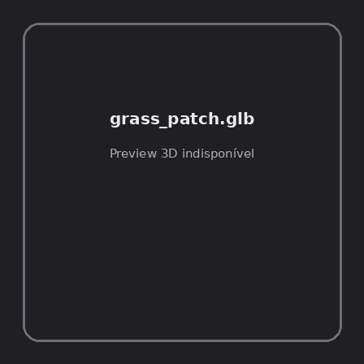
ID | NOV-004512
Origem | Asset novo
Pack/Fonte | retro_nature_pack
Categoria | Nature / Models
Arquivo | grass_patch.glb
Caminho | 00_Packs_Raw/retro_nature_pack/models/glTF/grass/grass_patch.glb
Formato | GLB
Tamanho | 35.37 KB
SHA-256 | 29d3214c0f19ec1a4510…
Status técnico | ERROR
Licença | MISSING_REVIEW_REQUIRED — sem evidência localizada
Objetos / meshes | N/D / N/D
Vértices | N/D
Faces / triângulos | N/D / N/D
Materiais | N/D —
UV sets / vertex colors | N/D / N/D
Dimensões XYZ | N/D
Rig / armatures / bones | N/D / N/D / N/D
Skinned meshes | N/D
Animações | N/D —
Duração total clips | N/D
Root motion detectado | N/D
LODs / colliders | Nenhum / Nenhum
Texturas vinculadas | N/D (0 ausentes)
Alertas | Licença/fonte não localizada automaticamente; revisão legal necessária.
Notas | Falha na inspeção 3D: RuntimeError: Error: Python: Traceback (most recent call last):  File "/usr/share/blender/scripts/addons/io_scene_gltf2/__init__.py", line 1064, in execute  return self.import_gltf2(context)  File "/usr/share/blender/scripts/addons/io_scene_gltf2/__init__.py", line 1083, in import_gltf2  return self.unit_import(self.filepath, import_settings)  File "/usr/share/blender/scripts/addons/io_scene_gltf2/__init__.py", line 1088, in unit_import  from .blender.imp.gltf2_blender_gltf import BlenderGlTF  File "/usr/share/blender/scripts/addons/io_scene_gltf2/blender/imp/gltf2_blender_gltf.py", line 17, in <module>  from .gltf2_blender_scene import BlenderScene  File "/usr/share/blender/scripts/addons/io_scene_gltf2/blender/imp/gltf2_blender_scene.py", line 17, in <module>  from .gltf2_blender_node import BlenderNode  File "/usr/share/blender/scripts/addons/io_scene_gltf2/blender/imp/gltf2_blender_node.py", line 18, in <module>  from .gltf2_blender_mesh import BlenderMesh  File "/usr/share/blender/scripts/addons/io_scene_gltf2/blender/imp/gltf2_blender_mesh.py", line 17, in <module>  import numpy as np  ModuleNotFoundError: No module named 'numpy'  location: /usr/share/blender/scripts/modules/bpy/ops.py:132  Traceback (most recent call last):  File "/home/runner/work/PSX_demons_whip/PSX_demons_whip/workspace/demons/tools/asset_catalog/blender_batch.py", line 427, in inspect_task  import_model(path)  File "/home/runner/work/PSX_demons_whip/PSX_demons_whip/workspace/demons/tools/asset_catalog/blender_batch.py", line 52, in import_model  bpy.ops.import_scene.gltf(filepath=str(path))  File "/usr/share/blender/scripts/modules/bpy/ops.py", line 132, in __call__  ret = _op_call(self.idname_py(), None, kw)  RuntimeError: Error: Python: Traceback (most recent call last):  File "/usr/share/blender/scripts/addons/io_scene_gltf2/__init__.py", line 1064, in execute  return self.import_gltf2(context)  File "/usr/share/blender/scripts/addons/io_scene_gltf2/__init__.py", line 1083, in import_gltf2  return self.unit_import(self.filepath, import_settings)  File "/usr/share/blender/scripts/addons/io_scene_gltf2/__init__.py", line 1088, in unit_import  from .blender.imp.gltf2_blender_gltf import BlenderGlTF  File "/usr/share/blender/scripts/addons/io_scene_gltf2/blender/imp/gltf2_blender_gltf.py", line 17, in <module>  from .gltf2_blender_scene import BlenderScene  File "/usr/share/blender/scripts/addons/io_scene_gltf2/blender/imp/gltf2_blender_scene.py", line 17, in <module>  from .gltf2_blender_node import BlenderNode  File "/usr/share/blender/scripts/addons/io_scene_gltf2/blender/imp/gltf2_blender_node.py", line 18, in <module>  from .gltf2_blender_mesh import BlenderMesh  File "/usr/share/blender/scripts/addons/io_scene_gltf2/blender/imp/gltf2_blender_mesh.py", line 17, in <module>  import numpy as np  ModuleNotFoundError: No module named 'numpy'  location: /usr/share/blender/scripts/modules/bpy/ops.py:132

NOV-004509 • grass_patch_corner [ERROR]

ID | NOV-004509
Origem | Asset novo
Pack/Fonte | retro_nature_pack
Categoria | Nature / Models
Arquivo | grass_patch_corner.glb
Caminho | 00_Packs_Raw/retro_nature_pack/models/glTF/grass/grass_patch_corner.glb
Formato | GLB
Tamanho | 36.28 KB
SHA-256 | cab5ce47ce6a110b8f19…
Status técnico | ERROR
Licença | MISSING_REVIEW_REQUIRED — sem evidência localizada
Objetos / meshes | N/D / N/D
Vértices | N/D
Faces / triângulos | N/D / N/D
Materiais | N/D —
UV sets / vertex colors | N/D / N/D
Dimensões XYZ | N/D
Rig / armatures / bones | N/D / N/D / N/D
Skinned meshes | N/D
Animações | N/D —
Duração total clips | N/D
Root motion detectado | N/D
LODs / colliders | Nenhum / Nenhum
Texturas vinculadas | N/D (0 ausentes)
Alertas | Licença/fonte não localizada automaticamente; revisão legal necessária.
Notas | Falha na inspeção 3D: RuntimeError: Error: Python: Traceback (most recent call last):  File "/usr/share/blender/scripts/addons/io_scene_gltf2/__init__.py", line 1064, in execute  return self.import_gltf2(context)  File "/usr/share/blender/scripts/addons/io_scene_gltf2/__init__.py", line 1083, in import_gltf2  return self.unit_import(self.filepath, import_settings)  File "/usr/share/blender/scripts/addons/io_scene_gltf2/__init__.py", line 1088, in unit_import  from .blender.imp.gltf2_blender_gltf import BlenderGlTF  File "/usr/share/blender/scripts/addons/io_scene_gltf2/blender/imp/gltf2_blender_gltf.py", line 17, in <module>  from .gltf2_blender_scene import BlenderScene  File "/usr/share/blender/scripts/addons/io_scene_gltf2/blender/imp/gltf2_blender_scene.py", line 17, in <module>  from .gltf2_blender_node import BlenderNode  File "/usr/share/blender/scripts/addons/io_scene_gltf2/blender/imp/gltf2_blender_node.py", line 18, in <module>  from .gltf2_blender_mesh import BlenderMesh  File "/usr/share/blender/scripts/addons/io_scene_gltf2/blender/imp/gltf2_blender_mesh.py", line 17, in <module>  import numpy as np  ModuleNotFoundError: No module named 'numpy'  location: /usr/share/blender/scripts/modules/bpy/ops.py:132  Traceback (most recent call last):  File "/home/runner/work/PSX_demons_whip/PSX_demons_whip/workspace/demons/tools/asset_catalog/blender_batch.py", line 427, in inspect_task  import_model(path)  File "/home/runner/work/PSX_demons_whip/PSX_demons_whip/workspace/demons/tools/asset_catalog/blender_batch.py", line 52, in import_model  bpy.ops.import_scene.gltf(filepath=str(path))  File "/usr/share/blender/scripts/modules/bpy/ops.py", line 132, in __call__  ret = _op_call(self.idname_py(), None, kw)  RuntimeError: Error: Python: Traceback (most recent call last):  File "/usr/share/blender/scripts/addons/io_scene_gltf2/__init__.py", line 1064, in execute  return self.import_gltf2(context)  File "/usr/share/blender/scripts/addons/io_scene_gltf2/__init__.py", line 1083, in import_gltf2  return self.unit_import(self.filepath, import_settings)  File "/usr/share/blender/scripts/addons/io_scene_gltf2/__init__.py", line 1088, in unit_import  from .blender.imp.gltf2_blender_gltf import BlenderGlTF  File "/usr/share/blender/scripts/addons/io_scene_gltf2/blender/imp/gltf2_blender_gltf.py", line 17, in <module>  from .gltf2_blender_scene import BlenderScene  File "/usr/share/blender/scripts/addons/io_scene_gltf2/blender/imp/gltf2_blender_scene.py", line 17, in <module>  from .gltf2_blender_node import BlenderNode  File "/usr/share/blender/scripts/addons/io_scene_gltf2/blender/imp/gltf2_blender_node.py", line 18, in <module>  from .gltf2_blender_mesh import BlenderMesh  File "/usr/share/blender/scripts/addons/io_scene_gltf2/blender/imp/gltf2_blender_mesh.py", line 17, in <module>  import numpy as np  ModuleNotFoundError: No module named 'numpy'  location: /usr/share/blender/scripts/modules/bpy/ops.py:132

NOV-004504 • tree01 [ERROR]
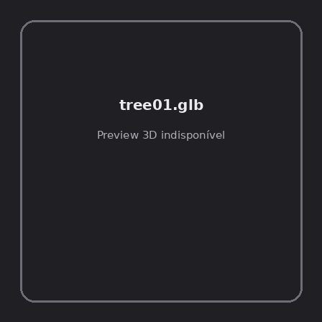
ID | NOV-004504
Origem | Asset novo
Pack/Fonte | retro_nature_pack
Categoria | Nature / Models
Arquivo | tree01.glb
Caminho | 00_Packs_Raw/retro_nature_pack/models/glTF/trees/tree01.glb
Formato | GLB
Tamanho | 37.44 KB
SHA-256 | 6272d054a328fc74b03f…
Status técnico | ERROR
Licença | MISSING_REVIEW_REQUIRED — sem evidência localizada
Objetos / meshes | N/D / N/D
Vértices | N/D
Faces / triângulos | N/D / N/D
Materiais | N/D —
UV sets / vertex colors | N/D / N/D
Dimensões XYZ | N/D
Rig / armatures / bones | N/D / N/D / N/D
Skinned meshes | N/D
Animações | N/D —
Duração total clips | N/D
Root motion detectado | N/D
LODs / colliders | Nenhum / Nenhum
Texturas vinculadas | N/D (0 ausentes)
Alertas | Licença/fonte não localizada automaticamente; revisão legal necessária.
Notas | Falha na inspeção 3D: RuntimeError: Error: Python: Traceback (most recent call last):  File "/usr/share/blender/scripts/addons/io_scene_gltf2/__init__.py", line 1064, in execute  return self.import_gltf2(context)  File "/usr/share/blender/scripts/addons/io_scene_gltf2/__init__.py", line 1083, in import_gltf2  return self.unit_import(self.filepath, import_settings)  File "/usr/share/blender/scripts/addons/io_scene_gltf2/__init__.py", line 1088, in unit_import  from .blender.imp.gltf2_blender_gltf import BlenderGlTF  File "/usr/share/blender/scripts/addons/io_scene_gltf2/blender/imp/gltf2_blender_gltf.py", line 17, in <module>  from .gltf2_blender_scene import BlenderScene  File "/usr/share/blender/scripts/addons/io_scene_gltf2/blender/imp/gltf2_blender_scene.py", line 17, in <module>  from .gltf2_blender_node import BlenderNode  File "/usr/share/blender/scripts/addons/io_scene_gltf2/blender/imp/gltf2_blender_node.py", line 18, in <module>  from .gltf2_blender_mesh import BlenderMesh  File "/usr/share/blender/scripts/addons/io_scene_gltf2/blender/imp/gltf2_blender_mesh.py", line 17, in <module>  import numpy as np  ModuleNotFoundError: No module named 'numpy'  location: /usr/share/blender/scripts/modules/bpy/ops.py:132  Traceback (most recent call last):  File "/home/runner/work/PSX_demons_whip/PSX_demons_whip/workspace/demons/tools/asset_catalog/blender_batch.py", line 427, in inspect_task  import_model(path)  File "/home/runner/work/PSX_demons_whip/PSX_demons_whip/workspace/demons/tools/asset_catalog/blender_batch.py", line 52, in import_model  bpy.ops.import_scene.gltf(filepath=str(path))  File "/usr/share/blender/scripts/modules/bpy/ops.py", line 132, in __call__  ret = _op_call(self.idname_py(), None, kw)  RuntimeError: Error: Python: Traceback (most recent call last):  File "/usr/share/blender/scripts/addons/io_scene_gltf2/__init__.py", line 1064, in execute  return self.import_gltf2(context)  File "/usr/share/blender/scripts/addons/io_scene_gltf2/__init__.py", line 1083, in import_gltf2  return self.unit_import(self.filepath, import_settings)  File "/usr/share/blender/scripts/addons/io_scene_gltf2/__init__.py", line 1088, in unit_import  from .blender.imp.gltf2_blender_gltf import BlenderGlTF  File "/usr/share/blender/scripts/addons/io_scene_gltf2/blender/imp/gltf2_blender_gltf.py", line 17, in <module>  from .gltf2_blender_scene import BlenderScene  File "/usr/share/blender/scripts/addons/io_scene_gltf2/blender/imp/gltf2_blender_scene.py", line 17, in <module>  from .gltf2_blender_node import BlenderNode  File "/usr/share/blender/scripts/addons/io_scene_gltf2/blender/imp/gltf2_blender_node.py", line 18, in <module>  from .gltf2_blender_mesh import BlenderMesh  File "/usr/share/blender/scripts/addons/io_scene_gltf2/blender/imp/gltf2_blender_mesh.py", line 17, in <module>  import numpy as np  ModuleNotFoundError: No module named 'numpy'  location: /usr/share/blender/scripts/modules/bpy/ops.py:132

NOV-004497 • tree01_winter [ERROR]
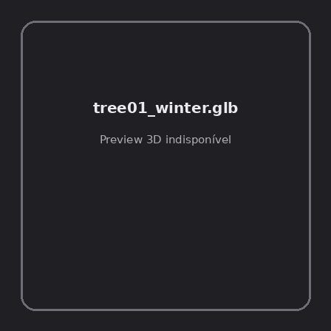
ID | NOV-004497
Origem | Asset novo
Pack/Fonte | retro_nature_pack
Categoria | Nature / Models
Arquivo | tree01_winter.glb
Caminho | 00_Packs_Raw/retro_nature_pack/models/glTF/trees/tree01_winter.glb
Formato | GLB
Tamanho | 12.53 KB
SHA-256 | 1abd8677e7564388f1ed…
Status técnico | ERROR
Licença | MISSING_REVIEW_REQUIRED — sem evidência localizada
Objetos / meshes | N/D / N/D
Vértices | N/D
Faces / triângulos | N/D / N/D
Materiais | N/D —
UV sets / vertex colors | N/D / N/D
Dimensões XYZ | N/D
Rig / armatures / bones | N/D / N/D / N/D
Skinned meshes | N/D
Animações | N/D —
Duração total clips | N/D
Root motion detectado | N/D
LODs / colliders | Nenhum / Nenhum
Texturas vinculadas | N/D (0 ausentes)
Alertas | Licença/fonte não localizada automaticamente; revisão legal necessária.
Notas | Falha na inspeção 3D: RuntimeError: Error: Python: Traceback (most recent call last):  File "/usr/share/blender/scripts/addons/io_scene_gltf2/__init__.py", line 1064, in execute  return self.import_gltf2(context)  File "/usr/share/blender/scripts/addons/io_scene_gltf2/__init__.py", line 1083, in import_gltf2  return self.unit_import(self.filepath, import_settings)  File "/usr/share/blender/scripts/addons/io_scene_gltf2/__init__.py", line 1088, in unit_import  from .blender.imp.gltf2_blender_gltf import BlenderGlTF  File "/usr/share/blender/scripts/addons/io_scene_gltf2/blender/imp/gltf2_blender_gltf.py", line 17, in <module>  from .gltf2_blender_scene import BlenderScene  File "/usr/share/blender/scripts/addons/io_scene_gltf2/blender/imp/gltf2_blender_scene.py", line 17, in <module>  from .gltf2_blender_node import BlenderNode  File "/usr/share/blender/scripts/addons/io_scene_gltf2/blender/imp/gltf2_blender_node.py", line 18, in <module>  from .gltf2_blender_mesh import BlenderMesh  File "/usr/share/blender/scripts/addons/io_scene_gltf2/blender/imp/gltf2_blender_mesh.py", line 17, in <module>  import numpy as np  ModuleNotFoundError: No module named 'numpy'  location: /usr/share/blender/scripts/modules/bpy/ops.py:132  Traceback (most recent call last):  File "/home/runner/work/PSX_demons_whip/PSX_demons_whip/workspace/demons/tools/asset_catalog/blender_batch.py", line 427, in inspect_task  import_model(path)  File "/home/runner/work/PSX_demons_whip/PSX_demons_whip/workspace/demons/tools/asset_catalog/blender_batch.py", line 52, in import_model  bpy.ops.import_scene.gltf(filepath=str(path))  File "/usr/share/blender/scripts/modules/bpy/ops.py", line 132, in __call__  ret = _op_call(self.idname_py(), None, kw)  RuntimeError: Error: Python: Traceback (most recent call last):  File "/usr/share/blender/scripts/addons/io_scene_gltf2/__init__.py", line 1064, in execute  return self.import_gltf2(context)  File "/usr/share/blender/scripts/addons/io_scene_gltf2/__init__.py", line 1083, in import_gltf2  return self.unit_import(self.filepath, import_settings)  File "/usr/share/blender/scripts/addons/io_scene_gltf2/__init__.py", line 1088, in unit_import  from .blender.imp.gltf2_blender_gltf import BlenderGlTF  File "/usr/share/blender/scripts/addons/io_scene_gltf2/blender/imp/gltf2_blender_gltf.py", line 17, in <module>  from .gltf2_blender_scene import BlenderScene  File "/usr/share/blender/scripts/addons/io_scene_gltf2/blender/imp/gltf2_blender_scene.py", line 17, in <module>  from .gltf2_blender_node import BlenderNode  File "/usr/share/blender/scripts/addons/io_scene_gltf2/blender/imp/gltf2_blender_node.py", line 18, in <module>  from .gltf2_blender_mesh import BlenderMesh  File "/usr/share/blender/scripts/addons/io_scene_gltf2/blender/imp/gltf2_blender_mesh.py", line 17, in <module>  import numpy as np  ModuleNotFoundError: No module named 'numpy'  location: /usr/share/blender/scripts/modules/bpy/ops.py:132

NOV-004499 • tree02 [ERROR]
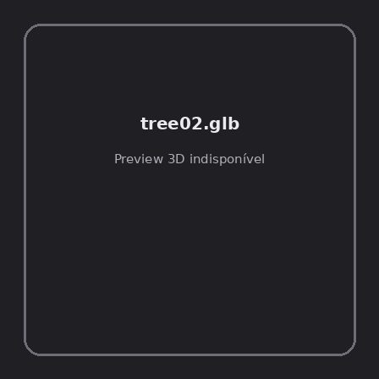
ID | NOV-004499
Origem | Asset novo
Pack/Fonte | retro_nature_pack
Categoria | Nature / Models
Arquivo | tree02.glb
Caminho | 00_Packs_Raw/retro_nature_pack/models/glTF/trees/tree02.glb
Formato | GLB
Tamanho | 35.49 KB
SHA-256 | ac9903275f80f2cdf48d…
Status técnico | ERROR
Licença | MISSING_REVIEW_REQUIRED — sem evidência localizada
Objetos / meshes | N/D / N/D
Vértices | N/D
Faces / triângulos | N/D / N/D
Materiais | N/D —
UV sets / vertex colors | N/D / N/D
Dimensões XYZ | N/D
Rig / armatures / bones | N/D / N/D / N/D
Skinned meshes | N/D
Animações | N/D —
Duração total clips | N/D
Root motion detectado | N/D
LODs / colliders | Nenhum / Nenhum
Texturas vinculadas | N/D (0 ausentes)
Alertas | Licença/fonte não localizada automaticamente; revisão legal necessária.
Notas | Falha na inspeção 3D: RuntimeError: Error: Python: Traceback (most recent call last):  File "/usr/share/blender/scripts/addons/io_scene_gltf2/__init__.py", line 1064, in execute  return self.import_gltf2(context)  File "/usr/share/blender/scripts/addons/io_scene_gltf2/__init__.py", line 1083, in import_gltf2  return self.unit_import(self.filepath, import_settings)  File "/usr/share/blender/scripts/addons/io_scene_gltf2/__init__.py", line 1088, in unit_import  from .blender.imp.gltf2_blender_gltf import BlenderGlTF  File "/usr/share/blender/scripts/addons/io_scene_gltf2/blender/imp/gltf2_blender_gltf.py", line 17, in <module>  from .gltf2_blender_scene import BlenderScene  File "/usr/share/blender/scripts/addons/io_scene_gltf2/blender/imp/gltf2_blender_scene.py", line 17, in <module>  from .gltf2_blender_node import BlenderNode  File "/usr/share/blender/scripts/addons/io_scene_gltf2/blender/imp/gltf2_blender_node.py", line 18, in <module>  from .gltf2_blender_mesh import BlenderMesh  File "/usr/share/blender/scripts/addons/io_scene_gltf2/blender/imp/gltf2_blender_mesh.py", line 17, in <module>  import numpy as np  ModuleNotFoundError: No module named 'numpy'  location: /usr/share/blender/scripts/modules/bpy/ops.py:132  Traceback (most recent call last):  File "/home/runner/work/PSX_demons_whip/PSX_demons_whip/workspace/demons/tools/asset_catalog/blender_batch.py", line 427, in inspect_task  import_model(path)  File "/home/runner/work/PSX_demons_whip/PSX_demons_whip/workspace/demons/tools/asset_catalog/blender_batch.py", line 52, in import_model  bpy.ops.import_scene.gltf(filepath=str(path))  File "/usr/share/blender/scripts/modules/bpy/ops.py", line 132, in __call__  ret = _op_call(self.idname_py(), None, kw)  RuntimeError: Error: Python: Traceback (most recent call last):  File "/usr/share/blender/scripts/addons/io_scene_gltf2/__init__.py", line 1064, in execute  return self.import_gltf2(context)  File "/usr/share/blender/scripts/addons/io_scene_gltf2/__init__.py", line 1083, in import_gltf2  return self.unit_import(self.filepath, import_settings)  File "/usr/share/blender/scripts/addons/io_scene_gltf2/__init__.py", line 1088, in unit_import  from .blender.imp.gltf2_blender_gltf import BlenderGlTF  File "/usr/share/blender/scripts/addons/io_scene_gltf2/blender/imp/gltf2_blender_gltf.py", line 17, in <module>  from .gltf2_blender_scene import BlenderScene  File "/usr/share/blender/scripts/addons/io_scene_gltf2/blender/imp/gltf2_blender_scene.py", line 17, in <module>  from .gltf2_blender_node import BlenderNode  File "/usr/share/blender/scripts/addons/io_scene_gltf2/blender/imp/gltf2_blender_node.py", line 18, in <module>  from .gltf2_blender_mesh import BlenderMesh  File "/usr/share/blender/scripts/addons/io_scene_gltf2/blender/imp/gltf2_blender_mesh.py", line 17, in <module>  import numpy as np  ModuleNotFoundError: No module named 'numpy'  location: /usr/share/blender/scripts/modules/bpy/ops.py:132

NOV-004502 • tree02_winter [ERROR]
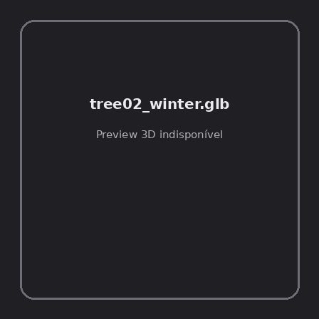
ID | NOV-004502
Origem | Asset novo
Pack/Fonte | retro_nature_pack
Categoria | Nature / Models
Arquivo | tree02_winter.glb
Caminho | 00_Packs_Raw/retro_nature_pack/models/glTF/trees/tree02_winter.glb
Formato | GLB
Tamanho | 132 B
SHA-256 | 0f96c535e3b4abe33adb…
Status técnico | ERROR
Licença | MISSING_REVIEW_REQUIRED — sem evidência localizada
Objetos / meshes | N/D / N/D
Vértices | N/D
Faces / triângulos | N/D / N/D
Materiais | N/D —
UV sets / vertex colors | N/D / N/D
Dimensões XYZ | N/D
Rig / armatures / bones | N/D / N/D / N/D
Skinned meshes | N/D
Animações | N/D —
Duração total clips | N/D
Root motion detectado | N/D
LODs / colliders | Nenhum / Nenhum
Texturas vinculadas | N/D (0 ausentes)
Alertas | Licença/fonte não localizada automaticamente; revisão legal necessária.
Notas | Falha na inspeção 3D: RuntimeError: Error: Python: Traceback (most recent call last):  File "/usr/share/blender/scripts/addons/io_scene_gltf2/__init__.py", line 1064, in execute  return self.import_gltf2(context)  File "/usr/share/blender/scripts/addons/io_scene_gltf2/__init__.py", line 1083, in import_gltf2  return self.unit_import(self.filepath, import_settings)  File "/usr/share/blender/scripts/addons/io_scene_gltf2/__init__.py", line 1088, in unit_import  from .blender.imp.gltf2_blender_gltf import BlenderGlTF  File "/usr/share/blender/scripts/addons/io_scene_gltf2/blender/imp/gltf2_blender_gltf.py", line 17, in <module>  from .gltf2_blender_scene import BlenderScene  File "/usr/share/blender/scripts/addons/io_scene_gltf2/blender/imp/gltf2_blender_scene.py", line 17, in <module>  from .gltf2_blender_node import BlenderNode  File "/usr/share/blender/scripts/addons/io_scene_gltf2/blender/imp/gltf2_blender_node.py", line 18, in <module>  from .gltf2_blender_mesh import BlenderMesh  File "/usr/share/blender/scripts/addons/io_scene_gltf2/blender/imp/gltf2_blender_mesh.py", line 17, in <module>  import numpy as np  ModuleNotFoundError: No module named 'numpy'  location: /usr/share/blender/scripts/modules/bpy/ops.py:132  Traceback (most recent call last):  File "/home/runner/work/PSX_demons_whip/PSX_demons_whip/workspace/demons/tools/asset_catalog/blender_batch.py", line 427, in inspect_task  import_model(path)  File "/home/runner/work/PSX_demons_whip/PSX_demons_whip/workspace/demons/tools/asset_catalog/blender_batch.py", line 52, in import_model  bpy.ops.import_scene.gltf(filepath=str(path))  File "/usr/share/blender/scripts/modules/bpy/ops.py", line 132, in __call__  ret = _op_call(self.idname_py(), None, kw)  RuntimeError: Error: Python: Traceback (most recent call last):  File "/usr/share/blender/scripts/addons/io_scene_gltf2/__init__.py", line 1064, in execute  return self.import_gltf2(context)  File "/usr/share/blender/scripts/addons/io_scene_gltf2/__init__.py", line 1083, in import_gltf2  return self.unit_import(self.filepath, import_settings)  File "/usr/share/blender/scripts/addons/io_scene_gltf2/__init__.py", line 1088, in unit_import  from .blender.imp.gltf2_blender_gltf import BlenderGlTF  File "/usr/share/blender/scripts/addons/io_scene_gltf2/blender/imp/gltf2_blender_gltf.py", line 17, in <module>  from .gltf2_blender_scene import BlenderScene  File "/usr/share/blender/scripts/addons/io_scene_gltf2/blender/imp/gltf2_blender_scene.py", line 17, in <module>  from .gltf2_blender_node import BlenderNode  File "/usr/share/blender/scripts/addons/io_scene_gltf2/blender/imp/gltf2_blender_node.py", line 18, in <module>  from .gltf2_blender_mesh import BlenderMesh  File "/usr/share/blender/scripts/addons/io_scene_gltf2/blender/imp/gltf2_blender_mesh.py", line 17, in <module>  import numpy as np  ModuleNotFoundError: No module named 'numpy'  location: /usr/share/blender/scripts/modules/bpy/ops.py:132

NOV-004493 • tree03 [ERROR]
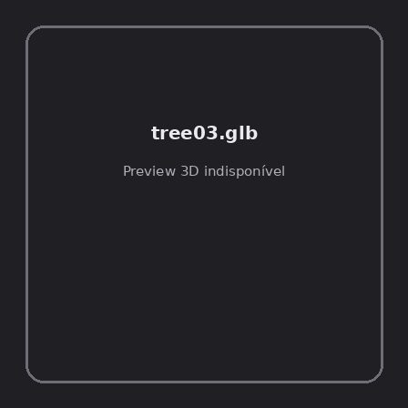
ID | NOV-004493
Origem | Asset novo
Pack/Fonte | retro_nature_pack
Categoria | Nature / Models
Arquivo | tree03.glb
Caminho | 00_Packs_Raw/retro_nature_pack/models/glTF/trees/tree03.glb
Formato | GLB
Tamanho | 44.65 KB
SHA-256 | 52e1cf771e182cdea3b1…
Status técnico | ERROR
Licença | MISSING_REVIEW_REQUIRED — sem evidência localizada
Objetos / meshes | N/D / N/D
Vértices | N/D
Faces / triângulos | N/D / N/D
Materiais | N/D —
UV sets / vertex colors | N/D / N/D
Dimensões XYZ | N/D
Rig / armatures / bones | N/D / N/D / N/D
Skinned meshes | N/D
Animações | N/D —
Duração total clips | N/D
Root motion detectado | N/D
LODs / colliders | Nenhum / Nenhum
Texturas vinculadas | N/D (0 ausentes)
Alertas | Licença/fonte não localizada automaticamente; revisão legal necessária.
Notas | Falha na inspeção 3D: RuntimeError: Error: Python: Traceback (most recent call last):  File "/usr/share/blender/scripts/addons/io_scene_gltf2/__init__.py", line 1064, in execute  return self.import_gltf2(context)  File "/usr/share/blender/scripts/addons/io_scene_gltf2/__init__.py", line 1083, in import_gltf2  return self.unit_import(self.filepath, import_settings)  File "/usr/share/blender/scripts/addons/io_scene_gltf2/__init__.py", line 1088, in unit_import  from .blender.imp.gltf2_blender_gltf import BlenderGlTF  File "/usr/share/blender/scripts/addons/io_scene_gltf2/blender/imp/gltf2_blender_gltf.py", line 17, in <module>  from .gltf2_blender_scene import BlenderScene  File "/usr/share/blender/scripts/addons/io_scene_gltf2/blender/imp/gltf2_blender_scene.py", line 17, in <module>  from .gltf2_blender_node import BlenderNode  File "/usr/share/blender/scripts/addons/io_scene_gltf2/blender/imp/gltf2_blender_node.py", line 18, in <module>  from .gltf2_blender_mesh import BlenderMesh  File "/usr/share/blender/scripts/addons/io_scene_gltf2/blender/imp/gltf2_blender_mesh.py", line 17, in <module>  import numpy as np  ModuleNotFoundError: No module named 'numpy'  location: /usr/share/blender/scripts/modules/bpy/ops.py:132  Traceback (most recent call last):  File "/home/runner/work/PSX_demons_whip/PSX_demons_whip/workspace/demons/tools/asset_catalog/blender_batch.py", line 427, in inspect_task  import_model(path)  File "/home/runner/work/PSX_demons_whip/PSX_demons_whip/workspace/demons/tools/asset_catalog/blender_batch.py", line 52, in import_model  bpy.ops.import_scene.gltf(filepath=str(path))  File "/usr/share/blender/scripts/modules/bpy/ops.py", line 132, in __call__  ret = _op_call(self.idname_py(), None, kw)  RuntimeError: Error: Python: Traceback (most recent call last):  File "/usr/share/blender/scripts/addons/io_scene_gltf2/__init__.py", line 1064, in execute  return self.import_gltf2(context)  File "/usr/share/blender/scripts/addons/io_scene_gltf2/__init__.py", line 1083, in import_gltf2  return self.unit_import(self.filepath, import_settings)  File "/usr/share/blender/scripts/addons/io_scene_gltf2/__init__.py", line 1088, in unit_import  from .blender.imp.gltf2_blender_gltf import BlenderGlTF  File "/usr/share/blender/scripts/addons/io_scene_gltf2/blender/imp/gltf2_blender_gltf.py", line 17, in <module>  from .gltf2_blender_scene import BlenderScene  File "/usr/share/blender/scripts/addons/io_scene_gltf2/blender/imp/gltf2_blender_scene.py", line 17, in <module>  from .gltf2_blender_node import BlenderNode  File "/usr/share/blender/scripts/addons/io_scene_gltf2/blender/imp/gltf2_blender_node.py", line 18, in <module>  from .gltf2_blender_mesh import BlenderMesh  File "/usr/share/blender/scripts/addons/io_scene_gltf2/blender/imp/gltf2_blender_mesh.py", line 17, in <module>  import numpy as np  ModuleNotFoundError: No module named 'numpy'  location: /usr/share/blender/scripts/modules/bpy/ops.py:132

NOV-004495 • tree03_winter [ERROR]
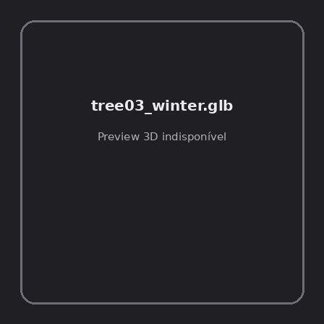
ID | NOV-004495
Origem | Asset novo
Pack/Fonte | retro_nature_pack
Categoria | Nature / Models
Arquivo | tree03_winter.glb
Caminho | 00_Packs_Raw/retro_nature_pack/models/glTF/trees/tree03_winter.glb
Formato | GLB
Tamanho | 13.13 KB
SHA-256 | f46bf9b95c4f46718d23…
Status técnico | ERROR
Licença | MISSING_REVIEW_REQUIRED — sem evidência localizada
Objetos / meshes | N/D / N/D
Vértices | N/D
Faces / triângulos | N/D / N/D
Materiais | N/D —
UV sets / vertex colors | N/D / N/D
Dimensões XYZ | N/D
Rig / armatures / bones | N/D / N/D / N/D
Skinned meshes | N/D
Animações | N/D —
Duração total clips | N/D
Root motion detectado | N/D
LODs / colliders | Nenhum / Nenhum
Texturas vinculadas | N/D (0 ausentes)
Alertas | Licença/fonte não localizada automaticamente; revisão legal necessária.
Notas | Falha na inspeção 3D: RuntimeError: Error: Python: Traceback (most recent call last):  File "/usr/share/blender/scripts/addons/io_scene_gltf2/__init__.py", line 1064, in execute  return self.import_gltf2(context)  File "/usr/share/blender/scripts/addons/io_scene_gltf2/__init__.py", line 1083, in import_gltf2  return self.unit_import(self.filepath, import_settings)  File "/usr/share/blender/scripts/addons/io_scene_gltf2/__init__.py", line 1088, in unit_import  from .blender.imp.gltf2_blender_gltf import BlenderGlTF  File "/usr/share/blender/scripts/addons/io_scene_gltf2/blender/imp/gltf2_blender_gltf.py", line 17, in <module>  from .gltf2_blender_scene import BlenderScene  File "/usr/share/blender/scripts/addons/io_scene_gltf2/blender/imp/gltf2_blender_scene.py", line 17, in <module>  from .gltf2_blender_node import BlenderNode  File "/usr/share/blender/scripts/addons/io_scene_gltf2/blender/imp/gltf2_blender_node.py", line 18, in <module>  from .gltf2_blender_mesh import BlenderMesh  File "/usr/share/blender/scripts/addons/io_scene_gltf2/blender/imp/gltf2_blender_mesh.py", line 17, in <module>  import numpy as np  ModuleNotFoundError: No module named 'numpy'  location: /usr/share/blender/scripts/modules/bpy/ops.py:132  Traceback (most recent call last):  File "/home/runner/work/PSX_demons_whip/PSX_demons_whip/workspace/demons/tools/asset_catalog/blender_batch.py", line 427, in inspect_task  import_model(path)  File "/home/runner/work/PSX_demons_whip/PSX_demons_whip/workspace/demons/tools/asset_catalog/blender_batch.py", line 52, in import_model  bpy.ops.import_scene.gltf(filepath=str(path))  File "/usr/share/blender/scripts/modules/bpy/ops.py", line 132, in __call__  ret = _op_call(self.idname_py(), None, kw)  RuntimeError: Error: Python: Traceback (most recent call last):  File "/usr/share/blender/scripts/addons/io_scene_gltf2/__init__.py", line 1064, in execute  return self.import_gltf2(context)  File "/usr/share/blender/scripts/addons/io_scene_gltf2/__init__.py", line 1083, in import_gltf2  return self.unit_import(self.filepath, import_settings)  File "/usr/share/blender/scripts/addons/io_scene_gltf2/__init__.py", line 1088, in unit_import  from .blender.imp.gltf2_blender_gltf import BlenderGlTF  File "/usr/share/blender/scripts/addons/io_scene_gltf2/blender/imp/gltf2_blender_gltf.py", line 17, in <module>  from .gltf2_blender_scene import BlenderScene  File "/usr/share/blender/scripts/addons/io_scene_gltf2/blender/imp/gltf2_blender_scene.py", line 17, in <module>  from .gltf2_blender_node import BlenderNode  File "/usr/share/blender/scripts/addons/io_scene_gltf2/blender/imp/gltf2_blender_node.py", line 18, in <module>  from .gltf2_blender_mesh import BlenderMesh  File "/usr/share/blender/scripts/addons/io_scene_gltf2/blender/imp/gltf2_blender_mesh.py", line 17, in <module>  import numpy as np  ModuleNotFoundError: No module named 'numpy'  location: /usr/share/blender/scripts/modules/bpy/ops.py:132

NOV-004503 • tree04 [ERROR]
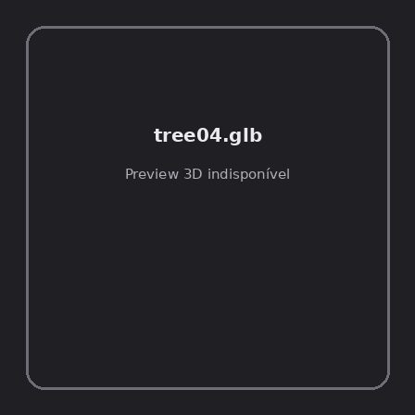
ID | NOV-004503
Origem | Asset novo
Pack/Fonte | retro_nature_pack
Categoria | Nature / Models
Arquivo | tree04.glb
Caminho | 00_Packs_Raw/retro_nature_pack/models/glTF/trees/tree04.glb
Formato | GLB
Tamanho | 44.59 KB
SHA-256 | 4cc2437cc50b8e19f68a…
Status técnico | ERROR
Licença | MISSING_REVIEW_REQUIRED — sem evidência localizada
Objetos / meshes | N/D / N/D
Vértices | N/D
Faces / triângulos | N/D / N/D
Materiais | N/D —
UV sets / vertex colors | N/D / N/D
Dimensões XYZ | N/D
Rig / armatures / bones | N/D / N/D / N/D
Skinned meshes | N/D
Animações | N/D —
Duração total clips | N/D
Root motion detectado | N/D
LODs / colliders | Nenhum / Nenhum
Texturas vinculadas | N/D (0 ausentes)
Alertas | Licença/fonte não localizada automaticamente; revisão legal necessária.
Notas | Falha na inspeção 3D: RuntimeError: Error: Python: Traceback (most recent call last):  File "/usr/share/blender/scripts/addons/io_scene_gltf2/__init__.py", line 1064, in execute  return self.import_gltf2(context)  File "/usr/share/blender/scripts/addons/io_scene_gltf2/__init__.py", line 1083, in import_gltf2  return self.unit_import(self.filepath, import_settings)  File "/usr/share/blender/scripts/addons/io_scene_gltf2/__init__.py", line 1088, in unit_import  from .blender.imp.gltf2_blender_gltf import BlenderGlTF  File "/usr/share/blender/scripts/addons/io_scene_gltf2/blender/imp/gltf2_blender_gltf.py", line 17, in <module>  from .gltf2_blender_scene import BlenderScene  File "/usr/share/blender/scripts/addons/io_scene_gltf2/blender/imp/gltf2_blender_scene.py", line 17, in <module>  from .gltf2_blender_node import BlenderNode  File "/usr/share/blender/scripts/addons/io_scene_gltf2/blender/imp/gltf2_blender_node.py", line 18, in <module>  from .gltf2_blender_mesh import BlenderMesh  File "/usr/share/blender/scripts/addons/io_scene_gltf2/blender/imp/gltf2_blender_mesh.py", line 17, in <module>  import numpy as np  ModuleNotFoundError: No module named 'numpy'  location: /usr/share/blender/scripts/modules/bpy/ops.py:132  Traceback (most recent call last):  File "/home/runner/work/PSX_demons_whip/PSX_demons_whip/workspace/demons/tools/asset_catalog/blender_batch.py", line 427, in inspect_task  import_model(path)  File "/home/runner/work/PSX_demons_whip/PSX_demons_whip/workspace/demons/tools/asset_catalog/blender_batch.py", line 52, in import_model  bpy.ops.import_scene.gltf(filepath=str(path))  File "/usr/share/blender/scripts/modules/bpy/ops.py", line 132, in __call__  ret = _op_call(self.idname_py(), None, kw)  RuntimeError: Error: Python: Traceback (most recent call last):  File "/usr/share/blender/scripts/addons/io_scene_gltf2/__init__.py", line 1064, in execute  return self.import_gltf2(context)  File "/usr/share/blender/scripts/addons/io_scene_gltf2/__init__.py", line 1083, in import_gltf2  return self.unit_import(self.filepath, import_settings)  File "/usr/share/blender/scripts/addons/io_scene_gltf2/__init__.py", line 1088, in unit_import  from .blender.imp.gltf2_blender_gltf import BlenderGlTF  File "/usr/share/blender/scripts/addons/io_scene_gltf2/blender/imp/gltf2_blender_gltf.py", line 17, in <module>  from .gltf2_blender_scene import BlenderScene  File "/usr/share/blender/scripts/addons/io_scene_gltf2/blender/imp/gltf2_blender_scene.py", line 17, in <module>  from .gltf2_blender_node import BlenderNode  File "/usr/share/blender/scripts/addons/io_scene_gltf2/blender/imp/gltf2_blender_node.py", line 18, in <module>  from .gltf2_blender_mesh import BlenderMesh  File "/usr/share/blender/scripts/addons/io_scene_gltf2/blender/imp/gltf2_blender_mesh.py", line 17, in <module>  import numpy as np  ModuleNotFoundError: No module named 'numpy'  location: /usr/share/blender/scripts/modules/bpy/ops.py:132

NOV-004506 • tree04_winter [ERROR]
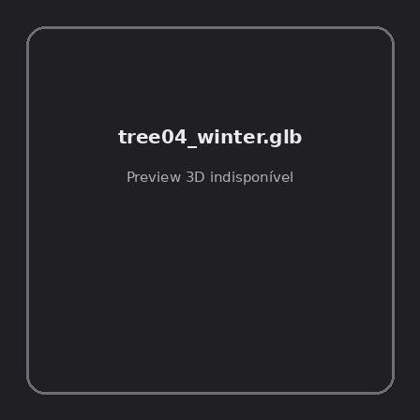
ID | NOV-004506
Origem | Asset novo
Pack/Fonte | retro_nature_pack
Categoria | Nature / Models
Arquivo | tree04_winter.glb
Caminho | 00_Packs_Raw/retro_nature_pack/models/glTF/trees/tree04_winter.glb
Formato | GLB
Tamanho | 13.07 KB
SHA-256 | 686dee44a64444e908a9…
Status técnico | ERROR
Licença | MISSING_REVIEW_REQUIRED — sem evidência localizada
Objetos / meshes | N/D / N/D
Vértices | N/D
Faces / triângulos | N/D / N/D
Materiais | N/D —
UV sets / vertex colors | N/D / N/D
Dimensões XYZ | N/D
Rig / armatures / bones | N/D / N/D / N/D
Skinned meshes | N/D
Animações | N/D —
Duração total clips | N/D
Root motion detectado | N/D
LODs / colliders | Nenhum / Nenhum
Texturas vinculadas | N/D (0 ausentes)
Alertas | Licença/fonte não localizada automaticamente; revisão legal necessária.
Notas | Falha na inspeção 3D: RuntimeError: Error: Python: Traceback (most recent call last):  File "/usr/share/blender/scripts/addons/io_scene_gltf2/__init__.py", line 1064, in execute  return self.import_gltf2(context)  File "/usr/share/blender/scripts/addons/io_scene_gltf2/__init__.py", line 1083, in import_gltf2  return self.unit_import(self.filepath, import_settings)  File "/usr/share/blender/scripts/addons/io_scene_gltf2/__init__.py", line 1088, in unit_import  from .blender.imp.gltf2_blender_gltf import BlenderGlTF  File "/usr/share/blender/scripts/addons/io_scene_gltf2/blender/imp/gltf2_blender_gltf.py", line 17, in <module>  from .gltf2_blender_scene import BlenderScene  File "/usr/share/blender/scripts/addons/io_scene_gltf2/blender/imp/gltf2_blender_scene.py", line 17, in <module>  from .gltf2_blender_node import BlenderNode  File "/usr/share/blender/scripts/addons/io_scene_gltf2/blender/imp/gltf2_blender_node.py", line 18, in <module>  from .gltf2_blender_mesh import BlenderMesh  File "/usr/share/blender/scripts/addons/io_scene_gltf2/blender/imp/gltf2_blender_mesh.py", line 17, in <module>  import numpy as np  ModuleNotFoundError: No module named 'numpy'  location: /usr/share/blender/scripts/modules/bpy/ops.py:132  Traceback (most recent call last):  File "/home/runner/work/PSX_demons_whip/PSX_demons_whip/workspace/demons/tools/asset_catalog/blender_batch.py", line 427, in inspect_task  import_model(path)  File "/home/runner/work/PSX_demons_whip/PSX_demons_whip/workspace/demons/tools/asset_catalog/blender_batch.py", line 52, in import_model  bpy.ops.import_scene.gltf(filepath=str(path))  File "/usr/share/blender/scripts/modules/bpy/ops.py", line 132, in __call__  ret = _op_call(self.idname_py(), None, kw)  RuntimeError: Error: Python: Traceback (most recent call last):  File "/usr/share/blender/scripts/addons/io_scene_gltf2/__init__.py", line 1064, in execute  return self.import_gltf2(context)  File "/usr/share/blender/scripts/addons/io_scene_gltf2/__init__.py", line 1083, in import_gltf2  return self.unit_import(self.filepath, import_settings)  File "/usr/share/blender/scripts/addons/io_scene_gltf2/__init__.py", line 1088, in unit_import  from .blender.imp.gltf2_blender_gltf import BlenderGlTF  File "/usr/share/blender/scripts/addons/io_scene_gltf2/blender/imp/gltf2_blender_gltf.py", line 17, in <module>  from .gltf2_blender_scene import BlenderScene  File "/usr/share/blender/scripts/addons/io_scene_gltf2/blender/imp/gltf2_blender_scene.py", line 17, in <module>  from .gltf2_blender_node import BlenderNode  File "/usr/share/blender/scripts/addons/io_scene_gltf2/blender/imp/gltf2_blender_node.py", line 18, in <module>  from .gltf2_blender_mesh import BlenderMesh  File "/usr/share/blender/scripts/addons/io_scene_gltf2/blender/imp/gltf2_blender_mesh.py", line 17, in <module>  import numpy as np  ModuleNotFoundError: No module named 'numpy'  location: /usr/share/blender/scripts/modules/bpy/ops.py:132

