DEMONS WHIP - NOVO - NATURE
MODEL 3D • Volume 5 de 5

Assets neste volume: 46
Origem: NOVO
Gerado em: 2026-08-17T19:04:38+00:00

NOV-004496 • tree05 [ERROR]
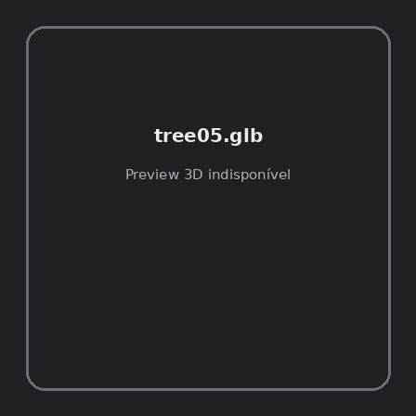
ID | NOV-004496
Origem | Asset novo
Pack/Fonte | retro_nature_pack
Categoria | Nature / Models
Arquivo | tree05.glb
Caminho | 00_Packs_Raw/retro_nature_pack/models/glTF/trees/tree05.glb
Formato | GLB
Tamanho | 45.34 KB
SHA-256 | 3d1ca2e3e36418dae4a8…
Status técnico | ERROR
Licença | MISSING_REVIEW_REQUIRED — sem evidência localizada
Objetos / meshes | N/D / N/D
Vértices | N/D
Faces / triângulos | N/D / N/D
Materiais | N/D —
UV sets / vertex colors | N/D / N/D
Dimensões XYZ | N/D
Rig / armatures / bones | N/D / N/D / N/D
Skinned meshes | N/D
Animações | N/D —
Duração total clips | N/D
Root motion detectado | N/D
LODs / colliders | Nenhum / Nenhum
Texturas vinculadas | N/D (0 ausentes)
Alertas | Licença/fonte não localizada automaticamente; revisão legal necessária.
Notas | Falha na inspeção 3D: RuntimeError: Error: Python: Traceback (most recent call last):  File "/usr/share/blender/scripts/addons/io_scene_gltf2/__init__.py", line 1064, in execute  return self.import_gltf2(context)  File "/usr/share/blender/scripts/addons/io_scene_gltf2/__init__.py", line 1083, in import_gltf2  return self.unit_import(self.filepath, import_settings)  File "/usr/share/blender/scripts/addons/io_scene_gltf2/__init__.py", line 1088, in unit_import  from .blender.imp.gltf2_blender_gltf import BlenderGlTF  File "/usr/share/blender/scripts/addons/io_scene_gltf2/blender/imp/gltf2_blender_gltf.py", line 17, in <module>  from .gltf2_blender_scene import BlenderScene  File "/usr/share/blender/scripts/addons/io_scene_gltf2/blender/imp/gltf2_blender_scene.py", line 17, in <module>  from .gltf2_blender_node import BlenderNode  File "/usr/share/blender/scripts/addons/io_scene_gltf2/blender/imp/gltf2_blender_node.py", line 18, in <module>  from .gltf2_blender_mesh import BlenderMesh  File "/usr/share/blender/scripts/addons/io_scene_gltf2/blender/imp/gltf2_blender_mesh.py", line 17, in <module>  import numpy as np  ModuleNotFoundError: No module named 'numpy'  location: /usr/share/blender/scripts/modules/bpy/ops.py:132  Traceback (most recent call last):  File "/home/runner/work/PSX_demons_whip/PSX_demons_whip/workspace/demons/tools/asset_catalog/blender_batch.py", line 427, in inspect_task  import_model(path)  File "/home/runner/work/PSX_demons_whip/PSX_demons_whip/workspace/demons/tools/asset_catalog/blender_batch.py", line 52, in import_model  bpy.ops.import_scene.gltf(filepath=str(path))  File "/usr/share/blender/scripts/modules/bpy/ops.py", line 132, in __call__  ret = _op_call(self.idname_py(), None, kw)  RuntimeError: Error: Python: Traceback (most recent call last):  File "/usr/share/blender/scripts/addons/io_scene_gltf2/__init__.py", line 1064, in execute  return self.import_gltf2(context)  File "/usr/share/blender/scripts/addons/io_scene_gltf2/__init__.py", line 1083, in import_gltf2  return self.unit_import(self.filepath, import_settings)  File "/usr/share/blender/scripts/addons/io_scene_gltf2/__init__.py", line 1088, in unit_import  from .blender.imp.gltf2_blender_gltf import BlenderGlTF  File "/usr/share/blender/scripts/addons/io_scene_gltf2/blender/imp/gltf2_blender_gltf.py", line 17, in <module>  from .gltf2_blender_scene import BlenderScene  File "/usr/share/blender/scripts/addons/io_scene_gltf2/blender/imp/gltf2_blender_scene.py", line 17, in <module>  from .gltf2_blender_node import BlenderNode  File "/usr/share/blender/scripts/addons/io_scene_gltf2/blender/imp/gltf2_blender_node.py", line 18, in <module>  from .gltf2_blender_mesh import BlenderMesh  File "/usr/share/blender/scripts/addons/io_scene_gltf2/blender/imp/gltf2_blender_mesh.py", line 17, in <module>  import numpy as np  ModuleNotFoundError: No module named 'numpy'  location: /usr/share/blender/scripts/modules/bpy/ops.py:132

NOV-004505 • tree05_winter [ERROR]
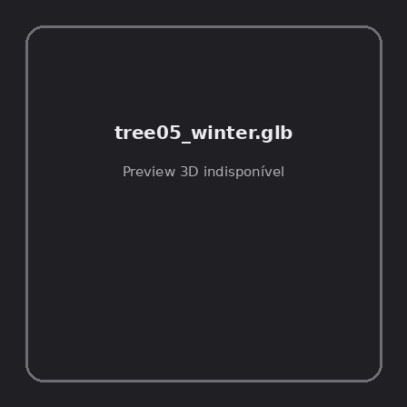
ID | NOV-004505
Origem | Asset novo
Pack/Fonte | retro_nature_pack
Categoria | Nature / Models
Arquivo | tree05_winter.glb
Caminho | 00_Packs_Raw/retro_nature_pack/models/glTF/trees/tree05_winter.glb
Formato | GLB
Tamanho | 12.91 KB
SHA-256 | dc25f343caf457911227…
Status técnico | ERROR
Licença | MISSING_REVIEW_REQUIRED — sem evidência localizada
Objetos / meshes | N/D / N/D
Vértices | N/D
Faces / triângulos | N/D / N/D
Materiais | N/D —
UV sets / vertex colors | N/D / N/D
Dimensões XYZ | N/D
Rig / armatures / bones | N/D / N/D / N/D
Skinned meshes | N/D
Animações | N/D —
Duração total clips | N/D
Root motion detectado | N/D
LODs / colliders | Nenhum / Nenhum
Texturas vinculadas | N/D (0 ausentes)
Alertas | Licença/fonte não localizada automaticamente; revisão legal necessária.
Notas | Falha na inspeção 3D: RuntimeError: Error: Python: Traceback (most recent call last):  File "/usr/share/blender/scripts/addons/io_scene_gltf2/__init__.py", line 1064, in execute  return self.import_gltf2(context)  File "/usr/share/blender/scripts/addons/io_scene_gltf2/__init__.py", line 1083, in import_gltf2  return self.unit_import(self.filepath, import_settings)  File "/usr/share/blender/scripts/addons/io_scene_gltf2/__init__.py", line 1088, in unit_import  from .blender.imp.gltf2_blender_gltf import BlenderGlTF  File "/usr/share/blender/scripts/addons/io_scene_gltf2/blender/imp/gltf2_blender_gltf.py", line 17, in <module>  from .gltf2_blender_scene import BlenderScene  File "/usr/share/blender/scripts/addons/io_scene_gltf2/blender/imp/gltf2_blender_scene.py", line 17, in <module>  from .gltf2_blender_node import BlenderNode  File "/usr/share/blender/scripts/addons/io_scene_gltf2/blender/imp/gltf2_blender_node.py", line 18, in <module>  from .gltf2_blender_mesh import BlenderMesh  File "/usr/share/blender/scripts/addons/io_scene_gltf2/blender/imp/gltf2_blender_mesh.py", line 17, in <module>  import numpy as np  ModuleNotFoundError: No module named 'numpy'  location: /usr/share/blender/scripts/modules/bpy/ops.py:132  Traceback (most recent call last):  File "/home/runner/work/PSX_demons_whip/PSX_demons_whip/workspace/demons/tools/asset_catalog/blender_batch.py", line 427, in inspect_task  import_model(path)  File "/home/runner/work/PSX_demons_whip/PSX_demons_whip/workspace/demons/tools/asset_catalog/blender_batch.py", line 52, in import_model  bpy.ops.import_scene.gltf(filepath=str(path))  File "/usr/share/blender/scripts/modules/bpy/ops.py", line 132, in __call__  ret = _op_call(self.idname_py(), None, kw)  RuntimeError: Error: Python: Traceback (most recent call last):  File "/usr/share/blender/scripts/addons/io_scene_gltf2/__init__.py", line 1064, in execute  return self.import_gltf2(context)  File "/usr/share/blender/scripts/addons/io_scene_gltf2/__init__.py", line 1083, in import_gltf2  return self.unit_import(self.filepath, import_settings)  File "/usr/share/blender/scripts/addons/io_scene_gltf2/__init__.py", line 1088, in unit_import  from .blender.imp.gltf2_blender_gltf import BlenderGlTF  File "/usr/share/blender/scripts/addons/io_scene_gltf2/blender/imp/gltf2_blender_gltf.py", line 17, in <module>  from .gltf2_blender_scene import BlenderScene  File "/usr/share/blender/scripts/addons/io_scene_gltf2/blender/imp/gltf2_blender_scene.py", line 17, in <module>  from .gltf2_blender_node import BlenderNode  File "/usr/share/blender/scripts/addons/io_scene_gltf2/blender/imp/gltf2_blender_node.py", line 18, in <module>  from .gltf2_blender_mesh import BlenderMesh  File "/usr/share/blender/scripts/addons/io_scene_gltf2/blender/imp/gltf2_blender_mesh.py", line 17, in <module>  import numpy as np  ModuleNotFoundError: No module named 'numpy'  location: /usr/share/blender/scripts/modules/bpy/ops.py:132

NOV-004501 • tree06 [ERROR]
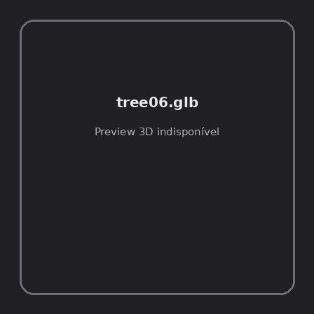
ID | NOV-004501
Origem | Asset novo
Pack/Fonte | retro_nature_pack
Categoria | Nature / Models
Arquivo | tree06.glb
Caminho | 00_Packs_Raw/retro_nature_pack/models/glTF/trees/tree06.glb
Formato | GLB
Tamanho | 43.02 KB
SHA-256 | 1d3a367fd285e50be14d…
Status técnico | ERROR
Licença | MISSING_REVIEW_REQUIRED — sem evidência localizada
Objetos / meshes | N/D / N/D
Vértices | N/D
Faces / triângulos | N/D / N/D
Materiais | N/D —
UV sets / vertex colors | N/D / N/D
Dimensões XYZ | N/D
Rig / armatures / bones | N/D / N/D / N/D
Skinned meshes | N/D
Animações | N/D —
Duração total clips | N/D
Root motion detectado | N/D
LODs / colliders | Nenhum / Nenhum
Texturas vinculadas | N/D (0 ausentes)
Alertas | Licença/fonte não localizada automaticamente; revisão legal necessária.
Notas | Falha na inspeção 3D: RuntimeError: Error: Python: Traceback (most recent call last):  File "/usr/share/blender/scripts/addons/io_scene_gltf2/__init__.py", line 1064, in execute  return self.import_gltf2(context)  File "/usr/share/blender/scripts/addons/io_scene_gltf2/__init__.py", line 1083, in import_gltf2  return self.unit_import(self.filepath, import_settings)  File "/usr/share/blender/scripts/addons/io_scene_gltf2/__init__.py", line 1088, in unit_import  from .blender.imp.gltf2_blender_gltf import BlenderGlTF  File "/usr/share/blender/scripts/addons/io_scene_gltf2/blender/imp/gltf2_blender_gltf.py", line 17, in <module>  from .gltf2_blender_scene import BlenderScene  File "/usr/share/blender/scripts/addons/io_scene_gltf2/blender/imp/gltf2_blender_scene.py", line 17, in <module>  from .gltf2_blender_node import BlenderNode  File "/usr/share/blender/scripts/addons/io_scene_gltf2/blender/imp/gltf2_blender_node.py", line 18, in <module>  from .gltf2_blender_mesh import BlenderMesh  File "/usr/share/blender/scripts/addons/io_scene_gltf2/blender/imp/gltf2_blender_mesh.py", line 17, in <module>  import numpy as np  ModuleNotFoundError: No module named 'numpy'  location: /usr/share/blender/scripts/modules/bpy/ops.py:132  Traceback (most recent call last):  File "/home/runner/work/PSX_demons_whip/PSX_demons_whip/workspace/demons/tools/asset_catalog/blender_batch.py", line 427, in inspect_task  import_model(path)  File "/home/runner/work/PSX_demons_whip/PSX_demons_whip/workspace/demons/tools/asset_catalog/blender_batch.py", line 52, in import_model  bpy.ops.import_scene.gltf(filepath=str(path))  File "/usr/share/blender/scripts/modules/bpy/ops.py", line 132, in __call__  ret = _op_call(self.idname_py(), None, kw)  RuntimeError: Error: Python: Traceback (most recent call last):  File "/usr/share/blender/scripts/addons/io_scene_gltf2/__init__.py", line 1064, in execute  return self.import_gltf2(context)  File "/usr/share/blender/scripts/addons/io_scene_gltf2/__init__.py", line 1083, in import_gltf2  return self.unit_import(self.filepath, import_settings)  File "/usr/share/blender/scripts/addons/io_scene_gltf2/__init__.py", line 1088, in unit_import  from .blender.imp.gltf2_blender_gltf import BlenderGlTF  File "/usr/share/blender/scripts/addons/io_scene_gltf2/blender/imp/gltf2_blender_gltf.py", line 17, in <module>  from .gltf2_blender_scene import BlenderScene  File "/usr/share/blender/scripts/addons/io_scene_gltf2/blender/imp/gltf2_blender_scene.py", line 17, in <module>  from .gltf2_blender_node import BlenderNode  File "/usr/share/blender/scripts/addons/io_scene_gltf2/blender/imp/gltf2_blender_node.py", line 18, in <module>  from .gltf2_blender_mesh import BlenderMesh  File "/usr/share/blender/scripts/addons/io_scene_gltf2/blender/imp/gltf2_blender_mesh.py", line 17, in <module>  import numpy as np  ModuleNotFoundError: No module named 'numpy'  location: /usr/share/blender/scripts/modules/bpy/ops.py:132

NOV-004498 • tree06_winter [ERROR]
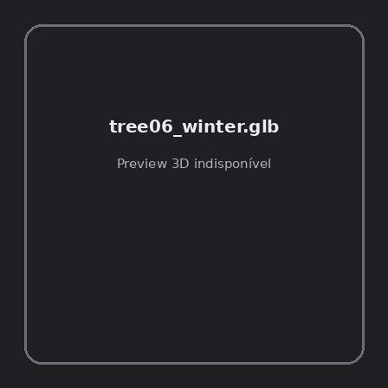
ID | NOV-004498
Origem | Asset novo
Pack/Fonte | retro_nature_pack
Categoria | Nature / Models
Arquivo | tree06_winter.glb
Caminho | 00_Packs_Raw/retro_nature_pack/models/glTF/trees/tree06_winter.glb
Formato | GLB
Tamanho | 13.13 KB
SHA-256 | 800b7bf9be119053f5b6…
Status técnico | ERROR
Licença | MISSING_REVIEW_REQUIRED — sem evidência localizada
Objetos / meshes | N/D / N/D
Vértices | N/D
Faces / triângulos | N/D / N/D
Materiais | N/D —
UV sets / vertex colors | N/D / N/D
Dimensões XYZ | N/D
Rig / armatures / bones | N/D / N/D / N/D
Skinned meshes | N/D
Animações | N/D —
Duração total clips | N/D
Root motion detectado | N/D
LODs / colliders | Nenhum / Nenhum
Texturas vinculadas | N/D (0 ausentes)
Alertas | Licença/fonte não localizada automaticamente; revisão legal necessária.
Notas | Falha na inspeção 3D: RuntimeError: Error: Python: Traceback (most recent call last):  File "/usr/share/blender/scripts/addons/io_scene_gltf2/__init__.py", line 1064, in execute  return self.import_gltf2(context)  File "/usr/share/blender/scripts/addons/io_scene_gltf2/__init__.py", line 1083, in import_gltf2  return self.unit_import(self.filepath, import_settings)  File "/usr/share/blender/scripts/addons/io_scene_gltf2/__init__.py", line 1088, in unit_import  from .blender.imp.gltf2_blender_gltf import BlenderGlTF  File "/usr/share/blender/scripts/addons/io_scene_gltf2/blender/imp/gltf2_blender_gltf.py", line 17, in <module>  from .gltf2_blender_scene import BlenderScene  File "/usr/share/blender/scripts/addons/io_scene_gltf2/blender/imp/gltf2_blender_scene.py", line 17, in <module>  from .gltf2_blender_node import BlenderNode  File "/usr/share/blender/scripts/addons/io_scene_gltf2/blender/imp/gltf2_blender_node.py", line 18, in <module>  from .gltf2_blender_mesh import BlenderMesh  File "/usr/share/blender/scripts/addons/io_scene_gltf2/blender/imp/gltf2_blender_mesh.py", line 17, in <module>  import numpy as np  ModuleNotFoundError: No module named 'numpy'  location: /usr/share/blender/scripts/modules/bpy/ops.py:132  Traceback (most recent call last):  File "/home/runner/work/PSX_demons_whip/PSX_demons_whip/workspace/demons/tools/asset_catalog/blender_batch.py", line 427, in inspect_task  import_model(path)  File "/home/runner/work/PSX_demons_whip/PSX_demons_whip/workspace/demons/tools/asset_catalog/blender_batch.py", line 52, in import_model  bpy.ops.import_scene.gltf(filepath=str(path))  File "/usr/share/blender/scripts/modules/bpy/ops.py", line 132, in __call__  ret = _op_call(self.idname_py(), None, kw)  RuntimeError: Error: Python: Traceback (most recent call last):  File "/usr/share/blender/scripts/addons/io_scene_gltf2/__init__.py", line 1064, in execute  return self.import_gltf2(context)  File "/usr/share/blender/scripts/addons/io_scene_gltf2/__init__.py", line 1083, in import_gltf2  return self.unit_import(self.filepath, import_settings)  File "/usr/share/blender/scripts/addons/io_scene_gltf2/__init__.py", line 1088, in unit_import  from .blender.imp.gltf2_blender_gltf import BlenderGlTF  File "/usr/share/blender/scripts/addons/io_scene_gltf2/blender/imp/gltf2_blender_gltf.py", line 17, in <module>  from .gltf2_blender_scene import BlenderScene  File "/usr/share/blender/scripts/addons/io_scene_gltf2/blender/imp/gltf2_blender_scene.py", line 17, in <module>  from .gltf2_blender_node import BlenderNode  File "/usr/share/blender/scripts/addons/io_scene_gltf2/blender/imp/gltf2_blender_node.py", line 18, in <module>  from .gltf2_blender_mesh import BlenderMesh  File "/usr/share/blender/scripts/addons/io_scene_gltf2/blender/imp/gltf2_blender_mesh.py", line 17, in <module>  import numpy as np  ModuleNotFoundError: No module named 'numpy'  location: /usr/share/blender/scripts/modules/bpy/ops.py:132

NOV-004494 • tree07 [ERROR]
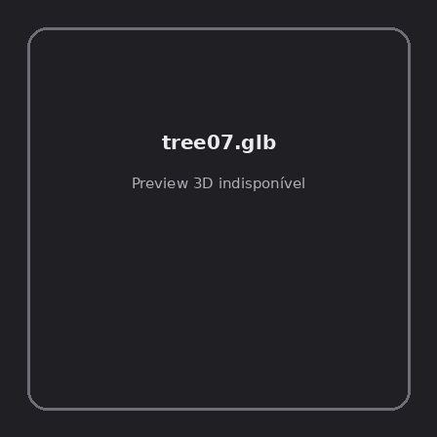
ID | NOV-004494
Origem | Asset novo
Pack/Fonte | retro_nature_pack
Categoria | Nature / Models
Arquivo | tree07.glb
Caminho | 00_Packs_Raw/retro_nature_pack/models/glTF/trees/tree07.glb
Formato | GLB
Tamanho | 40.55 KB
SHA-256 | faa56792329e6c3a47f2…
Status técnico | ERROR
Licença | MISSING_REVIEW_REQUIRED — sem evidência localizada
Objetos / meshes | N/D / N/D
Vértices | N/D
Faces / triângulos | N/D / N/D
Materiais | N/D —
UV sets / vertex colors | N/D / N/D
Dimensões XYZ | N/D
Rig / armatures / bones | N/D / N/D / N/D
Skinned meshes | N/D
Animações | N/D —
Duração total clips | N/D
Root motion detectado | N/D
LODs / colliders | Nenhum / Nenhum
Texturas vinculadas | N/D (0 ausentes)
Alertas | Licença/fonte não localizada automaticamente; revisão legal necessária.
Notas | Falha na inspeção 3D: RuntimeError: Error: Python: Traceback (most recent call last):  File "/usr/share/blender/scripts/addons/io_scene_gltf2/__init__.py", line 1064, in execute  return self.import_gltf2(context)  File "/usr/share/blender/scripts/addons/io_scene_gltf2/__init__.py", line 1083, in import_gltf2  return self.unit_import(self.filepath, import_settings)  File "/usr/share/blender/scripts/addons/io_scene_gltf2/__init__.py", line 1088, in unit_import  from .blender.imp.gltf2_blender_gltf import BlenderGlTF  File "/usr/share/blender/scripts/addons/io_scene_gltf2/blender/imp/gltf2_blender_gltf.py", line 17, in <module>  from .gltf2_blender_scene import BlenderScene  File "/usr/share/blender/scripts/addons/io_scene_gltf2/blender/imp/gltf2_blender_scene.py", line 17, in <module>  from .gltf2_blender_node import BlenderNode  File "/usr/share/blender/scripts/addons/io_scene_gltf2/blender/imp/gltf2_blender_node.py", line 18, in <module>  from .gltf2_blender_mesh import BlenderMesh  File "/usr/share/blender/scripts/addons/io_scene_gltf2/blender/imp/gltf2_blender_mesh.py", line 17, in <module>  import numpy as np  ModuleNotFoundError: No module named 'numpy'  location: /usr/share/blender/scripts/modules/bpy/ops.py:132  Traceback (most recent call last):  File "/home/runner/work/PSX_demons_whip/PSX_demons_whip/workspace/demons/tools/asset_catalog/blender_batch.py", line 427, in inspect_task  import_model(path)  File "/home/runner/work/PSX_demons_whip/PSX_demons_whip/workspace/demons/tools/asset_catalog/blender_batch.py", line 52, in import_model  bpy.ops.import_scene.gltf(filepath=str(path))  File "/usr/share/blender/scripts/modules/bpy/ops.py", line 132, in __call__  ret = _op_call(self.idname_py(), None, kw)  RuntimeError: Error: Python: Traceback (most recent call last):  File "/usr/share/blender/scripts/addons/io_scene_gltf2/__init__.py", line 1064, in execute  return self.import_gltf2(context)  File "/usr/share/blender/scripts/addons/io_scene_gltf2/__init__.py", line 1083, in import_gltf2  return self.unit_import(self.filepath, import_settings)  File "/usr/share/blender/scripts/addons/io_scene_gltf2/__init__.py", line 1088, in unit_import  from .blender.imp.gltf2_blender_gltf import BlenderGlTF  File "/usr/share/blender/scripts/addons/io_scene_gltf2/blender/imp/gltf2_blender_gltf.py", line 17, in <module>  from .gltf2_blender_scene import BlenderScene  File "/usr/share/blender/scripts/addons/io_scene_gltf2/blender/imp/gltf2_blender_scene.py", line 17, in <module>  from .gltf2_blender_node import BlenderNode  File "/usr/share/blender/scripts/addons/io_scene_gltf2/blender/imp/gltf2_blender_node.py", line 18, in <module>  from .gltf2_blender_mesh import BlenderMesh  File "/usr/share/blender/scripts/addons/io_scene_gltf2/blender/imp/gltf2_blender_mesh.py", line 17, in <module>  import numpy as np  ModuleNotFoundError: No module named 'numpy'  location: /usr/share/blender/scripts/modules/bpy/ops.py:132

NOV-004500 • tree08 [ERROR]
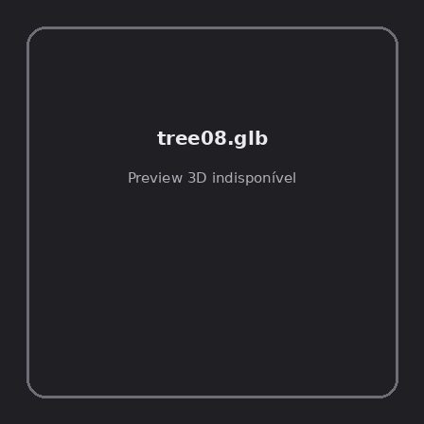
ID | NOV-004500
Origem | Asset novo
Pack/Fonte | retro_nature_pack
Categoria | Nature / Models
Arquivo | tree08.glb
Caminho | 00_Packs_Raw/retro_nature_pack/models/glTF/trees/tree08.glb
Formato | GLB
Tamanho | 32.85 KB
SHA-256 | 38ac27ddf2025d6537f3…
Status técnico | ERROR
Licença | MISSING_REVIEW_REQUIRED — sem evidência localizada
Objetos / meshes | N/D / N/D
Vértices | N/D
Faces / triângulos | N/D / N/D
Materiais | N/D —
UV sets / vertex colors | N/D / N/D
Dimensões XYZ | N/D
Rig / armatures / bones | N/D / N/D / N/D
Skinned meshes | N/D
Animações | N/D —
Duração total clips | N/D
Root motion detectado | N/D
LODs / colliders | Nenhum / Nenhum
Texturas vinculadas | N/D (0 ausentes)
Alertas | Licença/fonte não localizada automaticamente; revisão legal necessária.
Notas | Falha na inspeção 3D: RuntimeError: Error: Python: Traceback (most recent call last):  File "/usr/share/blender/scripts/addons/io_scene_gltf2/__init__.py", line 1064, in execute  return self.import_gltf2(context)  File "/usr/share/blender/scripts/addons/io_scene_gltf2/__init__.py", line 1083, in import_gltf2  return self.unit_import(self.filepath, import_settings)  File "/usr/share/blender/scripts/addons/io_scene_gltf2/__init__.py", line 1088, in unit_import  from .blender.imp.gltf2_blender_gltf import BlenderGlTF  File "/usr/share/blender/scripts/addons/io_scene_gltf2/blender/imp/gltf2_blender_gltf.py", line 17, in <module>  from .gltf2_blender_scene import BlenderScene  File "/usr/share/blender/scripts/addons/io_scene_gltf2/blender/imp/gltf2_blender_scene.py", line 17, in <module>  from .gltf2_blender_node import BlenderNode  File "/usr/share/blender/scripts/addons/io_scene_gltf2/blender/imp/gltf2_blender_node.py", line 18, in <module>  from .gltf2_blender_mesh import BlenderMesh  File "/usr/share/blender/scripts/addons/io_scene_gltf2/blender/imp/gltf2_blender_mesh.py", line 17, in <module>  import numpy as np  ModuleNotFoundError: No module named 'numpy'  location: /usr/share/blender/scripts/modules/bpy/ops.py:132  Traceback (most recent call last):  File "/home/runner/work/PSX_demons_whip/PSX_demons_whip/workspace/demons/tools/asset_catalog/blender_batch.py", line 427, in inspect_task  import_model(path)  File "/home/runner/work/PSX_demons_whip/PSX_demons_whip/workspace/demons/tools/asset_catalog/blender_batch.py", line 52, in import_model  bpy.ops.import_scene.gltf(filepath=str(path))  File "/usr/share/blender/scripts/modules/bpy/ops.py", line 132, in __call__  ret = _op_call(self.idname_py(), None, kw)  RuntimeError: Error: Python: Traceback (most recent call last):  File "/usr/share/blender/scripts/addons/io_scene_gltf2/__init__.py", line 1064, in execute  return self.import_gltf2(context)  File "/usr/share/blender/scripts/addons/io_scene_gltf2/__init__.py", line 1083, in import_gltf2  return self.unit_import(self.filepath, import_settings)  File "/usr/share/blender/scripts/addons/io_scene_gltf2/__init__.py", line 1088, in unit_import  from .blender.imp.gltf2_blender_gltf import BlenderGlTF  File "/usr/share/blender/scripts/addons/io_scene_gltf2/blender/imp/gltf2_blender_gltf.py", line 17, in <module>  from .gltf2_blender_scene import BlenderScene  File "/usr/share/blender/scripts/addons/io_scene_gltf2/blender/imp/gltf2_blender_scene.py", line 17, in <module>  from .gltf2_blender_node import BlenderNode  File "/usr/share/blender/scripts/addons/io_scene_gltf2/blender/imp/gltf2_blender_node.py", line 18, in <module>  from .gltf2_blender_mesh import BlenderMesh  File "/usr/share/blender/scripts/addons/io_scene_gltf2/blender/imp/gltf2_blender_mesh.py", line 17, in <module>  import numpy as np  ModuleNotFoundError: No module named 'numpy'  location: /usr/share/blender/scripts/modules/bpy/ops.py:132

NOV-004523 • bush01 [ERROR]
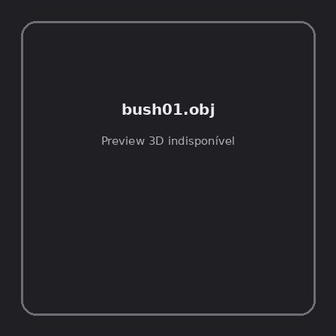
ID | NOV-004523
Origem | Asset novo
Pack/Fonte | retro_nature_pack
Categoria | Nature / Models
Arquivo | bush01.obj
Caminho | 00_Packs_Raw/retro_nature_pack/models/OBJ/bushes/bush01.obj
Formato | OBJ
Tamanho | 16.05 KB
SHA-256 | 7ebc0f074b25eb02b91a…
Status técnico | ERROR
Licença | MISSING_REVIEW_REQUIRED — sem evidência localizada
Objetos / meshes | N/D / N/D
Vértices | N/D
Faces / triângulos | N/D / N/D
Materiais | N/D —
UV sets / vertex colors | N/D / N/D
Dimensões XYZ | N/D
Rig / armatures / bones | N/D / N/D / N/D
Skinned meshes | N/D
Animações | N/D —
Duração total clips | N/D
Root motion detectado | N/D
LODs / colliders | Nenhum / Nenhum
Texturas vinculadas | N/D (0 ausentes)
Alertas | Licença/fonte não localizada automaticamente; revisão legal necessária.
Notas | Falha na inspeção 3D: AttributeError: Calling operator "bpy.ops.wm.obj_import" error, could not be found  Traceback (most recent call last):  File "/home/runner/work/PSX_demons_whip/PSX_demons_whip/workspace/demons/tools/asset_catalog/blender_batch.py", line 427, in inspect_task  import_model(path)  File "/home/runner/work/PSX_demons_whip/PSX_demons_whip/workspace/demons/tools/asset_catalog/blender_batch.py", line 59, in import_model  bpy.ops.wm.obj_import(filepath=str(path))  File "/usr/share/blender/scripts/modules/bpy/ops.py", line 132, in __call__  ret = _op_call(self.idname_py(), None, kw)  AttributeError: Calling operator "bpy.ops.wm.obj_import" error, could not be found

NOV-004521 • bush01_winter [ERROR]
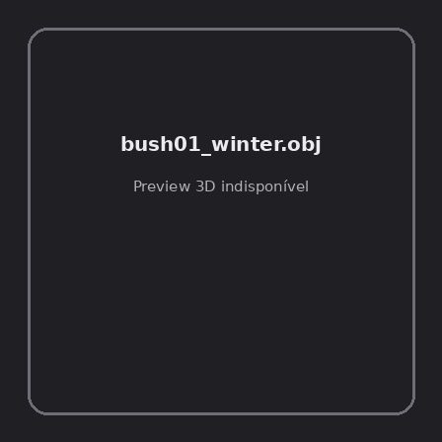
ID | NOV-004521
Origem | Asset novo
Pack/Fonte | retro_nature_pack
Categoria | Nature / Models
Arquivo | bush01_winter.obj
Caminho | 00_Packs_Raw/retro_nature_pack/models/OBJ/bushes/bush01_winter.obj
Formato | OBJ
Tamanho | 3.58 KB
SHA-256 | bca99e8abff1c008a558…
Status técnico | ERROR
Licença | MISSING_REVIEW_REQUIRED — sem evidência localizada
Objetos / meshes | N/D / N/D
Vértices | N/D
Faces / triângulos | N/D / N/D
Materiais | N/D —
UV sets / vertex colors | N/D / N/D
Dimensões XYZ | N/D
Rig / armatures / bones | N/D / N/D / N/D
Skinned meshes | N/D
Animações | N/D —
Duração total clips | N/D
Root motion detectado | N/D
LODs / colliders | Nenhum / Nenhum
Texturas vinculadas | N/D (0 ausentes)
Alertas | Licença/fonte não localizada automaticamente; revisão legal necessária.
Notas | Falha na inspeção 3D: AttributeError: Calling operator "bpy.ops.wm.obj_import" error, could not be found  Traceback (most recent call last):  File "/home/runner/work/PSX_demons_whip/PSX_demons_whip/workspace/demons/tools/asset_catalog/blender_batch.py", line 427, in inspect_task  import_model(path)  File "/home/runner/work/PSX_demons_whip/PSX_demons_whip/workspace/demons/tools/asset_catalog/blender_batch.py", line 59, in import_model  bpy.ops.wm.obj_import(filepath=str(path))  File "/usr/share/blender/scripts/modules/bpy/ops.py", line 132, in __call__  ret = _op_call(self.idname_py(), None, kw)  AttributeError: Calling operator "bpy.ops.wm.obj_import" error, could not be found

NOV-004529 • bush02 [ERROR]
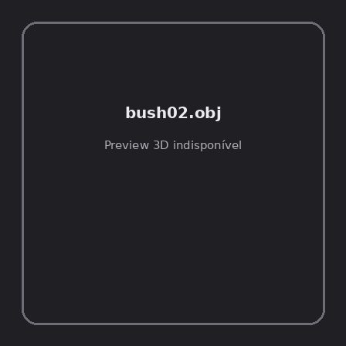
ID | NOV-004529
Origem | Asset novo
Pack/Fonte | retro_nature_pack
Categoria | Nature / Models
Arquivo | bush02.obj
Caminho | 00_Packs_Raw/retro_nature_pack/models/OBJ/bushes/bush02.obj
Formato | OBJ
Tamanho | 23.20 KB
SHA-256 | 505ad92f827c6a2e5eb0…
Status técnico | ERROR
Licença | MISSING_REVIEW_REQUIRED — sem evidência localizada
Objetos / meshes | N/D / N/D
Vértices | N/D
Faces / triângulos | N/D / N/D
Materiais | N/D —
UV sets / vertex colors | N/D / N/D
Dimensões XYZ | N/D
Rig / armatures / bones | N/D / N/D / N/D
Skinned meshes | N/D
Animações | N/D —
Duração total clips | N/D
Root motion detectado | N/D
LODs / colliders | Nenhum / Nenhum
Texturas vinculadas | N/D (0 ausentes)
Alertas | Licença/fonte não localizada automaticamente; revisão legal necessária.
Notas | Falha na inspeção 3D: AttributeError: Calling operator "bpy.ops.wm.obj_import" error, could not be found  Traceback (most recent call last):  File "/home/runner/work/PSX_demons_whip/PSX_demons_whip/workspace/demons/tools/asset_catalog/blender_batch.py", line 427, in inspect_task  import_model(path)  File "/home/runner/work/PSX_demons_whip/PSX_demons_whip/workspace/demons/tools/asset_catalog/blender_batch.py", line 59, in import_model  bpy.ops.wm.obj_import(filepath=str(path))  File "/usr/share/blender/scripts/modules/bpy/ops.py", line 132, in __call__  ret = _op_call(self.idname_py(), None, kw)  AttributeError: Calling operator "bpy.ops.wm.obj_import" error, could not be found

NOV-004520 • bush02_winter [ERROR]
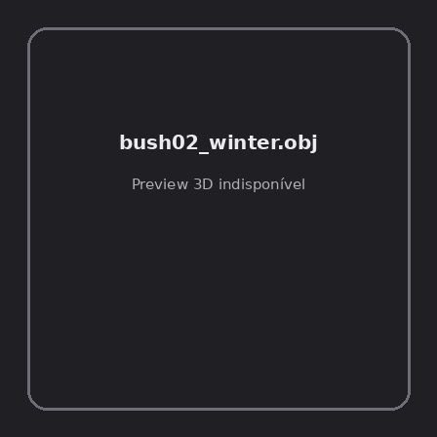
ID | NOV-004520
Origem | Asset novo
Pack/Fonte | retro_nature_pack
Categoria | Nature / Models
Arquivo | bush02_winter.obj
Caminho | 00_Packs_Raw/retro_nature_pack/models/OBJ/bushes/bush02_winter.obj
Formato | OBJ
Tamanho | 2.84 KB
SHA-256 | 7c47d34cfd8ad54d2eb0…
Status técnico | ERROR
Licença | MISSING_REVIEW_REQUIRED — sem evidência localizada
Objetos / meshes | N/D / N/D
Vértices | N/D
Faces / triângulos | N/D / N/D
Materiais | N/D —
UV sets / vertex colors | N/D / N/D
Dimensões XYZ | N/D
Rig / armatures / bones | N/D / N/D / N/D
Skinned meshes | N/D
Animações | N/D —
Duração total clips | N/D
Root motion detectado | N/D
LODs / colliders | Nenhum / Nenhum
Texturas vinculadas | N/D (0 ausentes)
Alertas | Licença/fonte não localizada automaticamente; revisão legal necessária.
Notas | Falha na inspeção 3D: AttributeError: Calling operator "bpy.ops.wm.obj_import" error, could not be found  Traceback (most recent call last):  File "/home/runner/work/PSX_demons_whip/PSX_demons_whip/workspace/demons/tools/asset_catalog/blender_batch.py", line 427, in inspect_task  import_model(path)  File "/home/runner/work/PSX_demons_whip/PSX_demons_whip/workspace/demons/tools/asset_catalog/blender_batch.py", line 59, in import_model  bpy.ops.wm.obj_import(filepath=str(path))  File "/usr/share/blender/scripts/modules/bpy/ops.py", line 132, in __call__  ret = _op_call(self.idname_py(), None, kw)  AttributeError: Calling operator "bpy.ops.wm.obj_import" error, could not be found

NOV-004530 • bush03 [ERROR]
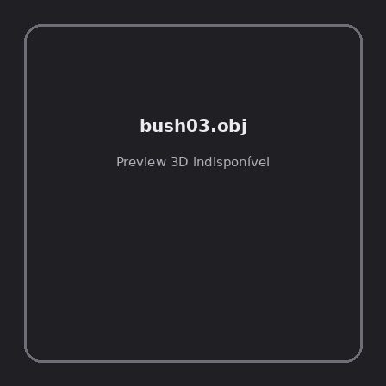
ID | NOV-004530
Origem | Asset novo
Pack/Fonte | retro_nature_pack
Categoria | Nature / Models
Arquivo | bush03.obj
Caminho | 00_Packs_Raw/retro_nature_pack/models/OBJ/bushes/bush03.obj
Formato | OBJ
Tamanho | 21.96 KB
SHA-256 | bd73e46fee6212a4b854…
Status técnico | ERROR
Licença | MISSING_REVIEW_REQUIRED — sem evidência localizada
Objetos / meshes | N/D / N/D
Vértices | N/D
Faces / triângulos | N/D / N/D
Materiais | N/D —
UV sets / vertex colors | N/D / N/D
Dimensões XYZ | N/D
Rig / armatures / bones | N/D / N/D / N/D
Skinned meshes | N/D
Animações | N/D —
Duração total clips | N/D
Root motion detectado | N/D
LODs / colliders | Nenhum / Nenhum
Texturas vinculadas | N/D (0 ausentes)
Alertas | Licença/fonte não localizada automaticamente; revisão legal necessária.
Notas | Falha na inspeção 3D: AttributeError: Calling operator "bpy.ops.wm.obj_import" error, could not be found  Traceback (most recent call last):  File "/home/runner/work/PSX_demons_whip/PSX_demons_whip/workspace/demons/tools/asset_catalog/blender_batch.py", line 427, in inspect_task  import_model(path)  File "/home/runner/work/PSX_demons_whip/PSX_demons_whip/workspace/demons/tools/asset_catalog/blender_batch.py", line 59, in import_model  bpy.ops.wm.obj_import(filepath=str(path))  File "/usr/share/blender/scripts/modules/bpy/ops.py", line 132, in __call__  ret = _op_call(self.idname_py(), None, kw)  AttributeError: Calling operator "bpy.ops.wm.obj_import" error, could not be found

NOV-004522 • bush03_winter [ERROR]
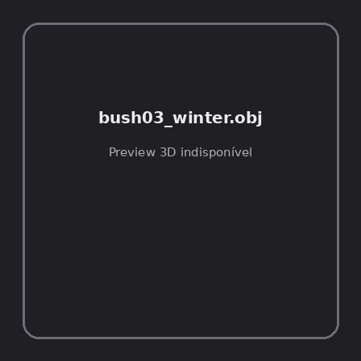
ID | NOV-004522
Origem | Asset novo
Pack/Fonte | retro_nature_pack
Categoria | Nature / Models
Arquivo | bush03_winter.obj
Caminho | 00_Packs_Raw/retro_nature_pack/models/OBJ/bushes/bush03_winter.obj
Formato | OBJ
Tamanho | 2.19 KB
SHA-256 | 8506361d38a7598aeb1a…
Status técnico | ERROR
Licença | MISSING_REVIEW_REQUIRED — sem evidência localizada
Objetos / meshes | N/D / N/D
Vértices | N/D
Faces / triângulos | N/D / N/D
Materiais | N/D —
UV sets / vertex colors | N/D / N/D
Dimensões XYZ | N/D
Rig / armatures / bones | N/D / N/D / N/D
Skinned meshes | N/D
Animações | N/D —
Duração total clips | N/D
Root motion detectado | N/D
LODs / colliders | Nenhum / Nenhum
Texturas vinculadas | N/D (0 ausentes)
Alertas | Licença/fonte não localizada automaticamente; revisão legal necessária.
Notas | Falha na inspeção 3D: AttributeError: Calling operator "bpy.ops.wm.obj_import" error, could not be found  Traceback (most recent call last):  File "/home/runner/work/PSX_demons_whip/PSX_demons_whip/workspace/demons/tools/asset_catalog/blender_batch.py", line 427, in inspect_task  import_model(path)  File "/home/runner/work/PSX_demons_whip/PSX_demons_whip/workspace/demons/tools/asset_catalog/blender_batch.py", line 59, in import_model  bpy.ops.wm.obj_import(filepath=str(path))  File "/usr/share/blender/scripts/modules/bpy/ops.py", line 132, in __call__  ret = _op_call(self.idname_py(), None, kw)  AttributeError: Calling operator "bpy.ops.wm.obj_import" error, could not be found

NOV-004524 • bush04 [ERROR]
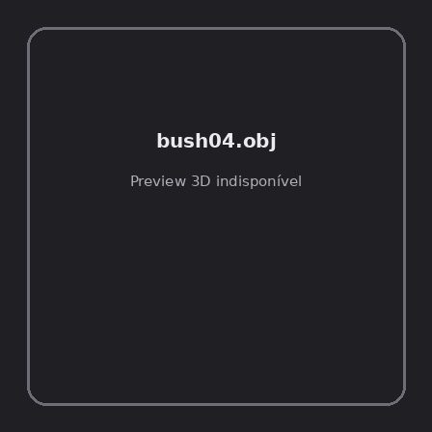
ID | NOV-004524
Origem | Asset novo
Pack/Fonte | retro_nature_pack
Categoria | Nature / Models
Arquivo | bush04.obj
Caminho | 00_Packs_Raw/retro_nature_pack/models/OBJ/bushes/bush04.obj
Formato | OBJ
Tamanho | 23.40 KB
SHA-256 | dd89f439a2e9d474df27…
Status técnico | ERROR
Licença | MISSING_REVIEW_REQUIRED — sem evidência localizada
Objetos / meshes | N/D / N/D
Vértices | N/D
Faces / triângulos | N/D / N/D
Materiais | N/D —
UV sets / vertex colors | N/D / N/D
Dimensões XYZ | N/D
Rig / armatures / bones | N/D / N/D / N/D
Skinned meshes | N/D
Animações | N/D —
Duração total clips | N/D
Root motion detectado | N/D
LODs / colliders | Nenhum / Nenhum
Texturas vinculadas | N/D (0 ausentes)
Alertas | Licença/fonte não localizada automaticamente; revisão legal necessária.
Notas | Falha na inspeção 3D: AttributeError: Calling operator "bpy.ops.wm.obj_import" error, could not be found  Traceback (most recent call last):  File "/home/runner/work/PSX_demons_whip/PSX_demons_whip/workspace/demons/tools/asset_catalog/blender_batch.py", line 427, in inspect_task  import_model(path)  File "/home/runner/work/PSX_demons_whip/PSX_demons_whip/workspace/demons/tools/asset_catalog/blender_batch.py", line 59, in import_model  bpy.ops.wm.obj_import(filepath=str(path))  File "/usr/share/blender/scripts/modules/bpy/ops.py", line 132, in __call__  ret = _op_call(self.idname_py(), None, kw)  AttributeError: Calling operator "bpy.ops.wm.obj_import" error, could not be found

NOV-004526 • bush04_winter [ERROR]
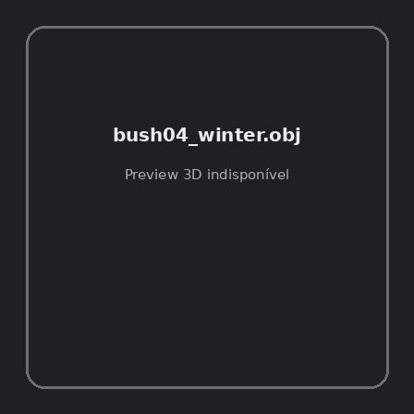
ID | NOV-004526
Origem | Asset novo
Pack/Fonte | retro_nature_pack
Categoria | Nature / Models
Arquivo | bush04_winter.obj
Caminho | 00_Packs_Raw/retro_nature_pack/models/OBJ/bushes/bush04_winter.obj
Formato | OBJ
Tamanho | 2.32 KB
SHA-256 | f9738fe20baefd7636d9…
Status técnico | ERROR
Licença | MISSING_REVIEW_REQUIRED — sem evidência localizada
Objetos / meshes | N/D / N/D
Vértices | N/D
Faces / triângulos | N/D / N/D
Materiais | N/D —
UV sets / vertex colors | N/D / N/D
Dimensões XYZ | N/D
Rig / armatures / bones | N/D / N/D / N/D
Skinned meshes | N/D
Animações | N/D —
Duração total clips | N/D
Root motion detectado | N/D
LODs / colliders | Nenhum / Nenhum
Texturas vinculadas | N/D (0 ausentes)
Alertas | Licença/fonte não localizada automaticamente; revisão legal necessária.
Notas | Falha na inspeção 3D: AttributeError: Calling operator "bpy.ops.wm.obj_import" error, could not be found  Traceback (most recent call last):  File "/home/runner/work/PSX_demons_whip/PSX_demons_whip/workspace/demons/tools/asset_catalog/blender_batch.py", line 427, in inspect_task  import_model(path)  File "/home/runner/work/PSX_demons_whip/PSX_demons_whip/workspace/demons/tools/asset_catalog/blender_batch.py", line 59, in import_model  bpy.ops.wm.obj_import(filepath=str(path))  File "/usr/share/blender/scripts/modules/bpy/ops.py", line 132, in __call__  ret = _op_call(self.idname_py(), None, kw)  AttributeError: Calling operator "bpy.ops.wm.obj_import" error, could not be found

NOV-004527 • bush05 [ERROR]
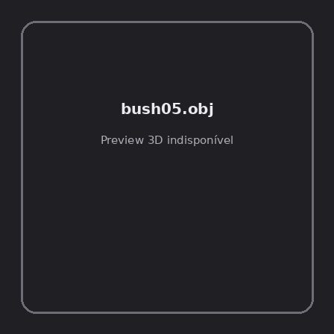
ID | NOV-004527
Origem | Asset novo
Pack/Fonte | retro_nature_pack
Categoria | Nature / Models
Arquivo | bush05.obj
Caminho | 00_Packs_Raw/retro_nature_pack/models/OBJ/bushes/bush05.obj
Formato | OBJ
Tamanho | 23.64 KB
SHA-256 | 3639e75ff38aefd2f6ff…
Status técnico | ERROR
Licença | MISSING_REVIEW_REQUIRED — sem evidência localizada
Objetos / meshes | N/D / N/D
Vértices | N/D
Faces / triângulos | N/D / N/D
Materiais | N/D —
UV sets / vertex colors | N/D / N/D
Dimensões XYZ | N/D
Rig / armatures / bones | N/D / N/D / N/D
Skinned meshes | N/D
Animações | N/D —
Duração total clips | N/D
Root motion detectado | N/D
LODs / colliders | Nenhum / Nenhum
Texturas vinculadas | N/D (0 ausentes)
Alertas | Licença/fonte não localizada automaticamente; revisão legal necessária.
Notas | Falha na inspeção 3D: AttributeError: Calling operator "bpy.ops.wm.obj_import" error, could not be found  Traceback (most recent call last):  File "/home/runner/work/PSX_demons_whip/PSX_demons_whip/workspace/demons/tools/asset_catalog/blender_batch.py", line 427, in inspect_task  import_model(path)  File "/home/runner/work/PSX_demons_whip/PSX_demons_whip/workspace/demons/tools/asset_catalog/blender_batch.py", line 59, in import_model  bpy.ops.wm.obj_import(filepath=str(path))  File "/usr/share/blender/scripts/modules/bpy/ops.py", line 132, in __call__  ret = _op_call(self.idname_py(), None, kw)  AttributeError: Calling operator "bpy.ops.wm.obj_import" error, could not be found

NOV-004525 • bush05_winter [ERROR]
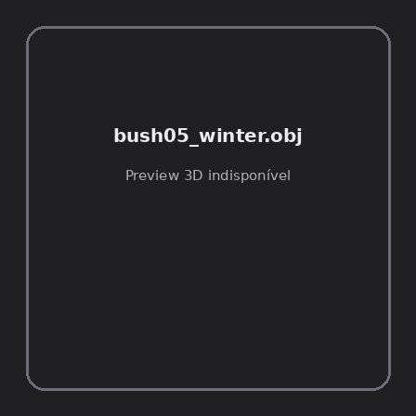
ID | NOV-004525
Origem | Asset novo
Pack/Fonte | retro_nature_pack
Categoria | Nature / Models
Arquivo | bush05_winter.obj
Caminho | 00_Packs_Raw/retro_nature_pack/models/OBJ/bushes/bush05_winter.obj
Formato | OBJ
Tamanho | 3.56 KB
SHA-256 | a0e5e8929d4d9b56f8d5…
Status técnico | ERROR
Licença | MISSING_REVIEW_REQUIRED — sem evidência localizada
Objetos / meshes | N/D / N/D
Vértices | N/D
Faces / triângulos | N/D / N/D
Materiais | N/D —
UV sets / vertex colors | N/D / N/D
Dimensões XYZ | N/D
Rig / armatures / bones | N/D / N/D / N/D
Skinned meshes | N/D
Animações | N/D —
Duração total clips | N/D
Root motion detectado | N/D
LODs / colliders | Nenhum / Nenhum
Texturas vinculadas | N/D (0 ausentes)
Alertas | Licença/fonte não localizada automaticamente; revisão legal necessária.
Notas | Falha na inspeção 3D: AttributeError: Calling operator "bpy.ops.wm.obj_import" error, could not be found  Traceback (most recent call last):  File "/home/runner/work/PSX_demons_whip/PSX_demons_whip/workspace/demons/tools/asset_catalog/blender_batch.py", line 427, in inspect_task  import_model(path)  File "/home/runner/work/PSX_demons_whip/PSX_demons_whip/workspace/demons/tools/asset_catalog/blender_batch.py", line 59, in import_model  bpy.ops.wm.obj_import(filepath=str(path))  File "/usr/share/blender/scripts/modules/bpy/ops.py", line 132, in __call__  ret = _op_call(self.idname_py(), None, kw)  AttributeError: Calling operator "bpy.ops.wm.obj_import" error, could not be found

NOV-004519 • bush06 [ERROR]
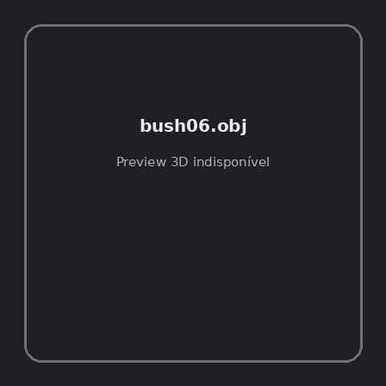
ID | NOV-004519
Origem | Asset novo
Pack/Fonte | retro_nature_pack
Categoria | Nature / Models
Arquivo | bush06.obj
Caminho | 00_Packs_Raw/retro_nature_pack/models/OBJ/bushes/bush06.obj
Formato | OBJ
Tamanho | 23.19 KB
SHA-256 | 965ac9c40d73c2bb3038…
Status técnico | ERROR
Licença | MISSING_REVIEW_REQUIRED — sem evidência localizada
Objetos / meshes | N/D / N/D
Vértices | N/D
Faces / triângulos | N/D / N/D
Materiais | N/D —
UV sets / vertex colors | N/D / N/D
Dimensões XYZ | N/D
Rig / armatures / bones | N/D / N/D / N/D
Skinned meshes | N/D
Animações | N/D —
Duração total clips | N/D
Root motion detectado | N/D
LODs / colliders | Nenhum / Nenhum
Texturas vinculadas | N/D (0 ausentes)
Alertas | Licença/fonte não localizada automaticamente; revisão legal necessária.
Notas | Falha na inspeção 3D: AttributeError: Calling operator "bpy.ops.wm.obj_import" error, could not be found  Traceback (most recent call last):  File "/home/runner/work/PSX_demons_whip/PSX_demons_whip/workspace/demons/tools/asset_catalog/blender_batch.py", line 427, in inspect_task  import_model(path)  File "/home/runner/work/PSX_demons_whip/PSX_demons_whip/workspace/demons/tools/asset_catalog/blender_batch.py", line 59, in import_model  bpy.ops.wm.obj_import(filepath=str(path))  File "/usr/share/blender/scripts/modules/bpy/ops.py", line 132, in __call__  ret = _op_call(self.idname_py(), None, kw)  AttributeError: Calling operator "bpy.ops.wm.obj_import" error, could not be found

NOV-004531 • bush06_winter [ERROR]
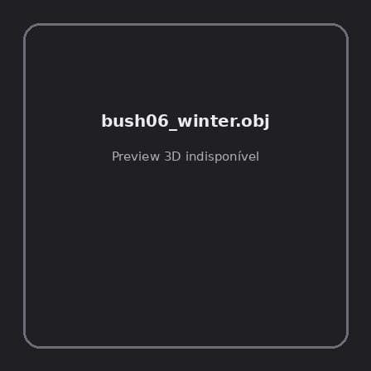
ID | NOV-004531
Origem | Asset novo
Pack/Fonte | retro_nature_pack
Categoria | Nature / Models
Arquivo | bush06_winter.obj
Caminho | 00_Packs_Raw/retro_nature_pack/models/OBJ/bushes/bush06_winter.obj
Formato | OBJ
Tamanho | 2.32 KB
SHA-256 | 900b86c2707b883946c6…
Status técnico | ERROR
Licença | MISSING_REVIEW_REQUIRED — sem evidência localizada
Objetos / meshes | N/D / N/D
Vértices | N/D
Faces / triângulos | N/D / N/D
Materiais | N/D —
UV sets / vertex colors | N/D / N/D
Dimensões XYZ | N/D
Rig / armatures / bones | N/D / N/D / N/D
Skinned meshes | N/D
Animações | N/D —
Duração total clips | N/D
Root motion detectado | N/D
LODs / colliders | Nenhum / Nenhum
Texturas vinculadas | N/D (0 ausentes)
Alertas | Licença/fonte não localizada automaticamente; revisão legal necessária.
Notas | Falha na inspeção 3D: AttributeError: Calling operator "bpy.ops.wm.obj_import" error, could not be found  Traceback (most recent call last):  File "/home/runner/work/PSX_demons_whip/PSX_demons_whip/workspace/demons/tools/asset_catalog/blender_batch.py", line 427, in inspect_task  import_model(path)  File "/home/runner/work/PSX_demons_whip/PSX_demons_whip/workspace/demons/tools/asset_catalog/blender_batch.py", line 59, in import_model  bpy.ops.wm.obj_import(filepath=str(path))  File "/usr/share/blender/scripts/modules/bpy/ops.py", line 132, in __call__  ret = _op_call(self.idname_py(), None, kw)  AttributeError: Calling operator "bpy.ops.wm.obj_import" error, could not be found

NOV-004532 • bush07 [ERROR]
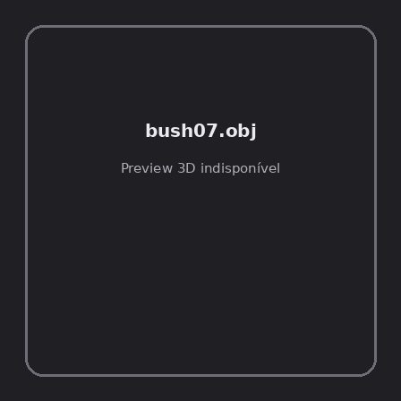
ID | NOV-004532
Origem | Asset novo
Pack/Fonte | retro_nature_pack
Categoria | Nature / Models
Arquivo | bush07.obj
Caminho | 00_Packs_Raw/retro_nature_pack/models/OBJ/bushes/bush07.obj
Formato | OBJ
Tamanho | 23.27 KB
SHA-256 | d9c3a5158cf238563f0f…
Status técnico | ERROR
Licença | MISSING_REVIEW_REQUIRED — sem evidência localizada
Objetos / meshes | N/D / N/D
Vértices | N/D
Faces / triângulos | N/D / N/D
Materiais | N/D —
UV sets / vertex colors | N/D / N/D
Dimensões XYZ | N/D
Rig / armatures / bones | N/D / N/D / N/D
Skinned meshes | N/D
Animações | N/D —
Duração total clips | N/D
Root motion detectado | N/D
LODs / colliders | Nenhum / Nenhum
Texturas vinculadas | N/D (0 ausentes)
Alertas | Licença/fonte não localizada automaticamente; revisão legal necessária.
Notas | Falha na inspeção 3D: AttributeError: Calling operator "bpy.ops.wm.obj_import" error, could not be found  Traceback (most recent call last):  File "/home/runner/work/PSX_demons_whip/PSX_demons_whip/workspace/demons/tools/asset_catalog/blender_batch.py", line 427, in inspect_task  import_model(path)  File "/home/runner/work/PSX_demons_whip/PSX_demons_whip/workspace/demons/tools/asset_catalog/blender_batch.py", line 59, in import_model  bpy.ops.wm.obj_import(filepath=str(path))  File "/usr/share/blender/scripts/modules/bpy/ops.py", line 132, in __call__  ret = _op_call(self.idname_py(), None, kw)  AttributeError: Calling operator "bpy.ops.wm.obj_import" error, could not be found

NOV-004528 • bush08 [ERROR]
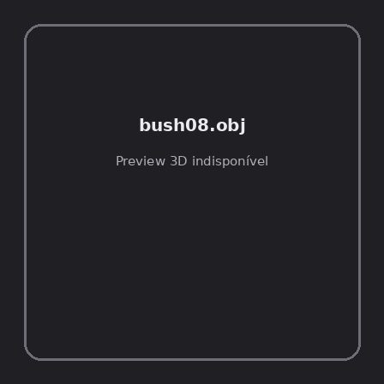
ID | NOV-004528
Origem | Asset novo
Pack/Fonte | retro_nature_pack
Categoria | Nature / Models
Arquivo | bush08.obj
Caminho | 00_Packs_Raw/retro_nature_pack/models/OBJ/bushes/bush08.obj
Formato | OBJ
Tamanho | 24.05 KB
SHA-256 | 8f22023b4cc82ecd841c…
Status técnico | ERROR
Licença | MISSING_REVIEW_REQUIRED — sem evidência localizada
Objetos / meshes | N/D / N/D
Vértices | N/D
Faces / triângulos | N/D / N/D
Materiais | N/D —
UV sets / vertex colors | N/D / N/D
Dimensões XYZ | N/D
Rig / armatures / bones | N/D / N/D / N/D
Skinned meshes | N/D
Animações | N/D —
Duração total clips | N/D
Root motion detectado | N/D
LODs / colliders | Nenhum / Nenhum
Texturas vinculadas | N/D (0 ausentes)
Alertas | Licença/fonte não localizada automaticamente; revisão legal necessária.
Notas | Falha na inspeção 3D: AttributeError: Calling operator "bpy.ops.wm.obj_import" error, could not be found  Traceback (most recent call last):  File "/home/runner/work/PSX_demons_whip/PSX_demons_whip/workspace/demons/tools/asset_catalog/blender_batch.py", line 427, in inspect_task  import_model(path)  File "/home/runner/work/PSX_demons_whip/PSX_demons_whip/workspace/demons/tools/asset_catalog/blender_batch.py", line 59, in import_model  bpy.ops.wm.obj_import(filepath=str(path))  File "/usr/share/blender/scripts/modules/bpy/ops.py", line 132, in __call__  ret = _op_call(self.idname_py(), None, kw)  AttributeError: Calling operator "bpy.ops.wm.obj_import" error, could not be found

NOV-004554 • grass01 [ERROR]
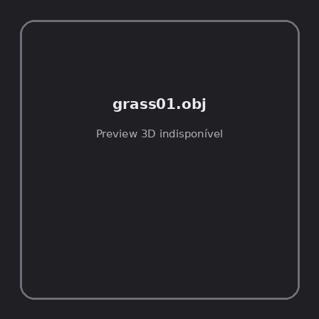
ID | NOV-004554
Origem | Asset novo
Pack/Fonte | retro_nature_pack
Categoria | Nature / Models
Arquivo | grass01.obj
Caminho | 00_Packs_Raw/retro_nature_pack/models/OBJ/grass/grass01.obj
Formato | OBJ
Tamanho | 969 B
SHA-256 | afc1a8200339c4b737f9…
Status técnico | ERROR
Licença | MISSING_REVIEW_REQUIRED — sem evidência localizada
Objetos / meshes | N/D / N/D
Vértices | N/D
Faces / triângulos | N/D / N/D
Materiais | N/D —
UV sets / vertex colors | N/D / N/D
Dimensões XYZ | N/D
Rig / armatures / bones | N/D / N/D / N/D
Skinned meshes | N/D
Animações | N/D —
Duração total clips | N/D
Root motion detectado | N/D
LODs / colliders | Nenhum / Nenhum
Texturas vinculadas | N/D (0 ausentes)
Alertas | Licença/fonte não localizada automaticamente; revisão legal necessária.
Notas | Falha na inspeção 3D: AttributeError: Calling operator "bpy.ops.wm.obj_import" error, could not be found  Traceback (most recent call last):  File "/home/runner/work/PSX_demons_whip/PSX_demons_whip/workspace/demons/tools/asset_catalog/blender_batch.py", line 427, in inspect_task  import_model(path)  File "/home/runner/work/PSX_demons_whip/PSX_demons_whip/workspace/demons/tools/asset_catalog/blender_batch.py", line 59, in import_model  bpy.ops.wm.obj_import(filepath=str(path))  File "/usr/share/blender/scripts/modules/bpy/ops.py", line 132, in __call__  ret = _op_call(self.idname_py(), None, kw)  AttributeError: Calling operator "bpy.ops.wm.obj_import" error, could not be found

NOV-004553 • grass02 [ERROR]
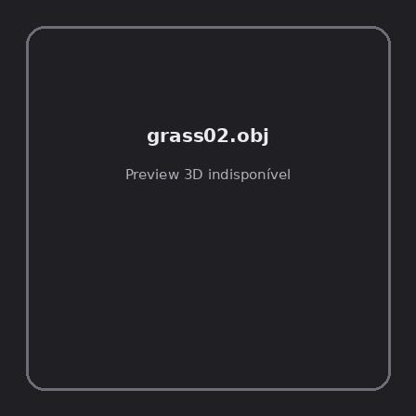
ID | NOV-004553
Origem | Asset novo
Pack/Fonte | retro_nature_pack
Categoria | Nature / Models
Arquivo | grass02.obj
Caminho | 00_Packs_Raw/retro_nature_pack/models/OBJ/grass/grass02.obj
Formato | OBJ
Tamanho | 970 B
SHA-256 | d91af41d754d095f9142…
Status técnico | ERROR
Licença | MISSING_REVIEW_REQUIRED — sem evidência localizada
Objetos / meshes | N/D / N/D
Vértices | N/D
Faces / triângulos | N/D / N/D
Materiais | N/D —
UV sets / vertex colors | N/D / N/D
Dimensões XYZ | N/D
Rig / armatures / bones | N/D / N/D / N/D
Skinned meshes | N/D
Animações | N/D —
Duração total clips | N/D
Root motion detectado | N/D
LODs / colliders | Nenhum / Nenhum
Texturas vinculadas | N/D (0 ausentes)
Alertas | Licença/fonte não localizada automaticamente; revisão legal necessária.
Notas | Falha na inspeção 3D: AttributeError: Calling operator "bpy.ops.wm.obj_import" error, could not be found  Traceback (most recent call last):  File "/home/runner/work/PSX_demons_whip/PSX_demons_whip/workspace/demons/tools/asset_catalog/blender_batch.py", line 427, in inspect_task  import_model(path)  File "/home/runner/work/PSX_demons_whip/PSX_demons_whip/workspace/demons/tools/asset_catalog/blender_batch.py", line 59, in import_model  bpy.ops.wm.obj_import(filepath=str(path))  File "/usr/share/blender/scripts/modules/bpy/ops.py", line 132, in __call__  ret = _op_call(self.idname_py(), None, kw)  AttributeError: Calling operator "bpy.ops.wm.obj_import" error, could not be found

NOV-004548 • grass03 [ERROR]
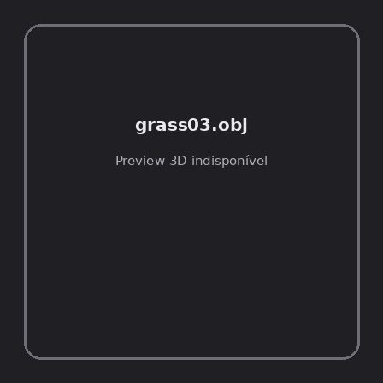
ID | NOV-004548
Origem | Asset novo
Pack/Fonte | retro_nature_pack
Categoria | Nature / Models
Arquivo | grass03.obj
Caminho | 00_Packs_Raw/retro_nature_pack/models/OBJ/grass/grass03.obj
Formato | OBJ
Tamanho | 973 B
SHA-256 | 5b57f1ddec26c768352f…
Status técnico | ERROR
Licença | MISSING_REVIEW_REQUIRED — sem evidência localizada
Objetos / meshes | N/D / N/D
Vértices | N/D
Faces / triângulos | N/D / N/D
Materiais | N/D —
UV sets / vertex colors | N/D / N/D
Dimensões XYZ | N/D
Rig / armatures / bones | N/D / N/D / N/D
Skinned meshes | N/D
Animações | N/D —
Duração total clips | N/D
Root motion detectado | N/D
LODs / colliders | Nenhum / Nenhum
Texturas vinculadas | N/D (0 ausentes)
Alertas | Licença/fonte não localizada automaticamente; revisão legal necessária.
Notas | Falha na inspeção 3D: AttributeError: Calling operator "bpy.ops.wm.obj_import" error, could not be found  Traceback (most recent call last):  File "/home/runner/work/PSX_demons_whip/PSX_demons_whip/workspace/demons/tools/asset_catalog/blender_batch.py", line 427, in inspect_task  import_model(path)  File "/home/runner/work/PSX_demons_whip/PSX_demons_whip/workspace/demons/tools/asset_catalog/blender_batch.py", line 59, in import_model  bpy.ops.wm.obj_import(filepath=str(path))  File "/usr/share/blender/scripts/modules/bpy/ops.py", line 132, in __call__  ret = _op_call(self.idname_py(), None, kw)  AttributeError: Calling operator "bpy.ops.wm.obj_import" error, could not be found

NOV-004550 • grass04 [ERROR]
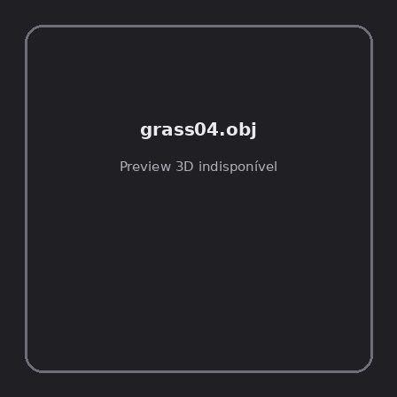
ID | NOV-004550
Origem | Asset novo
Pack/Fonte | retro_nature_pack
Categoria | Nature / Models
Arquivo | grass04.obj
Caminho | 00_Packs_Raw/retro_nature_pack/models/OBJ/grass/grass04.obj
Formato | OBJ
Tamanho | 974 B
SHA-256 | 2a32bd7636dc4e50f29e…
Status técnico | ERROR
Licença | MISSING_REVIEW_REQUIRED — sem evidência localizada
Objetos / meshes | N/D / N/D
Vértices | N/D
Faces / triângulos | N/D / N/D
Materiais | N/D —
UV sets / vertex colors | N/D / N/D
Dimensões XYZ | N/D
Rig / armatures / bones | N/D / N/D / N/D
Skinned meshes | N/D
Animações | N/D —
Duração total clips | N/D
Root motion detectado | N/D
LODs / colliders | Nenhum / Nenhum
Texturas vinculadas | N/D (0 ausentes)
Alertas | Licença/fonte não localizada automaticamente; revisão legal necessária.
Notas | Falha na inspeção 3D: AttributeError: Calling operator "bpy.ops.wm.obj_import" error, could not be found  Traceback (most recent call last):  File "/home/runner/work/PSX_demons_whip/PSX_demons_whip/workspace/demons/tools/asset_catalog/blender_batch.py", line 427, in inspect_task  import_model(path)  File "/home/runner/work/PSX_demons_whip/PSX_demons_whip/workspace/demons/tools/asset_catalog/blender_batch.py", line 59, in import_model  bpy.ops.wm.obj_import(filepath=str(path))  File "/usr/share/blender/scripts/modules/bpy/ops.py", line 132, in __call__  ret = _op_call(self.idname_py(), None, kw)  AttributeError: Calling operator "bpy.ops.wm.obj_import" error, could not be found

NOV-004556 • grass05 [ERROR]
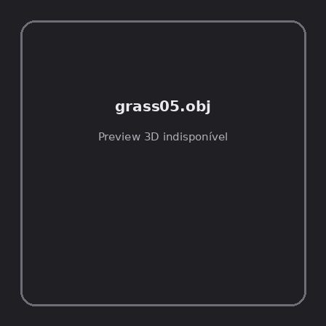
ID | NOV-004556
Origem | Asset novo
Pack/Fonte | retro_nature_pack
Categoria | Nature / Models
Arquivo | grass05.obj
Caminho | 00_Packs_Raw/retro_nature_pack/models/OBJ/grass/grass05.obj
Formato | OBJ
Tamanho | 971 B
SHA-256 | f2e6ac371e0d1fa161af…
Status técnico | ERROR
Licença | MISSING_REVIEW_REQUIRED — sem evidência localizada
Objetos / meshes | N/D / N/D
Vértices | N/D
Faces / triângulos | N/D / N/D
Materiais | N/D —
UV sets / vertex colors | N/D / N/D
Dimensões XYZ | N/D
Rig / armatures / bones | N/D / N/D / N/D
Skinned meshes | N/D
Animações | N/D —
Duração total clips | N/D
Root motion detectado | N/D
LODs / colliders | Nenhum / Nenhum
Texturas vinculadas | N/D (0 ausentes)
Alertas | Licença/fonte não localizada automaticamente; revisão legal necessária.
Notas | Falha na inspeção 3D: AttributeError: Calling operator "bpy.ops.wm.obj_import" error, could not be found  Traceback (most recent call last):  File "/home/runner/work/PSX_demons_whip/PSX_demons_whip/workspace/demons/tools/asset_catalog/blender_batch.py", line 427, in inspect_task  import_model(path)  File "/home/runner/work/PSX_demons_whip/PSX_demons_whip/workspace/demons/tools/asset_catalog/blender_batch.py", line 59, in import_model  bpy.ops.wm.obj_import(filepath=str(path))  File "/usr/share/blender/scripts/modules/bpy/ops.py", line 132, in __call__  ret = _op_call(self.idname_py(), None, kw)  AttributeError: Calling operator "bpy.ops.wm.obj_import" error, could not be found

NOV-004552 • grass06 [ERROR]
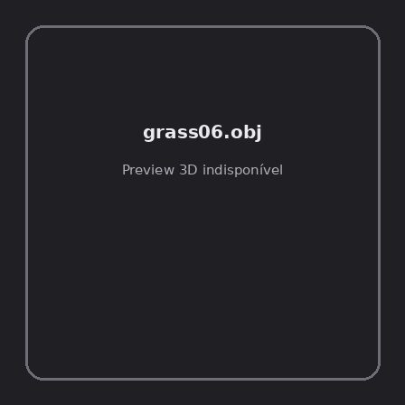
ID | NOV-004552
Origem | Asset novo
Pack/Fonte | retro_nature_pack
Categoria | Nature / Models
Arquivo | grass06.obj
Caminho | 00_Packs_Raw/retro_nature_pack/models/OBJ/grass/grass06.obj
Formato | OBJ
Tamanho | 971 B
SHA-256 | 97a98c1d5aec5b126d31…
Status técnico | ERROR
Licença | MISSING_REVIEW_REQUIRED — sem evidência localizada
Objetos / meshes | N/D / N/D
Vértices | N/D
Faces / triângulos | N/D / N/D
Materiais | N/D —
UV sets / vertex colors | N/D / N/D
Dimensões XYZ | N/D
Rig / armatures / bones | N/D / N/D / N/D
Skinned meshes | N/D
Animações | N/D —
Duração total clips | N/D
Root motion detectado | N/D
LODs / colliders | Nenhum / Nenhum
Texturas vinculadas | N/D (0 ausentes)
Alertas | Licença/fonte não localizada automaticamente; revisão legal necessária.
Notas | Falha na inspeção 3D: AttributeError: Calling operator "bpy.ops.wm.obj_import" error, could not be found  Traceback (most recent call last):  File "/home/runner/work/PSX_demons_whip/PSX_demons_whip/workspace/demons/tools/asset_catalog/blender_batch.py", line 427, in inspect_task  import_model(path)  File "/home/runner/work/PSX_demons_whip/PSX_demons_whip/workspace/demons/tools/asset_catalog/blender_batch.py", line 59, in import_model  bpy.ops.wm.obj_import(filepath=str(path))  File "/usr/share/blender/scripts/modules/bpy/ops.py", line 132, in __call__  ret = _op_call(self.idname_py(), None, kw)  AttributeError: Calling operator "bpy.ops.wm.obj_import" error, could not be found

NOV-004549 • grass07 [ERROR]
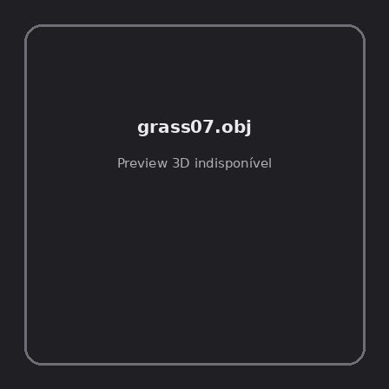
ID | NOV-004549
Origem | Asset novo
Pack/Fonte | retro_nature_pack
Categoria | Nature / Models
Arquivo | grass07.obj
Caminho | 00_Packs_Raw/retro_nature_pack/models/OBJ/grass/grass07.obj
Formato | OBJ
Tamanho | 976 B
SHA-256 | 69e223412d480b08e40a…
Status técnico | ERROR
Licença | MISSING_REVIEW_REQUIRED — sem evidência localizada
Objetos / meshes | N/D / N/D
Vértices | N/D
Faces / triângulos | N/D / N/D
Materiais | N/D —
UV sets / vertex colors | N/D / N/D
Dimensões XYZ | N/D
Rig / armatures / bones | N/D / N/D / N/D
Skinned meshes | N/D
Animações | N/D —
Duração total clips | N/D
Root motion detectado | N/D
LODs / colliders | Nenhum / Nenhum
Texturas vinculadas | N/D (0 ausentes)
Alertas | Licença/fonte não localizada automaticamente; revisão legal necessária.
Notas | Falha na inspeção 3D: AttributeError: Calling operator "bpy.ops.wm.obj_import" error, could not be found  Traceback (most recent call last):  File "/home/runner/work/PSX_demons_whip/PSX_demons_whip/workspace/demons/tools/asset_catalog/blender_batch.py", line 427, in inspect_task  import_model(path)  File "/home/runner/work/PSX_demons_whip/PSX_demons_whip/workspace/demons/tools/asset_catalog/blender_batch.py", line 59, in import_model  bpy.ops.wm.obj_import(filepath=str(path))  File "/usr/share/blender/scripts/modules/bpy/ops.py", line 132, in __call__  ret = _op_call(self.idname_py(), None, kw)  AttributeError: Calling operator "bpy.ops.wm.obj_import" error, could not be found

NOV-004557 • grass08 [ERROR]
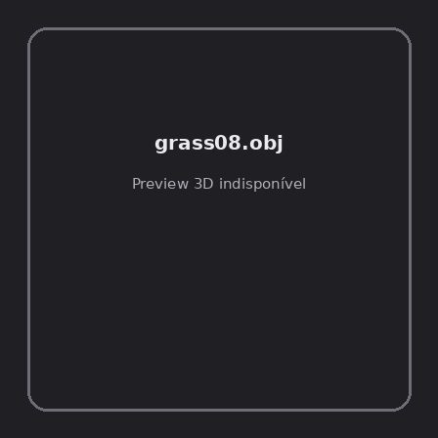
ID | NOV-004557
Origem | Asset novo
Pack/Fonte | retro_nature_pack
Categoria | Nature / Models
Arquivo | grass08.obj
Caminho | 00_Packs_Raw/retro_nature_pack/models/OBJ/grass/grass08.obj
Formato | OBJ
Tamanho | 969 B
SHA-256 | b9ef70f89d20cd4f419c…
Status técnico | ERROR
Licença | MISSING_REVIEW_REQUIRED — sem evidência localizada
Objetos / meshes | N/D / N/D
Vértices | N/D
Faces / triângulos | N/D / N/D
Materiais | N/D —
UV sets / vertex colors | N/D / N/D
Dimensões XYZ | N/D
Rig / armatures / bones | N/D / N/D / N/D
Skinned meshes | N/D
Animações | N/D —
Duração total clips | N/D
Root motion detectado | N/D
LODs / colliders | Nenhum / Nenhum
Texturas vinculadas | N/D (0 ausentes)
Alertas | Licença/fonte não localizada automaticamente; revisão legal necessária.
Notas | Falha na inspeção 3D: AttributeError: Calling operator "bpy.ops.wm.obj_import" error, could not be found  Traceback (most recent call last):  File "/home/runner/work/PSX_demons_whip/PSX_demons_whip/workspace/demons/tools/asset_catalog/blender_batch.py", line 427, in inspect_task  import_model(path)  File "/home/runner/work/PSX_demons_whip/PSX_demons_whip/workspace/demons/tools/asset_catalog/blender_batch.py", line 59, in import_model  bpy.ops.wm.obj_import(filepath=str(path))  File "/usr/share/blender/scripts/modules/bpy/ops.py", line 132, in __call__  ret = _op_call(self.idname_py(), None, kw)  AttributeError: Calling operator "bpy.ops.wm.obj_import" error, could not be found

NOV-004547 • grass09 [ERROR]
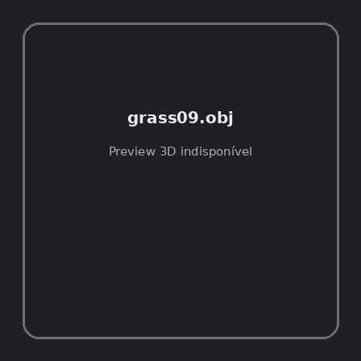
ID | NOV-004547
Origem | Asset novo
Pack/Fonte | retro_nature_pack
Categoria | Nature / Models
Arquivo | grass09.obj
Caminho | 00_Packs_Raw/retro_nature_pack/models/OBJ/grass/grass09.obj
Formato | OBJ
Tamanho | 907 B
SHA-256 | aedbd713ef17e98e4c44…
Status técnico | ERROR
Licença | MISSING_REVIEW_REQUIRED — sem evidência localizada
Objetos / meshes | N/D / N/D
Vértices | N/D
Faces / triângulos | N/D / N/D
Materiais | N/D —
UV sets / vertex colors | N/D / N/D
Dimensões XYZ | N/D
Rig / armatures / bones | N/D / N/D / N/D
Skinned meshes | N/D
Animações | N/D —
Duração total clips | N/D
Root motion detectado | N/D
LODs / colliders | Nenhum / Nenhum
Texturas vinculadas | N/D (0 ausentes)
Alertas | Licença/fonte não localizada automaticamente; revisão legal necessária.
Notas | Falha na inspeção 3D: AttributeError: Calling operator "bpy.ops.wm.obj_import" error, could not be found  Traceback (most recent call last):  File "/home/runner/work/PSX_demons_whip/PSX_demons_whip/workspace/demons/tools/asset_catalog/blender_batch.py", line 427, in inspect_task  import_model(path)  File "/home/runner/work/PSX_demons_whip/PSX_demons_whip/workspace/demons/tools/asset_catalog/blender_batch.py", line 59, in import_model  bpy.ops.wm.obj_import(filepath=str(path))  File "/usr/share/blender/scripts/modules/bpy/ops.py", line 132, in __call__  ret = _op_call(self.idname_py(), None, kw)  AttributeError: Calling operator "bpy.ops.wm.obj_import" error, could not be found

NOV-004558 • grass_bush [ERROR]

ID | NOV-004558
Origem | Asset novo
Pack/Fonte | retro_nature_pack
Categoria | Nature / Models
Arquivo | grass_bush.obj
Caminho | 00_Packs_Raw/retro_nature_pack/models/OBJ/grass/grass_bush.obj
Formato | OBJ
Tamanho | 5.10 KB
SHA-256 | 936bf1c80c7b881dd454…
Status técnico | ERROR
Licença | MISSING_REVIEW_REQUIRED — sem evidência localizada
Objetos / meshes | N/D / N/D
Vértices | N/D
Faces / triângulos | N/D / N/D
Materiais | N/D —
UV sets / vertex colors | N/D / N/D
Dimensões XYZ | N/D
Rig / armatures / bones | N/D / N/D / N/D
Skinned meshes | N/D
Animações | N/D —
Duração total clips | N/D
Root motion detectado | N/D
LODs / colliders | Nenhum / Nenhum
Texturas vinculadas | N/D (0 ausentes)
Alertas | Licença/fonte não localizada automaticamente; revisão legal necessária.
Notas | Falha na inspeção 3D: AttributeError: Calling operator "bpy.ops.wm.obj_import" error, could not be found  Traceback (most recent call last):  File "/home/runner/work/PSX_demons_whip/PSX_demons_whip/workspace/demons/tools/asset_catalog/blender_batch.py", line 427, in inspect_task  import_model(path)  File "/home/runner/work/PSX_demons_whip/PSX_demons_whip/workspace/demons/tools/asset_catalog/blender_batch.py", line 59, in import_model  bpy.ops.wm.obj_import(filepath=str(path))  File "/usr/share/blender/scripts/modules/bpy/ops.py", line 132, in __call__  ret = _op_call(self.idname_py(), None, kw)  AttributeError: Calling operator "bpy.ops.wm.obj_import" error, could not be found

NOV-004555 • grass_patch [ERROR]
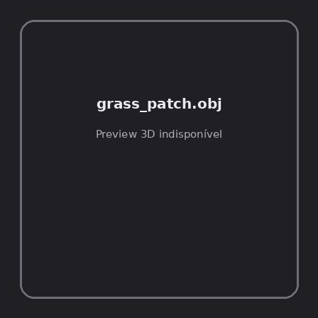
ID | NOV-004555
Origem | Asset novo
Pack/Fonte | retro_nature_pack
Categoria | Nature / Models
Arquivo | grass_patch.obj
Caminho | 00_Packs_Raw/retro_nature_pack/models/OBJ/grass/grass_patch.obj
Formato | OBJ
Tamanho | 23.11 KB
SHA-256 | ca841222c9606901f055…
Status técnico | ERROR
Licença | MISSING_REVIEW_REQUIRED — sem evidência localizada
Objetos / meshes | N/D / N/D
Vértices | N/D
Faces / triângulos | N/D / N/D
Materiais | N/D —
UV sets / vertex colors | N/D / N/D
Dimensões XYZ | N/D
Rig / armatures / bones | N/D / N/D / N/D
Skinned meshes | N/D
Animações | N/D —
Duração total clips | N/D
Root motion detectado | N/D
LODs / colliders | Nenhum / Nenhum
Texturas vinculadas | N/D (0 ausentes)
Alertas | Licença/fonte não localizada automaticamente; revisão legal necessária.
Notas | Falha na inspeção 3D: AttributeError: Calling operator "bpy.ops.wm.obj_import" error, could not be found  Traceback (most recent call last):  File "/home/runner/work/PSX_demons_whip/PSX_demons_whip/workspace/demons/tools/asset_catalog/blender_batch.py", line 427, in inspect_task  import_model(path)  File "/home/runner/work/PSX_demons_whip/PSX_demons_whip/workspace/demons/tools/asset_catalog/blender_batch.py", line 59, in import_model  bpy.ops.wm.obj_import(filepath=str(path))  File "/usr/share/blender/scripts/modules/bpy/ops.py", line 132, in __call__  ret = _op_call(self.idname_py(), None, kw)  AttributeError: Calling operator "bpy.ops.wm.obj_import" error, could not be found

NOV-004551 • grass_patch_corner [ERROR]
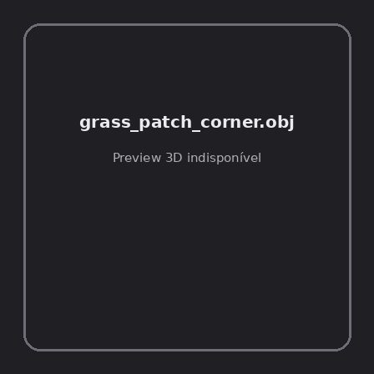
ID | NOV-004551
Origem | Asset novo
Pack/Fonte | retro_nature_pack
Categoria | Nature / Models
Arquivo | grass_patch_corner.obj
Caminho | 00_Packs_Raw/retro_nature_pack/models/OBJ/grass/grass_patch_corner.obj
Formato | OBJ
Tamanho | 23.84 KB
SHA-256 | 0020f81b17e9d605b205…
Status técnico | ERROR
Licença | MISSING_REVIEW_REQUIRED — sem evidência localizada
Objetos / meshes | N/D / N/D
Vértices | N/D
Faces / triângulos | N/D / N/D
Materiais | N/D —
UV sets / vertex colors | N/D / N/D
Dimensões XYZ | N/D
Rig / armatures / bones | N/D / N/D / N/D
Skinned meshes | N/D
Animações | N/D —
Duração total clips | N/D
Root motion detectado | N/D
LODs / colliders | Nenhum / Nenhum
Texturas vinculadas | N/D (0 ausentes)
Alertas | Licença/fonte não localizada automaticamente; revisão legal necessária.
Notas | Falha na inspeção 3D: AttributeError: Calling operator "bpy.ops.wm.obj_import" error, could not be found  Traceback (most recent call last):  File "/home/runner/work/PSX_demons_whip/PSX_demons_whip/workspace/demons/tools/asset_catalog/blender_batch.py", line 427, in inspect_task  import_model(path)  File "/home/runner/work/PSX_demons_whip/PSX_demons_whip/workspace/demons/tools/asset_catalog/blender_batch.py", line 59, in import_model  bpy.ops.wm.obj_import(filepath=str(path))  File "/usr/share/blender/scripts/modules/bpy/ops.py", line 132, in __call__  ret = _op_call(self.idname_py(), None, kw)  AttributeError: Calling operator "bpy.ops.wm.obj_import" error, could not be found

NOV-004542 • tree01 [ERROR]
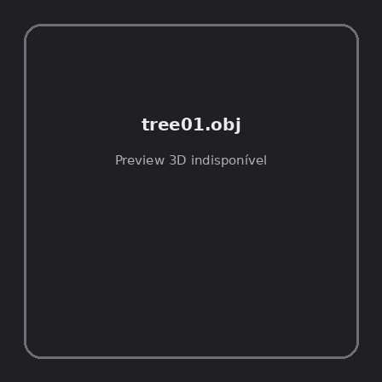
ID | NOV-004542
Origem | Asset novo
Pack/Fonte | retro_nature_pack
Categoria | Nature / Models
Arquivo | tree01.obj
Caminho | 00_Packs_Raw/retro_nature_pack/models/OBJ/trees/tree01.obj
Formato | OBJ
Tamanho | 33.15 KB
SHA-256 | b5170c77c3ab19862ea4…
Status técnico | ERROR
Licença | MISSING_REVIEW_REQUIRED — sem evidência localizada
Objetos / meshes | N/D / N/D
Vértices | N/D
Faces / triângulos | N/D / N/D
Materiais | N/D —
UV sets / vertex colors | N/D / N/D
Dimensões XYZ | N/D
Rig / armatures / bones | N/D / N/D / N/D
Skinned meshes | N/D
Animações | N/D —
Duração total clips | N/D
Root motion detectado | N/D
LODs / colliders | Nenhum / Nenhum
Texturas vinculadas | N/D (0 ausentes)
Alertas | Licença/fonte não localizada automaticamente; revisão legal necessária.
Notas | Falha na inspeção 3D: AttributeError: Calling operator "bpy.ops.wm.obj_import" error, could not be found  Traceback (most recent call last):  File "/home/runner/work/PSX_demons_whip/PSX_demons_whip/workspace/demons/tools/asset_catalog/blender_batch.py", line 427, in inspect_task  import_model(path)  File "/home/runner/work/PSX_demons_whip/PSX_demons_whip/workspace/demons/tools/asset_catalog/blender_batch.py", line 59, in import_model  bpy.ops.wm.obj_import(filepath=str(path))  File "/usr/share/blender/scripts/modules/bpy/ops.py", line 132, in __call__  ret = _op_call(self.idname_py(), None, kw)  AttributeError: Calling operator "bpy.ops.wm.obj_import" error, could not be found

NOV-004539 • tree01_winter [ERROR]
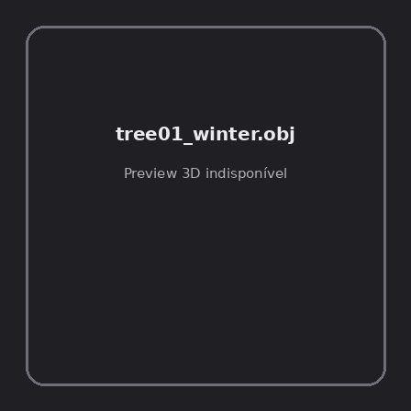
ID | NOV-004539
Origem | Asset novo
Pack/Fonte | retro_nature_pack
Categoria | Nature / Models
Arquivo | tree01_winter.obj
Caminho | 00_Packs_Raw/retro_nature_pack/models/OBJ/trees/tree01_winter.obj
Formato | OBJ
Tamanho | 10.53 KB
SHA-256 | 21cda359a156dc23db72…
Status técnico | ERROR
Licença | MISSING_REVIEW_REQUIRED — sem evidência localizada
Objetos / meshes | N/D / N/D
Vértices | N/D
Faces / triângulos | N/D / N/D
Materiais | N/D —
UV sets / vertex colors | N/D / N/D
Dimensões XYZ | N/D
Rig / armatures / bones | N/D / N/D / N/D
Skinned meshes | N/D
Animações | N/D —
Duração total clips | N/D
Root motion detectado | N/D
LODs / colliders | Nenhum / Nenhum
Texturas vinculadas | N/D (0 ausentes)
Alertas | Licença/fonte não localizada automaticamente; revisão legal necessária.
Notas | Falha na inspeção 3D: AttributeError: Calling operator "bpy.ops.wm.obj_import" error, could not be found  Traceback (most recent call last):  File "/home/runner/work/PSX_demons_whip/PSX_demons_whip/workspace/demons/tools/asset_catalog/blender_batch.py", line 427, in inspect_task  import_model(path)  File "/home/runner/work/PSX_demons_whip/PSX_demons_whip/workspace/demons/tools/asset_catalog/blender_batch.py", line 59, in import_model  bpy.ops.wm.obj_import(filepath=str(path))  File "/usr/share/blender/scripts/modules/bpy/ops.py", line 132, in __call__  ret = _op_call(self.idname_py(), None, kw)  AttributeError: Calling operator "bpy.ops.wm.obj_import" error, could not be found

NOV-004543 • tree02 [ERROR]
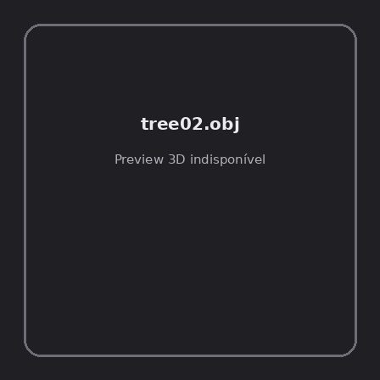
ID | NOV-004543
Origem | Asset novo
Pack/Fonte | retro_nature_pack
Categoria | Nature / Models
Arquivo | tree02.obj
Caminho | 00_Packs_Raw/retro_nature_pack/models/OBJ/trees/tree02.obj
Formato | OBJ
Tamanho | 30.87 KB
SHA-256 | b448cb3a0648ef13b472…
Status técnico | ERROR
Licença | MISSING_REVIEW_REQUIRED — sem evidência localizada
Objetos / meshes | N/D / N/D
Vértices | N/D
Faces / triângulos | N/D / N/D
Materiais | N/D —
UV sets / vertex colors | N/D / N/D
Dimensões XYZ | N/D
Rig / armatures / bones | N/D / N/D / N/D
Skinned meshes | N/D
Animações | N/D —
Duração total clips | N/D
Root motion detectado | N/D
LODs / colliders | Nenhum / Nenhum
Texturas vinculadas | N/D (0 ausentes)
Alertas | Licença/fonte não localizada automaticamente; revisão legal necessária.
Notas | Falha na inspeção 3D: AttributeError: Calling operator "bpy.ops.wm.obj_import" error, could not be found  Traceback (most recent call last):  File "/home/runner/work/PSX_demons_whip/PSX_demons_whip/workspace/demons/tools/asset_catalog/blender_batch.py", line 427, in inspect_task  import_model(path)  File "/home/runner/work/PSX_demons_whip/PSX_demons_whip/workspace/demons/tools/asset_catalog/blender_batch.py", line 59, in import_model  bpy.ops.wm.obj_import(filepath=str(path))  File "/usr/share/blender/scripts/modules/bpy/ops.py", line 132, in __call__  ret = _op_call(self.idname_py(), None, kw)  AttributeError: Calling operator "bpy.ops.wm.obj_import" error, could not be found

NOV-004541 • tree02_winter [ERROR]
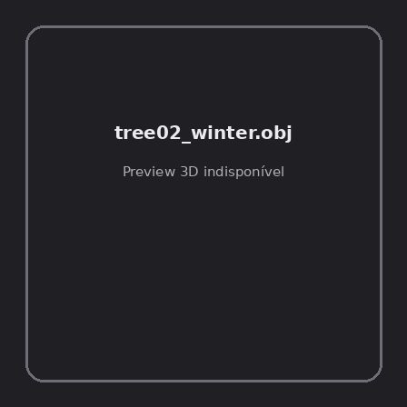
ID | NOV-004541
Origem | Asset novo
Pack/Fonte | retro_nature_pack
Categoria | Nature / Models
Arquivo | tree02_winter.obj
Caminho | 00_Packs_Raw/retro_nature_pack/models/OBJ/trees/tree02_winter.obj
Formato | OBJ
Tamanho | 10.97 KB
SHA-256 | f57cf1193ff30913b94c…
Status técnico | ERROR
Licença | MISSING_REVIEW_REQUIRED — sem evidência localizada
Objetos / meshes | N/D / N/D
Vértices | N/D
Faces / triângulos | N/D / N/D
Materiais | N/D —
UV sets / vertex colors | N/D / N/D
Dimensões XYZ | N/D
Rig / armatures / bones | N/D / N/D / N/D
Skinned meshes | N/D
Animações | N/D —
Duração total clips | N/D
Root motion detectado | N/D
LODs / colliders | Nenhum / Nenhum
Texturas vinculadas | N/D (0 ausentes)
Alertas | Licença/fonte não localizada automaticamente; revisão legal necessária.
Notas | Falha na inspeção 3D: AttributeError: Calling operator "bpy.ops.wm.obj_import" error, could not be found  Traceback (most recent call last):  File "/home/runner/work/PSX_demons_whip/PSX_demons_whip/workspace/demons/tools/asset_catalog/blender_batch.py", line 427, in inspect_task  import_model(path)  File "/home/runner/work/PSX_demons_whip/PSX_demons_whip/workspace/demons/tools/asset_catalog/blender_batch.py", line 59, in import_model  bpy.ops.wm.obj_import(filepath=str(path))  File "/usr/share/blender/scripts/modules/bpy/ops.py", line 132, in __call__  ret = _op_call(self.idname_py(), None, kw)  AttributeError: Calling operator "bpy.ops.wm.obj_import" error, could not be found

NOV-004545 • tree03 [ERROR]
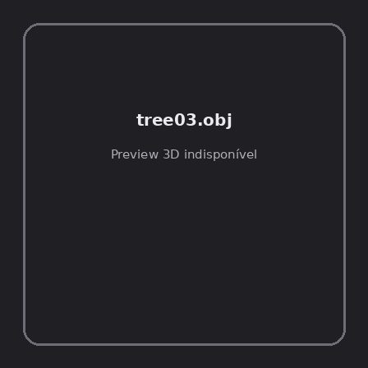
ID | NOV-004545
Origem | Asset novo
Pack/Fonte | retro_nature_pack
Categoria | Nature / Models
Arquivo | tree03.obj
Caminho | 00_Packs_Raw/retro_nature_pack/models/OBJ/trees/tree03.obj
Formato | OBJ
Tamanho | 34.24 KB
SHA-256 | 4f1e093e7750a3793727…
Status técnico | ERROR
Licença | MISSING_REVIEW_REQUIRED — sem evidência localizada
Objetos / meshes | N/D / N/D
Vértices | N/D
Faces / triângulos | N/D / N/D
Materiais | N/D —
UV sets / vertex colors | N/D / N/D
Dimensões XYZ | N/D
Rig / armatures / bones | N/D / N/D / N/D
Skinned meshes | N/D
Animações | N/D —
Duração total clips | N/D
Root motion detectado | N/D
LODs / colliders | Nenhum / Nenhum
Texturas vinculadas | N/D (0 ausentes)
Alertas | Licença/fonte não localizada automaticamente; revisão legal necessária.
Notas | Falha na inspeção 3D: AttributeError: Calling operator "bpy.ops.wm.obj_import" error, could not be found  Traceback (most recent call last):  File "/home/runner/work/PSX_demons_whip/PSX_demons_whip/workspace/demons/tools/asset_catalog/blender_batch.py", line 427, in inspect_task  import_model(path)  File "/home/runner/work/PSX_demons_whip/PSX_demons_whip/workspace/demons/tools/asset_catalog/blender_batch.py", line 59, in import_model  bpy.ops.wm.obj_import(filepath=str(path))  File "/usr/share/blender/scripts/modules/bpy/ops.py", line 132, in __call__  ret = _op_call(self.idname_py(), None, kw)  AttributeError: Calling operator "bpy.ops.wm.obj_import" error, could not be found

NOV-004540 • tree03_winter [ERROR]
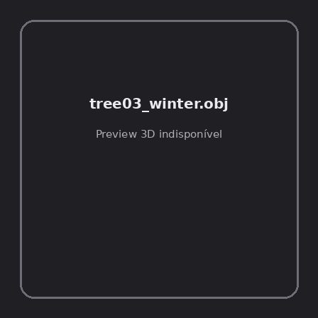
ID | NOV-004540
Origem | Asset novo
Pack/Fonte | retro_nature_pack
Categoria | Nature / Models
Arquivo | tree03_winter.obj
Caminho | 00_Packs_Raw/retro_nature_pack/models/OBJ/trees/tree03_winter.obj
Formato | OBJ
Tamanho | 10.88 KB
SHA-256 | fbdd2c9b1b9132c73f29…
Status técnico | ERROR
Licença | MISSING_REVIEW_REQUIRED — sem evidência localizada
Objetos / meshes | N/D / N/D
Vértices | N/D
Faces / triângulos | N/D / N/D
Materiais | N/D —
UV sets / vertex colors | N/D / N/D
Dimensões XYZ | N/D
Rig / armatures / bones | N/D / N/D / N/D
Skinned meshes | N/D
Animações | N/D —
Duração total clips | N/D
Root motion detectado | N/D
LODs / colliders | Nenhum / Nenhum
Texturas vinculadas | N/D (0 ausentes)
Alertas | Licença/fonte não localizada automaticamente; revisão legal necessária.
Notas | Falha na inspeção 3D: AttributeError: Calling operator "bpy.ops.wm.obj_import" error, could not be found  Traceback (most recent call last):  File "/home/runner/work/PSX_demons_whip/PSX_demons_whip/workspace/demons/tools/asset_catalog/blender_batch.py", line 427, in inspect_task  import_model(path)  File "/home/runner/work/PSX_demons_whip/PSX_demons_whip/workspace/demons/tools/asset_catalog/blender_batch.py", line 59, in import_model  bpy.ops.wm.obj_import(filepath=str(path))  File "/usr/share/blender/scripts/modules/bpy/ops.py", line 132, in __call__  ret = _op_call(self.idname_py(), None, kw)  AttributeError: Calling operator "bpy.ops.wm.obj_import" error, could not be found

NOV-004538 • tree04 [ERROR]
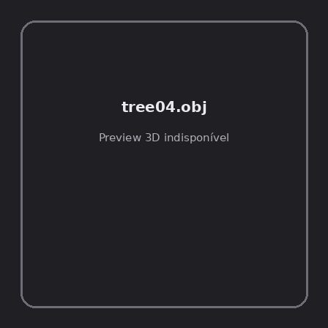
ID | NOV-004538
Origem | Asset novo
Pack/Fonte | retro_nature_pack
Categoria | Nature / Models
Arquivo | tree04.obj
Caminho | 00_Packs_Raw/retro_nature_pack/models/OBJ/trees/tree04.obj
Formato | OBJ
Tamanho | 33.88 KB
SHA-256 | b3faeac003392bcedd95…
Status técnico | ERROR
Licença | MISSING_REVIEW_REQUIRED — sem evidência localizada
Objetos / meshes | N/D / N/D
Vértices | N/D
Faces / triângulos | N/D / N/D
Materiais | N/D —
UV sets / vertex colors | N/D / N/D
Dimensões XYZ | N/D
Rig / armatures / bones | N/D / N/D / N/D
Skinned meshes | N/D
Animações | N/D —
Duração total clips | N/D
Root motion detectado | N/D
LODs / colliders | Nenhum / Nenhum
Texturas vinculadas | N/D (0 ausentes)
Alertas | Licença/fonte não localizada automaticamente; revisão legal necessária.
Notas | Falha na inspeção 3D: AttributeError: Calling operator "bpy.ops.wm.obj_import" error, could not be found  Traceback (most recent call last):  File "/home/runner/work/PSX_demons_whip/PSX_demons_whip/workspace/demons/tools/asset_catalog/blender_batch.py", line 427, in inspect_task  import_model(path)  File "/home/runner/work/PSX_demons_whip/PSX_demons_whip/workspace/demons/tools/asset_catalog/blender_batch.py", line 59, in import_model  bpy.ops.wm.obj_import(filepath=str(path))  File "/usr/share/blender/scripts/modules/bpy/ops.py", line 132, in __call__  ret = _op_call(self.idname_py(), None, kw)  AttributeError: Calling operator "bpy.ops.wm.obj_import" error, could not be found

NOV-004546 • tree04_winter [ERROR]
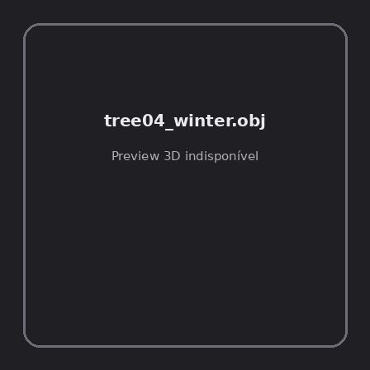
ID | NOV-004546
Origem | Asset novo
Pack/Fonte | retro_nature_pack
Categoria | Nature / Models
Arquivo | tree04_winter.obj
Caminho | 00_Packs_Raw/retro_nature_pack/models/OBJ/trees/tree04_winter.obj
Formato | OBJ
Tamanho | 10.35 KB
SHA-256 | 29ef91daeeee12ff9f41…
Status técnico | ERROR
Licença | MISSING_REVIEW_REQUIRED — sem evidência localizada
Objetos / meshes | N/D / N/D
Vértices | N/D
Faces / triângulos | N/D / N/D
Materiais | N/D —
UV sets / vertex colors | N/D / N/D
Dimensões XYZ | N/D
Rig / armatures / bones | N/D / N/D / N/D
Skinned meshes | N/D
Animações | N/D —
Duração total clips | N/D
Root motion detectado | N/D
LODs / colliders | Nenhum / Nenhum
Texturas vinculadas | N/D (0 ausentes)
Alertas | Licença/fonte não localizada automaticamente; revisão legal necessária.
Notas | Falha na inspeção 3D: AttributeError: Calling operator "bpy.ops.wm.obj_import" error, could not be found  Traceback (most recent call last):  File "/home/runner/work/PSX_demons_whip/PSX_demons_whip/workspace/demons/tools/asset_catalog/blender_batch.py", line 427, in inspect_task  import_model(path)  File "/home/runner/work/PSX_demons_whip/PSX_demons_whip/workspace/demons/tools/asset_catalog/blender_batch.py", line 59, in import_model  bpy.ops.wm.obj_import(filepath=str(path))  File "/usr/share/blender/scripts/modules/bpy/ops.py", line 132, in __call__  ret = _op_call(self.idname_py(), None, kw)  AttributeError: Calling operator "bpy.ops.wm.obj_import" error, could not be found

NOV-004535 • tree05 [ERROR]
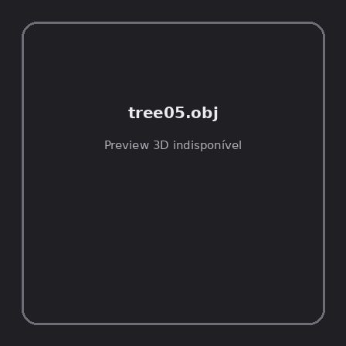
ID | NOV-004535
Origem | Asset novo
Pack/Fonte | retro_nature_pack
Categoria | Nature / Models
Arquivo | tree05.obj
Caminho | 00_Packs_Raw/retro_nature_pack/models/OBJ/trees/tree05.obj
Formato | OBJ
Tamanho | 37.92 KB
SHA-256 | 3554f331d4b04554ab09…
Status técnico | ERROR
Licença | MISSING_REVIEW_REQUIRED — sem evidência localizada
Objetos / meshes | N/D / N/D
Vértices | N/D
Faces / triângulos | N/D / N/D
Materiais | N/D —
UV sets / vertex colors | N/D / N/D
Dimensões XYZ | N/D
Rig / armatures / bones | N/D / N/D / N/D
Skinned meshes | N/D
Animações | N/D —
Duração total clips | N/D
Root motion detectado | N/D
LODs / colliders | Nenhum / Nenhum
Texturas vinculadas | N/D (0 ausentes)
Alertas | Licença/fonte não localizada automaticamente; revisão legal necessária.
Notas | Falha na inspeção 3D: AttributeError: Calling operator "bpy.ops.wm.obj_import" error, could not be found  Traceback (most recent call last):  File "/home/runner/work/PSX_demons_whip/PSX_demons_whip/workspace/demons/tools/asset_catalog/blender_batch.py", line 427, in inspect_task  import_model(path)  File "/home/runner/work/PSX_demons_whip/PSX_demons_whip/workspace/demons/tools/asset_catalog/blender_batch.py", line 59, in import_model  bpy.ops.wm.obj_import(filepath=str(path))  File "/usr/share/blender/scripts/modules/bpy/ops.py", line 132, in __call__  ret = _op_call(self.idname_py(), None, kw)  AttributeError: Calling operator "bpy.ops.wm.obj_import" error, could not be found

NOV-004544 • tree05_winter [ERROR]
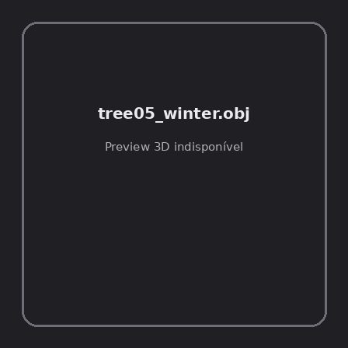
ID | NOV-004544
Origem | Asset novo
Pack/Fonte | retro_nature_pack
Categoria | Nature / Models
Arquivo | tree05_winter.obj
Caminho | 00_Packs_Raw/retro_nature_pack/models/OBJ/trees/tree05_winter.obj
Formato | OBJ
Tamanho | 11.17 KB
SHA-256 | 10d936d2ab7ec78aaf01…
Status técnico | ERROR
Licença | MISSING_REVIEW_REQUIRED — sem evidência localizada
Objetos / meshes | N/D / N/D
Vértices | N/D
Faces / triângulos | N/D / N/D
Materiais | N/D —
UV sets / vertex colors | N/D / N/D
Dimensões XYZ | N/D
Rig / armatures / bones | N/D / N/D / N/D
Skinned meshes | N/D
Animações | N/D —
Duração total clips | N/D
Root motion detectado | N/D
LODs / colliders | Nenhum / Nenhum
Texturas vinculadas | N/D (0 ausentes)
Alertas | Licença/fonte não localizada automaticamente; revisão legal necessária.
Notas | Falha na inspeção 3D: AttributeError: Calling operator "bpy.ops.wm.obj_import" error, could not be found  Traceback (most recent call last):  File "/home/runner/work/PSX_demons_whip/PSX_demons_whip/workspace/demons/tools/asset_catalog/blender_batch.py", line 427, in inspect_task  import_model(path)  File "/home/runner/work/PSX_demons_whip/PSX_demons_whip/workspace/demons/tools/asset_catalog/blender_batch.py", line 59, in import_model  bpy.ops.wm.obj_import(filepath=str(path))  File "/usr/share/blender/scripts/modules/bpy/ops.py", line 132, in __call__  ret = _op_call(self.idname_py(), None, kw)  AttributeError: Calling operator "bpy.ops.wm.obj_import" error, could not be found

NOV-004533 • tree06 [ERROR]
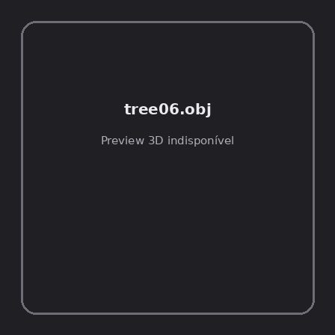
ID | NOV-004533
Origem | Asset novo
Pack/Fonte | retro_nature_pack
Categoria | Nature / Models
Arquivo | tree06.obj
Caminho | 00_Packs_Raw/retro_nature_pack/models/OBJ/trees/tree06.obj
Formato | OBJ
Tamanho | 35.39 KB
SHA-256 | 9b252be5a628074e4f35…
Status técnico | ERROR
Licença | MISSING_REVIEW_REQUIRED — sem evidência localizada
Objetos / meshes | N/D / N/D
Vértices | N/D
Faces / triângulos | N/D / N/D
Materiais | N/D —
UV sets / vertex colors | N/D / N/D
Dimensões XYZ | N/D
Rig / armatures / bones | N/D / N/D / N/D
Skinned meshes | N/D
Animações | N/D —
Duração total clips | N/D
Root motion detectado | N/D
LODs / colliders | Nenhum / Nenhum
Texturas vinculadas | N/D (0 ausentes)
Alertas | Licença/fonte não localizada automaticamente; revisão legal necessária.
Notas | Falha na inspeção 3D: AttributeError: Calling operator "bpy.ops.wm.obj_import" error, could not be found  Traceback (most recent call last):  File "/home/runner/work/PSX_demons_whip/PSX_demons_whip/workspace/demons/tools/asset_catalog/blender_batch.py", line 427, in inspect_task  import_model(path)  File "/home/runner/work/PSX_demons_whip/PSX_demons_whip/workspace/demons/tools/asset_catalog/blender_batch.py", line 59, in import_model  bpy.ops.wm.obj_import(filepath=str(path))  File "/usr/share/blender/scripts/modules/bpy/ops.py", line 132, in __call__  ret = _op_call(self.idname_py(), None, kw)  AttributeError: Calling operator "bpy.ops.wm.obj_import" error, could not be found

NOV-004537 • tree06_winter [ERROR]
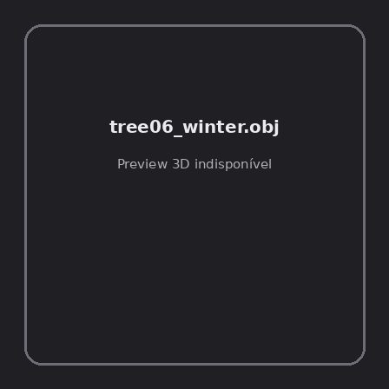
ID | NOV-004537
Origem | Asset novo
Pack/Fonte | retro_nature_pack
Categoria | Nature / Models
Arquivo | tree06_winter.obj
Caminho | 00_Packs_Raw/retro_nature_pack/models/OBJ/trees/tree06_winter.obj
Formato | OBJ
Tamanho | 10.36 KB
SHA-256 | 6010352d3f1626b52ff7…
Status técnico | ERROR
Licença | MISSING_REVIEW_REQUIRED — sem evidência localizada
Objetos / meshes | N/D / N/D
Vértices | N/D
Faces / triângulos | N/D / N/D
Materiais | N/D —
UV sets / vertex colors | N/D / N/D
Dimensões XYZ | N/D
Rig / armatures / bones | N/D / N/D / N/D
Skinned meshes | N/D
Animações | N/D —
Duração total clips | N/D
Root motion detectado | N/D
LODs / colliders | Nenhum / Nenhum
Texturas vinculadas | N/D (0 ausentes)
Alertas | Licença/fonte não localizada automaticamente; revisão legal necessária.
Notas | Falha na inspeção 3D: AttributeError: Calling operator "bpy.ops.wm.obj_import" error, could not be found  Traceback (most recent call last):  File "/home/runner/work/PSX_demons_whip/PSX_demons_whip/workspace/demons/tools/asset_catalog/blender_batch.py", line 427, in inspect_task  import_model(path)  File "/home/runner/work/PSX_demons_whip/PSX_demons_whip/workspace/demons/tools/asset_catalog/blender_batch.py", line 59, in import_model  bpy.ops.wm.obj_import(filepath=str(path))  File "/usr/share/blender/scripts/modules/bpy/ops.py", line 132, in __call__  ret = _op_call(self.idname_py(), None, kw)  AttributeError: Calling operator "bpy.ops.wm.obj_import" error, could not be found

NOV-004534 • tree07 [ERROR]
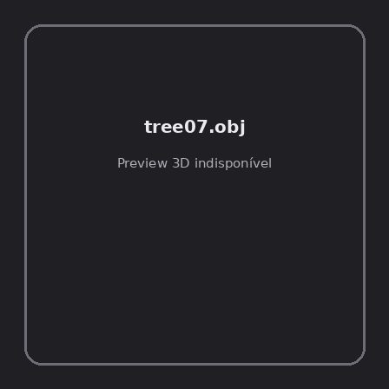
ID | NOV-004534
Origem | Asset novo
Pack/Fonte | retro_nature_pack
Categoria | Nature / Models
Arquivo | tree07.obj
Caminho | 00_Packs_Raw/retro_nature_pack/models/OBJ/trees/tree07.obj
Formato | OBJ
Tamanho | 31.75 KB
SHA-256 | 687d9e20ef1455c971cd…
Status técnico | ERROR
Licença | MISSING_REVIEW_REQUIRED — sem evidência localizada
Objetos / meshes | N/D / N/D
Vértices | N/D
Faces / triângulos | N/D / N/D
Materiais | N/D —
UV sets / vertex colors | N/D / N/D
Dimensões XYZ | N/D
Rig / armatures / bones | N/D / N/D / N/D
Skinned meshes | N/D
Animações | N/D —
Duração total clips | N/D
Root motion detectado | N/D
LODs / colliders | Nenhum / Nenhum
Texturas vinculadas | N/D (0 ausentes)
Alertas | Licença/fonte não localizada automaticamente; revisão legal necessária.
Notas | Falha na inspeção 3D: AttributeError: Calling operator "bpy.ops.wm.obj_import" error, could not be found  Traceback (most recent call last):  File "/home/runner/work/PSX_demons_whip/PSX_demons_whip/workspace/demons/tools/asset_catalog/blender_batch.py", line 427, in inspect_task  import_model(path)  File "/home/runner/work/PSX_demons_whip/PSX_demons_whip/workspace/demons/tools/asset_catalog/blender_batch.py", line 59, in import_model  bpy.ops.wm.obj_import(filepath=str(path))  File "/usr/share/blender/scripts/modules/bpy/ops.py", line 132, in __call__  ret = _op_call(self.idname_py(), None, kw)  AttributeError: Calling operator "bpy.ops.wm.obj_import" error, could not be found

NOV-004536 • tree08 [ERROR]
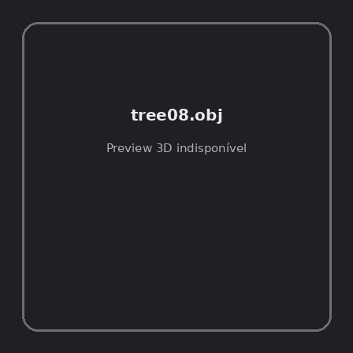
ID | NOV-004536
Origem | Asset novo
Pack/Fonte | retro_nature_pack
Categoria | Nature / Models
Arquivo | tree08.obj
Caminho | 00_Packs_Raw/retro_nature_pack/models/OBJ/trees/tree08.obj
Formato | OBJ
Tamanho | 26.24 KB
SHA-256 | e993c65bcbd7f20188d3…
Status técnico | ERROR
Licença | MISSING_REVIEW_REQUIRED — sem evidência localizada
Objetos / meshes | N/D / N/D
Vértices | N/D
Faces / triângulos | N/D / N/D
Materiais | N/D —
UV sets / vertex colors | N/D / N/D
Dimensões XYZ | N/D
Rig / armatures / bones | N/D / N/D / N/D
Skinned meshes | N/D
Animações | N/D —
Duração total clips | N/D
Root motion detectado | N/D
LODs / colliders | Nenhum / Nenhum
Texturas vinculadas | N/D (0 ausentes)
Alertas | Licença/fonte não localizada automaticamente; revisão legal necessária.
Notas | Falha na inspeção 3D: AttributeError: Calling operator "bpy.ops.wm.obj_import" error, could not be found  Traceback (most recent call last):  File "/home/runner/work/PSX_demons_whip/PSX_demons_whip/workspace/demons/tools/asset_catalog/blender_batch.py", line 427, in inspect_task  import_model(path)  File "/home/runner/work/PSX_demons_whip/PSX_demons_whip/workspace/demons/tools/asset_catalog/blender_batch.py", line 59, in import_model  bpy.ops.wm.obj_import(filepath=str(path))  File "/usr/share/blender/scripts/modules/bpy/ops.py", line 132, in __call__  ret = _op_call(self.idname_py(), None, kw)  AttributeError: Calling operator "bpy.ops.wm.obj_import" error, could not be found

