DEMONS WHIP - NOVO - WEAPONS
MODEL 3D • Volume 2 de 2

Assets neste volume: 48
Origem: NOVO
Gerado em: 2026-08-17T19:05:23+00:00

NOV-005535 • shield_round [ERROR]

ID | NOV-005535
Origem | Asset novo
Pack/Fonte | Assets Organizados - Weapons
Categoria | Weapons / Shield Round.Glb
Arquivo | shield_round.glb
Caminho | 01_Assets_Organizados/Weapons/shield_round.glb
Formato | GLB
Tamanho | 29.72 KB
SHA-256 | 1f184eb71cf5f9bbbc8d…
Status técnico | ERROR
Licença | MISSING_REVIEW_REQUIRED — sem evidência localizada
Objetos / meshes | N/D / N/D
Vértices | N/D
Faces / triângulos | N/D / N/D
Materiais | N/D —
UV sets / vertex colors | N/D / N/D
Dimensões XYZ | N/D
Rig / armatures / bones | N/D / N/D / N/D
Skinned meshes | N/D
Animações | N/D —
Duração total clips | N/D
Root motion detectado | N/D
LODs / colliders | Nenhum / Nenhum
Texturas vinculadas | N/D (0 ausentes)
Alertas | Licença/fonte não localizada automaticamente; revisão legal necessária. | Duplicado exato: grupo DUP-00893 (2 cópias).
Notas | Falha na inspeção 3D: RuntimeError: Error: Python: Traceback (most recent call last):  File "/usr/share/blender/scripts/addons/io_scene_gltf2/__init__.py", line 1064, in execute  return self.import_gltf2(context)  File "/usr/share/blender/scripts/addons/io_scene_gltf2/__init__.py", line 1083, in import_gltf2  return self.unit_import(self.filepath, import_settings)  File "/usr/share/blender/scripts/addons/io_scene_gltf2/__init__.py", line 1088, in unit_import  from .blender.imp.gltf2_blender_gltf import BlenderGlTF  File "/usr/share/blender/scripts/addons/io_scene_gltf2/blender/imp/gltf2_blender_gltf.py", line 17, in <module>  from .gltf2_blender_scene import BlenderScene  File "/usr/share/blender/scripts/addons/io_scene_gltf2/blender/imp/gltf2_blender_scene.py", line 17, in <module>  from .gltf2_blender_node import BlenderNode  File "/usr/share/blender/scripts/addons/io_scene_gltf2/blender/imp/gltf2_blender_node.py", line 18, in <module>  from .gltf2_blender_mesh import BlenderMesh  File "/usr/share/blender/scripts/addons/io_scene_gltf2/blender/imp/gltf2_blender_mesh.py", line 17, in <module>  import numpy as np  ModuleNotFoundError: No module named 'numpy'  location: /usr/share/blender/scripts/modules/bpy/ops.py:132  Traceback (most recent call last):  File "/home/runner/work/PSX_demons_whip/PSX_demons_whip/workspace/demons/tools/asset_catalog/blender_batch.py", line 427, in inspect_task  import_model(path)  File "/home/runner/work/PSX_demons_whip/PSX_demons_whip/workspace/demons/tools/asset_catalog/blender_batch.py", line 52, in import_model  bpy.ops.import_scene.gltf(filepath=str(path))  File "/usr/share/blender/scripts/modules/bpy/ops.py", line 132, in __call__  ret = _op_call(self.idname_py(), None, kw)  RuntimeError: Error: Python: Traceback (most recent call last):  File "/usr/share/blender/scripts/addons/io_scene_gltf2/__init__.py", line 1064, in execute  return self.import_gltf2(context)  File "/usr/share/blender/scripts/addons/io_scene_gltf2/__init__.py", line 1083, in import_gltf2  return self.unit_import(self.filepath, import_settings)  File "/usr/share/blender/scripts/addons/io_scene_gltf2/__init__.py", line 1088, in unit_import  from .blender.imp.gltf2_blender_gltf import BlenderGlTF  File "/usr/share/blender/scripts/addons/io_scene_gltf2/blender/imp/gltf2_blender_gltf.py", line 17, in <module>  from .gltf2_blender_scene import BlenderScene  File "/usr/share/blender/scripts/addons/io_scene_gltf2/blender/imp/gltf2_blender_scene.py", line 17, in <module>  from .gltf2_blender_node import BlenderNode  File "/usr/share/blender/scripts/addons/io_scene_gltf2/blender/imp/gltf2_blender_node.py", line 18, in <module>  from .gltf2_blender_mesh import BlenderMesh  File "/usr/share/blender/scripts/addons/io_scene_gltf2/blender/imp/gltf2_blender_mesh.py", line 17, in <module>  import numpy as np  ModuleNotFoundError: No module named 'numpy'  location: /usr/share/blender/scripts/modules/bpy/ops.py:132  | Metadados 3D reutilizados do duplicado idêntico TEM-002267.

NOV-005495 • shield_square [ERROR]
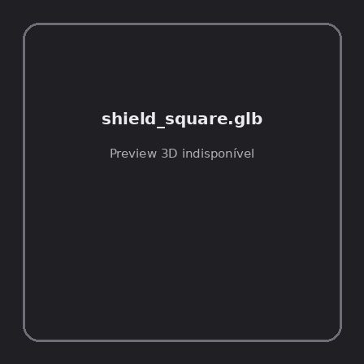
ID | NOV-005495
Origem | Asset novo
Pack/Fonte | Assets Organizados - Weapons
Categoria | Weapons / Shield Square.Glb
Arquivo | shield_square.glb
Caminho | 01_Assets_Organizados/Weapons/shield_square.glb
Formato | GLB
Tamanho | 29.26 KB
SHA-256 | 72b44c7882482f161b6a…
Status técnico | ERROR
Licença | MISSING_REVIEW_REQUIRED — sem evidência localizada
Objetos / meshes | N/D / N/D
Vértices | N/D
Faces / triângulos | N/D / N/D
Materiais | N/D —
UV sets / vertex colors | N/D / N/D
Dimensões XYZ | N/D
Rig / armatures / bones | N/D / N/D / N/D
Skinned meshes | N/D
Animações | N/D —
Duração total clips | N/D
Root motion detectado | N/D
LODs / colliders | Nenhum / Nenhum
Texturas vinculadas | N/D (0 ausentes)
Alertas | Licença/fonte não localizada automaticamente; revisão legal necessária. | Duplicado exato: grupo DUP-00855 (2 cópias).
Notas | Falha na inspeção 3D: RuntimeError: Error: Python: Traceback (most recent call last):  File "/usr/share/blender/scripts/addons/io_scene_gltf2/__init__.py", line 1064, in execute  return self.import_gltf2(context)  File "/usr/share/blender/scripts/addons/io_scene_gltf2/__init__.py", line 1083, in import_gltf2  return self.unit_import(self.filepath, import_settings)  File "/usr/share/blender/scripts/addons/io_scene_gltf2/__init__.py", line 1088, in unit_import  from .blender.imp.gltf2_blender_gltf import BlenderGlTF  File "/usr/share/blender/scripts/addons/io_scene_gltf2/blender/imp/gltf2_blender_gltf.py", line 17, in <module>  from .gltf2_blender_scene import BlenderScene  File "/usr/share/blender/scripts/addons/io_scene_gltf2/blender/imp/gltf2_blender_scene.py", line 17, in <module>  from .gltf2_blender_node import BlenderNode  File "/usr/share/blender/scripts/addons/io_scene_gltf2/blender/imp/gltf2_blender_node.py", line 18, in <module>  from .gltf2_blender_mesh import BlenderMesh  File "/usr/share/blender/scripts/addons/io_scene_gltf2/blender/imp/gltf2_blender_mesh.py", line 17, in <module>  import numpy as np  ModuleNotFoundError: No module named 'numpy'  location: /usr/share/blender/scripts/modules/bpy/ops.py:132  Traceback (most recent call last):  File "/home/runner/work/PSX_demons_whip/PSX_demons_whip/workspace/demons/tools/asset_catalog/blender_batch.py", line 427, in inspect_task  import_model(path)  File "/home/runner/work/PSX_demons_whip/PSX_demons_whip/workspace/demons/tools/asset_catalog/blender_batch.py", line 52, in import_model  bpy.ops.import_scene.gltf(filepath=str(path))  File "/usr/share/blender/scripts/modules/bpy/ops.py", line 132, in __call__  ret = _op_call(self.idname_py(), None, kw)  RuntimeError: Error: Python: Traceback (most recent call last):  File "/usr/share/blender/scripts/addons/io_scene_gltf2/__init__.py", line 1064, in execute  return self.import_gltf2(context)  File "/usr/share/blender/scripts/addons/io_scene_gltf2/__init__.py", line 1083, in import_gltf2  return self.unit_import(self.filepath, import_settings)  File "/usr/share/blender/scripts/addons/io_scene_gltf2/__init__.py", line 1088, in unit_import  from .blender.imp.gltf2_blender_gltf import BlenderGlTF  File "/usr/share/blender/scripts/addons/io_scene_gltf2/blender/imp/gltf2_blender_gltf.py", line 17, in <module>  from .gltf2_blender_scene import BlenderScene  File "/usr/share/blender/scripts/addons/io_scene_gltf2/blender/imp/gltf2_blender_scene.py", line 17, in <module>  from .gltf2_blender_node import BlenderNode  File "/usr/share/blender/scripts/addons/io_scene_gltf2/blender/imp/gltf2_blender_node.py", line 18, in <module>  from .gltf2_blender_mesh import BlenderMesh  File "/usr/share/blender/scripts/addons/io_scene_gltf2/blender/imp/gltf2_blender_mesh.py", line 17, in <module>  import numpy as np  ModuleNotFoundError: No module named 'numpy'  location: /usr/share/blender/scripts/modules/bpy/ops.py:132  | Metadados 3D reutilizados do duplicado idêntico TEM-002229.

NOV-005537 • simple_farmhand_crossbow [ERROR]
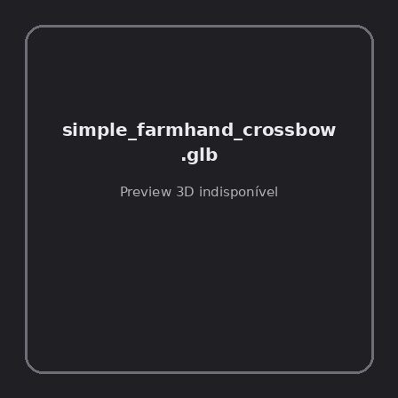
ID | NOV-005537
Origem | Asset novo
Pack/Fonte | Assets Organizados - Weapons
Categoria | Weapons / Simple Farmhand Crossbow.Glb
Arquivo | simple_farmhand_crossbow.glb
Caminho | 01_Assets_Organizados/Weapons/simple_farmhand_crossbow.glb
Formato | GLB
Tamanho | 180.86 KB
SHA-256 | 4b065700be84851f0681…
Status técnico | ERROR
Licença | MISSING_REVIEW_REQUIRED — sem evidência localizada
Objetos / meshes | N/D / N/D
Vértices | N/D
Faces / triângulos | N/D / N/D
Materiais | N/D —
UV sets / vertex colors | N/D / N/D
Dimensões XYZ | N/D
Rig / armatures / bones | N/D / N/D / N/D
Skinned meshes | N/D
Animações | N/D —
Duração total clips | N/D
Root motion detectado | N/D
LODs / colliders | Nenhum / Nenhum
Texturas vinculadas | N/D (0 ausentes)
Alertas | Licença/fonte não localizada automaticamente; revisão legal necessária. | Duplicado exato: grupo DUP-00895 (2 cópias).
Notas | Falha na inspeção 3D: RuntimeError: Error: Python: Traceback (most recent call last):  File "/usr/share/blender/scripts/addons/io_scene_gltf2/__init__.py", line 1064, in execute  return self.import_gltf2(context)  File "/usr/share/blender/scripts/addons/io_scene_gltf2/__init__.py", line 1083, in import_gltf2  return self.unit_import(self.filepath, import_settings)  File "/usr/share/blender/scripts/addons/io_scene_gltf2/__init__.py", line 1088, in unit_import  from .blender.imp.gltf2_blender_gltf import BlenderGlTF  File "/usr/share/blender/scripts/addons/io_scene_gltf2/blender/imp/gltf2_blender_gltf.py", line 17, in <module>  from .gltf2_blender_scene import BlenderScene  File "/usr/share/blender/scripts/addons/io_scene_gltf2/blender/imp/gltf2_blender_scene.py", line 17, in <module>  from .gltf2_blender_node import BlenderNode  File "/usr/share/blender/scripts/addons/io_scene_gltf2/blender/imp/gltf2_blender_node.py", line 18, in <module>  from .gltf2_blender_mesh import BlenderMesh  File "/usr/share/blender/scripts/addons/io_scene_gltf2/blender/imp/gltf2_blender_mesh.py", line 17, in <module>  import numpy as np  ModuleNotFoundError: No module named 'numpy'  location: /usr/share/blender/scripts/modules/bpy/ops.py:132  Traceback (most recent call last):  File "/home/runner/work/PSX_demons_whip/PSX_demons_whip/workspace/demons/tools/asset_catalog/blender_batch.py", line 427, in inspect_task  import_model(path)  File "/home/runner/work/PSX_demons_whip/PSX_demons_whip/workspace/demons/tools/asset_catalog/blender_batch.py", line 52, in import_model  bpy.ops.import_scene.gltf(filepath=str(path))  File "/usr/share/blender/scripts/modules/bpy/ops.py", line 132, in __call__  ret = _op_call(self.idname_py(), None, kw)  RuntimeError: Error: Python: Traceback (most recent call last):  File "/usr/share/blender/scripts/addons/io_scene_gltf2/__init__.py", line 1064, in execute  return self.import_gltf2(context)  File "/usr/share/blender/scripts/addons/io_scene_gltf2/__init__.py", line 1083, in import_gltf2  return self.unit_import(self.filepath, import_settings)  File "/usr/share/blender/scripts/addons/io_scene_gltf2/__init__.py", line 1088, in unit_import  from .blender.imp.gltf2_blender_gltf import BlenderGlTF  File "/usr/share/blender/scripts/addons/io_scene_gltf2/blender/imp/gltf2_blender_gltf.py", line 17, in <module>  from .gltf2_blender_scene import BlenderScene  File "/usr/share/blender/scripts/addons/io_scene_gltf2/blender/imp/gltf2_blender_scene.py", line 17, in <module>  from .gltf2_blender_node import BlenderNode  File "/usr/share/blender/scripts/addons/io_scene_gltf2/blender/imp/gltf2_blender_node.py", line 18, in <module>  from .gltf2_blender_mesh import BlenderMesh  File "/usr/share/blender/scripts/addons/io_scene_gltf2/blender/imp/gltf2_blender_mesh.py", line 17, in <module>  import numpy as np  ModuleNotFoundError: No module named 'numpy'  location: /usr/share/blender/scripts/modules/bpy/ops.py:132  | Metadados 3D reutilizados do duplicado idêntico TEM-002269.

NOV-005439 • skeleton_axe [ERROR]
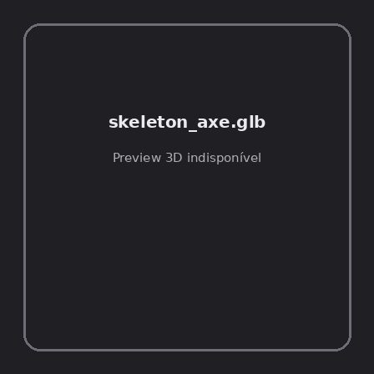
ID | NOV-005439
Origem | Asset novo
Pack/Fonte | Assets Organizados - Weapons
Categoria | Weapons / Skeleton Axe.Glb
Arquivo | skeleton_axe.glb
Caminho | 01_Assets_Organizados/Weapons/skeleton_axe.glb
Formato | GLB
Tamanho | 37.57 KB
SHA-256 | 887b4defc1f8c3e6f64f…
Status técnico | ERROR
Licença | MISSING_REVIEW_REQUIRED — sem evidência localizada
Objetos / meshes | N/D / N/D
Vértices | N/D
Faces / triângulos | N/D / N/D
Materiais | N/D —
UV sets / vertex colors | N/D / N/D
Dimensões XYZ | N/D
Rig / armatures / bones | N/D / N/D / N/D
Skinned meshes | N/D
Animações | N/D —
Duração total clips | N/D
Root motion detectado | N/D
LODs / colliders | Nenhum / Nenhum
Texturas vinculadas | N/D (0 ausentes)
Alertas | Licença/fonte não localizada automaticamente; revisão legal necessária. | Duplicado exato: grupo DUP-00799 (2 cópias).
Notas | Falha na inspeção 3D: RuntimeError: Error: Python: Traceback (most recent call last):  File "/usr/share/blender/scripts/addons/io_scene_gltf2/__init__.py", line 1064, in execute  return self.import_gltf2(context)  File "/usr/share/blender/scripts/addons/io_scene_gltf2/__init__.py", line 1083, in import_gltf2  return self.unit_import(self.filepath, import_settings)  File "/usr/share/blender/scripts/addons/io_scene_gltf2/__init__.py", line 1088, in unit_import  from .blender.imp.gltf2_blender_gltf import BlenderGlTF  File "/usr/share/blender/scripts/addons/io_scene_gltf2/blender/imp/gltf2_blender_gltf.py", line 17, in <module>  from .gltf2_blender_scene import BlenderScene  File "/usr/share/blender/scripts/addons/io_scene_gltf2/blender/imp/gltf2_blender_scene.py", line 17, in <module>  from .gltf2_blender_node import BlenderNode  File "/usr/share/blender/scripts/addons/io_scene_gltf2/blender/imp/gltf2_blender_node.py", line 18, in <module>  from .gltf2_blender_mesh import BlenderMesh  File "/usr/share/blender/scripts/addons/io_scene_gltf2/blender/imp/gltf2_blender_mesh.py", line 17, in <module>  import numpy as np  ModuleNotFoundError: No module named 'numpy'  location: /usr/share/blender/scripts/modules/bpy/ops.py:132  Traceback (most recent call last):  File "/home/runner/work/PSX_demons_whip/PSX_demons_whip/workspace/demons/tools/asset_catalog/blender_batch.py", line 427, in inspect_task  import_model(path)  File "/home/runner/work/PSX_demons_whip/PSX_demons_whip/workspace/demons/tools/asset_catalog/blender_batch.py", line 52, in import_model  bpy.ops.import_scene.gltf(filepath=str(path))  File "/usr/share/blender/scripts/modules/bpy/ops.py", line 132, in __call__  ret = _op_call(self.idname_py(), None, kw)  RuntimeError: Error: Python: Traceback (most recent call last):  File "/usr/share/blender/scripts/addons/io_scene_gltf2/__init__.py", line 1064, in execute  return self.import_gltf2(context)  File "/usr/share/blender/scripts/addons/io_scene_gltf2/__init__.py", line 1083, in import_gltf2  return self.unit_import(self.filepath, import_settings)  File "/usr/share/blender/scripts/addons/io_scene_gltf2/__init__.py", line 1088, in unit_import  from .blender.imp.gltf2_blender_gltf import BlenderGlTF  File "/usr/share/blender/scripts/addons/io_scene_gltf2/blender/imp/gltf2_blender_gltf.py", line 17, in <module>  from .gltf2_blender_scene import BlenderScene  File "/usr/share/blender/scripts/addons/io_scene_gltf2/blender/imp/gltf2_blender_scene.py", line 17, in <module>  from .gltf2_blender_node import BlenderNode  File "/usr/share/blender/scripts/addons/io_scene_gltf2/blender/imp/gltf2_blender_node.py", line 18, in <module>  from .gltf2_blender_mesh import BlenderMesh  File "/usr/share/blender/scripts/addons/io_scene_gltf2/blender/imp/gltf2_blender_mesh.py", line 17, in <module>  import numpy as np  ModuleNotFoundError: No module named 'numpy'  location: /usr/share/blender/scripts/modules/bpy/ops.py:132  | Metadados 3D reutilizados do duplicado idêntico TEM-002173.

NOV-005469 • skeleton_blade [ERROR]
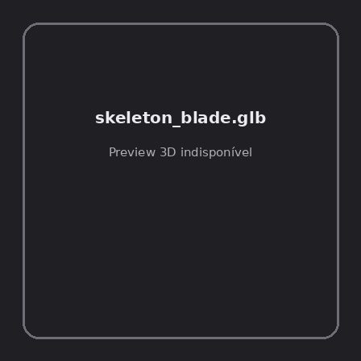
ID | NOV-005469
Origem | Asset novo
Pack/Fonte | Assets Organizados - Weapons
Categoria | Weapons / Skeleton Blade.Glb
Arquivo | skeleton_blade.glb
Caminho | 01_Assets_Organizados/Weapons/skeleton_blade.glb
Formato | GLB
Tamanho | 36.23 KB
SHA-256 | 72e0b4fd163e60f1082f…
Status técnico | ERROR
Licença | MISSING_REVIEW_REQUIRED — sem evidência localizada
Objetos / meshes | N/D / N/D
Vértices | N/D
Faces / triângulos | N/D / N/D
Materiais | N/D —
UV sets / vertex colors | N/D / N/D
Dimensões XYZ | N/D
Rig / armatures / bones | N/D / N/D / N/D
Skinned meshes | N/D
Animações | N/D —
Duração total clips | N/D
Root motion detectado | N/D
LODs / colliders | Nenhum / Nenhum
Texturas vinculadas | N/D (0 ausentes)
Alertas | Licença/fonte não localizada automaticamente; revisão legal necessária. | Duplicado exato: grupo DUP-00829 (2 cópias).
Notas | Falha na inspeção 3D: RuntimeError: Error: Python: Traceback (most recent call last):  File "/usr/share/blender/scripts/addons/io_scene_gltf2/__init__.py", line 1064, in execute  return self.import_gltf2(context)  File "/usr/share/blender/scripts/addons/io_scene_gltf2/__init__.py", line 1083, in import_gltf2  return self.unit_import(self.filepath, import_settings)  File "/usr/share/blender/scripts/addons/io_scene_gltf2/__init__.py", line 1088, in unit_import  from .blender.imp.gltf2_blender_gltf import BlenderGlTF  File "/usr/share/blender/scripts/addons/io_scene_gltf2/blender/imp/gltf2_blender_gltf.py", line 17, in <module>  from .gltf2_blender_scene import BlenderScene  File "/usr/share/blender/scripts/addons/io_scene_gltf2/blender/imp/gltf2_blender_scene.py", line 17, in <module>  from .gltf2_blender_node import BlenderNode  File "/usr/share/blender/scripts/addons/io_scene_gltf2/blender/imp/gltf2_blender_node.py", line 18, in <module>  from .gltf2_blender_mesh import BlenderMesh  File "/usr/share/blender/scripts/addons/io_scene_gltf2/blender/imp/gltf2_blender_mesh.py", line 17, in <module>  import numpy as np  ModuleNotFoundError: No module named 'numpy'  location: /usr/share/blender/scripts/modules/bpy/ops.py:132  Traceback (most recent call last):  File "/home/runner/work/PSX_demons_whip/PSX_demons_whip/workspace/demons/tools/asset_catalog/blender_batch.py", line 427, in inspect_task  import_model(path)  File "/home/runner/work/PSX_demons_whip/PSX_demons_whip/workspace/demons/tools/asset_catalog/blender_batch.py", line 52, in import_model  bpy.ops.import_scene.gltf(filepath=str(path))  File "/usr/share/blender/scripts/modules/bpy/ops.py", line 132, in __call__  ret = _op_call(self.idname_py(), None, kw)  RuntimeError: Error: Python: Traceback (most recent call last):  File "/usr/share/blender/scripts/addons/io_scene_gltf2/__init__.py", line 1064, in execute  return self.import_gltf2(context)  File "/usr/share/blender/scripts/addons/io_scene_gltf2/__init__.py", line 1083, in import_gltf2  return self.unit_import(self.filepath, import_settings)  File "/usr/share/blender/scripts/addons/io_scene_gltf2/__init__.py", line 1088, in unit_import  from .blender.imp.gltf2_blender_gltf import BlenderGlTF  File "/usr/share/blender/scripts/addons/io_scene_gltf2/blender/imp/gltf2_blender_gltf.py", line 17, in <module>  from .gltf2_blender_scene import BlenderScene  File "/usr/share/blender/scripts/addons/io_scene_gltf2/blender/imp/gltf2_blender_scene.py", line 17, in <module>  from .gltf2_blender_node import BlenderNode  File "/usr/share/blender/scripts/addons/io_scene_gltf2/blender/imp/gltf2_blender_node.py", line 18, in <module>  from .gltf2_blender_mesh import BlenderMesh  File "/usr/share/blender/scripts/addons/io_scene_gltf2/blender/imp/gltf2_blender_mesh.py", line 17, in <module>  import numpy as np  ModuleNotFoundError: No module named 'numpy'  location: /usr/share/blender/scripts/modules/bpy/ops.py:132  | Metadados 3D reutilizados do duplicado idêntico TEM-002203.

NOV-005519 • skeleton_crossbow [ERROR]

ID | NOV-005519
Origem | Asset novo
Pack/Fonte | Assets Organizados - Weapons
Categoria | Weapons / Skeleton Crossbow.Glb
Arquivo | skeleton_crossbow.glb
Caminho | 01_Assets_Organizados/Weapons/skeleton_crossbow.glb
Formato | GLB
Tamanho | 38.96 KB
SHA-256 | b3cd96dbff30d2531164…
Status técnico | ERROR
Licença | MISSING_REVIEW_REQUIRED — sem evidência localizada
Objetos / meshes | N/D / N/D
Vértices | N/D
Faces / triângulos | N/D / N/D
Materiais | N/D —
UV sets / vertex colors | N/D / N/D
Dimensões XYZ | N/D
Rig / armatures / bones | N/D / N/D / N/D
Skinned meshes | N/D
Animações | N/D —
Duração total clips | N/D
Root motion detectado | N/D
LODs / colliders | Nenhum / Nenhum
Texturas vinculadas | N/D (0 ausentes)
Alertas | Licença/fonte não localizada automaticamente; revisão legal necessária. | Duplicado exato: grupo DUP-00878 (2 cópias).
Notas | Falha na inspeção 3D: RuntimeError: Error: Python: Traceback (most recent call last):  File "/usr/share/blender/scripts/addons/io_scene_gltf2/__init__.py", line 1064, in execute  return self.import_gltf2(context)  File "/usr/share/blender/scripts/addons/io_scene_gltf2/__init__.py", line 1083, in import_gltf2  return self.unit_import(self.filepath, import_settings)  File "/usr/share/blender/scripts/addons/io_scene_gltf2/__init__.py", line 1088, in unit_import  from .blender.imp.gltf2_blender_gltf import BlenderGlTF  File "/usr/share/blender/scripts/addons/io_scene_gltf2/blender/imp/gltf2_blender_gltf.py", line 17, in <module>  from .gltf2_blender_scene import BlenderScene  File "/usr/share/blender/scripts/addons/io_scene_gltf2/blender/imp/gltf2_blender_scene.py", line 17, in <module>  from .gltf2_blender_node import BlenderNode  File "/usr/share/blender/scripts/addons/io_scene_gltf2/blender/imp/gltf2_blender_node.py", line 18, in <module>  from .gltf2_blender_mesh import BlenderMesh  File "/usr/share/blender/scripts/addons/io_scene_gltf2/blender/imp/gltf2_blender_mesh.py", line 17, in <module>  import numpy as np  ModuleNotFoundError: No module named 'numpy'  location: /usr/share/blender/scripts/modules/bpy/ops.py:132  Traceback (most recent call last):  File "/home/runner/work/PSX_demons_whip/PSX_demons_whip/workspace/demons/tools/asset_catalog/blender_batch.py", line 427, in inspect_task  import_model(path)  File "/home/runner/work/PSX_demons_whip/PSX_demons_whip/workspace/demons/tools/asset_catalog/blender_batch.py", line 52, in import_model  bpy.ops.import_scene.gltf(filepath=str(path))  File "/usr/share/blender/scripts/modules/bpy/ops.py", line 132, in __call__  ret = _op_call(self.idname_py(), None, kw)  RuntimeError: Error: Python: Traceback (most recent call last):  File "/usr/share/blender/scripts/addons/io_scene_gltf2/__init__.py", line 1064, in execute  return self.import_gltf2(context)  File "/usr/share/blender/scripts/addons/io_scene_gltf2/__init__.py", line 1083, in import_gltf2  return self.unit_import(self.filepath, import_settings)  File "/usr/share/blender/scripts/addons/io_scene_gltf2/__init__.py", line 1088, in unit_import  from .blender.imp.gltf2_blender_gltf import BlenderGlTF  File "/usr/share/blender/scripts/addons/io_scene_gltf2/blender/imp/gltf2_blender_gltf.py", line 17, in <module>  from .gltf2_blender_scene import BlenderScene  File "/usr/share/blender/scripts/addons/io_scene_gltf2/blender/imp/gltf2_blender_scene.py", line 17, in <module>  from .gltf2_blender_node import BlenderNode  File "/usr/share/blender/scripts/addons/io_scene_gltf2/blender/imp/gltf2_blender_node.py", line 18, in <module>  from .gltf2_blender_mesh import BlenderMesh  File "/usr/share/blender/scripts/addons/io_scene_gltf2/blender/imp/gltf2_blender_mesh.py", line 17, in <module>  import numpy as np  ModuleNotFoundError: No module named 'numpy'  location: /usr/share/blender/scripts/modules/bpy/ops.py:132  | Metadados 3D reutilizados do duplicado idêntico TEM-002252.

NOV-005532 • skeleton_shield_large_a [ERROR]
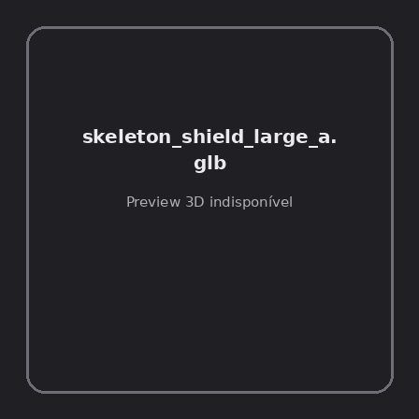
ID | NOV-005532
Origem | Asset novo
Pack/Fonte | Assets Organizados - Weapons
Categoria | Weapons / Skeleton Shield Large A.Glb
Arquivo | skeleton_shield_large_a.glb
Caminho | 01_Assets_Organizados/Weapons/skeleton_shield_large_a.glb
Formato | GLB
Tamanho | 40.49 KB
SHA-256 | 879d7e1757d3aa7971ab…
Status técnico | ERROR
Licença | MISSING_REVIEW_REQUIRED — sem evidência localizada
Objetos / meshes | N/D / N/D
Vértices | N/D
Faces / triângulos | N/D / N/D
Materiais | N/D —
UV sets / vertex colors | N/D / N/D
Dimensões XYZ | N/D
Rig / armatures / bones | N/D / N/D / N/D
Skinned meshes | N/D
Animações | N/D —
Duração total clips | N/D
Root motion detectado | N/D
LODs / colliders | Nenhum / Nenhum
Texturas vinculadas | N/D (0 ausentes)
Alertas | Licença/fonte não localizada automaticamente; revisão legal necessária. | Duplicado exato: grupo DUP-00891 (2 cópias).
Notas | Falha na inspeção 3D: RuntimeError: Error: Python: Traceback (most recent call last):  File "/usr/share/blender/scripts/addons/io_scene_gltf2/__init__.py", line 1064, in execute  return self.import_gltf2(context)  File "/usr/share/blender/scripts/addons/io_scene_gltf2/__init__.py", line 1083, in import_gltf2  return self.unit_import(self.filepath, import_settings)  File "/usr/share/blender/scripts/addons/io_scene_gltf2/__init__.py", line 1088, in unit_import  from .blender.imp.gltf2_blender_gltf import BlenderGlTF  File "/usr/share/blender/scripts/addons/io_scene_gltf2/blender/imp/gltf2_blender_gltf.py", line 17, in <module>  from .gltf2_blender_scene import BlenderScene  File "/usr/share/blender/scripts/addons/io_scene_gltf2/blender/imp/gltf2_blender_scene.py", line 17, in <module>  from .gltf2_blender_node import BlenderNode  File "/usr/share/blender/scripts/addons/io_scene_gltf2/blender/imp/gltf2_blender_node.py", line 18, in <module>  from .gltf2_blender_mesh import BlenderMesh  File "/usr/share/blender/scripts/addons/io_scene_gltf2/blender/imp/gltf2_blender_mesh.py", line 17, in <module>  import numpy as np  ModuleNotFoundError: No module named 'numpy'  location: /usr/share/blender/scripts/modules/bpy/ops.py:132  Traceback (most recent call last):  File "/home/runner/work/PSX_demons_whip/PSX_demons_whip/workspace/demons/tools/asset_catalog/blender_batch.py", line 427, in inspect_task  import_model(path)  File "/home/runner/work/PSX_demons_whip/PSX_demons_whip/workspace/demons/tools/asset_catalog/blender_batch.py", line 52, in import_model  bpy.ops.import_scene.gltf(filepath=str(path))  File "/usr/share/blender/scripts/modules/bpy/ops.py", line 132, in __call__  ret = _op_call(self.idname_py(), None, kw)  RuntimeError: Error: Python: Traceback (most recent call last):  File "/usr/share/blender/scripts/addons/io_scene_gltf2/__init__.py", line 1064, in execute  return self.import_gltf2(context)  File "/usr/share/blender/scripts/addons/io_scene_gltf2/__init__.py", line 1083, in import_gltf2  return self.unit_import(self.filepath, import_settings)  File "/usr/share/blender/scripts/addons/io_scene_gltf2/__init__.py", line 1088, in unit_import  from .blender.imp.gltf2_blender_gltf import BlenderGlTF  File "/usr/share/blender/scripts/addons/io_scene_gltf2/blender/imp/gltf2_blender_gltf.py", line 17, in <module>  from .gltf2_blender_scene import BlenderScene  File "/usr/share/blender/scripts/addons/io_scene_gltf2/blender/imp/gltf2_blender_scene.py", line 17, in <module>  from .gltf2_blender_node import BlenderNode  File "/usr/share/blender/scripts/addons/io_scene_gltf2/blender/imp/gltf2_blender_node.py", line 18, in <module>  from .gltf2_blender_mesh import BlenderMesh  File "/usr/share/blender/scripts/addons/io_scene_gltf2/blender/imp/gltf2_blender_mesh.py", line 17, in <module>  import numpy as np  ModuleNotFoundError: No module named 'numpy'  location: /usr/share/blender/scripts/modules/bpy/ops.py:132  | Metadados 3D reutilizados do duplicado idêntico TEM-002265.

NOV-005478 • skeleton_staff [ERROR]
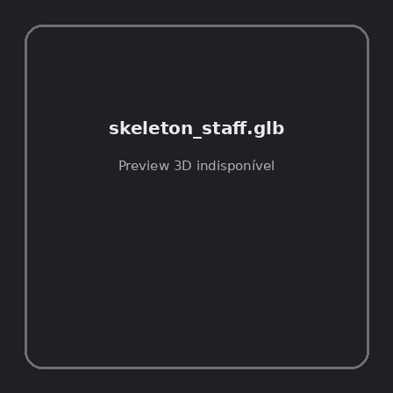
ID | NOV-005478
Origem | Asset novo
Pack/Fonte | Assets Organizados - Weapons
Categoria | Weapons / Skeleton Staff.Glb
Arquivo | skeleton_staff.glb
Caminho | 01_Assets_Organizados/Weapons/skeleton_staff.glb
Formato | GLB
Tamanho | 50.45 KB
SHA-256 | 75147e92b25e4d88a5ed…
Status técnico | ERROR
Licença | MISSING_REVIEW_REQUIRED — sem evidência localizada
Objetos / meshes | N/D / N/D
Vértices | N/D
Faces / triângulos | N/D / N/D
Materiais | N/D —
UV sets / vertex colors | N/D / N/D
Dimensões XYZ | N/D
Rig / armatures / bones | N/D / N/D / N/D
Skinned meshes | N/D
Animações | N/D —
Duração total clips | N/D
Root motion detectado | N/D
LODs / colliders | Nenhum / Nenhum
Texturas vinculadas | N/D (0 ausentes)
Alertas | Licença/fonte não localizada automaticamente; revisão legal necessária. | Duplicado exato: grupo DUP-00838 (2 cópias).
Notas | Falha na inspeção 3D: RuntimeError: Error: Python: Traceback (most recent call last):  File "/usr/share/blender/scripts/addons/io_scene_gltf2/__init__.py", line 1064, in execute  return self.import_gltf2(context)  File "/usr/share/blender/scripts/addons/io_scene_gltf2/__init__.py", line 1083, in import_gltf2  return self.unit_import(self.filepath, import_settings)  File "/usr/share/blender/scripts/addons/io_scene_gltf2/__init__.py", line 1088, in unit_import  from .blender.imp.gltf2_blender_gltf import BlenderGlTF  File "/usr/share/blender/scripts/addons/io_scene_gltf2/blender/imp/gltf2_blender_gltf.py", line 17, in <module>  from .gltf2_blender_scene import BlenderScene  File "/usr/share/blender/scripts/addons/io_scene_gltf2/blender/imp/gltf2_blender_scene.py", line 17, in <module>  from .gltf2_blender_node import BlenderNode  File "/usr/share/blender/scripts/addons/io_scene_gltf2/blender/imp/gltf2_blender_node.py", line 18, in <module>  from .gltf2_blender_mesh import BlenderMesh  File "/usr/share/blender/scripts/addons/io_scene_gltf2/blender/imp/gltf2_blender_mesh.py", line 17, in <module>  import numpy as np  ModuleNotFoundError: No module named 'numpy'  location: /usr/share/blender/scripts/modules/bpy/ops.py:132  Traceback (most recent call last):  File "/home/runner/work/PSX_demons_whip/PSX_demons_whip/workspace/demons/tools/asset_catalog/blender_batch.py", line 427, in inspect_task  import_model(path)  File "/home/runner/work/PSX_demons_whip/PSX_demons_whip/workspace/demons/tools/asset_catalog/blender_batch.py", line 52, in import_model  bpy.ops.import_scene.gltf(filepath=str(path))  File "/usr/share/blender/scripts/modules/bpy/ops.py", line 132, in __call__  ret = _op_call(self.idname_py(), None, kw)  RuntimeError: Error: Python: Traceback (most recent call last):  File "/usr/share/blender/scripts/addons/io_scene_gltf2/__init__.py", line 1064, in execute  return self.import_gltf2(context)  File "/usr/share/blender/scripts/addons/io_scene_gltf2/__init__.py", line 1083, in import_gltf2  return self.unit_import(self.filepath, import_settings)  File "/usr/share/blender/scripts/addons/io_scene_gltf2/__init__.py", line 1088, in unit_import  from .blender.imp.gltf2_blender_gltf import BlenderGlTF  File "/usr/share/blender/scripts/addons/io_scene_gltf2/blender/imp/gltf2_blender_gltf.py", line 17, in <module>  from .gltf2_blender_scene import BlenderScene  File "/usr/share/blender/scripts/addons/io_scene_gltf2/blender/imp/gltf2_blender_scene.py", line 17, in <module>  from .gltf2_blender_node import BlenderNode  File "/usr/share/blender/scripts/addons/io_scene_gltf2/blender/imp/gltf2_blender_node.py", line 18, in <module>  from .gltf2_blender_mesh import BlenderMesh  File "/usr/share/blender/scripts/addons/io_scene_gltf2/blender/imp/gltf2_blender_mesh.py", line 17, in <module>  import numpy as np  ModuleNotFoundError: No module named 'numpy'  location: /usr/share/blender/scripts/modules/bpy/ops.py:132  | Metadados 3D reutilizados do duplicado idêntico TEM-002212.

NOV-005527 • skyrender_the_firmament_s_wound [ERROR]
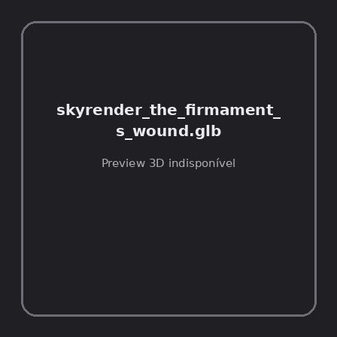
ID | NOV-005527
Origem | Asset novo
Pack/Fonte | Assets Organizados - Weapons
Categoria | Weapons / Skyrender The Firmament S Wound.Glb
Arquivo | skyrender_the_firmament_s_wound.glb
Caminho | 01_Assets_Organizados/Weapons/skyrender_the_firmament_s_wound.glb
Formato | GLB
Tamanho | 84.08 KB
SHA-256 | e0746737f254a9fe0400…
Status técnico | ERROR
Licença | MISSING_REVIEW_REQUIRED — sem evidência localizada
Objetos / meshes | N/D / N/D
Vértices | N/D
Faces / triângulos | N/D / N/D
Materiais | N/D —
UV sets / vertex colors | N/D / N/D
Dimensões XYZ | N/D
Rig / armatures / bones | N/D / N/D / N/D
Skinned meshes | N/D
Animações | N/D —
Duração total clips | N/D
Root motion detectado | N/D
LODs / colliders | Nenhum / Nenhum
Texturas vinculadas | N/D (0 ausentes)
Alertas | Licença/fonte não localizada automaticamente; revisão legal necessária. | Duplicado exato: grupo DUP-00886 (2 cópias).
Notas | Falha na inspeção 3D: RuntimeError: Error: Python: Traceback (most recent call last):  File "/usr/share/blender/scripts/addons/io_scene_gltf2/__init__.py", line 1064, in execute  return self.import_gltf2(context)  File "/usr/share/blender/scripts/addons/io_scene_gltf2/__init__.py", line 1083, in import_gltf2  return self.unit_import(self.filepath, import_settings)  File "/usr/share/blender/scripts/addons/io_scene_gltf2/__init__.py", line 1088, in unit_import  from .blender.imp.gltf2_blender_gltf import BlenderGlTF  File "/usr/share/blender/scripts/addons/io_scene_gltf2/blender/imp/gltf2_blender_gltf.py", line 17, in <module>  from .gltf2_blender_scene import BlenderScene  File "/usr/share/blender/scripts/addons/io_scene_gltf2/blender/imp/gltf2_blender_scene.py", line 17, in <module>  from .gltf2_blender_node import BlenderNode  File "/usr/share/blender/scripts/addons/io_scene_gltf2/blender/imp/gltf2_blender_node.py", line 18, in <module>  from .gltf2_blender_mesh import BlenderMesh  File "/usr/share/blender/scripts/addons/io_scene_gltf2/blender/imp/gltf2_blender_mesh.py", line 17, in <module>  import numpy as np  ModuleNotFoundError: No module named 'numpy'  location: /usr/share/blender/scripts/modules/bpy/ops.py:132  Traceback (most recent call last):  File "/home/runner/work/PSX_demons_whip/PSX_demons_whip/workspace/demons/tools/asset_catalog/blender_batch.py", line 427, in inspect_task  import_model(path)  File "/home/runner/work/PSX_demons_whip/PSX_demons_whip/workspace/demons/tools/asset_catalog/blender_batch.py", line 52, in import_model  bpy.ops.import_scene.gltf(filepath=str(path))  File "/usr/share/blender/scripts/modules/bpy/ops.py", line 132, in __call__  ret = _op_call(self.idname_py(), None, kw)  RuntimeError: Error: Python: Traceback (most recent call last):  File "/usr/share/blender/scripts/addons/io_scene_gltf2/__init__.py", line 1064, in execute  return self.import_gltf2(context)  File "/usr/share/blender/scripts/addons/io_scene_gltf2/__init__.py", line 1083, in import_gltf2  return self.unit_import(self.filepath, import_settings)  File "/usr/share/blender/scripts/addons/io_scene_gltf2/__init__.py", line 1088, in unit_import  from .blender.imp.gltf2_blender_gltf import BlenderGlTF  File "/usr/share/blender/scripts/addons/io_scene_gltf2/blender/imp/gltf2_blender_gltf.py", line 17, in <module>  from .gltf2_blender_scene import BlenderScene  File "/usr/share/blender/scripts/addons/io_scene_gltf2/blender/imp/gltf2_blender_scene.py", line 17, in <module>  from .gltf2_blender_node import BlenderNode  File "/usr/share/blender/scripts/addons/io_scene_gltf2/blender/imp/gltf2_blender_node.py", line 18, in <module>  from .gltf2_blender_mesh import BlenderMesh  File "/usr/share/blender/scripts/addons/io_scene_gltf2/blender/imp/gltf2_blender_mesh.py", line 17, in <module>  import numpy as np  ModuleNotFoundError: No module named 'numpy'  location: /usr/share/blender/scripts/modules/bpy/ops.py:132  | Metadados 3D reutilizados do duplicado idêntico TEM-002260.

NOV-005512 • smoulderfall [ERROR]
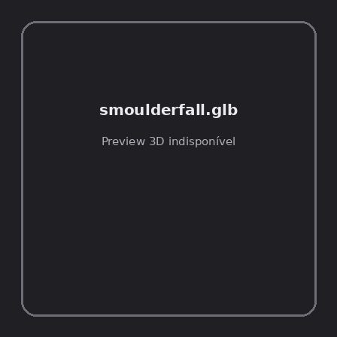
ID | NOV-005512
Origem | Asset novo
Pack/Fonte | Assets Organizados - Weapons
Categoria | Weapons / Smoulderfall.Glb
Arquivo | smoulderfall.glb
Caminho | 01_Assets_Organizados/Weapons/smoulderfall.glb
Formato | GLB
Tamanho | 81.09 KB
SHA-256 | 547e08749a77fee3c3df…
Status técnico | ERROR
Licença | MISSING_REVIEW_REQUIRED — sem evidência localizada
Objetos / meshes | N/D / N/D
Vértices | N/D
Faces / triângulos | N/D / N/D
Materiais | N/D —
UV sets / vertex colors | N/D / N/D
Dimensões XYZ | N/D
Rig / armatures / bones | N/D / N/D / N/D
Skinned meshes | N/D
Animações | N/D —
Duração total clips | N/D
Root motion detectado | N/D
LODs / colliders | Nenhum / Nenhum
Texturas vinculadas | N/D (0 ausentes)
Alertas | Licença/fonte não localizada automaticamente; revisão legal necessária. | Duplicado exato: grupo DUP-00871 (2 cópias).
Notas | Falha na inspeção 3D: RuntimeError: Error: Python: Traceback (most recent call last):  File "/usr/share/blender/scripts/addons/io_scene_gltf2/__init__.py", line 1064, in execute  return self.import_gltf2(context)  File "/usr/share/blender/scripts/addons/io_scene_gltf2/__init__.py", line 1083, in import_gltf2  return self.unit_import(self.filepath, import_settings)  File "/usr/share/blender/scripts/addons/io_scene_gltf2/__init__.py", line 1088, in unit_import  from .blender.imp.gltf2_blender_gltf import BlenderGlTF  File "/usr/share/blender/scripts/addons/io_scene_gltf2/blender/imp/gltf2_blender_gltf.py", line 17, in <module>  from .gltf2_blender_scene import BlenderScene  File "/usr/share/blender/scripts/addons/io_scene_gltf2/blender/imp/gltf2_blender_scene.py", line 17, in <module>  from .gltf2_blender_node import BlenderNode  File "/usr/share/blender/scripts/addons/io_scene_gltf2/blender/imp/gltf2_blender_node.py", line 18, in <module>  from .gltf2_blender_mesh import BlenderMesh  File "/usr/share/blender/scripts/addons/io_scene_gltf2/blender/imp/gltf2_blender_mesh.py", line 17, in <module>  import numpy as np  ModuleNotFoundError: No module named 'numpy'  location: /usr/share/blender/scripts/modules/bpy/ops.py:132  Traceback (most recent call last):  File "/home/runner/work/PSX_demons_whip/PSX_demons_whip/workspace/demons/tools/asset_catalog/blender_batch.py", line 427, in inspect_task  import_model(path)  File "/home/runner/work/PSX_demons_whip/PSX_demons_whip/workspace/demons/tools/asset_catalog/blender_batch.py", line 52, in import_model  bpy.ops.import_scene.gltf(filepath=str(path))  File "/usr/share/blender/scripts/modules/bpy/ops.py", line 132, in __call__  ret = _op_call(self.idname_py(), None, kw)  RuntimeError: Error: Python: Traceback (most recent call last):  File "/usr/share/blender/scripts/addons/io_scene_gltf2/__init__.py", line 1064, in execute  return self.import_gltf2(context)  File "/usr/share/blender/scripts/addons/io_scene_gltf2/__init__.py", line 1083, in import_gltf2  return self.unit_import(self.filepath, import_settings)  File "/usr/share/blender/scripts/addons/io_scene_gltf2/__init__.py", line 1088, in unit_import  from .blender.imp.gltf2_blender_gltf import BlenderGlTF  File "/usr/share/blender/scripts/addons/io_scene_gltf2/blender/imp/gltf2_blender_gltf.py", line 17, in <module>  from .gltf2_blender_scene import BlenderScene  File "/usr/share/blender/scripts/addons/io_scene_gltf2/blender/imp/gltf2_blender_scene.py", line 17, in <module>  from .gltf2_blender_node import BlenderNode  File "/usr/share/blender/scripts/addons/io_scene_gltf2/blender/imp/gltf2_blender_node.py", line 18, in <module>  from .gltf2_blender_mesh import BlenderMesh  File "/usr/share/blender/scripts/addons/io_scene_gltf2/blender/imp/gltf2_blender_mesh.py", line 17, in <module>  import numpy as np  ModuleNotFoundError: No module named 'numpy'  location: /usr/share/blender/scripts/modules/bpy/ops.py:132  | Metadados 3D reutilizados do duplicado idêntico TEM-002245.

NOV-005458 • solheim_last_light_of_the_dawn [ERROR]
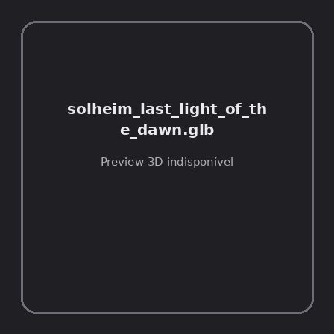
ID | NOV-005458
Origem | Asset novo
Pack/Fonte | Assets Organizados - Weapons
Categoria | Weapons / Solheim Last Light Of The Dawn.Glb
Arquivo | solheim_last_light_of_the_dawn.glb
Caminho | 01_Assets_Organizados/Weapons/solheim_last_light_of_the_dawn.glb
Formato | GLB
Tamanho | 127.04 KB
SHA-256 | b69e90ab6a4a1da8fef4…
Status técnico | ERROR
Licença | MISSING_REVIEW_REQUIRED — sem evidência localizada
Objetos / meshes | N/D / N/D
Vértices | N/D
Faces / triângulos | N/D / N/D
Materiais | N/D —
UV sets / vertex colors | N/D / N/D
Dimensões XYZ | N/D
Rig / armatures / bones | N/D / N/D / N/D
Skinned meshes | N/D
Animações | N/D —
Duração total clips | N/D
Root motion detectado | N/D
LODs / colliders | Nenhum / Nenhum
Texturas vinculadas | N/D (0 ausentes)
Alertas | Licença/fonte não localizada automaticamente; revisão legal necessária. | Duplicado exato: grupo DUP-00818 (2 cópias).
Notas | Falha na inspeção 3D: RuntimeError: Error: Python: Traceback (most recent call last):  File "/usr/share/blender/scripts/addons/io_scene_gltf2/__init__.py", line 1064, in execute  return self.import_gltf2(context)  File "/usr/share/blender/scripts/addons/io_scene_gltf2/__init__.py", line 1083, in import_gltf2  return self.unit_import(self.filepath, import_settings)  File "/usr/share/blender/scripts/addons/io_scene_gltf2/__init__.py", line 1088, in unit_import  from .blender.imp.gltf2_blender_gltf import BlenderGlTF  File "/usr/share/blender/scripts/addons/io_scene_gltf2/blender/imp/gltf2_blender_gltf.py", line 17, in <module>  from .gltf2_blender_scene import BlenderScene  File "/usr/share/blender/scripts/addons/io_scene_gltf2/blender/imp/gltf2_blender_scene.py", line 17, in <module>  from .gltf2_blender_node import BlenderNode  File "/usr/share/blender/scripts/addons/io_scene_gltf2/blender/imp/gltf2_blender_node.py", line 18, in <module>  from .gltf2_blender_mesh import BlenderMesh  File "/usr/share/blender/scripts/addons/io_scene_gltf2/blender/imp/gltf2_blender_mesh.py", line 17, in <module>  import numpy as np  ModuleNotFoundError: No module named 'numpy'  location: /usr/share/blender/scripts/modules/bpy/ops.py:132  Traceback (most recent call last):  File "/home/runner/work/PSX_demons_whip/PSX_demons_whip/workspace/demons/tools/asset_catalog/blender_batch.py", line 427, in inspect_task  import_model(path)  File "/home/runner/work/PSX_demons_whip/PSX_demons_whip/workspace/demons/tools/asset_catalog/blender_batch.py", line 52, in import_model  bpy.ops.import_scene.gltf(filepath=str(path))  File "/usr/share/blender/scripts/modules/bpy/ops.py", line 132, in __call__  ret = _op_call(self.idname_py(), None, kw)  RuntimeError: Error: Python: Traceback (most recent call last):  File "/usr/share/blender/scripts/addons/io_scene_gltf2/__init__.py", line 1064, in execute  return self.import_gltf2(context)  File "/usr/share/blender/scripts/addons/io_scene_gltf2/__init__.py", line 1083, in import_gltf2  return self.unit_import(self.filepath, import_settings)  File "/usr/share/blender/scripts/addons/io_scene_gltf2/__init__.py", line 1088, in unit_import  from .blender.imp.gltf2_blender_gltf import BlenderGlTF  File "/usr/share/blender/scripts/addons/io_scene_gltf2/blender/imp/gltf2_blender_gltf.py", line 17, in <module>  from .gltf2_blender_scene import BlenderScene  File "/usr/share/blender/scripts/addons/io_scene_gltf2/blender/imp/gltf2_blender_scene.py", line 17, in <module>  from .gltf2_blender_node import BlenderNode  File "/usr/share/blender/scripts/addons/io_scene_gltf2/blender/imp/gltf2_blender_node.py", line 18, in <module>  from .gltf2_blender_mesh import BlenderMesh  File "/usr/share/blender/scripts/addons/io_scene_gltf2/blender/imp/gltf2_blender_mesh.py", line 17, in <module>  import numpy as np  ModuleNotFoundError: No module named 'numpy'  location: /usr/share/blender/scripts/modules/bpy/ops.py:132  | Metadados 3D reutilizados do duplicado idêntico TEM-002192.

NOV-005446 • spear_a [ERROR]
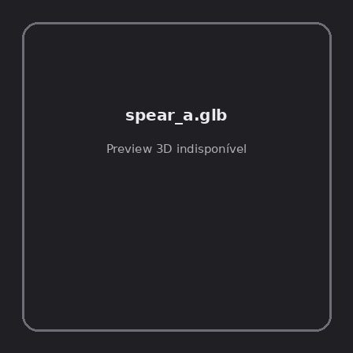
ID | NOV-005446
Origem | Asset novo
Pack/Fonte | Assets Organizados - Weapons
Categoria | Weapons / Spear A.Glb
Arquivo | spear_a.glb
Caminho | 01_Assets_Organizados/Weapons/spear_a.glb
Formato | GLB
Tamanho | 76.71 KB
SHA-256 | 27e7969ec3efdd8ba59f…
Status técnico | ERROR
Licença | MISSING_REVIEW_REQUIRED — sem evidência localizada
Objetos / meshes | N/D / N/D
Vértices | N/D
Faces / triângulos | N/D / N/D
Materiais | N/D —
UV sets / vertex colors | N/D / N/D
Dimensões XYZ | N/D
Rig / armatures / bones | N/D / N/D / N/D
Skinned meshes | N/D
Animações | N/D —
Duração total clips | N/D
Root motion detectado | N/D
LODs / colliders | Nenhum / Nenhum
Texturas vinculadas | N/D (0 ausentes)
Alertas | Licença/fonte não localizada automaticamente; revisão legal necessária. | Duplicado exato: grupo DUP-00806 (2 cópias).
Notas | Falha na inspeção 3D: RuntimeError: Error: Python: Traceback (most recent call last):  File "/usr/share/blender/scripts/addons/io_scene_gltf2/__init__.py", line 1064, in execute  return self.import_gltf2(context)  File "/usr/share/blender/scripts/addons/io_scene_gltf2/__init__.py", line 1083, in import_gltf2  return self.unit_import(self.filepath, import_settings)  File "/usr/share/blender/scripts/addons/io_scene_gltf2/__init__.py", line 1088, in unit_import  from .blender.imp.gltf2_blender_gltf import BlenderGlTF  File "/usr/share/blender/scripts/addons/io_scene_gltf2/blender/imp/gltf2_blender_gltf.py", line 17, in <module>  from .gltf2_blender_scene import BlenderScene  File "/usr/share/blender/scripts/addons/io_scene_gltf2/blender/imp/gltf2_blender_scene.py", line 17, in <module>  from .gltf2_blender_node import BlenderNode  File "/usr/share/blender/scripts/addons/io_scene_gltf2/blender/imp/gltf2_blender_node.py", line 18, in <module>  from .gltf2_blender_mesh import BlenderMesh  File "/usr/share/blender/scripts/addons/io_scene_gltf2/blender/imp/gltf2_blender_mesh.py", line 17, in <module>  import numpy as np  ModuleNotFoundError: No module named 'numpy'  location: /usr/share/blender/scripts/modules/bpy/ops.py:132  Traceback (most recent call last):  File "/home/runner/work/PSX_demons_whip/PSX_demons_whip/workspace/demons/tools/asset_catalog/blender_batch.py", line 427, in inspect_task  import_model(path)  File "/home/runner/work/PSX_demons_whip/PSX_demons_whip/workspace/demons/tools/asset_catalog/blender_batch.py", line 52, in import_model  bpy.ops.import_scene.gltf(filepath=str(path))  File "/usr/share/blender/scripts/modules/bpy/ops.py", line 132, in __call__  ret = _op_call(self.idname_py(), None, kw)  RuntimeError: Error: Python: Traceback (most recent call last):  File "/usr/share/blender/scripts/addons/io_scene_gltf2/__init__.py", line 1064, in execute  return self.import_gltf2(context)  File "/usr/share/blender/scripts/addons/io_scene_gltf2/__init__.py", line 1083, in import_gltf2  return self.unit_import(self.filepath, import_settings)  File "/usr/share/blender/scripts/addons/io_scene_gltf2/__init__.py", line 1088, in unit_import  from .blender.imp.gltf2_blender_gltf import BlenderGlTF  File "/usr/share/blender/scripts/addons/io_scene_gltf2/blender/imp/gltf2_blender_gltf.py", line 17, in <module>  from .gltf2_blender_scene import BlenderScene  File "/usr/share/blender/scripts/addons/io_scene_gltf2/blender/imp/gltf2_blender_scene.py", line 17, in <module>  from .gltf2_blender_node import BlenderNode  File "/usr/share/blender/scripts/addons/io_scene_gltf2/blender/imp/gltf2_blender_node.py", line 18, in <module>  from .gltf2_blender_mesh import BlenderMesh  File "/usr/share/blender/scripts/addons/io_scene_gltf2/blender/imp/gltf2_blender_mesh.py", line 17, in <module>  import numpy as np  ModuleNotFoundError: No module named 'numpy'  location: /usr/share/blender/scripts/modules/bpy/ops.py:132  | Metadados 3D reutilizados do duplicado idêntico TEM-002180.

NOV-005454 • spellbook_open [ERROR]
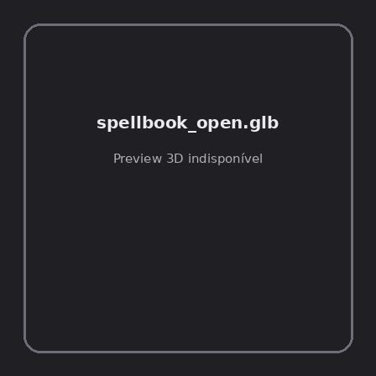
ID | NOV-005454
Origem | Asset novo
Pack/Fonte | Assets Organizados - Weapons
Categoria | Weapons / Spellbook Open.Glb
Arquivo | spellbook_open.glb
Caminho | 01_Assets_Organizados/Weapons/spellbook_open.glb
Formato | GLB
Tamanho | 34.31 KB
SHA-256 | e564abd17649ec4fa471…
Status técnico | ERROR
Licença | MISSING_REVIEW_REQUIRED — sem evidência localizada
Objetos / meshes | N/D / N/D
Vértices | N/D
Faces / triângulos | N/D / N/D
Materiais | N/D —
UV sets / vertex colors | N/D / N/D
Dimensões XYZ | N/D
Rig / armatures / bones | N/D / N/D / N/D
Skinned meshes | N/D
Animações | N/D —
Duração total clips | N/D
Root motion detectado | N/D
LODs / colliders | Nenhum / Nenhum
Texturas vinculadas | N/D (0 ausentes)
Alertas | Licença/fonte não localizada automaticamente; revisão legal necessária. | Duplicado exato: grupo DUP-00814 (2 cópias).
Notas | Falha na inspeção 3D: RuntimeError: Error: Python: Traceback (most recent call last):  File "/usr/share/blender/scripts/addons/io_scene_gltf2/__init__.py", line 1064, in execute  return self.import_gltf2(context)  File "/usr/share/blender/scripts/addons/io_scene_gltf2/__init__.py", line 1083, in import_gltf2  return self.unit_import(self.filepath, import_settings)  File "/usr/share/blender/scripts/addons/io_scene_gltf2/__init__.py", line 1088, in unit_import  from .blender.imp.gltf2_blender_gltf import BlenderGlTF  File "/usr/share/blender/scripts/addons/io_scene_gltf2/blender/imp/gltf2_blender_gltf.py", line 17, in <module>  from .gltf2_blender_scene import BlenderScene  File "/usr/share/blender/scripts/addons/io_scene_gltf2/blender/imp/gltf2_blender_scene.py", line 17, in <module>  from .gltf2_blender_node import BlenderNode  File "/usr/share/blender/scripts/addons/io_scene_gltf2/blender/imp/gltf2_blender_node.py", line 18, in <module>  from .gltf2_blender_mesh import BlenderMesh  File "/usr/share/blender/scripts/addons/io_scene_gltf2/blender/imp/gltf2_blender_mesh.py", line 17, in <module>  import numpy as np  ModuleNotFoundError: No module named 'numpy'  location: /usr/share/blender/scripts/modules/bpy/ops.py:132  Traceback (most recent call last):  File "/home/runner/work/PSX_demons_whip/PSX_demons_whip/workspace/demons/tools/asset_catalog/blender_batch.py", line 427, in inspect_task  import_model(path)  File "/home/runner/work/PSX_demons_whip/PSX_demons_whip/workspace/demons/tools/asset_catalog/blender_batch.py", line 52, in import_model  bpy.ops.import_scene.gltf(filepath=str(path))  File "/usr/share/blender/scripts/modules/bpy/ops.py", line 132, in __call__  ret = _op_call(self.idname_py(), None, kw)  RuntimeError: Error: Python: Traceback (most recent call last):  File "/usr/share/blender/scripts/addons/io_scene_gltf2/__init__.py", line 1064, in execute  return self.import_gltf2(context)  File "/usr/share/blender/scripts/addons/io_scene_gltf2/__init__.py", line 1083, in import_gltf2  return self.unit_import(self.filepath, import_settings)  File "/usr/share/blender/scripts/addons/io_scene_gltf2/__init__.py", line 1088, in unit_import  from .blender.imp.gltf2_blender_gltf import BlenderGlTF  File "/usr/share/blender/scripts/addons/io_scene_gltf2/blender/imp/gltf2_blender_gltf.py", line 17, in <module>  from .gltf2_blender_scene import BlenderScene  File "/usr/share/blender/scripts/addons/io_scene_gltf2/blender/imp/gltf2_blender_scene.py", line 17, in <module>  from .gltf2_blender_node import BlenderNode  File "/usr/share/blender/scripts/addons/io_scene_gltf2/blender/imp/gltf2_blender_node.py", line 18, in <module>  from .gltf2_blender_mesh import BlenderMesh  File "/usr/share/blender/scripts/addons/io_scene_gltf2/blender/imp/gltf2_blender_mesh.py", line 17, in <module>  import numpy as np  ModuleNotFoundError: No module named 'numpy'  location: /usr/share/blender/scripts/modules/bpy/ops.py:132  | Metadados 3D reutilizados do duplicado idêntico TEM-002188.

NOV-005457 • staff [ERROR]

ID | NOV-005457
Origem | Asset novo
Pack/Fonte | Assets Organizados - Weapons
Categoria | Weapons / Staff.Glb
Arquivo | staff.glb
Caminho | 01_Assets_Organizados/Weapons/staff.glb
Formato | GLB
Tamanho | 35.32 KB
SHA-256 | 0958a09b353f4e1228c6…
Status técnico | ERROR
Licença | MISSING_REVIEW_REQUIRED — sem evidência localizada
Objetos / meshes | N/D / N/D
Vértices | N/D
Faces / triângulos | N/D / N/D
Materiais | N/D —
UV sets / vertex colors | N/D / N/D
Dimensões XYZ | N/D
Rig / armatures / bones | N/D / N/D / N/D
Skinned meshes | N/D
Animações | N/D —
Duração total clips | N/D
Root motion detectado | N/D
LODs / colliders | Nenhum / Nenhum
Texturas vinculadas | N/D (0 ausentes)
Alertas | Licença/fonte não localizada automaticamente; revisão legal necessária. | Duplicado exato: grupo DUP-00817 (2 cópias).
Notas | Falha na inspeção 3D: RuntimeError: Error: Python: Traceback (most recent call last):  File "/usr/share/blender/scripts/addons/io_scene_gltf2/__init__.py", line 1064, in execute  return self.import_gltf2(context)  File "/usr/share/blender/scripts/addons/io_scene_gltf2/__init__.py", line 1083, in import_gltf2  return self.unit_import(self.filepath, import_settings)  File "/usr/share/blender/scripts/addons/io_scene_gltf2/__init__.py", line 1088, in unit_import  from .blender.imp.gltf2_blender_gltf import BlenderGlTF  File "/usr/share/blender/scripts/addons/io_scene_gltf2/blender/imp/gltf2_blender_gltf.py", line 17, in <module>  from .gltf2_blender_scene import BlenderScene  File "/usr/share/blender/scripts/addons/io_scene_gltf2/blender/imp/gltf2_blender_scene.py", line 17, in <module>  from .gltf2_blender_node import BlenderNode  File "/usr/share/blender/scripts/addons/io_scene_gltf2/blender/imp/gltf2_blender_node.py", line 18, in <module>  from .gltf2_blender_mesh import BlenderMesh  File "/usr/share/blender/scripts/addons/io_scene_gltf2/blender/imp/gltf2_blender_mesh.py", line 17, in <module>  import numpy as np  ModuleNotFoundError: No module named 'numpy'  location: /usr/share/blender/scripts/modules/bpy/ops.py:132  Traceback (most recent call last):  File "/home/runner/work/PSX_demons_whip/PSX_demons_whip/workspace/demons/tools/asset_catalog/blender_batch.py", line 427, in inspect_task  import_model(path)  File "/home/runner/work/PSX_demons_whip/PSX_demons_whip/workspace/demons/tools/asset_catalog/blender_batch.py", line 52, in import_model  bpy.ops.import_scene.gltf(filepath=str(path))  File "/usr/share/blender/scripts/modules/bpy/ops.py", line 132, in __call__  ret = _op_call(self.idname_py(), None, kw)  RuntimeError: Error: Python: Traceback (most recent call last):  File "/usr/share/blender/scripts/addons/io_scene_gltf2/__init__.py", line 1064, in execute  return self.import_gltf2(context)  File "/usr/share/blender/scripts/addons/io_scene_gltf2/__init__.py", line 1083, in import_gltf2  return self.unit_import(self.filepath, import_settings)  File "/usr/share/blender/scripts/addons/io_scene_gltf2/__init__.py", line 1088, in unit_import  from .blender.imp.gltf2_blender_gltf import BlenderGlTF  File "/usr/share/blender/scripts/addons/io_scene_gltf2/blender/imp/gltf2_blender_gltf.py", line 17, in <module>  from .gltf2_blender_scene import BlenderScene  File "/usr/share/blender/scripts/addons/io_scene_gltf2/blender/imp/gltf2_blender_scene.py", line 17, in <module>  from .gltf2_blender_node import BlenderNode  File "/usr/share/blender/scripts/addons/io_scene_gltf2/blender/imp/gltf2_blender_node.py", line 18, in <module>  from .gltf2_blender_mesh import BlenderMesh  File "/usr/share/blender/scripts/addons/io_scene_gltf2/blender/imp/gltf2_blender_mesh.py", line 17, in <module>  import numpy as np  ModuleNotFoundError: No module named 'numpy'  location: /usr/share/blender/scripts/modules/bpy/ops.py:132  | Metadados 3D reutilizados do duplicado idêntico TEM-002191.

NOV-005453 • staff_a [ERROR]
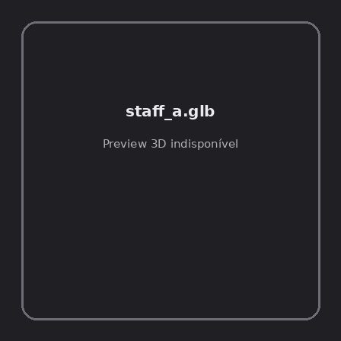
ID | NOV-005453
Origem | Asset novo
Pack/Fonte | Assets Organizados - Weapons
Categoria | Weapons / Staff A.Glb
Arquivo | staff_a.glb
Caminho | 01_Assets_Organizados/Weapons/staff_a.glb
Formato | GLB
Tamanho | 45.73 KB
SHA-256 | fe0df06990f3afbfd37b…
Status técnico | ERROR
Licença | MISSING_REVIEW_REQUIRED — sem evidência localizada
Objetos / meshes | N/D / N/D
Vértices | N/D
Faces / triângulos | N/D / N/D
Materiais | N/D —
UV sets / vertex colors | N/D / N/D
Dimensões XYZ | N/D
Rig / armatures / bones | N/D / N/D / N/D
Skinned meshes | N/D
Animações | N/D —
Duração total clips | N/D
Root motion detectado | N/D
LODs / colliders | Nenhum / Nenhum
Texturas vinculadas | N/D (0 ausentes)
Alertas | Licença/fonte não localizada automaticamente; revisão legal necessária. | Duplicado exato: grupo DUP-00813 (2 cópias).
Notas | Falha na inspeção 3D: RuntimeError: Error: Python: Traceback (most recent call last):  File "/usr/share/blender/scripts/addons/io_scene_gltf2/__init__.py", line 1064, in execute  return self.import_gltf2(context)  File "/usr/share/blender/scripts/addons/io_scene_gltf2/__init__.py", line 1083, in import_gltf2  return self.unit_import(self.filepath, import_settings)  File "/usr/share/blender/scripts/addons/io_scene_gltf2/__init__.py", line 1088, in unit_import  from .blender.imp.gltf2_blender_gltf import BlenderGlTF  File "/usr/share/blender/scripts/addons/io_scene_gltf2/blender/imp/gltf2_blender_gltf.py", line 17, in <module>  from .gltf2_blender_scene import BlenderScene  File "/usr/share/blender/scripts/addons/io_scene_gltf2/blender/imp/gltf2_blender_scene.py", line 17, in <module>  from .gltf2_blender_node import BlenderNode  File "/usr/share/blender/scripts/addons/io_scene_gltf2/blender/imp/gltf2_blender_node.py", line 18, in <module>  from .gltf2_blender_mesh import BlenderMesh  File "/usr/share/blender/scripts/addons/io_scene_gltf2/blender/imp/gltf2_blender_mesh.py", line 17, in <module>  import numpy as np  ModuleNotFoundError: No module named 'numpy'  location: /usr/share/blender/scripts/modules/bpy/ops.py:132  Traceback (most recent call last):  File "/home/runner/work/PSX_demons_whip/PSX_demons_whip/workspace/demons/tools/asset_catalog/blender_batch.py", line 427, in inspect_task  import_model(path)  File "/home/runner/work/PSX_demons_whip/PSX_demons_whip/workspace/demons/tools/asset_catalog/blender_batch.py", line 52, in import_model  bpy.ops.import_scene.gltf(filepath=str(path))  File "/usr/share/blender/scripts/modules/bpy/ops.py", line 132, in __call__  ret = _op_call(self.idname_py(), None, kw)  RuntimeError: Error: Python: Traceback (most recent call last):  File "/usr/share/blender/scripts/addons/io_scene_gltf2/__init__.py", line 1064, in execute  return self.import_gltf2(context)  File "/usr/share/blender/scripts/addons/io_scene_gltf2/__init__.py", line 1083, in import_gltf2  return self.unit_import(self.filepath, import_settings)  File "/usr/share/blender/scripts/addons/io_scene_gltf2/__init__.py", line 1088, in unit_import  from .blender.imp.gltf2_blender_gltf import BlenderGlTF  File "/usr/share/blender/scripts/addons/io_scene_gltf2/blender/imp/gltf2_blender_gltf.py", line 17, in <module>  from .gltf2_blender_scene import BlenderScene  File "/usr/share/blender/scripts/addons/io_scene_gltf2/blender/imp/gltf2_blender_scene.py", line 17, in <module>  from .gltf2_blender_node import BlenderNode  File "/usr/share/blender/scripts/addons/io_scene_gltf2/blender/imp/gltf2_blender_node.py", line 18, in <module>  from .gltf2_blender_mesh import BlenderMesh  File "/usr/share/blender/scripts/addons/io_scene_gltf2/blender/imp/gltf2_blender_mesh.py", line 17, in <module>  import numpy as np  ModuleNotFoundError: No module named 'numpy'  location: /usr/share/blender/scripts/modules/bpy/ops.py:132  | Metadados 3D reutilizados do duplicado idêntico TEM-002187.

NOV-005461 • staff_b [ERROR]

ID | NOV-005461
Origem | Asset novo
Pack/Fonte | Assets Organizados - Weapons
Categoria | Weapons / Staff B.Glb
Arquivo | staff_b.glb
Caminho | 01_Assets_Organizados/Weapons/staff_b.glb
Formato | GLB
Tamanho | 57.00 KB
SHA-256 | d684cbdb0cbfbfa7a4da…
Status técnico | ERROR
Licença | MISSING_REVIEW_REQUIRED — sem evidência localizada
Objetos / meshes | N/D / N/D
Vértices | N/D
Faces / triângulos | N/D / N/D
Materiais | N/D —
UV sets / vertex colors | N/D / N/D
Dimensões XYZ | N/D
Rig / armatures / bones | N/D / N/D / N/D
Skinned meshes | N/D
Animações | N/D —
Duração total clips | N/D
Root motion detectado | N/D
LODs / colliders | Nenhum / Nenhum
Texturas vinculadas | N/D (0 ausentes)
Alertas | Licença/fonte não localizada automaticamente; revisão legal necessária. | Duplicado exato: grupo DUP-00821 (2 cópias).
Notas | Falha na inspeção 3D: RuntimeError: Error: Python: Traceback (most recent call last):  File "/usr/share/blender/scripts/addons/io_scene_gltf2/__init__.py", line 1064, in execute  return self.import_gltf2(context)  File "/usr/share/blender/scripts/addons/io_scene_gltf2/__init__.py", line 1083, in import_gltf2  return self.unit_import(self.filepath, import_settings)  File "/usr/share/blender/scripts/addons/io_scene_gltf2/__init__.py", line 1088, in unit_import  from .blender.imp.gltf2_blender_gltf import BlenderGlTF  File "/usr/share/blender/scripts/addons/io_scene_gltf2/blender/imp/gltf2_blender_gltf.py", line 17, in <module>  from .gltf2_blender_scene import BlenderScene  File "/usr/share/blender/scripts/addons/io_scene_gltf2/blender/imp/gltf2_blender_scene.py", line 17, in <module>  from .gltf2_blender_node import BlenderNode  File "/usr/share/blender/scripts/addons/io_scene_gltf2/blender/imp/gltf2_blender_node.py", line 18, in <module>  from .gltf2_blender_mesh import BlenderMesh  File "/usr/share/blender/scripts/addons/io_scene_gltf2/blender/imp/gltf2_blender_mesh.py", line 17, in <module>  import numpy as np  ModuleNotFoundError: No module named 'numpy'  location: /usr/share/blender/scripts/modules/bpy/ops.py:132  Traceback (most recent call last):  File "/home/runner/work/PSX_demons_whip/PSX_demons_whip/workspace/demons/tools/asset_catalog/blender_batch.py", line 427, in inspect_task  import_model(path)  File "/home/runner/work/PSX_demons_whip/PSX_demons_whip/workspace/demons/tools/asset_catalog/blender_batch.py", line 52, in import_model  bpy.ops.import_scene.gltf(filepath=str(path))  File "/usr/share/blender/scripts/modules/bpy/ops.py", line 132, in __call__  ret = _op_call(self.idname_py(), None, kw)  RuntimeError: Error: Python: Traceback (most recent call last):  File "/usr/share/blender/scripts/addons/io_scene_gltf2/__init__.py", line 1064, in execute  return self.import_gltf2(context)  File "/usr/share/blender/scripts/addons/io_scene_gltf2/__init__.py", line 1083, in import_gltf2  return self.unit_import(self.filepath, import_settings)  File "/usr/share/blender/scripts/addons/io_scene_gltf2/__init__.py", line 1088, in unit_import  from .blender.imp.gltf2_blender_gltf import BlenderGlTF  File "/usr/share/blender/scripts/addons/io_scene_gltf2/blender/imp/gltf2_blender_gltf.py", line 17, in <module>  from .gltf2_blender_scene import BlenderScene  File "/usr/share/blender/scripts/addons/io_scene_gltf2/blender/imp/gltf2_blender_scene.py", line 17, in <module>  from .gltf2_blender_node import BlenderNode  File "/usr/share/blender/scripts/addons/io_scene_gltf2/blender/imp/gltf2_blender_node.py", line 18, in <module>  from .gltf2_blender_mesh import BlenderMesh  File "/usr/share/blender/scripts/addons/io_scene_gltf2/blender/imp/gltf2_blender_mesh.py", line 17, in <module>  import numpy as np  ModuleNotFoundError: No module named 'numpy'  location: /usr/share/blender/scripts/modules/bpy/ops.py:132  | Metadados 3D reutilizados do duplicado idêntico TEM-002195.

NOV-005474 • staff_c [ERROR]
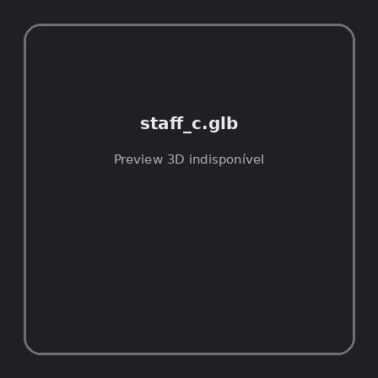
ID | NOV-005474
Origem | Asset novo
Pack/Fonte | Assets Organizados - Weapons
Categoria | Weapons / Staff C.Glb
Arquivo | staff_c.glb
Caminho | 01_Assets_Organizados/Weapons/staff_c.glb
Formato | GLB
Tamanho | 87.18 KB
SHA-256 | bf2a356bfe8a5b22cb6d…
Status técnico | ERROR
Licença | MISSING_REVIEW_REQUIRED — sem evidência localizada
Objetos / meshes | N/D / N/D
Vértices | N/D
Faces / triângulos | N/D / N/D
Materiais | N/D —
UV sets / vertex colors | N/D / N/D
Dimensões XYZ | N/D
Rig / armatures / bones | N/D / N/D / N/D
Skinned meshes | N/D
Animações | N/D —
Duração total clips | N/D
Root motion detectado | N/D
LODs / colliders | Nenhum / Nenhum
Texturas vinculadas | N/D (0 ausentes)
Alertas | Licença/fonte não localizada automaticamente; revisão legal necessária. | Duplicado exato: grupo DUP-00834 (2 cópias).
Notas | Falha na inspeção 3D: RuntimeError: Error: Python: Traceback (most recent call last):  File "/usr/share/blender/scripts/addons/io_scene_gltf2/__init__.py", line 1064, in execute  return self.import_gltf2(context)  File "/usr/share/blender/scripts/addons/io_scene_gltf2/__init__.py", line 1083, in import_gltf2  return self.unit_import(self.filepath, import_settings)  File "/usr/share/blender/scripts/addons/io_scene_gltf2/__init__.py", line 1088, in unit_import  from .blender.imp.gltf2_blender_gltf import BlenderGlTF  File "/usr/share/blender/scripts/addons/io_scene_gltf2/blender/imp/gltf2_blender_gltf.py", line 17, in <module>  from .gltf2_blender_scene import BlenderScene  File "/usr/share/blender/scripts/addons/io_scene_gltf2/blender/imp/gltf2_blender_scene.py", line 17, in <module>  from .gltf2_blender_node import BlenderNode  File "/usr/share/blender/scripts/addons/io_scene_gltf2/blender/imp/gltf2_blender_node.py", line 18, in <module>  from .gltf2_blender_mesh import BlenderMesh  File "/usr/share/blender/scripts/addons/io_scene_gltf2/blender/imp/gltf2_blender_mesh.py", line 17, in <module>  import numpy as np  ModuleNotFoundError: No module named 'numpy'  location: /usr/share/blender/scripts/modules/bpy/ops.py:132  Traceback (most recent call last):  File "/home/runner/work/PSX_demons_whip/PSX_demons_whip/workspace/demons/tools/asset_catalog/blender_batch.py", line 427, in inspect_task  import_model(path)  File "/home/runner/work/PSX_demons_whip/PSX_demons_whip/workspace/demons/tools/asset_catalog/blender_batch.py", line 52, in import_model  bpy.ops.import_scene.gltf(filepath=str(path))  File "/usr/share/blender/scripts/modules/bpy/ops.py", line 132, in __call__  ret = _op_call(self.idname_py(), None, kw)  RuntimeError: Error: Python: Traceback (most recent call last):  File "/usr/share/blender/scripts/addons/io_scene_gltf2/__init__.py", line 1064, in execute  return self.import_gltf2(context)  File "/usr/share/blender/scripts/addons/io_scene_gltf2/__init__.py", line 1083, in import_gltf2  return self.unit_import(self.filepath, import_settings)  File "/usr/share/blender/scripts/addons/io_scene_gltf2/__init__.py", line 1088, in unit_import  from .blender.imp.gltf2_blender_gltf import BlenderGlTF  File "/usr/share/blender/scripts/addons/io_scene_gltf2/blender/imp/gltf2_blender_gltf.py", line 17, in <module>  from .gltf2_blender_scene import BlenderScene  File "/usr/share/blender/scripts/addons/io_scene_gltf2/blender/imp/gltf2_blender_scene.py", line 17, in <module>  from .gltf2_blender_node import BlenderNode  File "/usr/share/blender/scripts/addons/io_scene_gltf2/blender/imp/gltf2_blender_node.py", line 18, in <module>  from .gltf2_blender_mesh import BlenderMesh  File "/usr/share/blender/scripts/addons/io_scene_gltf2/blender/imp/gltf2_blender_mesh.py", line 17, in <module>  import numpy as np  ModuleNotFoundError: No module named 'numpy'  location: /usr/share/blender/scripts/modules/bpy/ops.py:132  | Metadados 3D reutilizados do duplicado idêntico TEM-002208.

NOV-005529 • staff_d [ERROR]
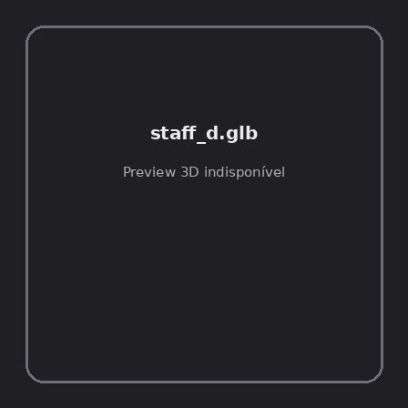
ID | NOV-005529
Origem | Asset novo
Pack/Fonte | Assets Organizados - Weapons
Categoria | Weapons / Staff D.Glb
Arquivo | staff_d.glb
Caminho | 01_Assets_Organizados/Weapons/staff_d.glb
Formato | GLB
Tamanho | 98.86 KB
SHA-256 | 94b636897cb86461157d…
Status técnico | ERROR
Licença | MISSING_REVIEW_REQUIRED — sem evidência localizada
Objetos / meshes | N/D / N/D
Vértices | N/D
Faces / triângulos | N/D / N/D
Materiais | N/D —
UV sets / vertex colors | N/D / N/D
Dimensões XYZ | N/D
Rig / armatures / bones | N/D / N/D / N/D
Skinned meshes | N/D
Animações | N/D —
Duração total clips | N/D
Root motion detectado | N/D
LODs / colliders | Nenhum / Nenhum
Texturas vinculadas | N/D (0 ausentes)
Alertas | Licença/fonte não localizada automaticamente; revisão legal necessária. | Duplicado exato: grupo DUP-00888 (2 cópias).
Notas | Falha na inspeção 3D: RuntimeError: Error: Python: Traceback (most recent call last):  File "/usr/share/blender/scripts/addons/io_scene_gltf2/__init__.py", line 1064, in execute  return self.import_gltf2(context)  File "/usr/share/blender/scripts/addons/io_scene_gltf2/__init__.py", line 1083, in import_gltf2  return self.unit_import(self.filepath, import_settings)  File "/usr/share/blender/scripts/addons/io_scene_gltf2/__init__.py", line 1088, in unit_import  from .blender.imp.gltf2_blender_gltf import BlenderGlTF  File "/usr/share/blender/scripts/addons/io_scene_gltf2/blender/imp/gltf2_blender_gltf.py", line 17, in <module>  from .gltf2_blender_scene import BlenderScene  File "/usr/share/blender/scripts/addons/io_scene_gltf2/blender/imp/gltf2_blender_scene.py", line 17, in <module>  from .gltf2_blender_node import BlenderNode  File "/usr/share/blender/scripts/addons/io_scene_gltf2/blender/imp/gltf2_blender_node.py", line 18, in <module>  from .gltf2_blender_mesh import BlenderMesh  File "/usr/share/blender/scripts/addons/io_scene_gltf2/blender/imp/gltf2_blender_mesh.py", line 17, in <module>  import numpy as np  ModuleNotFoundError: No module named 'numpy'  location: /usr/share/blender/scripts/modules/bpy/ops.py:132  Traceback (most recent call last):  File "/home/runner/work/PSX_demons_whip/PSX_demons_whip/workspace/demons/tools/asset_catalog/blender_batch.py", line 427, in inspect_task  import_model(path)  File "/home/runner/work/PSX_demons_whip/PSX_demons_whip/workspace/demons/tools/asset_catalog/blender_batch.py", line 52, in import_model  bpy.ops.import_scene.gltf(filepath=str(path))  File "/usr/share/blender/scripts/modules/bpy/ops.py", line 132, in __call__  ret = _op_call(self.idname_py(), None, kw)  RuntimeError: Error: Python: Traceback (most recent call last):  File "/usr/share/blender/scripts/addons/io_scene_gltf2/__init__.py", line 1064, in execute  return self.import_gltf2(context)  File "/usr/share/blender/scripts/addons/io_scene_gltf2/__init__.py", line 1083, in import_gltf2  return self.unit_import(self.filepath, import_settings)  File "/usr/share/blender/scripts/addons/io_scene_gltf2/__init__.py", line 1088, in unit_import  from .blender.imp.gltf2_blender_gltf import BlenderGlTF  File "/usr/share/blender/scripts/addons/io_scene_gltf2/blender/imp/gltf2_blender_gltf.py", line 17, in <module>  from .gltf2_blender_scene import BlenderScene  File "/usr/share/blender/scripts/addons/io_scene_gltf2/blender/imp/gltf2_blender_scene.py", line 17, in <module>  from .gltf2_blender_node import BlenderNode  File "/usr/share/blender/scripts/addons/io_scene_gltf2/blender/imp/gltf2_blender_node.py", line 18, in <module>  from .gltf2_blender_mesh import BlenderMesh  File "/usr/share/blender/scripts/addons/io_scene_gltf2/blender/imp/gltf2_blender_mesh.py", line 17, in <module>  import numpy as np  ModuleNotFoundError: No module named 'numpy'  location: /usr/share/blender/scripts/modules/bpy/ops.py:132  | Metadados 3D reutilizados do duplicado idêntico TEM-002262.

NOV-005542 • starfall_judgment_of_the_heavens [ERROR]

ID | NOV-005542
Origem | Asset novo
Pack/Fonte | Assets Organizados - Weapons
Categoria | Weapons / Starfall Judgment Of The Heavens.Glb
Arquivo | starfall_judgment_of_the_heavens.glb
Caminho | 01_Assets_Organizados/Weapons/starfall_judgment_of_the_heavens.glb
Formato | GLB
Tamanho | 88.57 KB
SHA-256 | 2b2254a0e051802f8444…
Status técnico | ERROR
Licença | MISSING_REVIEW_REQUIRED — sem evidência localizada
Objetos / meshes | N/D / N/D
Vértices | N/D
Faces / triângulos | N/D / N/D
Materiais | N/D —
UV sets / vertex colors | N/D / N/D
Dimensões XYZ | N/D
Rig / armatures / bones | N/D / N/D / N/D
Skinned meshes | N/D
Animações | N/D —
Duração total clips | N/D
Root motion detectado | N/D
LODs / colliders | Nenhum / Nenhum
Texturas vinculadas | N/D (0 ausentes)
Alertas | Licença/fonte não localizada automaticamente; revisão legal necessária. | Duplicado exato: grupo DUP-00900 (2 cópias).
Notas | Falha na inspeção 3D: RuntimeError: Error: Python: Traceback (most recent call last):  File "/usr/share/blender/scripts/addons/io_scene_gltf2/__init__.py", line 1064, in execute  return self.import_gltf2(context)  File "/usr/share/blender/scripts/addons/io_scene_gltf2/__init__.py", line 1083, in import_gltf2  return self.unit_import(self.filepath, import_settings)  File "/usr/share/blender/scripts/addons/io_scene_gltf2/__init__.py", line 1088, in unit_import  from .blender.imp.gltf2_blender_gltf import BlenderGlTF  File "/usr/share/blender/scripts/addons/io_scene_gltf2/blender/imp/gltf2_blender_gltf.py", line 17, in <module>  from .gltf2_blender_scene import BlenderScene  File "/usr/share/blender/scripts/addons/io_scene_gltf2/blender/imp/gltf2_blender_scene.py", line 17, in <module>  from .gltf2_blender_node import BlenderNode  File "/usr/share/blender/scripts/addons/io_scene_gltf2/blender/imp/gltf2_blender_node.py", line 18, in <module>  from .gltf2_blender_mesh import BlenderMesh  File "/usr/share/blender/scripts/addons/io_scene_gltf2/blender/imp/gltf2_blender_mesh.py", line 17, in <module>  import numpy as np  ModuleNotFoundError: No module named 'numpy'  location: /usr/share/blender/scripts/modules/bpy/ops.py:132  Traceback (most recent call last):  File "/home/runner/work/PSX_demons_whip/PSX_demons_whip/workspace/demons/tools/asset_catalog/blender_batch.py", line 427, in inspect_task  import_model(path)  File "/home/runner/work/PSX_demons_whip/PSX_demons_whip/workspace/demons/tools/asset_catalog/blender_batch.py", line 52, in import_model  bpy.ops.import_scene.gltf(filepath=str(path))  File "/usr/share/blender/scripts/modules/bpy/ops.py", line 132, in __call__  ret = _op_call(self.idname_py(), None, kw)  RuntimeError: Error: Python: Traceback (most recent call last):  File "/usr/share/blender/scripts/addons/io_scene_gltf2/__init__.py", line 1064, in execute  return self.import_gltf2(context)  File "/usr/share/blender/scripts/addons/io_scene_gltf2/__init__.py", line 1083, in import_gltf2  return self.unit_import(self.filepath, import_settings)  File "/usr/share/blender/scripts/addons/io_scene_gltf2/__init__.py", line 1088, in unit_import  from .blender.imp.gltf2_blender_gltf import BlenderGlTF  File "/usr/share/blender/scripts/addons/io_scene_gltf2/blender/imp/gltf2_blender_gltf.py", line 17, in <module>  from .gltf2_blender_scene import BlenderScene  File "/usr/share/blender/scripts/addons/io_scene_gltf2/blender/imp/gltf2_blender_scene.py", line 17, in <module>  from .gltf2_blender_node import BlenderNode  File "/usr/share/blender/scripts/addons/io_scene_gltf2/blender/imp/gltf2_blender_node.py", line 18, in <module>  from .gltf2_blender_mesh import BlenderMesh  File "/usr/share/blender/scripts/addons/io_scene_gltf2/blender/imp/gltf2_blender_mesh.py", line 17, in <module>  import numpy as np  ModuleNotFoundError: No module named 'numpy'  location: /usr/share/blender/scripts/modules/bpy/ops.py:132  | Metadados 3D reutilizados do duplicado idêntico TEM-002274.

NOV-005462 • sword_1handed [ERROR]
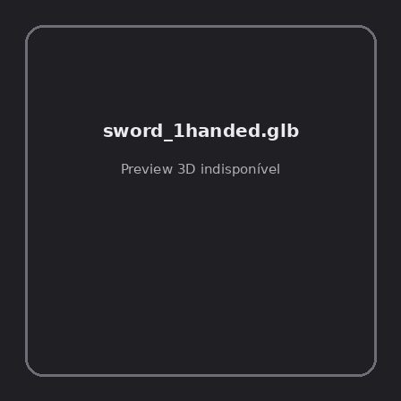
ID | NOV-005462
Origem | Asset novo
Pack/Fonte | Assets Organizados - Weapons
Categoria | Weapons / Sword 1Handed.Glb
Arquivo | sword_1handed.glb
Caminho | 01_Assets_Organizados/Weapons/sword_1handed.glb
Formato | GLB
Tamanho | 29.89 KB
SHA-256 | 3105728b5d9d5636b45c…
Status técnico | ERROR
Licença | MISSING_REVIEW_REQUIRED — sem evidência localizada
Objetos / meshes | N/D / N/D
Vértices | N/D
Faces / triângulos | N/D / N/D
Materiais | N/D —
UV sets / vertex colors | N/D / N/D
Dimensões XYZ | N/D
Rig / armatures / bones | N/D / N/D / N/D
Skinned meshes | N/D
Animações | N/D —
Duração total clips | N/D
Root motion detectado | N/D
LODs / colliders | Nenhum / Nenhum
Texturas vinculadas | N/D (0 ausentes)
Alertas | Licença/fonte não localizada automaticamente; revisão legal necessária. | Duplicado exato: grupo DUP-00822 (2 cópias).
Notas | Falha na inspeção 3D: RuntimeError: Error: Python: Traceback (most recent call last):  File "/usr/share/blender/scripts/addons/io_scene_gltf2/__init__.py", line 1064, in execute  return self.import_gltf2(context)  File "/usr/share/blender/scripts/addons/io_scene_gltf2/__init__.py", line 1083, in import_gltf2  return self.unit_import(self.filepath, import_settings)  File "/usr/share/blender/scripts/addons/io_scene_gltf2/__init__.py", line 1088, in unit_import  from .blender.imp.gltf2_blender_gltf import BlenderGlTF  File "/usr/share/blender/scripts/addons/io_scene_gltf2/blender/imp/gltf2_blender_gltf.py", line 17, in <module>  from .gltf2_blender_scene import BlenderScene  File "/usr/share/blender/scripts/addons/io_scene_gltf2/blender/imp/gltf2_blender_scene.py", line 17, in <module>  from .gltf2_blender_node import BlenderNode  File "/usr/share/blender/scripts/addons/io_scene_gltf2/blender/imp/gltf2_blender_node.py", line 18, in <module>  from .gltf2_blender_mesh import BlenderMesh  File "/usr/share/blender/scripts/addons/io_scene_gltf2/blender/imp/gltf2_blender_mesh.py", line 17, in <module>  import numpy as np  ModuleNotFoundError: No module named 'numpy'  location: /usr/share/blender/scripts/modules/bpy/ops.py:132  Traceback (most recent call last):  File "/home/runner/work/PSX_demons_whip/PSX_demons_whip/workspace/demons/tools/asset_catalog/blender_batch.py", line 427, in inspect_task  import_model(path)  File "/home/runner/work/PSX_demons_whip/PSX_demons_whip/workspace/demons/tools/asset_catalog/blender_batch.py", line 52, in import_model  bpy.ops.import_scene.gltf(filepath=str(path))  File "/usr/share/blender/scripts/modules/bpy/ops.py", line 132, in __call__  ret = _op_call(self.idname_py(), None, kw)  RuntimeError: Error: Python: Traceback (most recent call last):  File "/usr/share/blender/scripts/addons/io_scene_gltf2/__init__.py", line 1064, in execute  return self.import_gltf2(context)  File "/usr/share/blender/scripts/addons/io_scene_gltf2/__init__.py", line 1083, in import_gltf2  return self.unit_import(self.filepath, import_settings)  File "/usr/share/blender/scripts/addons/io_scene_gltf2/__init__.py", line 1088, in unit_import  from .blender.imp.gltf2_blender_gltf import BlenderGlTF  File "/usr/share/blender/scripts/addons/io_scene_gltf2/blender/imp/gltf2_blender_gltf.py", line 17, in <module>  from .gltf2_blender_scene import BlenderScene  File "/usr/share/blender/scripts/addons/io_scene_gltf2/blender/imp/gltf2_blender_scene.py", line 17, in <module>  from .gltf2_blender_node import BlenderNode  File "/usr/share/blender/scripts/addons/io_scene_gltf2/blender/imp/gltf2_blender_node.py", line 18, in <module>  from .gltf2_blender_mesh import BlenderMesh  File "/usr/share/blender/scripts/addons/io_scene_gltf2/blender/imp/gltf2_blender_mesh.py", line 17, in <module>  import numpy as np  ModuleNotFoundError: No module named 'numpy'  location: /usr/share/blender/scripts/modules/bpy/ops.py:132  | Metadados 3D reutilizados do duplicado idêntico TEM-002196.

NOV-005467 • sword_2handed [ERROR]
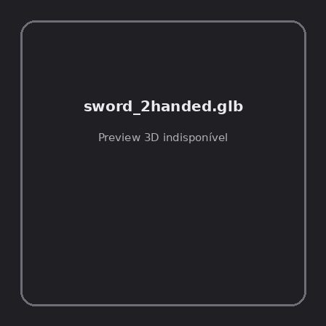
ID | NOV-005467
Origem | Asset novo
Pack/Fonte | Assets Organizados - Weapons
Categoria | Weapons / Sword 2Handed.Glb
Arquivo | sword_2handed.glb
Caminho | 01_Assets_Organizados/Weapons/sword_2handed.glb
Formato | GLB
Tamanho | 31.76 KB
SHA-256 | 253a022ab12076b48c97…
Status técnico | ERROR
Licença | MISSING_REVIEW_REQUIRED — sem evidência localizada
Objetos / meshes | N/D / N/D
Vértices | N/D
Faces / triângulos | N/D / N/D
Materiais | N/D —
UV sets / vertex colors | N/D / N/D
Dimensões XYZ | N/D
Rig / armatures / bones | N/D / N/D / N/D
Skinned meshes | N/D
Animações | N/D —
Duração total clips | N/D
Root motion detectado | N/D
LODs / colliders | Nenhum / Nenhum
Texturas vinculadas | N/D (0 ausentes)
Alertas | Licença/fonte não localizada automaticamente; revisão legal necessária. | Duplicado exato: grupo DUP-00827 (2 cópias).
Notas | Falha na inspeção 3D: RuntimeError: Error: Python: Traceback (most recent call last):  File "/usr/share/blender/scripts/addons/io_scene_gltf2/__init__.py", line 1064, in execute  return self.import_gltf2(context)  File "/usr/share/blender/scripts/addons/io_scene_gltf2/__init__.py", line 1083, in import_gltf2  return self.unit_import(self.filepath, import_settings)  File "/usr/share/blender/scripts/addons/io_scene_gltf2/__init__.py", line 1088, in unit_import  from .blender.imp.gltf2_blender_gltf import BlenderGlTF  File "/usr/share/blender/scripts/addons/io_scene_gltf2/blender/imp/gltf2_blender_gltf.py", line 17, in <module>  from .gltf2_blender_scene import BlenderScene  File "/usr/share/blender/scripts/addons/io_scene_gltf2/blender/imp/gltf2_blender_scene.py", line 17, in <module>  from .gltf2_blender_node import BlenderNode  File "/usr/share/blender/scripts/addons/io_scene_gltf2/blender/imp/gltf2_blender_node.py", line 18, in <module>  from .gltf2_blender_mesh import BlenderMesh  File "/usr/share/blender/scripts/addons/io_scene_gltf2/blender/imp/gltf2_blender_mesh.py", line 17, in <module>  import numpy as np  ModuleNotFoundError: No module named 'numpy'  location: /usr/share/blender/scripts/modules/bpy/ops.py:132  Traceback (most recent call last):  File "/home/runner/work/PSX_demons_whip/PSX_demons_whip/workspace/demons/tools/asset_catalog/blender_batch.py", line 427, in inspect_task  import_model(path)  File "/home/runner/work/PSX_demons_whip/PSX_demons_whip/workspace/demons/tools/asset_catalog/blender_batch.py", line 52, in import_model  bpy.ops.import_scene.gltf(filepath=str(path))  File "/usr/share/blender/scripts/modules/bpy/ops.py", line 132, in __call__  ret = _op_call(self.idname_py(), None, kw)  RuntimeError: Error: Python: Traceback (most recent call last):  File "/usr/share/blender/scripts/addons/io_scene_gltf2/__init__.py", line 1064, in execute  return self.import_gltf2(context)  File "/usr/share/blender/scripts/addons/io_scene_gltf2/__init__.py", line 1083, in import_gltf2  return self.unit_import(self.filepath, import_settings)  File "/usr/share/blender/scripts/addons/io_scene_gltf2/__init__.py", line 1088, in unit_import  from .blender.imp.gltf2_blender_gltf import BlenderGlTF  File "/usr/share/blender/scripts/addons/io_scene_gltf2/blender/imp/gltf2_blender_gltf.py", line 17, in <module>  from .gltf2_blender_scene import BlenderScene  File "/usr/share/blender/scripts/addons/io_scene_gltf2/blender/imp/gltf2_blender_scene.py", line 17, in <module>  from .gltf2_blender_node import BlenderNode  File "/usr/share/blender/scripts/addons/io_scene_gltf2/blender/imp/gltf2_blender_node.py", line 18, in <module>  from .gltf2_blender_mesh import BlenderMesh  File "/usr/share/blender/scripts/addons/io_scene_gltf2/blender/imp/gltf2_blender_mesh.py", line 17, in <module>  import numpy as np  ModuleNotFoundError: No module named 'numpy'  location: /usr/share/blender/scripts/modules/bpy/ops.py:132  | Metadados 3D reutilizados do duplicado idêntico TEM-002201.

NOV-005531 • sword_a [ERROR]
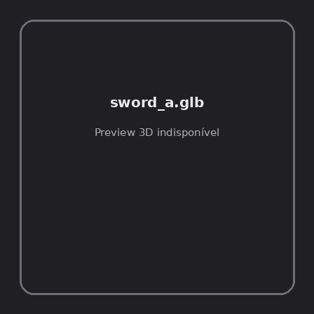
ID | NOV-005531
Origem | Asset novo
Pack/Fonte | Assets Organizados - Weapons
Categoria | Weapons / Sword A.Glb
Arquivo | sword_a.glb
Caminho | 01_Assets_Organizados/Weapons/sword_a.glb
Formato | GLB
Tamanho | 38.39 KB
SHA-256 | f6eab292389ff213d7df…
Status técnico | ERROR
Licença | MISSING_REVIEW_REQUIRED — sem evidência localizada
Objetos / meshes | N/D / N/D
Vértices | N/D
Faces / triângulos | N/D / N/D
Materiais | N/D —
UV sets / vertex colors | N/D / N/D
Dimensões XYZ | N/D
Rig / armatures / bones | N/D / N/D / N/D
Skinned meshes | N/D
Animações | N/D —
Duração total clips | N/D
Root motion detectado | N/D
LODs / colliders | Nenhum / Nenhum
Texturas vinculadas | N/D (0 ausentes)
Alertas | Licença/fonte não localizada automaticamente; revisão legal necessária. | Duplicado exato: grupo DUP-00890 (2 cópias).
Notas | Falha na inspeção 3D: RuntimeError: Error: Python: Traceback (most recent call last):  File "/usr/share/blender/scripts/addons/io_scene_gltf2/__init__.py", line 1064, in execute  return self.import_gltf2(context)  File "/usr/share/blender/scripts/addons/io_scene_gltf2/__init__.py", line 1083, in import_gltf2  return self.unit_import(self.filepath, import_settings)  File "/usr/share/blender/scripts/addons/io_scene_gltf2/__init__.py", line 1088, in unit_import  from .blender.imp.gltf2_blender_gltf import BlenderGlTF  File "/usr/share/blender/scripts/addons/io_scene_gltf2/blender/imp/gltf2_blender_gltf.py", line 17, in <module>  from .gltf2_blender_scene import BlenderScene  File "/usr/share/blender/scripts/addons/io_scene_gltf2/blender/imp/gltf2_blender_scene.py", line 17, in <module>  from .gltf2_blender_node import BlenderNode  File "/usr/share/blender/scripts/addons/io_scene_gltf2/blender/imp/gltf2_blender_node.py", line 18, in <module>  from .gltf2_blender_mesh import BlenderMesh  File "/usr/share/blender/scripts/addons/io_scene_gltf2/blender/imp/gltf2_blender_mesh.py", line 17, in <module>  import numpy as np  ModuleNotFoundError: No module named 'numpy'  location: /usr/share/blender/scripts/modules/bpy/ops.py:132  Traceback (most recent call last):  File "/home/runner/work/PSX_demons_whip/PSX_demons_whip/workspace/demons/tools/asset_catalog/blender_batch.py", line 427, in inspect_task  import_model(path)  File "/home/runner/work/PSX_demons_whip/PSX_demons_whip/workspace/demons/tools/asset_catalog/blender_batch.py", line 52, in import_model  bpy.ops.import_scene.gltf(filepath=str(path))  File "/usr/share/blender/scripts/modules/bpy/ops.py", line 132, in __call__  ret = _op_call(self.idname_py(), None, kw)  RuntimeError: Error: Python: Traceback (most recent call last):  File "/usr/share/blender/scripts/addons/io_scene_gltf2/__init__.py", line 1064, in execute  return self.import_gltf2(context)  File "/usr/share/blender/scripts/addons/io_scene_gltf2/__init__.py", line 1083, in import_gltf2  return self.unit_import(self.filepath, import_settings)  File "/usr/share/blender/scripts/addons/io_scene_gltf2/__init__.py", line 1088, in unit_import  from .blender.imp.gltf2_blender_gltf import BlenderGlTF  File "/usr/share/blender/scripts/addons/io_scene_gltf2/blender/imp/gltf2_blender_gltf.py", line 17, in <module>  from .gltf2_blender_scene import BlenderScene  File "/usr/share/blender/scripts/addons/io_scene_gltf2/blender/imp/gltf2_blender_scene.py", line 17, in <module>  from .gltf2_blender_node import BlenderNode  File "/usr/share/blender/scripts/addons/io_scene_gltf2/blender/imp/gltf2_blender_node.py", line 18, in <module>  from .gltf2_blender_mesh import BlenderMesh  File "/usr/share/blender/scripts/addons/io_scene_gltf2/blender/imp/gltf2_blender_mesh.py", line 17, in <module>  import numpy as np  ModuleNotFoundError: No module named 'numpy'  location: /usr/share/blender/scripts/modules/bpy/ops.py:132  | Metadados 3D reutilizados do duplicado idêntico TEM-002264.

NOV-005480 • sword_b [ERROR]

ID | NOV-005480
Origem | Asset novo
Pack/Fonte | Assets Organizados - Weapons
Categoria | Weapons / Sword B.Glb
Arquivo | sword_b.glb
Caminho | 01_Assets_Organizados/Weapons/sword_b.glb
Formato | GLB
Tamanho | 44.97 KB
SHA-256 | f3c06d74db3873de33f0…
Status técnico | ERROR
Licença | MISSING_REVIEW_REQUIRED — sem evidência localizada
Objetos / meshes | N/D / N/D
Vértices | N/D
Faces / triângulos | N/D / N/D
Materiais | N/D —
UV sets / vertex colors | N/D / N/D
Dimensões XYZ | N/D
Rig / armatures / bones | N/D / N/D / N/D
Skinned meshes | N/D
Animações | N/D —
Duração total clips | N/D
Root motion detectado | N/D
LODs / colliders | Nenhum / Nenhum
Texturas vinculadas | N/D (0 ausentes)
Alertas | Licença/fonte não localizada automaticamente; revisão legal necessária. | Duplicado exato: grupo DUP-00840 (2 cópias).
Notas | Falha na inspeção 3D: RuntimeError: Error: Python: Traceback (most recent call last):  File "/usr/share/blender/scripts/addons/io_scene_gltf2/__init__.py", line 1064, in execute  return self.import_gltf2(context)  File "/usr/share/blender/scripts/addons/io_scene_gltf2/__init__.py", line 1083, in import_gltf2  return self.unit_import(self.filepath, import_settings)  File "/usr/share/blender/scripts/addons/io_scene_gltf2/__init__.py", line 1088, in unit_import  from .blender.imp.gltf2_blender_gltf import BlenderGlTF  File "/usr/share/blender/scripts/addons/io_scene_gltf2/blender/imp/gltf2_blender_gltf.py", line 17, in <module>  from .gltf2_blender_scene import BlenderScene  File "/usr/share/blender/scripts/addons/io_scene_gltf2/blender/imp/gltf2_blender_scene.py", line 17, in <module>  from .gltf2_blender_node import BlenderNode  File "/usr/share/blender/scripts/addons/io_scene_gltf2/blender/imp/gltf2_blender_node.py", line 18, in <module>  from .gltf2_blender_mesh import BlenderMesh  File "/usr/share/blender/scripts/addons/io_scene_gltf2/blender/imp/gltf2_blender_mesh.py", line 17, in <module>  import numpy as np  ModuleNotFoundError: No module named 'numpy'  location: /usr/share/blender/scripts/modules/bpy/ops.py:132  Traceback (most recent call last):  File "/home/runner/work/PSX_demons_whip/PSX_demons_whip/workspace/demons/tools/asset_catalog/blender_batch.py", line 427, in inspect_task  import_model(path)  File "/home/runner/work/PSX_demons_whip/PSX_demons_whip/workspace/demons/tools/asset_catalog/blender_batch.py", line 52, in import_model  bpy.ops.import_scene.gltf(filepath=str(path))  File "/usr/share/blender/scripts/modules/bpy/ops.py", line 132, in __call__  ret = _op_call(self.idname_py(), None, kw)  RuntimeError: Error: Python: Traceback (most recent call last):  File "/usr/share/blender/scripts/addons/io_scene_gltf2/__init__.py", line 1064, in execute  return self.import_gltf2(context)  File "/usr/share/blender/scripts/addons/io_scene_gltf2/__init__.py", line 1083, in import_gltf2  return self.unit_import(self.filepath, import_settings)  File "/usr/share/blender/scripts/addons/io_scene_gltf2/__init__.py", line 1088, in unit_import  from .blender.imp.gltf2_blender_gltf import BlenderGlTF  File "/usr/share/blender/scripts/addons/io_scene_gltf2/blender/imp/gltf2_blender_gltf.py", line 17, in <module>  from .gltf2_blender_scene import BlenderScene  File "/usr/share/blender/scripts/addons/io_scene_gltf2/blender/imp/gltf2_blender_scene.py", line 17, in <module>  from .gltf2_blender_node import BlenderNode  File "/usr/share/blender/scripts/addons/io_scene_gltf2/blender/imp/gltf2_blender_node.py", line 18, in <module>  from .gltf2_blender_mesh import BlenderMesh  File "/usr/share/blender/scripts/addons/io_scene_gltf2/blender/imp/gltf2_blender_mesh.py", line 17, in <module>  import numpy as np  ModuleNotFoundError: No module named 'numpy'  location: /usr/share/blender/scripts/modules/bpy/ops.py:132  | Metadados 3D reutilizados do duplicado idêntico TEM-002214.

NOV-005488 • sword_c [ERROR]
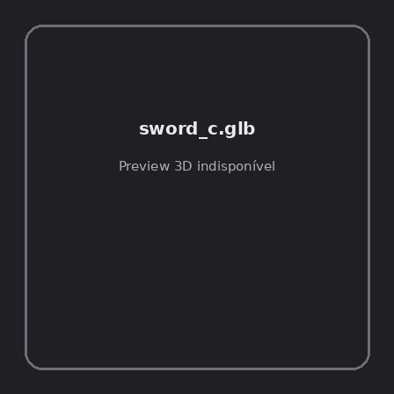
ID | NOV-005488
Origem | Asset novo
Pack/Fonte | Assets Organizados - Weapons
Categoria | Weapons / Sword C.Glb
Arquivo | sword_c.glb
Caminho | 01_Assets_Organizados/Weapons/sword_c.glb
Formato | GLB
Tamanho | 41.79 KB
SHA-256 | 458e0f1a5426f52d3fd3…
Status técnico | ERROR
Licença | MISSING_REVIEW_REQUIRED — sem evidência localizada
Objetos / meshes | N/D / N/D
Vértices | N/D
Faces / triângulos | N/D / N/D
Materiais | N/D —
UV sets / vertex colors | N/D / N/D
Dimensões XYZ | N/D
Rig / armatures / bones | N/D / N/D / N/D
Skinned meshes | N/D
Animações | N/D —
Duração total clips | N/D
Root motion detectado | N/D
LODs / colliders | Nenhum / Nenhum
Texturas vinculadas | N/D (0 ausentes)
Alertas | Licença/fonte não localizada automaticamente; revisão legal necessária. | Duplicado exato: grupo DUP-00848 (2 cópias).
Notas | Falha na inspeção 3D: RuntimeError: Error: Python: Traceback (most recent call last):  File "/usr/share/blender/scripts/addons/io_scene_gltf2/__init__.py", line 1064, in execute  return self.import_gltf2(context)  File "/usr/share/blender/scripts/addons/io_scene_gltf2/__init__.py", line 1083, in import_gltf2  return self.unit_import(self.filepath, import_settings)  File "/usr/share/blender/scripts/addons/io_scene_gltf2/__init__.py", line 1088, in unit_import  from .blender.imp.gltf2_blender_gltf import BlenderGlTF  File "/usr/share/blender/scripts/addons/io_scene_gltf2/blender/imp/gltf2_blender_gltf.py", line 17, in <module>  from .gltf2_blender_scene import BlenderScene  File "/usr/share/blender/scripts/addons/io_scene_gltf2/blender/imp/gltf2_blender_scene.py", line 17, in <module>  from .gltf2_blender_node import BlenderNode  File "/usr/share/blender/scripts/addons/io_scene_gltf2/blender/imp/gltf2_blender_node.py", line 18, in <module>  from .gltf2_blender_mesh import BlenderMesh  File "/usr/share/blender/scripts/addons/io_scene_gltf2/blender/imp/gltf2_blender_mesh.py", line 17, in <module>  import numpy as np  ModuleNotFoundError: No module named 'numpy'  location: /usr/share/blender/scripts/modules/bpy/ops.py:132  Traceback (most recent call last):  File "/home/runner/work/PSX_demons_whip/PSX_demons_whip/workspace/demons/tools/asset_catalog/blender_batch.py", line 427, in inspect_task  import_model(path)  File "/home/runner/work/PSX_demons_whip/PSX_demons_whip/workspace/demons/tools/asset_catalog/blender_batch.py", line 52, in import_model  bpy.ops.import_scene.gltf(filepath=str(path))  File "/usr/share/blender/scripts/modules/bpy/ops.py", line 132, in __call__  ret = _op_call(self.idname_py(), None, kw)  RuntimeError: Error: Python: Traceback (most recent call last):  File "/usr/share/blender/scripts/addons/io_scene_gltf2/__init__.py", line 1064, in execute  return self.import_gltf2(context)  File "/usr/share/blender/scripts/addons/io_scene_gltf2/__init__.py", line 1083, in import_gltf2  return self.unit_import(self.filepath, import_settings)  File "/usr/share/blender/scripts/addons/io_scene_gltf2/__init__.py", line 1088, in unit_import  from .blender.imp.gltf2_blender_gltf import BlenderGlTF  File "/usr/share/blender/scripts/addons/io_scene_gltf2/blender/imp/gltf2_blender_gltf.py", line 17, in <module>  from .gltf2_blender_scene import BlenderScene  File "/usr/share/blender/scripts/addons/io_scene_gltf2/blender/imp/gltf2_blender_scene.py", line 17, in <module>  from .gltf2_blender_node import BlenderNode  File "/usr/share/blender/scripts/addons/io_scene_gltf2/blender/imp/gltf2_blender_node.py", line 18, in <module>  from .gltf2_blender_mesh import BlenderMesh  File "/usr/share/blender/scripts/addons/io_scene_gltf2/blender/imp/gltf2_blender_mesh.py", line 17, in <module>  import numpy as np  ModuleNotFoundError: No module named 'numpy'  location: /usr/share/blender/scripts/modules/bpy/ops.py:132  | Metadados 3D reutilizados do duplicado idêntico TEM-002222.

NOV-005504 • sword_d [ERROR]
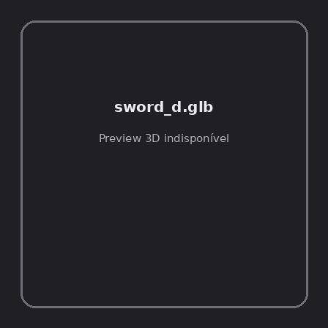
ID | NOV-005504
Origem | Asset novo
Pack/Fonte | Assets Organizados - Weapons
Categoria | Weapons / Sword D.Glb
Arquivo | sword_d.glb
Caminho | 01_Assets_Organizados/Weapons/sword_d.glb
Formato | GLB
Tamanho | 50.57 KB
SHA-256 | af20cd476a533dd600d1…
Status técnico | ERROR
Licença | MISSING_REVIEW_REQUIRED — sem evidência localizada
Objetos / meshes | N/D / N/D
Vértices | N/D
Faces / triângulos | N/D / N/D
Materiais | N/D —
UV sets / vertex colors | N/D / N/D
Dimensões XYZ | N/D
Rig / armatures / bones | N/D / N/D / N/D
Skinned meshes | N/D
Animações | N/D —
Duração total clips | N/D
Root motion detectado | N/D
LODs / colliders | Nenhum / Nenhum
Texturas vinculadas | N/D (0 ausentes)
Alertas | Licença/fonte não localizada automaticamente; revisão legal necessária. | Duplicado exato: grupo DUP-00864 (2 cópias).
Notas | Falha na inspeção 3D: RuntimeError: Error: Python: Traceback (most recent call last):  File "/usr/share/blender/scripts/addons/io_scene_gltf2/__init__.py", line 1064, in execute  return self.import_gltf2(context)  File "/usr/share/blender/scripts/addons/io_scene_gltf2/__init__.py", line 1083, in import_gltf2  return self.unit_import(self.filepath, import_settings)  File "/usr/share/blender/scripts/addons/io_scene_gltf2/__init__.py", line 1088, in unit_import  from .blender.imp.gltf2_blender_gltf import BlenderGlTF  File "/usr/share/blender/scripts/addons/io_scene_gltf2/blender/imp/gltf2_blender_gltf.py", line 17, in <module>  from .gltf2_blender_scene import BlenderScene  File "/usr/share/blender/scripts/addons/io_scene_gltf2/blender/imp/gltf2_blender_scene.py", line 17, in <module>  from .gltf2_blender_node import BlenderNode  File "/usr/share/blender/scripts/addons/io_scene_gltf2/blender/imp/gltf2_blender_node.py", line 18, in <module>  from .gltf2_blender_mesh import BlenderMesh  File "/usr/share/blender/scripts/addons/io_scene_gltf2/blender/imp/gltf2_blender_mesh.py", line 17, in <module>  import numpy as np  ModuleNotFoundError: No module named 'numpy'  location: /usr/share/blender/scripts/modules/bpy/ops.py:132  Traceback (most recent call last):  File "/home/runner/work/PSX_demons_whip/PSX_demons_whip/workspace/demons/tools/asset_catalog/blender_batch.py", line 427, in inspect_task  import_model(path)  File "/home/runner/work/PSX_demons_whip/PSX_demons_whip/workspace/demons/tools/asset_catalog/blender_batch.py", line 52, in import_model  bpy.ops.import_scene.gltf(filepath=str(path))  File "/usr/share/blender/scripts/modules/bpy/ops.py", line 132, in __call__  ret = _op_call(self.idname_py(), None, kw)  RuntimeError: Error: Python: Traceback (most recent call last):  File "/usr/share/blender/scripts/addons/io_scene_gltf2/__init__.py", line 1064, in execute  return self.import_gltf2(context)  File "/usr/share/blender/scripts/addons/io_scene_gltf2/__init__.py", line 1083, in import_gltf2  return self.unit_import(self.filepath, import_settings)  File "/usr/share/blender/scripts/addons/io_scene_gltf2/__init__.py", line 1088, in unit_import  from .blender.imp.gltf2_blender_gltf import BlenderGlTF  File "/usr/share/blender/scripts/addons/io_scene_gltf2/blender/imp/gltf2_blender_gltf.py", line 17, in <module>  from .gltf2_blender_scene import BlenderScene  File "/usr/share/blender/scripts/addons/io_scene_gltf2/blender/imp/gltf2_blender_scene.py", line 17, in <module>  from .gltf2_blender_node import BlenderNode  File "/usr/share/blender/scripts/addons/io_scene_gltf2/blender/imp/gltf2_blender_node.py", line 18, in <module>  from .gltf2_blender_mesh import BlenderMesh  File "/usr/share/blender/scripts/addons/io_scene_gltf2/blender/imp/gltf2_blender_mesh.py", line 17, in <module>  import numpy as np  ModuleNotFoundError: No module named 'numpy'  location: /usr/share/blender/scripts/modules/bpy/ops.py:132  | Metadados 3D reutilizados do duplicado idêntico TEM-002238.

NOV-005490 • sword_e [ERROR]
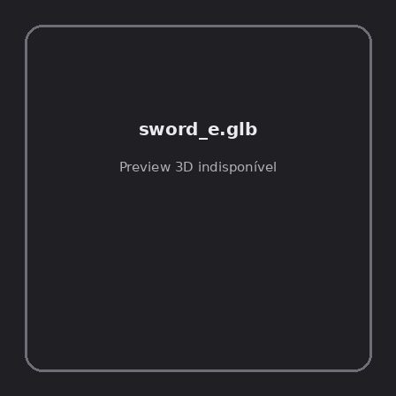
ID | NOV-005490
Origem | Asset novo
Pack/Fonte | Assets Organizados - Weapons
Categoria | Weapons / Sword E.Glb
Arquivo | sword_e.glb
Caminho | 01_Assets_Organizados/Weapons/sword_e.glb
Formato | GLB
Tamanho | 54.38 KB
SHA-256 | 7f4884010f02ac19fd8f…
Status técnico | ERROR
Licença | MISSING_REVIEW_REQUIRED — sem evidência localizada
Objetos / meshes | N/D / N/D
Vértices | N/D
Faces / triângulos | N/D / N/D
Materiais | N/D —
UV sets / vertex colors | N/D / N/D
Dimensões XYZ | N/D
Rig / armatures / bones | N/D / N/D / N/D
Skinned meshes | N/D
Animações | N/D —
Duração total clips | N/D
Root motion detectado | N/D
LODs / colliders | Nenhum / Nenhum
Texturas vinculadas | N/D (0 ausentes)
Alertas | Licença/fonte não localizada automaticamente; revisão legal necessária. | Duplicado exato: grupo DUP-00850 (2 cópias).
Notas | Falha na inspeção 3D: RuntimeError: Error: Python: Traceback (most recent call last):  File "/usr/share/blender/scripts/addons/io_scene_gltf2/__init__.py", line 1064, in execute  return self.import_gltf2(context)  File "/usr/share/blender/scripts/addons/io_scene_gltf2/__init__.py", line 1083, in import_gltf2  return self.unit_import(self.filepath, import_settings)  File "/usr/share/blender/scripts/addons/io_scene_gltf2/__init__.py", line 1088, in unit_import  from .blender.imp.gltf2_blender_gltf import BlenderGlTF  File "/usr/share/blender/scripts/addons/io_scene_gltf2/blender/imp/gltf2_blender_gltf.py", line 17, in <module>  from .gltf2_blender_scene import BlenderScene  File "/usr/share/blender/scripts/addons/io_scene_gltf2/blender/imp/gltf2_blender_scene.py", line 17, in <module>  from .gltf2_blender_node import BlenderNode  File "/usr/share/blender/scripts/addons/io_scene_gltf2/blender/imp/gltf2_blender_node.py", line 18, in <module>  from .gltf2_blender_mesh import BlenderMesh  File "/usr/share/blender/scripts/addons/io_scene_gltf2/blender/imp/gltf2_blender_mesh.py", line 17, in <module>  import numpy as np  ModuleNotFoundError: No module named 'numpy'  location: /usr/share/blender/scripts/modules/bpy/ops.py:132  Traceback (most recent call last):  File "/home/runner/work/PSX_demons_whip/PSX_demons_whip/workspace/demons/tools/asset_catalog/blender_batch.py", line 427, in inspect_task  import_model(path)  File "/home/runner/work/PSX_demons_whip/PSX_demons_whip/workspace/demons/tools/asset_catalog/blender_batch.py", line 52, in import_model  bpy.ops.import_scene.gltf(filepath=str(path))  File "/usr/share/blender/scripts/modules/bpy/ops.py", line 132, in __call__  ret = _op_call(self.idname_py(), None, kw)  RuntimeError: Error: Python: Traceback (most recent call last):  File "/usr/share/blender/scripts/addons/io_scene_gltf2/__init__.py", line 1064, in execute  return self.import_gltf2(context)  File "/usr/share/blender/scripts/addons/io_scene_gltf2/__init__.py", line 1083, in import_gltf2  return self.unit_import(self.filepath, import_settings)  File "/usr/share/blender/scripts/addons/io_scene_gltf2/__init__.py", line 1088, in unit_import  from .blender.imp.gltf2_blender_gltf import BlenderGlTF  File "/usr/share/blender/scripts/addons/io_scene_gltf2/blender/imp/gltf2_blender_gltf.py", line 17, in <module>  from .gltf2_blender_scene import BlenderScene  File "/usr/share/blender/scripts/addons/io_scene_gltf2/blender/imp/gltf2_blender_scene.py", line 17, in <module>  from .gltf2_blender_node import BlenderNode  File "/usr/share/blender/scripts/addons/io_scene_gltf2/blender/imp/gltf2_blender_node.py", line 18, in <module>  from .gltf2_blender_mesh import BlenderMesh  File "/usr/share/blender/scripts/addons/io_scene_gltf2/blender/imp/gltf2_blender_mesh.py", line 17, in <module>  import numpy as np  ModuleNotFoundError: No module named 'numpy'  location: /usr/share/blender/scripts/modules/bpy/ops.py:132  | Metadados 3D reutilizados do duplicado idêntico TEM-002224.

NOV-005442 • sword_f [ERROR]
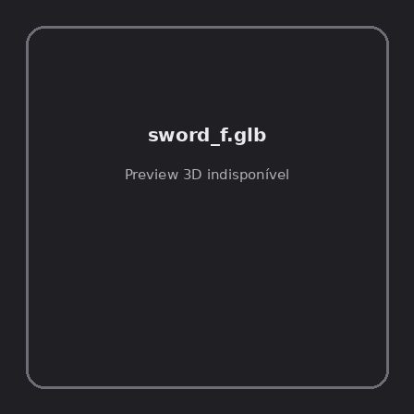
ID | NOV-005442
Origem | Asset novo
Pack/Fonte | Assets Organizados - Weapons
Categoria | Weapons / Sword F.Glb
Arquivo | sword_f.glb
Caminho | 01_Assets_Organizados/Weapons/sword_f.glb
Formato | GLB
Tamanho | 60.18 KB
SHA-256 | fa88102e77ed025c2eec…
Status técnico | ERROR
Licença | MISSING_REVIEW_REQUIRED — sem evidência localizada
Objetos / meshes | N/D / N/D
Vértices | N/D
Faces / triângulos | N/D / N/D
Materiais | N/D —
UV sets / vertex colors | N/D / N/D
Dimensões XYZ | N/D
Rig / armatures / bones | N/D / N/D / N/D
Skinned meshes | N/D
Animações | N/D —
Duração total clips | N/D
Root motion detectado | N/D
LODs / colliders | Nenhum / Nenhum
Texturas vinculadas | N/D (0 ausentes)
Alertas | Licença/fonte não localizada automaticamente; revisão legal necessária. | Duplicado exato: grupo DUP-00802 (2 cópias).
Notas | Falha na inspeção 3D: RuntimeError: Error: Python: Traceback (most recent call last):  File "/usr/share/blender/scripts/addons/io_scene_gltf2/__init__.py", line 1064, in execute  return self.import_gltf2(context)  File "/usr/share/blender/scripts/addons/io_scene_gltf2/__init__.py", line 1083, in import_gltf2  return self.unit_import(self.filepath, import_settings)  File "/usr/share/blender/scripts/addons/io_scene_gltf2/__init__.py", line 1088, in unit_import  from .blender.imp.gltf2_blender_gltf import BlenderGlTF  File "/usr/share/blender/scripts/addons/io_scene_gltf2/blender/imp/gltf2_blender_gltf.py", line 17, in <module>  from .gltf2_blender_scene import BlenderScene  File "/usr/share/blender/scripts/addons/io_scene_gltf2/blender/imp/gltf2_blender_scene.py", line 17, in <module>  from .gltf2_blender_node import BlenderNode  File "/usr/share/blender/scripts/addons/io_scene_gltf2/blender/imp/gltf2_blender_node.py", line 18, in <module>  from .gltf2_blender_mesh import BlenderMesh  File "/usr/share/blender/scripts/addons/io_scene_gltf2/blender/imp/gltf2_blender_mesh.py", line 17, in <module>  import numpy as np  ModuleNotFoundError: No module named 'numpy'  location: /usr/share/blender/scripts/modules/bpy/ops.py:132  Traceback (most recent call last):  File "/home/runner/work/PSX_demons_whip/PSX_demons_whip/workspace/demons/tools/asset_catalog/blender_batch.py", line 427, in inspect_task  import_model(path)  File "/home/runner/work/PSX_demons_whip/PSX_demons_whip/workspace/demons/tools/asset_catalog/blender_batch.py", line 52, in import_model  bpy.ops.import_scene.gltf(filepath=str(path))  File "/usr/share/blender/scripts/modules/bpy/ops.py", line 132, in __call__  ret = _op_call(self.idname_py(), None, kw)  RuntimeError: Error: Python: Traceback (most recent call last):  File "/usr/share/blender/scripts/addons/io_scene_gltf2/__init__.py", line 1064, in execute  return self.import_gltf2(context)  File "/usr/share/blender/scripts/addons/io_scene_gltf2/__init__.py", line 1083, in import_gltf2  return self.unit_import(self.filepath, import_settings)  File "/usr/share/blender/scripts/addons/io_scene_gltf2/__init__.py", line 1088, in unit_import  from .blender.imp.gltf2_blender_gltf import BlenderGlTF  File "/usr/share/blender/scripts/addons/io_scene_gltf2/blender/imp/gltf2_blender_gltf.py", line 17, in <module>  from .gltf2_blender_scene import BlenderScene  File "/usr/share/blender/scripts/addons/io_scene_gltf2/blender/imp/gltf2_blender_scene.py", line 17, in <module>  from .gltf2_blender_node import BlenderNode  File "/usr/share/blender/scripts/addons/io_scene_gltf2/blender/imp/gltf2_blender_node.py", line 18, in <module>  from .gltf2_blender_mesh import BlenderMesh  File "/usr/share/blender/scripts/addons/io_scene_gltf2/blender/imp/gltf2_blender_mesh.py", line 17, in <module>  import numpy as np  ModuleNotFoundError: No module named 'numpy'  location: /usr/share/blender/scripts/modules/bpy/ops.py:132  | Metadados 3D reutilizados do duplicado idêntico TEM-002176.

NOV-005520 • sword_g [ERROR]
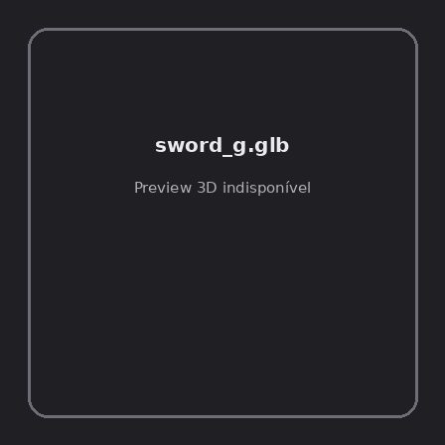
ID | NOV-005520
Origem | Asset novo
Pack/Fonte | Assets Organizados - Weapons
Categoria | Weapons / Sword G.Glb
Arquivo | sword_g.glb
Caminho | 01_Assets_Organizados/Weapons/sword_g.glb
Formato | GLB
Tamanho | 75.74 KB
SHA-256 | 7f1096a5c203dc079589…
Status técnico | ERROR
Licença | MISSING_REVIEW_REQUIRED — sem evidência localizada
Objetos / meshes | N/D / N/D
Vértices | N/D
Faces / triângulos | N/D / N/D
Materiais | N/D —
UV sets / vertex colors | N/D / N/D
Dimensões XYZ | N/D
Rig / armatures / bones | N/D / N/D / N/D
Skinned meshes | N/D
Animações | N/D —
Duração total clips | N/D
Root motion detectado | N/D
LODs / colliders | Nenhum / Nenhum
Texturas vinculadas | N/D (0 ausentes)
Alertas | Licença/fonte não localizada automaticamente; revisão legal necessária. | Duplicado exato: grupo DUP-00879 (2 cópias).
Notas | Falha na inspeção 3D: RuntimeError: Error: Python: Traceback (most recent call last):  File "/usr/share/blender/scripts/addons/io_scene_gltf2/__init__.py", line 1064, in execute  return self.import_gltf2(context)  File "/usr/share/blender/scripts/addons/io_scene_gltf2/__init__.py", line 1083, in import_gltf2  return self.unit_import(self.filepath, import_settings)  File "/usr/share/blender/scripts/addons/io_scene_gltf2/__init__.py", line 1088, in unit_import  from .blender.imp.gltf2_blender_gltf import BlenderGlTF  File "/usr/share/blender/scripts/addons/io_scene_gltf2/blender/imp/gltf2_blender_gltf.py", line 17, in <module>  from .gltf2_blender_scene import BlenderScene  File "/usr/share/blender/scripts/addons/io_scene_gltf2/blender/imp/gltf2_blender_scene.py", line 17, in <module>  from .gltf2_blender_node import BlenderNode  File "/usr/share/blender/scripts/addons/io_scene_gltf2/blender/imp/gltf2_blender_node.py", line 18, in <module>  from .gltf2_blender_mesh import BlenderMesh  File "/usr/share/blender/scripts/addons/io_scene_gltf2/blender/imp/gltf2_blender_mesh.py", line 17, in <module>  import numpy as np  ModuleNotFoundError: No module named 'numpy'  location: /usr/share/blender/scripts/modules/bpy/ops.py:132  Traceback (most recent call last):  File "/home/runner/work/PSX_demons_whip/PSX_demons_whip/workspace/demons/tools/asset_catalog/blender_batch.py", line 427, in inspect_task  import_model(path)  File "/home/runner/work/PSX_demons_whip/PSX_demons_whip/workspace/demons/tools/asset_catalog/blender_batch.py", line 52, in import_model  bpy.ops.import_scene.gltf(filepath=str(path))  File "/usr/share/blender/scripts/modules/bpy/ops.py", line 132, in __call__  ret = _op_call(self.idname_py(), None, kw)  RuntimeError: Error: Python: Traceback (most recent call last):  File "/usr/share/blender/scripts/addons/io_scene_gltf2/__init__.py", line 1064, in execute  return self.import_gltf2(context)  File "/usr/share/blender/scripts/addons/io_scene_gltf2/__init__.py", line 1083, in import_gltf2  return self.unit_import(self.filepath, import_settings)  File "/usr/share/blender/scripts/addons/io_scene_gltf2/__init__.py", line 1088, in unit_import  from .blender.imp.gltf2_blender_gltf import BlenderGlTF  File "/usr/share/blender/scripts/addons/io_scene_gltf2/blender/imp/gltf2_blender_gltf.py", line 17, in <module>  from .gltf2_blender_scene import BlenderScene  File "/usr/share/blender/scripts/addons/io_scene_gltf2/blender/imp/gltf2_blender_scene.py", line 17, in <module>  from .gltf2_blender_node import BlenderNode  File "/usr/share/blender/scripts/addons/io_scene_gltf2/blender/imp/gltf2_blender_node.py", line 18, in <module>  from .gltf2_blender_mesh import BlenderMesh  File "/usr/share/blender/scripts/addons/io_scene_gltf2/blender/imp/gltf2_blender_mesh.py", line 17, in <module>  import numpy as np  ModuleNotFoundError: No module named 'numpy'  location: /usr/share/blender/scripts/modules/bpy/ops.py:132  | Metadados 3D reutilizados do duplicado idêntico TEM-002253.

NOV-005499 • tempered_flanged_mace [ERROR]
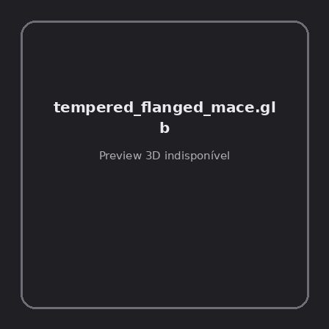
ID | NOV-005499
Origem | Asset novo
Pack/Fonte | Assets Organizados - Weapons
Categoria | Weapons / Tempered Flanged Mace.Glb
Arquivo | tempered_flanged_mace.glb
Caminho | 01_Assets_Organizados/Weapons/tempered_flanged_mace.glb
Formato | GLB
Tamanho | 231.85 KB
SHA-256 | 8b75923d9366b6190445…
Status técnico | ERROR
Licença | MISSING_REVIEW_REQUIRED — sem evidência localizada
Objetos / meshes | N/D / N/D
Vértices | N/D
Faces / triângulos | N/D / N/D
Materiais | N/D —
UV sets / vertex colors | N/D / N/D
Dimensões XYZ | N/D
Rig / armatures / bones | N/D / N/D / N/D
Skinned meshes | N/D
Animações | N/D —
Duração total clips | N/D
Root motion detectado | N/D
LODs / colliders | Nenhum / Nenhum
Texturas vinculadas | N/D (0 ausentes)
Alertas | Licença/fonte não localizada automaticamente; revisão legal necessária. | Duplicado exato: grupo DUP-00859 (2 cópias).
Notas | Falha na inspeção 3D: RuntimeError: Error: Python: Traceback (most recent call last):  File "/usr/share/blender/scripts/addons/io_scene_gltf2/__init__.py", line 1064, in execute  return self.import_gltf2(context)  File "/usr/share/blender/scripts/addons/io_scene_gltf2/__init__.py", line 1083, in import_gltf2  return self.unit_import(self.filepath, import_settings)  File "/usr/share/blender/scripts/addons/io_scene_gltf2/__init__.py", line 1088, in unit_import  from .blender.imp.gltf2_blender_gltf import BlenderGlTF  File "/usr/share/blender/scripts/addons/io_scene_gltf2/blender/imp/gltf2_blender_gltf.py", line 17, in <module>  from .gltf2_blender_scene import BlenderScene  File "/usr/share/blender/scripts/addons/io_scene_gltf2/blender/imp/gltf2_blender_scene.py", line 17, in <module>  from .gltf2_blender_node import BlenderNode  File "/usr/share/blender/scripts/addons/io_scene_gltf2/blender/imp/gltf2_blender_node.py", line 18, in <module>  from .gltf2_blender_mesh import BlenderMesh  File "/usr/share/blender/scripts/addons/io_scene_gltf2/blender/imp/gltf2_blender_mesh.py", line 17, in <module>  import numpy as np  ModuleNotFoundError: No module named 'numpy'  location: /usr/share/blender/scripts/modules/bpy/ops.py:132  Traceback (most recent call last):  File "/home/runner/work/PSX_demons_whip/PSX_demons_whip/workspace/demons/tools/asset_catalog/blender_batch.py", line 427, in inspect_task  import_model(path)  File "/home/runner/work/PSX_demons_whip/PSX_demons_whip/workspace/demons/tools/asset_catalog/blender_batch.py", line 52, in import_model  bpy.ops.import_scene.gltf(filepath=str(path))  File "/usr/share/blender/scripts/modules/bpy/ops.py", line 132, in __call__  ret = _op_call(self.idname_py(), None, kw)  RuntimeError: Error: Python: Traceback (most recent call last):  File "/usr/share/blender/scripts/addons/io_scene_gltf2/__init__.py", line 1064, in execute  return self.import_gltf2(context)  File "/usr/share/blender/scripts/addons/io_scene_gltf2/__init__.py", line 1083, in import_gltf2  return self.unit_import(self.filepath, import_settings)  File "/usr/share/blender/scripts/addons/io_scene_gltf2/__init__.py", line 1088, in unit_import  from .blender.imp.gltf2_blender_gltf import BlenderGlTF  File "/usr/share/blender/scripts/addons/io_scene_gltf2/blender/imp/gltf2_blender_gltf.py", line 17, in <module>  from .gltf2_blender_scene import BlenderScene  File "/usr/share/blender/scripts/addons/io_scene_gltf2/blender/imp/gltf2_blender_scene.py", line 17, in <module>  from .gltf2_blender_node import BlenderNode  File "/usr/share/blender/scripts/addons/io_scene_gltf2/blender/imp/gltf2_blender_node.py", line 18, in <module>  from .gltf2_blender_mesh import BlenderMesh  File "/usr/share/blender/scripts/addons/io_scene_gltf2/blender/imp/gltf2_blender_mesh.py", line 17, in <module>  import numpy as np  ModuleNotFoundError: No module named 'numpy'  location: /usr/share/blender/scripts/modules/bpy/ops.py:132  | Metadados 3D reutilizados do duplicado idêntico TEM-002233.

NOV-005438 • wand [ERROR]
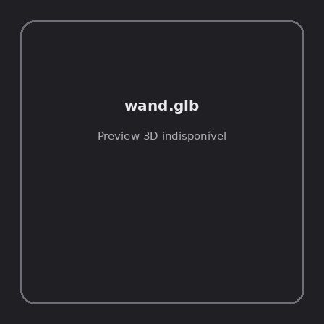
ID | NOV-005438
Origem | Asset novo
Pack/Fonte | Assets Organizados - Weapons
Categoria | Weapons / Wand.Glb
Arquivo | wand.glb
Caminho | 01_Assets_Organizados/Weapons/wand.glb
Formato | GLB
Tamanho | 31.76 KB
SHA-256 | aecd32413de89cdd1375…
Status técnico | ERROR
Licença | MISSING_REVIEW_REQUIRED — sem evidência localizada
Objetos / meshes | N/D / N/D
Vértices | N/D
Faces / triângulos | N/D / N/D
Materiais | N/D —
UV sets / vertex colors | N/D / N/D
Dimensões XYZ | N/D
Rig / armatures / bones | N/D / N/D / N/D
Skinned meshes | N/D
Animações | N/D —
Duração total clips | N/D
Root motion detectado | N/D
LODs / colliders | Nenhum / Nenhum
Texturas vinculadas | N/D (0 ausentes)
Alertas | Licença/fonte não localizada automaticamente; revisão legal necessária. | Duplicado exato: grupo DUP-00798 (2 cópias).
Notas | Falha na inspeção 3D: RuntimeError: Error: Python: Traceback (most recent call last):  File "/usr/share/blender/scripts/addons/io_scene_gltf2/__init__.py", line 1064, in execute  return self.import_gltf2(context)  File "/usr/share/blender/scripts/addons/io_scene_gltf2/__init__.py", line 1083, in import_gltf2  return self.unit_import(self.filepath, import_settings)  File "/usr/share/blender/scripts/addons/io_scene_gltf2/__init__.py", line 1088, in unit_import  from .blender.imp.gltf2_blender_gltf import BlenderGlTF  File "/usr/share/blender/scripts/addons/io_scene_gltf2/blender/imp/gltf2_blender_gltf.py", line 17, in <module>  from .gltf2_blender_scene import BlenderScene  File "/usr/share/blender/scripts/addons/io_scene_gltf2/blender/imp/gltf2_blender_scene.py", line 17, in <module>  from .gltf2_blender_node import BlenderNode  File "/usr/share/blender/scripts/addons/io_scene_gltf2/blender/imp/gltf2_blender_node.py", line 18, in <module>  from .gltf2_blender_mesh import BlenderMesh  File "/usr/share/blender/scripts/addons/io_scene_gltf2/blender/imp/gltf2_blender_mesh.py", line 17, in <module>  import numpy as np  ModuleNotFoundError: No module named 'numpy'  location: /usr/share/blender/scripts/modules/bpy/ops.py:132  Traceback (most recent call last):  File "/home/runner/work/PSX_demons_whip/PSX_demons_whip/workspace/demons/tools/asset_catalog/blender_batch.py", line 427, in inspect_task  import_model(path)  File "/home/runner/work/PSX_demons_whip/PSX_demons_whip/workspace/demons/tools/asset_catalog/blender_batch.py", line 52, in import_model  bpy.ops.import_scene.gltf(filepath=str(path))  File "/usr/share/blender/scripts/modules/bpy/ops.py", line 132, in __call__  ret = _op_call(self.idname_py(), None, kw)  RuntimeError: Error: Python: Traceback (most recent call last):  File "/usr/share/blender/scripts/addons/io_scene_gltf2/__init__.py", line 1064, in execute  return self.import_gltf2(context)  File "/usr/share/blender/scripts/addons/io_scene_gltf2/__init__.py", line 1083, in import_gltf2  return self.unit_import(self.filepath, import_settings)  File "/usr/share/blender/scripts/addons/io_scene_gltf2/__init__.py", line 1088, in unit_import  from .blender.imp.gltf2_blender_gltf import BlenderGlTF  File "/usr/share/blender/scripts/addons/io_scene_gltf2/blender/imp/gltf2_blender_gltf.py", line 17, in <module>  from .gltf2_blender_scene import BlenderScene  File "/usr/share/blender/scripts/addons/io_scene_gltf2/blender/imp/gltf2_blender_scene.py", line 17, in <module>  from .gltf2_blender_node import BlenderNode  File "/usr/share/blender/scripts/addons/io_scene_gltf2/blender/imp/gltf2_blender_node.py", line 18, in <module>  from .gltf2_blender_mesh import BlenderMesh  File "/usr/share/blender/scripts/addons/io_scene_gltf2/blender/imp/gltf2_blender_mesh.py", line 17, in <module>  import numpy as np  ModuleNotFoundError: No module named 'numpy'  location: /usr/share/blender/scripts/modules/bpy/ops.py:132  | Metadados 3D reutilizados do duplicado idêntico TEM-002172.

NOV-005521 • wand_a [ERROR]
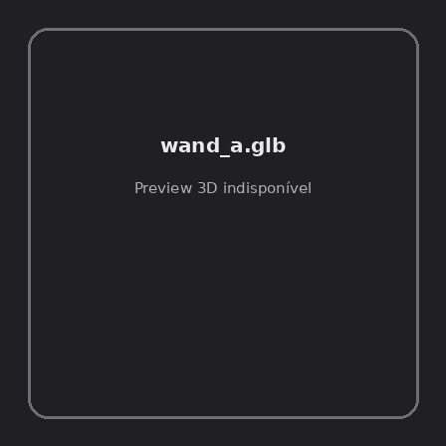
ID | NOV-005521
Origem | Asset novo
Pack/Fonte | Assets Organizados - Weapons
Categoria | Weapons / Wand A.Glb
Arquivo | wand_a.glb
Caminho | 01_Assets_Organizados/Weapons/wand_a.glb
Formato | GLB
Tamanho | 44.39 KB
SHA-256 | 2f8a337283e4d67fb4e2…
Status técnico | ERROR
Licença | MISSING_REVIEW_REQUIRED — sem evidência localizada
Objetos / meshes | N/D / N/D
Vértices | N/D
Faces / triângulos | N/D / N/D
Materiais | N/D —
UV sets / vertex colors | N/D / N/D
Dimensões XYZ | N/D
Rig / armatures / bones | N/D / N/D / N/D
Skinned meshes | N/D
Animações | N/D —
Duração total clips | N/D
Root motion detectado | N/D
LODs / colliders | Nenhum / Nenhum
Texturas vinculadas | N/D (0 ausentes)
Alertas | Licença/fonte não localizada automaticamente; revisão legal necessária. | Duplicado exato: grupo DUP-00880 (2 cópias).
Notas | Falha na inspeção 3D: RuntimeError: Error: Python: Traceback (most recent call last):  File "/usr/share/blender/scripts/addons/io_scene_gltf2/__init__.py", line 1064, in execute  return self.import_gltf2(context)  File "/usr/share/blender/scripts/addons/io_scene_gltf2/__init__.py", line 1083, in import_gltf2  return self.unit_import(self.filepath, import_settings)  File "/usr/share/blender/scripts/addons/io_scene_gltf2/__init__.py", line 1088, in unit_import  from .blender.imp.gltf2_blender_gltf import BlenderGlTF  File "/usr/share/blender/scripts/addons/io_scene_gltf2/blender/imp/gltf2_blender_gltf.py", line 17, in <module>  from .gltf2_blender_scene import BlenderScene  File "/usr/share/blender/scripts/addons/io_scene_gltf2/blender/imp/gltf2_blender_scene.py", line 17, in <module>  from .gltf2_blender_node import BlenderNode  File "/usr/share/blender/scripts/addons/io_scene_gltf2/blender/imp/gltf2_blender_node.py", line 18, in <module>  from .gltf2_blender_mesh import BlenderMesh  File "/usr/share/blender/scripts/addons/io_scene_gltf2/blender/imp/gltf2_blender_mesh.py", line 17, in <module>  import numpy as np  ModuleNotFoundError: No module named 'numpy'  location: /usr/share/blender/scripts/modules/bpy/ops.py:132  Traceback (most recent call last):  File "/home/runner/work/PSX_demons_whip/PSX_demons_whip/workspace/demons/tools/asset_catalog/blender_batch.py", line 427, in inspect_task  import_model(path)  File "/home/runner/work/PSX_demons_whip/PSX_demons_whip/workspace/demons/tools/asset_catalog/blender_batch.py", line 52, in import_model  bpy.ops.import_scene.gltf(filepath=str(path))  File "/usr/share/blender/scripts/modules/bpy/ops.py", line 132, in __call__  ret = _op_call(self.idname_py(), None, kw)  RuntimeError: Error: Python: Traceback (most recent call last):  File "/usr/share/blender/scripts/addons/io_scene_gltf2/__init__.py", line 1064, in execute  return self.import_gltf2(context)  File "/usr/share/blender/scripts/addons/io_scene_gltf2/__init__.py", line 1083, in import_gltf2  return self.unit_import(self.filepath, import_settings)  File "/usr/share/blender/scripts/addons/io_scene_gltf2/__init__.py", line 1088, in unit_import  from .blender.imp.gltf2_blender_gltf import BlenderGlTF  File "/usr/share/blender/scripts/addons/io_scene_gltf2/blender/imp/gltf2_blender_gltf.py", line 17, in <module>  from .gltf2_blender_scene import BlenderScene  File "/usr/share/blender/scripts/addons/io_scene_gltf2/blender/imp/gltf2_blender_scene.py", line 17, in <module>  from .gltf2_blender_node import BlenderNode  File "/usr/share/blender/scripts/addons/io_scene_gltf2/blender/imp/gltf2_blender_node.py", line 18, in <module>  from .gltf2_blender_mesh import BlenderMesh  File "/usr/share/blender/scripts/addons/io_scene_gltf2/blender/imp/gltf2_blender_mesh.py", line 17, in <module>  import numpy as np  ModuleNotFoundError: No module named 'numpy'  location: /usr/share/blender/scripts/modules/bpy/ops.py:132  | Metadados 3D reutilizados do duplicado idêntico TEM-002254.

NOV-005540 • wand_b [ERROR]
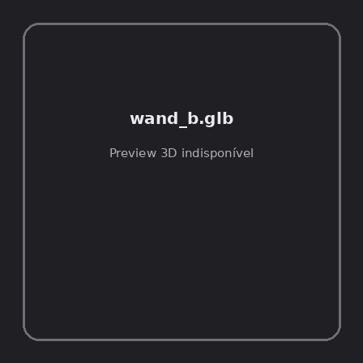
ID | NOV-005540
Origem | Asset novo
Pack/Fonte | Assets Organizados - Weapons
Categoria | Weapons / Wand B.Glb
Arquivo | wand_b.glb
Caminho | 01_Assets_Organizados/Weapons/wand_b.glb
Formato | GLB
Tamanho | 46.21 KB
SHA-256 | f609d2b62378abec4a83…
Status técnico | ERROR
Licença | MISSING_REVIEW_REQUIRED — sem evidência localizada
Objetos / meshes | N/D / N/D
Vértices | N/D
Faces / triângulos | N/D / N/D
Materiais | N/D —
UV sets / vertex colors | N/D / N/D
Dimensões XYZ | N/D
Rig / armatures / bones | N/D / N/D / N/D
Skinned meshes | N/D
Animações | N/D —
Duração total clips | N/D
Root motion detectado | N/D
LODs / colliders | Nenhum / Nenhum
Texturas vinculadas | N/D (0 ausentes)
Alertas | Licença/fonte não localizada automaticamente; revisão legal necessária. | Duplicado exato: grupo DUP-00898 (2 cópias).
Notas | Falha na inspeção 3D: RuntimeError: Error: Python: Traceback (most recent call last):  File "/usr/share/blender/scripts/addons/io_scene_gltf2/__init__.py", line 1064, in execute  return self.import_gltf2(context)  File "/usr/share/blender/scripts/addons/io_scene_gltf2/__init__.py", line 1083, in import_gltf2  return self.unit_import(self.filepath, import_settings)  File "/usr/share/blender/scripts/addons/io_scene_gltf2/__init__.py", line 1088, in unit_import  from .blender.imp.gltf2_blender_gltf import BlenderGlTF  File "/usr/share/blender/scripts/addons/io_scene_gltf2/blender/imp/gltf2_blender_gltf.py", line 17, in <module>  from .gltf2_blender_scene import BlenderScene  File "/usr/share/blender/scripts/addons/io_scene_gltf2/blender/imp/gltf2_blender_scene.py", line 17, in <module>  from .gltf2_blender_node import BlenderNode  File "/usr/share/blender/scripts/addons/io_scene_gltf2/blender/imp/gltf2_blender_node.py", line 18, in <module>  from .gltf2_blender_mesh import BlenderMesh  File "/usr/share/blender/scripts/addons/io_scene_gltf2/blender/imp/gltf2_blender_mesh.py", line 17, in <module>  import numpy as np  ModuleNotFoundError: No module named 'numpy'  location: /usr/share/blender/scripts/modules/bpy/ops.py:132  Traceback (most recent call last):  File "/home/runner/work/PSX_demons_whip/PSX_demons_whip/workspace/demons/tools/asset_catalog/blender_batch.py", line 427, in inspect_task  import_model(path)  File "/home/runner/work/PSX_demons_whip/PSX_demons_whip/workspace/demons/tools/asset_catalog/blender_batch.py", line 52, in import_model  bpy.ops.import_scene.gltf(filepath=str(path))  File "/usr/share/blender/scripts/modules/bpy/ops.py", line 132, in __call__  ret = _op_call(self.idname_py(), None, kw)  RuntimeError: Error: Python: Traceback (most recent call last):  File "/usr/share/blender/scripts/addons/io_scene_gltf2/__init__.py", line 1064, in execute  return self.import_gltf2(context)  File "/usr/share/blender/scripts/addons/io_scene_gltf2/__init__.py", line 1083, in import_gltf2  return self.unit_import(self.filepath, import_settings)  File "/usr/share/blender/scripts/addons/io_scene_gltf2/__init__.py", line 1088, in unit_import  from .blender.imp.gltf2_blender_gltf import BlenderGlTF  File "/usr/share/blender/scripts/addons/io_scene_gltf2/blender/imp/gltf2_blender_gltf.py", line 17, in <module>  from .gltf2_blender_scene import BlenderScene  File "/usr/share/blender/scripts/addons/io_scene_gltf2/blender/imp/gltf2_blender_scene.py", line 17, in <module>  from .gltf2_blender_node import BlenderNode  File "/usr/share/blender/scripts/addons/io_scene_gltf2/blender/imp/gltf2_blender_node.py", line 18, in <module>  from .gltf2_blender_mesh import BlenderMesh  File "/usr/share/blender/scripts/addons/io_scene_gltf2/blender/imp/gltf2_blender_mesh.py", line 17, in <module>  import numpy as np  ModuleNotFoundError: No module named 'numpy'  location: /usr/share/blender/scripts/modules/bpy/ops.py:132  | Metadados 3D reutilizados do duplicado idêntico TEM-002272.

NOV-005538 • whittler_s_knife [ERROR]
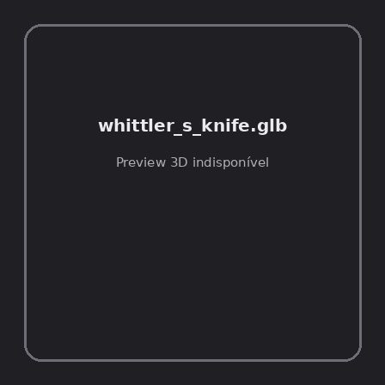
ID | NOV-005538
Origem | Asset novo
Pack/Fonte | Assets Organizados - Weapons
Categoria | Weapons / Whittler S Knife.Glb
Arquivo | whittler_s_knife.glb
Caminho | 01_Assets_Organizados/Weapons/whittler_s_knife.glb
Formato | GLB
Tamanho | 179.61 KB
SHA-256 | 388e9da402c7dfb5b13d…
Status técnico | ERROR
Licença | MISSING_REVIEW_REQUIRED — sem evidência localizada
Objetos / meshes | N/D / N/D
Vértices | N/D
Faces / triângulos | N/D / N/D
Materiais | N/D —
UV sets / vertex colors | N/D / N/D
Dimensões XYZ | N/D
Rig / armatures / bones | N/D / N/D / N/D
Skinned meshes | N/D
Animações | N/D —
Duração total clips | N/D
Root motion detectado | N/D
LODs / colliders | Nenhum / Nenhum
Texturas vinculadas | N/D (0 ausentes)
Alertas | Licença/fonte não localizada automaticamente; revisão legal necessária. | Duplicado exato: grupo DUP-00896 (2 cópias).
Notas | Falha na inspeção 3D: RuntimeError: Error: Python: Traceback (most recent call last):  File "/usr/share/blender/scripts/addons/io_scene_gltf2/__init__.py", line 1064, in execute  return self.import_gltf2(context)  File "/usr/share/blender/scripts/addons/io_scene_gltf2/__init__.py", line 1083, in import_gltf2  return self.unit_import(self.filepath, import_settings)  File "/usr/share/blender/scripts/addons/io_scene_gltf2/__init__.py", line 1088, in unit_import  from .blender.imp.gltf2_blender_gltf import BlenderGlTF  File "/usr/share/blender/scripts/addons/io_scene_gltf2/blender/imp/gltf2_blender_gltf.py", line 17, in <module>  from .gltf2_blender_scene import BlenderScene  File "/usr/share/blender/scripts/addons/io_scene_gltf2/blender/imp/gltf2_blender_scene.py", line 17, in <module>  from .gltf2_blender_node import BlenderNode  File "/usr/share/blender/scripts/addons/io_scene_gltf2/blender/imp/gltf2_blender_node.py", line 18, in <module>  from .gltf2_blender_mesh import BlenderMesh  File "/usr/share/blender/scripts/addons/io_scene_gltf2/blender/imp/gltf2_blender_mesh.py", line 17, in <module>  import numpy as np  ModuleNotFoundError: No module named 'numpy'  location: /usr/share/blender/scripts/modules/bpy/ops.py:132  Traceback (most recent call last):  File "/home/runner/work/PSX_demons_whip/PSX_demons_whip/workspace/demons/tools/asset_catalog/blender_batch.py", line 427, in inspect_task  import_model(path)  File "/home/runner/work/PSX_demons_whip/PSX_demons_whip/workspace/demons/tools/asset_catalog/blender_batch.py", line 52, in import_model  bpy.ops.import_scene.gltf(filepath=str(path))  File "/usr/share/blender/scripts/modules/bpy/ops.py", line 132, in __call__  ret = _op_call(self.idname_py(), None, kw)  RuntimeError: Error: Python: Traceback (most recent call last):  File "/usr/share/blender/scripts/addons/io_scene_gltf2/__init__.py", line 1064, in execute  return self.import_gltf2(context)  File "/usr/share/blender/scripts/addons/io_scene_gltf2/__init__.py", line 1083, in import_gltf2  return self.unit_import(self.filepath, import_settings)  File "/usr/share/blender/scripts/addons/io_scene_gltf2/__init__.py", line 1088, in unit_import  from .blender.imp.gltf2_blender_gltf import BlenderGlTF  File "/usr/share/blender/scripts/addons/io_scene_gltf2/blender/imp/gltf2_blender_gltf.py", line 17, in <module>  from .gltf2_blender_scene import BlenderScene  File "/usr/share/blender/scripts/addons/io_scene_gltf2/blender/imp/gltf2_blender_scene.py", line 17, in <module>  from .gltf2_blender_node import BlenderNode  File "/usr/share/blender/scripts/addons/io_scene_gltf2/blender/imp/gltf2_blender_node.py", line 18, in <module>  from .gltf2_blender_mesh import BlenderMesh  File "/usr/share/blender/scripts/addons/io_scene_gltf2/blender/imp/gltf2_blender_mesh.py", line 17, in <module>  import numpy as np  ModuleNotFoundError: No module named 'numpy'  location: /usr/share/blender/scripts/modules/bpy/ops.py:132  | Metadados 3D reutilizados do duplicado idêntico TEM-002270.

NOV-005449 • winterbite [ERROR]
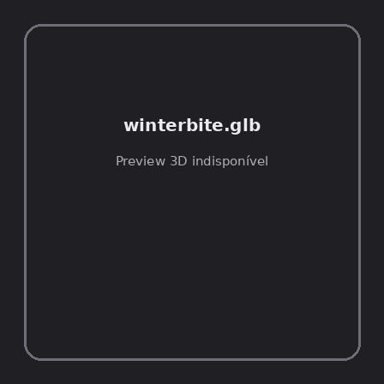
ID | NOV-005449
Origem | Asset novo
Pack/Fonte | Assets Organizados - Weapons
Categoria | Weapons / Winterbite.Glb
Arquivo | winterbite.glb
Caminho | 01_Assets_Organizados/Weapons/winterbite.glb
Formato | GLB
Tamanho | 89.66 KB
SHA-256 | aabe66590f3495f942e4…
Status técnico | ERROR
Licença | MISSING_REVIEW_REQUIRED — sem evidência localizada
Objetos / meshes | N/D / N/D
Vértices | N/D
Faces / triângulos | N/D / N/D
Materiais | N/D —
UV sets / vertex colors | N/D / N/D
Dimensões XYZ | N/D
Rig / armatures / bones | N/D / N/D / N/D
Skinned meshes | N/D
Animações | N/D —
Duração total clips | N/D
Root motion detectado | N/D
LODs / colliders | Nenhum / Nenhum
Texturas vinculadas | N/D (0 ausentes)
Alertas | Licença/fonte não localizada automaticamente; revisão legal necessária. | Duplicado exato: grupo DUP-00809 (2 cópias).
Notas | Falha na inspeção 3D: RuntimeError: Error: Python: Traceback (most recent call last):  File "/usr/share/blender/scripts/addons/io_scene_gltf2/__init__.py", line 1064, in execute  return self.import_gltf2(context)  File "/usr/share/blender/scripts/addons/io_scene_gltf2/__init__.py", line 1083, in import_gltf2  return self.unit_import(self.filepath, import_settings)  File "/usr/share/blender/scripts/addons/io_scene_gltf2/__init__.py", line 1088, in unit_import  from .blender.imp.gltf2_blender_gltf import BlenderGlTF  File "/usr/share/blender/scripts/addons/io_scene_gltf2/blender/imp/gltf2_blender_gltf.py", line 17, in <module>  from .gltf2_blender_scene import BlenderScene  File "/usr/share/blender/scripts/addons/io_scene_gltf2/blender/imp/gltf2_blender_scene.py", line 17, in <module>  from .gltf2_blender_node import BlenderNode  File "/usr/share/blender/scripts/addons/io_scene_gltf2/blender/imp/gltf2_blender_node.py", line 18, in <module>  from .gltf2_blender_mesh import BlenderMesh  File "/usr/share/blender/scripts/addons/io_scene_gltf2/blender/imp/gltf2_blender_mesh.py", line 17, in <module>  import numpy as np  ModuleNotFoundError: No module named 'numpy'  location: /usr/share/blender/scripts/modules/bpy/ops.py:132  Traceback (most recent call last):  File "/home/runner/work/PSX_demons_whip/PSX_demons_whip/workspace/demons/tools/asset_catalog/blender_batch.py", line 427, in inspect_task  import_model(path)  File "/home/runner/work/PSX_demons_whip/PSX_demons_whip/workspace/demons/tools/asset_catalog/blender_batch.py", line 52, in import_model  bpy.ops.import_scene.gltf(filepath=str(path))  File "/usr/share/blender/scripts/modules/bpy/ops.py", line 132, in __call__  ret = _op_call(self.idname_py(), None, kw)  RuntimeError: Error: Python: Traceback (most recent call last):  File "/usr/share/blender/scripts/addons/io_scene_gltf2/__init__.py", line 1064, in execute  return self.import_gltf2(context)  File "/usr/share/blender/scripts/addons/io_scene_gltf2/__init__.py", line 1083, in import_gltf2  return self.unit_import(self.filepath, import_settings)  File "/usr/share/blender/scripts/addons/io_scene_gltf2/__init__.py", line 1088, in unit_import  from .blender.imp.gltf2_blender_gltf import BlenderGlTF  File "/usr/share/blender/scripts/addons/io_scene_gltf2/blender/imp/gltf2_blender_gltf.py", line 17, in <module>  from .gltf2_blender_scene import BlenderScene  File "/usr/share/blender/scripts/addons/io_scene_gltf2/blender/imp/gltf2_blender_scene.py", line 17, in <module>  from .gltf2_blender_node import BlenderNode  File "/usr/share/blender/scripts/addons/io_scene_gltf2/blender/imp/gltf2_blender_node.py", line 18, in <module>  from .gltf2_blender_mesh import BlenderMesh  File "/usr/share/blender/scripts/addons/io_scene_gltf2/blender/imp/gltf2_blender_mesh.py", line 17, in <module>  import numpy as np  ModuleNotFoundError: No module named 'numpy'  location: /usr/share/blender/scripts/modules/bpy/ops.py:132  | Metadados 3D reutilizados do duplicado idêntico TEM-002183.

NOV-005526 • wrought_iron_longsword [ERROR]
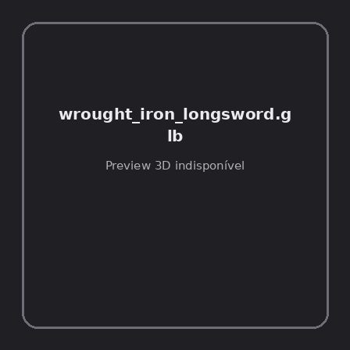
ID | NOV-005526
Origem | Asset novo
Pack/Fonte | Assets Organizados - Weapons
Categoria | Weapons / Wrought Iron Longsword.Glb
Arquivo | wrought_iron_longsword.glb
Caminho | 01_Assets_Organizados/Weapons/wrought_iron_longsword.glb
Formato | GLB
Tamanho | 212.70 KB
SHA-256 | f747648f9a4c25eeccd2…
Status técnico | ERROR
Licença | MISSING_REVIEW_REQUIRED — sem evidência localizada
Objetos / meshes | N/D / N/D
Vértices | N/D
Faces / triângulos | N/D / N/D
Materiais | N/D —
UV sets / vertex colors | N/D / N/D
Dimensões XYZ | N/D
Rig / armatures / bones | N/D / N/D / N/D
Skinned meshes | N/D
Animações | N/D —
Duração total clips | N/D
Root motion detectado | N/D
LODs / colliders | Nenhum / Nenhum
Texturas vinculadas | N/D (0 ausentes)
Alertas | Licença/fonte não localizada automaticamente; revisão legal necessária. | Duplicado exato: grupo DUP-00885 (2 cópias).
Notas | Falha na inspeção 3D: RuntimeError: Error: Python: Traceback (most recent call last):  File "/usr/share/blender/scripts/addons/io_scene_gltf2/__init__.py", line 1064, in execute  return self.import_gltf2(context)  File "/usr/share/blender/scripts/addons/io_scene_gltf2/__init__.py", line 1083, in import_gltf2  return self.unit_import(self.filepath, import_settings)  File "/usr/share/blender/scripts/addons/io_scene_gltf2/__init__.py", line 1088, in unit_import  from .blender.imp.gltf2_blender_gltf import BlenderGlTF  File "/usr/share/blender/scripts/addons/io_scene_gltf2/blender/imp/gltf2_blender_gltf.py", line 17, in <module>  from .gltf2_blender_scene import BlenderScene  File "/usr/share/blender/scripts/addons/io_scene_gltf2/blender/imp/gltf2_blender_scene.py", line 17, in <module>  from .gltf2_blender_node import BlenderNode  File "/usr/share/blender/scripts/addons/io_scene_gltf2/blender/imp/gltf2_blender_node.py", line 18, in <module>  from .gltf2_blender_mesh import BlenderMesh  File "/usr/share/blender/scripts/addons/io_scene_gltf2/blender/imp/gltf2_blender_mesh.py", line 17, in <module>  import numpy as np  ModuleNotFoundError: No module named 'numpy'  location: /usr/share/blender/scripts/modules/bpy/ops.py:132  Traceback (most recent call last):  File "/home/runner/work/PSX_demons_whip/PSX_demons_whip/workspace/demons/tools/asset_catalog/blender_batch.py", line 427, in inspect_task  import_model(path)  File "/home/runner/work/PSX_demons_whip/PSX_demons_whip/workspace/demons/tools/asset_catalog/blender_batch.py", line 52, in import_model  bpy.ops.import_scene.gltf(filepath=str(path))  File "/usr/share/blender/scripts/modules/bpy/ops.py", line 132, in __call__  ret = _op_call(self.idname_py(), None, kw)  RuntimeError: Error: Python: Traceback (most recent call last):  File "/usr/share/blender/scripts/addons/io_scene_gltf2/__init__.py", line 1064, in execute  return self.import_gltf2(context)  File "/usr/share/blender/scripts/addons/io_scene_gltf2/__init__.py", line 1083, in import_gltf2  return self.unit_import(self.filepath, import_settings)  File "/usr/share/blender/scripts/addons/io_scene_gltf2/__init__.py", line 1088, in unit_import  from .blender.imp.gltf2_blender_gltf import BlenderGlTF  File "/usr/share/blender/scripts/addons/io_scene_gltf2/blender/imp/gltf2_blender_gltf.py", line 17, in <module>  from .gltf2_blender_scene import BlenderScene  File "/usr/share/blender/scripts/addons/io_scene_gltf2/blender/imp/gltf2_blender_scene.py", line 17, in <module>  from .gltf2_blender_node import BlenderNode  File "/usr/share/blender/scripts/addons/io_scene_gltf2/blender/imp/gltf2_blender_node.py", line 18, in <module>  from .gltf2_blender_mesh import BlenderMesh  File "/usr/share/blender/scripts/addons/io_scene_gltf2/blender/imp/gltf2_blender_mesh.py", line 17, in <module>  import numpy as np  ModuleNotFoundError: No module named 'numpy'  location: /usr/share/blender/scripts/modules/bpy/ops.py:132  | Metadados 3D reutilizados do duplicado idêntico TEM-002259.

NOV-004699 • demonicaxe [ERROR]
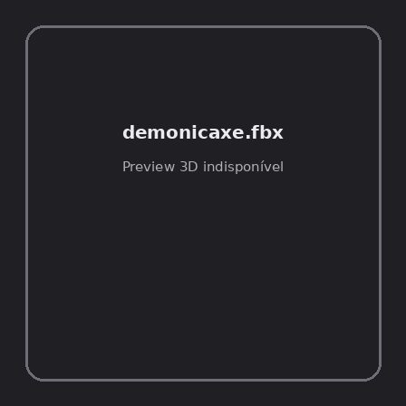
ID | NOV-004699
Origem | Asset novo
Pack/Fonte | demonic weapons pack
Categoria | Weapons / Axe
Arquivo | demonicaxe.fbx
Caminho | 00_Packs_Raw/demonic weapons pack/axe/demonicaxe.fbx
Formato | FBX
Tamanho | 28.03 KB
SHA-256 | eda845712699beb8dbf7…
Status técnico | ERROR
Licença | MISSING_REVIEW_REQUIRED — sem evidência localizada
Objetos / meshes | N/D / N/D
Vértices | N/D
Faces / triângulos | N/D / N/D
Materiais | N/D —
UV sets / vertex colors | N/D / N/D
Dimensões XYZ | N/D
Rig / armatures / bones | N/D / N/D / N/D
Skinned meshes | N/D
Animações | N/D —
Duração total clips | N/D
Root motion detectado | N/D
LODs / colliders | Nenhum / Nenhum
Texturas vinculadas | N/D (0 ausentes)
Alertas | Licença/fonte não localizada automaticamente; revisão legal necessária.
Notas | Falha na inspeção 3D: RuntimeError: Error: Python: Traceback (most recent call last):  File "/usr/share/blender/scripts/addons/io_scene_fbx/__init__.py", line 220, in execute  return import_fbx.load(self, context, filepath=self.filepath, **keywords)  File "/usr/share/blender/scripts/addons/io_scene_fbx/import_fbx.py", line 3200, in load  _(); del _  File "/usr/share/blender/scripts/addons/io_scene_fbx/import_fbx.py", line 3192, in _  ma_wrap.alpha_texture.copy_from(ma_wrap.base_color_texture)  File "/usr/share/blender/scripts/modules/bpy_extras/node_shader_utils.py", line 632, in copy_from  self.image = tex.image  File "/usr/share/blender/scripts/modules/bpy_extras/node_shader_utils.py", line 36, in wrapper  return func(self, *args, **kwargs)  File "/usr/share/blender/scripts/modules/bpy_extras/node_shader_utils.py", line 710, in image_set  image.colorspace_settings.name = self.colorspace_name  TypeError: bpy_struct: item.attr = val: enum "Non-Color" not found in ('Linear', 'sRGB')  location: /usr/share/blender/scripts/modules/bpy/ops.py:132  Traceback (most recent call last):  File "/home/runner/work/PSX_demons_whip/PSX_demons_whip/workspace/demons/tools/asset_catalog/blender_batch.py", line 427, in inspect_task  import_model(path)  File "/home/runner/work/PSX_demons_whip/PSX_demons_whip/workspace/demons/tools/asset_catalog/blender_batch.py", line 55, in import_model  bpy.ops.import_scene.fbx(filepath=str(path), automatic_bone_orientation=False)  File "/usr/share/blender/scripts/modules/bpy/ops.py", line 132, in __call__  ret = _op_call(self.idname_py(), None, kw)  RuntimeError: Error: Python: Traceback (most recent call last):  File "/usr/share/blender/scripts/addons/io_scene_fbx/__init__.py", line 220, in execute  return import_fbx.load(self, context, filepath=self.filepath, **keywords)  File "/usr/share/blender/scripts/addons/io_scene_fbx/import_fbx.py", line 3200, in load  _(); del _  File "/usr/share/blender/scripts/addons/io_scene_fbx/import_fbx.py", line 3192, in _  ma_wrap.alpha_texture.copy_from(ma_wrap.base_color_texture)  File "/usr/share/blender/scripts/modules/bpy_extras/node_shader_utils.py", line 632, in copy_from  self.image = tex.image  File "/usr/share/blender/scripts/modules/bpy_extras/node_shader_utils.py", line 36, in wrapper  return func(self, *args, **kwargs)  File "/usr/share/blender/scripts/modules/bpy_extras/node_shader_utils.py", line 710, in image_set  image.colorspace_settings.name = self.colorspace_name  TypeError: bpy_struct: item.attr = val: enum "Non-Color" not found in ('Linear', 'sRGB')  location: /usr/share/blender/scripts/modules/bpy/ops.py:132

NOV-004700 • demonicaxegodot [ERROR]
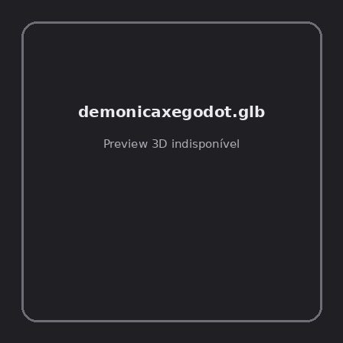
ID | NOV-004700
Origem | Asset novo
Pack/Fonte | demonic weapons pack
Categoria | Weapons / Axe
Arquivo | demonicaxegodot.glb
Caminho | 00_Packs_Raw/demonic weapons pack/axe/demonicaxegodot.glb
Formato | GLB
Tamanho | 103.88 KB
SHA-256 | f552e1bcc33cd82bf356…
Status técnico | ERROR
Licença | MISSING_REVIEW_REQUIRED — sem evidência localizada
Objetos / meshes | N/D / N/D
Vértices | N/D
Faces / triângulos | N/D / N/D
Materiais | N/D —
UV sets / vertex colors | N/D / N/D
Dimensões XYZ | N/D
Rig / armatures / bones | N/D / N/D / N/D
Skinned meshes | N/D
Animações | N/D —
Duração total clips | N/D
Root motion detectado | N/D
LODs / colliders | Nenhum / Nenhum
Texturas vinculadas | N/D (0 ausentes)
Alertas | Licença/fonte não localizada automaticamente; revisão legal necessária.
Notas | Falha na inspeção 3D: RuntimeError: Error: Python: Traceback (most recent call last):  File "/usr/share/blender/scripts/addons/io_scene_gltf2/__init__.py", line 1064, in execute  return self.import_gltf2(context)  File "/usr/share/blender/scripts/addons/io_scene_gltf2/__init__.py", line 1083, in import_gltf2  return self.unit_import(self.filepath, import_settings)  File "/usr/share/blender/scripts/addons/io_scene_gltf2/__init__.py", line 1088, in unit_import  from .blender.imp.gltf2_blender_gltf import BlenderGlTF  File "/usr/share/blender/scripts/addons/io_scene_gltf2/blender/imp/gltf2_blender_gltf.py", line 17, in <module>  from .gltf2_blender_scene import BlenderScene  File "/usr/share/blender/scripts/addons/io_scene_gltf2/blender/imp/gltf2_blender_scene.py", line 17, in <module>  from .gltf2_blender_node import BlenderNode  File "/usr/share/blender/scripts/addons/io_scene_gltf2/blender/imp/gltf2_blender_node.py", line 18, in <module>  from .gltf2_blender_mesh import BlenderMesh  File "/usr/share/blender/scripts/addons/io_scene_gltf2/blender/imp/gltf2_blender_mesh.py", line 17, in <module>  import numpy as np  ModuleNotFoundError: No module named 'numpy'  location: /usr/share/blender/scripts/modules/bpy/ops.py:132  Traceback (most recent call last):  File "/home/runner/work/PSX_demons_whip/PSX_demons_whip/workspace/demons/tools/asset_catalog/blender_batch.py", line 427, in inspect_task  import_model(path)  File "/home/runner/work/PSX_demons_whip/PSX_demons_whip/workspace/demons/tools/asset_catalog/blender_batch.py", line 52, in import_model  bpy.ops.import_scene.gltf(filepath=str(path))  File "/usr/share/blender/scripts/modules/bpy/ops.py", line 132, in __call__  ret = _op_call(self.idname_py(), None, kw)  RuntimeError: Error: Python: Traceback (most recent call last):  File "/usr/share/blender/scripts/addons/io_scene_gltf2/__init__.py", line 1064, in execute  return self.import_gltf2(context)  File "/usr/share/blender/scripts/addons/io_scene_gltf2/__init__.py", line 1083, in import_gltf2  return self.unit_import(self.filepath, import_settings)  File "/usr/share/blender/scripts/addons/io_scene_gltf2/__init__.py", line 1088, in unit_import  from .blender.imp.gltf2_blender_gltf import BlenderGlTF  File "/usr/share/blender/scripts/addons/io_scene_gltf2/blender/imp/gltf2_blender_gltf.py", line 17, in <module>  from .gltf2_blender_scene import BlenderScene  File "/usr/share/blender/scripts/addons/io_scene_gltf2/blender/imp/gltf2_blender_scene.py", line 17, in <module>  from .gltf2_blender_node import BlenderNode  File "/usr/share/blender/scripts/addons/io_scene_gltf2/blender/imp/gltf2_blender_node.py", line 18, in <module>  from .gltf2_blender_mesh import BlenderMesh  File "/usr/share/blender/scripts/addons/io_scene_gltf2/blender/imp/gltf2_blender_mesh.py", line 17, in <module>  import numpy as np  ModuleNotFoundError: No module named 'numpy'  location: /usr/share/blender/scripts/modules/bpy/ops.py:132

NOV-004708 • demonicdagger [ERROR]
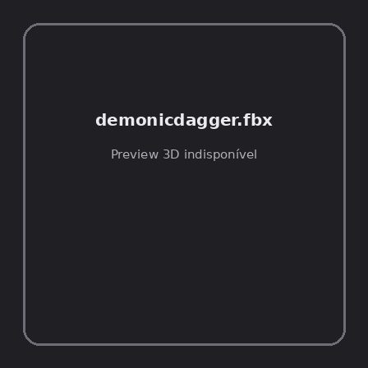
ID | NOV-004708
Origem | Asset novo
Pack/Fonte | demonic weapons pack
Categoria | Weapons / Dagger
Arquivo | demonicdagger.fbx
Caminho | 00_Packs_Raw/demonic weapons pack/dagger/demonicdagger.fbx
Formato | FBX
Tamanho | 26.57 KB
SHA-256 | 1ff0bf9345a8df397074…
Status técnico | ERROR
Licença | MISSING_REVIEW_REQUIRED — sem evidência localizada
Objetos / meshes | N/D / N/D
Vértices | N/D
Faces / triângulos | N/D / N/D
Materiais | N/D —
UV sets / vertex colors | N/D / N/D
Dimensões XYZ | N/D
Rig / armatures / bones | N/D / N/D / N/D
Skinned meshes | N/D
Animações | N/D —
Duração total clips | N/D
Root motion detectado | N/D
LODs / colliders | Nenhum / Nenhum
Texturas vinculadas | N/D (0 ausentes)
Alertas | Licença/fonte não localizada automaticamente; revisão legal necessária.
Notas | Falha na inspeção 3D: RuntimeError: Error: Python: Traceback (most recent call last):  File "/usr/share/blender/scripts/addons/io_scene_fbx/__init__.py", line 220, in execute  return import_fbx.load(self, context, filepath=self.filepath, **keywords)  File "/usr/share/blender/scripts/addons/io_scene_fbx/import_fbx.py", line 3200, in load  _(); del _  File "/usr/share/blender/scripts/addons/io_scene_fbx/import_fbx.py", line 3192, in _  ma_wrap.alpha_texture.copy_from(ma_wrap.base_color_texture)  File "/usr/share/blender/scripts/modules/bpy_extras/node_shader_utils.py", line 632, in copy_from  self.image = tex.image  File "/usr/share/blender/scripts/modules/bpy_extras/node_shader_utils.py", line 36, in wrapper  return func(self, *args, **kwargs)  File "/usr/share/blender/scripts/modules/bpy_extras/node_shader_utils.py", line 710, in image_set  image.colorspace_settings.name = self.colorspace_name  TypeError: bpy_struct: item.attr = val: enum "Non-Color" not found in ('Linear', 'sRGB')  location: /usr/share/blender/scripts/modules/bpy/ops.py:132  Traceback (most recent call last):  File "/home/runner/work/PSX_demons_whip/PSX_demons_whip/workspace/demons/tools/asset_catalog/blender_batch.py", line 427, in inspect_task  import_model(path)  File "/home/runner/work/PSX_demons_whip/PSX_demons_whip/workspace/demons/tools/asset_catalog/blender_batch.py", line 55, in import_model  bpy.ops.import_scene.fbx(filepath=str(path), automatic_bone_orientation=False)  File "/usr/share/blender/scripts/modules/bpy/ops.py", line 132, in __call__  ret = _op_call(self.idname_py(), None, kw)  RuntimeError: Error: Python: Traceback (most recent call last):  File "/usr/share/blender/scripts/addons/io_scene_fbx/__init__.py", line 220, in execute  return import_fbx.load(self, context, filepath=self.filepath, **keywords)  File "/usr/share/blender/scripts/addons/io_scene_fbx/import_fbx.py", line 3200, in load  _(); del _  File "/usr/share/blender/scripts/addons/io_scene_fbx/import_fbx.py", line 3192, in _  ma_wrap.alpha_texture.copy_from(ma_wrap.base_color_texture)  File "/usr/share/blender/scripts/modules/bpy_extras/node_shader_utils.py", line 632, in copy_from  self.image = tex.image  File "/usr/share/blender/scripts/modules/bpy_extras/node_shader_utils.py", line 36, in wrapper  return func(self, *args, **kwargs)  File "/usr/share/blender/scripts/modules/bpy_extras/node_shader_utils.py", line 710, in image_set  image.colorspace_settings.name = self.colorspace_name  TypeError: bpy_struct: item.attr = val: enum "Non-Color" not found in ('Linear', 'sRGB')  location: /usr/share/blender/scripts/modules/bpy/ops.py:132

NOV-004709 • demonicdaggergodot [ERROR]
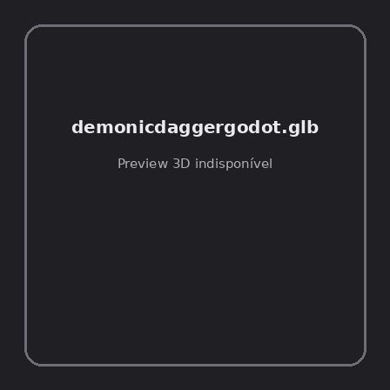
ID | NOV-004709
Origem | Asset novo
Pack/Fonte | demonic weapons pack
Categoria | Weapons / Dagger
Arquivo | demonicdaggergodot.glb
Caminho | 00_Packs_Raw/demonic weapons pack/dagger/demonicdaggergodot.glb
Formato | GLB
Tamanho | 80.44 KB
SHA-256 | 0a3f14d03b5eab59a3e5…
Status técnico | ERROR
Licença | MISSING_REVIEW_REQUIRED — sem evidência localizada
Objetos / meshes | N/D / N/D
Vértices | N/D
Faces / triângulos | N/D / N/D
Materiais | N/D —
UV sets / vertex colors | N/D / N/D
Dimensões XYZ | N/D
Rig / armatures / bones | N/D / N/D / N/D
Skinned meshes | N/D
Animações | N/D —
Duração total clips | N/D
Root motion detectado | N/D
LODs / colliders | Nenhum / Nenhum
Texturas vinculadas | N/D (0 ausentes)
Alertas | Licença/fonte não localizada automaticamente; revisão legal necessária.
Notas | Falha na inspeção 3D: RuntimeError: Error: Python: Traceback (most recent call last):  File "/usr/share/blender/scripts/addons/io_scene_gltf2/__init__.py", line 1064, in execute  return self.import_gltf2(context)  File "/usr/share/blender/scripts/addons/io_scene_gltf2/__init__.py", line 1083, in import_gltf2  return self.unit_import(self.filepath, import_settings)  File "/usr/share/blender/scripts/addons/io_scene_gltf2/__init__.py", line 1088, in unit_import  from .blender.imp.gltf2_blender_gltf import BlenderGlTF  File "/usr/share/blender/scripts/addons/io_scene_gltf2/blender/imp/gltf2_blender_gltf.py", line 17, in <module>  from .gltf2_blender_scene import BlenderScene  File "/usr/share/blender/scripts/addons/io_scene_gltf2/blender/imp/gltf2_blender_scene.py", line 17, in <module>  from .gltf2_blender_node import BlenderNode  File "/usr/share/blender/scripts/addons/io_scene_gltf2/blender/imp/gltf2_blender_node.py", line 18, in <module>  from .gltf2_blender_mesh import BlenderMesh  File "/usr/share/blender/scripts/addons/io_scene_gltf2/blender/imp/gltf2_blender_mesh.py", line 17, in <module>  import numpy as np  ModuleNotFoundError: No module named 'numpy'  location: /usr/share/blender/scripts/modules/bpy/ops.py:132  Traceback (most recent call last):  File "/home/runner/work/PSX_demons_whip/PSX_demons_whip/workspace/demons/tools/asset_catalog/blender_batch.py", line 427, in inspect_task  import_model(path)  File "/home/runner/work/PSX_demons_whip/PSX_demons_whip/workspace/demons/tools/asset_catalog/blender_batch.py", line 52, in import_model  bpy.ops.import_scene.gltf(filepath=str(path))  File "/usr/share/blender/scripts/modules/bpy/ops.py", line 132, in __call__  ret = _op_call(self.idname_py(), None, kw)  RuntimeError: Error: Python: Traceback (most recent call last):  File "/usr/share/blender/scripts/addons/io_scene_gltf2/__init__.py", line 1064, in execute  return self.import_gltf2(context)  File "/usr/share/blender/scripts/addons/io_scene_gltf2/__init__.py", line 1083, in import_gltf2  return self.unit_import(self.filepath, import_settings)  File "/usr/share/blender/scripts/addons/io_scene_gltf2/__init__.py", line 1088, in unit_import  from .blender.imp.gltf2_blender_gltf import BlenderGlTF  File "/usr/share/blender/scripts/addons/io_scene_gltf2/blender/imp/gltf2_blender_gltf.py", line 17, in <module>  from .gltf2_blender_scene import BlenderScene  File "/usr/share/blender/scripts/addons/io_scene_gltf2/blender/imp/gltf2_blender_scene.py", line 17, in <module>  from .gltf2_blender_node import BlenderNode  File "/usr/share/blender/scripts/addons/io_scene_gltf2/blender/imp/gltf2_blender_node.py", line 18, in <module>  from .gltf2_blender_mesh import BlenderMesh  File "/usr/share/blender/scripts/addons/io_scene_gltf2/blender/imp/gltf2_blender_mesh.py", line 17, in <module>  import numpy as np  ModuleNotFoundError: No module named 'numpy'  location: /usr/share/blender/scripts/modules/bpy/ops.py:132

NOV-004697 • demonicgreatsword [ERROR]
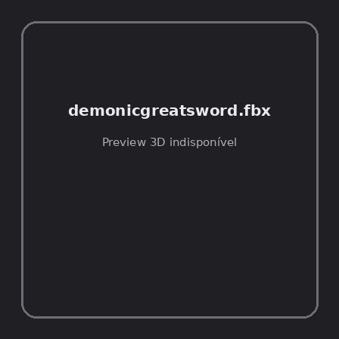
ID | NOV-004697
Origem | Asset novo
Pack/Fonte | demonic weapons pack
Categoria | Weapons / Greatsword
Arquivo | demonicgreatsword.fbx
Caminho | 00_Packs_Raw/demonic weapons pack/greatsword/demonicgreatsword.fbx
Formato | FBX
Tamanho | 24.96 KB
SHA-256 | 97498d2735b415221d92…
Status técnico | ERROR
Licença | MISSING_REVIEW_REQUIRED — sem evidência localizada
Objetos / meshes | N/D / N/D
Vértices | N/D
Faces / triângulos | N/D / N/D
Materiais | N/D —
UV sets / vertex colors | N/D / N/D
Dimensões XYZ | N/D
Rig / armatures / bones | N/D / N/D / N/D
Skinned meshes | N/D
Animações | N/D —
Duração total clips | N/D
Root motion detectado | N/D
LODs / colliders | Nenhum / Nenhum
Texturas vinculadas | N/D (0 ausentes)
Alertas | Licença/fonte não localizada automaticamente; revisão legal necessária.
Notas | Falha na inspeção 3D: RuntimeError: Error: Python: Traceback (most recent call last):  File "/usr/share/blender/scripts/addons/io_scene_fbx/__init__.py", line 220, in execute  return import_fbx.load(self, context, filepath=self.filepath, **keywords)  File "/usr/share/blender/scripts/addons/io_scene_fbx/import_fbx.py", line 3200, in load  _(); del _  File "/usr/share/blender/scripts/addons/io_scene_fbx/import_fbx.py", line 3192, in _  ma_wrap.alpha_texture.copy_from(ma_wrap.base_color_texture)  File "/usr/share/blender/scripts/modules/bpy_extras/node_shader_utils.py", line 632, in copy_from  self.image = tex.image  File "/usr/share/blender/scripts/modules/bpy_extras/node_shader_utils.py", line 36, in wrapper  return func(self, *args, **kwargs)  File "/usr/share/blender/scripts/modules/bpy_extras/node_shader_utils.py", line 710, in image_set  image.colorspace_settings.name = self.colorspace_name  TypeError: bpy_struct: item.attr = val: enum "Non-Color" not found in ('Linear', 'sRGB')  location: /usr/share/blender/scripts/modules/bpy/ops.py:132  Traceback (most recent call last):  File "/home/runner/work/PSX_demons_whip/PSX_demons_whip/workspace/demons/tools/asset_catalog/blender_batch.py", line 427, in inspect_task  import_model(path)  File "/home/runner/work/PSX_demons_whip/PSX_demons_whip/workspace/demons/tools/asset_catalog/blender_batch.py", line 55, in import_model  bpy.ops.import_scene.fbx(filepath=str(path), automatic_bone_orientation=False)  File "/usr/share/blender/scripts/modules/bpy/ops.py", line 132, in __call__  ret = _op_call(self.idname_py(), None, kw)  RuntimeError: Error: Python: Traceback (most recent call last):  File "/usr/share/blender/scripts/addons/io_scene_fbx/__init__.py", line 220, in execute  return import_fbx.load(self, context, filepath=self.filepath, **keywords)  File "/usr/share/blender/scripts/addons/io_scene_fbx/import_fbx.py", line 3200, in load  _(); del _  File "/usr/share/blender/scripts/addons/io_scene_fbx/import_fbx.py", line 3192, in _  ma_wrap.alpha_texture.copy_from(ma_wrap.base_color_texture)  File "/usr/share/blender/scripts/modules/bpy_extras/node_shader_utils.py", line 632, in copy_from  self.image = tex.image  File "/usr/share/blender/scripts/modules/bpy_extras/node_shader_utils.py", line 36, in wrapper  return func(self, *args, **kwargs)  File "/usr/share/blender/scripts/modules/bpy_extras/node_shader_utils.py", line 710, in image_set  image.colorspace_settings.name = self.colorspace_name  TypeError: bpy_struct: item.attr = val: enum "Non-Color" not found in ('Linear', 'sRGB')  location: /usr/share/blender/scripts/modules/bpy/ops.py:132

NOV-004696 • demonicgreatswordgodot [ERROR]
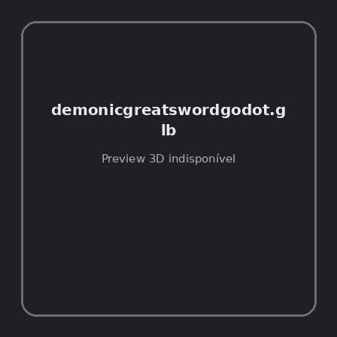
ID | NOV-004696
Origem | Asset novo
Pack/Fonte | demonic weapons pack
Categoria | Weapons / Greatsword
Arquivo | demonicgreatswordgodot.glb
Caminho | 00_Packs_Raw/demonic weapons pack/greatsword/demonicgreatswordgodot.glb
Formato | GLB
Tamanho | 96.34 KB
SHA-256 | a6d31502bf81c04b80e3…
Status técnico | ERROR
Licença | MISSING_REVIEW_REQUIRED — sem evidência localizada
Objetos / meshes | N/D / N/D
Vértices | N/D
Faces / triângulos | N/D / N/D
Materiais | N/D —
UV sets / vertex colors | N/D / N/D
Dimensões XYZ | N/D
Rig / armatures / bones | N/D / N/D / N/D
Skinned meshes | N/D
Animações | N/D —
Duração total clips | N/D
Root motion detectado | N/D
LODs / colliders | Nenhum / Nenhum
Texturas vinculadas | N/D (0 ausentes)
Alertas | Licença/fonte não localizada automaticamente; revisão legal necessária.
Notas | Falha na inspeção 3D: RuntimeError: Error: Python: Traceback (most recent call last):  File "/usr/share/blender/scripts/addons/io_scene_gltf2/__init__.py", line 1064, in execute  return self.import_gltf2(context)  File "/usr/share/blender/scripts/addons/io_scene_gltf2/__init__.py", line 1083, in import_gltf2  return self.unit_import(self.filepath, import_settings)  File "/usr/share/blender/scripts/addons/io_scene_gltf2/__init__.py", line 1088, in unit_import  from .blender.imp.gltf2_blender_gltf import BlenderGlTF  File "/usr/share/blender/scripts/addons/io_scene_gltf2/blender/imp/gltf2_blender_gltf.py", line 17, in <module>  from .gltf2_blender_scene import BlenderScene  File "/usr/share/blender/scripts/addons/io_scene_gltf2/blender/imp/gltf2_blender_scene.py", line 17, in <module>  from .gltf2_blender_node import BlenderNode  File "/usr/share/blender/scripts/addons/io_scene_gltf2/blender/imp/gltf2_blender_node.py", line 18, in <module>  from .gltf2_blender_mesh import BlenderMesh  File "/usr/share/blender/scripts/addons/io_scene_gltf2/blender/imp/gltf2_blender_mesh.py", line 17, in <module>  import numpy as np  ModuleNotFoundError: No module named 'numpy'  location: /usr/share/blender/scripts/modules/bpy/ops.py:132  Traceback (most recent call last):  File "/home/runner/work/PSX_demons_whip/PSX_demons_whip/workspace/demons/tools/asset_catalog/blender_batch.py", line 427, in inspect_task  import_model(path)  File "/home/runner/work/PSX_demons_whip/PSX_demons_whip/workspace/demons/tools/asset_catalog/blender_batch.py", line 52, in import_model  bpy.ops.import_scene.gltf(filepath=str(path))  File "/usr/share/blender/scripts/modules/bpy/ops.py", line 132, in __call__  ret = _op_call(self.idname_py(), None, kw)  RuntimeError: Error: Python: Traceback (most recent call last):  File "/usr/share/blender/scripts/addons/io_scene_gltf2/__init__.py", line 1064, in execute  return self.import_gltf2(context)  File "/usr/share/blender/scripts/addons/io_scene_gltf2/__init__.py", line 1083, in import_gltf2  return self.unit_import(self.filepath, import_settings)  File "/usr/share/blender/scripts/addons/io_scene_gltf2/__init__.py", line 1088, in unit_import  from .blender.imp.gltf2_blender_gltf import BlenderGlTF  File "/usr/share/blender/scripts/addons/io_scene_gltf2/blender/imp/gltf2_blender_gltf.py", line 17, in <module>  from .gltf2_blender_scene import BlenderScene  File "/usr/share/blender/scripts/addons/io_scene_gltf2/blender/imp/gltf2_blender_scene.py", line 17, in <module>  from .gltf2_blender_node import BlenderNode  File "/usr/share/blender/scripts/addons/io_scene_gltf2/blender/imp/gltf2_blender_node.py", line 18, in <module>  from .gltf2_blender_mesh import BlenderMesh  File "/usr/share/blender/scripts/addons/io_scene_gltf2/blender/imp/gltf2_blender_mesh.py", line 17, in <module>  import numpy as np  ModuleNotFoundError: No module named 'numpy'  location: /usr/share/blender/scripts/modules/bpy/ops.py:132

NOV-004707 • demonicscythe [ERROR]
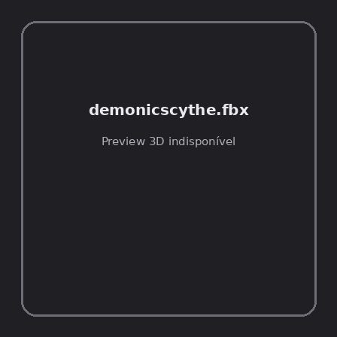
ID | NOV-004707
Origem | Asset novo
Pack/Fonte | demonic weapons pack
Categoria | Weapons / Scythe
Arquivo | demonicscythe.fbx
Caminho | 00_Packs_Raw/demonic weapons pack/scythe/demonicscythe.fbx
Formato | FBX
Tamanho | 28.51 KB
SHA-256 | bcb3ef4070373a716304…
Status técnico | ERROR
Licença | MISSING_REVIEW_REQUIRED — sem evidência localizada
Objetos / meshes | N/D / N/D
Vértices | N/D
Faces / triângulos | N/D / N/D
Materiais | N/D —
UV sets / vertex colors | N/D / N/D
Dimensões XYZ | N/D
Rig / armatures / bones | N/D / N/D / N/D
Skinned meshes | N/D
Animações | N/D —
Duração total clips | N/D
Root motion detectado | N/D
LODs / colliders | Nenhum / Nenhum
Texturas vinculadas | N/D (0 ausentes)
Alertas | Licença/fonte não localizada automaticamente; revisão legal necessária.
Notas | Falha na inspeção 3D: RuntimeError: Error: Python: Traceback (most recent call last):  File "/usr/share/blender/scripts/addons/io_scene_fbx/__init__.py", line 220, in execute  return import_fbx.load(self, context, filepath=self.filepath, **keywords)  File "/usr/share/blender/scripts/addons/io_scene_fbx/import_fbx.py", line 3200, in load  _(); del _  File "/usr/share/blender/scripts/addons/io_scene_fbx/import_fbx.py", line 3192, in _  ma_wrap.alpha_texture.copy_from(ma_wrap.base_color_texture)  File "/usr/share/blender/scripts/modules/bpy_extras/node_shader_utils.py", line 632, in copy_from  self.image = tex.image  File "/usr/share/blender/scripts/modules/bpy_extras/node_shader_utils.py", line 36, in wrapper  return func(self, *args, **kwargs)  File "/usr/share/blender/scripts/modules/bpy_extras/node_shader_utils.py", line 710, in image_set  image.colorspace_settings.name = self.colorspace_name  TypeError: bpy_struct: item.attr = val: enum "Non-Color" not found in ('Linear', 'sRGB')  location: /usr/share/blender/scripts/modules/bpy/ops.py:132  Traceback (most recent call last):  File "/home/runner/work/PSX_demons_whip/PSX_demons_whip/workspace/demons/tools/asset_catalog/blender_batch.py", line 427, in inspect_task  import_model(path)  File "/home/runner/work/PSX_demons_whip/PSX_demons_whip/workspace/demons/tools/asset_catalog/blender_batch.py", line 55, in import_model  bpy.ops.import_scene.fbx(filepath=str(path), automatic_bone_orientation=False)  File "/usr/share/blender/scripts/modules/bpy/ops.py", line 132, in __call__  ret = _op_call(self.idname_py(), None, kw)  RuntimeError: Error: Python: Traceback (most recent call last):  File "/usr/share/blender/scripts/addons/io_scene_fbx/__init__.py", line 220, in execute  return import_fbx.load(self, context, filepath=self.filepath, **keywords)  File "/usr/share/blender/scripts/addons/io_scene_fbx/import_fbx.py", line 3200, in load  _(); del _  File "/usr/share/blender/scripts/addons/io_scene_fbx/import_fbx.py", line 3192, in _  ma_wrap.alpha_texture.copy_from(ma_wrap.base_color_texture)  File "/usr/share/blender/scripts/modules/bpy_extras/node_shader_utils.py", line 632, in copy_from  self.image = tex.image  File "/usr/share/blender/scripts/modules/bpy_extras/node_shader_utils.py", line 36, in wrapper  return func(self, *args, **kwargs)  File "/usr/share/blender/scripts/modules/bpy_extras/node_shader_utils.py", line 710, in image_set  image.colorspace_settings.name = self.colorspace_name  TypeError: bpy_struct: item.attr = val: enum "Non-Color" not found in ('Linear', 'sRGB')  location: /usr/share/blender/scripts/modules/bpy/ops.py:132

NOV-004705 • demonicscythe [ERROR]
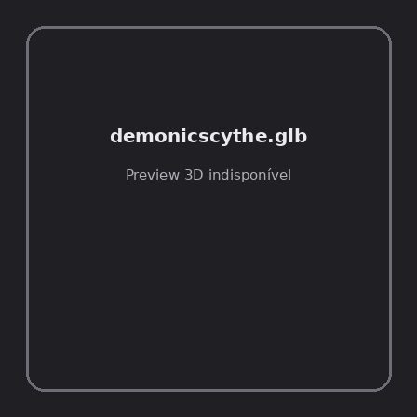
ID | NOV-004705
Origem | Asset novo
Pack/Fonte | demonic weapons pack
Categoria | Weapons / Scythe
Arquivo | demonicscythe.glb
Caminho | 00_Packs_Raw/demonic weapons pack/scythe/demonicscythe.glb
Formato | GLB
Tamanho | 110.38 KB
SHA-256 | 8485e1a2ef2c0d280eb5…
Status técnico | ERROR
Licença | MISSING_REVIEW_REQUIRED — sem evidência localizada
Objetos / meshes | N/D / N/D
Vértices | N/D
Faces / triângulos | N/D / N/D
Materiais | N/D —
UV sets / vertex colors | N/D / N/D
Dimensões XYZ | N/D
Rig / armatures / bones | N/D / N/D / N/D
Skinned meshes | N/D
Animações | N/D —
Duração total clips | N/D
Root motion detectado | N/D
LODs / colliders | Nenhum / Nenhum
Texturas vinculadas | N/D (0 ausentes)
Alertas | Licença/fonte não localizada automaticamente; revisão legal necessária.
Notas | Falha na inspeção 3D: RuntimeError: Error: Python: Traceback (most recent call last):  File "/usr/share/blender/scripts/addons/io_scene_gltf2/__init__.py", line 1064, in execute  return self.import_gltf2(context)  File "/usr/share/blender/scripts/addons/io_scene_gltf2/__init__.py", line 1083, in import_gltf2  return self.unit_import(self.filepath, import_settings)  File "/usr/share/blender/scripts/addons/io_scene_gltf2/__init__.py", line 1088, in unit_import  from .blender.imp.gltf2_blender_gltf import BlenderGlTF  File "/usr/share/blender/scripts/addons/io_scene_gltf2/blender/imp/gltf2_blender_gltf.py", line 17, in <module>  from .gltf2_blender_scene import BlenderScene  File "/usr/share/blender/scripts/addons/io_scene_gltf2/blender/imp/gltf2_blender_scene.py", line 17, in <module>  from .gltf2_blender_node import BlenderNode  File "/usr/share/blender/scripts/addons/io_scene_gltf2/blender/imp/gltf2_blender_node.py", line 18, in <module>  from .gltf2_blender_mesh import BlenderMesh  File "/usr/share/blender/scripts/addons/io_scene_gltf2/blender/imp/gltf2_blender_mesh.py", line 17, in <module>  import numpy as np  ModuleNotFoundError: No module named 'numpy'  location: /usr/share/blender/scripts/modules/bpy/ops.py:132  Traceback (most recent call last):  File "/home/runner/work/PSX_demons_whip/PSX_demons_whip/workspace/demons/tools/asset_catalog/blender_batch.py", line 427, in inspect_task  import_model(path)  File "/home/runner/work/PSX_demons_whip/PSX_demons_whip/workspace/demons/tools/asset_catalog/blender_batch.py", line 52, in import_model  bpy.ops.import_scene.gltf(filepath=str(path))  File "/usr/share/blender/scripts/modules/bpy/ops.py", line 132, in __call__  ret = _op_call(self.idname_py(), None, kw)  RuntimeError: Error: Python: Traceback (most recent call last):  File "/usr/share/blender/scripts/addons/io_scene_gltf2/__init__.py", line 1064, in execute  return self.import_gltf2(context)  File "/usr/share/blender/scripts/addons/io_scene_gltf2/__init__.py", line 1083, in import_gltf2  return self.unit_import(self.filepath, import_settings)  File "/usr/share/blender/scripts/addons/io_scene_gltf2/__init__.py", line 1088, in unit_import  from .blender.imp.gltf2_blender_gltf import BlenderGlTF  File "/usr/share/blender/scripts/addons/io_scene_gltf2/blender/imp/gltf2_blender_gltf.py", line 17, in <module>  from .gltf2_blender_scene import BlenderScene  File "/usr/share/blender/scripts/addons/io_scene_gltf2/blender/imp/gltf2_blender_scene.py", line 17, in <module>  from .gltf2_blender_node import BlenderNode  File "/usr/share/blender/scripts/addons/io_scene_gltf2/blender/imp/gltf2_blender_node.py", line 18, in <module>  from .gltf2_blender_mesh import BlenderMesh  File "/usr/share/blender/scripts/addons/io_scene_gltf2/blender/imp/gltf2_blender_mesh.py", line 17, in <module>  import numpy as np  ModuleNotFoundError: No module named 'numpy'  location: /usr/share/blender/scripts/modules/bpy/ops.py:132

NOV-004693 • demonicspear [ERROR]
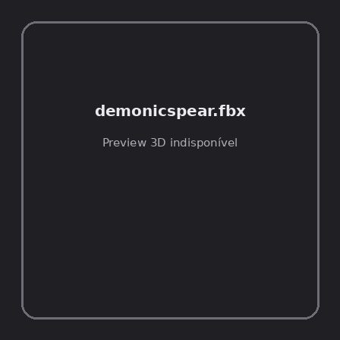
ID | NOV-004693
Origem | Asset novo
Pack/Fonte | demonic weapons pack
Categoria | Weapons / Spear
Arquivo | demonicspear.fbx
Caminho | 00_Packs_Raw/demonic weapons pack/spear/demonicspear.fbx
Formato | FBX
Tamanho | 30.06 KB
SHA-256 | 8b2bb5db0c579af7ebdc…
Status técnico | ERROR
Licença | MISSING_REVIEW_REQUIRED — sem evidência localizada
Objetos / meshes | N/D / N/D
Vértices | N/D
Faces / triângulos | N/D / N/D
Materiais | N/D —
UV sets / vertex colors | N/D / N/D
Dimensões XYZ | N/D
Rig / armatures / bones | N/D / N/D / N/D
Skinned meshes | N/D
Animações | N/D —
Duração total clips | N/D
Root motion detectado | N/D
LODs / colliders | Nenhum / Nenhum
Texturas vinculadas | N/D (0 ausentes)
Alertas | Licença/fonte não localizada automaticamente; revisão legal necessária.
Notas | Falha na inspeção 3D: RuntimeError: Error: Python: Traceback (most recent call last):  File "/usr/share/blender/scripts/addons/io_scene_fbx/__init__.py", line 220, in execute  return import_fbx.load(self, context, filepath=self.filepath, **keywords)  File "/usr/share/blender/scripts/addons/io_scene_fbx/import_fbx.py", line 3200, in load  _(); del _  File "/usr/share/blender/scripts/addons/io_scene_fbx/import_fbx.py", line 3192, in _  ma_wrap.alpha_texture.copy_from(ma_wrap.base_color_texture)  File "/usr/share/blender/scripts/modules/bpy_extras/node_shader_utils.py", line 632, in copy_from  self.image = tex.image  File "/usr/share/blender/scripts/modules/bpy_extras/node_shader_utils.py", line 36, in wrapper  return func(self, *args, **kwargs)  File "/usr/share/blender/scripts/modules/bpy_extras/node_shader_utils.py", line 710, in image_set  image.colorspace_settings.name = self.colorspace_name  TypeError: bpy_struct: item.attr = val: enum "Non-Color" not found in ('Linear', 'sRGB')  location: /usr/share/blender/scripts/modules/bpy/ops.py:132  Traceback (most recent call last):  File "/home/runner/work/PSX_demons_whip/PSX_demons_whip/workspace/demons/tools/asset_catalog/blender_batch.py", line 427, in inspect_task  import_model(path)  File "/home/runner/work/PSX_demons_whip/PSX_demons_whip/workspace/demons/tools/asset_catalog/blender_batch.py", line 55, in import_model  bpy.ops.import_scene.fbx(filepath=str(path), automatic_bone_orientation=False)  File "/usr/share/blender/scripts/modules/bpy/ops.py", line 132, in __call__  ret = _op_call(self.idname_py(), None, kw)  RuntimeError: Error: Python: Traceback (most recent call last):  File "/usr/share/blender/scripts/addons/io_scene_fbx/__init__.py", line 220, in execute  return import_fbx.load(self, context, filepath=self.filepath, **keywords)  File "/usr/share/blender/scripts/addons/io_scene_fbx/import_fbx.py", line 3200, in load  _(); del _  File "/usr/share/blender/scripts/addons/io_scene_fbx/import_fbx.py", line 3192, in _  ma_wrap.alpha_texture.copy_from(ma_wrap.base_color_texture)  File "/usr/share/blender/scripts/modules/bpy_extras/node_shader_utils.py", line 632, in copy_from  self.image = tex.image  File "/usr/share/blender/scripts/modules/bpy_extras/node_shader_utils.py", line 36, in wrapper  return func(self, *args, **kwargs)  File "/usr/share/blender/scripts/modules/bpy_extras/node_shader_utils.py", line 710, in image_set  image.colorspace_settings.name = self.colorspace_name  TypeError: bpy_struct: item.attr = val: enum "Non-Color" not found in ('Linear', 'sRGB')  location: /usr/share/blender/scripts/modules/bpy/ops.py:132

NOV-004694 • demonicspeargodot [ERROR]
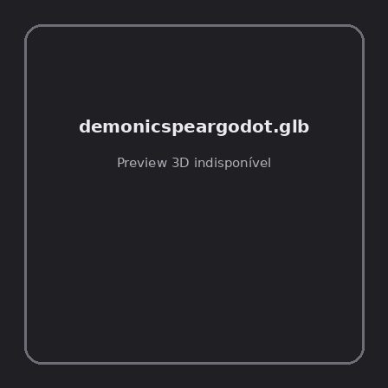
ID | NOV-004694
Origem | Asset novo
Pack/Fonte | demonic weapons pack
Categoria | Weapons / Spear
Arquivo | demonicspeargodot.glb
Caminho | 00_Packs_Raw/demonic weapons pack/spear/demonicspeargodot.glb
Formato | GLB
Tamanho | 57.26 KB
SHA-256 | e75478f0d4fd3630a200…
Status técnico | ERROR
Licença | MISSING_REVIEW_REQUIRED — sem evidência localizada
Objetos / meshes | N/D / N/D
Vértices | N/D
Faces / triângulos | N/D / N/D
Materiais | N/D —
UV sets / vertex colors | N/D / N/D
Dimensões XYZ | N/D
Rig / armatures / bones | N/D / N/D / N/D
Skinned meshes | N/D
Animações | N/D —
Duração total clips | N/D
Root motion detectado | N/D
LODs / colliders | Nenhum / Nenhum
Texturas vinculadas | N/D (0 ausentes)
Alertas | Licença/fonte não localizada automaticamente; revisão legal necessária.
Notas | Falha na inspeção 3D: RuntimeError: Error: Python: Traceback (most recent call last):  File "/usr/share/blender/scripts/addons/io_scene_gltf2/__init__.py", line 1064, in execute  return self.import_gltf2(context)  File "/usr/share/blender/scripts/addons/io_scene_gltf2/__init__.py", line 1083, in import_gltf2  return self.unit_import(self.filepath, import_settings)  File "/usr/share/blender/scripts/addons/io_scene_gltf2/__init__.py", line 1088, in unit_import  from .blender.imp.gltf2_blender_gltf import BlenderGlTF  File "/usr/share/blender/scripts/addons/io_scene_gltf2/blender/imp/gltf2_blender_gltf.py", line 17, in <module>  from .gltf2_blender_scene import BlenderScene  File "/usr/share/blender/scripts/addons/io_scene_gltf2/blender/imp/gltf2_blender_scene.py", line 17, in <module>  from .gltf2_blender_node import BlenderNode  File "/usr/share/blender/scripts/addons/io_scene_gltf2/blender/imp/gltf2_blender_node.py", line 18, in <module>  from .gltf2_blender_mesh import BlenderMesh  File "/usr/share/blender/scripts/addons/io_scene_gltf2/blender/imp/gltf2_blender_mesh.py", line 17, in <module>  import numpy as np  ModuleNotFoundError: No module named 'numpy'  location: /usr/share/blender/scripts/modules/bpy/ops.py:132  Traceback (most recent call last):  File "/home/runner/work/PSX_demons_whip/PSX_demons_whip/workspace/demons/tools/asset_catalog/blender_batch.py", line 427, in inspect_task  import_model(path)  File "/home/runner/work/PSX_demons_whip/PSX_demons_whip/workspace/demons/tools/asset_catalog/blender_batch.py", line 52, in import_model  bpy.ops.import_scene.gltf(filepath=str(path))  File "/usr/share/blender/scripts/modules/bpy/ops.py", line 132, in __call__  ret = _op_call(self.idname_py(), None, kw)  RuntimeError: Error: Python: Traceback (most recent call last):  File "/usr/share/blender/scripts/addons/io_scene_gltf2/__init__.py", line 1064, in execute  return self.import_gltf2(context)  File "/usr/share/blender/scripts/addons/io_scene_gltf2/__init__.py", line 1083, in import_gltf2  return self.unit_import(self.filepath, import_settings)  File "/usr/share/blender/scripts/addons/io_scene_gltf2/__init__.py", line 1088, in unit_import  from .blender.imp.gltf2_blender_gltf import BlenderGlTF  File "/usr/share/blender/scripts/addons/io_scene_gltf2/blender/imp/gltf2_blender_gltf.py", line 17, in <module>  from .gltf2_blender_scene import BlenderScene  File "/usr/share/blender/scripts/addons/io_scene_gltf2/blender/imp/gltf2_blender_scene.py", line 17, in <module>  from .gltf2_blender_node import BlenderNode  File "/usr/share/blender/scripts/addons/io_scene_gltf2/blender/imp/gltf2_blender_node.py", line 18, in <module>  from .gltf2_blender_mesh import BlenderMesh  File "/usr/share/blender/scripts/addons/io_scene_gltf2/blender/imp/gltf2_blender_mesh.py", line 17, in <module>  import numpy as np  ModuleNotFoundError: No module named 'numpy'  location: /usr/share/blender/scripts/modules/bpy/ops.py:132

NOV-004702 • demonicsword [ERROR]
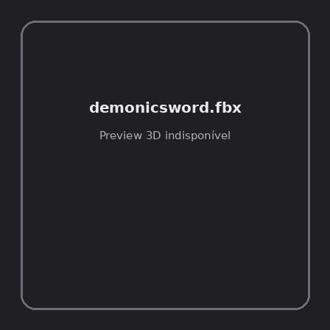
ID | NOV-004702
Origem | Asset novo
Pack/Fonte | demonic weapons pack
Categoria | Weapons / Sword
Arquivo | demonicsword.fbx
Caminho | 00_Packs_Raw/demonic weapons pack/sword/demonicsword.fbx
Formato | FBX
Tamanho | 24.98 KB
SHA-256 | 59c22cbf24bab10880ae…
Status técnico | ERROR
Licença | MISSING_REVIEW_REQUIRED — sem evidência localizada
Objetos / meshes | N/D / N/D
Vértices | N/D
Faces / triângulos | N/D / N/D
Materiais | N/D —
UV sets / vertex colors | N/D / N/D
Dimensões XYZ | N/D
Rig / armatures / bones | N/D / N/D / N/D
Skinned meshes | N/D
Animações | N/D —
Duração total clips | N/D
Root motion detectado | N/D
LODs / colliders | Nenhum / Nenhum
Texturas vinculadas | N/D (0 ausentes)
Alertas | Licença/fonte não localizada automaticamente; revisão legal necessária.
Notas | Falha na inspeção 3D: RuntimeError: Error: Python: Traceback (most recent call last):  File "/usr/share/blender/scripts/addons/io_scene_fbx/__init__.py", line 220, in execute  return import_fbx.load(self, context, filepath=self.filepath, **keywords)  File "/usr/share/blender/scripts/addons/io_scene_fbx/import_fbx.py", line 3200, in load  _(); del _  File "/usr/share/blender/scripts/addons/io_scene_fbx/import_fbx.py", line 3192, in _  ma_wrap.alpha_texture.copy_from(ma_wrap.base_color_texture)  File "/usr/share/blender/scripts/modules/bpy_extras/node_shader_utils.py", line 632, in copy_from  self.image = tex.image  File "/usr/share/blender/scripts/modules/bpy_extras/node_shader_utils.py", line 36, in wrapper  return func(self, *args, **kwargs)  File "/usr/share/blender/scripts/modules/bpy_extras/node_shader_utils.py", line 710, in image_set  image.colorspace_settings.name = self.colorspace_name  TypeError: bpy_struct: item.attr = val: enum "Non-Color" not found in ('Linear', 'sRGB')  location: /usr/share/blender/scripts/modules/bpy/ops.py:132  Traceback (most recent call last):  File "/home/runner/work/PSX_demons_whip/PSX_demons_whip/workspace/demons/tools/asset_catalog/blender_batch.py", line 427, in inspect_task  import_model(path)  File "/home/runner/work/PSX_demons_whip/PSX_demons_whip/workspace/demons/tools/asset_catalog/blender_batch.py", line 55, in import_model  bpy.ops.import_scene.fbx(filepath=str(path), automatic_bone_orientation=False)  File "/usr/share/blender/scripts/modules/bpy/ops.py", line 132, in __call__  ret = _op_call(self.idname_py(), None, kw)  RuntimeError: Error: Python: Traceback (most recent call last):  File "/usr/share/blender/scripts/addons/io_scene_fbx/__init__.py", line 220, in execute  return import_fbx.load(self, context, filepath=self.filepath, **keywords)  File "/usr/share/blender/scripts/addons/io_scene_fbx/import_fbx.py", line 3200, in load  _(); del _  File "/usr/share/blender/scripts/addons/io_scene_fbx/import_fbx.py", line 3192, in _  ma_wrap.alpha_texture.copy_from(ma_wrap.base_color_texture)  File "/usr/share/blender/scripts/modules/bpy_extras/node_shader_utils.py", line 632, in copy_from  self.image = tex.image  File "/usr/share/blender/scripts/modules/bpy_extras/node_shader_utils.py", line 36, in wrapper  return func(self, *args, **kwargs)  File "/usr/share/blender/scripts/modules/bpy_extras/node_shader_utils.py", line 710, in image_set  image.colorspace_settings.name = self.colorspace_name  TypeError: bpy_struct: item.attr = val: enum "Non-Color" not found in ('Linear', 'sRGB')  location: /usr/share/blender/scripts/modules/bpy/ops.py:132

NOV-004703 • demonicswordgodot [ERROR]
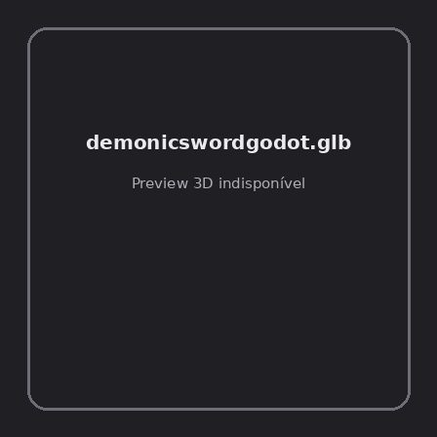
ID | NOV-004703
Origem | Asset novo
Pack/Fonte | demonic weapons pack
Categoria | Weapons / Sword
Arquivo | demonicswordgodot.glb
Caminho | 00_Packs_Raw/demonic weapons pack/sword/demonicswordgodot.glb
Formato | GLB
Tamanho | 93.35 KB
SHA-256 | 85b18901530d9e51d539…
Status técnico | ERROR
Licença | MISSING_REVIEW_REQUIRED — sem evidência localizada
Objetos / meshes | N/D / N/D
Vértices | N/D
Faces / triângulos | N/D / N/D
Materiais | N/D —
UV sets / vertex colors | N/D / N/D
Dimensões XYZ | N/D
Rig / armatures / bones | N/D / N/D / N/D
Skinned meshes | N/D
Animações | N/D —
Duração total clips | N/D
Root motion detectado | N/D
LODs / colliders | Nenhum / Nenhum
Texturas vinculadas | N/D (0 ausentes)
Alertas | Licença/fonte não localizada automaticamente; revisão legal necessária.
Notas | Falha na inspeção 3D: RuntimeError: Error: Python: Traceback (most recent call last):  File "/usr/share/blender/scripts/addons/io_scene_gltf2/__init__.py", line 1064, in execute  return self.import_gltf2(context)  File "/usr/share/blender/scripts/addons/io_scene_gltf2/__init__.py", line 1083, in import_gltf2  return self.unit_import(self.filepath, import_settings)  File "/usr/share/blender/scripts/addons/io_scene_gltf2/__init__.py", line 1088, in unit_import  from .blender.imp.gltf2_blender_gltf import BlenderGlTF  File "/usr/share/blender/scripts/addons/io_scene_gltf2/blender/imp/gltf2_blender_gltf.py", line 17, in <module>  from .gltf2_blender_scene import BlenderScene  File "/usr/share/blender/scripts/addons/io_scene_gltf2/blender/imp/gltf2_blender_scene.py", line 17, in <module>  from .gltf2_blender_node import BlenderNode  File "/usr/share/blender/scripts/addons/io_scene_gltf2/blender/imp/gltf2_blender_node.py", line 18, in <module>  from .gltf2_blender_mesh import BlenderMesh  File "/usr/share/blender/scripts/addons/io_scene_gltf2/blender/imp/gltf2_blender_mesh.py", line 17, in <module>  import numpy as np  ModuleNotFoundError: No module named 'numpy'  location: /usr/share/blender/scripts/modules/bpy/ops.py:132  Traceback (most recent call last):  File "/home/runner/work/PSX_demons_whip/PSX_demons_whip/workspace/demons/tools/asset_catalog/blender_batch.py", line 427, in inspect_task  import_model(path)  File "/home/runner/work/PSX_demons_whip/PSX_demons_whip/workspace/demons/tools/asset_catalog/blender_batch.py", line 52, in import_model  bpy.ops.import_scene.gltf(filepath=str(path))  File "/usr/share/blender/scripts/modules/bpy/ops.py", line 132, in __call__  ret = _op_call(self.idname_py(), None, kw)  RuntimeError: Error: Python: Traceback (most recent call last):  File "/usr/share/blender/scripts/addons/io_scene_gltf2/__init__.py", line 1064, in execute  return self.import_gltf2(context)  File "/usr/share/blender/scripts/addons/io_scene_gltf2/__init__.py", line 1083, in import_gltf2  return self.unit_import(self.filepath, import_settings)  File "/usr/share/blender/scripts/addons/io_scene_gltf2/__init__.py", line 1088, in unit_import  from .blender.imp.gltf2_blender_gltf import BlenderGlTF  File "/usr/share/blender/scripts/addons/io_scene_gltf2/blender/imp/gltf2_blender_gltf.py", line 17, in <module>  from .gltf2_blender_scene import BlenderScene  File "/usr/share/blender/scripts/addons/io_scene_gltf2/blender/imp/gltf2_blender_scene.py", line 17, in <module>  from .gltf2_blender_node import BlenderNode  File "/usr/share/blender/scripts/addons/io_scene_gltf2/blender/imp/gltf2_blender_node.py", line 18, in <module>  from .gltf2_blender_mesh import BlenderMesh  File "/usr/share/blender/scripts/addons/io_scene_gltf2/blender/imp/gltf2_blender_mesh.py", line 17, in <module>  import numpy as np  ModuleNotFoundError: No module named 'numpy'  location: /usr/share/blender/scripts/modules/bpy/ops.py:132

NOV-004363 • ps1_Sword [ERROR]
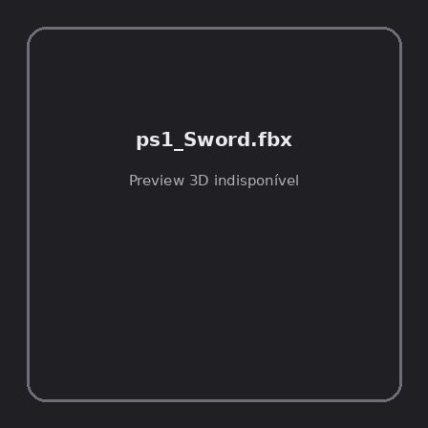
ID | NOV-004363
Origem | Asset novo
Pack/Fonte | PS1 Dark Fantasy Horror Game Assets (by Stark Crafts)
Categoria | Weapons / Ps1 Skull
Arquivo | ps1_Sword.fbx
Caminho | 00_Packs_Raw/PS1 Dark Fantasy Horror Game Assets (by Stark Crafts)/PS1_Skull/ps1_Sword.fbx
Formato | FBX
Tamanho | 21.42 KB
SHA-256 | 54954f126884cfa1cd12…
Status técnico | ERROR
Licença | MISSING_REVIEW_REQUIRED — sem evidência localizada
Objetos / meshes | N/D / N/D
Vértices | N/D
Faces / triângulos | N/D / N/D
Materiais | N/D —
UV sets / vertex colors | N/D / N/D
Dimensões XYZ | N/D
Rig / armatures / bones | N/D / N/D / N/D
Skinned meshes | N/D
Animações | N/D —
Duração total clips | N/D
Root motion detectado | N/D
LODs / colliders | Nenhum / Nenhum
Texturas vinculadas | N/D (0 ausentes)
Alertas | Licença/fonte não localizada automaticamente; revisão legal necessária.
Notas | Falha na inspeção 3D: Unable to open a display

