DEMONS WHIP - NOVO - CHARACTERS
MODEL 3D • Volume 1 de 1

Assets neste volume: 32
Origem: NOVO
Gerado em: 2026-08-17T19:03:59+00:00

NOV-005760 • barbarian [ERROR]
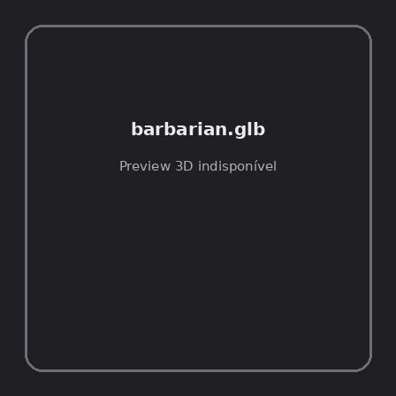
ID | NOV-005760
Origem | Asset novo
Pack/Fonte | Assets Organizados - Characters
Categoria | Characters / Barbarian.Glb
Arquivo | barbarian.glb
Caminho | 01_Assets_Organizados/Characters/barbarian.glb
Formato | GLB
Tamanho | 433.83 KB
SHA-256 | 2fb8d32c29d2b5c4b9b4…
Status técnico | ERROR
Licença | MISSING_REVIEW_REQUIRED — sem evidência localizada
Objetos / meshes | N/D / N/D
Vértices | N/D
Faces / triângulos | N/D / N/D
Materiais | N/D —
UV sets / vertex colors | N/D / N/D
Dimensões XYZ | N/D
Rig / armatures / bones | N/D / N/D / N/D
Skinned meshes | N/D
Animações | N/D —
Duração total clips | N/D
Root motion detectado | N/D
LODs / colliders | Nenhum / Nenhum
Texturas vinculadas | N/D (0 ausentes)
Alertas | Licença/fonte não localizada automaticamente; revisão legal necessária. | Duplicado exato: grupo DUP-01087 (2 cópias).
Notas | Falha na inspeção 3D: RuntimeError: Error: Python: Traceback (most recent call last):  File "/usr/share/blender/scripts/addons/io_scene_gltf2/__init__.py", line 1064, in execute  return self.import_gltf2(context)  File "/usr/share/blender/scripts/addons/io_scene_gltf2/__init__.py", line 1083, in import_gltf2  return self.unit_import(self.filepath, import_settings)  File "/usr/share/blender/scripts/addons/io_scene_gltf2/__init__.py", line 1088, in unit_import  from .blender.imp.gltf2_blender_gltf import BlenderGlTF  File "/usr/share/blender/scripts/addons/io_scene_gltf2/blender/imp/gltf2_blender_gltf.py", line 17, in <module>  from .gltf2_blender_scene import BlenderScene  File "/usr/share/blender/scripts/addons/io_scene_gltf2/blender/imp/gltf2_blender_scene.py", line 17, in <module>  from .gltf2_blender_node import BlenderNode  File "/usr/share/blender/scripts/addons/io_scene_gltf2/blender/imp/gltf2_blender_node.py", line 18, in <module>  from .gltf2_blender_mesh import BlenderMesh  File "/usr/share/blender/scripts/addons/io_scene_gltf2/blender/imp/gltf2_blender_mesh.py", line 17, in <module>  import numpy as np  ModuleNotFoundError: No module named 'numpy'  location: /usr/share/blender/scripts/modules/bpy/ops.py:132  Traceback (most recent call last):  File "/home/runner/work/PSX_demons_whip/PSX_demons_whip/workspace/demons/tools/asset_catalog/blender_batch.py", line 427, in inspect_task  import_model(path)  File "/home/runner/work/PSX_demons_whip/PSX_demons_whip/workspace/demons/tools/asset_catalog/blender_batch.py", line 52, in import_model  bpy.ops.import_scene.gltf(filepath=str(path))  File "/usr/share/blender/scripts/modules/bpy/ops.py", line 132, in __call__  ret = _op_call(self.idname_py(), None, kw)  RuntimeError: Error: Python: Traceback (most recent call last):  File "/usr/share/blender/scripts/addons/io_scene_gltf2/__init__.py", line 1064, in execute  return self.import_gltf2(context)  File "/usr/share/blender/scripts/addons/io_scene_gltf2/__init__.py", line 1083, in import_gltf2  return self.unit_import(self.filepath, import_settings)  File "/usr/share/blender/scripts/addons/io_scene_gltf2/__init__.py", line 1088, in unit_import  from .blender.imp.gltf2_blender_gltf import BlenderGlTF  File "/usr/share/blender/scripts/addons/io_scene_gltf2/blender/imp/gltf2_blender_gltf.py", line 17, in <module>  from .gltf2_blender_scene import BlenderScene  File "/usr/share/blender/scripts/addons/io_scene_gltf2/blender/imp/gltf2_blender_scene.py", line 17, in <module>  from .gltf2_blender_node import BlenderNode  File "/usr/share/blender/scripts/addons/io_scene_gltf2/blender/imp/gltf2_blender_node.py", line 18, in <module>  from .gltf2_blender_mesh import BlenderMesh  File "/usr/share/blender/scripts/addons/io_scene_gltf2/blender/imp/gltf2_blender_mesh.py", line 17, in <module>  import numpy as np  ModuleNotFoundError: No module named 'numpy'  location: /usr/share/blender/scripts/modules/bpy/ops.py:132  | Metadados 3D reutilizados do duplicado idêntico TEM-002571.

NOV-005775 • barbarian_hit_variety_anims [ERROR]
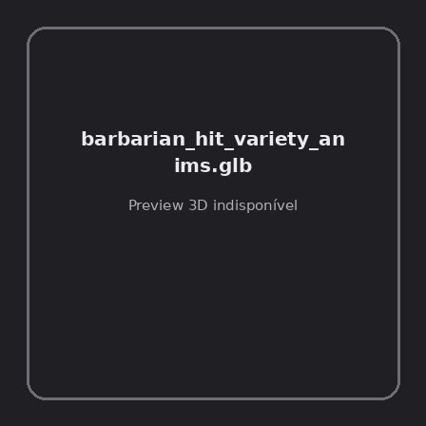
ID | NOV-005775
Origem | Asset novo
Pack/Fonte | Assets Organizados - Characters
Categoria | Characters / Barbarian Hit Variety Anims.Glb
Arquivo | barbarian_hit_variety_anims.glb
Caminho | 01_Assets_Organizados/Characters/barbarian_hit_variety_anims.glb
Formato | GLB
Tamanho | 21.09 KB
SHA-256 | 7321b010ff5e4f082019…
Status técnico | ERROR
Licença | MISSING_REVIEW_REQUIRED — sem evidência localizada
Objetos / meshes | N/D / N/D
Vértices | N/D
Faces / triângulos | N/D / N/D
Materiais | N/D —
UV sets / vertex colors | N/D / N/D
Dimensões XYZ | N/D
Rig / armatures / bones | N/D / N/D / N/D
Skinned meshes | N/D
Animações | N/D —
Duração total clips | N/D
Root motion detectado | N/D
LODs / colliders | Nenhum / Nenhum
Texturas vinculadas | N/D (0 ausentes)
Alertas | Licença/fonte não localizada automaticamente; revisão legal necessária.
Notas | Falha na inspeção 3D: RuntimeError: Error: Python: Traceback (most recent call last):  File "/usr/share/blender/scripts/addons/io_scene_gltf2/__init__.py", line 1064, in execute  return self.import_gltf2(context)  File "/usr/share/blender/scripts/addons/io_scene_gltf2/__init__.py", line 1083, in import_gltf2  return self.unit_import(self.filepath, import_settings)  File "/usr/share/blender/scripts/addons/io_scene_gltf2/__init__.py", line 1088, in unit_import  from .blender.imp.gltf2_blender_gltf import BlenderGlTF  File "/usr/share/blender/scripts/addons/io_scene_gltf2/blender/imp/gltf2_blender_gltf.py", line 17, in <module>  from .gltf2_blender_scene import BlenderScene  File "/usr/share/blender/scripts/addons/io_scene_gltf2/blender/imp/gltf2_blender_scene.py", line 17, in <module>  from .gltf2_blender_node import BlenderNode  File "/usr/share/blender/scripts/addons/io_scene_gltf2/blender/imp/gltf2_blender_node.py", line 18, in <module>  from .gltf2_blender_mesh import BlenderMesh  File "/usr/share/blender/scripts/addons/io_scene_gltf2/blender/imp/gltf2_blender_mesh.py", line 17, in <module>  import numpy as np  ModuleNotFoundError: No module named 'numpy'  location: /usr/share/blender/scripts/modules/bpy/ops.py:132  Traceback (most recent call last):  File "/home/runner/work/PSX_demons_whip/PSX_demons_whip/workspace/demons/tools/asset_catalog/blender_batch.py", line 427, in inspect_task  import_model(path)  File "/home/runner/work/PSX_demons_whip/PSX_demons_whip/workspace/demons/tools/asset_catalog/blender_batch.py", line 52, in import_model  bpy.ops.import_scene.gltf(filepath=str(path))  File "/usr/share/blender/scripts/modules/bpy/ops.py", line 132, in __call__  ret = _op_call(self.idname_py(), None, kw)  RuntimeError: Error: Python: Traceback (most recent call last):  File "/usr/share/blender/scripts/addons/io_scene_gltf2/__init__.py", line 1064, in execute  return self.import_gltf2(context)  File "/usr/share/blender/scripts/addons/io_scene_gltf2/__init__.py", line 1083, in import_gltf2  return self.unit_import(self.filepath, import_settings)  File "/usr/share/blender/scripts/addons/io_scene_gltf2/__init__.py", line 1088, in unit_import  from .blender.imp.gltf2_blender_gltf import BlenderGlTF  File "/usr/share/blender/scripts/addons/io_scene_gltf2/blender/imp/gltf2_blender_gltf.py", line 17, in <module>  from .gltf2_blender_scene import BlenderScene  File "/usr/share/blender/scripts/addons/io_scene_gltf2/blender/imp/gltf2_blender_scene.py", line 17, in <module>  from .gltf2_blender_node import BlenderNode  File "/usr/share/blender/scripts/addons/io_scene_gltf2/blender/imp/gltf2_blender_node.py", line 18, in <module>  from .gltf2_blender_mesh import BlenderMesh  File "/usr/share/blender/scripts/addons/io_scene_gltf2/blender/imp/gltf2_blender_mesh.py", line 17, in <module>  import numpy as np  ModuleNotFoundError: No module named 'numpy'  location: /usr/share/blender/scripts/modules/bpy/ops.py:132

NOV-005746 • bow_anims [ERROR]
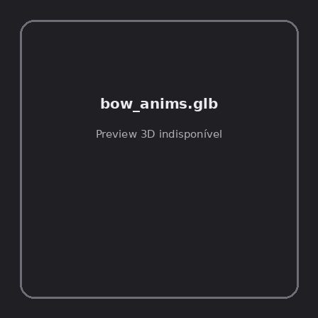
ID | NOV-005746
Origem | Asset novo
Pack/Fonte | Assets Organizados - Characters
Categoria | Characters / Bow Anims.Glb
Arquivo | bow_anims.glb
Caminho | 01_Assets_Organizados/Characters/bow_anims.glb
Formato | GLB
Tamanho | 60.51 KB
SHA-256 | 11f1982870b3d89328e8…
Status técnico | ERROR
Licença | MISSING_REVIEW_REQUIRED — sem evidência localizada
Objetos / meshes | N/D / N/D
Vértices | N/D
Faces / triângulos | N/D / N/D
Materiais | N/D —
UV sets / vertex colors | N/D / N/D
Dimensões XYZ | N/D
Rig / armatures / bones | N/D / N/D / N/D
Skinned meshes | N/D
Animações | N/D —
Duração total clips | N/D
Root motion detectado | N/D
LODs / colliders | Nenhum / Nenhum
Texturas vinculadas | N/D (0 ausentes)
Alertas | Licença/fonte não localizada automaticamente; revisão legal necessária. | Duplicado exato: grupo DUP-01083 (2 cópias).
Notas | Falha na inspeção 3D: RuntimeError: Error: Python: Traceback (most recent call last):  File "/usr/share/blender/scripts/addons/io_scene_gltf2/__init__.py", line 1064, in execute  return self.import_gltf2(context)  File "/usr/share/blender/scripts/addons/io_scene_gltf2/__init__.py", line 1083, in import_gltf2  return self.unit_import(self.filepath, import_settings)  File "/usr/share/blender/scripts/addons/io_scene_gltf2/__init__.py", line 1088, in unit_import  from .blender.imp.gltf2_blender_gltf import BlenderGlTF  File "/usr/share/blender/scripts/addons/io_scene_gltf2/blender/imp/gltf2_blender_gltf.py", line 17, in <module>  from .gltf2_blender_scene import BlenderScene  File "/usr/share/blender/scripts/addons/io_scene_gltf2/blender/imp/gltf2_blender_scene.py", line 17, in <module>  from .gltf2_blender_node import BlenderNode  File "/usr/share/blender/scripts/addons/io_scene_gltf2/blender/imp/gltf2_blender_node.py", line 18, in <module>  from .gltf2_blender_mesh import BlenderMesh  File "/usr/share/blender/scripts/addons/io_scene_gltf2/blender/imp/gltf2_blender_mesh.py", line 17, in <module>  import numpy as np  ModuleNotFoundError: No module named 'numpy'  location: /usr/share/blender/scripts/modules/bpy/ops.py:132  Traceback (most recent call last):  File "/home/runner/work/PSX_demons_whip/PSX_demons_whip/workspace/demons/tools/asset_catalog/blender_batch.py", line 427, in inspect_task  import_model(path)  File "/home/runner/work/PSX_demons_whip/PSX_demons_whip/workspace/demons/tools/asset_catalog/blender_batch.py", line 52, in import_model  bpy.ops.import_scene.gltf(filepath=str(path))  File "/usr/share/blender/scripts/modules/bpy/ops.py", line 132, in __call__  ret = _op_call(self.idname_py(), None, kw)  RuntimeError: Error: Python: Traceback (most recent call last):  File "/usr/share/blender/scripts/addons/io_scene_gltf2/__init__.py", line 1064, in execute  return self.import_gltf2(context)  File "/usr/share/blender/scripts/addons/io_scene_gltf2/__init__.py", line 1083, in import_gltf2  return self.unit_import(self.filepath, import_settings)  File "/usr/share/blender/scripts/addons/io_scene_gltf2/__init__.py", line 1088, in unit_import  from .blender.imp.gltf2_blender_gltf import BlenderGlTF  File "/usr/share/blender/scripts/addons/io_scene_gltf2/blender/imp/gltf2_blender_gltf.py", line 17, in <module>  from .gltf2_blender_scene import BlenderScene  File "/usr/share/blender/scripts/addons/io_scene_gltf2/blender/imp/gltf2_blender_scene.py", line 17, in <module>  from .gltf2_blender_node import BlenderNode  File "/usr/share/blender/scripts/addons/io_scene_gltf2/blender/imp/gltf2_blender_node.py", line 18, in <module>  from .gltf2_blender_mesh import BlenderMesh  File "/usr/share/blender/scripts/addons/io_scene_gltf2/blender/imp/gltf2_blender_mesh.py", line 17, in <module>  import numpy as np  ModuleNotFoundError: No module named 'numpy'  location: /usr/share/blender/scripts/modules/bpy/ops.py:132  | Metadados 3D reutilizados do duplicado idêntico TEM-002567.

NOV-005768 • bow_hold_anim [ERROR]

ID | NOV-005768
Origem | Asset novo
Pack/Fonte | Assets Organizados - Characters
Categoria | Characters / Bow Hold Anim.Glb
Arquivo | bow_hold_anim.glb
Caminho | 01_Assets_Organizados/Characters/bow_hold_anim.glb
Formato | GLB
Tamanho | 35.62 KB
SHA-256 | 55a03fd920b36364864e…
Status técnico | ERROR
Licença | MISSING_REVIEW_REQUIRED — sem evidência localizada
Objetos / meshes | N/D / N/D
Vértices | N/D
Faces / triângulos | N/D / N/D
Materiais | N/D —
UV sets / vertex colors | N/D / N/D
Dimensões XYZ | N/D
Rig / armatures / bones | N/D / N/D / N/D
Skinned meshes | N/D
Animações | N/D —
Duração total clips | N/D
Root motion detectado | N/D
LODs / colliders | Nenhum / Nenhum
Texturas vinculadas | N/D (0 ausentes)
Alertas | Licença/fonte não localizada automaticamente; revisão legal necessária.
Notas | Falha na inspeção 3D: RuntimeError: Error: Python: Traceback (most recent call last):  File "/usr/share/blender/scripts/addons/io_scene_gltf2/__init__.py", line 1064, in execute  return self.import_gltf2(context)  File "/usr/share/blender/scripts/addons/io_scene_gltf2/__init__.py", line 1083, in import_gltf2  return self.unit_import(self.filepath, import_settings)  File "/usr/share/blender/scripts/addons/io_scene_gltf2/__init__.py", line 1088, in unit_import  from .blender.imp.gltf2_blender_gltf import BlenderGlTF  File "/usr/share/blender/scripts/addons/io_scene_gltf2/blender/imp/gltf2_blender_gltf.py", line 17, in <module>  from .gltf2_blender_scene import BlenderScene  File "/usr/share/blender/scripts/addons/io_scene_gltf2/blender/imp/gltf2_blender_scene.py", line 17, in <module>  from .gltf2_blender_node import BlenderNode  File "/usr/share/blender/scripts/addons/io_scene_gltf2/blender/imp/gltf2_blender_node.py", line 18, in <module>  from .gltf2_blender_mesh import BlenderMesh  File "/usr/share/blender/scripts/addons/io_scene_gltf2/blender/imp/gltf2_blender_mesh.py", line 17, in <module>  import numpy as np  ModuleNotFoundError: No module named 'numpy'  location: /usr/share/blender/scripts/modules/bpy/ops.py:132  Traceback (most recent call last):  File "/home/runner/work/PSX_demons_whip/PSX_demons_whip/workspace/demons/tools/asset_catalog/blender_batch.py", line 427, in inspect_task  import_model(path)  File "/home/runner/work/PSX_demons_whip/PSX_demons_whip/workspace/demons/tools/asset_catalog/blender_batch.py", line 52, in import_model  bpy.ops.import_scene.gltf(filepath=str(path))  File "/usr/share/blender/scripts/modules/bpy/ops.py", line 132, in __call__  ret = _op_call(self.idname_py(), None, kw)  RuntimeError: Error: Python: Traceback (most recent call last):  File "/usr/share/blender/scripts/addons/io_scene_gltf2/__init__.py", line 1064, in execute  return self.import_gltf2(context)  File "/usr/share/blender/scripts/addons/io_scene_gltf2/__init__.py", line 1083, in import_gltf2  return self.unit_import(self.filepath, import_settings)  File "/usr/share/blender/scripts/addons/io_scene_gltf2/__init__.py", line 1088, in unit_import  from .blender.imp.gltf2_blender_gltf import BlenderGlTF  File "/usr/share/blender/scripts/addons/io_scene_gltf2/blender/imp/gltf2_blender_gltf.py", line 17, in <module>  from .gltf2_blender_scene import BlenderScene  File "/usr/share/blender/scripts/addons/io_scene_gltf2/blender/imp/gltf2_blender_scene.py", line 17, in <module>  from .gltf2_blender_node import BlenderNode  File "/usr/share/blender/scripts/addons/io_scene_gltf2/blender/imp/gltf2_blender_node.py", line 18, in <module>  from .gltf2_blender_mesh import BlenderMesh  File "/usr/share/blender/scripts/addons/io_scene_gltf2/blender/imp/gltf2_blender_mesh.py", line 17, in <module>  import numpy as np  ModuleNotFoundError: No module named 'numpy'  location: /usr/share/blender/scripts/modules/bpy/ops.py:132

NOV-005756 • dark_fantasy_monk__psx_style_low-poly [ERROR]
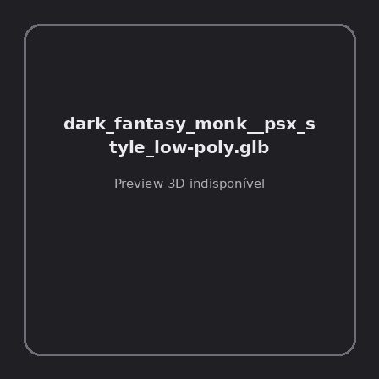
ID | NOV-005756
Origem | Asset novo
Pack/Fonte | Assets Organizados - Characters
Categoria | Characters / Dark Fantasy Monk Psx Style Low-Poly.Glb
Arquivo | dark_fantasy_monk__psx_style_low-poly.glb
Caminho | 01_Assets_Organizados/Characters/dark_fantasy_monk__psx_style_low-poly.glb
Formato | GLB
Tamanho | 153.80 KB
SHA-256 | 0cb2756f1bcd23923903…
Status técnico | ERROR
Licença | MISSING_REVIEW_REQUIRED — sem evidência localizada
Objetos / meshes | N/D / N/D
Vértices | N/D
Faces / triângulos | N/D / N/D
Materiais | N/D —
UV sets / vertex colors | N/D / N/D
Dimensões XYZ | N/D
Rig / armatures / bones | N/D / N/D / N/D
Skinned meshes | N/D
Animações | N/D —
Duração total clips | N/D
Root motion detectado | N/D
LODs / colliders | Nenhum / Nenhum
Texturas vinculadas | N/D (0 ausentes)
Alertas | Licença/fonte não localizada automaticamente; revisão legal necessária.
Notas | Falha na inspeção 3D: RuntimeError: Error: Python: Traceback (most recent call last):  File "/usr/share/blender/scripts/addons/io_scene_gltf2/__init__.py", line 1064, in execute  return self.import_gltf2(context)  File "/usr/share/blender/scripts/addons/io_scene_gltf2/__init__.py", line 1083, in import_gltf2  return self.unit_import(self.filepath, import_settings)  File "/usr/share/blender/scripts/addons/io_scene_gltf2/__init__.py", line 1088, in unit_import  from .blender.imp.gltf2_blender_gltf import BlenderGlTF  File "/usr/share/blender/scripts/addons/io_scene_gltf2/blender/imp/gltf2_blender_gltf.py", line 17, in <module>  from .gltf2_blender_scene import BlenderScene  File "/usr/share/blender/scripts/addons/io_scene_gltf2/blender/imp/gltf2_blender_scene.py", line 17, in <module>  from .gltf2_blender_node import BlenderNode  File "/usr/share/blender/scripts/addons/io_scene_gltf2/blender/imp/gltf2_blender_node.py", line 18, in <module>  from .gltf2_blender_mesh import BlenderMesh  File "/usr/share/blender/scripts/addons/io_scene_gltf2/blender/imp/gltf2_blender_mesh.py", line 17, in <module>  import numpy as np  ModuleNotFoundError: No module named 'numpy'  location: /usr/share/blender/scripts/modules/bpy/ops.py:132  Traceback (most recent call last):  File "/home/runner/work/PSX_demons_whip/PSX_demons_whip/workspace/demons/tools/asset_catalog/blender_batch.py", line 427, in inspect_task  import_model(path)  File "/home/runner/work/PSX_demons_whip/PSX_demons_whip/workspace/demons/tools/asset_catalog/blender_batch.py", line 52, in import_model  bpy.ops.import_scene.gltf(filepath=str(path))  File "/usr/share/blender/scripts/modules/bpy/ops.py", line 132, in __call__  ret = _op_call(self.idname_py(), None, kw)  RuntimeError: Error: Python: Traceback (most recent call last):  File "/usr/share/blender/scripts/addons/io_scene_gltf2/__init__.py", line 1064, in execute  return self.import_gltf2(context)  File "/usr/share/blender/scripts/addons/io_scene_gltf2/__init__.py", line 1083, in import_gltf2  return self.unit_import(self.filepath, import_settings)  File "/usr/share/blender/scripts/addons/io_scene_gltf2/__init__.py", line 1088, in unit_import  from .blender.imp.gltf2_blender_gltf import BlenderGlTF  File "/usr/share/blender/scripts/addons/io_scene_gltf2/blender/imp/gltf2_blender_gltf.py", line 17, in <module>  from .gltf2_blender_scene import BlenderScene  File "/usr/share/blender/scripts/addons/io_scene_gltf2/blender/imp/gltf2_blender_scene.py", line 17, in <module>  from .gltf2_blender_node import BlenderNode  File "/usr/share/blender/scripts/addons/io_scene_gltf2/blender/imp/gltf2_blender_node.py", line 18, in <module>  from .gltf2_blender_mesh import BlenderMesh  File "/usr/share/blender/scripts/addons/io_scene_gltf2/blender/imp/gltf2_blender_mesh.py", line 17, in <module>  import numpy as np  ModuleNotFoundError: No module named 'numpy'  location: /usr/share/blender/scripts/modules/bpy/ops.py:132

NOV-005754 • druid [ERROR]
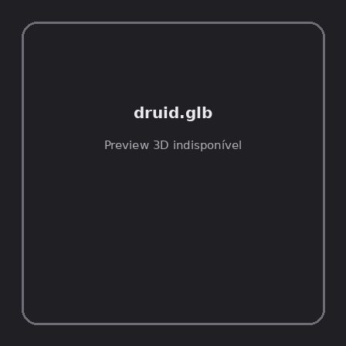
ID | NOV-005754
Origem | Asset novo
Pack/Fonte | Assets Organizados - Characters
Categoria | Characters / Druid.Glb
Arquivo | druid.glb
Caminho | 01_Assets_Organizados/Characters/druid.glb
Formato | GLB
Tamanho | 452.82 KB
SHA-256 | b1156d55834d003001da…
Status técnico | ERROR
Licença | MISSING_REVIEW_REQUIRED — sem evidência localizada
Objetos / meshes | N/D / N/D
Vértices | N/D
Faces / triângulos | N/D / N/D
Materiais | N/D —
UV sets / vertex colors | N/D / N/D
Dimensões XYZ | N/D
Rig / armatures / bones | N/D / N/D / N/D
Skinned meshes | N/D
Animações | N/D —
Duração total clips | N/D
Root motion detectado | N/D
LODs / colliders | Nenhum / Nenhum
Texturas vinculadas | N/D (0 ausentes)
Alertas | Licença/fonte não localizada automaticamente; revisão legal necessária. | Duplicado exato: grupo DUP-01085 (2 cópias).
Notas | Falha na inspeção 3D: RuntimeError: Error: Python: Traceback (most recent call last):  File "/usr/share/blender/scripts/addons/io_scene_gltf2/__init__.py", line 1064, in execute  return self.import_gltf2(context)  File "/usr/share/blender/scripts/addons/io_scene_gltf2/__init__.py", line 1083, in import_gltf2  return self.unit_import(self.filepath, import_settings)  File "/usr/share/blender/scripts/addons/io_scene_gltf2/__init__.py", line 1088, in unit_import  from .blender.imp.gltf2_blender_gltf import BlenderGlTF  File "/usr/share/blender/scripts/addons/io_scene_gltf2/blender/imp/gltf2_blender_gltf.py", line 17, in <module>  from .gltf2_blender_scene import BlenderScene  File "/usr/share/blender/scripts/addons/io_scene_gltf2/blender/imp/gltf2_blender_scene.py", line 17, in <module>  from .gltf2_blender_node import BlenderNode  File "/usr/share/blender/scripts/addons/io_scene_gltf2/blender/imp/gltf2_blender_node.py", line 18, in <module>  from .gltf2_blender_mesh import BlenderMesh  File "/usr/share/blender/scripts/addons/io_scene_gltf2/blender/imp/gltf2_blender_mesh.py", line 17, in <module>  import numpy as np  ModuleNotFoundError: No module named 'numpy'  location: /usr/share/blender/scripts/modules/bpy/ops.py:132  Traceback (most recent call last):  File "/home/runner/work/PSX_demons_whip/PSX_demons_whip/workspace/demons/tools/asset_catalog/blender_batch.py", line 427, in inspect_task  import_model(path)  File "/home/runner/work/PSX_demons_whip/PSX_demons_whip/workspace/demons/tools/asset_catalog/blender_batch.py", line 52, in import_model  bpy.ops.import_scene.gltf(filepath=str(path))  File "/usr/share/blender/scripts/modules/bpy/ops.py", line 132, in __call__  ret = _op_call(self.idname_py(), None, kw)  RuntimeError: Error: Python: Traceback (most recent call last):  File "/usr/share/blender/scripts/addons/io_scene_gltf2/__init__.py", line 1064, in execute  return self.import_gltf2(context)  File "/usr/share/blender/scripts/addons/io_scene_gltf2/__init__.py", line 1083, in import_gltf2  return self.unit_import(self.filepath, import_settings)  File "/usr/share/blender/scripts/addons/io_scene_gltf2/__init__.py", line 1088, in unit_import  from .blender.imp.gltf2_blender_gltf import BlenderGlTF  File "/usr/share/blender/scripts/addons/io_scene_gltf2/blender/imp/gltf2_blender_gltf.py", line 17, in <module>  from .gltf2_blender_scene import BlenderScene  File "/usr/share/blender/scripts/addons/io_scene_gltf2/blender/imp/gltf2_blender_scene.py", line 17, in <module>  from .gltf2_blender_node import BlenderNode  File "/usr/share/blender/scripts/addons/io_scene_gltf2/blender/imp/gltf2_blender_node.py", line 18, in <module>  from .gltf2_blender_mesh import BlenderMesh  File "/usr/share/blender/scripts/addons/io_scene_gltf2/blender/imp/gltf2_blender_mesh.py", line 17, in <module>  import numpy as np  ModuleNotFoundError: No module named 'numpy'  location: /usr/share/blender/scripts/modules/bpy/ops.py:132  | Metadados 3D reutilizados do duplicado idêntico TEM-002569.

NOV-005750 • druid_ability_anims [ERROR]
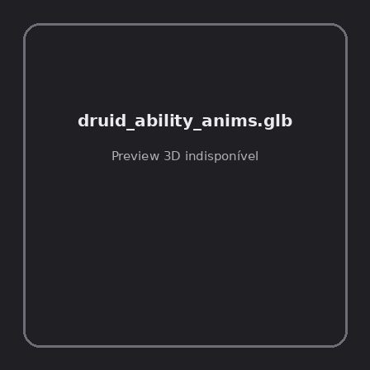
ID | NOV-005750
Origem | Asset novo
Pack/Fonte | Assets Organizados - Characters
Categoria | Characters / Druid Ability Anims.Glb
Arquivo | druid_ability_anims.glb
Caminho | 01_Assets_Organizados/Characters/druid_ability_anims.glb
Formato | GLB
Tamanho | 89.03 KB
SHA-256 | dc813ac0b1fff21b3ea4…
Status técnico | ERROR
Licença | MISSING_REVIEW_REQUIRED — sem evidência localizada
Objetos / meshes | N/D / N/D
Vértices | N/D
Faces / triângulos | N/D / N/D
Materiais | N/D —
UV sets / vertex colors | N/D / N/D
Dimensões XYZ | N/D
Rig / armatures / bones | N/D / N/D / N/D
Skinned meshes | N/D
Animações | N/D —
Duração total clips | N/D
Root motion detectado | N/D
LODs / colliders | Nenhum / Nenhum
Texturas vinculadas | N/D (0 ausentes)
Alertas | Licença/fonte não localizada automaticamente; revisão legal necessária.
Notas | Falha na inspeção 3D: RuntimeError: Error: Python: Traceback (most recent call last):  File "/usr/share/blender/scripts/addons/io_scene_gltf2/__init__.py", line 1064, in execute  return self.import_gltf2(context)  File "/usr/share/blender/scripts/addons/io_scene_gltf2/__init__.py", line 1083, in import_gltf2  return self.unit_import(self.filepath, import_settings)  File "/usr/share/blender/scripts/addons/io_scene_gltf2/__init__.py", line 1088, in unit_import  from .blender.imp.gltf2_blender_gltf import BlenderGlTF  File "/usr/share/blender/scripts/addons/io_scene_gltf2/blender/imp/gltf2_blender_gltf.py", line 17, in <module>  from .gltf2_blender_scene import BlenderScene  File "/usr/share/blender/scripts/addons/io_scene_gltf2/blender/imp/gltf2_blender_scene.py", line 17, in <module>  from .gltf2_blender_node import BlenderNode  File "/usr/share/blender/scripts/addons/io_scene_gltf2/blender/imp/gltf2_blender_node.py", line 18, in <module>  from .gltf2_blender_mesh import BlenderMesh  File "/usr/share/blender/scripts/addons/io_scene_gltf2/blender/imp/gltf2_blender_mesh.py", line 17, in <module>  import numpy as np  ModuleNotFoundError: No module named 'numpy'  location: /usr/share/blender/scripts/modules/bpy/ops.py:132  Traceback (most recent call last):  File "/home/runner/work/PSX_demons_whip/PSX_demons_whip/workspace/demons/tools/asset_catalog/blender_batch.py", line 427, in inspect_task  import_model(path)  File "/home/runner/work/PSX_demons_whip/PSX_demons_whip/workspace/demons/tools/asset_catalog/blender_batch.py", line 52, in import_model  bpy.ops.import_scene.gltf(filepath=str(path))  File "/usr/share/blender/scripts/modules/bpy/ops.py", line 132, in __call__  ret = _op_call(self.idname_py(), None, kw)  RuntimeError: Error: Python: Traceback (most recent call last):  File "/usr/share/blender/scripts/addons/io_scene_gltf2/__init__.py", line 1064, in execute  return self.import_gltf2(context)  File "/usr/share/blender/scripts/addons/io_scene_gltf2/__init__.py", line 1083, in import_gltf2  return self.unit_import(self.filepath, import_settings)  File "/usr/share/blender/scripts/addons/io_scene_gltf2/__init__.py", line 1088, in unit_import  from .blender.imp.gltf2_blender_gltf import BlenderGlTF  File "/usr/share/blender/scripts/addons/io_scene_gltf2/blender/imp/gltf2_blender_gltf.py", line 17, in <module>  from .gltf2_blender_scene import BlenderScene  File "/usr/share/blender/scripts/addons/io_scene_gltf2/blender/imp/gltf2_blender_scene.py", line 17, in <module>  from .gltf2_blender_node import BlenderNode  File "/usr/share/blender/scripts/addons/io_scene_gltf2/blender/imp/gltf2_blender_node.py", line 18, in <module>  from .gltf2_blender_mesh import BlenderMesh  File "/usr/share/blender/scripts/addons/io_scene_gltf2/blender/imp/gltf2_blender_mesh.py", line 17, in <module>  import numpy as np  ModuleNotFoundError: No module named 'numpy'  location: /usr/share/blender/scripts/modules/bpy/ops.py:132

NOV-005772 • druid_hit_variety_anims [ERROR]
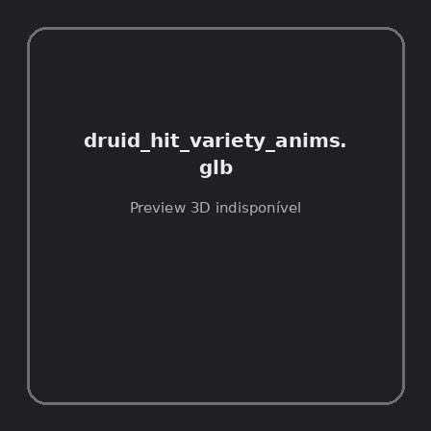
ID | NOV-005772
Origem | Asset novo
Pack/Fonte | Assets Organizados - Characters
Categoria | Characters / Druid Hit Variety Anims.Glb
Arquivo | druid_hit_variety_anims.glb
Caminho | 01_Assets_Organizados/Characters/druid_hit_variety_anims.glb
Formato | GLB
Tamanho | 21.09 KB
SHA-256 | 33927356a56915b5a81b…
Status técnico | ERROR
Licença | MISSING_REVIEW_REQUIRED — sem evidência localizada
Objetos / meshes | N/D / N/D
Vértices | N/D
Faces / triângulos | N/D / N/D
Materiais | N/D —
UV sets / vertex colors | N/D / N/D
Dimensões XYZ | N/D
Rig / armatures / bones | N/D / N/D / N/D
Skinned meshes | N/D
Animações | N/D —
Duração total clips | N/D
Root motion detectado | N/D
LODs / colliders | Nenhum / Nenhum
Texturas vinculadas | N/D (0 ausentes)
Alertas | Licença/fonte não localizada automaticamente; revisão legal necessária.
Notas | Falha na inspeção 3D: RuntimeError: Error: Python: Traceback (most recent call last):  File "/usr/share/blender/scripts/addons/io_scene_gltf2/__init__.py", line 1064, in execute  return self.import_gltf2(context)  File "/usr/share/blender/scripts/addons/io_scene_gltf2/__init__.py", line 1083, in import_gltf2  return self.unit_import(self.filepath, import_settings)  File "/usr/share/blender/scripts/addons/io_scene_gltf2/__init__.py", line 1088, in unit_import  from .blender.imp.gltf2_blender_gltf import BlenderGlTF  File "/usr/share/blender/scripts/addons/io_scene_gltf2/blender/imp/gltf2_blender_gltf.py", line 17, in <module>  from .gltf2_blender_scene import BlenderScene  File "/usr/share/blender/scripts/addons/io_scene_gltf2/blender/imp/gltf2_blender_scene.py", line 17, in <module>  from .gltf2_blender_node import BlenderNode  File "/usr/share/blender/scripts/addons/io_scene_gltf2/blender/imp/gltf2_blender_node.py", line 18, in <module>  from .gltf2_blender_mesh import BlenderMesh  File "/usr/share/blender/scripts/addons/io_scene_gltf2/blender/imp/gltf2_blender_mesh.py", line 17, in <module>  import numpy as np  ModuleNotFoundError: No module named 'numpy'  location: /usr/share/blender/scripts/modules/bpy/ops.py:132  Traceback (most recent call last):  File "/home/runner/work/PSX_demons_whip/PSX_demons_whip/workspace/demons/tools/asset_catalog/blender_batch.py", line 427, in inspect_task  import_model(path)  File "/home/runner/work/PSX_demons_whip/PSX_demons_whip/workspace/demons/tools/asset_catalog/blender_batch.py", line 52, in import_model  bpy.ops.import_scene.gltf(filepath=str(path))  File "/usr/share/blender/scripts/modules/bpy/ops.py", line 132, in __call__  ret = _op_call(self.idname_py(), None, kw)  RuntimeError: Error: Python: Traceback (most recent call last):  File "/usr/share/blender/scripts/addons/io_scene_gltf2/__init__.py", line 1064, in execute  return self.import_gltf2(context)  File "/usr/share/blender/scripts/addons/io_scene_gltf2/__init__.py", line 1083, in import_gltf2  return self.unit_import(self.filepath, import_settings)  File "/usr/share/blender/scripts/addons/io_scene_gltf2/__init__.py", line 1088, in unit_import  from .blender.imp.gltf2_blender_gltf import BlenderGlTF  File "/usr/share/blender/scripts/addons/io_scene_gltf2/blender/imp/gltf2_blender_gltf.py", line 17, in <module>  from .gltf2_blender_scene import BlenderScene  File "/usr/share/blender/scripts/addons/io_scene_gltf2/blender/imp/gltf2_blender_scene.py", line 17, in <module>  from .gltf2_blender_node import BlenderNode  File "/usr/share/blender/scripts/addons/io_scene_gltf2/blender/imp/gltf2_blender_node.py", line 18, in <module>  from .gltf2_blender_mesh import BlenderMesh  File "/usr/share/blender/scripts/addons/io_scene_gltf2/blender/imp/gltf2_blender_mesh.py", line 17, in <module>  import numpy as np  ModuleNotFoundError: No module named 'numpy'  location: /usr/share/blender/scripts/modules/bpy/ops.py:132

NOV-005762 • hunter_ability_anims [ERROR]
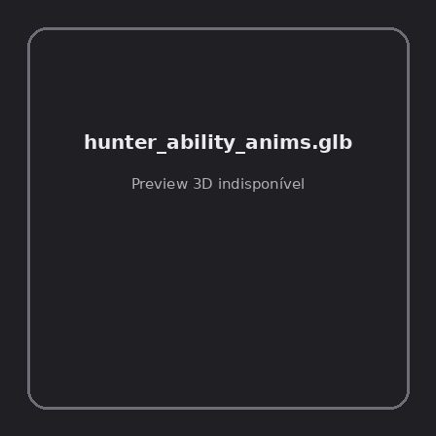
ID | NOV-005762
Origem | Asset novo
Pack/Fonte | Assets Organizados - Characters
Categoria | Characters / Hunter Ability Anims.Glb
Arquivo | hunter_ability_anims.glb
Caminho | 01_Assets_Organizados/Characters/hunter_ability_anims.glb
Formato | GLB
Tamanho | 108.10 KB
SHA-256 | 7e49780d12574a617c42…
Status técnico | ERROR
Licença | MISSING_REVIEW_REQUIRED — sem evidência localizada
Objetos / meshes | N/D / N/D
Vértices | N/D
Faces / triângulos | N/D / N/D
Materiais | N/D —
UV sets / vertex colors | N/D / N/D
Dimensões XYZ | N/D
Rig / armatures / bones | N/D / N/D / N/D
Skinned meshes | N/D
Animações | N/D —
Duração total clips | N/D
Root motion detectado | N/D
LODs / colliders | Nenhum / Nenhum
Texturas vinculadas | N/D (0 ausentes)
Alertas | Licença/fonte não localizada automaticamente; revisão legal necessária.
Notas | Falha na inspeção 3D: RuntimeError: Error: Python: Traceback (most recent call last):  File "/usr/share/blender/scripts/addons/io_scene_gltf2/__init__.py", line 1064, in execute  return self.import_gltf2(context)  File "/usr/share/blender/scripts/addons/io_scene_gltf2/__init__.py", line 1083, in import_gltf2  return self.unit_import(self.filepath, import_settings)  File "/usr/share/blender/scripts/addons/io_scene_gltf2/__init__.py", line 1088, in unit_import  from .blender.imp.gltf2_blender_gltf import BlenderGlTF  File "/usr/share/blender/scripts/addons/io_scene_gltf2/blender/imp/gltf2_blender_gltf.py", line 17, in <module>  from .gltf2_blender_scene import BlenderScene  File "/usr/share/blender/scripts/addons/io_scene_gltf2/blender/imp/gltf2_blender_scene.py", line 17, in <module>  from .gltf2_blender_node import BlenderNode  File "/usr/share/blender/scripts/addons/io_scene_gltf2/blender/imp/gltf2_blender_node.py", line 18, in <module>  from .gltf2_blender_mesh import BlenderMesh  File "/usr/share/blender/scripts/addons/io_scene_gltf2/blender/imp/gltf2_blender_mesh.py", line 17, in <module>  import numpy as np  ModuleNotFoundError: No module named 'numpy'  location: /usr/share/blender/scripts/modules/bpy/ops.py:132  Traceback (most recent call last):  File "/home/runner/work/PSX_demons_whip/PSX_demons_whip/workspace/demons/tools/asset_catalog/blender_batch.py", line 427, in inspect_task  import_model(path)  File "/home/runner/work/PSX_demons_whip/PSX_demons_whip/workspace/demons/tools/asset_catalog/blender_batch.py", line 52, in import_model  bpy.ops.import_scene.gltf(filepath=str(path))  File "/usr/share/blender/scripts/modules/bpy/ops.py", line 132, in __call__  ret = _op_call(self.idname_py(), None, kw)  RuntimeError: Error: Python: Traceback (most recent call last):  File "/usr/share/blender/scripts/addons/io_scene_gltf2/__init__.py", line 1064, in execute  return self.import_gltf2(context)  File "/usr/share/blender/scripts/addons/io_scene_gltf2/__init__.py", line 1083, in import_gltf2  return self.unit_import(self.filepath, import_settings)  File "/usr/share/blender/scripts/addons/io_scene_gltf2/__init__.py", line 1088, in unit_import  from .blender.imp.gltf2_blender_gltf import BlenderGlTF  File "/usr/share/blender/scripts/addons/io_scene_gltf2/blender/imp/gltf2_blender_gltf.py", line 17, in <module>  from .gltf2_blender_scene import BlenderScene  File "/usr/share/blender/scripts/addons/io_scene_gltf2/blender/imp/gltf2_blender_scene.py", line 17, in <module>  from .gltf2_blender_node import BlenderNode  File "/usr/share/blender/scripts/addons/io_scene_gltf2/blender/imp/gltf2_blender_node.py", line 18, in <module>  from .gltf2_blender_mesh import BlenderMesh  File "/usr/share/blender/scripts/addons/io_scene_gltf2/blender/imp/gltf2_blender_mesh.py", line 17, in <module>  import numpy as np  ModuleNotFoundError: No module named 'numpy'  location: /usr/share/blender/scripts/modules/bpy/ops.py:132

NOV-005774 • knight [ERROR]

ID | NOV-005774
Origem | Asset novo
Pack/Fonte | Assets Organizados - Characters
Categoria | Characters / Knight.Glb
Arquivo | knight.glb
Caminho | 01_Assets_Organizados/Characters/knight.glb
Formato | GLB
Tamanho | 452.07 KB
SHA-256 | 063f81b53c354eeb60bb…
Status técnico | ERROR
Licença | MISSING_REVIEW_REQUIRED — sem evidência localizada
Objetos / meshes | N/D / N/D
Vértices | N/D
Faces / triângulos | N/D / N/D
Materiais | N/D —
UV sets / vertex colors | N/D / N/D
Dimensões XYZ | N/D
Rig / armatures / bones | N/D / N/D / N/D
Skinned meshes | N/D
Animações | N/D —
Duração total clips | N/D
Root motion detectado | N/D
LODs / colliders | Nenhum / Nenhum
Texturas vinculadas | N/D (0 ausentes)
Alertas | Licença/fonte não localizada automaticamente; revisão legal necessária. | Duplicado exato: grupo DUP-01091 (2 cópias).
Notas | Falha na inspeção 3D: RuntimeError: Error: Python: Traceback (most recent call last):  File "/usr/share/blender/scripts/addons/io_scene_gltf2/__init__.py", line 1064, in execute  return self.import_gltf2(context)  File "/usr/share/blender/scripts/addons/io_scene_gltf2/__init__.py", line 1083, in import_gltf2  return self.unit_import(self.filepath, import_settings)  File "/usr/share/blender/scripts/addons/io_scene_gltf2/__init__.py", line 1088, in unit_import  from .blender.imp.gltf2_blender_gltf import BlenderGlTF  File "/usr/share/blender/scripts/addons/io_scene_gltf2/blender/imp/gltf2_blender_gltf.py", line 17, in <module>  from .gltf2_blender_scene import BlenderScene  File "/usr/share/blender/scripts/addons/io_scene_gltf2/blender/imp/gltf2_blender_scene.py", line 17, in <module>  from .gltf2_blender_node import BlenderNode  File "/usr/share/blender/scripts/addons/io_scene_gltf2/blender/imp/gltf2_blender_node.py", line 18, in <module>  from .gltf2_blender_mesh import BlenderMesh  File "/usr/share/blender/scripts/addons/io_scene_gltf2/blender/imp/gltf2_blender_mesh.py", line 17, in <module>  import numpy as np  ModuleNotFoundError: No module named 'numpy'  location: /usr/share/blender/scripts/modules/bpy/ops.py:132  Traceback (most recent call last):  File "/home/runner/work/PSX_demons_whip/PSX_demons_whip/workspace/demons/tools/asset_catalog/blender_batch.py", line 427, in inspect_task  import_model(path)  File "/home/runner/work/PSX_demons_whip/PSX_demons_whip/workspace/demons/tools/asset_catalog/blender_batch.py", line 52, in import_model  bpy.ops.import_scene.gltf(filepath=str(path))  File "/usr/share/blender/scripts/modules/bpy/ops.py", line 132, in __call__  ret = _op_call(self.idname_py(), None, kw)  RuntimeError: Error: Python: Traceback (most recent call last):  File "/usr/share/blender/scripts/addons/io_scene_gltf2/__init__.py", line 1064, in execute  return self.import_gltf2(context)  File "/usr/share/blender/scripts/addons/io_scene_gltf2/__init__.py", line 1083, in import_gltf2  return self.unit_import(self.filepath, import_settings)  File "/usr/share/blender/scripts/addons/io_scene_gltf2/__init__.py", line 1088, in unit_import  from .blender.imp.gltf2_blender_gltf import BlenderGlTF  File "/usr/share/blender/scripts/addons/io_scene_gltf2/blender/imp/gltf2_blender_gltf.py", line 17, in <module>  from .gltf2_blender_scene import BlenderScene  File "/usr/share/blender/scripts/addons/io_scene_gltf2/blender/imp/gltf2_blender_scene.py", line 17, in <module>  from .gltf2_blender_node import BlenderNode  File "/usr/share/blender/scripts/addons/io_scene_gltf2/blender/imp/gltf2_blender_node.py", line 18, in <module>  from .gltf2_blender_mesh import BlenderMesh  File "/usr/share/blender/scripts/addons/io_scene_gltf2/blender/imp/gltf2_blender_mesh.py", line 17, in <module>  import numpy as np  ModuleNotFoundError: No module named 'numpy'  location: /usr/share/blender/scripts/modules/bpy/ops.py:132  | Metadados 3D reutilizados do duplicado idêntico TEM-002575.

NOV-005769 • knight_hit_variety_anims [ERROR]

ID | NOV-005769
Origem | Asset novo
Pack/Fonte | Assets Organizados - Characters
Categoria | Characters / Knight Hit Variety Anims.Glb
Arquivo | knight_hit_variety_anims.glb
Caminho | 01_Assets_Organizados/Characters/knight_hit_variety_anims.glb
Formato | GLB
Tamanho | 21.09 KB
SHA-256 | 56249f6c349960a5f7bb…
Status técnico | ERROR
Licença | MISSING_REVIEW_REQUIRED — sem evidência localizada
Objetos / meshes | N/D / N/D
Vértices | N/D
Faces / triângulos | N/D / N/D
Materiais | N/D —
UV sets / vertex colors | N/D / N/D
Dimensões XYZ | N/D
Rig / armatures / bones | N/D / N/D / N/D
Skinned meshes | N/D
Animações | N/D —
Duração total clips | N/D
Root motion detectado | N/D
LODs / colliders | Nenhum / Nenhum
Texturas vinculadas | N/D (0 ausentes)
Alertas | Licença/fonte não localizada automaticamente; revisão legal necessária.
Notas | Falha na inspeção 3D: RuntimeError: Error: Python: Traceback (most recent call last):  File "/usr/share/blender/scripts/addons/io_scene_gltf2/__init__.py", line 1064, in execute  return self.import_gltf2(context)  File "/usr/share/blender/scripts/addons/io_scene_gltf2/__init__.py", line 1083, in import_gltf2  return self.unit_import(self.filepath, import_settings)  File "/usr/share/blender/scripts/addons/io_scene_gltf2/__init__.py", line 1088, in unit_import  from .blender.imp.gltf2_blender_gltf import BlenderGlTF  File "/usr/share/blender/scripts/addons/io_scene_gltf2/blender/imp/gltf2_blender_gltf.py", line 17, in <module>  from .gltf2_blender_scene import BlenderScene  File "/usr/share/blender/scripts/addons/io_scene_gltf2/blender/imp/gltf2_blender_scene.py", line 17, in <module>  from .gltf2_blender_node import BlenderNode  File "/usr/share/blender/scripts/addons/io_scene_gltf2/blender/imp/gltf2_blender_node.py", line 18, in <module>  from .gltf2_blender_mesh import BlenderMesh  File "/usr/share/blender/scripts/addons/io_scene_gltf2/blender/imp/gltf2_blender_mesh.py", line 17, in <module>  import numpy as np  ModuleNotFoundError: No module named 'numpy'  location: /usr/share/blender/scripts/modules/bpy/ops.py:132  Traceback (most recent call last):  File "/home/runner/work/PSX_demons_whip/PSX_demons_whip/workspace/demons/tools/asset_catalog/blender_batch.py", line 427, in inspect_task  import_model(path)  File "/home/runner/work/PSX_demons_whip/PSX_demons_whip/workspace/demons/tools/asset_catalog/blender_batch.py", line 52, in import_model  bpy.ops.import_scene.gltf(filepath=str(path))  File "/usr/share/blender/scripts/modules/bpy/ops.py", line 132, in __call__  ret = _op_call(self.idname_py(), None, kw)  RuntimeError: Error: Python: Traceback (most recent call last):  File "/usr/share/blender/scripts/addons/io_scene_gltf2/__init__.py", line 1064, in execute  return self.import_gltf2(context)  File "/usr/share/blender/scripts/addons/io_scene_gltf2/__init__.py", line 1083, in import_gltf2  return self.unit_import(self.filepath, import_settings)  File "/usr/share/blender/scripts/addons/io_scene_gltf2/__init__.py", line 1088, in unit_import  from .blender.imp.gltf2_blender_gltf import BlenderGlTF  File "/usr/share/blender/scripts/addons/io_scene_gltf2/blender/imp/gltf2_blender_gltf.py", line 17, in <module>  from .gltf2_blender_scene import BlenderScene  File "/usr/share/blender/scripts/addons/io_scene_gltf2/blender/imp/gltf2_blender_scene.py", line 17, in <module>  from .gltf2_blender_node import BlenderNode  File "/usr/share/blender/scripts/addons/io_scene_gltf2/blender/imp/gltf2_blender_node.py", line 18, in <module>  from .gltf2_blender_mesh import BlenderMesh  File "/usr/share/blender/scripts/addons/io_scene_gltf2/blender/imp/gltf2_blender_mesh.py", line 17, in <module>  import numpy as np  ModuleNotFoundError: No module named 'numpy'  location: /usr/share/blender/scripts/modules/bpy/ops.py:132

NOV-005747 • mage [ERROR]
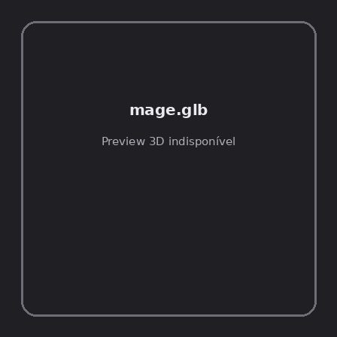
ID | NOV-005747
Origem | Asset novo
Pack/Fonte | Assets Organizados - Characters
Categoria | Characters / Mage.Glb
Arquivo | mage.glb
Caminho | 01_Assets_Organizados/Characters/mage.glb
Formato | GLB
Tamanho | 431.23 KB
SHA-256 | 28bbbc7a04fa114badde…
Status técnico | ERROR
Licença | MISSING_REVIEW_REQUIRED — sem evidência localizada
Objetos / meshes | N/D / N/D
Vértices | N/D
Faces / triângulos | N/D / N/D
Materiais | N/D —
UV sets / vertex colors | N/D / N/D
Dimensões XYZ | N/D
Rig / armatures / bones | N/D / N/D / N/D
Skinned meshes | N/D
Animações | N/D —
Duração total clips | N/D
Root motion detectado | N/D
LODs / colliders | Nenhum / Nenhum
Texturas vinculadas | N/D (0 ausentes)
Alertas | Licença/fonte não localizada automaticamente; revisão legal necessária. | Duplicado exato: grupo DUP-01084 (2 cópias).
Notas | Falha na inspeção 3D: RuntimeError: Error: Python: Traceback (most recent call last):  File "/usr/share/blender/scripts/addons/io_scene_gltf2/__init__.py", line 1064, in execute  return self.import_gltf2(context)  File "/usr/share/blender/scripts/addons/io_scene_gltf2/__init__.py", line 1083, in import_gltf2  return self.unit_import(self.filepath, import_settings)  File "/usr/share/blender/scripts/addons/io_scene_gltf2/__init__.py", line 1088, in unit_import  from .blender.imp.gltf2_blender_gltf import BlenderGlTF  File "/usr/share/blender/scripts/addons/io_scene_gltf2/blender/imp/gltf2_blender_gltf.py", line 17, in <module>  from .gltf2_blender_scene import BlenderScene  File "/usr/share/blender/scripts/addons/io_scene_gltf2/blender/imp/gltf2_blender_scene.py", line 17, in <module>  from .gltf2_blender_node import BlenderNode  File "/usr/share/blender/scripts/addons/io_scene_gltf2/blender/imp/gltf2_blender_node.py", line 18, in <module>  from .gltf2_blender_mesh import BlenderMesh  File "/usr/share/blender/scripts/addons/io_scene_gltf2/blender/imp/gltf2_blender_mesh.py", line 17, in <module>  import numpy as np  ModuleNotFoundError: No module named 'numpy'  location: /usr/share/blender/scripts/modules/bpy/ops.py:132  Traceback (most recent call last):  File "/home/runner/work/PSX_demons_whip/PSX_demons_whip/workspace/demons/tools/asset_catalog/blender_batch.py", line 427, in inspect_task  import_model(path)  File "/home/runner/work/PSX_demons_whip/PSX_demons_whip/workspace/demons/tools/asset_catalog/blender_batch.py", line 52, in import_model  bpy.ops.import_scene.gltf(filepath=str(path))  File "/usr/share/blender/scripts/modules/bpy/ops.py", line 132, in __call__  ret = _op_call(self.idname_py(), None, kw)  RuntimeError: Error: Python: Traceback (most recent call last):  File "/usr/share/blender/scripts/addons/io_scene_gltf2/__init__.py", line 1064, in execute  return self.import_gltf2(context)  File "/usr/share/blender/scripts/addons/io_scene_gltf2/__init__.py", line 1083, in import_gltf2  return self.unit_import(self.filepath, import_settings)  File "/usr/share/blender/scripts/addons/io_scene_gltf2/__init__.py", line 1088, in unit_import  from .blender.imp.gltf2_blender_gltf import BlenderGlTF  File "/usr/share/blender/scripts/addons/io_scene_gltf2/blender/imp/gltf2_blender_gltf.py", line 17, in <module>  from .gltf2_blender_scene import BlenderScene  File "/usr/share/blender/scripts/addons/io_scene_gltf2/blender/imp/gltf2_blender_scene.py", line 17, in <module>  from .gltf2_blender_node import BlenderNode  File "/usr/share/blender/scripts/addons/io_scene_gltf2/blender/imp/gltf2_blender_node.py", line 18, in <module>  from .gltf2_blender_mesh import BlenderMesh  File "/usr/share/blender/scripts/addons/io_scene_gltf2/blender/imp/gltf2_blender_mesh.py", line 17, in <module>  import numpy as np  ModuleNotFoundError: No module named 'numpy'  location: /usr/share/blender/scripts/modules/bpy/ops.py:132  | Metadados 3D reutilizados do duplicado idêntico TEM-002568.

NOV-005759 • mage_ability_anims [ERROR]
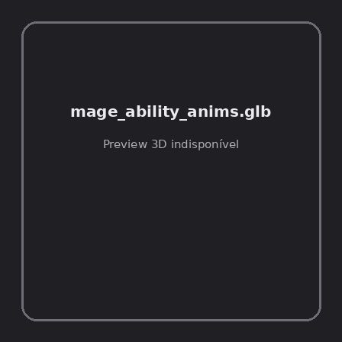
ID | NOV-005759
Origem | Asset novo
Pack/Fonte | Assets Organizados - Characters
Categoria | Characters / Mage Ability Anims.Glb
Arquivo | mage_ability_anims.glb
Caminho | 01_Assets_Organizados/Characters/mage_ability_anims.glb
Formato | GLB
Tamanho | 95.04 KB
SHA-256 | 3e6d02173484719d3a40…
Status técnico | ERROR
Licença | MISSING_REVIEW_REQUIRED — sem evidência localizada
Objetos / meshes | N/D / N/D
Vértices | N/D
Faces / triângulos | N/D / N/D
Materiais | N/D —
UV sets / vertex colors | N/D / N/D
Dimensões XYZ | N/D
Rig / armatures / bones | N/D / N/D / N/D
Skinned meshes | N/D
Animações | N/D —
Duração total clips | N/D
Root motion detectado | N/D
LODs / colliders | Nenhum / Nenhum
Texturas vinculadas | N/D (0 ausentes)
Alertas | Licença/fonte não localizada automaticamente; revisão legal necessária.
Notas | Falha na inspeção 3D: RuntimeError: Error: Python: Traceback (most recent call last):  File "/usr/share/blender/scripts/addons/io_scene_gltf2/__init__.py", line 1064, in execute  return self.import_gltf2(context)  File "/usr/share/blender/scripts/addons/io_scene_gltf2/__init__.py", line 1083, in import_gltf2  return self.unit_import(self.filepath, import_settings)  File "/usr/share/blender/scripts/addons/io_scene_gltf2/__init__.py", line 1088, in unit_import  from .blender.imp.gltf2_blender_gltf import BlenderGlTF  File "/usr/share/blender/scripts/addons/io_scene_gltf2/blender/imp/gltf2_blender_gltf.py", line 17, in <module>  from .gltf2_blender_scene import BlenderScene  File "/usr/share/blender/scripts/addons/io_scene_gltf2/blender/imp/gltf2_blender_scene.py", line 17, in <module>  from .gltf2_blender_node import BlenderNode  File "/usr/share/blender/scripts/addons/io_scene_gltf2/blender/imp/gltf2_blender_node.py", line 18, in <module>  from .gltf2_blender_mesh import BlenderMesh  File "/usr/share/blender/scripts/addons/io_scene_gltf2/blender/imp/gltf2_blender_mesh.py", line 17, in <module>  import numpy as np  ModuleNotFoundError: No module named 'numpy'  location: /usr/share/blender/scripts/modules/bpy/ops.py:132  Traceback (most recent call last):  File "/home/runner/work/PSX_demons_whip/PSX_demons_whip/workspace/demons/tools/asset_catalog/blender_batch.py", line 427, in inspect_task  import_model(path)  File "/home/runner/work/PSX_demons_whip/PSX_demons_whip/workspace/demons/tools/asset_catalog/blender_batch.py", line 52, in import_model  bpy.ops.import_scene.gltf(filepath=str(path))  File "/usr/share/blender/scripts/modules/bpy/ops.py", line 132, in __call__  ret = _op_call(self.idname_py(), None, kw)  RuntimeError: Error: Python: Traceback (most recent call last):  File "/usr/share/blender/scripts/addons/io_scene_gltf2/__init__.py", line 1064, in execute  return self.import_gltf2(context)  File "/usr/share/blender/scripts/addons/io_scene_gltf2/__init__.py", line 1083, in import_gltf2  return self.unit_import(self.filepath, import_settings)  File "/usr/share/blender/scripts/addons/io_scene_gltf2/__init__.py", line 1088, in unit_import  from .blender.imp.gltf2_blender_gltf import BlenderGlTF  File "/usr/share/blender/scripts/addons/io_scene_gltf2/blender/imp/gltf2_blender_gltf.py", line 17, in <module>  from .gltf2_blender_scene import BlenderScene  File "/usr/share/blender/scripts/addons/io_scene_gltf2/blender/imp/gltf2_blender_scene.py", line 17, in <module>  from .gltf2_blender_node import BlenderNode  File "/usr/share/blender/scripts/addons/io_scene_gltf2/blender/imp/gltf2_blender_node.py", line 18, in <module>  from .gltf2_blender_mesh import BlenderMesh  File "/usr/share/blender/scripts/addons/io_scene_gltf2/blender/imp/gltf2_blender_mesh.py", line 17, in <module>  import numpy as np  ModuleNotFoundError: No module named 'numpy'  location: /usr/share/blender/scripts/modules/bpy/ops.py:132

NOV-005758 • mage_classic [ERROR]

ID | NOV-005758
Origem | Asset novo
Pack/Fonte | Assets Organizados - Characters
Categoria | Characters / Mage Classic.Glb
Arquivo | mage_classic.glb
Caminho | 01_Assets_Organizados/Characters/mage_classic.glb
Formato | GLB
Tamanho | 714.29 KB
SHA-256 | 2c7dfd4d882eaf97561d…
Status técnico | ERROR
Licença | MISSING_REVIEW_REQUIRED — sem evidência localizada
Objetos / meshes | N/D / N/D
Vértices | N/D
Faces / triângulos | N/D / N/D
Materiais | N/D —
UV sets / vertex colors | N/D / N/D
Dimensões XYZ | N/D
Rig / armatures / bones | N/D / N/D / N/D
Skinned meshes | N/D
Animações | N/D —
Duração total clips | N/D
Root motion detectado | N/D
LODs / colliders | Nenhum / Nenhum
Texturas vinculadas | N/D (0 ausentes)
Alertas | Licença/fonte não localizada automaticamente; revisão legal necessária. | Duplicado exato: grupo DUP-01086 (2 cópias).
Notas | Falha na inspeção 3D: RuntimeError: Error: Python: Traceback (most recent call last):  File "/usr/share/blender/scripts/addons/io_scene_gltf2/__init__.py", line 1064, in execute  return self.import_gltf2(context)  File "/usr/share/blender/scripts/addons/io_scene_gltf2/__init__.py", line 1083, in import_gltf2  return self.unit_import(self.filepath, import_settings)  File "/usr/share/blender/scripts/addons/io_scene_gltf2/__init__.py", line 1088, in unit_import  from .blender.imp.gltf2_blender_gltf import BlenderGlTF  File "/usr/share/blender/scripts/addons/io_scene_gltf2/blender/imp/gltf2_blender_gltf.py", line 17, in <module>  from .gltf2_blender_scene import BlenderScene  File "/usr/share/blender/scripts/addons/io_scene_gltf2/blender/imp/gltf2_blender_scene.py", line 17, in <module>  from .gltf2_blender_node import BlenderNode  File "/usr/share/blender/scripts/addons/io_scene_gltf2/blender/imp/gltf2_blender_node.py", line 18, in <module>  from .gltf2_blender_mesh import BlenderMesh  File "/usr/share/blender/scripts/addons/io_scene_gltf2/blender/imp/gltf2_blender_mesh.py", line 17, in <module>  import numpy as np  ModuleNotFoundError: No module named 'numpy'  location: /usr/share/blender/scripts/modules/bpy/ops.py:132  Traceback (most recent call last):  File "/home/runner/work/PSX_demons_whip/PSX_demons_whip/workspace/demons/tools/asset_catalog/blender_batch.py", line 427, in inspect_task  import_model(path)  File "/home/runner/work/PSX_demons_whip/PSX_demons_whip/workspace/demons/tools/asset_catalog/blender_batch.py", line 52, in import_model  bpy.ops.import_scene.gltf(filepath=str(path))  File "/usr/share/blender/scripts/modules/bpy/ops.py", line 132, in __call__  ret = _op_call(self.idname_py(), None, kw)  RuntimeError: Error: Python: Traceback (most recent call last):  File "/usr/share/blender/scripts/addons/io_scene_gltf2/__init__.py", line 1064, in execute  return self.import_gltf2(context)  File "/usr/share/blender/scripts/addons/io_scene_gltf2/__init__.py", line 1083, in import_gltf2  return self.unit_import(self.filepath, import_settings)  File "/usr/share/blender/scripts/addons/io_scene_gltf2/__init__.py", line 1088, in unit_import  from .blender.imp.gltf2_blender_gltf import BlenderGlTF  File "/usr/share/blender/scripts/addons/io_scene_gltf2/blender/imp/gltf2_blender_gltf.py", line 17, in <module>  from .gltf2_blender_scene import BlenderScene  File "/usr/share/blender/scripts/addons/io_scene_gltf2/blender/imp/gltf2_blender_scene.py", line 17, in <module>  from .gltf2_blender_node import BlenderNode  File "/usr/share/blender/scripts/addons/io_scene_gltf2/blender/imp/gltf2_blender_node.py", line 18, in <module>  from .gltf2_blender_mesh import BlenderMesh  File "/usr/share/blender/scripts/addons/io_scene_gltf2/blender/imp/gltf2_blender_mesh.py", line 17, in <module>  import numpy as np  ModuleNotFoundError: No module named 'numpy'  location: /usr/share/blender/scripts/modules/bpy/ops.py:132  | Metadados 3D reutilizados do duplicado idêntico TEM-002570.

NOV-005764 • mage_classic_hit_variety_anims [ERROR]

ID | NOV-005764
Origem | Asset novo
Pack/Fonte | Assets Organizados - Characters
Categoria | Characters / Mage Classic Hit Variety Anims.Glb
Arquivo | mage_classic_hit_variety_anims.glb
Caminho | 01_Assets_Organizados/Characters/mage_classic_hit_variety_anims.glb
Formato | GLB
Tamanho | 34.76 KB
SHA-256 | bb04eccc63490e37f7e2…
Status técnico | ERROR
Licença | MISSING_REVIEW_REQUIRED — sem evidência localizada
Objetos / meshes | N/D / N/D
Vértices | N/D
Faces / triângulos | N/D / N/D
Materiais | N/D —
UV sets / vertex colors | N/D / N/D
Dimensões XYZ | N/D
Rig / armatures / bones | N/D / N/D / N/D
Skinned meshes | N/D
Animações | N/D —
Duração total clips | N/D
Root motion detectado | N/D
LODs / colliders | Nenhum / Nenhum
Texturas vinculadas | N/D (0 ausentes)
Alertas | Licença/fonte não localizada automaticamente; revisão legal necessária.
Notas | Falha na inspeção 3D: RuntimeError: Error: Python: Traceback (most recent call last):  File "/usr/share/blender/scripts/addons/io_scene_gltf2/__init__.py", line 1064, in execute  return self.import_gltf2(context)  File "/usr/share/blender/scripts/addons/io_scene_gltf2/__init__.py", line 1083, in import_gltf2  return self.unit_import(self.filepath, import_settings)  File "/usr/share/blender/scripts/addons/io_scene_gltf2/__init__.py", line 1088, in unit_import  from .blender.imp.gltf2_blender_gltf import BlenderGlTF  File "/usr/share/blender/scripts/addons/io_scene_gltf2/blender/imp/gltf2_blender_gltf.py", line 17, in <module>  from .gltf2_blender_scene import BlenderScene  File "/usr/share/blender/scripts/addons/io_scene_gltf2/blender/imp/gltf2_blender_scene.py", line 17, in <module>  from .gltf2_blender_node import BlenderNode  File "/usr/share/blender/scripts/addons/io_scene_gltf2/blender/imp/gltf2_blender_node.py", line 18, in <module>  from .gltf2_blender_mesh import BlenderMesh  File "/usr/share/blender/scripts/addons/io_scene_gltf2/blender/imp/gltf2_blender_mesh.py", line 17, in <module>  import numpy as np  ModuleNotFoundError: No module named 'numpy'  location: /usr/share/blender/scripts/modules/bpy/ops.py:132  Traceback (most recent call last):  File "/home/runner/work/PSX_demons_whip/PSX_demons_whip/workspace/demons/tools/asset_catalog/blender_batch.py", line 427, in inspect_task  import_model(path)  File "/home/runner/work/PSX_demons_whip/PSX_demons_whip/workspace/demons/tools/asset_catalog/blender_batch.py", line 52, in import_model  bpy.ops.import_scene.gltf(filepath=str(path))  File "/usr/share/blender/scripts/modules/bpy/ops.py", line 132, in __call__  ret = _op_call(self.idname_py(), None, kw)  RuntimeError: Error: Python: Traceback (most recent call last):  File "/usr/share/blender/scripts/addons/io_scene_gltf2/__init__.py", line 1064, in execute  return self.import_gltf2(context)  File "/usr/share/blender/scripts/addons/io_scene_gltf2/__init__.py", line 1083, in import_gltf2  return self.unit_import(self.filepath, import_settings)  File "/usr/share/blender/scripts/addons/io_scene_gltf2/__init__.py", line 1088, in unit_import  from .blender.imp.gltf2_blender_gltf import BlenderGlTF  File "/usr/share/blender/scripts/addons/io_scene_gltf2/blender/imp/gltf2_blender_gltf.py", line 17, in <module>  from .gltf2_blender_scene import BlenderScene  File "/usr/share/blender/scripts/addons/io_scene_gltf2/blender/imp/gltf2_blender_scene.py", line 17, in <module>  from .gltf2_blender_node import BlenderNode  File "/usr/share/blender/scripts/addons/io_scene_gltf2/blender/imp/gltf2_blender_node.py", line 18, in <module>  from .gltf2_blender_mesh import BlenderMesh  File "/usr/share/blender/scripts/addons/io_scene_gltf2/blender/imp/gltf2_blender_mesh.py", line 17, in <module>  import numpy as np  ModuleNotFoundError: No module named 'numpy'  location: /usr/share/blender/scripts/modules/bpy/ops.py:132

NOV-005757 • mage_hit_variety_anims [ERROR]
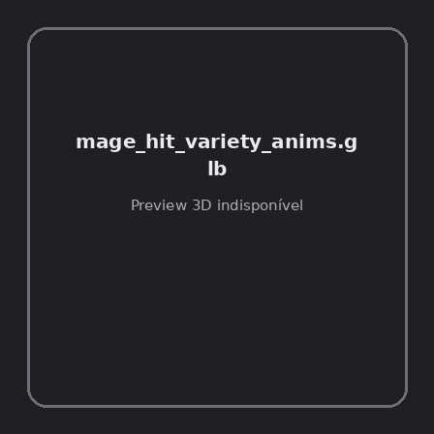
ID | NOV-005757
Origem | Asset novo
Pack/Fonte | Assets Organizados - Characters
Categoria | Characters / Mage Hit Variety Anims.Glb
Arquivo | mage_hit_variety_anims.glb
Caminho | 01_Assets_Organizados/Characters/mage_hit_variety_anims.glb
Formato | GLB
Tamanho | 21.09 KB
SHA-256 | 0ebe9138b085149ada89…
Status técnico | ERROR
Licença | MISSING_REVIEW_REQUIRED — sem evidência localizada
Objetos / meshes | N/D / N/D
Vértices | N/D
Faces / triângulos | N/D / N/D
Materiais | N/D —
UV sets / vertex colors | N/D / N/D
Dimensões XYZ | N/D
Rig / armatures / bones | N/D / N/D / N/D
Skinned meshes | N/D
Animações | N/D —
Duração total clips | N/D
Root motion detectado | N/D
LODs / colliders | Nenhum / Nenhum
Texturas vinculadas | N/D (0 ausentes)
Alertas | Licença/fonte não localizada automaticamente; revisão legal necessária.
Notas | Falha na inspeção 3D: RuntimeError: Error: Python: Traceback (most recent call last):  File "/usr/share/blender/scripts/addons/io_scene_gltf2/__init__.py", line 1064, in execute  return self.import_gltf2(context)  File "/usr/share/blender/scripts/addons/io_scene_gltf2/__init__.py", line 1083, in import_gltf2  return self.unit_import(self.filepath, import_settings)  File "/usr/share/blender/scripts/addons/io_scene_gltf2/__init__.py", line 1088, in unit_import  from .blender.imp.gltf2_blender_gltf import BlenderGlTF  File "/usr/share/blender/scripts/addons/io_scene_gltf2/blender/imp/gltf2_blender_gltf.py", line 17, in <module>  from .gltf2_blender_scene import BlenderScene  File "/usr/share/blender/scripts/addons/io_scene_gltf2/blender/imp/gltf2_blender_scene.py", line 17, in <module>  from .gltf2_blender_node import BlenderNode  File "/usr/share/blender/scripts/addons/io_scene_gltf2/blender/imp/gltf2_blender_node.py", line 18, in <module>  from .gltf2_blender_mesh import BlenderMesh  File "/usr/share/blender/scripts/addons/io_scene_gltf2/blender/imp/gltf2_blender_mesh.py", line 17, in <module>  import numpy as np  ModuleNotFoundError: No module named 'numpy'  location: /usr/share/blender/scripts/modules/bpy/ops.py:132  Traceback (most recent call last):  File "/home/runner/work/PSX_demons_whip/PSX_demons_whip/workspace/demons/tools/asset_catalog/blender_batch.py", line 427, in inspect_task  import_model(path)  File "/home/runner/work/PSX_demons_whip/PSX_demons_whip/workspace/demons/tools/asset_catalog/blender_batch.py", line 52, in import_model  bpy.ops.import_scene.gltf(filepath=str(path))  File "/usr/share/blender/scripts/modules/bpy/ops.py", line 132, in __call__  ret = _op_call(self.idname_py(), None, kw)  RuntimeError: Error: Python: Traceback (most recent call last):  File "/usr/share/blender/scripts/addons/io_scene_gltf2/__init__.py", line 1064, in execute  return self.import_gltf2(context)  File "/usr/share/blender/scripts/addons/io_scene_gltf2/__init__.py", line 1083, in import_gltf2  return self.unit_import(self.filepath, import_settings)  File "/usr/share/blender/scripts/addons/io_scene_gltf2/__init__.py", line 1088, in unit_import  from .blender.imp.gltf2_blender_gltf import BlenderGlTF  File "/usr/share/blender/scripts/addons/io_scene_gltf2/blender/imp/gltf2_blender_gltf.py", line 17, in <module>  from .gltf2_blender_scene import BlenderScene  File "/usr/share/blender/scripts/addons/io_scene_gltf2/blender/imp/gltf2_blender_scene.py", line 17, in <module>  from .gltf2_blender_node import BlenderNode  File "/usr/share/blender/scripts/addons/io_scene_gltf2/blender/imp/gltf2_blender_node.py", line 18, in <module>  from .gltf2_blender_mesh import BlenderMesh  File "/usr/share/blender/scripts/addons/io_scene_gltf2/blender/imp/gltf2_blender_mesh.py", line 17, in <module>  import numpy as np  ModuleNotFoundError: No module named 'numpy'  location: /usr/share/blender/scripts/modules/bpy/ops.py:132

NOV-005763 • paladin [ERROR]
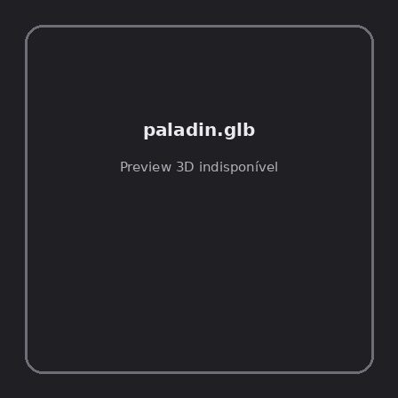
ID | NOV-005763
Origem | Asset novo
Pack/Fonte | Assets Organizados - Characters
Categoria | Characters / Paladin.Glb
Arquivo | paladin.glb
Caminho | 01_Assets_Organizados/Characters/paladin.glb
Formato | GLB
Tamanho | 438.30 KB
SHA-256 | 6481234c2f3c95087a6f…
Status técnico | ERROR
Licença | MISSING_REVIEW_REQUIRED — sem evidência localizada
Objetos / meshes | N/D / N/D
Vértices | N/D
Faces / triângulos | N/D / N/D
Materiais | N/D —
UV sets / vertex colors | N/D / N/D
Dimensões XYZ | N/D
Rig / armatures / bones | N/D / N/D / N/D
Skinned meshes | N/D
Animações | N/D —
Duração total clips | N/D
Root motion detectado | N/D
LODs / colliders | Nenhum / Nenhum
Texturas vinculadas | N/D (0 ausentes)
Alertas | Licença/fonte não localizada automaticamente; revisão legal necessária. | Duplicado exato: grupo DUP-01089 (2 cópias).
Notas | Falha na inspeção 3D: RuntimeError: Error: Python: Traceback (most recent call last):  File "/usr/share/blender/scripts/addons/io_scene_gltf2/__init__.py", line 1064, in execute  return self.import_gltf2(context)  File "/usr/share/blender/scripts/addons/io_scene_gltf2/__init__.py", line 1083, in import_gltf2  return self.unit_import(self.filepath, import_settings)  File "/usr/share/blender/scripts/addons/io_scene_gltf2/__init__.py", line 1088, in unit_import  from .blender.imp.gltf2_blender_gltf import BlenderGlTF  File "/usr/share/blender/scripts/addons/io_scene_gltf2/blender/imp/gltf2_blender_gltf.py", line 17, in <module>  from .gltf2_blender_scene import BlenderScene  File "/usr/share/blender/scripts/addons/io_scene_gltf2/blender/imp/gltf2_blender_scene.py", line 17, in <module>  from .gltf2_blender_node import BlenderNode  File "/usr/share/blender/scripts/addons/io_scene_gltf2/blender/imp/gltf2_blender_node.py", line 18, in <module>  from .gltf2_blender_mesh import BlenderMesh  File "/usr/share/blender/scripts/addons/io_scene_gltf2/blender/imp/gltf2_blender_mesh.py", line 17, in <module>  import numpy as np  ModuleNotFoundError: No module named 'numpy'  location: /usr/share/blender/scripts/modules/bpy/ops.py:132  Traceback (most recent call last):  File "/home/runner/work/PSX_demons_whip/PSX_demons_whip/workspace/demons/tools/asset_catalog/blender_batch.py", line 427, in inspect_task  import_model(path)  File "/home/runner/work/PSX_demons_whip/PSX_demons_whip/workspace/demons/tools/asset_catalog/blender_batch.py", line 52, in import_model  bpy.ops.import_scene.gltf(filepath=str(path))  File "/usr/share/blender/scripts/modules/bpy/ops.py", line 132, in __call__  ret = _op_call(self.idname_py(), None, kw)  RuntimeError: Error: Python: Traceback (most recent call last):  File "/usr/share/blender/scripts/addons/io_scene_gltf2/__init__.py", line 1064, in execute  return self.import_gltf2(context)  File "/usr/share/blender/scripts/addons/io_scene_gltf2/__init__.py", line 1083, in import_gltf2  return self.unit_import(self.filepath, import_settings)  File "/usr/share/blender/scripts/addons/io_scene_gltf2/__init__.py", line 1088, in unit_import  from .blender.imp.gltf2_blender_gltf import BlenderGlTF  File "/usr/share/blender/scripts/addons/io_scene_gltf2/blender/imp/gltf2_blender_gltf.py", line 17, in <module>  from .gltf2_blender_scene import BlenderScene  File "/usr/share/blender/scripts/addons/io_scene_gltf2/blender/imp/gltf2_blender_scene.py", line 17, in <module>  from .gltf2_blender_node import BlenderNode  File "/usr/share/blender/scripts/addons/io_scene_gltf2/blender/imp/gltf2_blender_node.py", line 18, in <module>  from .gltf2_blender_mesh import BlenderMesh  File "/usr/share/blender/scripts/addons/io_scene_gltf2/blender/imp/gltf2_blender_mesh.py", line 17, in <module>  import numpy as np  ModuleNotFoundError: No module named 'numpy'  location: /usr/share/blender/scripts/modules/bpy/ops.py:132  | Metadados 3D reutilizados do duplicado idêntico TEM-002573.

NOV-005773 • paladin_ability_anims [ERROR]
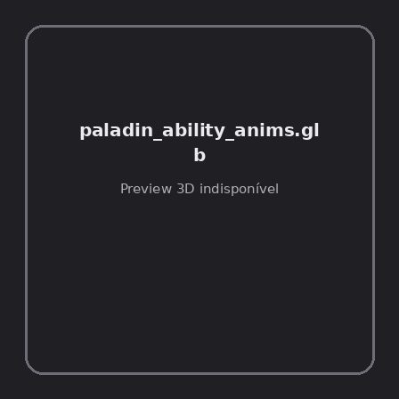
ID | NOV-005773
Origem | Asset novo
Pack/Fonte | Assets Organizados - Characters
Categoria | Characters / Paladin Ability Anims.Glb
Arquivo | paladin_ability_anims.glb
Caminho | 01_Assets_Organizados/Characters/paladin_ability_anims.glb
Formato | GLB
Tamanho | 106.41 KB
SHA-256 | ed24acea712d60be14ee…
Status técnico | ERROR
Licença | MISSING_REVIEW_REQUIRED — sem evidência localizada
Objetos / meshes | N/D / N/D
Vértices | N/D
Faces / triângulos | N/D / N/D
Materiais | N/D —
UV sets / vertex colors | N/D / N/D
Dimensões XYZ | N/D
Rig / armatures / bones | N/D / N/D / N/D
Skinned meshes | N/D
Animações | N/D —
Duração total clips | N/D
Root motion detectado | N/D
LODs / colliders | Nenhum / Nenhum
Texturas vinculadas | N/D (0 ausentes)
Alertas | Licença/fonte não localizada automaticamente; revisão legal necessária.
Notas | Falha na inspeção 3D: RuntimeError: Error: Python: Traceback (most recent call last):  File "/usr/share/blender/scripts/addons/io_scene_gltf2/__init__.py", line 1064, in execute  return self.import_gltf2(context)  File "/usr/share/blender/scripts/addons/io_scene_gltf2/__init__.py", line 1083, in import_gltf2  return self.unit_import(self.filepath, import_settings)  File "/usr/share/blender/scripts/addons/io_scene_gltf2/__init__.py", line 1088, in unit_import  from .blender.imp.gltf2_blender_gltf import BlenderGlTF  File "/usr/share/blender/scripts/addons/io_scene_gltf2/blender/imp/gltf2_blender_gltf.py", line 17, in <module>  from .gltf2_blender_scene import BlenderScene  File "/usr/share/blender/scripts/addons/io_scene_gltf2/blender/imp/gltf2_blender_scene.py", line 17, in <module>  from .gltf2_blender_node import BlenderNode  File "/usr/share/blender/scripts/addons/io_scene_gltf2/blender/imp/gltf2_blender_node.py", line 18, in <module>  from .gltf2_blender_mesh import BlenderMesh  File "/usr/share/blender/scripts/addons/io_scene_gltf2/blender/imp/gltf2_blender_mesh.py", line 17, in <module>  import numpy as np  ModuleNotFoundError: No module named 'numpy'  location: /usr/share/blender/scripts/modules/bpy/ops.py:132  Traceback (most recent call last):  File "/home/runner/work/PSX_demons_whip/PSX_demons_whip/workspace/demons/tools/asset_catalog/blender_batch.py", line 427, in inspect_task  import_model(path)  File "/home/runner/work/PSX_demons_whip/PSX_demons_whip/workspace/demons/tools/asset_catalog/blender_batch.py", line 52, in import_model  bpy.ops.import_scene.gltf(filepath=str(path))  File "/usr/share/blender/scripts/modules/bpy/ops.py", line 132, in __call__  ret = _op_call(self.idname_py(), None, kw)  RuntimeError: Error: Python: Traceback (most recent call last):  File "/usr/share/blender/scripts/addons/io_scene_gltf2/__init__.py", line 1064, in execute  return self.import_gltf2(context)  File "/usr/share/blender/scripts/addons/io_scene_gltf2/__init__.py", line 1083, in import_gltf2  return self.unit_import(self.filepath, import_settings)  File "/usr/share/blender/scripts/addons/io_scene_gltf2/__init__.py", line 1088, in unit_import  from .blender.imp.gltf2_blender_gltf import BlenderGlTF  File "/usr/share/blender/scripts/addons/io_scene_gltf2/blender/imp/gltf2_blender_gltf.py", line 17, in <module>  from .gltf2_blender_scene import BlenderScene  File "/usr/share/blender/scripts/addons/io_scene_gltf2/blender/imp/gltf2_blender_scene.py", line 17, in <module>  from .gltf2_blender_node import BlenderNode  File "/usr/share/blender/scripts/addons/io_scene_gltf2/blender/imp/gltf2_blender_node.py", line 18, in <module>  from .gltf2_blender_mesh import BlenderMesh  File "/usr/share/blender/scripts/addons/io_scene_gltf2/blender/imp/gltf2_blender_mesh.py", line 17, in <module>  import numpy as np  ModuleNotFoundError: No module named 'numpy'  location: /usr/share/blender/scripts/modules/bpy/ops.py:132

NOV-005771 • paladin_hit_variety_anims [ERROR]
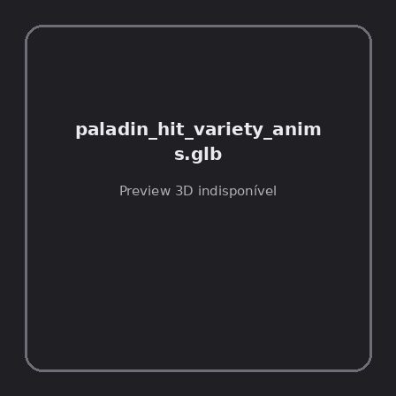
ID | NOV-005771
Origem | Asset novo
Pack/Fonte | Assets Organizados - Characters
Categoria | Characters / Paladin Hit Variety Anims.Glb
Arquivo | paladin_hit_variety_anims.glb
Caminho | 01_Assets_Organizados/Characters/paladin_hit_variety_anims.glb
Formato | GLB
Tamanho | 21.09 KB
SHA-256 | 3f202d4349983b9169a2…
Status técnico | ERROR
Licença | MISSING_REVIEW_REQUIRED — sem evidência localizada
Objetos / meshes | N/D / N/D
Vértices | N/D
Faces / triângulos | N/D / N/D
Materiais | N/D —
UV sets / vertex colors | N/D / N/D
Dimensões XYZ | N/D
Rig / armatures / bones | N/D / N/D / N/D
Skinned meshes | N/D
Animações | N/D —
Duração total clips | N/D
Root motion detectado | N/D
LODs / colliders | Nenhum / Nenhum
Texturas vinculadas | N/D (0 ausentes)
Alertas | Licença/fonte não localizada automaticamente; revisão legal necessária.
Notas | Falha na inspeção 3D: RuntimeError: Error: Python: Traceback (most recent call last):  File "/usr/share/blender/scripts/addons/io_scene_gltf2/__init__.py", line 1064, in execute  return self.import_gltf2(context)  File "/usr/share/blender/scripts/addons/io_scene_gltf2/__init__.py", line 1083, in import_gltf2  return self.unit_import(self.filepath, import_settings)  File "/usr/share/blender/scripts/addons/io_scene_gltf2/__init__.py", line 1088, in unit_import  from .blender.imp.gltf2_blender_gltf import BlenderGlTF  File "/usr/share/blender/scripts/addons/io_scene_gltf2/blender/imp/gltf2_blender_gltf.py", line 17, in <module>  from .gltf2_blender_scene import BlenderScene  File "/usr/share/blender/scripts/addons/io_scene_gltf2/blender/imp/gltf2_blender_scene.py", line 17, in <module>  from .gltf2_blender_node import BlenderNode  File "/usr/share/blender/scripts/addons/io_scene_gltf2/blender/imp/gltf2_blender_node.py", line 18, in <module>  from .gltf2_blender_mesh import BlenderMesh  File "/usr/share/blender/scripts/addons/io_scene_gltf2/blender/imp/gltf2_blender_mesh.py", line 17, in <module>  import numpy as np  ModuleNotFoundError: No module named 'numpy'  location: /usr/share/blender/scripts/modules/bpy/ops.py:132  Traceback (most recent call last):  File "/home/runner/work/PSX_demons_whip/PSX_demons_whip/workspace/demons/tools/asset_catalog/blender_batch.py", line 427, in inspect_task  import_model(path)  File "/home/runner/work/PSX_demons_whip/PSX_demons_whip/workspace/demons/tools/asset_catalog/blender_batch.py", line 52, in import_model  bpy.ops.import_scene.gltf(filepath=str(path))  File "/usr/share/blender/scripts/modules/bpy/ops.py", line 132, in __call__  ret = _op_call(self.idname_py(), None, kw)  RuntimeError: Error: Python: Traceback (most recent call last):  File "/usr/share/blender/scripts/addons/io_scene_gltf2/__init__.py", line 1064, in execute  return self.import_gltf2(context)  File "/usr/share/blender/scripts/addons/io_scene_gltf2/__init__.py", line 1083, in import_gltf2  return self.unit_import(self.filepath, import_settings)  File "/usr/share/blender/scripts/addons/io_scene_gltf2/__init__.py", line 1088, in unit_import  from .blender.imp.gltf2_blender_gltf import BlenderGlTF  File "/usr/share/blender/scripts/addons/io_scene_gltf2/blender/imp/gltf2_blender_gltf.py", line 17, in <module>  from .gltf2_blender_scene import BlenderScene  File "/usr/share/blender/scripts/addons/io_scene_gltf2/blender/imp/gltf2_blender_scene.py", line 17, in <module>  from .gltf2_blender_node import BlenderNode  File "/usr/share/blender/scripts/addons/io_scene_gltf2/blender/imp/gltf2_blender_node.py", line 18, in <module>  from .gltf2_blender_mesh import BlenderMesh  File "/usr/share/blender/scripts/addons/io_scene_gltf2/blender/imp/gltf2_blender_mesh.py", line 17, in <module>  import numpy as np  ModuleNotFoundError: No module named 'numpy'  location: /usr/share/blender/scripts/modules/bpy/ops.py:132

NOV-005752 • ps1_psx_knight [ERROR]
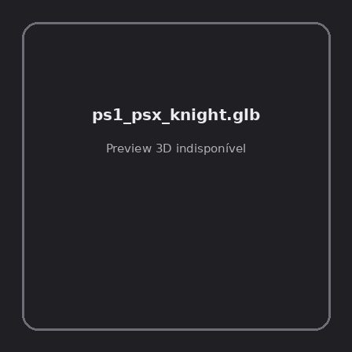
ID | NOV-005752
Origem | Asset novo
Pack/Fonte | Assets Organizados - Characters
Categoria | Characters / Ps1 Psx Knight.Glb
Arquivo | ps1_psx_knight.glb
Caminho | 01_Assets_Organizados/Characters/ps1_psx_knight.glb
Formato | GLB
Tamanho | 778.59 KB
SHA-256 | 268fbf8f6c6a6d459257…
Status técnico | ERROR
Licença | MISSING_REVIEW_REQUIRED — sem evidência localizada
Objetos / meshes | N/D / N/D
Vértices | N/D
Faces / triângulos | N/D / N/D
Materiais | N/D —
UV sets / vertex colors | N/D / N/D
Dimensões XYZ | N/D
Rig / armatures / bones | N/D / N/D / N/D
Skinned meshes | N/D
Animações | N/D —
Duração total clips | N/D
Root motion detectado | N/D
LODs / colliders | Nenhum / Nenhum
Texturas vinculadas | N/D (0 ausentes)
Alertas | Licença/fonte não localizada automaticamente; revisão legal necessária.
Notas | Falha na inspeção 3D: RuntimeError: Error: Python: Traceback (most recent call last):  File "/usr/share/blender/scripts/addons/io_scene_gltf2/__init__.py", line 1064, in execute  return self.import_gltf2(context)  File "/usr/share/blender/scripts/addons/io_scene_gltf2/__init__.py", line 1083, in import_gltf2  return self.unit_import(self.filepath, import_settings)  File "/usr/share/blender/scripts/addons/io_scene_gltf2/__init__.py", line 1088, in unit_import  from .blender.imp.gltf2_blender_gltf import BlenderGlTF  File "/usr/share/blender/scripts/addons/io_scene_gltf2/blender/imp/gltf2_blender_gltf.py", line 17, in <module>  from .gltf2_blender_scene import BlenderScene  File "/usr/share/blender/scripts/addons/io_scene_gltf2/blender/imp/gltf2_blender_scene.py", line 17, in <module>  from .gltf2_blender_node import BlenderNode  File "/usr/share/blender/scripts/addons/io_scene_gltf2/blender/imp/gltf2_blender_node.py", line 18, in <module>  from .gltf2_blender_mesh import BlenderMesh  File "/usr/share/blender/scripts/addons/io_scene_gltf2/blender/imp/gltf2_blender_mesh.py", line 17, in <module>  import numpy as np  ModuleNotFoundError: No module named 'numpy'  location: /usr/share/blender/scripts/modules/bpy/ops.py:132  Traceback (most recent call last):  File "/home/runner/work/PSX_demons_whip/PSX_demons_whip/workspace/demons/tools/asset_catalog/blender_batch.py", line 427, in inspect_task  import_model(path)  File "/home/runner/work/PSX_demons_whip/PSX_demons_whip/workspace/demons/tools/asset_catalog/blender_batch.py", line 52, in import_model  bpy.ops.import_scene.gltf(filepath=str(path))  File "/usr/share/blender/scripts/modules/bpy/ops.py", line 132, in __call__  ret = _op_call(self.idname_py(), None, kw)  RuntimeError: Error: Python: Traceback (most recent call last):  File "/usr/share/blender/scripts/addons/io_scene_gltf2/__init__.py", line 1064, in execute  return self.import_gltf2(context)  File "/usr/share/blender/scripts/addons/io_scene_gltf2/__init__.py", line 1083, in import_gltf2  return self.unit_import(self.filepath, import_settings)  File "/usr/share/blender/scripts/addons/io_scene_gltf2/__init__.py", line 1088, in unit_import  from .blender.imp.gltf2_blender_gltf import BlenderGlTF  File "/usr/share/blender/scripts/addons/io_scene_gltf2/blender/imp/gltf2_blender_gltf.py", line 17, in <module>  from .gltf2_blender_scene import BlenderScene  File "/usr/share/blender/scripts/addons/io_scene_gltf2/blender/imp/gltf2_blender_scene.py", line 17, in <module>  from .gltf2_blender_node import BlenderNode  File "/usr/share/blender/scripts/addons/io_scene_gltf2/blender/imp/gltf2_blender_node.py", line 18, in <module>  from .gltf2_blender_mesh import BlenderMesh  File "/usr/share/blender/scripts/addons/io_scene_gltf2/blender/imp/gltf2_blender_mesh.py", line 17, in <module>  import numpy as np  ModuleNotFoundError: No module named 'numpy'  location: /usr/share/blender/scripts/modules/bpy/ops.py:132

NOV-005748 • raging_wolf_knight_psx [ERROR]
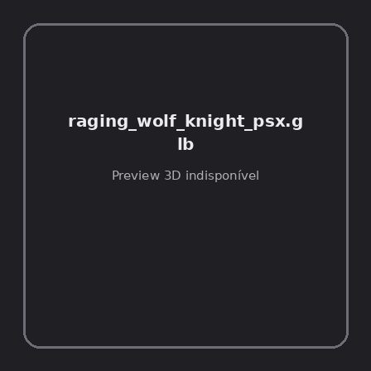
ID | NOV-005748
Origem | Asset novo
Pack/Fonte | Assets Organizados - Characters
Categoria | Characters / Raging Wolf Knight Psx.Glb
Arquivo | raging_wolf_knight_psx.glb
Caminho | 01_Assets_Organizados/Characters/raging_wolf_knight_psx.glb
Formato | GLB
Tamanho | 448.73 KB
SHA-256 | e3bd097308741e8f1191…
Status técnico | ERROR
Licença | MISSING_REVIEW_REQUIRED — sem evidência localizada
Objetos / meshes | N/D / N/D
Vértices | N/D
Faces / triângulos | N/D / N/D
Materiais | N/D —
UV sets / vertex colors | N/D / N/D
Dimensões XYZ | N/D
Rig / armatures / bones | N/D / N/D / N/D
Skinned meshes | N/D
Animações | N/D —
Duração total clips | N/D
Root motion detectado | N/D
LODs / colliders | Nenhum / Nenhum
Texturas vinculadas | N/D (0 ausentes)
Alertas | Licença/fonte não localizada automaticamente; revisão legal necessária.
Notas | Falha na inspeção 3D: RuntimeError: Error: Python: Traceback (most recent call last):  File "/usr/share/blender/scripts/addons/io_scene_gltf2/__init__.py", line 1064, in execute  return self.import_gltf2(context)  File "/usr/share/blender/scripts/addons/io_scene_gltf2/__init__.py", line 1083, in import_gltf2  return self.unit_import(self.filepath, import_settings)  File "/usr/share/blender/scripts/addons/io_scene_gltf2/__init__.py", line 1088, in unit_import  from .blender.imp.gltf2_blender_gltf import BlenderGlTF  File "/usr/share/blender/scripts/addons/io_scene_gltf2/blender/imp/gltf2_blender_gltf.py", line 17, in <module>  from .gltf2_blender_scene import BlenderScene  File "/usr/share/blender/scripts/addons/io_scene_gltf2/blender/imp/gltf2_blender_scene.py", line 17, in <module>  from .gltf2_blender_node import BlenderNode  File "/usr/share/blender/scripts/addons/io_scene_gltf2/blender/imp/gltf2_blender_node.py", line 18, in <module>  from .gltf2_blender_mesh import BlenderMesh  File "/usr/share/blender/scripts/addons/io_scene_gltf2/blender/imp/gltf2_blender_mesh.py", line 17, in <module>  import numpy as np  ModuleNotFoundError: No module named 'numpy'  location: /usr/share/blender/scripts/modules/bpy/ops.py:132  Traceback (most recent call last):  File "/home/runner/work/PSX_demons_whip/PSX_demons_whip/workspace/demons/tools/asset_catalog/blender_batch.py", line 427, in inspect_task  import_model(path)  File "/home/runner/work/PSX_demons_whip/PSX_demons_whip/workspace/demons/tools/asset_catalog/blender_batch.py", line 52, in import_model  bpy.ops.import_scene.gltf(filepath=str(path))  File "/usr/share/blender/scripts/modules/bpy/ops.py", line 132, in __call__  ret = _op_call(self.idname_py(), None, kw)  RuntimeError: Error: Python: Traceback (most recent call last):  File "/usr/share/blender/scripts/addons/io_scene_gltf2/__init__.py", line 1064, in execute  return self.import_gltf2(context)  File "/usr/share/blender/scripts/addons/io_scene_gltf2/__init__.py", line 1083, in import_gltf2  return self.unit_import(self.filepath, import_settings)  File "/usr/share/blender/scripts/addons/io_scene_gltf2/__init__.py", line 1088, in unit_import  from .blender.imp.gltf2_blender_gltf import BlenderGlTF  File "/usr/share/blender/scripts/addons/io_scene_gltf2/blender/imp/gltf2_blender_gltf.py", line 17, in <module>  from .gltf2_blender_scene import BlenderScene  File "/usr/share/blender/scripts/addons/io_scene_gltf2/blender/imp/gltf2_blender_scene.py", line 17, in <module>  from .gltf2_blender_node import BlenderNode  File "/usr/share/blender/scripts/addons/io_scene_gltf2/blender/imp/gltf2_blender_node.py", line 18, in <module>  from .gltf2_blender_mesh import BlenderMesh  File "/usr/share/blender/scripts/addons/io_scene_gltf2/blender/imp/gltf2_blender_mesh.py", line 17, in <module>  import numpy as np  ModuleNotFoundError: No module named 'numpy'  location: /usr/share/blender/scripts/modules/bpy/ops.py:132

NOV-005777 • ranger [ERROR]
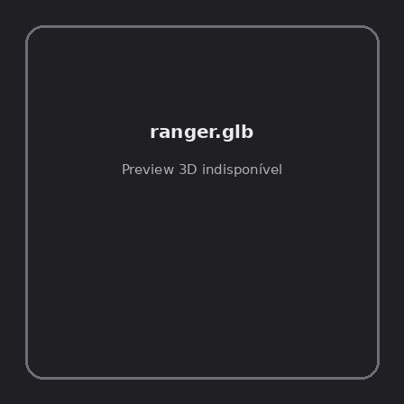
ID | NOV-005777
Origem | Asset novo
Pack/Fonte | Assets Organizados - Characters
Categoria | Characters / Ranger.Glb
Arquivo | ranger.glb
Caminho | 01_Assets_Organizados/Characters/ranger.glb
Formato | GLB
Tamanho | 455.04 KB
SHA-256 | 6a9aeb0d717d66f4ddd6…
Status técnico | ERROR
Licença | MISSING_REVIEW_REQUIRED — sem evidência localizada
Objetos / meshes | N/D / N/D
Vértices | N/D
Faces / triângulos | N/D / N/D
Materiais | N/D —
UV sets / vertex colors | N/D / N/D
Dimensões XYZ | N/D
Rig / armatures / bones | N/D / N/D / N/D
Skinned meshes | N/D
Animações | N/D —
Duração total clips | N/D
Root motion detectado | N/D
LODs / colliders | Nenhum / Nenhum
Texturas vinculadas | N/D (0 ausentes)
Alertas | Licença/fonte não localizada automaticamente; revisão legal necessária. | Duplicado exato: grupo DUP-01092 (2 cópias).
Notas | Falha na inspeção 3D: RuntimeError: Error: Python: Traceback (most recent call last):  File "/usr/share/blender/scripts/addons/io_scene_gltf2/__init__.py", line 1064, in execute  return self.import_gltf2(context)  File "/usr/share/blender/scripts/addons/io_scene_gltf2/__init__.py", line 1083, in import_gltf2  return self.unit_import(self.filepath, import_settings)  File "/usr/share/blender/scripts/addons/io_scene_gltf2/__init__.py", line 1088, in unit_import  from .blender.imp.gltf2_blender_gltf import BlenderGlTF  File "/usr/share/blender/scripts/addons/io_scene_gltf2/blender/imp/gltf2_blender_gltf.py", line 17, in <module>  from .gltf2_blender_scene import BlenderScene  File "/usr/share/blender/scripts/addons/io_scene_gltf2/blender/imp/gltf2_blender_scene.py", line 17, in <module>  from .gltf2_blender_node import BlenderNode  File "/usr/share/blender/scripts/addons/io_scene_gltf2/blender/imp/gltf2_blender_node.py", line 18, in <module>  from .gltf2_blender_mesh import BlenderMesh  File "/usr/share/blender/scripts/addons/io_scene_gltf2/blender/imp/gltf2_blender_mesh.py", line 17, in <module>  import numpy as np  ModuleNotFoundError: No module named 'numpy'  location: /usr/share/blender/scripts/modules/bpy/ops.py:132  Traceback (most recent call last):  File "/home/runner/work/PSX_demons_whip/PSX_demons_whip/workspace/demons/tools/asset_catalog/blender_batch.py", line 427, in inspect_task  import_model(path)  File "/home/runner/work/PSX_demons_whip/PSX_demons_whip/workspace/demons/tools/asset_catalog/blender_batch.py", line 52, in import_model  bpy.ops.import_scene.gltf(filepath=str(path))  File "/usr/share/blender/scripts/modules/bpy/ops.py", line 132, in __call__  ret = _op_call(self.idname_py(), None, kw)  RuntimeError: Error: Python: Traceback (most recent call last):  File "/usr/share/blender/scripts/addons/io_scene_gltf2/__init__.py", line 1064, in execute  return self.import_gltf2(context)  File "/usr/share/blender/scripts/addons/io_scene_gltf2/__init__.py", line 1083, in import_gltf2  return self.unit_import(self.filepath, import_settings)  File "/usr/share/blender/scripts/addons/io_scene_gltf2/__init__.py", line 1088, in unit_import  from .blender.imp.gltf2_blender_gltf import BlenderGlTF  File "/usr/share/blender/scripts/addons/io_scene_gltf2/blender/imp/gltf2_blender_gltf.py", line 17, in <module>  from .gltf2_blender_scene import BlenderScene  File "/usr/share/blender/scripts/addons/io_scene_gltf2/blender/imp/gltf2_blender_scene.py", line 17, in <module>  from .gltf2_blender_node import BlenderNode  File "/usr/share/blender/scripts/addons/io_scene_gltf2/blender/imp/gltf2_blender_node.py", line 18, in <module>  from .gltf2_blender_mesh import BlenderMesh  File "/usr/share/blender/scripts/addons/io_scene_gltf2/blender/imp/gltf2_blender_mesh.py", line 17, in <module>  import numpy as np  ModuleNotFoundError: No module named 'numpy'  location: /usr/share/blender/scripts/modules/bpy/ops.py:132  | Metadados 3D reutilizados do duplicado idêntico TEM-002576.

NOV-005767 • ranger_hit_variety_anims [ERROR]
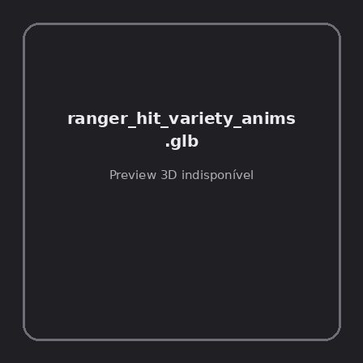
ID | NOV-005767
Origem | Asset novo
Pack/Fonte | Assets Organizados - Characters
Categoria | Characters / Ranger Hit Variety Anims.Glb
Arquivo | ranger_hit_variety_anims.glb
Caminho | 01_Assets_Organizados/Characters/ranger_hit_variety_anims.glb
Formato | GLB
Tamanho | 21.09 KB
SHA-256 | 7473fcc6c524d4b91b1d…
Status técnico | ERROR
Licença | MISSING_REVIEW_REQUIRED — sem evidência localizada
Objetos / meshes | N/D / N/D
Vértices | N/D
Faces / triângulos | N/D / N/D
Materiais | N/D —
UV sets / vertex colors | N/D / N/D
Dimensões XYZ | N/D
Rig / armatures / bones | N/D / N/D / N/D
Skinned meshes | N/D
Animações | N/D —
Duração total clips | N/D
Root motion detectado | N/D
LODs / colliders | Nenhum / Nenhum
Texturas vinculadas | N/D (0 ausentes)
Alertas | Licença/fonte não localizada automaticamente; revisão legal necessária.
Notas | Falha na inspeção 3D: RuntimeError: Error: Python: Traceback (most recent call last):  File "/usr/share/blender/scripts/addons/io_scene_gltf2/__init__.py", line 1064, in execute  return self.import_gltf2(context)  File "/usr/share/blender/scripts/addons/io_scene_gltf2/__init__.py", line 1083, in import_gltf2  return self.unit_import(self.filepath, import_settings)  File "/usr/share/blender/scripts/addons/io_scene_gltf2/__init__.py", line 1088, in unit_import  from .blender.imp.gltf2_blender_gltf import BlenderGlTF  File "/usr/share/blender/scripts/addons/io_scene_gltf2/blender/imp/gltf2_blender_gltf.py", line 17, in <module>  from .gltf2_blender_scene import BlenderScene  File "/usr/share/blender/scripts/addons/io_scene_gltf2/blender/imp/gltf2_blender_scene.py", line 17, in <module>  from .gltf2_blender_node import BlenderNode  File "/usr/share/blender/scripts/addons/io_scene_gltf2/blender/imp/gltf2_blender_node.py", line 18, in <module>  from .gltf2_blender_mesh import BlenderMesh  File "/usr/share/blender/scripts/addons/io_scene_gltf2/blender/imp/gltf2_blender_mesh.py", line 17, in <module>  import numpy as np  ModuleNotFoundError: No module named 'numpy'  location: /usr/share/blender/scripts/modules/bpy/ops.py:132  Traceback (most recent call last):  File "/home/runner/work/PSX_demons_whip/PSX_demons_whip/workspace/demons/tools/asset_catalog/blender_batch.py", line 427, in inspect_task  import_model(path)  File "/home/runner/work/PSX_demons_whip/PSX_demons_whip/workspace/demons/tools/asset_catalog/blender_batch.py", line 52, in import_model  bpy.ops.import_scene.gltf(filepath=str(path))  File "/usr/share/blender/scripts/modules/bpy/ops.py", line 132, in __call__  ret = _op_call(self.idname_py(), None, kw)  RuntimeError: Error: Python: Traceback (most recent call last):  File "/usr/share/blender/scripts/addons/io_scene_gltf2/__init__.py", line 1064, in execute  return self.import_gltf2(context)  File "/usr/share/blender/scripts/addons/io_scene_gltf2/__init__.py", line 1083, in import_gltf2  return self.unit_import(self.filepath, import_settings)  File "/usr/share/blender/scripts/addons/io_scene_gltf2/__init__.py", line 1088, in unit_import  from .blender.imp.gltf2_blender_gltf import BlenderGlTF  File "/usr/share/blender/scripts/addons/io_scene_gltf2/blender/imp/gltf2_blender_gltf.py", line 17, in <module>  from .gltf2_blender_scene import BlenderScene  File "/usr/share/blender/scripts/addons/io_scene_gltf2/blender/imp/gltf2_blender_scene.py", line 17, in <module>  from .gltf2_blender_node import BlenderNode  File "/usr/share/blender/scripts/addons/io_scene_gltf2/blender/imp/gltf2_blender_node.py", line 18, in <module>  from .gltf2_blender_mesh import BlenderMesh  File "/usr/share/blender/scripts/addons/io_scene_gltf2/blender/imp/gltf2_blender_mesh.py", line 17, in <module>  import numpy as np  ModuleNotFoundError: No module named 'numpy'  location: /usr/share/blender/scripts/modules/bpy/ops.py:132

NOV-005765 • rogue [ERROR]
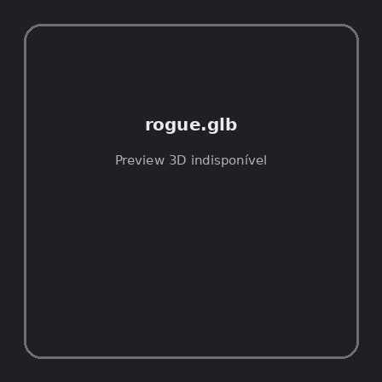
ID | NOV-005765
Origem | Asset novo
Pack/Fonte | Assets Organizados - Characters
Categoria | Characters / Rogue.Glb
Arquivo | rogue.glb
Caminho | 01_Assets_Organizados/Characters/rogue.glb
Formato | GLB
Tamanho | 466.77 KB
SHA-256 | 821bf642863cb49cb9c8…
Status técnico | ERROR
Licença | MISSING_REVIEW_REQUIRED — sem evidência localizada
Objetos / meshes | N/D / N/D
Vértices | N/D
Faces / triângulos | N/D / N/D
Materiais | N/D —
UV sets / vertex colors | N/D / N/D
Dimensões XYZ | N/D
Rig / armatures / bones | N/D / N/D / N/D
Skinned meshes | N/D
Animações | N/D —
Duração total clips | N/D
Root motion detectado | N/D
LODs / colliders | Nenhum / Nenhum
Texturas vinculadas | N/D (0 ausentes)
Alertas | Licença/fonte não localizada automaticamente; revisão legal necessária. | Duplicado exato: grupo DUP-01090 (2 cópias).
Notas | Falha na inspeção 3D: RuntimeError: Error: Python: Traceback (most recent call last):  File "/usr/share/blender/scripts/addons/io_scene_gltf2/__init__.py", line 1064, in execute  return self.import_gltf2(context)  File "/usr/share/blender/scripts/addons/io_scene_gltf2/__init__.py", line 1083, in import_gltf2  return self.unit_import(self.filepath, import_settings)  File "/usr/share/blender/scripts/addons/io_scene_gltf2/__init__.py", line 1088, in unit_import  from .blender.imp.gltf2_blender_gltf import BlenderGlTF  File "/usr/share/blender/scripts/addons/io_scene_gltf2/blender/imp/gltf2_blender_gltf.py", line 17, in <module>  from .gltf2_blender_scene import BlenderScene  File "/usr/share/blender/scripts/addons/io_scene_gltf2/blender/imp/gltf2_blender_scene.py", line 17, in <module>  from .gltf2_blender_node import BlenderNode  File "/usr/share/blender/scripts/addons/io_scene_gltf2/blender/imp/gltf2_blender_node.py", line 18, in <module>  from .gltf2_blender_mesh import BlenderMesh  File "/usr/share/blender/scripts/addons/io_scene_gltf2/blender/imp/gltf2_blender_mesh.py", line 17, in <module>  import numpy as np  ModuleNotFoundError: No module named 'numpy'  location: /usr/share/blender/scripts/modules/bpy/ops.py:132  Traceback (most recent call last):  File "/home/runner/work/PSX_demons_whip/PSX_demons_whip/workspace/demons/tools/asset_catalog/blender_batch.py", line 427, in inspect_task  import_model(path)  File "/home/runner/work/PSX_demons_whip/PSX_demons_whip/workspace/demons/tools/asset_catalog/blender_batch.py", line 52, in import_model  bpy.ops.import_scene.gltf(filepath=str(path))  File "/usr/share/blender/scripts/modules/bpy/ops.py", line 132, in __call__  ret = _op_call(self.idname_py(), None, kw)  RuntimeError: Error: Python: Traceback (most recent call last):  File "/usr/share/blender/scripts/addons/io_scene_gltf2/__init__.py", line 1064, in execute  return self.import_gltf2(context)  File "/usr/share/blender/scripts/addons/io_scene_gltf2/__init__.py", line 1083, in import_gltf2  return self.unit_import(self.filepath, import_settings)  File "/usr/share/blender/scripts/addons/io_scene_gltf2/__init__.py", line 1088, in unit_import  from .blender.imp.gltf2_blender_gltf import BlenderGlTF  File "/usr/share/blender/scripts/addons/io_scene_gltf2/blender/imp/gltf2_blender_gltf.py", line 17, in <module>  from .gltf2_blender_scene import BlenderScene  File "/usr/share/blender/scripts/addons/io_scene_gltf2/blender/imp/gltf2_blender_scene.py", line 17, in <module>  from .gltf2_blender_node import BlenderNode  File "/usr/share/blender/scripts/addons/io_scene_gltf2/blender/imp/gltf2_blender_node.py", line 18, in <module>  from .gltf2_blender_mesh import BlenderMesh  File "/usr/share/blender/scripts/addons/io_scene_gltf2/blender/imp/gltf2_blender_mesh.py", line 17, in <module>  import numpy as np  ModuleNotFoundError: No module named 'numpy'  location: /usr/share/blender/scripts/modules/bpy/ops.py:132  | Metadados 3D reutilizados do duplicado idêntico TEM-002574.

NOV-005753 • rogue_ability_anims [ERROR]
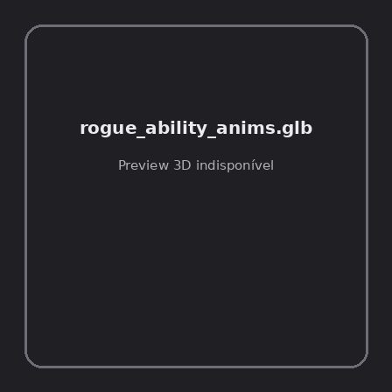
ID | NOV-005753
Origem | Asset novo
Pack/Fonte | Assets Organizados - Characters
Categoria | Characters / Rogue Ability Anims.Glb
Arquivo | rogue_ability_anims.glb
Caminho | 01_Assets_Organizados/Characters/rogue_ability_anims.glb
Formato | GLB
Tamanho | 90.63 KB
SHA-256 | 2850446cc437850020a4…
Status técnico | ERROR
Licença | MISSING_REVIEW_REQUIRED — sem evidência localizada
Objetos / meshes | N/D / N/D
Vértices | N/D
Faces / triângulos | N/D / N/D
Materiais | N/D —
UV sets / vertex colors | N/D / N/D
Dimensões XYZ | N/D
Rig / armatures / bones | N/D / N/D / N/D
Skinned meshes | N/D
Animações | N/D —
Duração total clips | N/D
Root motion detectado | N/D
LODs / colliders | Nenhum / Nenhum
Texturas vinculadas | N/D (0 ausentes)
Alertas | Licença/fonte não localizada automaticamente; revisão legal necessária.
Notas | Falha na inspeção 3D: RuntimeError: Error: Python: Traceback (most recent call last):  File "/usr/share/blender/scripts/addons/io_scene_gltf2/__init__.py", line 1064, in execute  return self.import_gltf2(context)  File "/usr/share/blender/scripts/addons/io_scene_gltf2/__init__.py", line 1083, in import_gltf2  return self.unit_import(self.filepath, import_settings)  File "/usr/share/blender/scripts/addons/io_scene_gltf2/__init__.py", line 1088, in unit_import  from .blender.imp.gltf2_blender_gltf import BlenderGlTF  File "/usr/share/blender/scripts/addons/io_scene_gltf2/blender/imp/gltf2_blender_gltf.py", line 17, in <module>  from .gltf2_blender_scene import BlenderScene  File "/usr/share/blender/scripts/addons/io_scene_gltf2/blender/imp/gltf2_blender_scene.py", line 17, in <module>  from .gltf2_blender_node import BlenderNode  File "/usr/share/blender/scripts/addons/io_scene_gltf2/blender/imp/gltf2_blender_node.py", line 18, in <module>  from .gltf2_blender_mesh import BlenderMesh  File "/usr/share/blender/scripts/addons/io_scene_gltf2/blender/imp/gltf2_blender_mesh.py", line 17, in <module>  import numpy as np  ModuleNotFoundError: No module named 'numpy'  location: /usr/share/blender/scripts/modules/bpy/ops.py:132  Traceback (most recent call last):  File "/home/runner/work/PSX_demons_whip/PSX_demons_whip/workspace/demons/tools/asset_catalog/blender_batch.py", line 427, in inspect_task  import_model(path)  File "/home/runner/work/PSX_demons_whip/PSX_demons_whip/workspace/demons/tools/asset_catalog/blender_batch.py", line 52, in import_model  bpy.ops.import_scene.gltf(filepath=str(path))  File "/usr/share/blender/scripts/modules/bpy/ops.py", line 132, in __call__  ret = _op_call(self.idname_py(), None, kw)  RuntimeError: Error: Python: Traceback (most recent call last):  File "/usr/share/blender/scripts/addons/io_scene_gltf2/__init__.py", line 1064, in execute  return self.import_gltf2(context)  File "/usr/share/blender/scripts/addons/io_scene_gltf2/__init__.py", line 1083, in import_gltf2  return self.unit_import(self.filepath, import_settings)  File "/usr/share/blender/scripts/addons/io_scene_gltf2/__init__.py", line 1088, in unit_import  from .blender.imp.gltf2_blender_gltf import BlenderGlTF  File "/usr/share/blender/scripts/addons/io_scene_gltf2/blender/imp/gltf2_blender_gltf.py", line 17, in <module>  from .gltf2_blender_scene import BlenderScene  File "/usr/share/blender/scripts/addons/io_scene_gltf2/blender/imp/gltf2_blender_scene.py", line 17, in <module>  from .gltf2_blender_node import BlenderNode  File "/usr/share/blender/scripts/addons/io_scene_gltf2/blender/imp/gltf2_blender_node.py", line 18, in <module>  from .gltf2_blender_mesh import BlenderMesh  File "/usr/share/blender/scripts/addons/io_scene_gltf2/blender/imp/gltf2_blender_mesh.py", line 17, in <module>  import numpy as np  ModuleNotFoundError: No module named 'numpy'  location: /usr/share/blender/scripts/modules/bpy/ops.py:132

NOV-005770 • rogue_hit_variety_anims [ERROR]
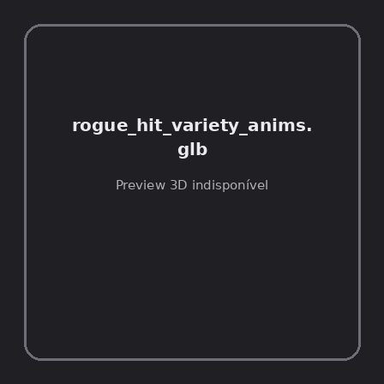
ID | NOV-005770
Origem | Asset novo
Pack/Fonte | Assets Organizados - Characters
Categoria | Characters / Rogue Hit Variety Anims.Glb
Arquivo | rogue_hit_variety_anims.glb
Caminho | 01_Assets_Organizados/Characters/rogue_hit_variety_anims.glb
Formato | GLB
Tamanho | 21.09 KB
SHA-256 | e485e1c74bcc0cbd8aa2…
Status técnico | ERROR
Licença | MISSING_REVIEW_REQUIRED — sem evidência localizada
Objetos / meshes | N/D / N/D
Vértices | N/D
Faces / triângulos | N/D / N/D
Materiais | N/D —
UV sets / vertex colors | N/D / N/D
Dimensões XYZ | N/D
Rig / armatures / bones | N/D / N/D / N/D
Skinned meshes | N/D
Animações | N/D —
Duração total clips | N/D
Root motion detectado | N/D
LODs / colliders | Nenhum / Nenhum
Texturas vinculadas | N/D (0 ausentes)
Alertas | Licença/fonte não localizada automaticamente; revisão legal necessária.
Notas | Falha na inspeção 3D: RuntimeError: Error: Python: Traceback (most recent call last):  File "/usr/share/blender/scripts/addons/io_scene_gltf2/__init__.py", line 1064, in execute  return self.import_gltf2(context)  File "/usr/share/blender/scripts/addons/io_scene_gltf2/__init__.py", line 1083, in import_gltf2  return self.unit_import(self.filepath, import_settings)  File "/usr/share/blender/scripts/addons/io_scene_gltf2/__init__.py", line 1088, in unit_import  from .blender.imp.gltf2_blender_gltf import BlenderGlTF  File "/usr/share/blender/scripts/addons/io_scene_gltf2/blender/imp/gltf2_blender_gltf.py", line 17, in <module>  from .gltf2_blender_scene import BlenderScene  File "/usr/share/blender/scripts/addons/io_scene_gltf2/blender/imp/gltf2_blender_scene.py", line 17, in <module>  from .gltf2_blender_node import BlenderNode  File "/usr/share/blender/scripts/addons/io_scene_gltf2/blender/imp/gltf2_blender_node.py", line 18, in <module>  from .gltf2_blender_mesh import BlenderMesh  File "/usr/share/blender/scripts/addons/io_scene_gltf2/blender/imp/gltf2_blender_mesh.py", line 17, in <module>  import numpy as np  ModuleNotFoundError: No module named 'numpy'  location: /usr/share/blender/scripts/modules/bpy/ops.py:132  Traceback (most recent call last):  File "/home/runner/work/PSX_demons_whip/PSX_demons_whip/workspace/demons/tools/asset_catalog/blender_batch.py", line 427, in inspect_task  import_model(path)  File "/home/runner/work/PSX_demons_whip/PSX_demons_whip/workspace/demons/tools/asset_catalog/blender_batch.py", line 52, in import_model  bpy.ops.import_scene.gltf(filepath=str(path))  File "/usr/share/blender/scripts/modules/bpy/ops.py", line 132, in __call__  ret = _op_call(self.idname_py(), None, kw)  RuntimeError: Error: Python: Traceback (most recent call last):  File "/usr/share/blender/scripts/addons/io_scene_gltf2/__init__.py", line 1064, in execute  return self.import_gltf2(context)  File "/usr/share/blender/scripts/addons/io_scene_gltf2/__init__.py", line 1083, in import_gltf2  return self.unit_import(self.filepath, import_settings)  File "/usr/share/blender/scripts/addons/io_scene_gltf2/__init__.py", line 1088, in unit_import  from .blender.imp.gltf2_blender_gltf import BlenderGlTF  File "/usr/share/blender/scripts/addons/io_scene_gltf2/blender/imp/gltf2_blender_gltf.py", line 17, in <module>  from .gltf2_blender_scene import BlenderScene  File "/usr/share/blender/scripts/addons/io_scene_gltf2/blender/imp/gltf2_blender_scene.py", line 17, in <module>  from .gltf2_blender_node import BlenderNode  File "/usr/share/blender/scripts/addons/io_scene_gltf2/blender/imp/gltf2_blender_node.py", line 18, in <module>  from .gltf2_blender_mesh import BlenderMesh  File "/usr/share/blender/scripts/addons/io_scene_gltf2/blender/imp/gltf2_blender_mesh.py", line 17, in <module>  import numpy as np  ModuleNotFoundError: No module named 'numpy'  location: /usr/share/blender/scripts/modules/bpy/ops.py:132

NOV-005761 • rogue_hooded [ERROR]
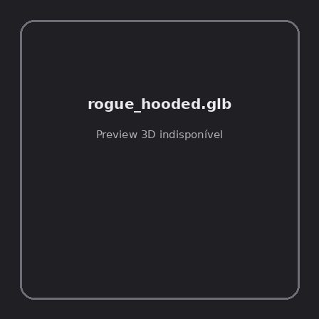
ID | NOV-005761
Origem | Asset novo
Pack/Fonte | Assets Organizados - Characters
Categoria | Characters / Rogue Hooded.Glb
Arquivo | rogue_hooded.glb
Caminho | 01_Assets_Organizados/Characters/rogue_hooded.glb
Formato | GLB
Tamanho | 438.22 KB
SHA-256 | 876d60366dc2105a801b…
Status técnico | ERROR
Licença | MISSING_REVIEW_REQUIRED — sem evidência localizada
Objetos / meshes | N/D / N/D
Vértices | N/D
Faces / triângulos | N/D / N/D
Materiais | N/D —
UV sets / vertex colors | N/D / N/D
Dimensões XYZ | N/D
Rig / armatures / bones | N/D / N/D / N/D
Skinned meshes | N/D
Animações | N/D —
Duração total clips | N/D
Root motion detectado | N/D
LODs / colliders | Nenhum / Nenhum
Texturas vinculadas | N/D (0 ausentes)
Alertas | Licença/fonte não localizada automaticamente; revisão legal necessária. | Duplicado exato: grupo DUP-01088 (2 cópias).
Notas | Falha na inspeção 3D: RuntimeError: Error: Python: Traceback (most recent call last):  File "/usr/share/blender/scripts/addons/io_scene_gltf2/__init__.py", line 1064, in execute  return self.import_gltf2(context)  File "/usr/share/blender/scripts/addons/io_scene_gltf2/__init__.py", line 1083, in import_gltf2  return self.unit_import(self.filepath, import_settings)  File "/usr/share/blender/scripts/addons/io_scene_gltf2/__init__.py", line 1088, in unit_import  from .blender.imp.gltf2_blender_gltf import BlenderGlTF  File "/usr/share/blender/scripts/addons/io_scene_gltf2/blender/imp/gltf2_blender_gltf.py", line 17, in <module>  from .gltf2_blender_scene import BlenderScene  File "/usr/share/blender/scripts/addons/io_scene_gltf2/blender/imp/gltf2_blender_scene.py", line 17, in <module>  from .gltf2_blender_node import BlenderNode  File "/usr/share/blender/scripts/addons/io_scene_gltf2/blender/imp/gltf2_blender_node.py", line 18, in <module>  from .gltf2_blender_mesh import BlenderMesh  File "/usr/share/blender/scripts/addons/io_scene_gltf2/blender/imp/gltf2_blender_mesh.py", line 17, in <module>  import numpy as np  ModuleNotFoundError: No module named 'numpy'  location: /usr/share/blender/scripts/modules/bpy/ops.py:132  Traceback (most recent call last):  File "/home/runner/work/PSX_demons_whip/PSX_demons_whip/workspace/demons/tools/asset_catalog/blender_batch.py", line 427, in inspect_task  import_model(path)  File "/home/runner/work/PSX_demons_whip/PSX_demons_whip/workspace/demons/tools/asset_catalog/blender_batch.py", line 52, in import_model  bpy.ops.import_scene.gltf(filepath=str(path))  File "/usr/share/blender/scripts/modules/bpy/ops.py", line 132, in __call__  ret = _op_call(self.idname_py(), None, kw)  RuntimeError: Error: Python: Traceback (most recent call last):  File "/usr/share/blender/scripts/addons/io_scene_gltf2/__init__.py", line 1064, in execute  return self.import_gltf2(context)  File "/usr/share/blender/scripts/addons/io_scene_gltf2/__init__.py", line 1083, in import_gltf2  return self.unit_import(self.filepath, import_settings)  File "/usr/share/blender/scripts/addons/io_scene_gltf2/__init__.py", line 1088, in unit_import  from .blender.imp.gltf2_blender_gltf import BlenderGlTF  File "/usr/share/blender/scripts/addons/io_scene_gltf2/blender/imp/gltf2_blender_gltf.py", line 17, in <module>  from .gltf2_blender_scene import BlenderScene  File "/usr/share/blender/scripts/addons/io_scene_gltf2/blender/imp/gltf2_blender_scene.py", line 17, in <module>  from .gltf2_blender_node import BlenderNode  File "/usr/share/blender/scripts/addons/io_scene_gltf2/blender/imp/gltf2_blender_node.py", line 18, in <module>  from .gltf2_blender_mesh import BlenderMesh  File "/usr/share/blender/scripts/addons/io_scene_gltf2/blender/imp/gltf2_blender_mesh.py", line 17, in <module>  import numpy as np  ModuleNotFoundError: No module named 'numpy'  location: /usr/share/blender/scripts/modules/bpy/ops.py:132  | Metadados 3D reutilizados do duplicado idêntico TEM-002572.

NOV-005749 • rogue_hooded_hit_variety_anims [ERROR]
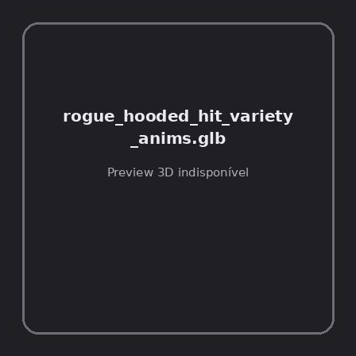
ID | NOV-005749
Origem | Asset novo
Pack/Fonte | Assets Organizados - Characters
Categoria | Characters / Rogue Hooded Hit Variety Anims.Glb
Arquivo | rogue_hooded_hit_variety_anims.glb
Caminho | 01_Assets_Organizados/Characters/rogue_hooded_hit_variety_anims.glb
Formato | GLB
Tamanho | 21.09 KB
SHA-256 | 8c78648d53ff434ea7b2…
Status técnico | ERROR
Licença | MISSING_REVIEW_REQUIRED — sem evidência localizada
Objetos / meshes | N/D / N/D
Vértices | N/D
Faces / triângulos | N/D / N/D
Materiais | N/D —
UV sets / vertex colors | N/D / N/D
Dimensões XYZ | N/D
Rig / armatures / bones | N/D / N/D / N/D
Skinned meshes | N/D
Animações | N/D —
Duração total clips | N/D
Root motion detectado | N/D
LODs / colliders | Nenhum / Nenhum
Texturas vinculadas | N/D (0 ausentes)
Alertas | Licença/fonte não localizada automaticamente; revisão legal necessária.
Notas | Falha na inspeção 3D: RuntimeError: Error: Python: Traceback (most recent call last):  File "/usr/share/blender/scripts/addons/io_scene_gltf2/__init__.py", line 1064, in execute  return self.import_gltf2(context)  File "/usr/share/blender/scripts/addons/io_scene_gltf2/__init__.py", line 1083, in import_gltf2  return self.unit_import(self.filepath, import_settings)  File "/usr/share/blender/scripts/addons/io_scene_gltf2/__init__.py", line 1088, in unit_import  from .blender.imp.gltf2_blender_gltf import BlenderGlTF  File "/usr/share/blender/scripts/addons/io_scene_gltf2/blender/imp/gltf2_blender_gltf.py", line 17, in <module>  from .gltf2_blender_scene import BlenderScene  File "/usr/share/blender/scripts/addons/io_scene_gltf2/blender/imp/gltf2_blender_scene.py", line 17, in <module>  from .gltf2_blender_node import BlenderNode  File "/usr/share/blender/scripts/addons/io_scene_gltf2/blender/imp/gltf2_blender_node.py", line 18, in <module>  from .gltf2_blender_mesh import BlenderMesh  File "/usr/share/blender/scripts/addons/io_scene_gltf2/blender/imp/gltf2_blender_mesh.py", line 17, in <module>  import numpy as np  ModuleNotFoundError: No module named 'numpy'  location: /usr/share/blender/scripts/modules/bpy/ops.py:132  Traceback (most recent call last):  File "/home/runner/work/PSX_demons_whip/PSX_demons_whip/workspace/demons/tools/asset_catalog/blender_batch.py", line 427, in inspect_task  import_model(path)  File "/home/runner/work/PSX_demons_whip/PSX_demons_whip/workspace/demons/tools/asset_catalog/blender_batch.py", line 52, in import_model  bpy.ops.import_scene.gltf(filepath=str(path))  File "/usr/share/blender/scripts/modules/bpy/ops.py", line 132, in __call__  ret = _op_call(self.idname_py(), None, kw)  RuntimeError: Error: Python: Traceback (most recent call last):  File "/usr/share/blender/scripts/addons/io_scene_gltf2/__init__.py", line 1064, in execute  return self.import_gltf2(context)  File "/usr/share/blender/scripts/addons/io_scene_gltf2/__init__.py", line 1083, in import_gltf2  return self.unit_import(self.filepath, import_settings)  File "/usr/share/blender/scripts/addons/io_scene_gltf2/__init__.py", line 1088, in unit_import  from .blender.imp.gltf2_blender_gltf import BlenderGlTF  File "/usr/share/blender/scripts/addons/io_scene_gltf2/blender/imp/gltf2_blender_gltf.py", line 17, in <module>  from .gltf2_blender_scene import BlenderScene  File "/usr/share/blender/scripts/addons/io_scene_gltf2/blender/imp/gltf2_blender_scene.py", line 17, in <module>  from .gltf2_blender_node import BlenderNode  File "/usr/share/blender/scripts/addons/io_scene_gltf2/blender/imp/gltf2_blender_node.py", line 18, in <module>  from .gltf2_blender_mesh import BlenderMesh  File "/usr/share/blender/scripts/addons/io_scene_gltf2/blender/imp/gltf2_blender_mesh.py", line 17, in <module>  import numpy as np  ModuleNotFoundError: No module named 'numpy'  location: /usr/share/blender/scripts/modules/bpy/ops.py:132

NOV-005751 • shaman_ability_anims [ERROR]
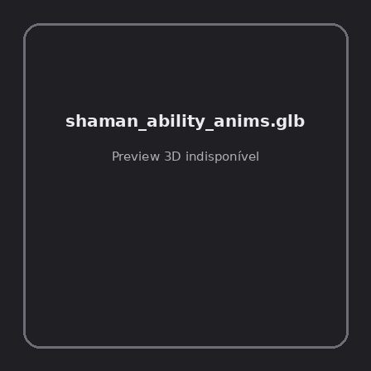
ID | NOV-005751
Origem | Asset novo
Pack/Fonte | Assets Organizados - Characters
Categoria | Characters / Shaman Ability Anims.Glb
Arquivo | shaman_ability_anims.glb
Caminho | 01_Assets_Organizados/Characters/shaman_ability_anims.glb
Formato | GLB
Tamanho | 89.58 KB
SHA-256 | 814c9e687619f89d4303…
Status técnico | ERROR
Licença | MISSING_REVIEW_REQUIRED — sem evidência localizada
Objetos / meshes | N/D / N/D
Vértices | N/D
Faces / triângulos | N/D / N/D
Materiais | N/D —
UV sets / vertex colors | N/D / N/D
Dimensões XYZ | N/D
Rig / armatures / bones | N/D / N/D / N/D
Skinned meshes | N/D
Animações | N/D —
Duração total clips | N/D
Root motion detectado | N/D
LODs / colliders | Nenhum / Nenhum
Texturas vinculadas | N/D (0 ausentes)
Alertas | Licença/fonte não localizada automaticamente; revisão legal necessária.
Notas | Falha na inspeção 3D: RuntimeError: Error: Python: Traceback (most recent call last):  File "/usr/share/blender/scripts/addons/io_scene_gltf2/__init__.py", line 1064, in execute  return self.import_gltf2(context)  File "/usr/share/blender/scripts/addons/io_scene_gltf2/__init__.py", line 1083, in import_gltf2  return self.unit_import(self.filepath, import_settings)  File "/usr/share/blender/scripts/addons/io_scene_gltf2/__init__.py", line 1088, in unit_import  from .blender.imp.gltf2_blender_gltf import BlenderGlTF  File "/usr/share/blender/scripts/addons/io_scene_gltf2/blender/imp/gltf2_blender_gltf.py", line 17, in <module>  from .gltf2_blender_scene import BlenderScene  File "/usr/share/blender/scripts/addons/io_scene_gltf2/blender/imp/gltf2_blender_scene.py", line 17, in <module>  from .gltf2_blender_node import BlenderNode  File "/usr/share/blender/scripts/addons/io_scene_gltf2/blender/imp/gltf2_blender_node.py", line 18, in <module>  from .gltf2_blender_mesh import BlenderMesh  File "/usr/share/blender/scripts/addons/io_scene_gltf2/blender/imp/gltf2_blender_mesh.py", line 17, in <module>  import numpy as np  ModuleNotFoundError: No module named 'numpy'  location: /usr/share/blender/scripts/modules/bpy/ops.py:132  Traceback (most recent call last):  File "/home/runner/work/PSX_demons_whip/PSX_demons_whip/workspace/demons/tools/asset_catalog/blender_batch.py", line 427, in inspect_task  import_model(path)  File "/home/runner/work/PSX_demons_whip/PSX_demons_whip/workspace/demons/tools/asset_catalog/blender_batch.py", line 52, in import_model  bpy.ops.import_scene.gltf(filepath=str(path))  File "/usr/share/blender/scripts/modules/bpy/ops.py", line 132, in __call__  ret = _op_call(self.idname_py(), None, kw)  RuntimeError: Error: Python: Traceback (most recent call last):  File "/usr/share/blender/scripts/addons/io_scene_gltf2/__init__.py", line 1064, in execute  return self.import_gltf2(context)  File "/usr/share/blender/scripts/addons/io_scene_gltf2/__init__.py", line 1083, in import_gltf2  return self.unit_import(self.filepath, import_settings)  File "/usr/share/blender/scripts/addons/io_scene_gltf2/__init__.py", line 1088, in unit_import  from .blender.imp.gltf2_blender_gltf import BlenderGlTF  File "/usr/share/blender/scripts/addons/io_scene_gltf2/blender/imp/gltf2_blender_gltf.py", line 17, in <module>  from .gltf2_blender_scene import BlenderScene  File "/usr/share/blender/scripts/addons/io_scene_gltf2/blender/imp/gltf2_blender_scene.py", line 17, in <module>  from .gltf2_blender_node import BlenderNode  File "/usr/share/blender/scripts/addons/io_scene_gltf2/blender/imp/gltf2_blender_node.py", line 18, in <module>  from .gltf2_blender_mesh import BlenderMesh  File "/usr/share/blender/scripts/addons/io_scene_gltf2/blender/imp/gltf2_blender_mesh.py", line 17, in <module>  import numpy as np  ModuleNotFoundError: No module named 'numpy'  location: /usr/share/blender/scripts/modules/bpy/ops.py:132

NOV-005755 • swim_anims [ERROR]
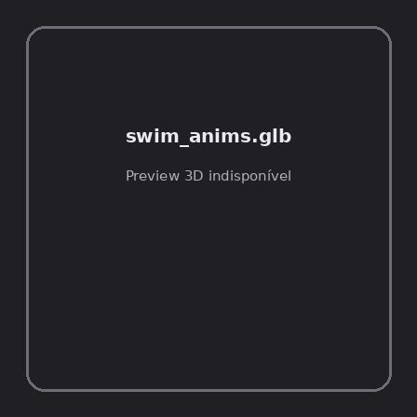
ID | NOV-005755
Origem | Asset novo
Pack/Fonte | Assets Organizados - Characters
Categoria | Characters / Swim Anims.Glb
Arquivo | swim_anims.glb
Caminho | 01_Assets_Organizados/Characters/swim_anims.glb
Formato | GLB
Tamanho | 91.59 KB
SHA-256 | 6021e6fc7132ea5d3271…
Status técnico | ERROR
Licença | MISSING_REVIEW_REQUIRED — sem evidência localizada
Objetos / meshes | N/D / N/D
Vértices | N/D
Faces / triângulos | N/D / N/D
Materiais | N/D —
UV sets / vertex colors | N/D / N/D
Dimensões XYZ | N/D
Rig / armatures / bones | N/D / N/D / N/D
Skinned meshes | N/D
Animações | N/D —
Duração total clips | N/D
Root motion detectado | N/D
LODs / colliders | Nenhum / Nenhum
Texturas vinculadas | N/D (0 ausentes)
Alertas | Licença/fonte não localizada automaticamente; revisão legal necessária.
Notas | Falha na inspeção 3D: RuntimeError: Error: Python: Traceback (most recent call last):  File "/usr/share/blender/scripts/addons/io_scene_gltf2/__init__.py", line 1064, in execute  return self.import_gltf2(context)  File "/usr/share/blender/scripts/addons/io_scene_gltf2/__init__.py", line 1083, in import_gltf2  return self.unit_import(self.filepath, import_settings)  File "/usr/share/blender/scripts/addons/io_scene_gltf2/__init__.py", line 1088, in unit_import  from .blender.imp.gltf2_blender_gltf import BlenderGlTF  File "/usr/share/blender/scripts/addons/io_scene_gltf2/blender/imp/gltf2_blender_gltf.py", line 17, in <module>  from .gltf2_blender_scene import BlenderScene  File "/usr/share/blender/scripts/addons/io_scene_gltf2/blender/imp/gltf2_blender_scene.py", line 17, in <module>  from .gltf2_blender_node import BlenderNode  File "/usr/share/blender/scripts/addons/io_scene_gltf2/blender/imp/gltf2_blender_node.py", line 18, in <module>  from .gltf2_blender_mesh import BlenderMesh  File "/usr/share/blender/scripts/addons/io_scene_gltf2/blender/imp/gltf2_blender_mesh.py", line 17, in <module>  import numpy as np  ModuleNotFoundError: No module named 'numpy'  location: /usr/share/blender/scripts/modules/bpy/ops.py:132  Traceback (most recent call last):  File "/home/runner/work/PSX_demons_whip/PSX_demons_whip/workspace/demons/tools/asset_catalog/blender_batch.py", line 427, in inspect_task  import_model(path)  File "/home/runner/work/PSX_demons_whip/PSX_demons_whip/workspace/demons/tools/asset_catalog/blender_batch.py", line 52, in import_model  bpy.ops.import_scene.gltf(filepath=str(path))  File "/usr/share/blender/scripts/modules/bpy/ops.py", line 132, in __call__  ret = _op_call(self.idname_py(), None, kw)  RuntimeError: Error: Python: Traceback (most recent call last):  File "/usr/share/blender/scripts/addons/io_scene_gltf2/__init__.py", line 1064, in execute  return self.import_gltf2(context)  File "/usr/share/blender/scripts/addons/io_scene_gltf2/__init__.py", line 1083, in import_gltf2  return self.unit_import(self.filepath, import_settings)  File "/usr/share/blender/scripts/addons/io_scene_gltf2/__init__.py", line 1088, in unit_import  from .blender.imp.gltf2_blender_gltf import BlenderGlTF  File "/usr/share/blender/scripts/addons/io_scene_gltf2/blender/imp/gltf2_blender_gltf.py", line 17, in <module>  from .gltf2_blender_scene import BlenderScene  File "/usr/share/blender/scripts/addons/io_scene_gltf2/blender/imp/gltf2_blender_scene.py", line 17, in <module>  from .gltf2_blender_node import BlenderNode  File "/usr/share/blender/scripts/addons/io_scene_gltf2/blender/imp/gltf2_blender_node.py", line 18, in <module>  from .gltf2_blender_mesh import BlenderMesh  File "/usr/share/blender/scripts/addons/io_scene_gltf2/blender/imp/gltf2_blender_mesh.py", line 17, in <module>  import numpy as np  ModuleNotFoundError: No module named 'numpy'  location: /usr/share/blender/scripts/modules/bpy/ops.py:132

NOV-005766 • warlock_ability_anims [ERROR]
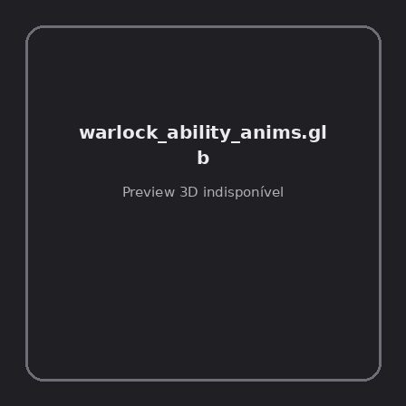
ID | NOV-005766
Origem | Asset novo
Pack/Fonte | Assets Organizados - Characters
Categoria | Characters / Warlock Ability Anims.Glb
Arquivo | warlock_ability_anims.glb
Caminho | 01_Assets_Organizados/Characters/warlock_ability_anims.glb
Formato | GLB
Tamanho | 74.11 KB
SHA-256 | 3c9ce0f27de66c942147…
Status técnico | ERROR
Licença | MISSING_REVIEW_REQUIRED — sem evidência localizada
Objetos / meshes | N/D / N/D
Vértices | N/D
Faces / triângulos | N/D / N/D
Materiais | N/D —
UV sets / vertex colors | N/D / N/D
Dimensões XYZ | N/D
Rig / armatures / bones | N/D / N/D / N/D
Skinned meshes | N/D
Animações | N/D —
Duração total clips | N/D
Root motion detectado | N/D
LODs / colliders | Nenhum / Nenhum
Texturas vinculadas | N/D (0 ausentes)
Alertas | Licença/fonte não localizada automaticamente; revisão legal necessária.
Notas | Falha na inspeção 3D: RuntimeError: Error: Python: Traceback (most recent call last):  File "/usr/share/blender/scripts/addons/io_scene_gltf2/__init__.py", line 1064, in execute  return self.import_gltf2(context)  File "/usr/share/blender/scripts/addons/io_scene_gltf2/__init__.py", line 1083, in import_gltf2  return self.unit_import(self.filepath, import_settings)  File "/usr/share/blender/scripts/addons/io_scene_gltf2/__init__.py", line 1088, in unit_import  from .blender.imp.gltf2_blender_gltf import BlenderGlTF  File "/usr/share/blender/scripts/addons/io_scene_gltf2/blender/imp/gltf2_blender_gltf.py", line 17, in <module>  from .gltf2_blender_scene import BlenderScene  File "/usr/share/blender/scripts/addons/io_scene_gltf2/blender/imp/gltf2_blender_scene.py", line 17, in <module>  from .gltf2_blender_node import BlenderNode  File "/usr/share/blender/scripts/addons/io_scene_gltf2/blender/imp/gltf2_blender_node.py", line 18, in <module>  from .gltf2_blender_mesh import BlenderMesh  File "/usr/share/blender/scripts/addons/io_scene_gltf2/blender/imp/gltf2_blender_mesh.py", line 17, in <module>  import numpy as np  ModuleNotFoundError: No module named 'numpy'  location: /usr/share/blender/scripts/modules/bpy/ops.py:132  Traceback (most recent call last):  File "/home/runner/work/PSX_demons_whip/PSX_demons_whip/workspace/demons/tools/asset_catalog/blender_batch.py", line 427, in inspect_task  import_model(path)  File "/home/runner/work/PSX_demons_whip/PSX_demons_whip/workspace/demons/tools/asset_catalog/blender_batch.py", line 52, in import_model  bpy.ops.import_scene.gltf(filepath=str(path))  File "/usr/share/blender/scripts/modules/bpy/ops.py", line 132, in __call__  ret = _op_call(self.idname_py(), None, kw)  RuntimeError: Error: Python: Traceback (most recent call last):  File "/usr/share/blender/scripts/addons/io_scene_gltf2/__init__.py", line 1064, in execute  return self.import_gltf2(context)  File "/usr/share/blender/scripts/addons/io_scene_gltf2/__init__.py", line 1083, in import_gltf2  return self.unit_import(self.filepath, import_settings)  File "/usr/share/blender/scripts/addons/io_scene_gltf2/__init__.py", line 1088, in unit_import  from .blender.imp.gltf2_blender_gltf import BlenderGlTF  File "/usr/share/blender/scripts/addons/io_scene_gltf2/blender/imp/gltf2_blender_gltf.py", line 17, in <module>  from .gltf2_blender_scene import BlenderScene  File "/usr/share/blender/scripts/addons/io_scene_gltf2/blender/imp/gltf2_blender_scene.py", line 17, in <module>  from .gltf2_blender_node import BlenderNode  File "/usr/share/blender/scripts/addons/io_scene_gltf2/blender/imp/gltf2_blender_node.py", line 18, in <module>  from .gltf2_blender_mesh import BlenderMesh  File "/usr/share/blender/scripts/addons/io_scene_gltf2/blender/imp/gltf2_blender_mesh.py", line 17, in <module>  import numpy as np  ModuleNotFoundError: No module named 'numpy'  location: /usr/share/blender/scripts/modules/bpy/ops.py:132

NOV-005776 • warrior_ability_anims [ERROR]
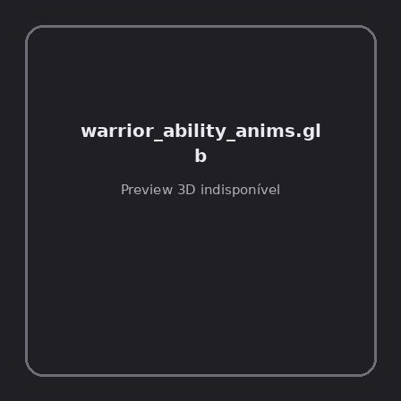
ID | NOV-005776
Origem | Asset novo
Pack/Fonte | Assets Organizados - Characters
Categoria | Characters / Warrior Ability Anims.Glb
Arquivo | warrior_ability_anims.glb
Caminho | 01_Assets_Organizados/Characters/warrior_ability_anims.glb
Formato | GLB
Tamanho | 23.91 KB
SHA-256 | 5cabf7ef81b856a1f4ce…
Status técnico | ERROR
Licença | MISSING_REVIEW_REQUIRED — sem evidência localizada
Objetos / meshes | N/D / N/D
Vértices | N/D
Faces / triângulos | N/D / N/D
Materiais | N/D —
UV sets / vertex colors | N/D / N/D
Dimensões XYZ | N/D
Rig / armatures / bones | N/D / N/D / N/D
Skinned meshes | N/D
Animações | N/D —
Duração total clips | N/D
Root motion detectado | N/D
LODs / colliders | Nenhum / Nenhum
Texturas vinculadas | N/D (0 ausentes)
Alertas | Licença/fonte não localizada automaticamente; revisão legal necessária.
Notas | Falha na inspeção 3D: RuntimeError: Error: Python: Traceback (most recent call last):  File "/usr/share/blender/scripts/addons/io_scene_gltf2/__init__.py", line 1064, in execute  return self.import_gltf2(context)  File "/usr/share/blender/scripts/addons/io_scene_gltf2/__init__.py", line 1083, in import_gltf2  return self.unit_import(self.filepath, import_settings)  File "/usr/share/blender/scripts/addons/io_scene_gltf2/__init__.py", line 1088, in unit_import  from .blender.imp.gltf2_blender_gltf import BlenderGlTF  File "/usr/share/blender/scripts/addons/io_scene_gltf2/blender/imp/gltf2_blender_gltf.py", line 17, in <module>  from .gltf2_blender_scene import BlenderScene  File "/usr/share/blender/scripts/addons/io_scene_gltf2/blender/imp/gltf2_blender_scene.py", line 17, in <module>  from .gltf2_blender_node import BlenderNode  File "/usr/share/blender/scripts/addons/io_scene_gltf2/blender/imp/gltf2_blender_node.py", line 18, in <module>  from .gltf2_blender_mesh import BlenderMesh  File "/usr/share/blender/scripts/addons/io_scene_gltf2/blender/imp/gltf2_blender_mesh.py", line 17, in <module>  import numpy as np  ModuleNotFoundError: No module named 'numpy'  location: /usr/share/blender/scripts/modules/bpy/ops.py:132  Traceback (most recent call last):  File "/home/runner/work/PSX_demons_whip/PSX_demons_whip/workspace/demons/tools/asset_catalog/blender_batch.py", line 427, in inspect_task  import_model(path)  File "/home/runner/work/PSX_demons_whip/PSX_demons_whip/workspace/demons/tools/asset_catalog/blender_batch.py", line 52, in import_model  bpy.ops.import_scene.gltf(filepath=str(path))  File "/usr/share/blender/scripts/modules/bpy/ops.py", line 132, in __call__  ret = _op_call(self.idname_py(), None, kw)  RuntimeError: Error: Python: Traceback (most recent call last):  File "/usr/share/blender/scripts/addons/io_scene_gltf2/__init__.py", line 1064, in execute  return self.import_gltf2(context)  File "/usr/share/blender/scripts/addons/io_scene_gltf2/__init__.py", line 1083, in import_gltf2  return self.unit_import(self.filepath, import_settings)  File "/usr/share/blender/scripts/addons/io_scene_gltf2/__init__.py", line 1088, in unit_import  from .blender.imp.gltf2_blender_gltf import BlenderGlTF  File "/usr/share/blender/scripts/addons/io_scene_gltf2/blender/imp/gltf2_blender_gltf.py", line 17, in <module>  from .gltf2_blender_scene import BlenderScene  File "/usr/share/blender/scripts/addons/io_scene_gltf2/blender/imp/gltf2_blender_scene.py", line 17, in <module>  from .gltf2_blender_node import BlenderNode  File "/usr/share/blender/scripts/addons/io_scene_gltf2/blender/imp/gltf2_blender_node.py", line 18, in <module>  from .gltf2_blender_mesh import BlenderMesh  File "/usr/share/blender/scripts/addons/io_scene_gltf2/blender/imp/gltf2_blender_mesh.py", line 17, in <module>  import numpy as np  ModuleNotFoundError: No module named 'numpy'  location: /usr/share/blender/scripts/modules/bpy/ops.py:132

