HW3 (Git)

**INSTRUCTIONS.** Take screen shots to document your actions for steps 2-8. Include local computer file directory, command line, and github pictures where applicable.

1. Create a github account and a SSH key that links your device to your account if you have not already. Done in class*

2. Create a “HW3_repo” directory (folder) at a location of your choice on your computer.

3. Initialize an empty git repository in the HW3_repo.

4. Put your HW2 file under version control in your “HW3_repo”.

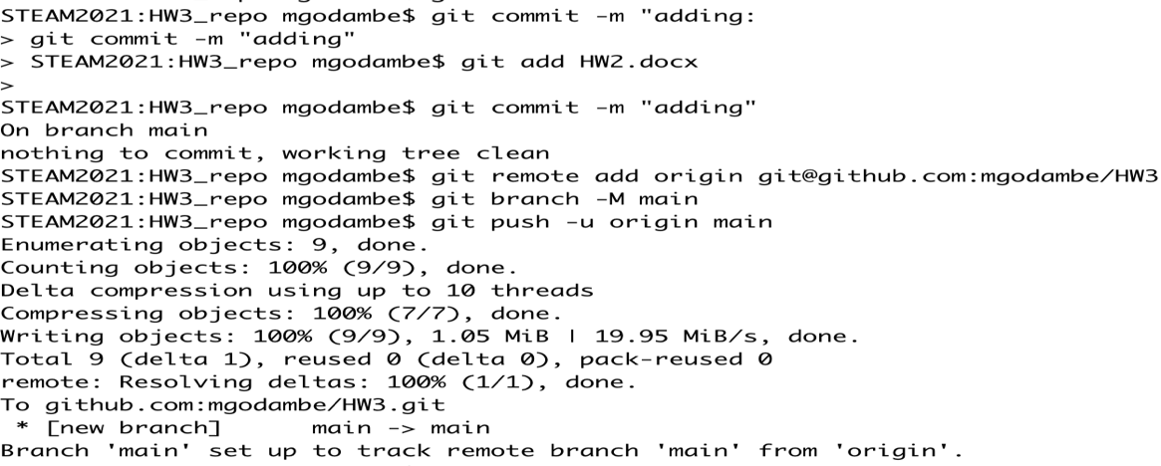

5. Record the changes to HW3_repo using git commit and include a commit message.

6. Create a HW3 project repository called ‘HW3’ on your GitHub site.

7. Make that repository your origin (i.e. where things get pushed to from your local git repository called HW3_repo).

8. Push your committed HW2 file to your Github repository.