# TARZAN TARZAN RULES

Tarzan Tarzan is a fun and silly game for 3+ players which requires high levels of precision and concentration.

## GAME SET UP:

The game Tarzan Tarzan is played with all players sitting in a circle.

One player is assigned to be 'Tarzan' and is king/queen of the jungle. All other players aim to become Tarzan and will get closer to this goal by moving clockwise around the circle. The player to Tarzan’s right is 'Jane' and is second in command. The player at the bottom of the heap sits to the left of Tarzan and is the ‘exploding chicken’. All other players choose an animal to become.

Each player then decides on an action and sound to represent their animal/character. For example, a 'snake' action may involve a slithering motion with the hands while making a hissing sound. Before starting the game, each player should show their action to the rest of the group.

## GAMEPLAY:

Once every player has invented an action and shown it to the rest of the group, the game is ready to start.

Tarzan begins the game by performing their action. They then immediately perform the action of another animal/character in the jungle. The person with the action that Tarzan just performed must then perform their action, and straight afterwards, perform somebody else’s action.

This pattern repeats continuously. To summarise, whenever a person’s action is performed by another player, they must perform their action and then the action of another animal/character. Here is an example snippet of play:

Tarzan: Tarzan action + Snake action

Snake: Snake action + Jane action

Jane: Jane action + Tarzan action

Tarzan: Tarzan action + Jane action

Etc…

This continues until somebody makes a mistake. This could involve hesitation before performing an action or performing the action incorrectly. When this happens, the player who made the mistake moves down to the bottom of the heap. Everyone else who was sitting clockwise of this player (up to and including the exploding chicken) then gets to move one seat clockwise. They are one space closer to reaching Tarzan!

Now, this next part is important - the actions performed by the players are linked to their position in the circle, not the players themselves. Each player who moves seats also changes their animal action.

For example, if the player sitting in Jane’s seat makes a mistake, then they will move to the left of Tarzan and become the exploding chicken. The player who was sitting to the left of Jane will then move one seat anti-clockwise, to sit in Jane’s seat and therefore become Jane. This is illustrated in the diagram below:

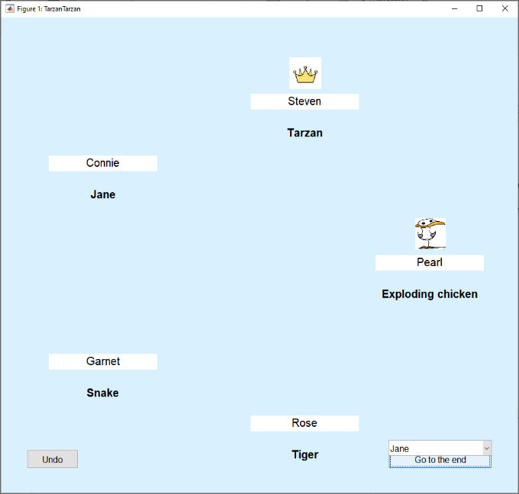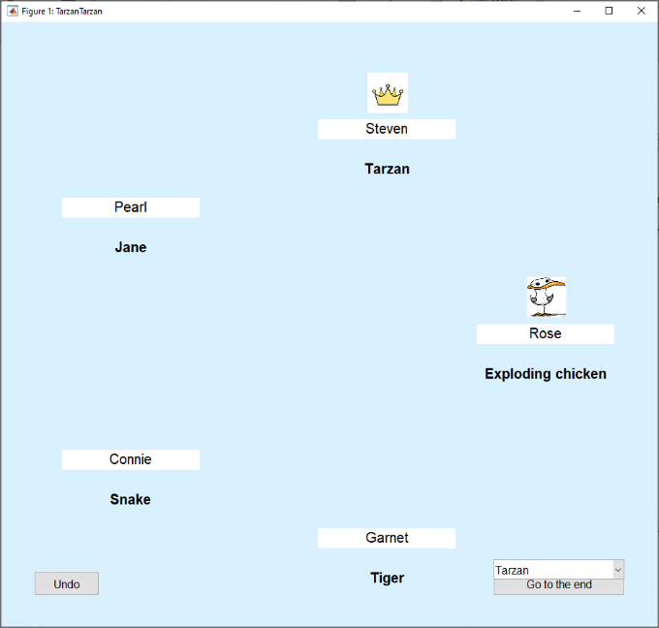

Pearl, sitting in Jane’s seat, makes a mistake and must go to the bottom of the heap.

Pearl then becomes the exploding chicken.

Steven doesn’t move as he is not below Jane in the jungle hierarchy.

All players anti-clockwise of Jane’s seat move one seat clockwise and change their actions. E.g. Connie is now the new ‘Jane’.

There is no ‘end’ to Tarzan Tarzan. The game can continue indefinitely and can go on for as long as time allows and the players are enjoying themselves!