19.11.2014

|  |
| --- |
|  |

Melanie Göbel

|  |  |
| --- | --- |
| 4BHIT TGM | ORM - Propel |

|  |  |
| --- | --- |
|  | time required/estimated |

|  |  |  |
| --- | --- | --- |
| Task | estimated time (in minutes) | required time (in minutes) |
| Install Propel | 10 | 10 |
| Design | 15 | 20 |
| Schema.xml | 30 | 30 |
| behaviors | 50 |  |
| Generate php-classes | 10 |  |
| CRUD | 50 |  |

# Install Propel

This short introduction is made on a Debian 64-Bit VM on VMWare. Further information for installing propel is on the propel-webside[1]

Git clone <https://github.com/propelorm/Propel2> vendor/propel

Wget <http://getcomposer.org/composer.phar>

apt-get update

apt-get install php5-cli

apt-get install mysql

export PATH=$PATH:/path/to/vendor/bin/

# Building a project (working with php)

To build a project we used the example bookstore[2]

Connect with mysql

Mysql –u root –p

Create Database

Create database notizverwaltung;

Create a new user in mysql

Grant all privileges on notizverwaltung.* to ‘notizuser’ @’%’ identified by ‘notiz’;

Create a directory named as the database in mysql and a directory named conf in the other one.

mkdir notizverwaltung

cd notizverwaltung

mkdir conf

Make schema.xml and propel.php

cd ..

touch schema.xml

touch conf/propel.php

Describing Your Database as XML Schema

The root tag of the XML schema is the database tag, in this tag are all tables.

<?xml version="1.0" encoding="UTF-8"?>

<database name="notizverwaltung" defaultIdMethod="native">

</database>

How to make tables with 2 columns (the first one is a primary key)

<table name ="person" phpName="Person">

<column name="name" type="varchar" size="250" required="true" primaryKey="true"/>

<column name="beschreibung" type="varchar" size="1000" required="false"/>

</table>

Foreign key (don’t forget to make a column too!!)

<column name="projekt" type="varchar" size="250"/>

<foreign-key foreignTable="projekt">

<reference local="projekt" foreign="name"/>

</foreign-key>

Setting up Configuration

To generate classes we will need the propel.php in conf. This code have to be in propel.php:

conf/propel.php

<?php

return [

'propel' => [

'database' => [

'connections' => [

'bookstore' => [

'adapter' => 'mysql',

'classname' => 'Propel\Runtime\Connection\ConnectionWrapper',

'dsn' => 'mysql:host=localhost;dbname=notizverwaltung,

'user' => 'notizuser,

'password' => ‘notiz',

'attributes' => []

]

]

],

'runtime' => [

'defaultConnection' => ‘ notizverwaltung ',

'connections' => [' notizverwaltung ']

],

'generator' => [

'defaultConnection' => ' notizverwaltung ',

'connections' => [' notizverwaltung ']

]

]

];

## Note-administration

|  |
| --- |
|  |

Note = Subject + Text + Date + Owner + Project (optional)  
Project = Name + Startdate + Enddate + participant (mind. 1)

Person = Name + description

Special Note:

ToDoNotiz = note + status [done | ready | in work] + priority  
recipe = note + ordered list of Subnotizen

## Design

Before we work on the schema.xml we need to design an ERD. The important thing is to show the relationships between the tables.

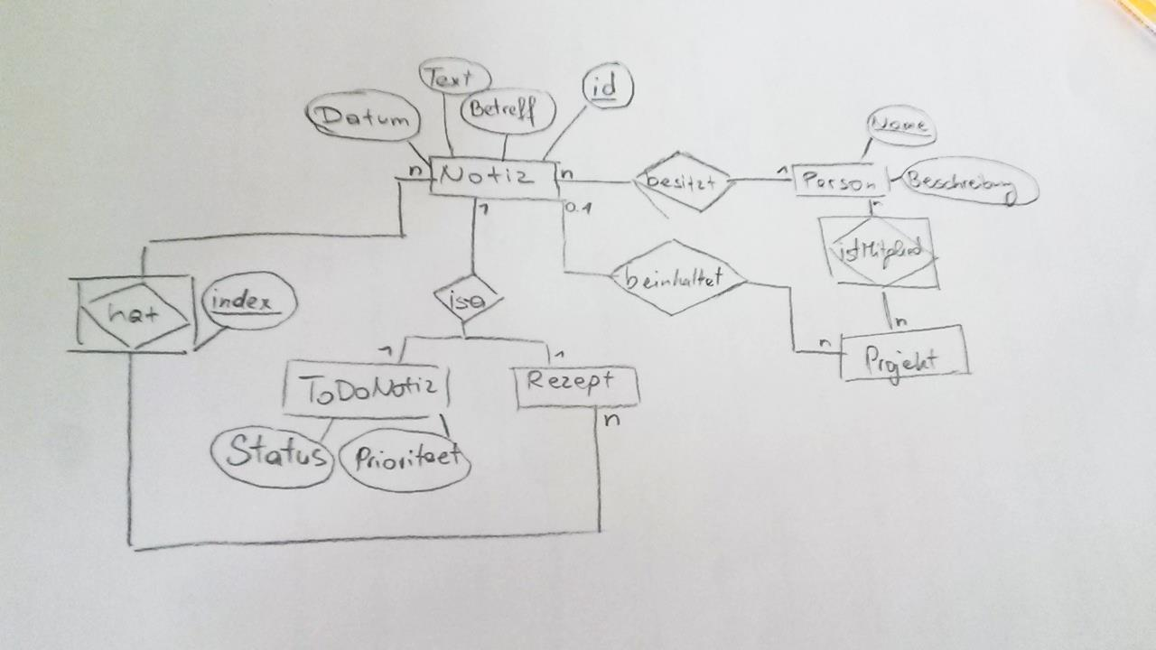

We have 7 tables in our project:

* Note
* Person
* Project
* ToDoNote
* Recipe
* Subnote
* Participant

*-*

## Work

1. From the ERD make schema.xml with all tables and their attributes
2. Add foreign keys from other tables.
3. propel sql:build
4. create a timestamp

## Sources

[1] Installing Propel – the propel team

Available at: <http://propelorm.org/documentation/01-installation.html> (last seen: 26.11.2014)

[2] The build time – the propel team

Available at: <http://propelorm.org/documentation/02-buildtime.html> (last seen: 26.11.2014)