BCSE301L - SOFTWARE ENGINEERING
Fall Semester 2026-27 | Digital Assignment
Campus Lost & Found
A web platform to report, search for and safely claim items lost on campus
Requirements Analysis
Problem statement, stakeholders, requirements, feasibility and use cases
Prepared by: Student 1 - Requirement Gathering & Analysis
Team members
# | Name | Reg. No. | Responsibility
Student 1 | [Student 1 name] | [Reg. No.] | Requirement Gathering & Analysis
Student 2 | [Student 2 name] | [Reg. No.] | System Design (UML)
Student 3 | [Student 3 name] | [Reg. No.] | Development
Student 4 | [Student 4 name] | [Reg. No.] | Testing
Student 5 | [Student 5 name] | [Reg. No.] | Documentation (SRS)

Submitted to: [Faculty name] Date: [Submission date]
Contents
1. Problem Statement 3
1.1 Background 3
1.2 Problem statement 3
1.3 Objectives 3
1.4 Scope 3
1.5 How the requirements were gathered 4
2. Stakeholder Identification 5
2.1 User classes 5
3. Functional Requirements 6
4. Non-Functional Requirements 9
5. Feasibility Analysis 10
5.1 Project schedule 10
5.2 Conclusion 10
6. Use Cases 11
6.1 Use case list 11
6.2 Use case specifications 12

1. Problem Statement

1.1 Background
Every day, students lose ID cards, water bottles, calculators, keys, chargers and clothing across campus - in lecture halls, the library, the canteen and hostels.
Today, finding them depends on scattered channels: class WhatsApp groups, handwritten notices on boards, or walking to the security desk. Messages are buried within hours, there is no way to search old posts, and the person who found an item rarely knows who to give it to.
Worse, there is no check of ownership: anyone who says "that is mine" can take an item, and finders who post their phone numbers in large groups expose personal details to hundreds of strangers.

1.2 Problem statement
Students who lose or find belongings on campus have no single, searchable, trustworthy place to connect with each other. As a result many items are never returned, items can be handed to the wrong person, and contact details are over-shared. The project builds a web application where finders post items, owners search and send a claim with proof of ownership, and the finder approves the rightful claim - while personal contact details are visible only to signed-in members of the campus.

1.3 Objectives
- Provide one central, searchable list of found and lost items for the whole campus.
- Let owners prove ownership through a claim message that the finder reviews before handing an item over.
- Protect privacy: contact details are visible only to logged-in users.
- Keep the system simple enough for any student to use without training.
- Apply the full SDLC - requirements, design, implementation, testing and documentation.

1.4 Scope
In scope (this release) | Out of scope (future work)
Student registration and login (email + password, JWT session) | Email / SMS / push notifications
Posting found and lost items with category, location, date and an optional photo | Mobile apps (the website is responsive instead)
Browsing, keyword search, filters (category, found/lost, open/returned) and pagination | Restricting sign-up to the college email domain or SSO login
Claim requests with an ownership message; approve / reject by the poster | Automatic image matching between lost and found items
Automatic status update to "returned" and rejection of competing requests | Public internet hosting (the project runs locally for the demonstration)
Edit / delete own posts; admin role can moderate any post

1.5 How the requirements were gathered
- Informal interviews with classmates and hostel residents about the last time they lost or found something and what they did.
- Observation of existing channels - class WhatsApp groups and notice boards - noting how quickly posts were buried and how often phone numbers were shared publicly.
- Discussion with the security / lost-and-found desk about how items are currently logged and handed back.
- Study of similar systems (generic lost-and-found websites) to identify the core flow and what to leave out for one semester.

2. Stakeholder Identification
A stakeholder is anyone who uses, pays for, is affected by, or evaluates the system. The table lists each group, its role and what it needs from the system.
Stakeholder | Role | Needs / interests | Influence
Students (finders) | Primary user | Post an item quickly, hand it to the real owner, avoid sharing their number with strangers | High
Students (owners) | Primary user | Search all found items in one place, prove ownership, track their claim | High
Campus security / lost-and-found desk | Admin user | Fewer walk-in enquiries, ability to remove spam or wrong posts | Medium
College administration | Sponsor | A safer campus with less loss; low cost; protection of student data | Medium
Faculty / course instructor | Evaluator | Correct application of SE principles across the SDLC, working demo | High
Development team (5 students) | Builder | Clear requirements, a feasible scope within one semester, maintainable code | High

2.1 User classes
- Visitor - anyone on the site who is not logged in. Can browse and search but cannot see contact details or post.
- Student - a registered, logged-in user. Can post items, send claims and decide on claims for their own posts.
- Admin - a trusted user (for example the security desk) who can edit or remove any post.

3. Functional Requirements
Functional requirements describe what the system must do. Priorities use the MoSCoW method (Must / Should / Could / Won't). The last column links each requirement to the test cases that verify it (see the Testing Report).
ID | Requirement | Description | Priority | Verified by
FR-01 | Register account | A visitor can create an account with name, email, password (min. 6 characters) and optional phone. Emails must be unique (case-insensitive) and in a valid format. | Must | TC-01 to TC-05
FR-02 | Log in / log out | A registered user logs in with email and password and receives a session token valid for 7 days. Wrong credentials give a generic error. Logging out clears the session. | Must | TC-07 to TC-12
FR-03 | Browse items | Anyone can see open items, newest first, 12 per page, as cards showing photo, type, title, category, location and date. | Must | TC-23, TC-27
FR-04 | Keyword search | Search text matches the title, description or location (case-insensitive). Special characters are treated as plain text. | Must | TC-24, TC-26
FR-05 | Filter items | Results can be filtered by category, by type (found / lost) and by status (open / returned / all). | Should | TC-25
FR-06 | View item details | Anyone can open an item to see its full description, photo and the poster's name. Unknown or malformed ids give a clear message. | Must | TC-28, TC-30
FR-07 | Contact privacy | The poster's email and phone are shown only to logged-in users. | Must | TC-28, TC-29
FR-08 | Post an item | A logged-in user posts a found or lost item with title, description, category (fixed list of 10), location and date. All fields except the photo are required. | Must | TC-13 to TC-16
FR-09 | Upload photo | An optional photo (jpg, png, webp, gif, max 5 MB) can be attached. It is stored under a random file name. | Should | TC-17 to TC-19
FR-10 | Edit / delete own post | The poster can update their own post (the website uses this for "Mark as returned") or delete it; an admin can do so for any post. Deleting removes the photo and all claim requests on it. | Must | TC-20, TC-21, TC-43
FR-11 | My posts | A logged-in user sees a list of the items they posted. | Should | TC-22
FR-12 | Send claim request | A logged-in user sends a claim on someone else's open item with a message proving ownership. Only one request per user per item; returned items cannot be claimed. | Must | TC-32 to TC-36, TC-41
FR-13 | View requests | Posters see requests received on their items (with claimant contact). Claimants see requests they have sent and their status. | Must | TC-37
FR-14 | Approve / reject request | Only the poster of the item can approve or reject a pending request. | Must | TC-38, TC-39
FR-15 | Mark item returned | Approving a request marks the item "returned" to that claimant and rejects all other pending requests. A returned item cannot be approved for anyone else. | Must | TC-40, TC-42
FR-16 | Home statistics | The home page shows counts of open found items, open lost items and items returned. | Could | TC-31

4. Non-Functional Requirements
Non-functional requirements describe how well the system must work - its quality attributes.
ID | Quality attribute | Requirement | Verified by
NFR-01 | Security - passwords | Passwords are hashed with bcrypt (cost 10) and are never returned by the API or stored as plain text. | TC-01, TC-06
NFR-02 | Security - authorisation | Every write operation checks that the caller is logged in and owns the record (or is an admin). | TC-14, TC-21, TC-33, TC-38
NFR-03 | Privacy | Personal contact details are never shown to visitors who are not logged in. | TC-28
NFR-04 | Input validation & error handling | All inputs are validated on both client and server; every error returns a clear, human-readable message and the correct HTTP status code - never a crash. | TC-02, TC-10, TC-15, TC-18, TC-30
NFR-05 | Upload safety | Only image files up to 5 MB are accepted; file names are replaced with random UUIDs so a crafted name cannot overwrite files. | TC-17 to TC-19
NFR-06 | Performance | Search results should appear within 1 second for up to 1,000 items on a normal laptop. A compound database index supports the common filters. | Design target
NFR-07 | Usability | A new user can find an item and send a claim in at most 3 screens; the layout works on phones and desktops. | Manual UI tests
NFR-08 | Reliability / data integrity | An item can be returned to only one claimant; deleting a post leaves no orphan claims or photos. | TC-36, TC-40, TC-42, TC-43
NFR-09 | Maintainability | Code is split into models, routes, middleware (server) and pages, components, context (client); automated tests can be re-run with one command. | npm test
NFR-10 | Portability | Runs on Windows, macOS or Linux with Node.js 20+ and MongoDB; works in current Chrome, Edge and Firefox. | Demo machine

5. Feasibility Analysis
Before development the team checked whether the project could be built and used successfully within the semester.
Type | Analysis | Result
Technical | The MERN stack (MongoDB, Express, React, Node.js) is free, well documented and was covered by the team's skills. All required features - authentication, file upload, search - have mature libraries (bcryptjs, jsonwebtoken, multer, mongoose). | Feasible
Economic | All software is open source. The app runs on an existing student laptop with MongoDB Community Server. Development cost: Rs. 0 in licences; only team time. Hosting later would fit a free cloud tier. | Feasible
Operational | Students already use the web daily; the flow (post -> search -> claim -> approve) mirrors how lost items are returned today, so no training is needed. The security desk can act as admin. | Feasible
Schedule | The scope was cut to features achievable in one semester (see timeline). Notifications and image matching were moved to future work. | Feasible
Legal / ethical | Only minimal personal data (name, email, optional phone) is stored, passwords are hashed, and contact details are hidden from the public. | Feasible

5.1 Project schedule
Period | Activity | Lead
Week 1-2 | Requirement gathering, stakeholder discussion, feasibility | Student 1
Week 3-4 | UML design, database schema, API design | Student 2
Week 5-8 | Implementation of backend API and React frontend | Student 3
Week 9-10 | Test planning, automated + manual testing, defect fixing | Student 4 (+3)
Week 11-12 | SRS document, user guide, presentation | Student 5 (all)

5.2 Conclusion
The project is feasible on all five dimensions. The biggest risk - running out of time - was handled by keeping notifications and image matching out of scope.

6. Use Cases
The use case diagram below summarises who interacts with the system and how. Detailed specifications for the five most important use cases follow.
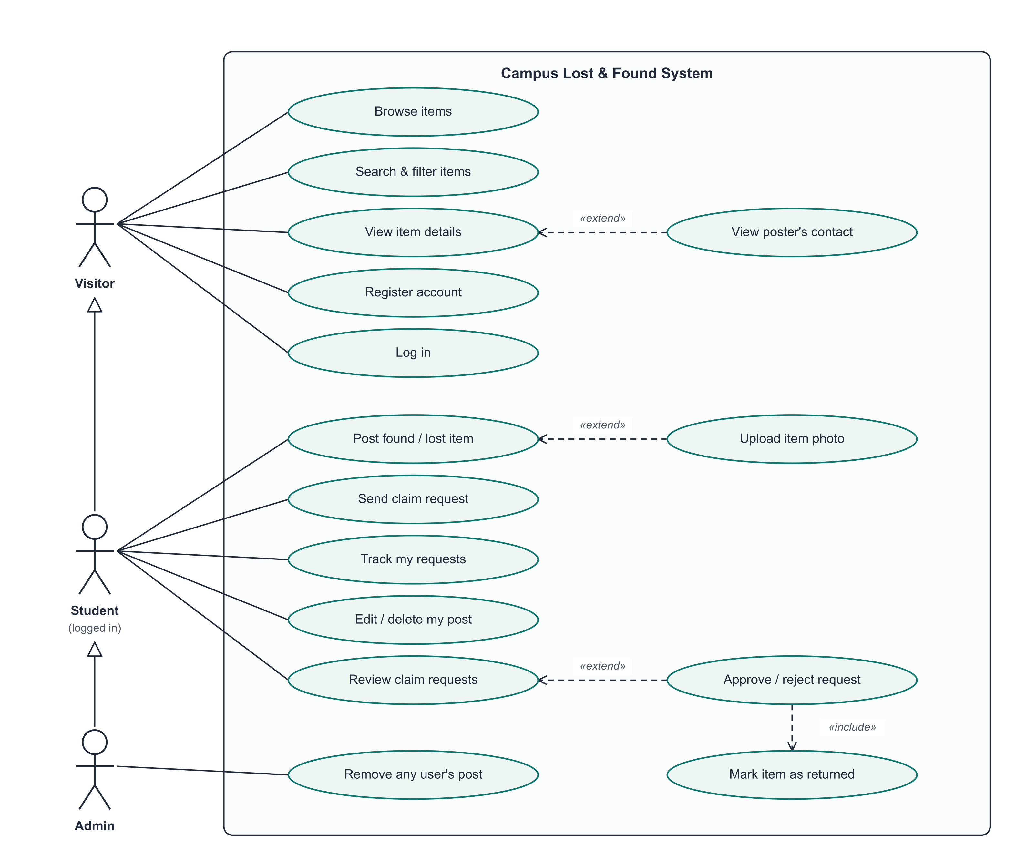
Figure 1 - Use case diagram

6.1 Use case list
Actor | Use cases
Visitor | Browse items; Search & filter items; View item details; Register account; Log in
Student | All Visitor use cases, plus: Post found / lost item (extend: Upload photo); View poster's contact; Send claim request; Track my requests; Edit / delete my post; Review claim requests (extend: Approve / reject request, which includes Mark item as returned)
Admin | All Student use cases, plus: Remove any user's post

6.2 Use case specifications

UC-01: Register and log in
Primary actor | Visitor
Precondition | The visitor is not logged in.
Main flow | 1. Visitor opens "Sign up" and enters name, email, password and (optionally) phone.  2. System validates the fields and checks the email is not already registered.  3. System hashes the password, creates the account and returns a session token.  4. Visitor is now logged in and taken to the home page.
Alternate flows | 2a. Missing field, invalid email or password shorter than 6 characters: system shows the error and keeps the form filled.  2b. Email already registered: system shows "An account with that email already exists."
Postcondition | An account exists and the user has an active session.

UC-02: Post a found / lost item
Primary actor | Student
Precondition | The student is logged in.
Main flow | 1. Student clicks "Post an item" and chooses Found or Lost.  2. Student enters title, description, category, location, date and optionally attaches a photo.  3. System validates the data and the photo (type and size).  4. System saves the item with status "open" and shows its detail page.
Alternate flows | 3a. A required field is missing or the category is invalid: an error message is shown.  3b. Photo is not an image or is larger than 5 MB: an error message is shown and nothing is saved.
Postcondition | The item appears in browse and search results.

UC-03: Search for an item
Primary actor | Visitor / Student
Precondition | None.
Main flow | 1. User opens the home page; the newest open items are listed.  2. User types a keyword and/or chooses category, type and status filters.  3. System returns matching items, 12 per page, newest first.  4. User opens an item to view its details.
Alternate flows | 3a. No matches: system shows an empty-state message.  4a. User is logged in: poster's email and phone are also shown (extend: View poster's contact).
Postcondition | None (read-only).

UC-04: Send claim request
Primary actor | Student (claimant)
Precondition | Student is logged in; the item is open and was posted by someone else.
Main flow | 1. Student opens the item and writes a message describing a detail that proves ownership.  2. Student clicks "Send request".  3. System checks the item exists, is open, is not the student's own post and has no earlier request from this student.  4. System saves the request as "pending"; it appears in the student's "Requests" page.
Alternate flows | 3a. Own post: "You cannot claim your own post."  3b. Item already returned: "This item has already been returned."  3c. Already requested: "You have already sent a request for this item."
Postcondition | A pending claim is visible to the poster.

UC-05: Review and approve a request
Primary actor | Student (poster)
Precondition | Poster is logged in and has at least one pending request on an open item.
Main flow | 1. Poster opens "Requests" and reads each claimant's message and contact.  2. Poster clicks Approve on the request whose proof matches.  3. System marks the request "approved", the item "returned" to that claimant, and rejects all other pending requests on the item (include: Mark item as returned).  4. Poster and claimant arrange the hand-over.
Alternate flows | 2a. Proof does not match: poster clicks Reject; the claim becomes "rejected".  3a. Someone other than the poster tries: "Only the person who posted the item can do that."  3b. Item already returned: approval is refused.
Postcondition | Item status is "returned"; exactly one approved claim exists for it.

