BCSE301L - SOFTWARE ENGINEERING
Fall Semester 2026-27 | Digital Assignment
Campus Lost & Found
A web platform to report, search for and safely claim items lost on campus
System Design
Five UML diagrams with explanations
Prepared by: Student 2 - System Design
Team members
# | Name | Reg. No. | Responsibility
Student 1 | [Student 1 name] | [Reg. No.] | Requirement Gathering & Analysis
Student 2 | [Student 2 name] | [Reg. No.] | System Design (UML)
Student 3 | [Student 3 name] | [Reg. No.] | Development
Student 4 | [Student 4 name] | [Reg. No.] | Testing
Student 5 | [Student 5 name] | [Reg. No.] | Documentation (SRS)

Submitted to: [Faculty name] Date: [Submission date]
Contents
1. Introduction 3
1.1 Why these five diagrams 3
1.2 Architecture overview 3
2. Use Case Diagram 4
How to read it 4
3. Class Diagram 5
How to read it 5
4. Sequence Diagram 6
How to read it 6
5. Activity Diagram 8
How to read it 8
6. Deployment Diagram 10
How to read it 10
7. Database and API Design 11
7.1 Collections 11
7.2 REST API 12
7.3 Design decisions 12

1. Introduction
This document presents the design of the Campus Lost & Found system using five UML diagrams. Together they describe the system from four viewpoints:
Viewpoint | Question answered | Diagram
Functional | Who uses the system and for what? | Use Case Diagram
Structural (static) | What data does the system hold and how is it related? | Class Diagram
Behavioural (dynamic) | How do the parts work together, step by step? | Sequence Diagram, Activity Diagram
Physical | Where does each part run and how do they connect? | Deployment Diagram

1.1 Why these five diagrams
- Use case - the system is user-driven, with three clear actor types.
- Class - the whole system revolves around three data classes (User, Item, Claim) and the rules between them.
- Sequence - claiming an item is the most important and most complex interaction, crossing browser, API and database.
- Activity - returning an item is a business process involving two people and the system, which swimlanes show well.
- Deployment - a MERN application has several separately running parts (browser, Vite, Express, MongoDB) that are easy to confuse without a picture.

1.2 Architecture overview
The system follows a three-tier client-server architecture:
- Presentation tier - a React single-page application (client/). Pages: Home, Item Detail, Post an Item, My Posts, Requests, Log in, Sign up.
- Application tier - an Express REST API (server/) organised into routes (auth, items, claims), middleware (authentication, upload, error handling) and models.
- Data tier - MongoDB, accessed through Mongoose schemas, plus a folder for uploaded photos.

2. Use Case Diagram
Purpose. Shows who uses the system and what they can do with it - the functional scope at a glance.

How to read it
- Three actors: Visitor (not logged in), Student (logged in) and Admin. The hollow-triangle arrows are generalisation: a Student can do everything a Visitor can, and an Admin everything a Student can.
- Visitors can browse, search, view items, register and log in.
- Students can post items, send and track claim requests, manage their own posts and review requests on their posts.
- «extend» marks optional behaviour: uploading a photo extends posting; seeing the poster's contact extends viewing (only when logged in); approving / rejecting extends reviewing.
- «include» marks behaviour that always happens: approving a request always marks the item as returned.
Where it appears in the code. Each use case maps to a page in client/src/pages and an endpoint in server/src/routes.
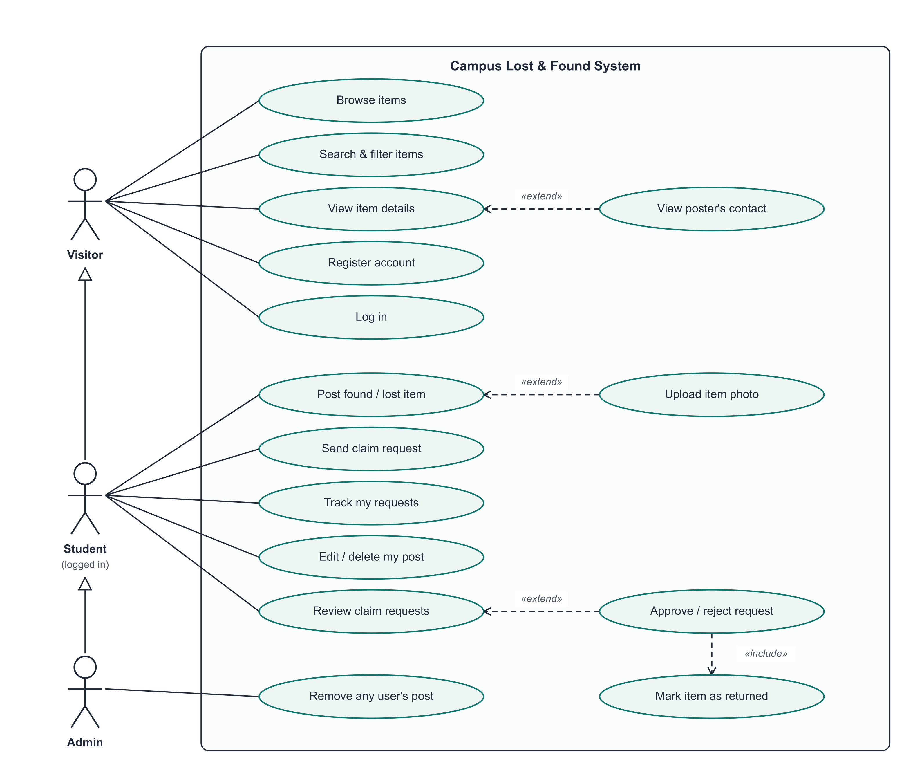
Figure 1 - Use Case Diagram

3. Class Diagram
Purpose. Shows the domain model: the three persistent classes, their attributes and operations, and how they relate.

How to read it
- User posts 0..* Items; an Item may be returned to 0..1 User (resolvedWith).
- A User makes 0..* Claims; each Claim belongs to exactly one Item and one claimant.
- The filled diamond between Item and Claim is composition: deleting an Item deletes all its Claims.
- Enumerations restrict values: ItemType (found/lost), ItemStatus (open/resolved), ClaimStatus (pending/approved/rejected), Role and the 10 Categories.
- The note records a business rule enforced by a unique database index: one claim per student per item.
Where it appears in the code. Implemented as Mongoose schemas in server/src/models/User.js, Item.js and Claim.js.
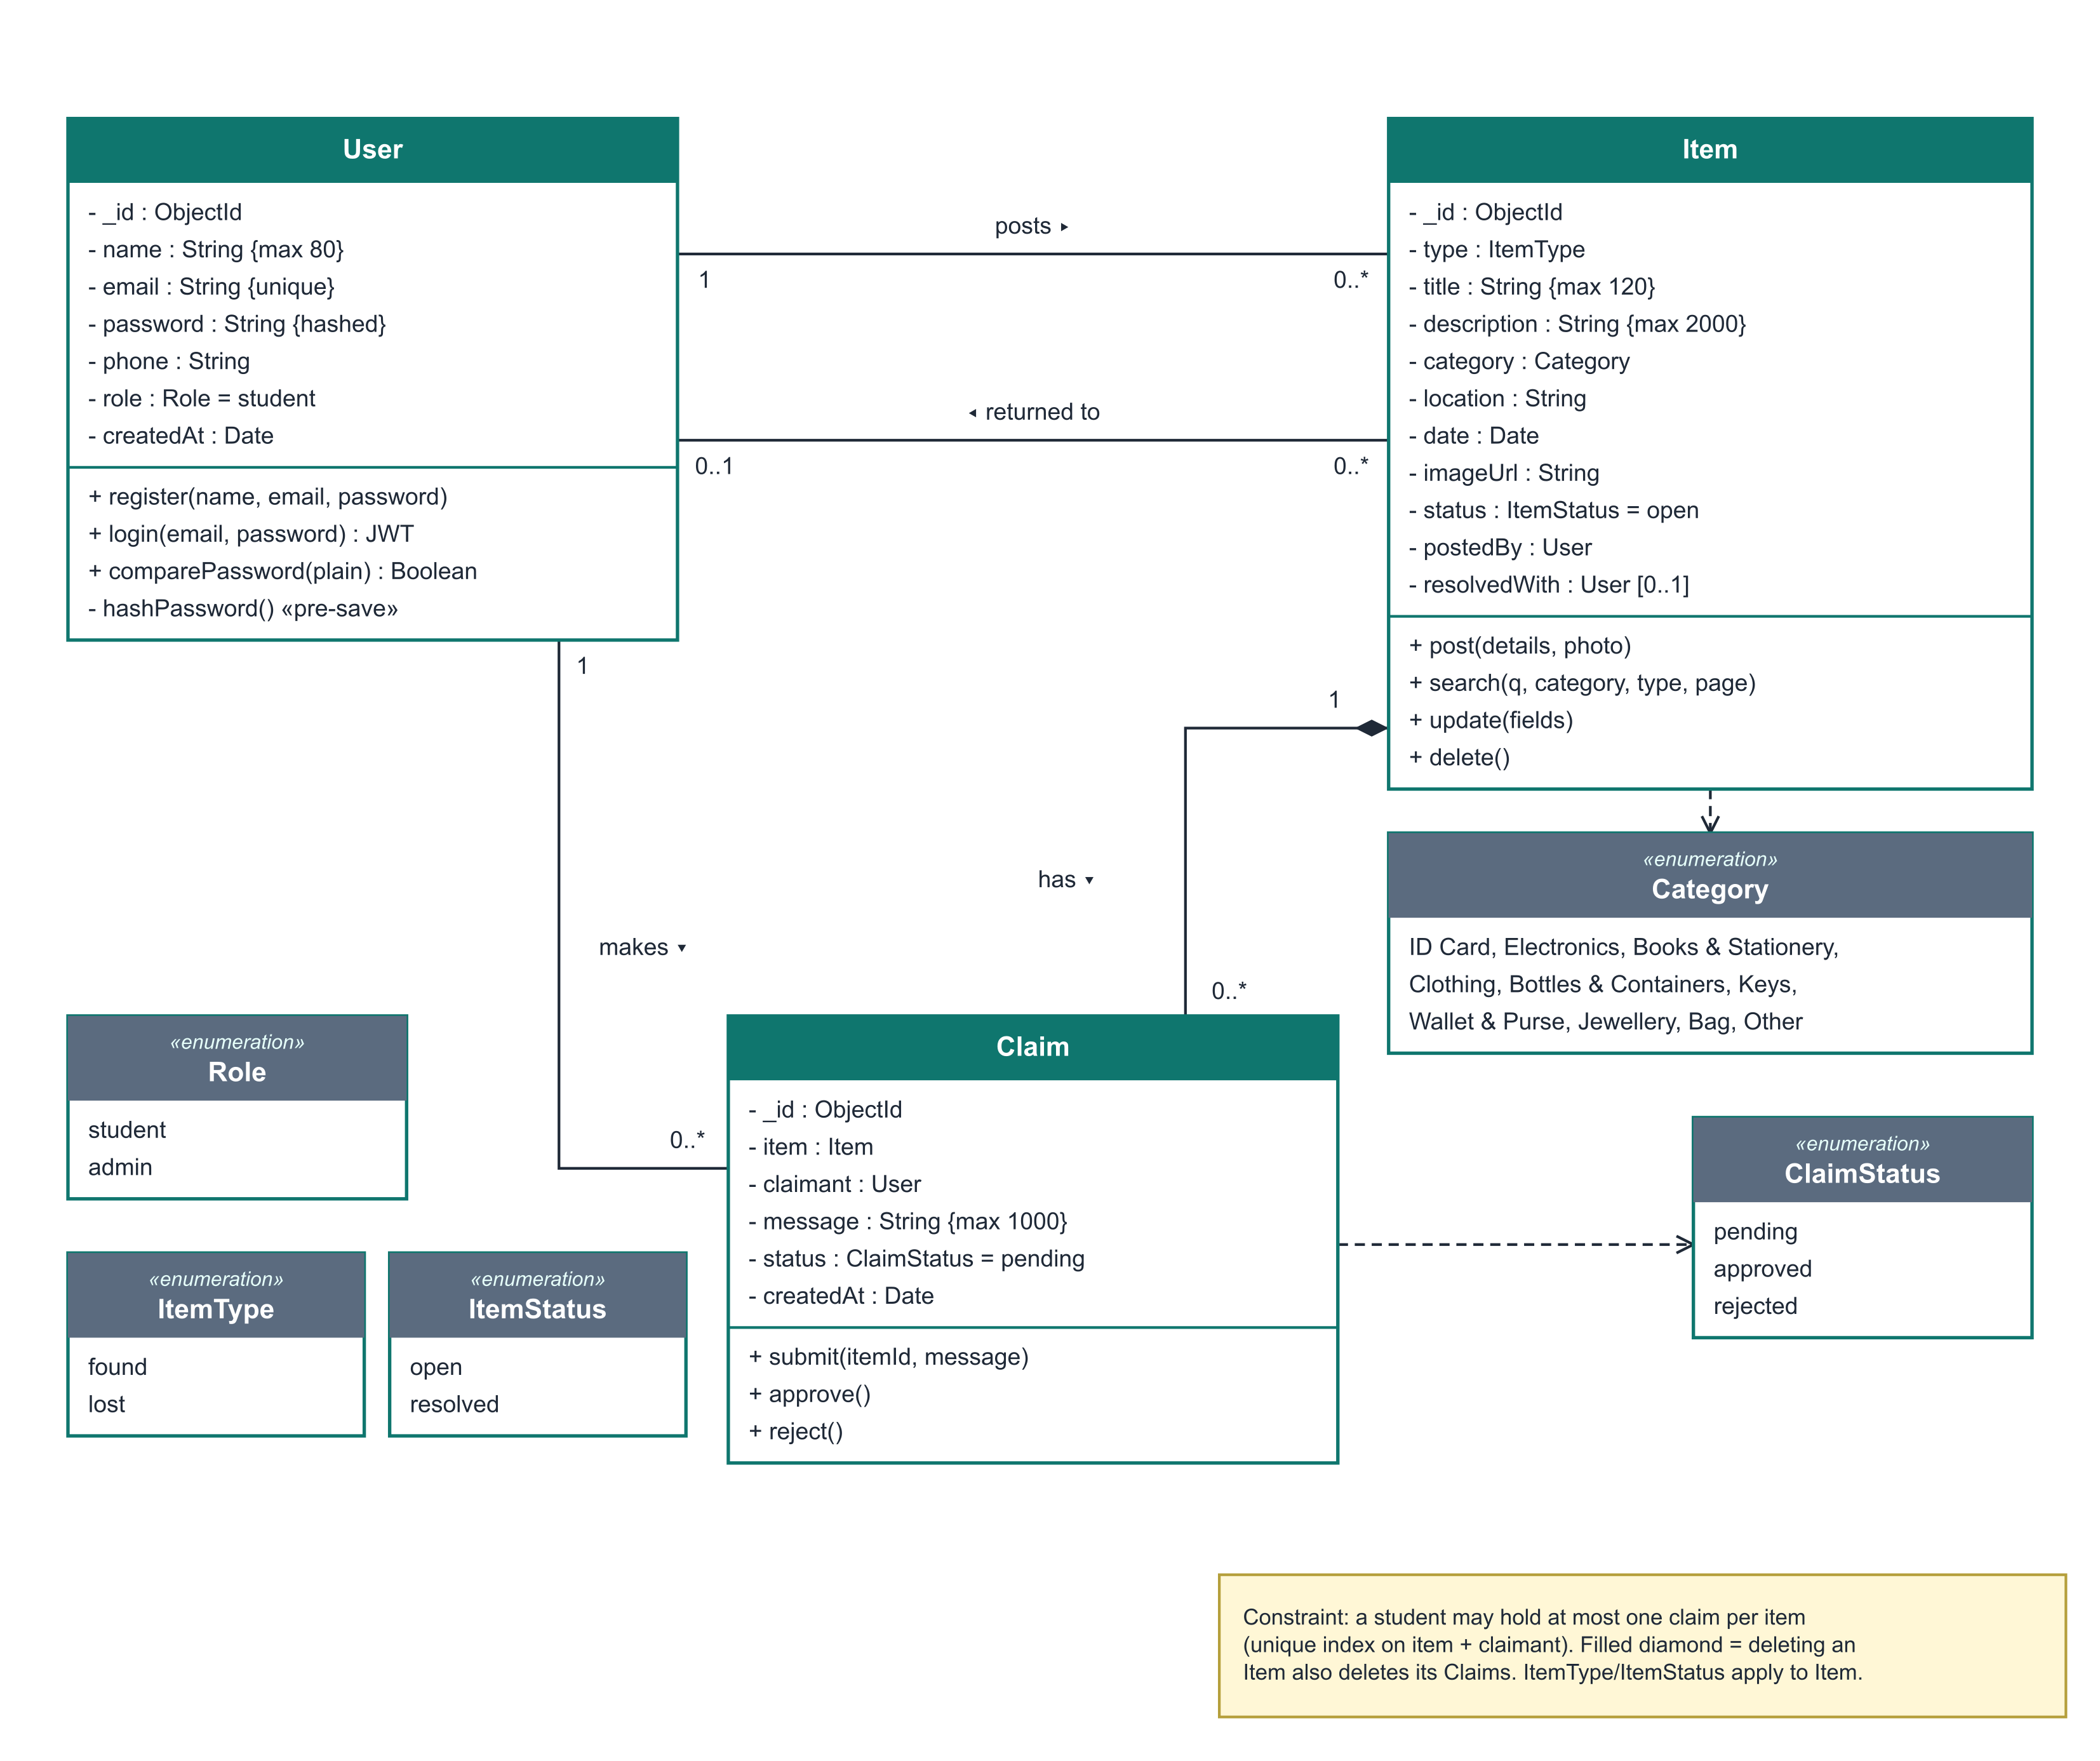
Figure 2 - Class Diagram

4. Sequence Diagram
Purpose. Shows, in time order, how the objects interact for the most important scenario: claiming an item and approving the claim.

How to read it
- Part A: the claimant's browser sends POST /api/claims with the login token; the API verifies the token, loads the item and runs the business checks.
- The alt fragment shows the alternatives: own post or returned item gives 400, an earlier request gives 409, otherwise the claim is saved as pending.
- Part B: the poster loads received requests, then approves one with PATCH /api/claims/:id.
- On approval the API performs three database updates: claim approved, item resolved, other pending claims rejected.
- Solid arrows are requests; dashed arrows are replies. Tall rectangles show when each object is active.
Where it appears in the code. See server/src/routes/claims.js and client/src/pages/ItemDetail.jsx / Requests.jsx.
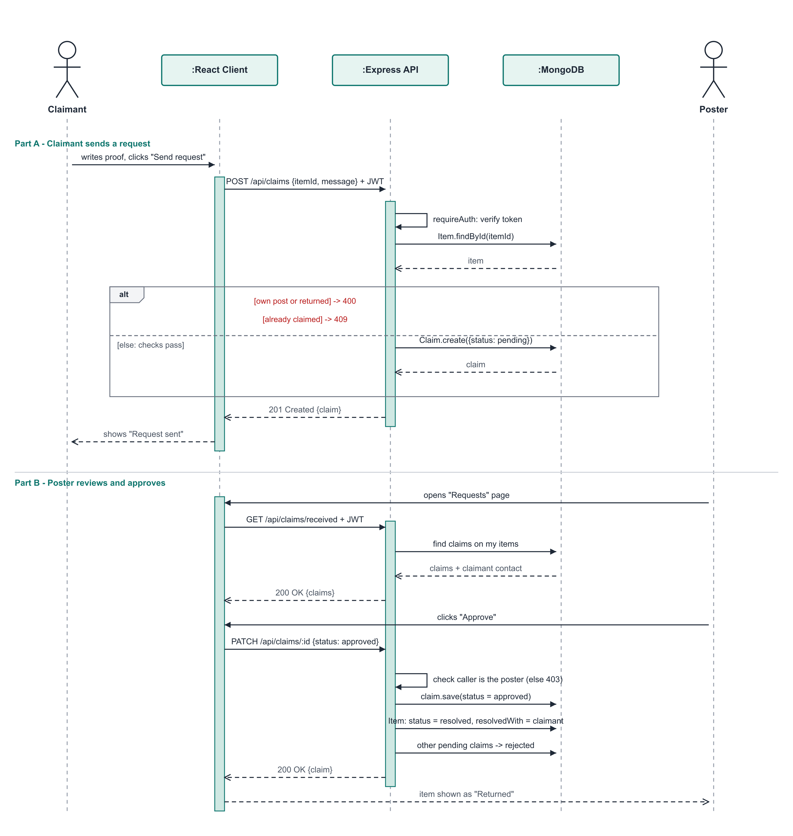
Figure 3 - Sequence Diagram

5. Activity Diagram
Purpose. Shows the end-to-end business workflow, from an item being found to it being returned, split into swimlanes for each participant.

How to read it
- Swimlanes: Finder (poster), System and Owner (claimant) - each action sits in the lane of whoever performs it.
- Diamonds are decisions with guard conditions in square brackets, e.g. [valid] / [invalid] form data.
- The Owner's flow joins the Finder's when they find the listing and send a claim with proof.
- The Finder's decision [proof matches] leads to approval and the item being returned; [does not match] leads to rejection.
- Filled circle = start; ringed circle = end. There are three possible end states.
Where it appears in the code. Matches the validations in routes/items.js and the claim workflow in routes/claims.js.
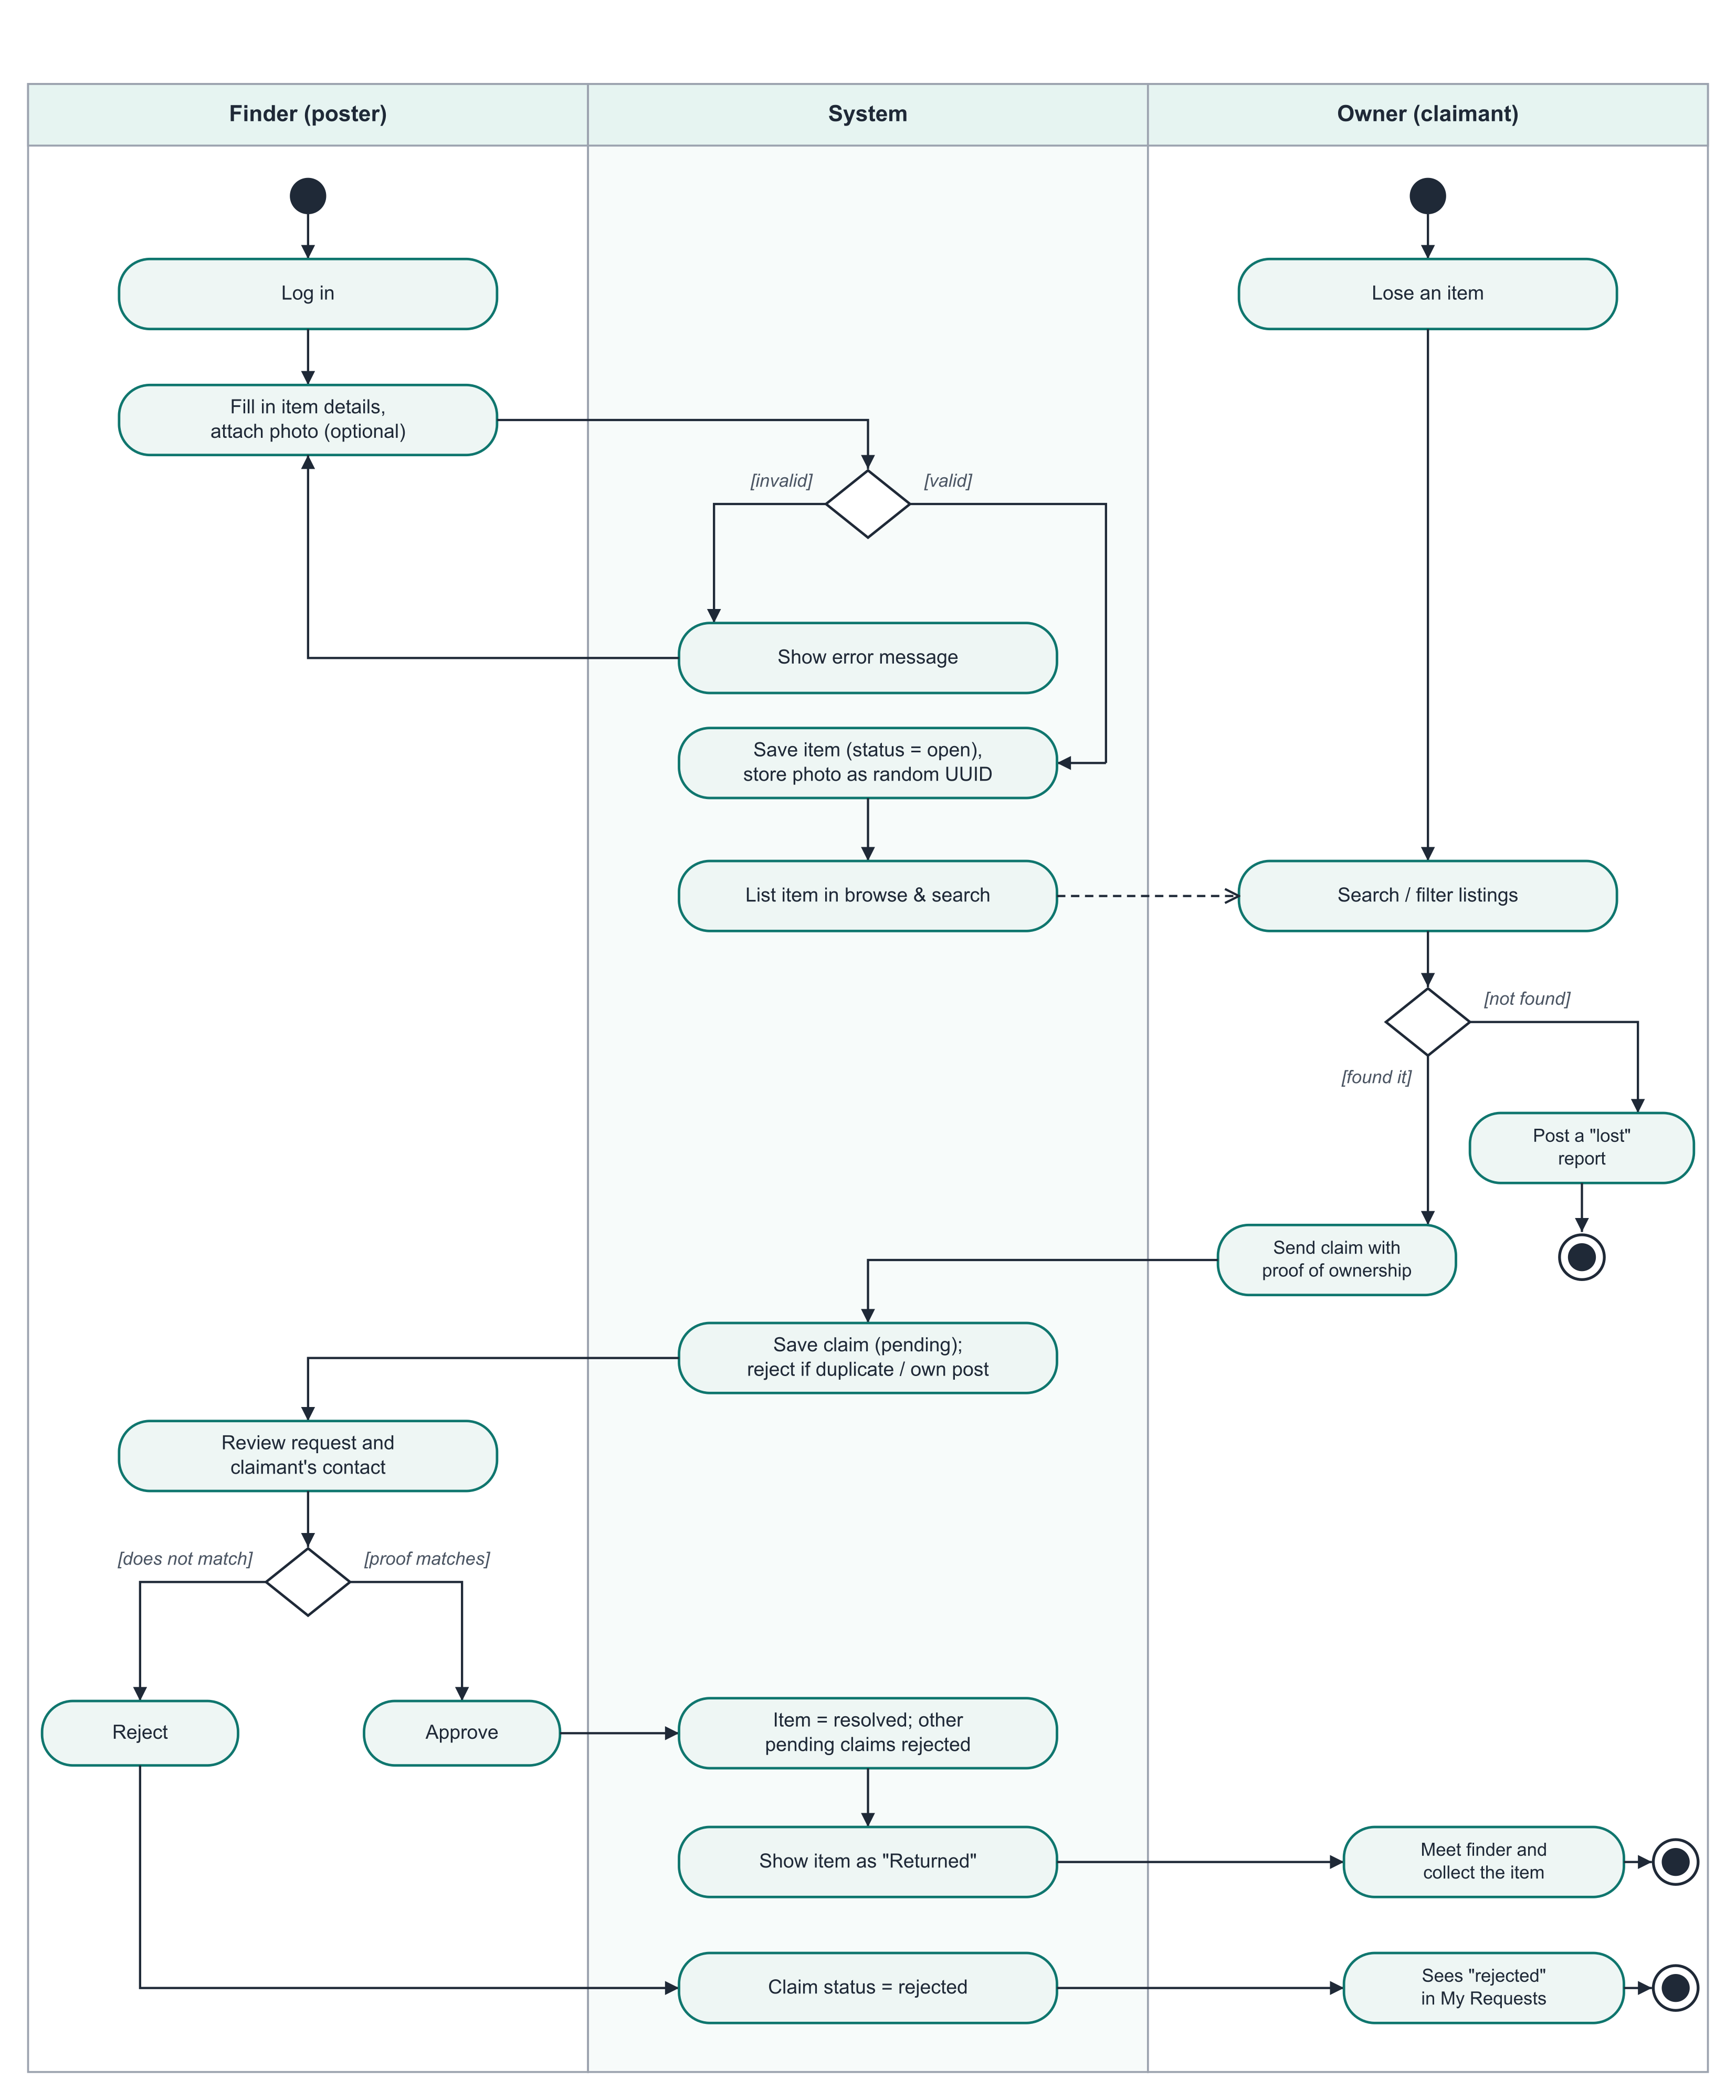
Figure 4 - Activity Diagram

6. Deployment Diagram
Purpose. Shows the physical architecture: which software runs on which machine and how they communicate.

How to read it
- The student's browser runs the React single-page app.
- The application server runs Node.js with two processes: the Vite dev server (port 5173) that serves the React bundle and proxies /api calls, and the Express REST API (port 5000).
- Express stores photos in the uploads/ folder and talks to MongoDB (port 27017) through the Mongoose driver.
- For the demonstration all three nodes are the same laptop; in production they could be separate servers.
Where it appears in the code. Ports and proxy are set in client/vite.config.js and server/.env.
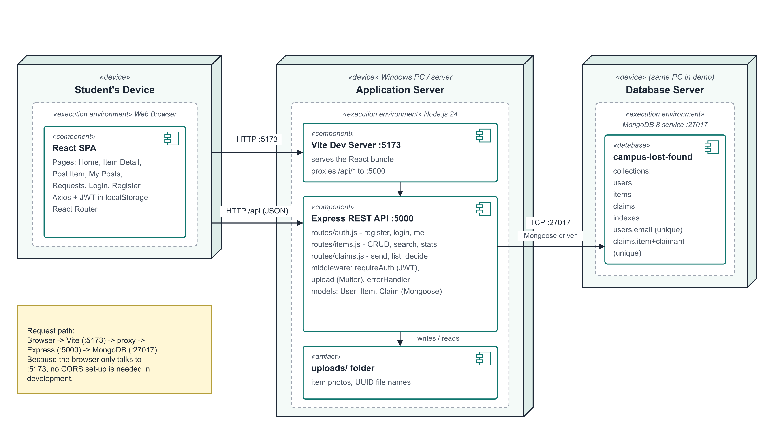
Figure 5 - Deployment Diagram

7. Database and API Design

7.1 Collections

User
Field | Type | Rules
name | String | Required, max 80 characters
email | String | Required, unique, lower-case, valid format
password | String | Required, min 6, bcrypt hash, hidden from queries
phone | String | Optional, max 20
role | Enum | student (default) | admin
createdAt / updatedAt | Date | Set automatically

Item
Field | Type | Rules
type | Enum | found | lost (required)
title | String | Required, max 120
description | String | Required, max 2000
category | Enum | One of 10 fixed categories
location | String | Required, max 160
date | Date | Required - when it was lost / found
imageUrl | String | Optional, /uploads/<uuid>.<ext>
status | Enum | open (default) | resolved
postedBy | ObjectId -> User | Required
resolvedWith | ObjectId -> User | Set when a claim is approved

Claim
Field | Type | Rules
item | ObjectId -> Item | Required
claimant | ObjectId -> User | Required; unique together with item
message | String | Required, max 1000 - proof of ownership
status | Enum | pending (default) | approved | rejected

7.2 REST API
Method | Endpoint | Who | Purpose
POST | /api/auth/register | Anyone | Create an account
POST | /api/auth/login | Anyone | Log in, returns a token
GET | /api/auth/me | Logged in | Current user details
GET | /api/items | Anyone | List / search (q, category, type, status, page, limit)
GET | /api/items/:id | Anyone | One item (contact hidden if logged out)
GET | /api/items/mine | Logged in | Items I posted
GET | /api/items/stats | Anyone | Counts for the home page
GET | /api/items/categories | Anyone | Category list
POST | /api/items | Logged in | Post an item (multipart, photo optional)
PATCH | /api/items/:id | Owner / admin | Edit or change status
DELETE | /api/items/:id | Owner / admin | Delete post, its photo and claims
POST | /api/claims | Logged in | Send a claim request
GET | /api/claims/sent | Logged in | Requests I sent
GET | /api/claims/received | Logged in | Requests on my posts
PATCH | /api/claims/:id | Item poster | Approve or reject

7.3 Design decisions
- JWT instead of server sessions - the API stays stateless; the token is sent in the Authorization header on every request.
- Vite proxy - the browser only talks to one origin (port 5173), avoiding CORS issues during development.
- Unique index on (item, claimant) - the database itself guarantees one claim per student per item, even if two requests arrive at once.
- Photos on disk, path in the database - keeps documents small; files get random UUID names.
- Optional authentication on item details - the same endpoint serves visitors and students, hiding contact data for visitors.

