BCSE301L - SOFTWARE ENGINEERING
Fall Semester 2026-27 | Digital Assignment
Campus Lost & Found
A web platform to report, search for and safely claim items lost on campus
Development Report
Implementation of the front end and back end, with demonstration screenshots
Prepared by: Student 3 - Development
Team members
# | Name | Reg. No. | Responsibility
Student 1 | [Student 1 name] | [Reg. No.] | Requirement Gathering & Analysis
Student 2 | [Student 2 name] | [Reg. No.] | System Design (UML)
Student 3 | [Student 3 name] | [Reg. No.] | Development
Student 4 | [Student 4 name] | [Reg. No.] | Testing
Student 5 | [Student 5 name] | [Reg. No.] | Documentation (SRS)

Submitted to: [Faculty name] Date: [Submission date]
Contents
1. Introduction 4
1.1 What was built 4
2. Development Approach 5
2.1 Tools and environment 5
2.2 Coding conventions 5
3. Technology Stack 6
4. System Architecture 7
4.1 Life of a request 7
4.2 Project structure 7
4.3 Module responsibilities 8
5. Back-End Implementation 9
5.1 Application setup 9
5.2 Data models 9
5.3 Authentication 10
5.4 Search and filters 10
5.5 Contact privacy 10
5.6 Photo upload 11
5.7 Claim approval workflow 11
5.8 Central error handling 12
6. Front-End Implementation 13
6.1 Pages and routes 13
6.2 Talking to the API 13
6.3 Login state and protected pages 13
6.4 User-interface design 14
7. Implemented Functionalities 15
8. Validation, Error Handling and Security 16
8.1 Validation on both sides 16
8.2 Security measures 16
9. Demonstration 17
9.1 Browsing and searching (visitor) 17
9.2 Accounts and validation 19
9.3 Posting an item 20
9.4 Claiming an item 21
9.5 Reviewing and approving 22
9.6 My posts and mobile layout 24
10. Running the Project 26
10.1 Requirements 26
10.2 Steps 26
10.3 Demo accounts 26
11. Challenges and Solutions 27
12. Conclusion 28
Possible improvements 28

1. Introduction
This report describes how Campus Lost & Found was implemented: the technologies chosen, the structure of the code, how each feature works, how input is validated and secured, and how to run the system. Section 9 demonstrates every implemented feature with screenshots of the running application.

1.1 What was built
Measure | Value
Application type | Full-stack web application (single-page front end + REST API + database)
Back end | 15 REST endpoints in 3 route modules, 3 middleware modules, 3 data models
Front end | 7 pages, 3 shared components, 1 shared login-state context
Source code | About 700 lines (server) + 1,770 lines (client, including styles), plus 440 lines of automated tests
Functional requirements implemented | All 16 (FR-01 to FR-16) - see Section 7

2. Development Approach
The system was built incrementally: each increment added one complete, working slice of functionality (database, API and screen together) that could be demonstrated and tested before moving on.
Increment | Delivered | Requirements
1. Foundation | Project setup, MongoDB connection, User / Item / Claim models, seed data | -
2. Accounts | Register, log in, JWT sessions, protected pages, navigation bar | FR-01, FR-02
3. Items | Post an item with photo upload, item detail page, My posts, delete | FR-06, FR-08 - FR-11
4. Search | Browse with pagination, keyword search, filters, home statistics | FR-03 - FR-05, FR-16
5. Claims | Send claim, received / sent lists, approve / reject, automatic "returned" | FR-12 - FR-15
6. Privacy & polish | Contact hiding for visitors, error banners, responsive layout | FR-07, NFRs
7. Hardening | Fixes for the 4 defects found in testing; app split out for automated tests | D-01 - D-04

2.1 Tools and environment
Tool | Use
Visual Studio Code | Code editor
Node.js 24 + npm | Runs the server and the build tools; installs libraries
MongoDB 8 Community Server | Local database, running as a Windows service
Vite 8 | Front-end dev server with instant reload and the /api proxy
Git | Version control
Google Chrome / Microsoft Edge | Running and debugging the website

2.2 Coding conventions
- Modern JavaScript (ES modules, async / await) on both server and client.
- One responsibility per file: models describe data, routes handle requests, middleware handles cross-cutting concerns (login check, uploads, errors).
- Every route passes unexpected errors to one central error handler, so all errors have the same JSON shape: { "message": "..." }.
- Secrets (database URL, JWT secret) are read from a .env file that is not committed to Git; .env.example documents the keys.

3. Technology Stack
The project uses the MERN stack. All parts are free, open source and widely documented, and the same language (JavaScript) is used on both the server and the client.
Layer | Technology | Version | Why it was chosen
Database | MongoDB + Mongoose | 8 / 8.20 | Flexible documents fit items with optional photos; Mongoose adds schemas and validation
Server | Node.js + Express | 24 / 5.1 | Simple, fast way to build a REST API in JavaScript
Front end | React | 19.2 | Component-based UI; pages re-render automatically when data changes
Routing | React Router | 7.18 | Multiple pages inside one single-page app
HTTP client | Axios | 1.20 | Calls the API; one place to attach the login token
Passwords | bcryptjs | 3.0 | Industry-standard password hashing
Sessions | jsonwebtoken | 9.0 | Signed login tokens (JWT), no server-side session store needed
Uploads | multer | 2.0 | Receives photo files from multipart forms
Build / dev | Vite | 8.2 | Fast dev server; proxies /api to the Express server
Testing | node:test (built in) | Node 24 | No extra test library needed

4. System Architecture
The application has three tiers. The browser runs the React app; the React app calls the Express REST API; the API reads and writes MongoDB and stores photos on disk.
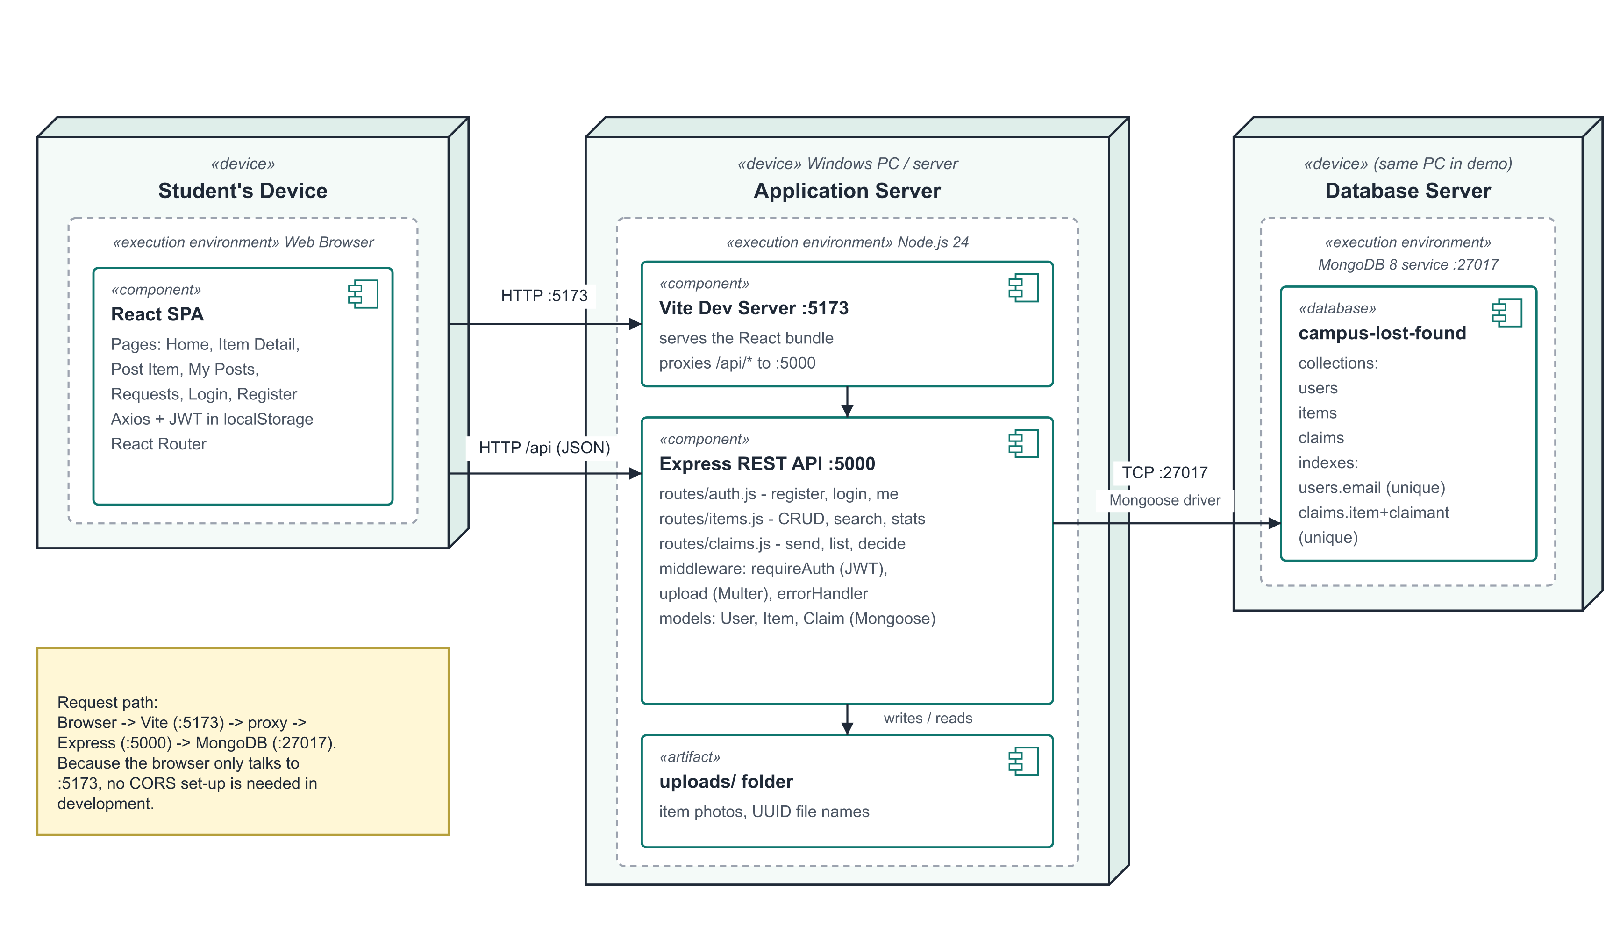
Figure 1 - Deployment architecture

4.1 Life of a request
For example, when a logged-in student opens an item:
- React (ItemDetail page) calls api.get("/items/<id>"). The Axios interceptor adds the header Authorization: Bearer <token>.
- The browser sends the request to Vite on port 5173, which forwards every /api request to Express on port 5000.
- Express matches the route GET /api/items/:id. The optionalAuth middleware verifies the token and attaches the user.
- The route loads the item with Mongoose, includes the poster's contact details because a user is logged in, and returns JSON.
- React stores the JSON in state and re-renders the page.

4.2 Project structure
Folder layout
SE PROJECT/
|-- server/ Back end (Express REST API)
| |-- .env PORT, MONGODB_URI, JWT_SECRET (not committed)
| |-- uploads/ Item photos (random UUID file names)
| |-- tests/api.test.js 45 automated system tests (npm test)
| `-- src/
| |-- index.js Connects to MongoDB, starts the server
| |-- app.js Express app: middleware + routes
| |-- config/db.js MongoDB connection
| |-- models/ User.js, Item.js, Claim.js
| |-- middleware/ auth.js, upload.js, errorHandler.js
| |-- routes/ auth.js, items.js, claims.js
| `-- seed.js Sample users and items for the demo
`-- client/ Front end (React + Vite)
|-- vite.config.js Dev server + /api proxy
`-- src/
|-- main.jsx Entry point
|-- App.jsx Page routes
|-- api.js Axios instance + token interceptor
|-- context/ AuthContext.jsx (logged-in user)
|-- components/ Navbar, ItemCard, ProtectedRoute
`-- pages/ Home, ItemDetail, ReportItem, Login,
Register, MyPosts, Requests

4.3 Module responsibilities
Module | Responsibility
server/src/app.js | Creates the Express app: CORS, JSON body parsing, static /uploads, the three routers, 404 and error handlers
server/src/models/* | Schemas with field rules (required, max length, enums, unique email, unique claim per item)
middleware/auth.js | requireAuth (must be logged in) and optionalAuth (identify the user if a token is present)
middleware/upload.js | Accepts one image up to 5 MB, saves it under a random UUID name
middleware/errorHandler.js | Turns any error into a clear JSON message with the right HTTP status
routes/auth.js | Register, log in, current user
routes/items.js | List / search / filter, stats, categories, my posts, detail, create, update, delete
routes/claims.js | Send a claim, list sent / received, approve or reject
client/src/api.js | Single Axios instance; attaches the token; extracts error messages
context/AuthContext.jsx | Holds the logged-in user for every page; login, register, logout
components/ProtectedRoute.jsx | Redirects to Log in when a page needs a logged-in user

5. Back-End Implementation

5.1 Application setup
The Express app is defined in app.js and started by index.js. Keeping them separate lets the automated tests start the same app against a test database.
server/src/app.js
const app = express();

app.use(cors({ origin: process.env.CLIENT_ORIGIN || 'http://localhost:5173' }));
app.use(express.json());
app.use('/uploads', express.static(path.resolve('uploads')));

app.get('/api/health', (req, res) => res.json({ status: 'ok' }));
app.use('/api/auth', authRoutes);
app.use('/api/items', itemRoutes);
app.use('/api/claims', claimRoutes);

app.use(notFound);
app.use(errorHandler);

5.2 Data models
Each collection is described by a Mongoose schema. The rules in the schema are enforced on every save, so invalid data can never reach the database even if a route forgets a check. The Claim schema shows two important rules: the allowed status values, and a unique compound index that guarantees one claim per student per item.
server/src/models/Claim.js
const claimSchema = new mongoose.Schema(
{
item: { type: mongoose.Schema.Types.ObjectId, ref: 'Item', required: true },
claimant: { type: mongoose.Schema.Types.ObjectId, ref: 'User', required: true },
message: { type: String, required: true, trim: true, maxlength: 1000 },
status: { type: String, enum: ['pending', 'approved', 'rejected'], default: 'pending' },
},
{ timestamps: true }
);

claimSchema.index({ item: 1, claimant: 1 }, { unique: true });

Passwords are hashed automatically before a user is saved, using a Mongoose "pre-save" hook:
server/src/models/User.js
userSchema.pre('save', async function hashPassword(next) {
if (!this.isModified('password')) return next();
this.password = await bcrypt.hash(this.password, 10);
next();
});

userSchema.methods.comparePassword = function comparePassword(plain) {
return bcrypt.compare(plain, this.password);
};

5.3 Authentication
On successful login the server signs a JSON Web Token containing the user id. The client sends it back on every request. requireAuth verifies the signature and expiry and loads the user; any problem gives a 401 with a readable message.
server/src/middleware/auth.js
export async function requireAuth(req, res, next) {
const token = readToken(req);

if (!token) {
return res.status(401).json({ message: 'You must be logged in to do that.' });
}

try {
const payload = jwt.verify(token, process.env.JWT_SECRET);
const user = await User.findById(payload.sub);
if (!user) {
return res.status(401).json({ message: 'Account no longer exists.' });
}
req.user = user;
next();
} catch {
return res.status(401).json({ message: 'Session expired. Please log in again.' });
}
}

5.4 Search and filters
GET /api/items builds a MongoDB filter from the query string. The search text is escaped first so characters such as ( or * are treated as plain text instead of breaking the regular expression (this blocks "regex injection").
server/src/routes/items.js - search
function escapeRegex(text) {
return text.replace(/[.*+?^${}()|[\]\\]/g, '\\$&');
}

const filter = {};
if (category) filter.category = category;
if (type) filter.type = type;
if (status !== 'all') filter.status = status;

if (q && q.trim()) {
const term = new RegExp(escapeRegex(q.trim()), 'i');
filter.$or = [{ title: term }, { description: term }, { location: term }];

5.5 Contact privacy
The item detail route uses optionalAuth. If nobody is logged in, the poster's email and phone are deleted from the response before it is sent:
server/src/routes/items.js - item detail
const payload = item.toObject();
if (!req.user) {
delete payload.postedBy.email;
delete payload.postedBy.phone;
}

res.json({ item: payload });

5.6 Photo upload
multer accepts one file per post. Only image extensions with an image MIME type are allowed, the size limit is 5 MB, and the original file name is thrown away and replaced by a random UUID so a crafted name such as ../../server.js cannot overwrite anything.
server/src/middleware/upload.js
const ALLOWED = new Set(['.jpg', '.jpeg', '.png', '.webp', '.gif']);

const storage = multer.diskStorage({
destination: (req, file, cb) => cb(null, uploadDir),
filename: (req, file, cb) => {
const ext = path.extname(file.originalname).toLowerCase();
cb(null, `${crypto.randomUUID()}${ext}`);
},
});

export const uploadImage = multer({
storage,
limits: { fileSize: 5 * 1024 * 1024 },
fileFilter: (req, file, cb) => {
const ext = path.extname(file.originalname).toLowerCase();
if (!ALLOWED.has(ext) || !file.mimetype.startsWith('image/')) {
const err = new Error('Only image files (jpg, png, webp, gif) are allowed.');
err.status = 400;
return cb(err);
}
cb(null, true);
},
}).single('image');

5.7 Claim approval workflow
This is the core business logic. Only the poster may decide; once an item is returned no further decisions are allowed; approving marks the item returned to the claimant and automatically rejects every other pending claim on it.
server/src/routes/claims.js - PATCH /api/claims/:id
const claim = await Claim.findById(req.params.id).populate('item');
if (!claim) return res.status(404).json({ message: 'Request not found.' });

if (!claim.item.postedBy.equals(req.user._id)) {
return res.status(403).json({ message: 'Only the person who posted the item can do that.' });
}
if (claim.item.status === 'resolved') {
return res.status(400).json({ message: 'This item has already been returned.' });
}

claim.status = status;
await claim.save();

if (status === 'approved') {
await Item.findByIdAndUpdate(claim.item._id, {
status: 'resolved',
resolvedWith: claim.claimant,
});
await Claim.updateMany(
{ item: claim.item._id, _id: { $ne: claim._id }, status: 'pending' },
{ status: 'rejected' }
);
}

res.json({ claim });

5.8 Central error handling
Every route passes unexpected errors to one handler that converts known error types into friendly messages and correct status codes:
Error | Status | Message shown to the user
File too large (multer) | 400 | Image must be smaller than 5 MB.
Wrong file type | 400 | Only image files (jpg, png, webp, gif) are allowed.
Mongoose validation (e.g. bad category) | 400 | The first validation message
Malformed id (CastError) | 400 | Invalid id.
Duplicate key (code 11000) | 409 | That record already exists.
Unknown route | 404 | Route not found: <method> <url>
Anything else | 500 | Something went wrong.

6. Front-End Implementation

6.1 Pages and routes
Route | Page | Login needed | API calls
/ | Home | No | GET /items, /items/stats, /items/categories
/items/:id | ItemDetail | No (more if logged in) | GET /items/:id; POST /claims; PATCH, DELETE /items/:id
/report | ReportItem | Yes | POST /items (multipart form with photo)
/my-posts | MyPosts | Yes | GET /items/mine
/requests | Requests | Yes | GET /claims/received, /claims/sent; PATCH /claims/:id
/login | Login | No | POST /auth/login
/register | Register | No | POST /auth/register

6.2 Talking to the API
All requests go through one Axios instance. An interceptor adds the saved token to every request, and apiError() turns any failure into the server's message, which pages show in a red banner.
client/src/api.js
const api = axios.create({ baseURL: '/api' });

api.interceptors.request.use((config) => {
const token = localStorage.getItem('token');
if (token) config.headers.Authorization = `Bearer ${token}`;
return config;
});

export function apiError(err) {
return err?.response?.data?.message || 'Something went wrong. Please try again.';
}

export default api;

6.3 Login state and protected pages
AuthContext keeps the current user in one place for the whole app. On start-up it asks GET /auth/me whether the saved token is still valid. ProtectedRoute wraps the pages that need a login and sends visitors to the Log in page, remembering where they wanted to go.
client/src/components/ProtectedRoute.jsx
export default function ProtectedRoute({ children }) {
const { user, loading } = useAuth();
const location = useLocation();

if (loading) return <p className="empty">Loading...</p>;
if (!user) return <Navigate to="/login" state={{ from: location.pathname }} replace />;
return children;
}

6.4 User-interface design
- Card grid for items with a photo (or "No photo" placeholder), Found / Lost tag and a Returned tag when resolved.
- Search updates as you type (with a 350 ms pause so the server is not called on every key press).
- The item page adapts to who is viewing: visitors see a prompt to log in, other students see the claim form, the poster sees Mark as returned / View requests / Delete post.
- Errors appear in a red banner and successes in a green banner, always with plain-language text.
- Responsive CSS: on phones the cards stack in one column and the navigation wraps (Fig. 16).

7. Implemented Functionalities
Every functional requirement from the Requirements Analysis is implemented. The table shows where each one lives in the code and which screenshot in Section 9 demonstrates it.
Req. | Feature | API endpoint | Front end | Shown in
FR-01 | Register | POST /auth/register | Register.jsx | Fig. 6
FR-02 | Log in / out | POST /auth/login, GET /auth/me | Login.jsx, AuthContext | Fig. 5
FR-03 | Browse | GET /items | Home.jsx, ItemCard | Fig. 2
FR-04 | Keyword search | GET /items?q= | Home.jsx | Fig. 3
FR-05 | Filters | GET /items?category&type&status | Home.jsx | Fig. 2
FR-06 | Item details | GET /items/:id | ItemDetail.jsx | Fig. 4
FR-07 | Contact privacy | GET /items/:id (optionalAuth) | ItemDetail.jsx | Fig. 4, Fig. 9
FR-08 | Post an item | POST /items | ReportItem.jsx | Fig. 7, Fig. 8
FR-09 | Photo upload | POST /items (multer) | ReportItem.jsx | Fig. 7
FR-10 | Update / delete post | PATCH, DELETE /items/:id | ItemDetail.jsx | Fig. 8
FR-11 | My posts | GET /items/mine | MyPosts.jsx | Fig. 15
FR-12 | Send claim | POST /claims | ItemDetail.jsx | Fig. 9, Fig. 10
FR-13 | View requests | GET /claims/received, /sent | Requests.jsx | Fig. 11, Fig. 13
FR-14 | Approve / reject | PATCH /claims/:id | Requests.jsx | Fig. 11, Fig. 12
FR-15 | Mark returned | PATCH /claims/:id (approve) | ItemDetail.jsx, ItemCard | Fig. 14, Fig. 15
FR-16 | Home statistics | GET /items/stats | Home.jsx | Fig. 2

8. Validation, Error Handling and Security

8.1 Validation on both sides
Input is checked twice: in the browser for instant feedback, and on the server because browser checks can be bypassed (Defect D-01 in the Testing Report was exactly such a case).
Rule | In the browser | On the server
Required fields | required attribute on inputs | Route checks + Mongoose required
Email format | type="email" input | Pattern check in routes/auth.js + schema match
Password at least 6 characters | minLength={6} | Route check + schema minlength
Text length limits | maxLength on inputs | Schema maxlength
Category from the fixed list | Drop-down list only | Schema enum
Photo type and size | accept="image/*" | multer file filter + 5 MB limit
Inputs must be text | - | typeof checks on login / register
Email not already used | - | Lookup, 409 Conflict
Only the owner can change a post | Buttons shown only to the owner | 403 Forbidden
Claim rules (not own, once, not returned) | Claim form hidden when not allowed | 400 / 409 with a reason

8.2 Security measures
Threat | Measure in the code
Stolen database exposes passwords | bcrypt hashing (cost 10); password field excluded from queries (select: false)
Someone edits another student's post | Ownership check on PATCH / DELETE / claim decisions
Strangers harvest phone numbers | Contact removed from responses for visitors
Guessing which emails are registered | Same "Incorrect email or password." message for both cases
NoSQL injection ({"$gt": ""} as email) | Non-string inputs rejected with 400
Regex injection in search | escapeRegex() before building the pattern
Malicious upload / path traversal | Image-only filter, 5 MB limit, random UUID file names
Leaked secrets in Git | .env in .gitignore; .env.example has placeholders only

9. Demonstration
The screenshots below were taken from the running application (React on port 5173, API on port 5000) using the seeded demo data. They follow one complete scenario: a visitor browses, Aarav posts a found backpack with a photo, Priya claims it with proof of ownership, Aarav approves, and the item is shown as returned. The item photos are sample images.

9.1 Browsing and searching (visitor)
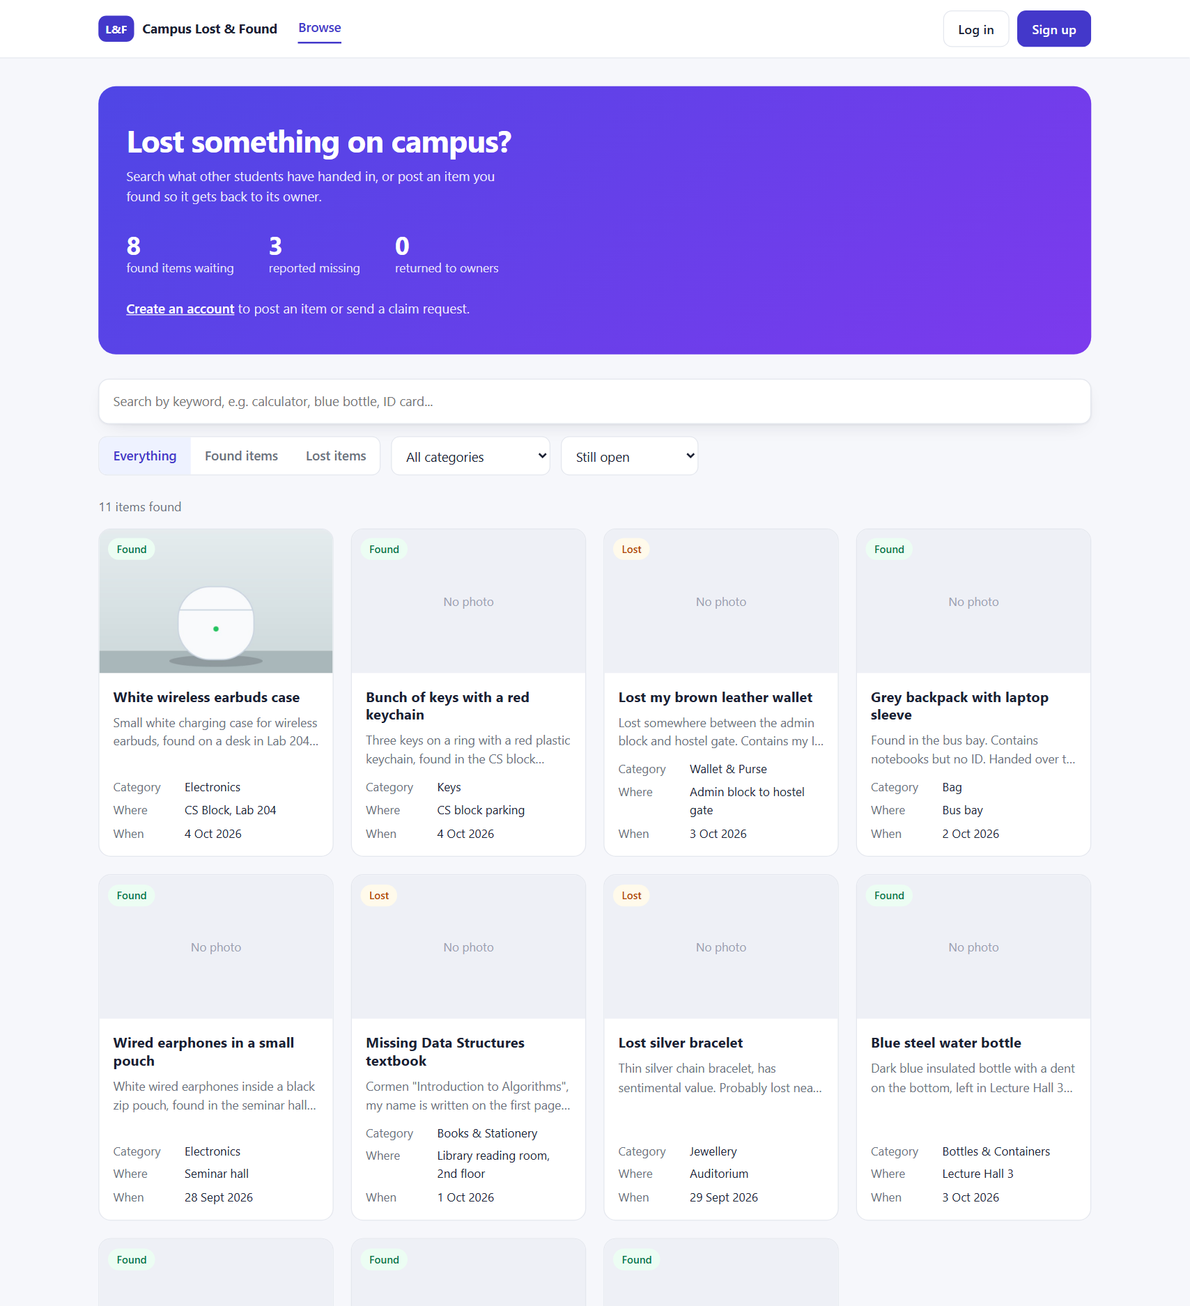
Figure 2 - Home page (logged out): statistics, search box, filters and the newest open items
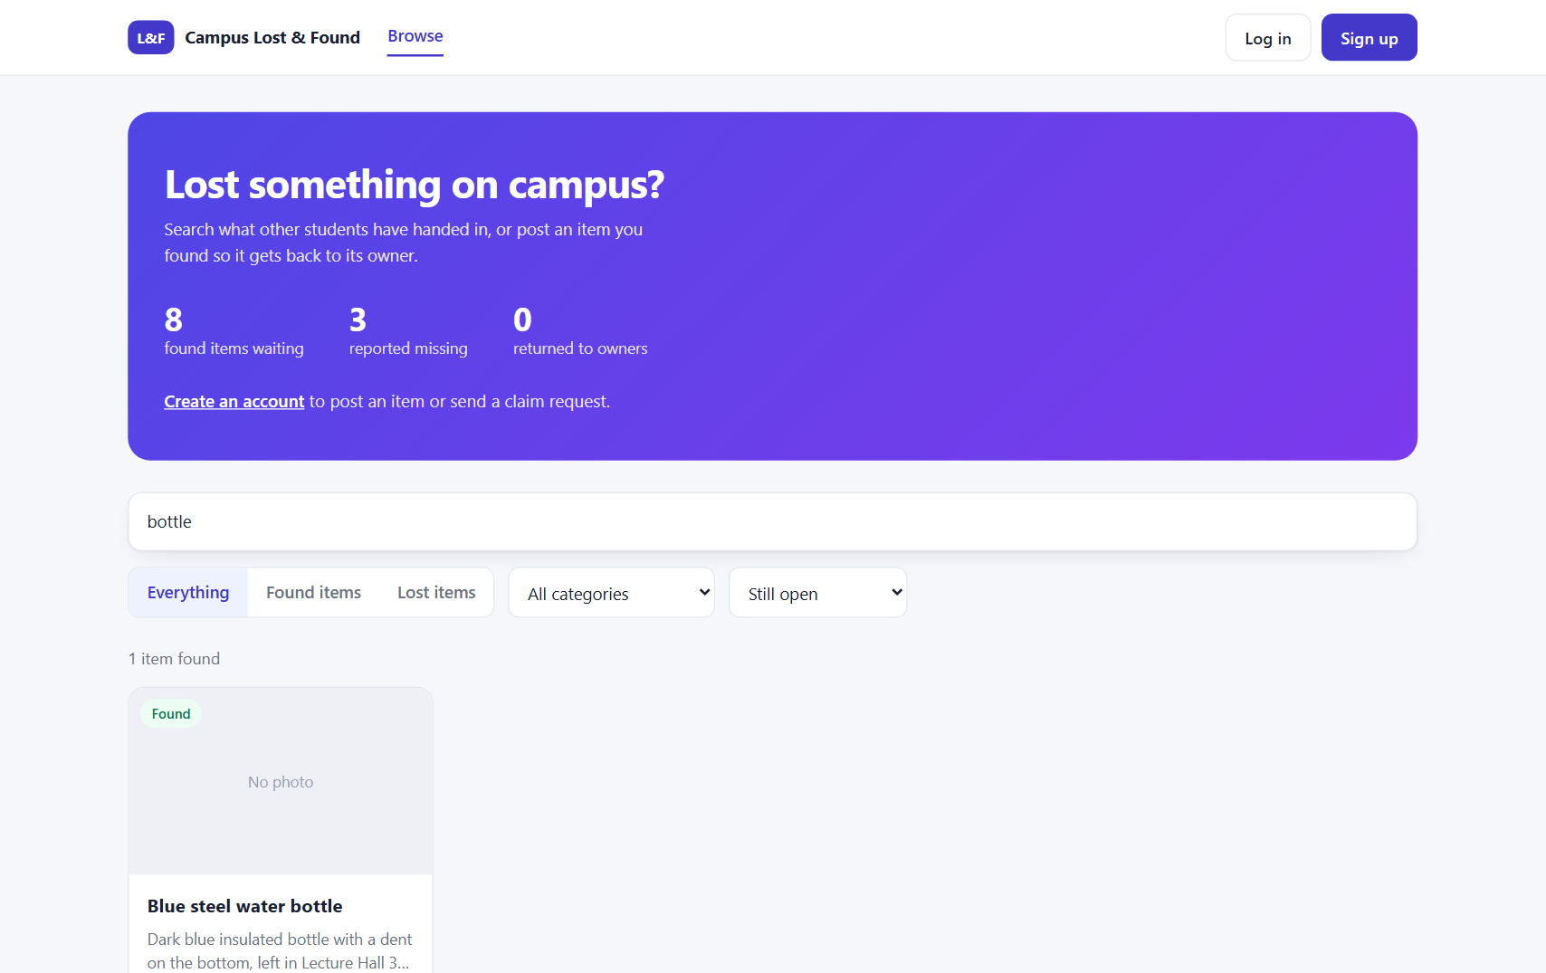
Figure 3 - Keyword search for "bottle" - results update as you type
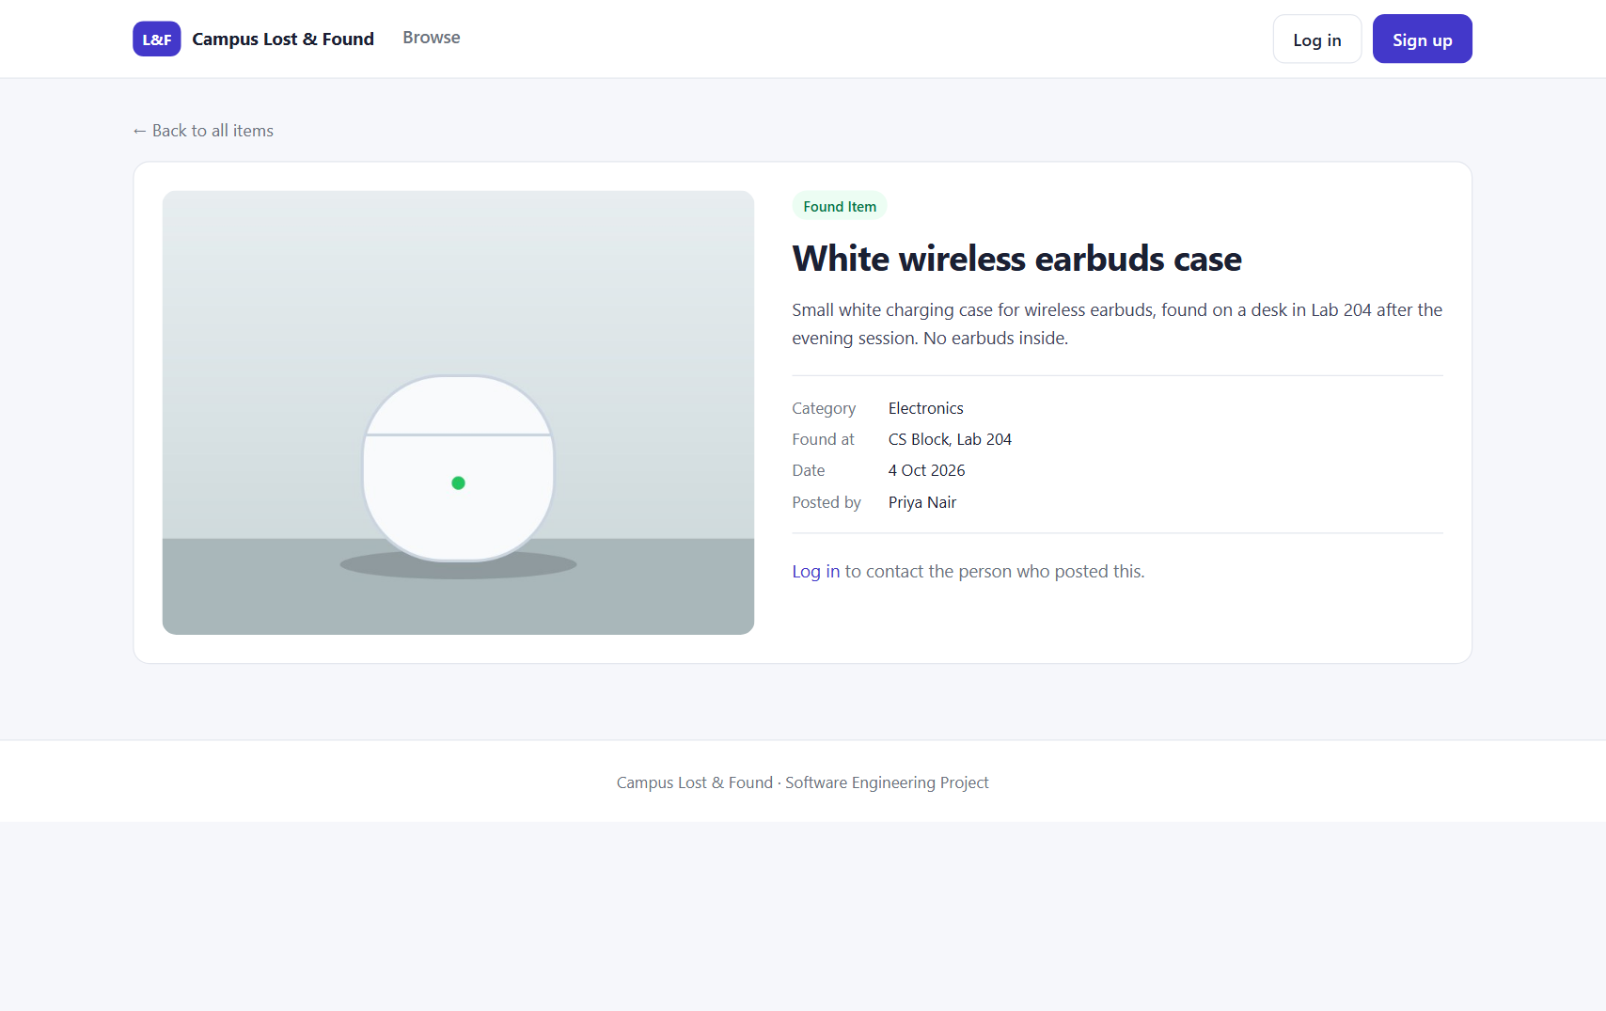
Figure 4 - Item detail while logged out: poster name shown, contact details hidden

9.2 Accounts and validation
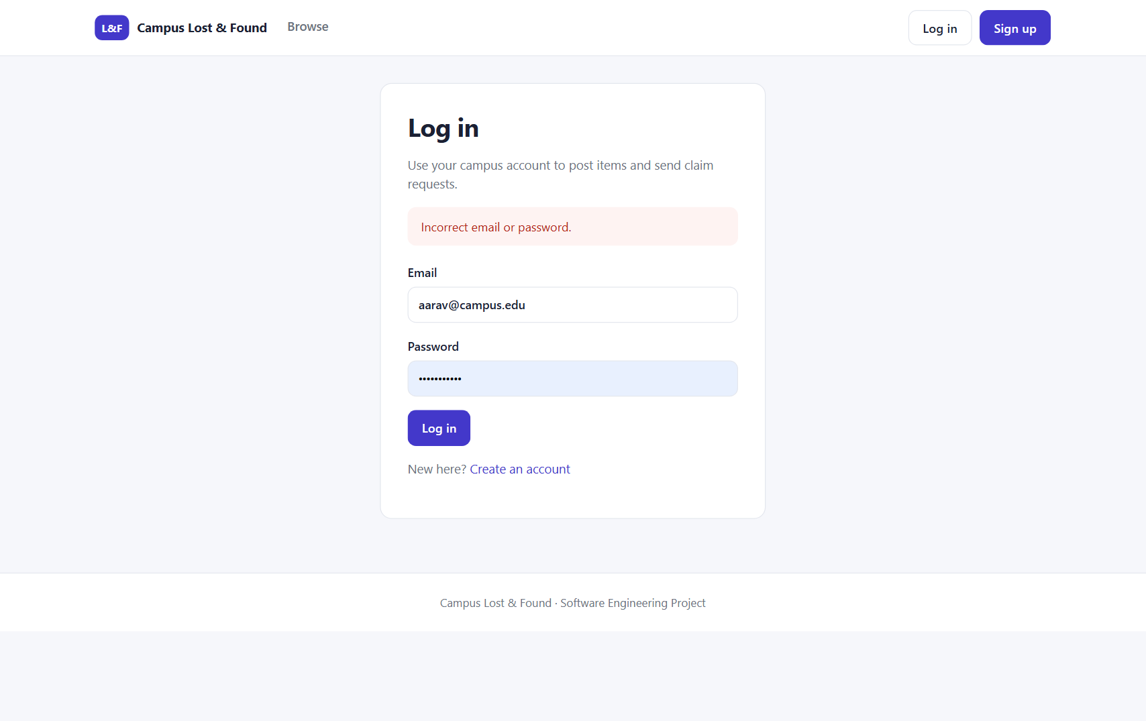
Figure 5 - Log in with a wrong password: a generic error message is shown
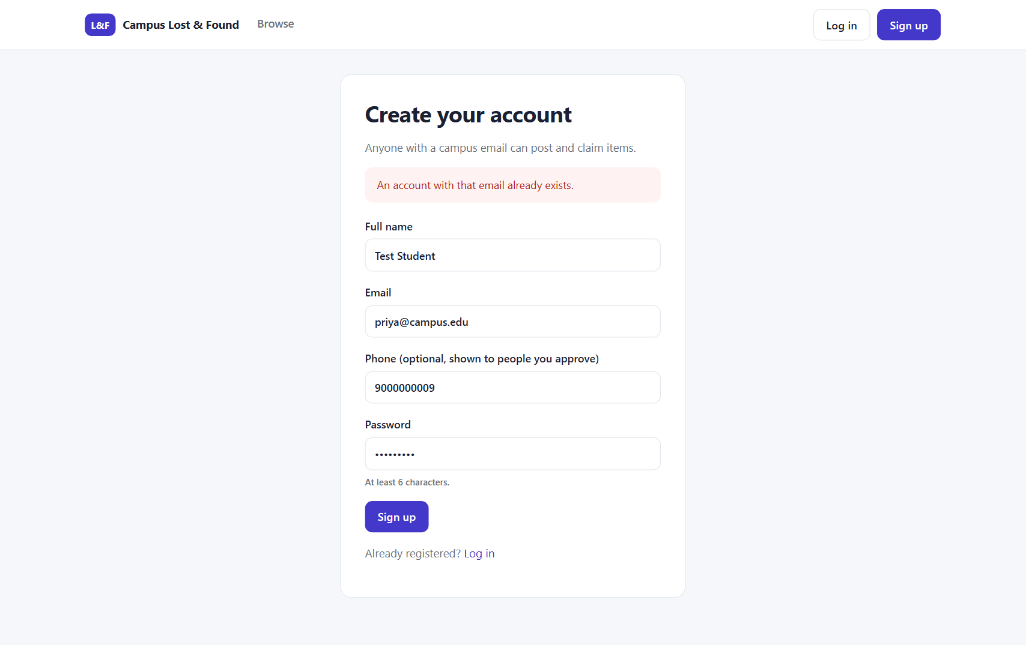
Figure 6 - Sign-up with an email that is already registered: clear error message

9.3 Posting an item
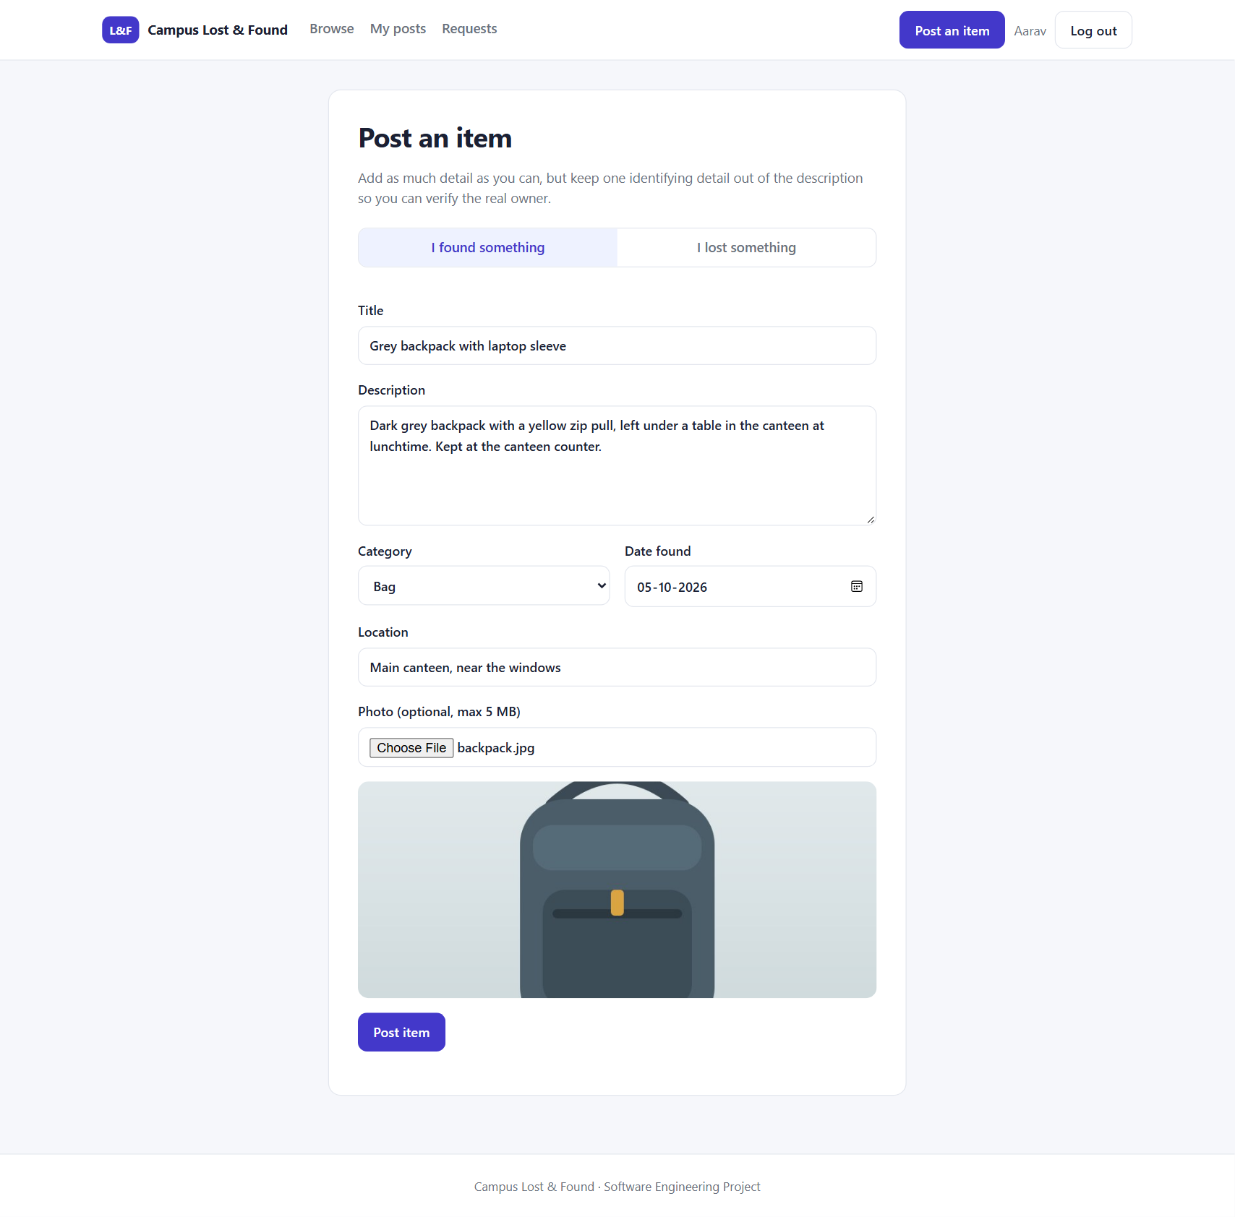
Figure 7 - Post an item form, filled in, with the photo preview
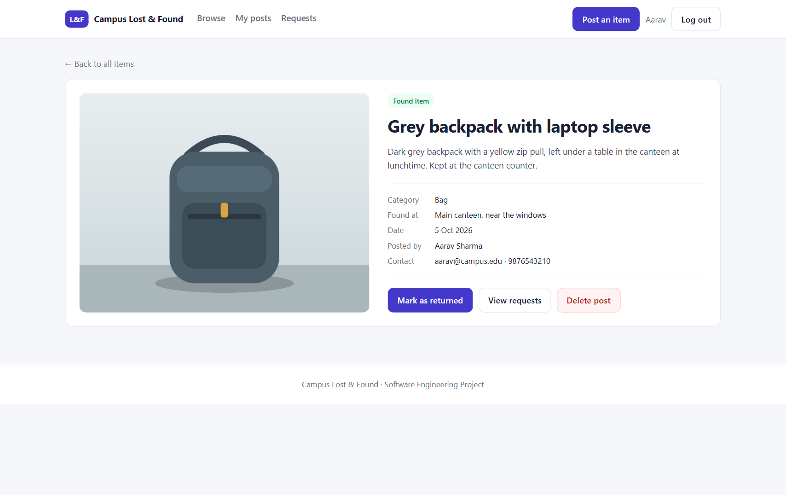
Figure 8 - The new post as seen by its owner: Mark as returned, View requests and Delete post

9.4 Claiming an item
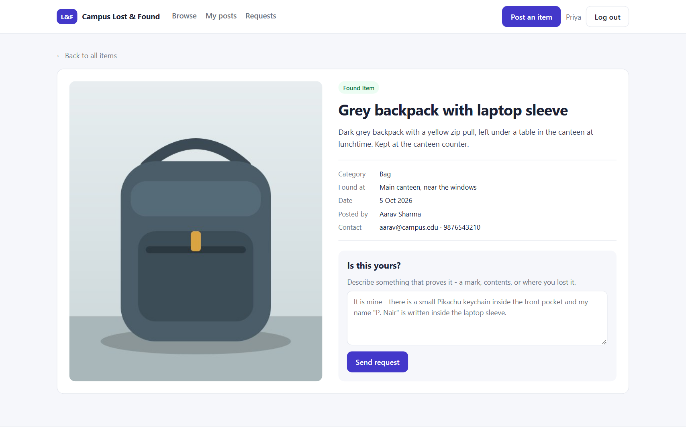
Figure 9 - Logged in as another student: contact details visible and the claim form with proof of ownership
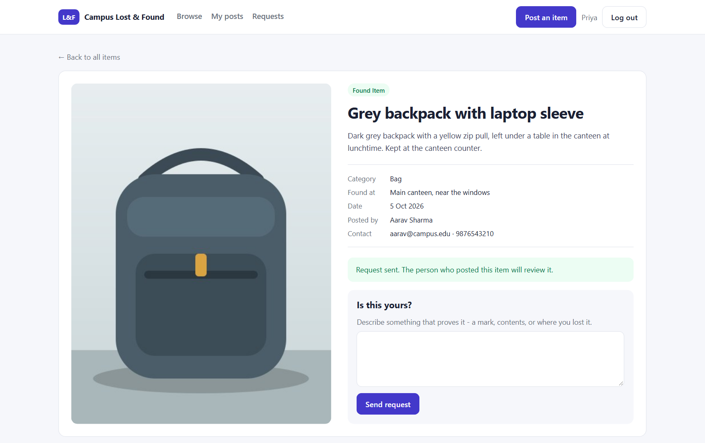
Figure 10 - After sending the claim: confirmation message

9.5 Reviewing and approving
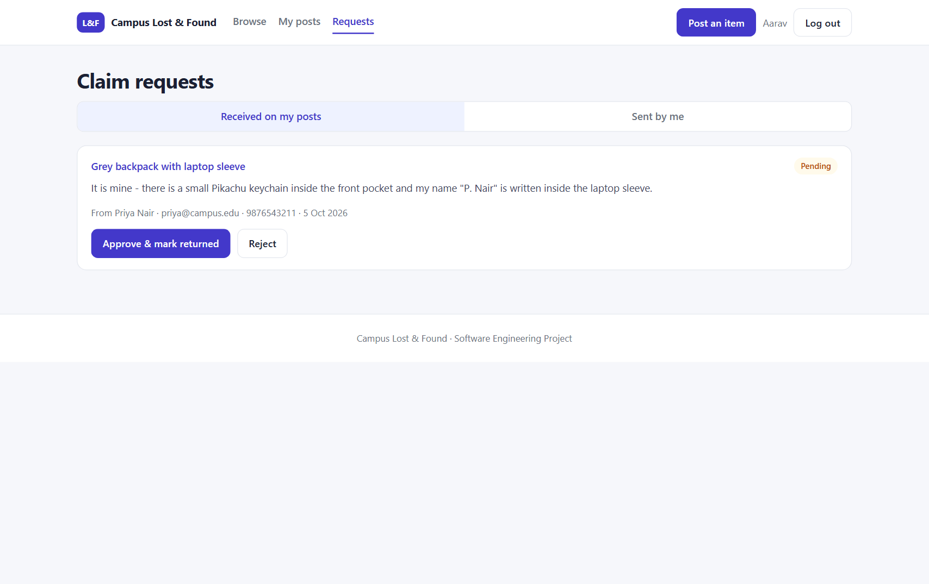
Figure 11 - Claim requests received by the poster, with the claimant's message and contact, and Approve / Reject buttons
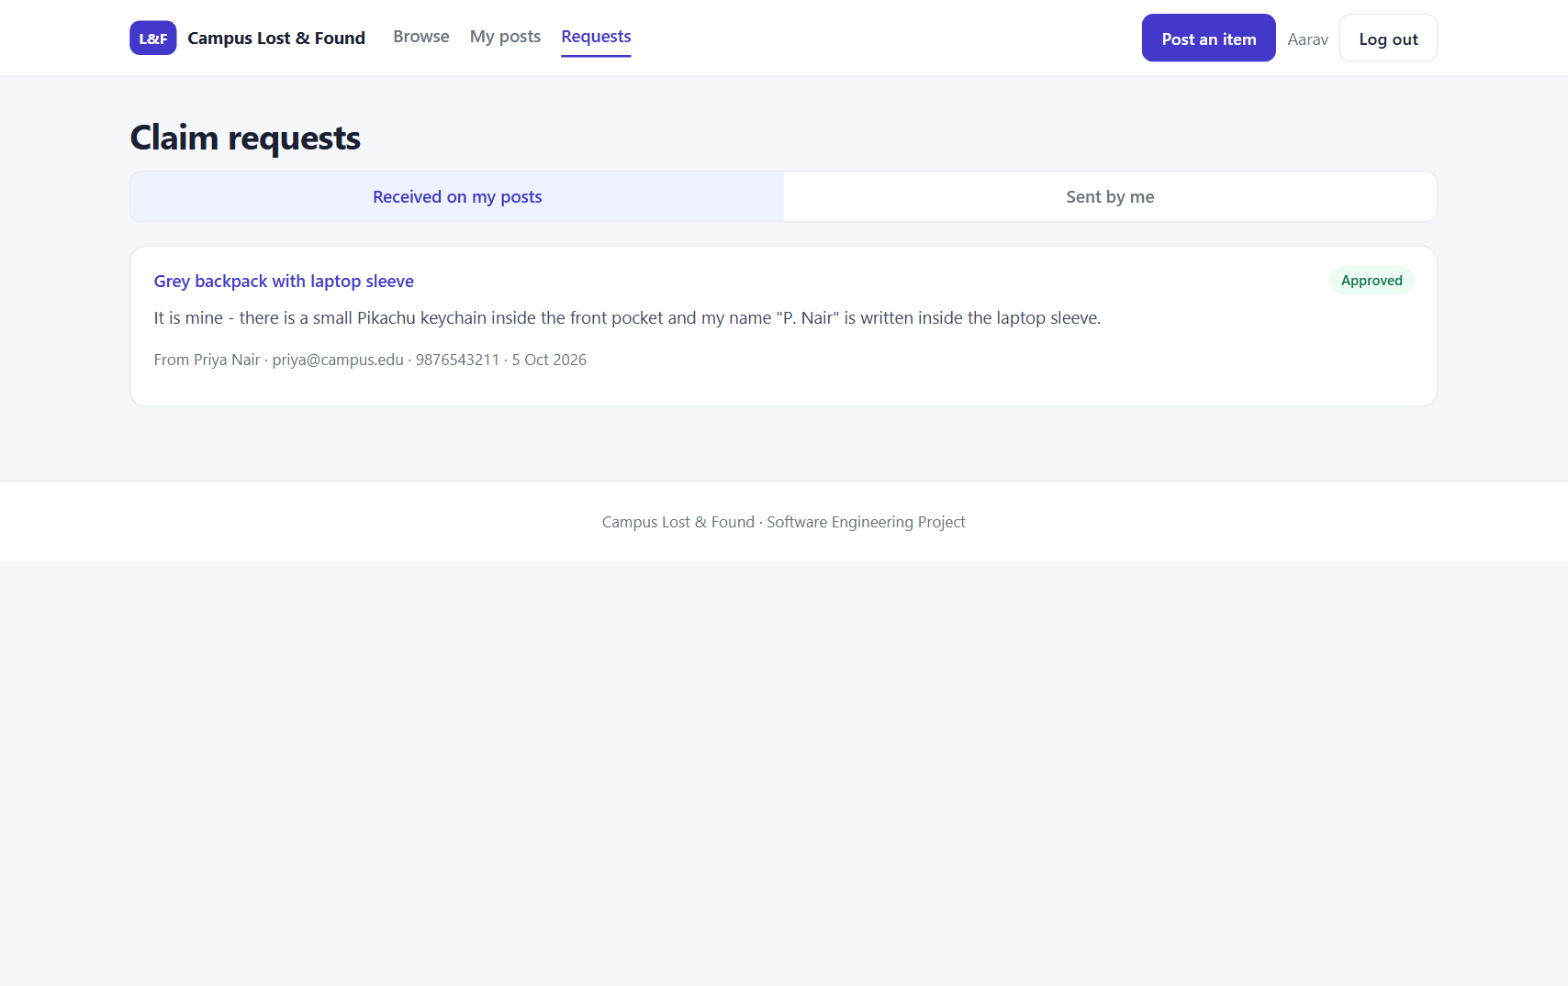
Figure 12 - After approving: the request is approved and the item is marked returned
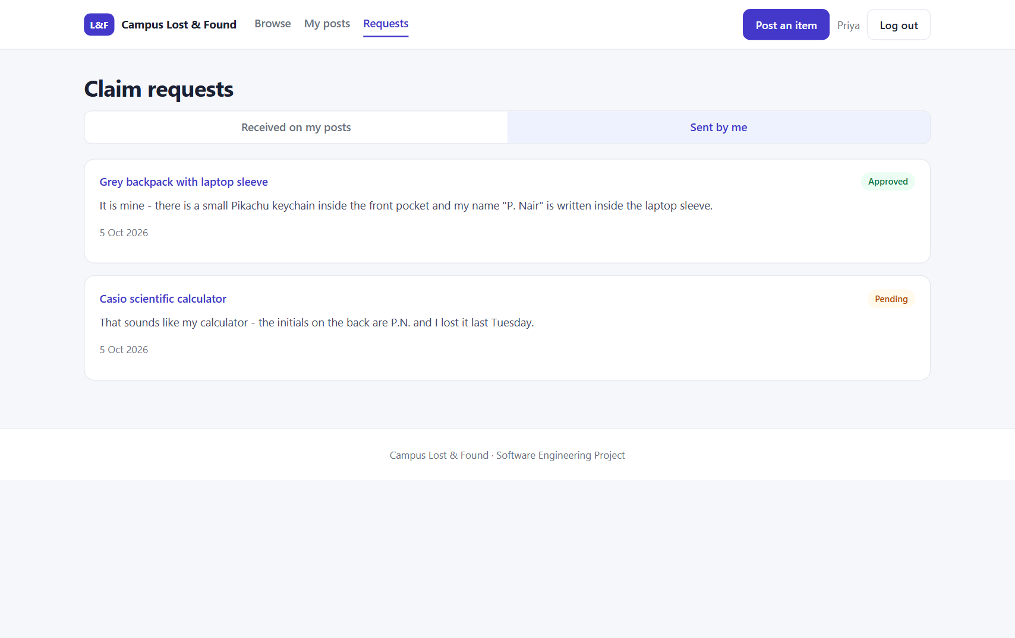
Figure 13 - The claimant's "Sent" tab shows the request as approved
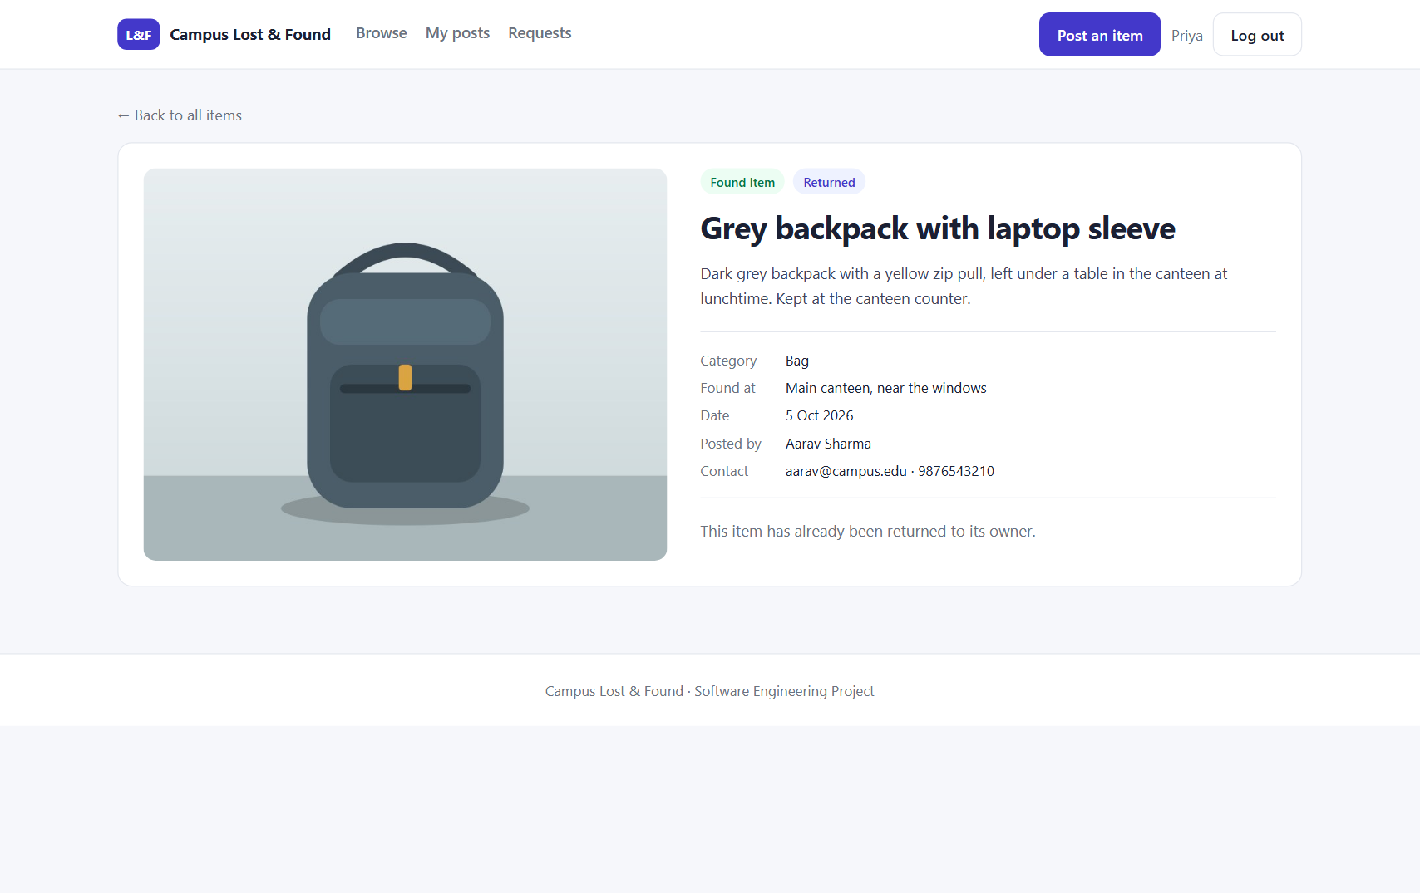
Figure 14 - The item now carries the "Returned" tag and can no longer be claimed

9.6 My posts and mobile layout
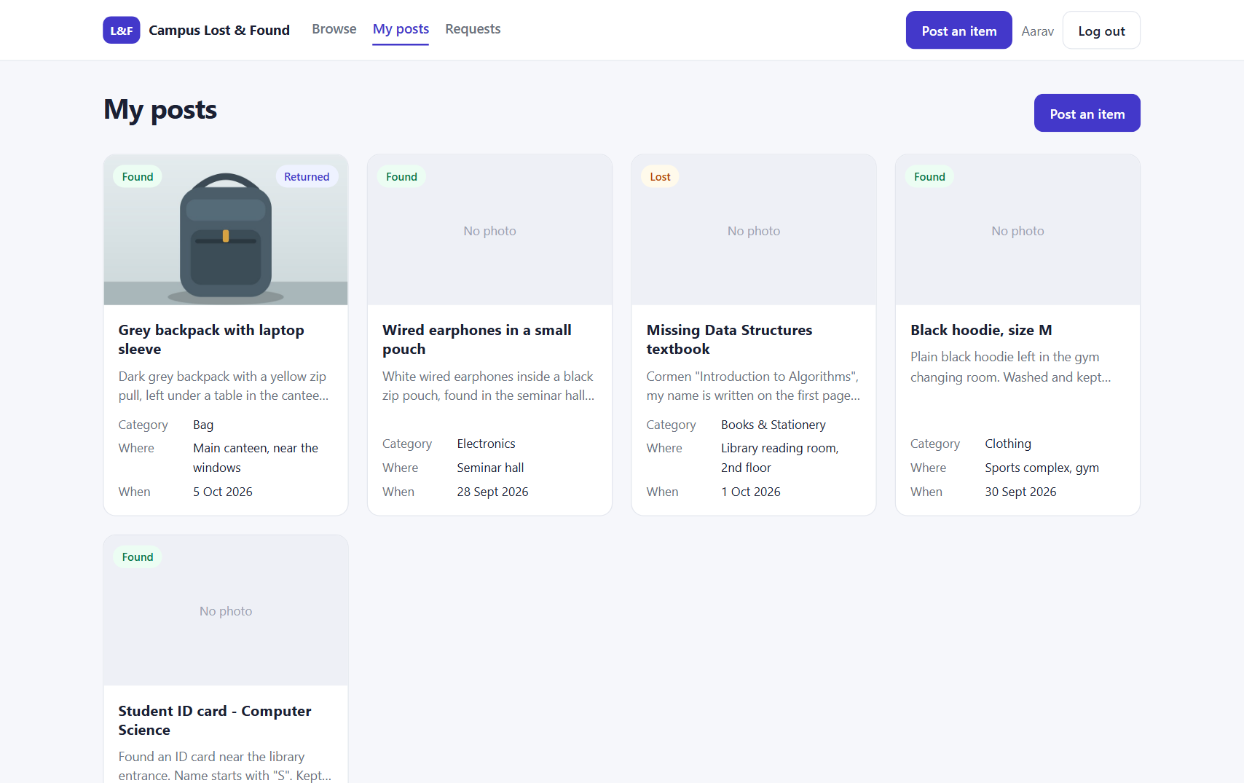
Figure 15 - "My posts" for Aarav
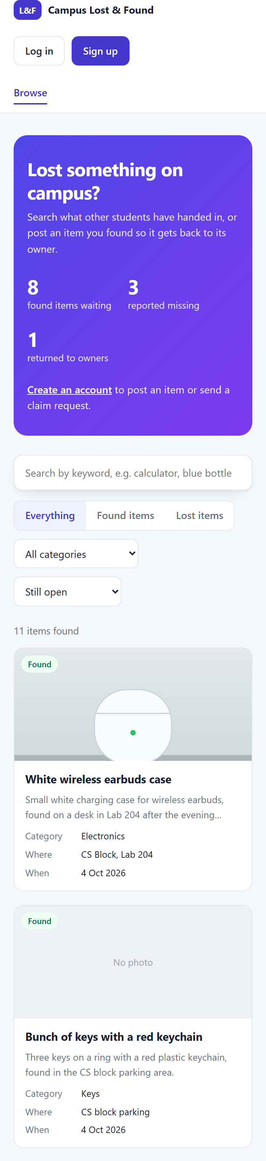
Figure 16 - Responsive layout on a phone-sized screen (390 px wide)

10. Running the Project

10.1 Requirements
- Node.js 20 or later (developed on 24)
- MongoDB running locally on port 27017
- A modern browser

10.2 Steps
Terminal
# 1. Back end (first terminal)
cd server
npm install # first time only
npm run seed # optional: sample users and items (clears the demo database)
npm run dev # API on http://localhost:5000

# 2. Front end (second terminal)
cd client
npm install # first time only
npm run dev # website on http://localhost:5173

# 3. Automated tests (any time, uses a separate test database)
cd server
npm test

10.3 Demo accounts
Email | Password
aarav@campus.edu | password123
priya@campus.edu | password123
rahul@campus.edu | password123

11. Challenges and Solutions
Challenge | Solution
The browser blocks calls from port 5173 to port 5000 (CORS). | Vite proxies /api and /uploads to the API, so the browser only ever talks to one origin.
Showing contact details only to logged-in users without writing two endpoints. | optionalAuth middleware identifies the user if a token is present; the route removes contact fields otherwise.
Two quick clicks could create duplicate claims. | A unique database index on (item, claimant) makes the database reject the second one; the error handler turns it into 409.
Search text such as "(" crashed the regular expression. | escapeRegex() escapes special characters before searching.
Deleted posts left orphan photos and claims. | DELETE removes the photo file and all claims before removing the item.
Testing found 4 defects (invalid emails accepted, crash on non-text login, wrong status for bad uploads, re-approval of returned items). | Each was fixed in the code and re-tested; all 45 automated tests now pass (see Testing Report, Section 5).
The automated tests needed the app without connecting to the real database. | The Express app was moved into app.js; index.js only connects and listens.

12. Conclusion
The implementation delivers all 16 functional requirements as a working full-stack application with an integrated front end and back end. Validation and error handling are applied on both client and server, the claim workflow enforces the business rules, and personal data is protected. The code is organised into small modules with single responsibilities and is covered by an automated test suite that can be re-run with one command.

Possible improvements
- Email notifications when a claim is received or decided.
- Restricting sign-up to the college email domain.
- An edit form for posts in the UI (the API already supports updates).
- Admin dashboard for moderating posts.
- Deployment to a cloud host with HTTPS.

