BCSE301L - SOFTWARE ENGINEERING
Fall Semester 2026-27 | Digital Assignment
Campus Lost & Found
A web platform to report, search for and safely claim items lost on campus
Testing Report
Test plan, test cases, results, defects and evidence
Prepared by: Student 4 - Testing
Team members
# | Name | Reg. No. | Responsibility
Student 1 | [Student 1 name] | [Reg. No.] | Requirement Gathering & Analysis
Student 2 | [Student 2 name] | [Reg. No.] | System Design (UML)
Student 3 | [Student 3 name] | [Reg. No.] | Development
Student 4 | [Student 4 name] | [Reg. No.] | Testing
Student 5 | [Student 5 name] | [Reg. No.] | Documentation (SRS)

Submitted to: [Faculty name] Date: [Submission date]
Contents
1. Introduction 3
1.1 Objectives 3
1.2 Summary of results 3
2. Test Plan 4
2.1 Scope 4
2.2 Test levels and types 4
2.3 Test environment 4
2.4 Entry and exit criteria 4
2.5 How the automated tests work 5
3. Test Cases 6
Module 1 - User accounts 6
Module 2 - Posting and managing items 7
Module 3 - Searching and viewing 7
Module 4 - Claim requests 8
Module 5 - General 8
Manual UI test cases 8
4. Test Results 10
4.1 Results by module 10
4.2 Analysis of Run 1 failures 10
4.3 Run 2 - regression 10
4.4 Requirements coverage 10
5. Defect Report 12
D-01: Invalid email addresses are accepted at sign-up 12
D-02: Non-text login input crashes the request (500) 12
D-03: Uploading a non-image returns a server error 13
D-04: A returned item can be "returned" again to another claimant 13
6. Evidence 14
Screenshots of manual UI tests 15
How to reproduce 15
7. Conclusion 16
Limitations 16

1. Introduction
This report describes how the Campus Lost & Found system was tested, the test cases that were executed, the defects found and how they were fixed and re-tested.

1.1 Objectives
- Verify that every functional requirement (FR-01 to FR-16) works as specified.
- Check validation, error handling and security rules with negative and boundary tests.
- Find and report defects, then confirm each fix by re-running the tests (regression testing).

1.2 Summary of results
Measure | Result
Automated system test cases | 45 (TC-01 to TC-45)
Manual UI test cases | 10 (UI-01 to UI-10)
Run 1 (before fixes) | 40 passed, 5 failed
Defects found and fixed | 4 (1 High, 2 Medium, 1 Low)
Test-script errors found | 1 (TC-24 expected value was wrong)
Run 2 (after fixes) | 45 passed, 0 failed (100 %)

2. Test Plan

2.1 Scope
In scope: all REST API endpoints (accounts, items, search, claims), file upload rules, authorisation rules, and the main user-interface flows. Out of scope: load / stress testing, cross-browser automation and penetration testing.

2.2 Test levels and types
Level / type | What it means here | How
System testing (black box) | The whole running back end is tested through its public HTTP interface, exactly as the website uses it. | Automated - Node.js test runner
Functional testing | Each feature behaves as the requirement says. | Automated + manual
Negative testing | Wrong, missing or malicious input is rejected with a clear message. | Automated
Boundary value testing | Limits such as the 6-character password and the 5 MB photo limit. | Automated
Security testing | Password hashing, authorisation, contact privacy, NoSQL injection, crafted file names, regex injection. | Automated
Regression testing | After fixing defects, the full suite is re-run to make sure nothing else broke. | Automated (Run 2)
UI / usability testing | Pages, messages, redirects and layout in the browser. | Manual

2.3 Test environment
Item | Value
Operating system | Windows 11
Runtime | Node.js 24, Express 5
Database | MongoDB 8 (local service) - separate test database "campus-lost-found-test", wiped before and after each run
Test framework | Node.js built-in test runner (node:test) with assert; HTTP requests via fetch
Command | cd server then npm test
Test file | server/tests/api.test.js
Browser (manual tests) | Google Chrome / Microsoft Edge (latest)

2.4 Entry and exit criteria
- Entry: code builds, MongoDB is running, the API starts without errors.
- Exit: all automated test cases pass, every defect is fixed and re-tested, no open High-severity defect.

2.5 How the automated tests work
The test file starts the real Express application on a random free port and sends real HTTP requests to it, the same way the React website does. Tests run in order and share a few accounts (a finder, an owner and a third student) so that later tests, such as approving a claim, can build on earlier ones. The run also includes 2 small setup steps (creating extra accounts and a lost item), so the runner reports 47 tests: 45 test cases + 2 setup steps.

3. Test Cases
Status shows the result of Run 1 (before fixes). Every case passed in Run 2 (after fixes).

Module 1 - User accounts
ID | Test case | Input / steps | Expected result | Run 1 | Run 2
TC-01 | Register with valid details | name, email finder@campus.edu, password secret123, phone | 201 Created; token returned; password not in response | Pass | Pass
TC-02 | Register with missing field | email + password only (no name) | 400; "Name, email and password are required." | Pass | Pass
TC-03 | Password shorter than 6 characters | password "123" | 400; "Password must be at least 6 characters." | Pass | Pass
TC-04 | Duplicate email (different case) | FINDER@campus.edu after finder@campus.edu | 409 Conflict | Pass | Pass
TC-05 | Invalid email format | email "not-an-email" | 400; "Please enter a valid email address." | Fail | Pass (fixed D-01)
TC-06 | Password stored hashed | Read stored password from DB | Value is a bcrypt hash ($2...), not "secret123" | Pass | Pass
TC-07 | Login with correct credentials | finder@campus.edu / secret123 | 200 OK; token returned | Pass | Pass
TC-08 | Login with wrong password | finder@campus.edu / wrongpass | 401; generic "Incorrect email or password." | Pass | Pass
TC-09 | Login with empty fields | email "", password "" | 400 Bad Request | Pass | Pass
TC-10 | Login with non-text email (NoSQL injection attempt) | email {"$gt": ""} | 400 Bad Request, no server error | Fail | Pass (fixed D-02)
TC-11 | "Who am I" with valid token | GET /api/auth/me + token | 200; correct user name | Pass | Pass
TC-12 | "Who am I" with no / fake token | No header; "fake.token.value" | 401 for both | Pass | Pass

Module 2 - Posting and managing items
ID | Test case | Input / steps | Expected result | Run 1 | Run 2
TC-13 | Post a found item | All fields, logged in | 201; status "open" | Pass | Pass
TC-14 | Post without logging in | No token | 401 Unauthorised | Pass | Pass
TC-15 | Post with a required field missing | location omitted | 400 Bad Request | Pass | Pass
TC-16 | Post with invalid category | category "Spaceship" | 400 Bad Request | Pass | Pass
TC-17 | Upload a valid photo (crafted file name) | PNG named "../../evil-name.png" | 201; saved as /uploads/<uuid>.png; file exists | Pass | Pass
TC-18 | Upload a non-image file | notes.txt (text/plain) | 400; "Only image files ... are allowed." | Fail | Pass (fixed D-03)
TC-19 | Upload image larger than 5 MB | 5.5 MB file | 400; "Image must be smaller than 5 MB." | Pass | Pass
TC-20 | Owner edits own post | PATCH new title | 200; title updated | Pass | Pass
TC-21 | Edit / delete someone else's post | Another user's token | 403 Forbidden for both | Pass | Pass
TC-22 | "My posts" shows only my items | GET /api/items/mine for two users | Finder: 2 items; other user: 0 | Pass | Pass

Module 3 - Searching and viewing
ID | Test case | Input / steps | Expected result | Run 1 | Run 2
TC-23 | Browse open items, newest first | GET /api/items | total = 3; newest item first | Pass | Pass
TC-24 | Keyword search | q = calculator / canteen / reading room | 1 / 1 / 2 results | Fail | Pass (test corrected)
TC-25 | Filter by category and type | category=Electronics; type=found; type=lost&category=Other | 1 / 2 / 0 results | Pass | Pass
TC-26 | Special characters in search | q = "(.*" | 200; 0 results; no crash | Pass | Pass
TC-27 | Pagination | limit=2&page=2 | 1 item on page 2; pages = 2 | Pass | Pass
TC-28 | Contact hidden from visitors | GET item without token | Poster name shown; email and phone absent | Pass | Pass
TC-29 | Contact shown to logged-in users | GET item with token | Email and phone present | Pass | Pass
TC-30 | Malformed / unknown item id | /api/items/12345; random valid id | 400 "Invalid id." / 404 | Pass | Pass
TC-31 | Home statistics | GET /api/items/stats | {found: 2, lost: 1, resolved: 0} | Pass | Pass

Module 4 - Claim requests
ID | Test case | Input / steps | Expected result | Run 1 | Run 2
TC-32 | Send a claim request | itemId + ownership message | 201; status "pending" | Pass | Pass
TC-33 | Claim without logging in | No token | 401 Unauthorised | Pass | Pass
TC-34 | Claim with empty message | message "" | 400 Bad Request | Pass | Pass
TC-35 | Claim own post | Poster claims own item | 400; "You cannot claim your own post." | Pass | Pass
TC-36 | Duplicate claim | Same user claims same item again | 409 Conflict | Pass | Pass
TC-37 | Received and sent request lists | Two claims on one item | Poster sees 2 (with contact); claimant sees 1 | Pass | Pass
TC-38 | Non-poster tries to approve | Other user PATCHes claim | 403 Forbidden | Pass | Pass
TC-39 | Invalid decision value | status "maybe" | 400 Bad Request | Pass | Pass
TC-40 | Approve a request | Poster approves claim 1 | Claim approved; item resolved to claimant; claim 2 rejected | Pass | Pass
TC-41 | Claim a returned item | New user claims resolved item | 400; "This item has already been returned." | Pass | Pass
TC-42 | Approve another request after return | Poster approves rejected claim 2 | 400; item stays returned to first claimant | Fail | Pass (fixed D-04)
TC-43 | Delete post cascades | Delete item that has a photo and a claim | 200; claims removed; photo file deleted | Pass | Pass

Module 5 - General
ID | Test case | Input / steps | Expected result | Run 1 | Run 2
TC-44 | Health check | GET /api/health | {status: "ok"} | Pass | Pass
TC-45 | Unknown route | GET /api/does-not-exist | 404; "Route not found ..." | Pass | Pass

Manual UI test cases
These are run by hand in the browser during testing and again during the demonstration. Paste a screenshot of each result into the evidence section (Section 6).
ID | Test case | Steps | Expected result | Result
UI-01 | Sign-up form shows server error | Sign up with an email that already exists | Red error banner: "An account with that email already exists." | [Pass / Fail]
UI-02 | Protected page redirects to login | Log out, then open /report directly | Redirected to Log in page; after login returns to Post an item | [Pass / Fail]
UI-03 | Post item with photo preview | Choose a photo on the Post an item form | Preview shown; after submit the card shows the photo | [Pass / Fail]
UI-04 | Search and filter on home page | Type "bottle", choose category "Bottles & Containers" | Only matching cards shown; "No items match your search..." if none | [Pass / Fail]
UI-05 | Contact hidden when logged out | Open any item while logged out | Poster name shown, no Contact row; message "Log in to contact the person who posted this." | [Pass / Fail]
UI-06 | Claim form not shown on own post | Open an item you posted | "Mark as returned", "View requests" and "Delete post" buttons instead of the claim form | [Pass / Fail]
UI-07 | Approve request from Requests page | Log in as poster, click Approve | Request shows Approved; item card shows "Returned" tag | [Pass / Fail]
UI-08 | Delete confirmation | Click Delete on own post | Browser asks "Delete this post permanently?"; Cancel keeps it | [Pass / Fail]
UI-09 | Responsive layout | Resize the browser to phone width | Cards stack in one column; navbar stays usable | [Pass / Fail]
UI-10 | Logout | Click Log out | Navbar shows Log in / Sign up; protected pages redirect | [Pass / Fail]

4. Test Results

4.1 Results by module
Module | Cases | Run 1 pass | Run 1 fail | Run 2 pass | Run 2 fail
Module 1 - User accounts | 12 | 10 | 2 | 12 | 0
Module 2 - Posting and managing items | 10 | 9 | 1 | 10 | 0
Module 3 - Searching and viewing | 9 | 8 | 1 | 9 | 0
Module 4 - Claim requests | 12 | 11 | 1 | 12 | 0
Module 5 - General | 2 | 2 | 0 | 2 | 0
Total | 45 | 40 | 5 | 45 | 0

4.2 Analysis of Run 1 failures
Run 1 had 5 failures. Each was investigated to decide whether the fault was in the product or in the test:
- 4 product defects (TC-05, TC-10, TC-18, TC-42) - logged as D-01 to D-04 in Section 5 and fixed in the code.
- 1 test-script error (TC-24) - the test expected 1 result for "reading room", but two test items legitimately mention the reading room. The product was correct; the expected value in the test was corrected to 2.

4.3 Run 2 - regression
After the fixes the complete suite was re-run. All 45 test cases passed, confirming that the fixes work and did not break any other feature.

4.4 Requirements coverage
Every functional requirement is covered by at least one passing test case:
Requirement | Test cases | Status
FR-01 Register account | TC-01 to TC-05 | Covered - Pass
FR-02 Log in / log out | TC-07 to TC-12 | Covered - Pass
FR-03 Browse items | TC-23, TC-27 | Covered - Pass
FR-04 Keyword search | TC-24, TC-26 | Covered - Pass
FR-05 Filter items | TC-25 | Covered - Pass
FR-06 View item details | TC-28, TC-30 | Covered - Pass
FR-07 Contact privacy | TC-28, TC-29 | Covered - Pass
FR-08 Post an item | TC-13 to TC-16 | Covered - Pass
FR-09 Upload photo | TC-17 to TC-19 | Covered - Pass
FR-10 Edit / delete own post | TC-20, TC-21, TC-43 | Covered - Pass
FR-11 My posts | TC-22 | Covered - Pass
FR-12 Send claim request | TC-32 to TC-36, TC-41 | Covered - Pass
FR-13 View requests | TC-37 | Covered - Pass
FR-14 Approve / reject request | TC-38, TC-39 | Covered - Pass
FR-15 Mark item returned | TC-40, TC-42 | Covered - Pass
FR-16 Home statistics | TC-31 | Covered - Pass

5. Defect Report
ID | Defect | Severity | Found by | Status
D-01 | Invalid email addresses are accepted at sign-up | Medium | TC-05 | Closed - fixed & re-tested
D-02 | Non-text login input crashes the request (500) | Medium | TC-10 | Closed - fixed & re-tested
D-03 | Uploading a non-image returns a server error | Low | TC-18 | Closed - fixed & re-tested
D-04 | A returned item can be "returned" again to another claimant | High | TC-42 | Closed - fixed & re-tested
Severity: High - wrong data or a broken business rule; Medium - wrong behaviour with a workaround or security weakness; Low - cosmetic or wrong status code only.

D-01: Invalid email addresses are accepted at sign-up
Found by | TC-05 (Run 1)
Severity / Priority | Medium / High
Steps to reproduce | POST /api/auth/register with email "not-an-email" and other valid fields.
Expected result | 400 Bad Request, "Please enter a valid email address."
Actual result | 201 Created - an account with an unusable email was stored.
Root cause | Neither the route nor the User model checked the email format (only the browser form did, which can be bypassed).
Fix | Added an email pattern check in routes/auth.js and a "match" validator on User.email.
Re-test | TC-05 passed in Run 2 - Closed

D-02: Non-text login input crashes the request (500)
Found by | TC-10 (Run 1)
Severity / Priority | Medium / High
Steps to reproduce | POST /api/auth/login with JSON body {"email": {"$gt": ""}, "password": "x"}.
Expected result | 400 Bad Request.
Actual result | 500 Internal Server Error - "email.toLowerCase is not a function".
Root cause | The route assumed email and password were strings. This pattern is also used in NoSQL-injection attacks.
Fix | routes/auth.js now rejects non-string email / password (and name on register) with 400.
Re-test | TC-10 passed in Run 2 - Closed

D-03: Uploading a non-image returns a server error
Found by | TC-18 (Run 1)
Severity / Priority | Low / Medium
Steps to reproduce | POST /api/items with a .txt file in the "image" field.
Expected result | 400 Bad Request with "Only image files ... are allowed."
Actual result | 500 Internal Server Error (message was correct, status code was wrong).
Root cause | The upload filter raised a plain Error with no status, so the error handler treated it as a server fault.
Fix | middleware/upload.js sets err.status = 400 on the rejected-file error.
Re-test | TC-18 passed in Run 2 - Closed

D-04: A returned item can be "returned" again to another claimant
Found by | TC-42 (Run 1)
Severity / Priority | High / High
Steps to reproduce | Approve claim A on an item (item becomes returned, claim B auto-rejected). Then PATCH claim B with status "approved".
Expected result | 400, "This item has already been returned."; item stays with claimant A.
Actual result | 200 OK - claim B approved and the item's resolvedWith changed to claimant B.
Root cause | routes/claims.js did not check the item status before applying a decision.
Fix | routes/claims.js refuses any decision on a claim whose item is already resolved.
Re-test | TC-42 passed in Run 2 - Closed

6. Evidence
The figures below show the console output of the two automated test runs (rendered from the saved test-runner logs; timing values removed for readability).
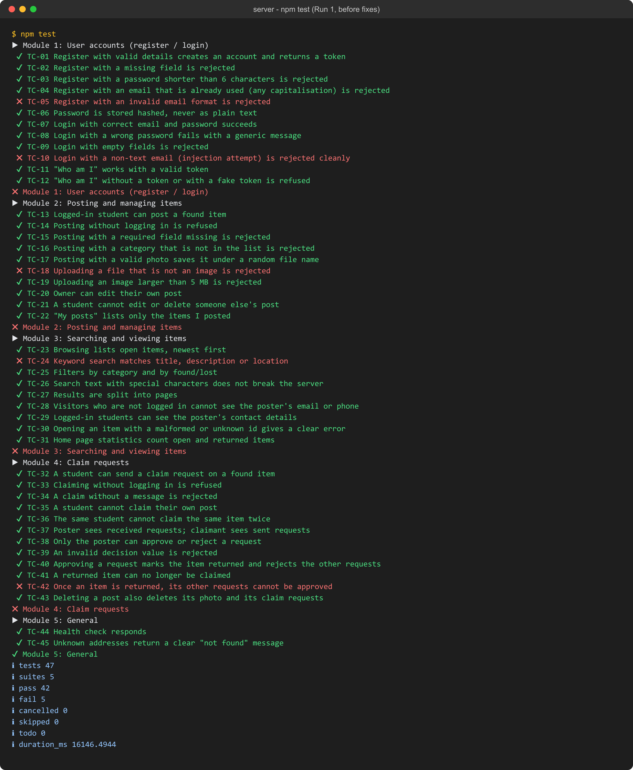
Figure 1 - Run 1, before fixes: 5 failures (runner total 47 = 45 test cases + 2 setup steps)
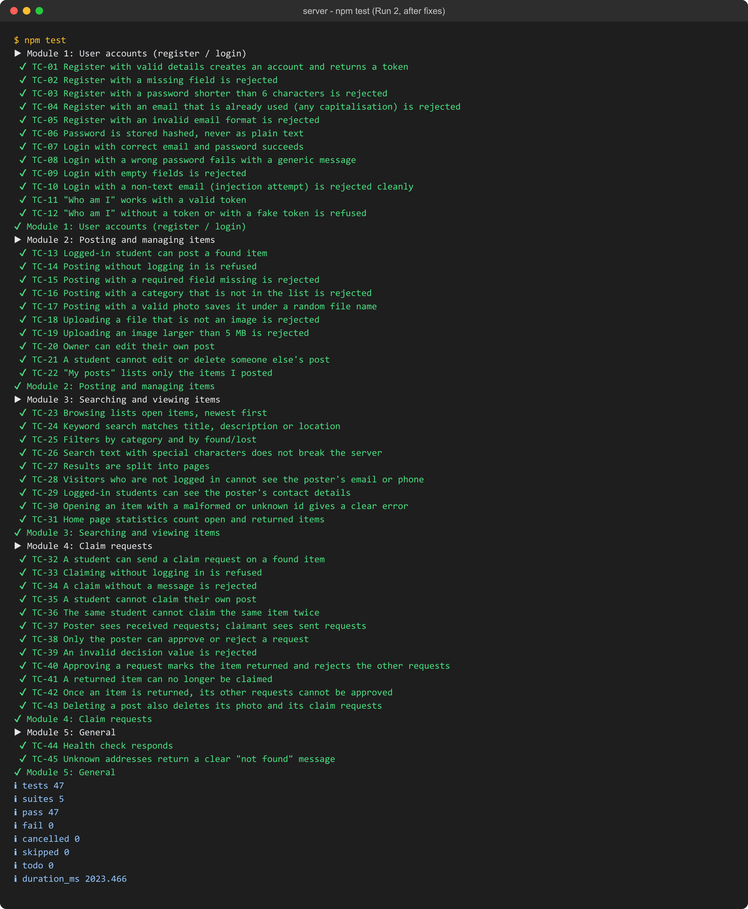
Figure 2 - Run 2, after fixes: all 47 passed (45 test cases + 2 setup steps)

Screenshots of manual UI tests
[Insert screenshots of UI-01 to UI-10 here, one per test case, with a caption such as "UI-04 - Search for bottle".]

How to reproduce
- Make sure MongoDB is running.
- Open a terminal in the server folder.
- Run npm test
- The runner prints each test case with a tick (pass) or cross (fail), then a summary.

7. Conclusion
Testing found 4 real defects, including one High-severity business-rule violation (D-04) that would have let an item be "returned" twice, and one input-handling weakness that is a common attack pattern (D-02). All were fixed and re-tested. The final run passes all 45 automated test cases, and every functional requirement is covered.

Limitations
- No load or performance testing was done; NFR-06 is a design target only.
- The front end is tested manually, not with automated browser tests.
- Tests run on one machine and one browser family.

