BCSE301L - SOFTWARE ENGINEERING
Fall Semester 2026-27 | Digital Assignment
Campus Lost & Found
A web platform to report, search for and safely claim items lost on campus
Software Requirements Specification
Following the IEEE 830 / ISO/IEC/IEEE 29148 structure | Version 1.0
Prepared by: Student 5 - Documentation
Team members
# | Name | Reg. No. | Responsibility
Student 1 | [Student 1 name] | [Reg. No.] | Requirement Gathering & Analysis
Student 2 | [Student 2 name] | [Reg. No.] | System Design (UML)
Student 3 | [Student 3 name] | [Reg. No.] | Development
Student 4 | [Student 4 name] | [Reg. No.] | Testing
Student 5 | [Student 5 name] | [Reg. No.] | Documentation (SRS)

Submitted to: [Faculty name] Date: [Submission date]
Revision history
Version | Date | Author | Changes
0.1 | [date] | Student 1 | Initial requirements and use cases
0.5 | [date] | Student 2 | Added design models and data requirements
0.9 | [date] | Student 4 | Added verification results and defect fixes
1.0 | [date] | Student 5 | Complete SRS for submission
Contents
1. Introduction 5
1.1 Purpose 5
1.2 Product scope 5
1.3 Definitions, acronyms and abbreviations 5
1.4 References 5
1.5 Document overview 6
2. Overall Description 7
2.1 Product perspective 7
2.2 Product functions 7
2.3 User classes and characteristics 7
2.4 Operating environment 7
2.5 Design and implementation constraints 8
2.6 User documentation 8
2.7 Assumptions and dependencies 8
3. External Interface Requirements 9
3.1 User interfaces 9
3.2 Hardware interfaces 9
3.3 Software interfaces 9
3.4 Communication interfaces 9
4. System Features 11
4.1 User accounts 11
4.2 Posting and managing items 11
4.3 Search and viewing 12
4.4 Claim requests 12
5. Non-Functional Requirements 14
5.1 Performance requirements 14
5.2 Safety and integrity requirements 14
5.3 Security requirements 14
5.4 Software quality attributes 15
5.5 Business rules 15
6. Data Requirements 16
7. Verification 18
Defects fixed during verification 18
Appendix A - Analysis Models 19
Appendix B - Use Case Specifications 22
Appendix C - Future Enhancements 24

1. Introduction

1.1 Purpose
This Software Requirements Specification (SRS) describes the functional and non-functional requirements of Campus Lost & Found, version 1.0. It is written for the course instructor, the development team and anyone who will maintain or extend the system.

1.2 Product scope
Students who lose or find belongings on campus have no single, searchable, trustworthy place to connect with each other. As a result many items are never returned, items can be handed to the wrong person, and contact details are over-shared. The project builds a web application where finders post items, owners search and send a claim with proof of ownership, and the finder approves the rightful claim - while personal contact details are visible only to signed-in members of the campus.
Benefits: more lost items returned, ownership checked before hand-over, less exposure of personal phone numbers, and one place to search instead of many chat groups.

1.3 Definitions, acronyms and abbreviations
Term | Meaning
Item | A found or lost object posted on the system
Finder / Poster | The student who posted the item
Claim / Request | A message from a student saying an item is theirs, with proof
Claimant | The student who sent a claim
Resolved / Returned | Status of an item after the poster approves a claim
MERN | MongoDB, Express, React, Node.js
API / REST | Application Programming Interface / Representational State Transfer
JWT | JSON Web Token - a signed token proving the user is logged in
SPA | Single-Page Application
UUID | Universally Unique Identifier - a random id used for photo file names
MoSCoW | Must, Should, Could, Won't - a prioritisation method

1.4 References
- IEEE Std 830-1998, Recommended Practice for Software Requirements Specifications.
- ISO/IEC/IEEE 29148:2018, Systems and software engineering - Life cycle processes - Requirements engineering.
- Campus Lost & Found - Requirements Analysis, System Design (UML) and Testing Report (companion documents).
- Project source code and README (client/ and server/ folders).

1.5 Document overview
Section 2 gives an overall description of the product. Section 3 lists external interfaces. Section 4 details each system feature and its functional requirements. Section 5 covers non-functional requirements, Section 6 the data requirements, and Section 7 how the requirements were verified. Appendices contain the analysis models and future work.

2. Overall Description

2.1 Product perspective
Campus Lost & Found is a new, self-contained web application that replaces informal channels (chat groups, notice boards). It is a three-tier system: a React front end in the browser, an Express REST API on Node.js, and a MongoDB database.
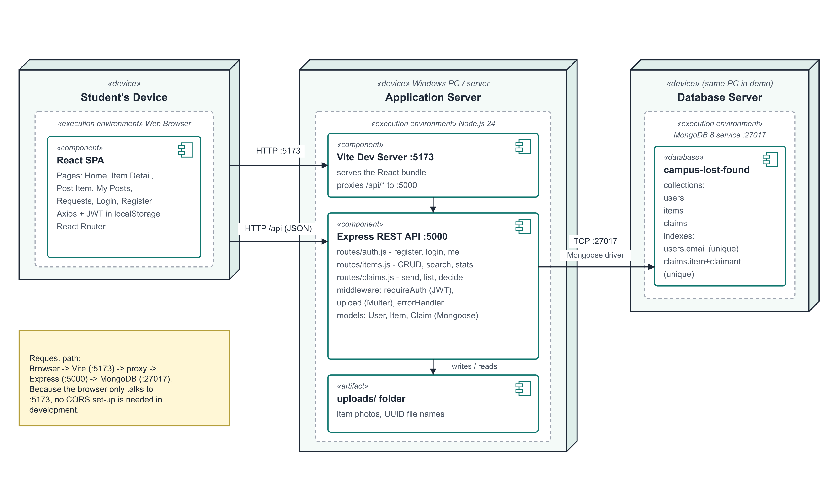
Figure 1 - Deployment view of the system

2.2 Product functions
- Account management - register, log in, log out.
- Item management - post found or lost items with optional photo, edit, delete, mark returned.
- Search - browse, keyword search, filters and pagination.
- Claims - send a claim with proof, view sent and received claims, approve or reject.
- Privacy - contact details only for logged-in users.

2.3 User classes and characteristics
User class | Characteristics | Permissions
Visitor | Anyone with the link; may be a new student or a guest | Browse, search, view (no contact details), register, log in
Student | Registered campus member; basic web skills; uses phone or laptop | All Visitor rights + post, claim, manage own posts, decide on own claims
Admin | Security / lost-and-found desk staff; trusted | All Student rights + edit or delete any post

2.4 Operating environment
- Client: any modern browser (Chrome, Edge, Firefox, Safari) on desktop or mobile.
- Server: Windows, macOS or Linux with Node.js 20 or later.
- Database: MongoDB 7 or later (Community Server), default port 27017.

2.5 Design and implementation constraints
- Must use open-source software only (no licence budget).
- Must be completed within one semester by a team of five.
- Photos limited to 5 MB and to jpg, png, webp and gif formats.
- Runs locally for the demonstration; no public hosting is assumed.

2.6 User documentation
A README in the project root explains installation, start-up, demo logins, the database design and the API. The application itself uses plain-language labels and error messages so that no separate manual is needed.

2.7 Assumptions and dependencies
- Users act in good faith when approving claims; the system records the decision but cannot physically verify ownership.
- The finder and owner arrange the physical hand-over themselves using the contact details shown.
- MongoDB is installed and running on the server.
- Depends on the libraries express, mongoose, bcryptjs, jsonwebtoken, multer, react, react-router-dom and axios.

3. External Interface Requirements

3.1 User interfaces
Screen | Route | Purpose
Home / Browse | / | Statistics, search box, filters, item cards with pagination
Item detail | /items/:id | Full item, poster, contact (if logged in), claim form or owner actions
Post an item | /report | Form: found/lost, title, description, category, location, date, photo with preview
My posts | /my-posts | Cards of items posted by the user
Requests | /requests | Tabs for received and sent claims; Approve / Reject buttons
Log in / Sign up | /login, /register | Account forms with inline error messages
All screens share a top navigation bar and show errors in a red banner and successes in a green banner. Protected screens redirect to Log in and return to the original page afterwards.

3.2 Hardware interfaces
No special hardware. The client needs a device with a browser; photos can be taken with the device camera and uploaded as files.

3.3 Software interfaces
Component | Interface
MongoDB | Accessed only by the API through the Mongoose ODM over TCP (port 27017)
File system | API writes photos to server/uploads and serves them at /uploads/<file>
Browser storage | The JWT is kept in localStorage under the key "token"

3.4 Communication interfaces
The client and server communicate over HTTP using JSON (multipart/form-data for photo uploads). Authenticated requests carry the header Authorization: Bearer <token>. In development the Vite server forwards /api requests from port 5173 to the API on port 5000.
Method | Endpoint | Access | Purpose
POST | /api/auth/register | Anyone | Create an account
POST | /api/auth/login | Anyone | Log in, returns a token
GET | /api/auth/me | Logged in | Current user details
GET | /api/items | Anyone | List / search (q, category, type, status, page, limit)
GET | /api/items/:id | Anyone | One item (contact hidden if logged out)
GET | /api/items/mine | Logged in | Items I posted
GET | /api/items/stats | Anyone | Counts for the home page
GET | /api/items/categories | Anyone | Category list
POST | /api/items | Logged in | Post an item (multipart, photo optional)
PATCH | /api/items/:id | Owner / admin | Edit or change status
DELETE | /api/items/:id | Owner / admin | Delete post, its photo and claims
POST | /api/claims | Logged in | Send a claim request
GET | /api/claims/sent | Logged in | Requests I sent
GET | /api/claims/received | Logged in | Requests on my posts
PATCH | /api/claims/:id | Item poster | Approve or reject

4. System Features

4.1 User accounts
Description and priority: Lets people create an account and log in so the system knows who is posting and claiming. Priority: High.
Stimulus / response sequences:
Stimulus | Response
Visitor submits sign-up form | Account created, user logged in
User submits login form | Token issued or generic error shown
User clicks Log out | Token removed; protected pages locked

Functional requirements:
ID | Requirement | Priority
FR-01 | Register account. A visitor can create an account with name, email, password (min. 6 characters) and optional phone. Emails must be unique (case-insensitive) and in a valid format. | Must
FR-02 | Log in / log out. A registered user logs in with email and password and receives a session token valid for 7 days. Wrong credentials give a generic error. Logging out clears the session. | Must

4.2 Posting and managing items
Description and priority: Lets finders (and owners of lost items) publish an item and later update or remove it. Priority: High.
Stimulus / response sequences:
Stimulus | Response
Student submits the Post an item form | Item saved as open and shown
Owner clicks Mark as returned | Status becomes resolved
Owner clicks Delete post and confirms | Item, photo and claims removed

Functional requirements:
ID | Requirement | Priority
FR-08 | Post an item. A logged-in user posts a found or lost item with title, description, category (fixed list of 10), location and date. All fields except the photo are required. | Must
FR-09 | Upload photo. An optional photo (jpg, png, webp, gif, max 5 MB) can be attached. It is stored under a random file name. | Should
FR-10 | Edit / delete own post. The poster can update their own post (the website uses this for "Mark as returned") or delete it; an admin can do so for any post. Deleting removes the photo and all claim requests on it. | Must
FR-11 | My posts. A logged-in user sees a list of the items they posted. | Should

4.3 Search and viewing
Description and priority: Lets anyone find items quickly. Priority: High.
Stimulus / response sequences:
Stimulus | Response
User types a keyword or picks a filter | Matching items shown, 12 per page
User opens an item | Details shown; contact only if logged in

Functional requirements:
ID | Requirement | Priority
FR-03 | Browse items. Anyone can see open items, newest first, 12 per page, as cards showing photo, type, title, category, location and date. | Must
FR-04 | Keyword search. Search text matches the title, description or location (case-insensitive). Special characters are treated as plain text. | Must
FR-05 | Filter items. Results can be filtered by category, by type (found / lost) and by status (open / returned / all). | Should
FR-06 | View item details. Anyone can open an item to see its full description, photo and the poster's name. Unknown or malformed ids give a clear message. | Must
FR-07 | Contact privacy. The poster's email and phone are shown only to logged-in users. | Must
FR-16 | Home statistics. The home page shows counts of open found items, open lost items and items returned. | Could

4.4 Claim requests
Description and priority: Lets an owner prove an item is theirs and lets the finder decide. Priority: High.
Stimulus / response sequences:
Stimulus | Response
Student sends a claim | Pending claim saved, or reason for refusal shown
Poster approves a claim | Item returned to claimant; other pending claims rejected
Poster rejects a claim | Claim marked rejected

Functional requirements:
ID | Requirement | Priority
FR-12 | Send claim request. A logged-in user sends a claim on someone else's open item with a message proving ownership. Only one request per user per item; returned items cannot be claimed. | Must
FR-13 | View requests. Posters see requests received on their items (with claimant contact). Claimants see requests they have sent and their status. | Must
FR-14 | Approve / reject request. Only the poster of the item can approve or reject a pending request. | Must
FR-15 | Mark item returned. Approving a request marks the item "returned" to that claimant and rejects all other pending requests. A returned item cannot be approved for anyone else. | Must

5. Non-Functional Requirements

5.1 Performance requirements
- Search results within 1 second for up to 1,000 items on a normal laptop (design target, supported by a compound index on category, type, status and date).
- Lists are paginated (12 items per page by default, maximum 48) so response size stays small.

5.2 Safety and integrity requirements
- An item can be returned to only one claimant (enforced in code and verified by TC-40 and TC-42).
- Deleting a post removes its photo and claims, leaving no orphan data.

5.3 Security requirements
- Passwords hashed with bcrypt; never returned by the API.
- JWT signed with a secret stored in .env (excluded from version control); tokens expire after 7 days.
- Ownership checks on every write; generic login error so attackers cannot learn which emails exist.
- Input type checks block NoSQL-injection payloads; search text is escaped before use in a regular expression.
- Uploads limited by type and size; stored under random UUID names.

5.4 Software quality attributes
ID | Quality attribute | Requirement | Verified by
NFR-01 | Security - passwords | Passwords are hashed with bcrypt (cost 10) and are never returned by the API or stored as plain text. | TC-01, TC-06
NFR-02 | Security - authorisation | Every write operation checks that the caller is logged in and owns the record (or is an admin). | TC-14, TC-21, TC-33, TC-38
NFR-03 | Privacy | Personal contact details are never shown to visitors who are not logged in. | TC-28
NFR-04 | Input validation & error handling | All inputs are validated on both client and server; every error returns a clear, human-readable message and the correct HTTP status code - never a crash. | TC-02, TC-10, TC-15, TC-18, TC-30
NFR-05 | Upload safety | Only image files up to 5 MB are accepted; file names are replaced with random UUIDs so a crafted name cannot overwrite files. | TC-17 to TC-19
NFR-06 | Performance | Search results should appear within 1 second for up to 1,000 items on a normal laptop. A compound database index supports the common filters. | Design target
NFR-07 | Usability | A new user can find an item and send a claim in at most 3 screens; the layout works on phones and desktops. | Manual UI tests
NFR-08 | Reliability / data integrity | An item can be returned to only one claimant; deleting a post leaves no orphan claims or photos. | TC-36, TC-40, TC-42, TC-43
NFR-09 | Maintainability | Code is split into models, routes, middleware (server) and pages, components, context (client); automated tests can be re-run with one command. | npm test
NFR-10 | Portability | Runs on Windows, macOS or Linux with Node.js 20+ and MongoDB; works in current Chrome, Edge and Firefox. | Demo machine

5.5 Business rules
- A student cannot claim their own post.
- A student can send at most one claim per item.
- Only the poster (or an admin for posts) can decide on a claim or change a post.
- A returned item cannot be claimed, and its claims cannot be decided again.
- Approving one claim automatically rejects all other pending claims on that item.

6. Data Requirements
The system stores three collections. Their relationships are shown in the class diagram.
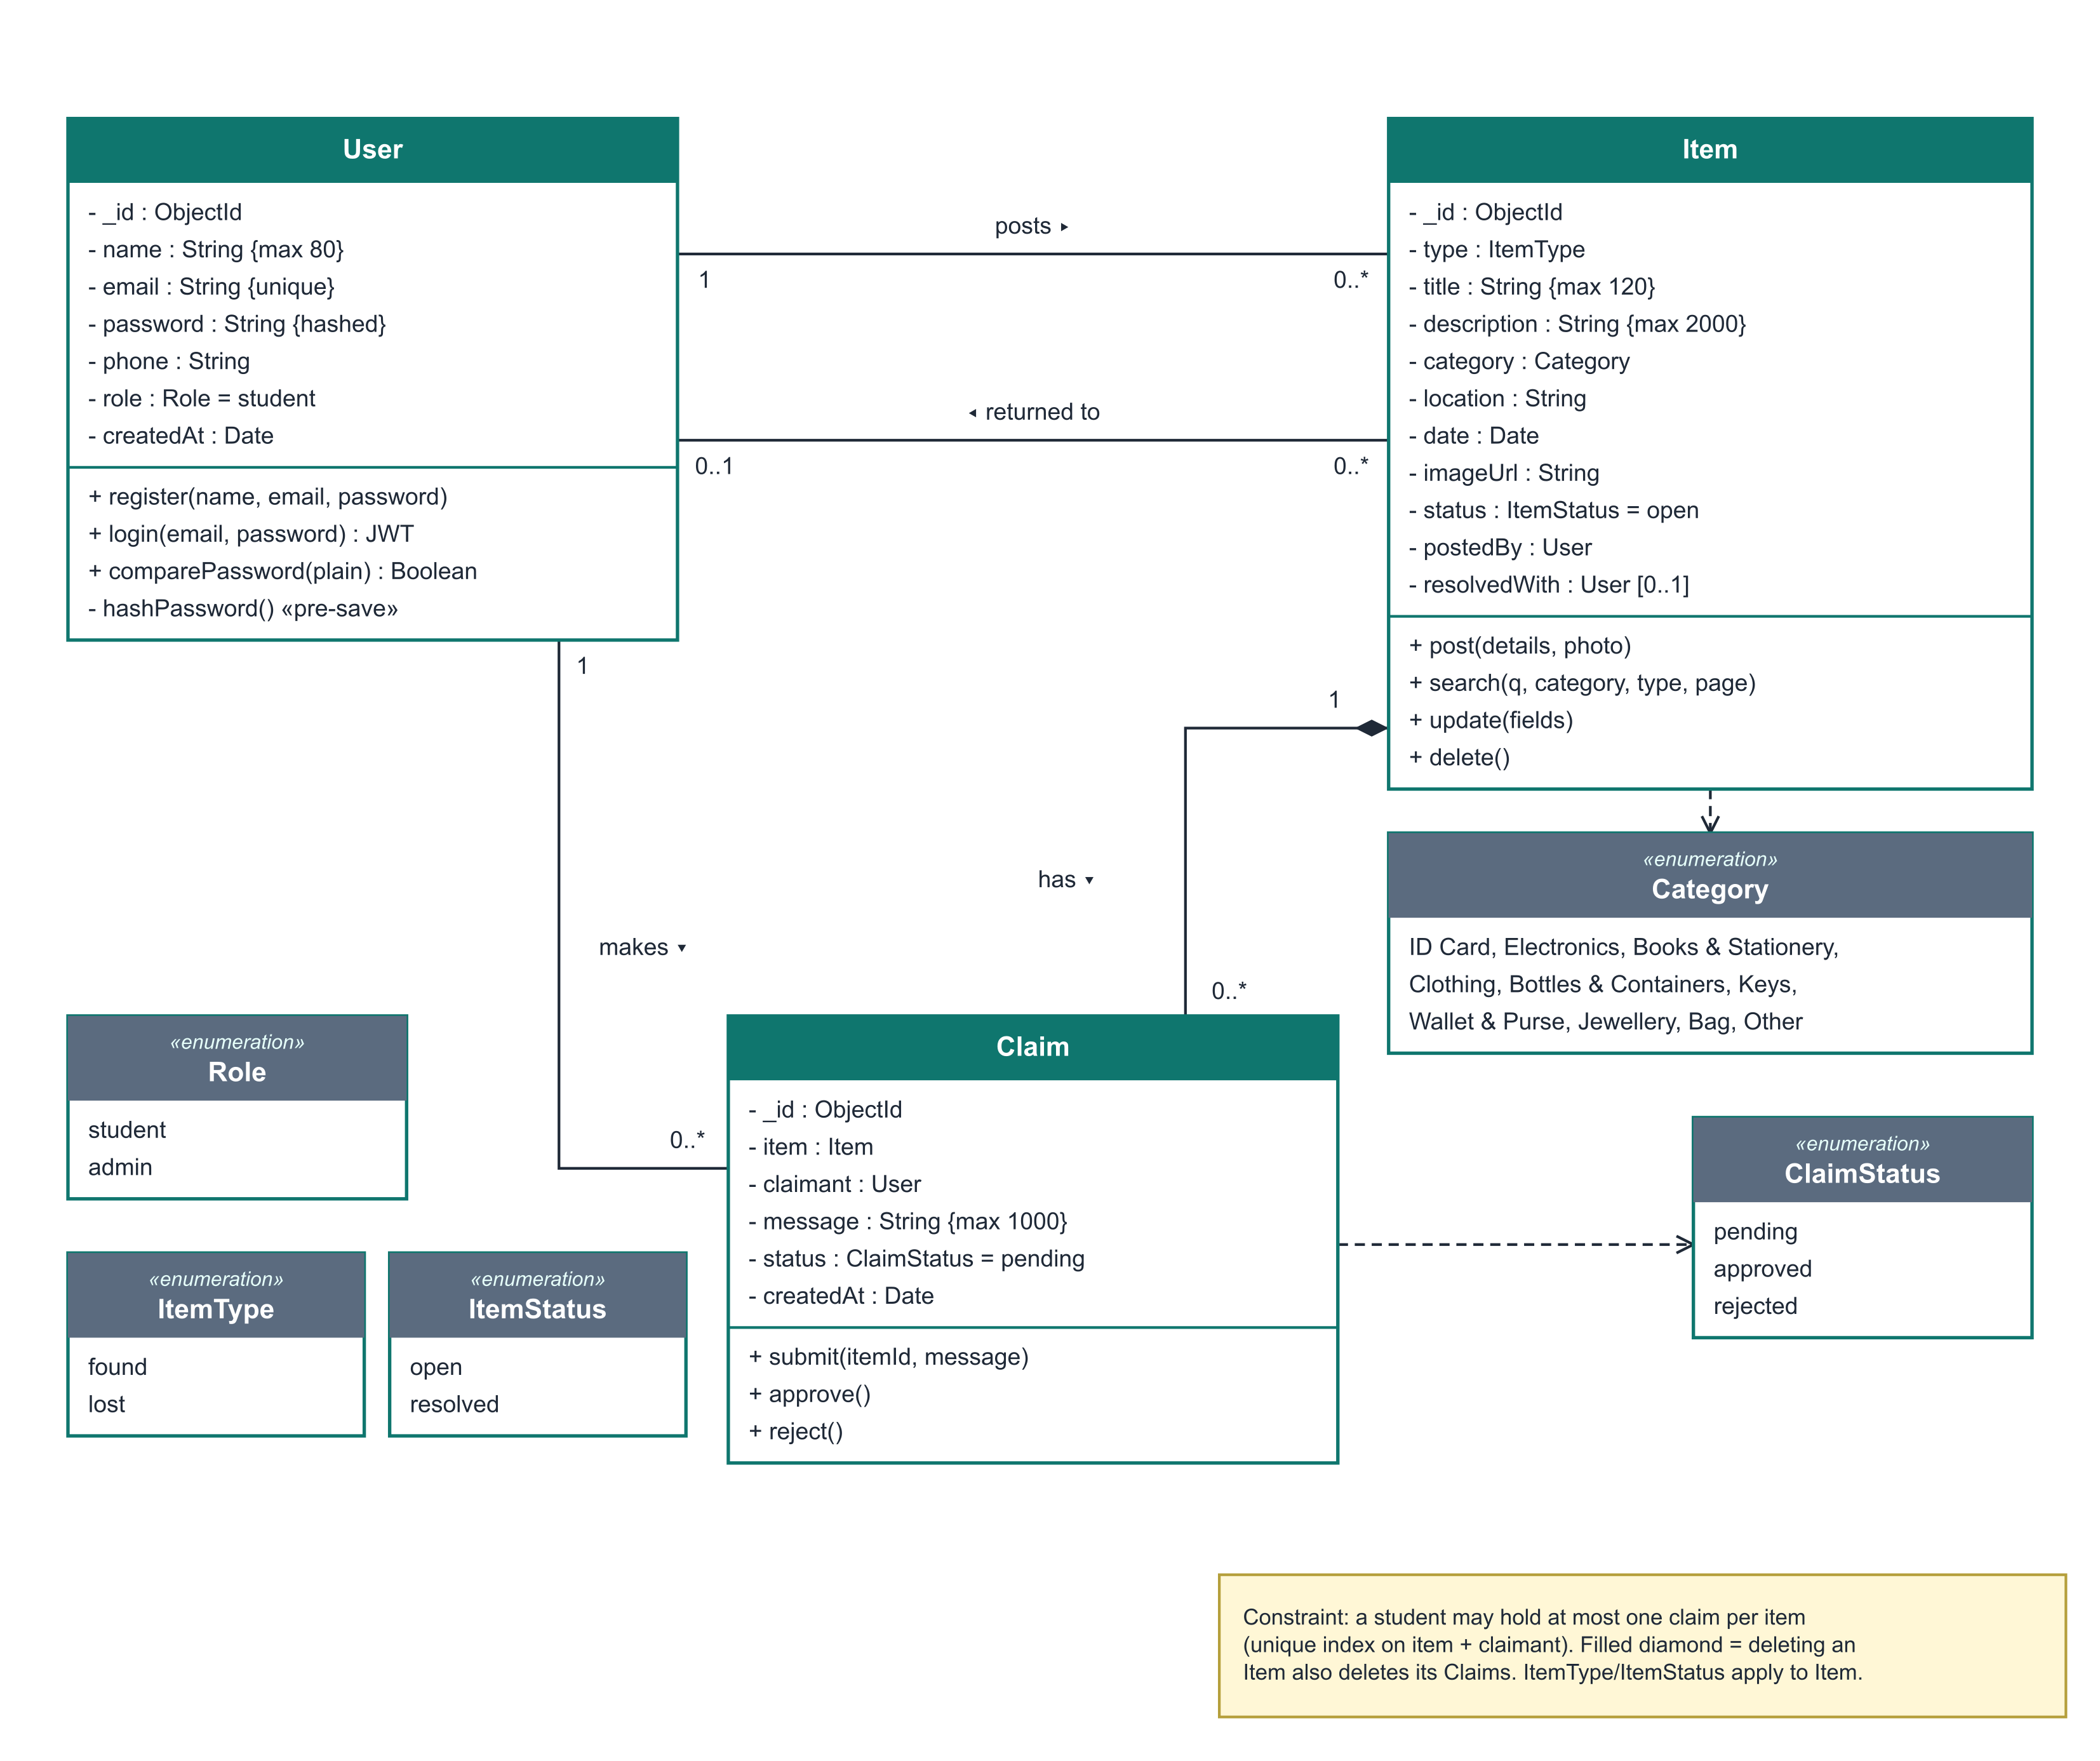
Figure 2 - Class diagram (logical data model)

User collection
Field | Type | Rules
name | String | Required, max 80 characters
email | String | Required, unique, lower-case, valid format
password | String | Required, min 6, bcrypt hash, hidden from queries
phone | String | Optional, max 20
role | Enum | student (default) | admin
createdAt / updatedAt | Date | Set automatically

Item collection
Field | Type | Rules
type | Enum | found | lost (required)
title | String | Required, max 120
description | String | Required, max 2000
category | Enum | One of 10 fixed categories
location | String | Required, max 160
date | Date | Required - when it was lost / found
imageUrl | String | Optional, /uploads/<uuid>.<ext>
status | Enum | open (default) | resolved
postedBy | ObjectId -> User | Required
resolvedWith | ObjectId -> User | Set when a claim is approved

Claim collection
Field | Type | Rules
item | ObjectId -> Item | Required
claimant | ObjectId -> User | Required; unique together with item
message | String | Required, max 1000 - proof of ownership
status | Enum | pending (default) | approved | rejected
Categories: ID Card, Electronics, Books & Stationery, Clothing, Bottles & Containers, Keys, Wallet & Purse, Jewellery, Bag, Other.

7. Verification
Each requirement was verified by automated system tests (server/tests/api.test.js) and manual UI tests. Results: Run 1 - 40 passed, 5 failed (4 product defects, 1 test error); Run 2 after fixes - all 45 test cases passed. Full details are in the Testing Report.
Requirement | Verified by | Result
FR-01 Register account | TC-01 to TC-05 | Pass
FR-02 Log in / log out | TC-07 to TC-12 | Pass
FR-03 Browse items | TC-23, TC-27 | Pass
FR-04 Keyword search | TC-24, TC-26 | Pass
FR-05 Filter items | TC-25 | Pass
FR-06 View item details | TC-28, TC-30 | Pass
FR-07 Contact privacy | TC-28, TC-29 | Pass
FR-08 Post an item | TC-13 to TC-16 | Pass
FR-09 Upload photo | TC-17 to TC-19 | Pass
FR-10 Edit / delete own post | TC-20, TC-21, TC-43 | Pass
FR-11 My posts | TC-22 | Pass
FR-12 Send claim request | TC-32 to TC-36, TC-41 | Pass
FR-13 View requests | TC-37 | Pass
FR-14 Approve / reject request | TC-38, TC-39 | Pass
FR-15 Mark item returned | TC-40, TC-42 | Pass
FR-16 Home statistics | TC-31 | Pass

Defects fixed during verification
ID | Defect | Severity | Fix
D-01 | Invalid email addresses are accepted at sign-up | Medium | Added an email pattern check in routes/auth.js and a "match" validator on User.email.
D-02 | Non-text login input crashes the request (500) | Medium | routes/auth.js now rejects non-string email / password (and name on register) with 400.
D-03 | Uploading a non-image returns a server error | Low | middleware/upload.js sets err.status = 400 on the rejected-file error.
D-04 | A returned item can be "returned" again to another claimant | High | routes/claims.js refuses any decision on a claim whose item is already resolved.

Appendix A - Analysis Models
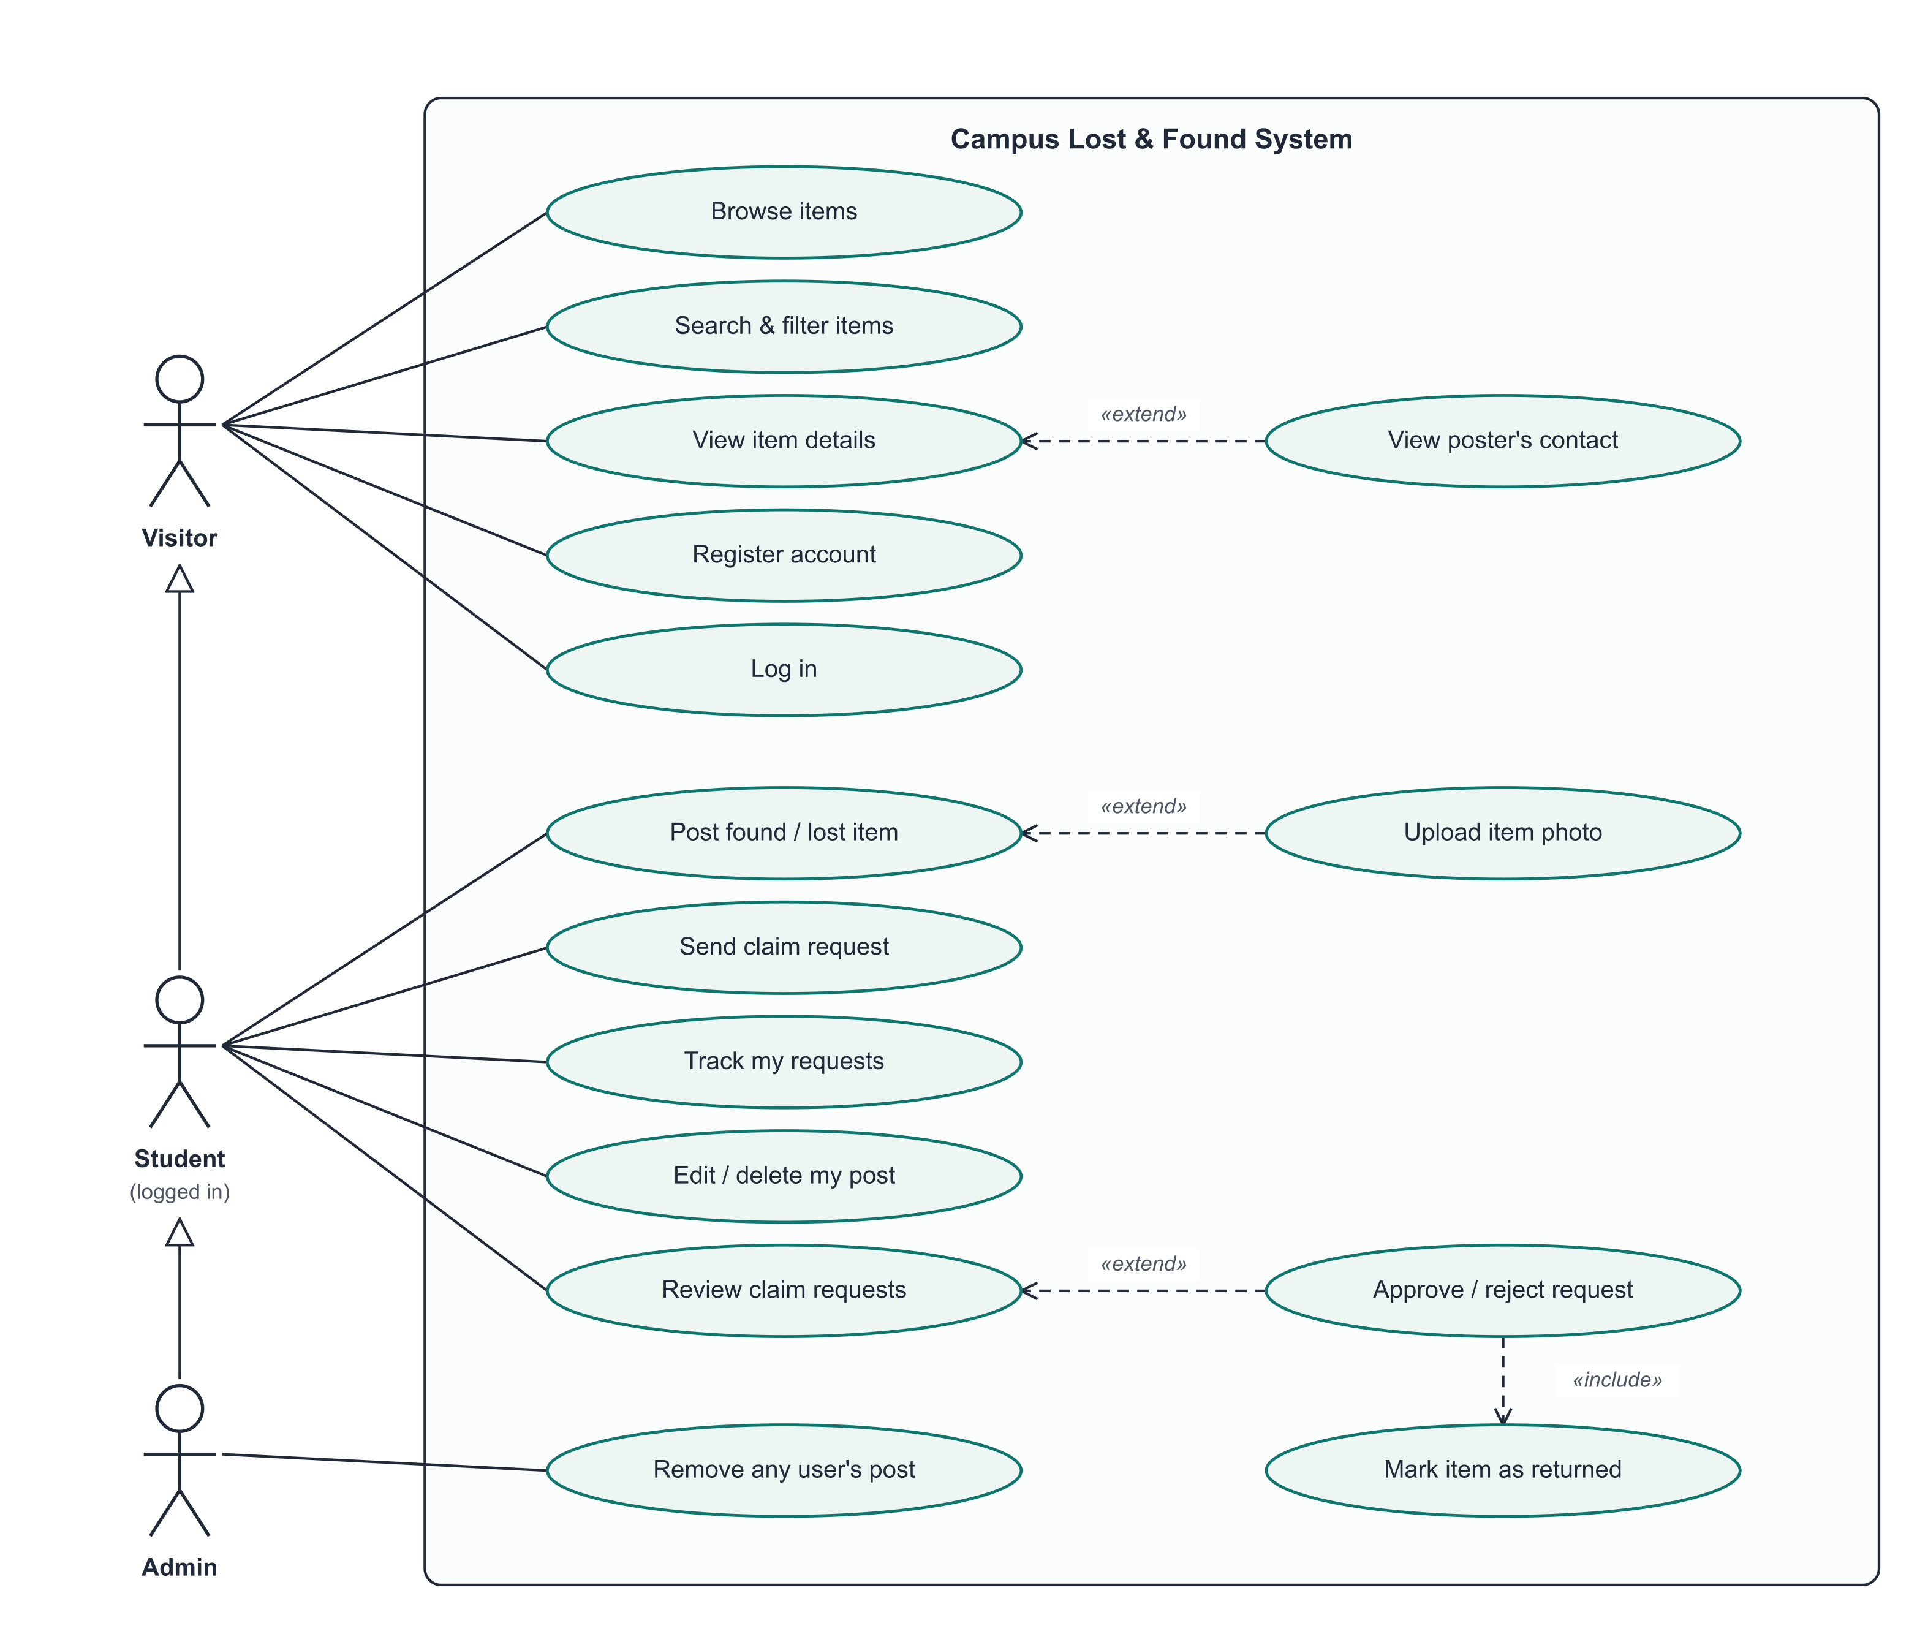
Figure A1 - Use case diagram
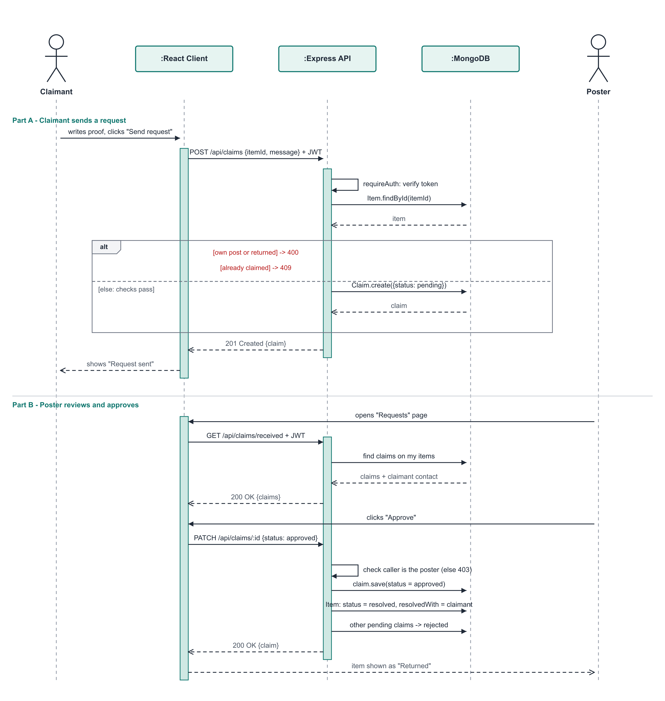
Figure A2 - Sequence diagram: claiming an item
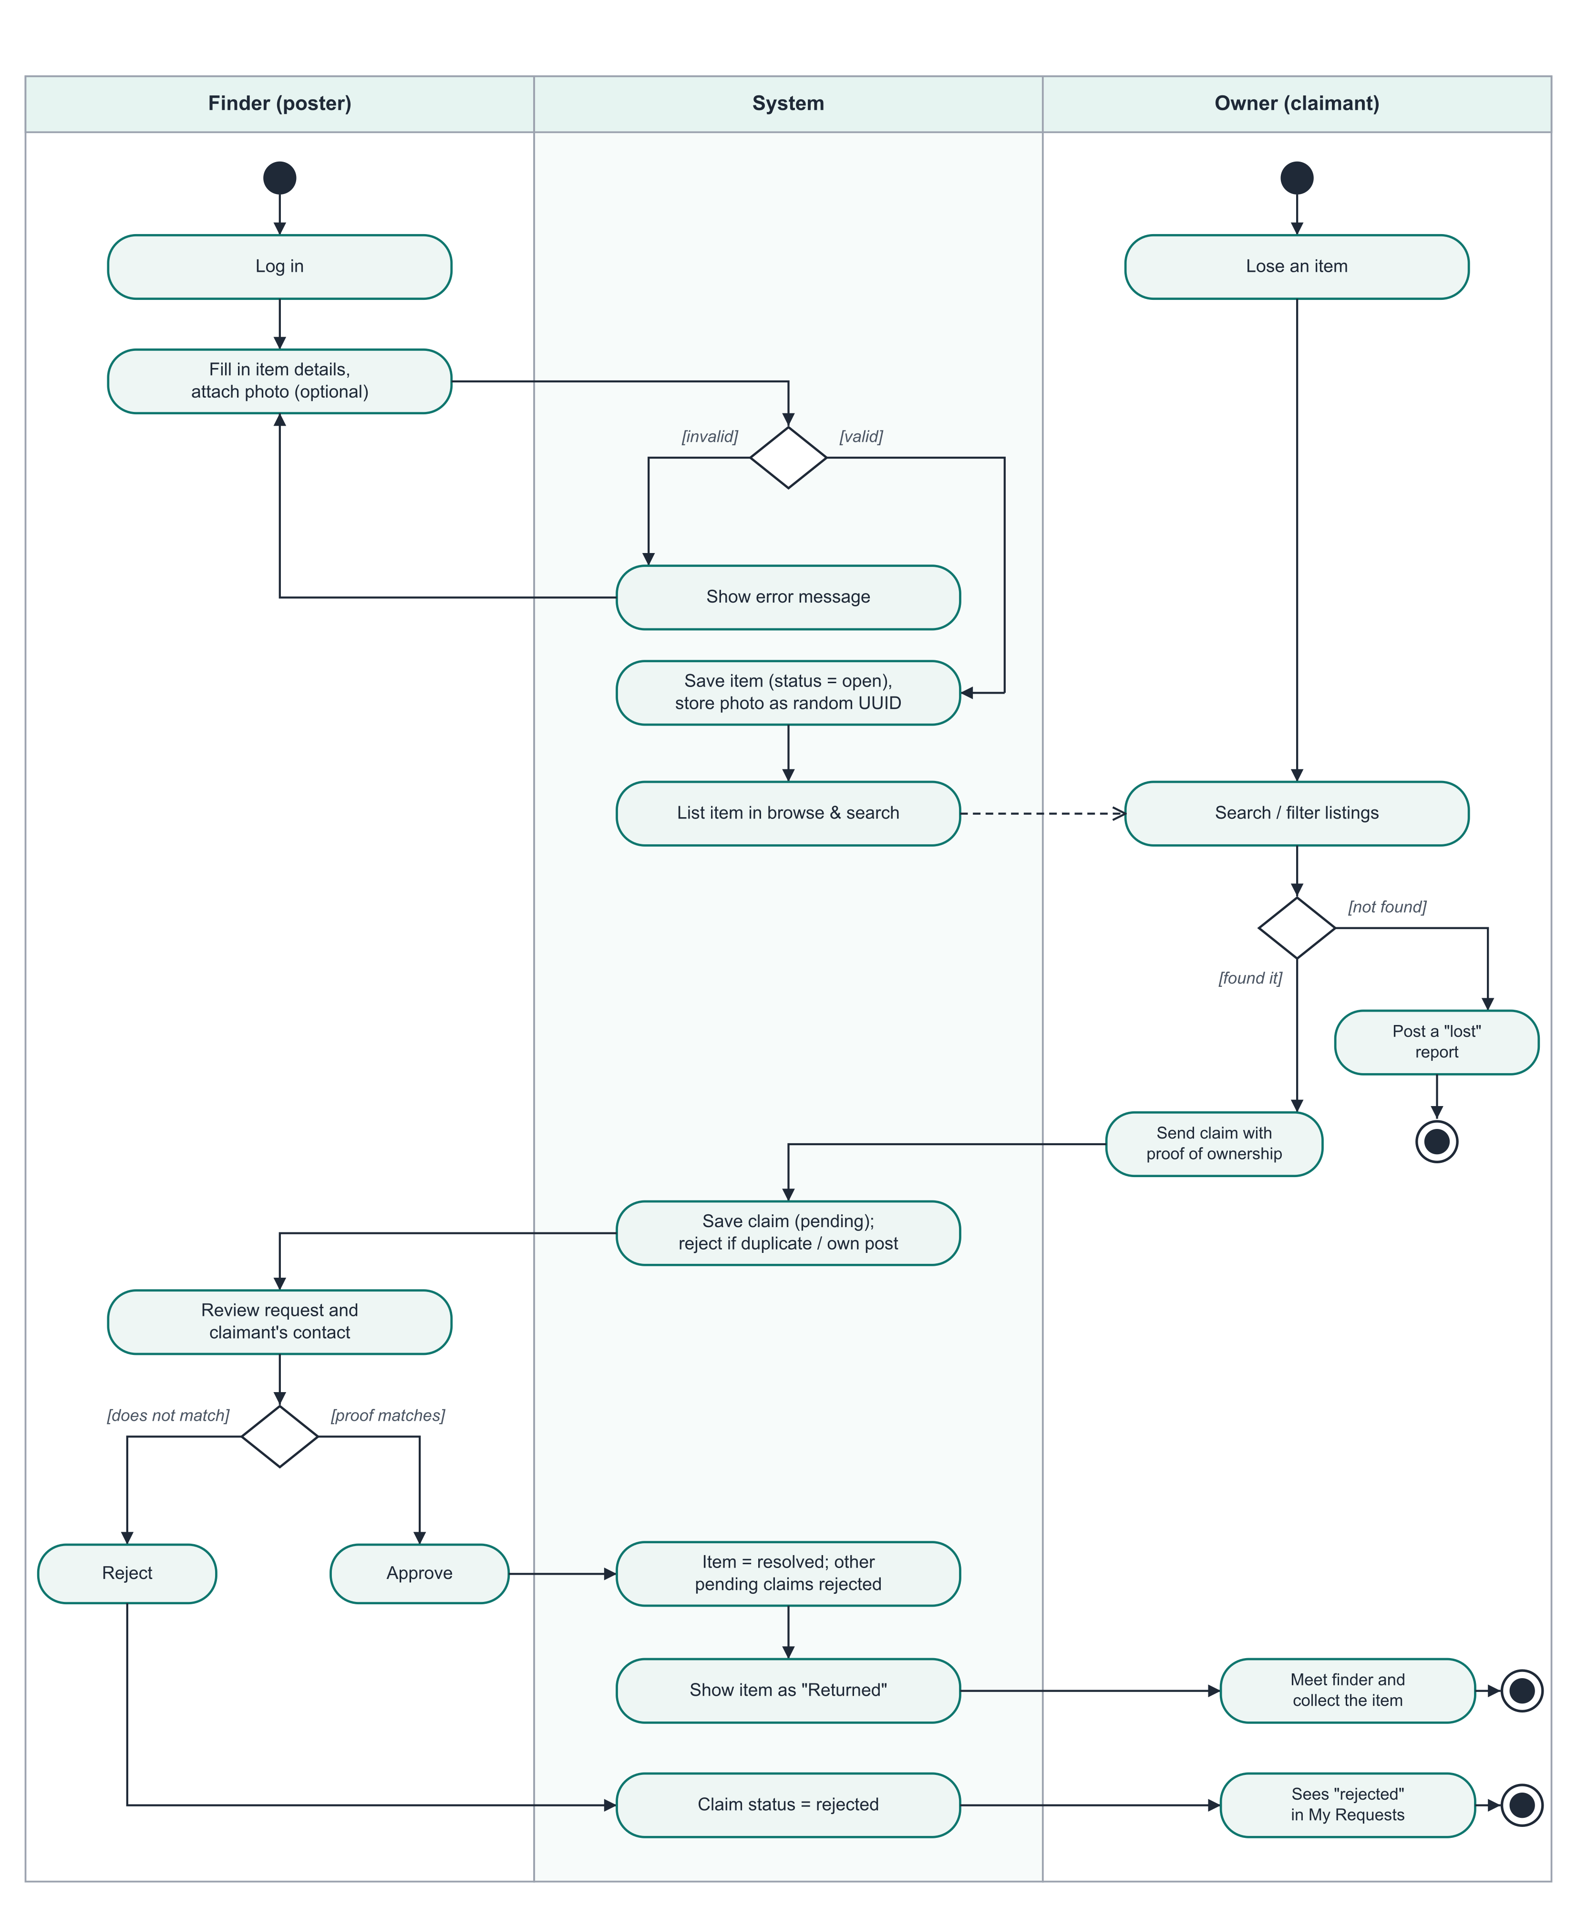
Figure A3 - Activity diagram: from posting to returning an item

Appendix B - Use Case Specifications

UC-01: Register and log in
Primary actor | Visitor
Precondition | The visitor is not logged in.
Main flow | 1. Visitor opens "Sign up" and enters name, email, password and (optionally) phone.  2. System validates the fields and checks the email is not already registered.  3. System hashes the password, creates the account and returns a session token.  4. Visitor is now logged in and taken to the home page.
Alternate flows | 2a. Missing field, invalid email or password shorter than 6 characters: system shows the error and keeps the form filled.  2b. Email already registered: system shows "An account with that email already exists."
Postcondition | An account exists and the user has an active session.

UC-02: Post a found / lost item
Primary actor | Student
Precondition | The student is logged in.
Main flow | 1. Student clicks "Post an item" and chooses Found or Lost.  2. Student enters title, description, category, location, date and optionally attaches a photo.  3. System validates the data and the photo (type and size).  4. System saves the item with status "open" and shows its detail page.
Alternate flows | 3a. A required field is missing or the category is invalid: an error message is shown.  3b. Photo is not an image or is larger than 5 MB: an error message is shown and nothing is saved.
Postcondition | The item appears in browse and search results.

UC-03: Search for an item
Primary actor | Visitor / Student
Precondition | None.
Main flow | 1. User opens the home page; the newest open items are listed.  2. User types a keyword and/or chooses category, type and status filters.  3. System returns matching items, 12 per page, newest first.  4. User opens an item to view its details.
Alternate flows | 3a. No matches: system shows an empty-state message.  4a. User is logged in: poster's email and phone are also shown (extend: View poster's contact).
Postcondition | None (read-only).

UC-04: Send claim request
Primary actor | Student (claimant)
Precondition | Student is logged in; the item is open and was posted by someone else.
Main flow | 1. Student opens the item and writes a message describing a detail that proves ownership.  2. Student clicks "Send request".  3. System checks the item exists, is open, is not the student's own post and has no earlier request from this student.  4. System saves the request as "pending"; it appears in the student's "Requests" page.
Alternate flows | 3a. Own post: "You cannot claim your own post."  3b. Item already returned: "This item has already been returned."  3c. Already requested: "You have already sent a request for this item."
Postcondition | A pending claim is visible to the poster.

UC-05: Review and approve a request
Primary actor | Student (poster)
Precondition | Poster is logged in and has at least one pending request on an open item.
Main flow | 1. Poster opens "Requests" and reads each claimant's message and contact.  2. Poster clicks Approve on the request whose proof matches.  3. System marks the request "approved", the item "returned" to that claimant, and rejects all other pending requests on the item (include: Mark item as returned).  4. Poster and claimant arrange the hand-over.
Alternate flows | 2a. Proof does not match: poster clicks Reject; the claim becomes "rejected".  3a. Someone other than the poster tries: "Only the person who posted the item can do that."  3b. Item already returned: approval is refused.
Postcondition | Item status is "returned"; exactly one approved claim exists for it.

Appendix C - Future Enhancements
- Email or push notification when someone claims your item or your claim is decided.
- Sign-up restricted to the college email domain, or single sign-on with the college account.
- Admin dashboard to review reported or spam posts.
- Automatic matching of lost and found reports using text and image similarity.
- Hosting on a cloud platform with HTTPS.

