Michael O’Keefe

PA2 – Output Results

**Output:**

When first running the program that the GUI screen will appear as such:

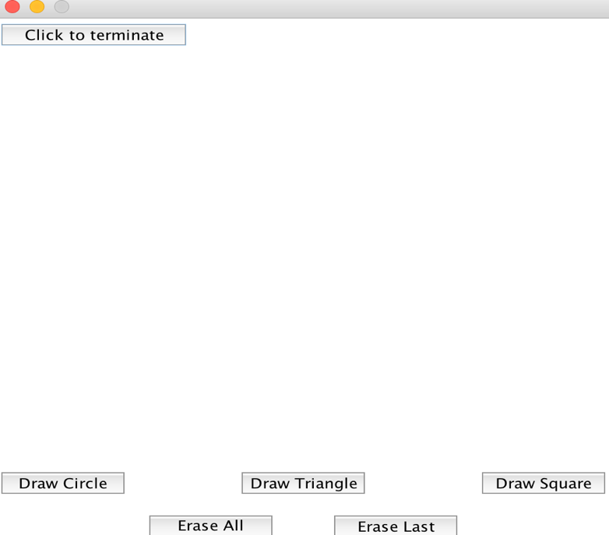

The following screen shows what happens after clicking all three draw <shape> buttons, note that the shapes appear in random places:

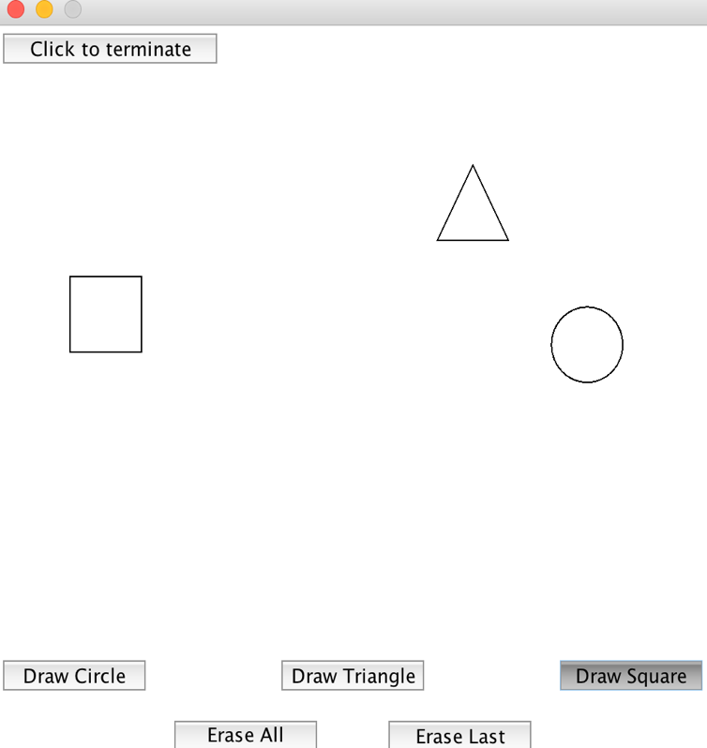

After clicking Erase Last is shown next (the square button was clicked last as shown in the picture above where the Draw Square button is pressed in):

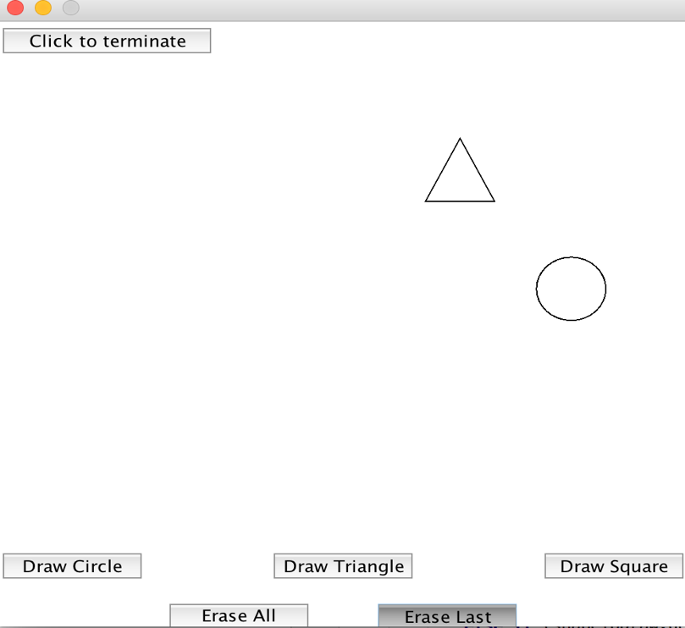

After Erase Last is pressed again:

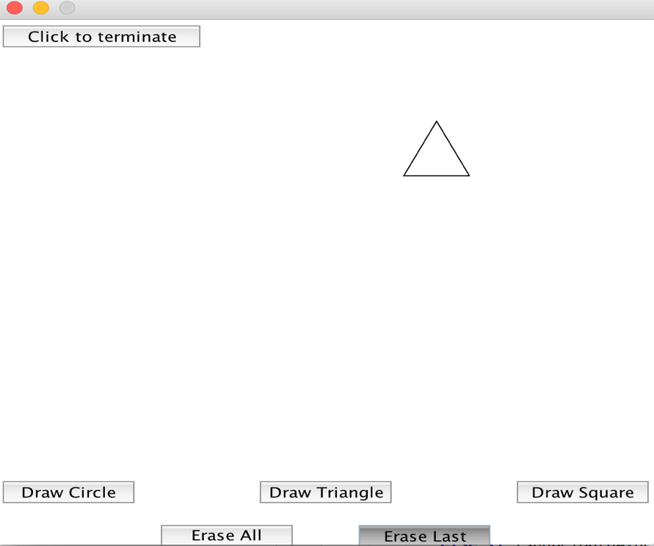

After pressing Draw Triangle many times:

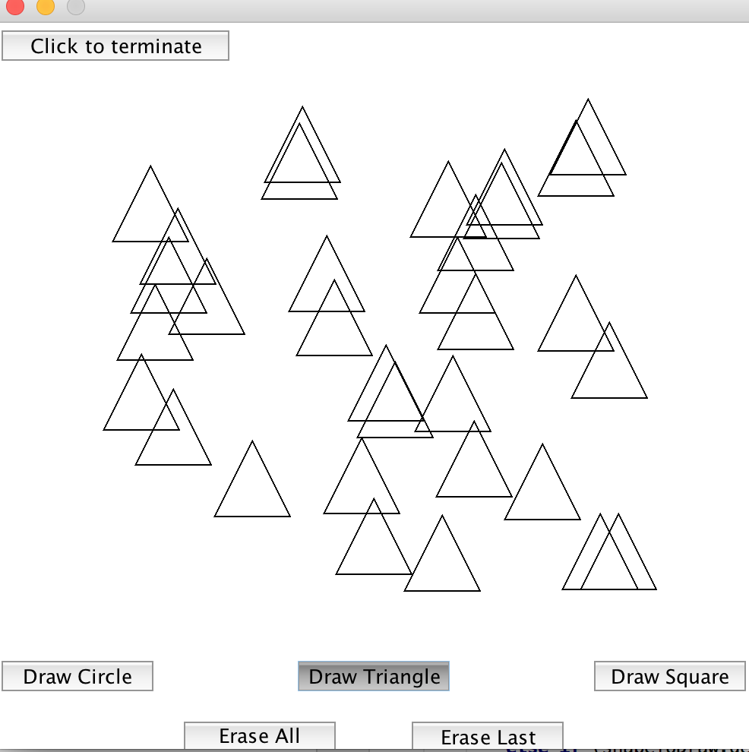

After pressing Erase All:

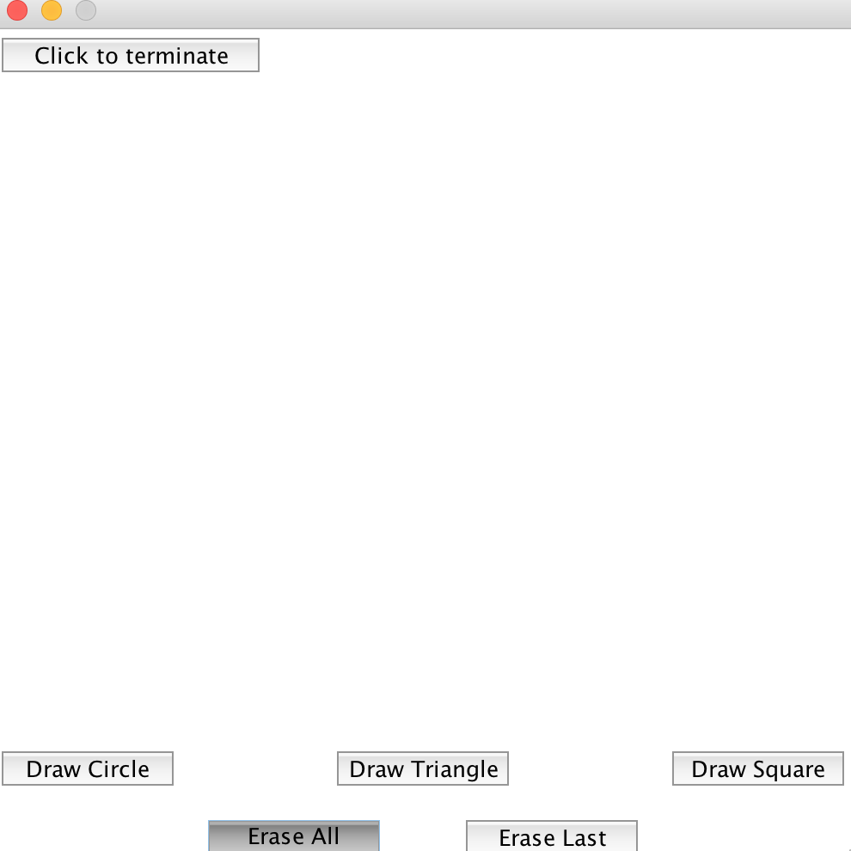

After pressing many of each Draw button:

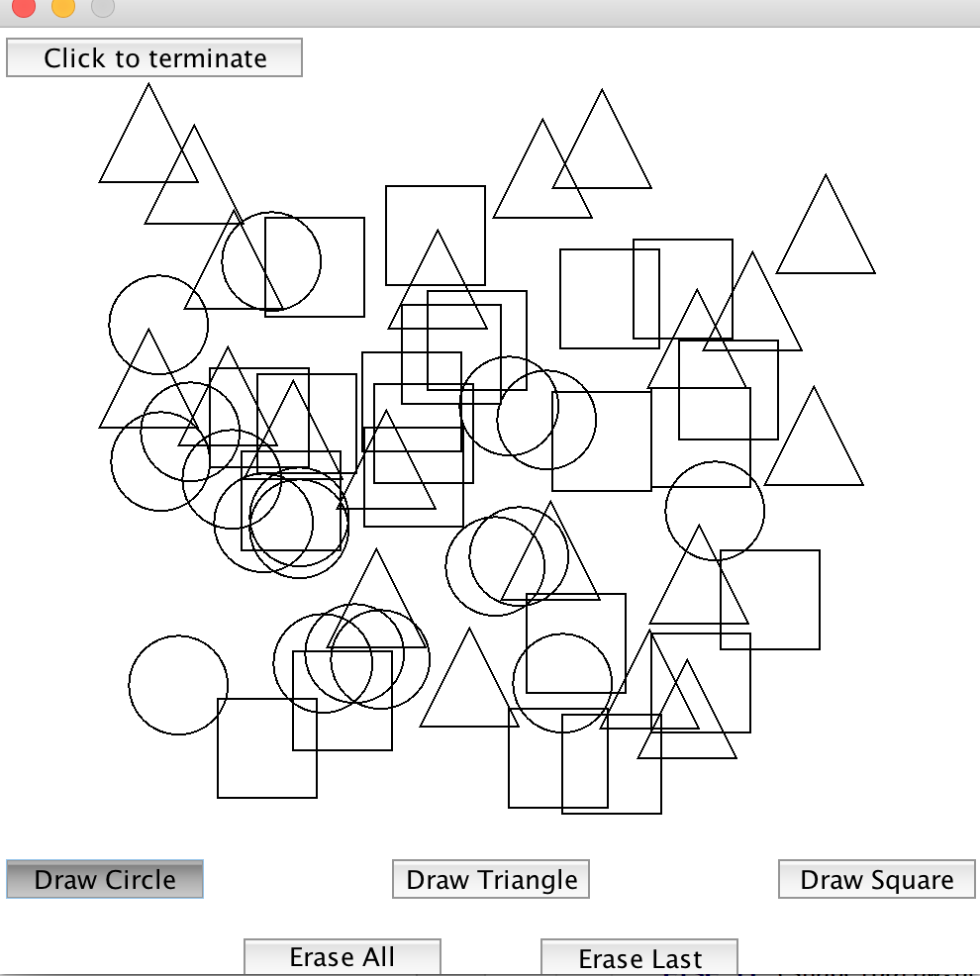

After pressing Erase Last multiple times (note that when a single shape is erased and it was previously overlapping with another shape, then the existing shape that was being overlapped will now have small gaps in its structure where the erased shape used to be: this was done on-purpose since recreating each shape on display after one is erased is a costly operation):

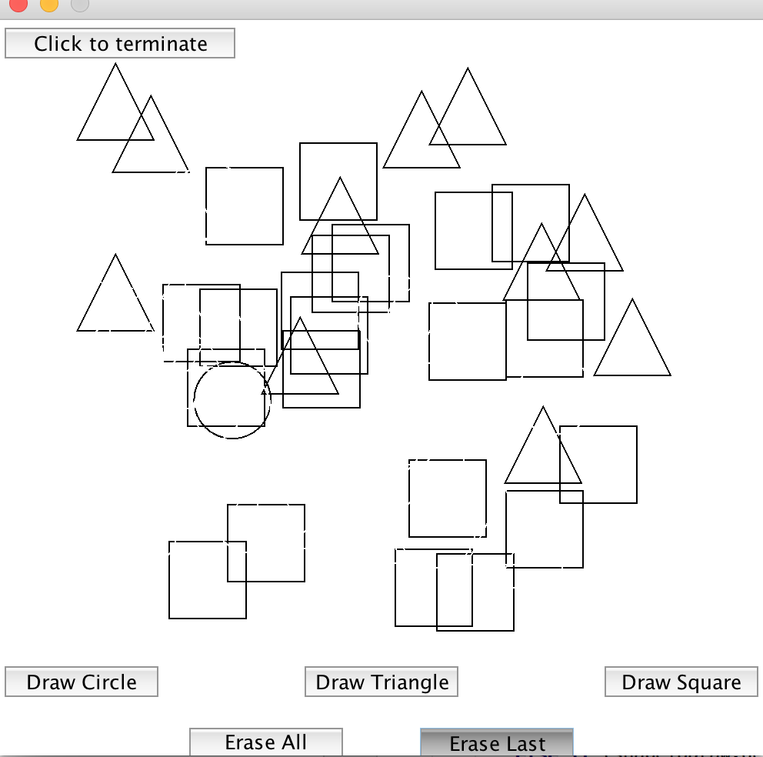

After clicking Erase All:

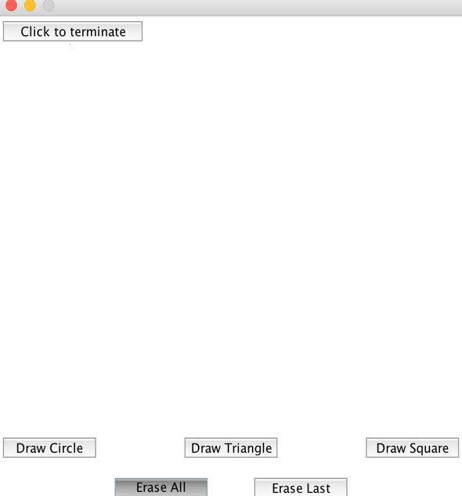

After clicking Click to terminate:

../Screen%20Shot%202016-02-01%20at%208.26.52%20PM.png