Copyright:
The information and material contained in this User Guide includes proprietary, confidential information pertaining to Qatar Airways. This User Guide is intended for use solely by the employees of Qatar Airways who have the privileges to use the iPrism Application. The Users of this Guide shall not disclose the contents outside of Qatar Airways and shall not duplicate, use, or disclose in any manner whatsoever to anyone, for any purpose other than to evaluate the contents of this document.
All registered trademarks, logos and copyright belong to Qatar Airways.
Other names and brands may be claimed as the property of others.

Purpose of Document
The purpose of this document is to provide information about the iPrism Application. This document contains step-by-step instructions to enable you to use the application.
Target Audience
The intended audience for this document is the end users of the Qatar – Cabin Crew. They include:
Qatar – Cabin Crew
Administrative Staff

Chapter Organization
This section provides information on how the chapters are organized within this user guide.

SI No. | Chapter Name | Description
1 | Introduction | Provides an overview of the application and describes the key features and benefits of using the application.
2 | Getting Started | Provides information on the prerequisites required to use the application. This includes system requirements. This chapter also provides step-by-step instructions on how to access the application.
3 | Navigating the User Interface | Describes the iPrism . This chapter also describes the application conventions and lists the shortcut keys that will enable you to easily navigate within the application.
4 | Using IPrism | Provides an overview of the various modules within the application and provides detailed step-by-step instructions that will enable you to use the various features.
5 | Abbreviations | Provides a list of terms specific to the application and their respective definitions.
6 | Index | Provides a list of terms and the pages on which they are located, enabling you to easily navigate this document.

Document Conventions
This section describes the style conventions used in this document.
SI No. | Style | Description | Convention
1 | Note | Provides additional information related to a particular topic. | Note:
2 | Warnings | Alerts the Users on critical actions in the application. | ! Warning:
3 | Navigation | Names of features and form controls such as titles, buttons and text boxes will be displayed in bold font.
4 | Related Topics | Provides links to related topics | Related Topics

Contents:
1.1 Contents: 4
1.2 Introduction 5
1.1 Site Overview 5
1.2 Key Feature 5
1.3 Key Benefits 5
2. Getting Started 7
2.1 System Requirements 7
2.2 Hardware Requirements- Minimum requirements 7
2.3 Software Requirements (Web Application User) 8
2.4 Login Process 8
3. Accessing the Application 10
3.1 Using IPrism 11
3.2 My Roster (Roster Module) 11
3.3 Detailed Roster 12
3.4 Station Info 13
3.5 Hotel Info 14
3.6 Crew Details. 15
3.7 Summary of Services. 16
3.8 Notifications 17
3.9 My Space 18
3.10 Global Weather 20
3.11 Currency Converter 20
3.12 OTP (On Time Performance) 21
3.13 Document library 21
3.14 Important Links 23
3.15 News 24
3.16 eVR 25
3.17 Requests 31
3.18 Help 34

Introduction
This chapter provides an overview of the IPrism. This chapter includes the following sections:
- Product Overview
- Key Features
- Key Benefits

Site Overview
IPrism is designed and developed to cater and track the activities and related information of the Cabin Crew members. Roster module depicts the Roster and Flight Schedule information along with Station, Hotel, Summary of Services and Crew On board details of the logged in user. It manages the related documents of the Crew Member, provides Departmental News, Corporate news, Airlines News, Currency Converter Feature, Weather information and many more. Crew members can have access to Mails, Notifications and Alerts through the iPrism application. The application also provides various modules to the crew members to enter Voyage reports, Assessment scores and raise different types of housing requests.

Key Feature

- My Roster (Roster Module)
- Notifications
- My Space
- City Weather Module
- Currency Converter Module
- Document Library Module (Documents related to Operational, Safety and Training documents, etc.)
- Corporate and Department news
- Airlines News
- Survey
- Application Links Module
- eVR
- Performance
- Requests

Key Benefits
- My Roster (Roster Module)
My Roster shows the daily flight schedule and available service code for the logged in crew members along with Station, Hotel, Summary of Services and Crew on Board details. The Roster Module shows the Roster details of the logged in user. By default the current day Roster details will be displayed. The user can get the roster information of the Current month, next month or the previous month as needed. Along with Monthly roster the crew member can view the Code explanations, Flight Indicator, UTC difference and Monthly block hours.
- City Weather Module
- Shows weather forecast of various places based on the City/Country selected.
- Shows weather Prediction for 5 days including the current day.
- Currency Converter Module
- Calculate currency and foreign exchange rates
- Provide an easy interface to convert more than hundred currency
- Accurate and reliable converter to cater the needs of the Crew Member.
- Document Library Module
- Provides an easy customized view of all the documents related to the logged in user.
- Shows documents of different Category like Operational Manual, Safety Document, Training Documents , Air Crew Notice Documents and Other Documents
- Facilitate to read the document.
- Departmental News
- Shows the Latest news of the Cabin Services Department.
- Airlines News
- Through RSS (Really Simple Syndication) Feed shows the latest Airlines News.
- Survey
- Shows the QR surveys
- Current user can respond to the survey
- Application Links Section
- Provides links to connect different QR application
- Logged in user can click on the links provided and new browser open up
- Useful Links
Contains important applications’ link which users use very often
- SSHR
- Interbids
- Estaff Travel
- ADQ
- My space
This module provides link for user to view personal profile. Here the users have access to all the personal information like personal documents, Destination visited, Milestones, Annual Leave entitlement, Qualifications and Training history
- eVR
This module is used to enter and view Voyage reports and Flight delays. User can add/edit flight details, search, view, enter, save and submit Voyage Reports and Flight Delays
- Performance
This module is used for entering assessments scores for Cabin services and SEP.
- Requests
The request module assists the crew members to raise housing requests as mentioned below.
- Change Accommodation/
- Moving Out/Moving In
- Item replacements
- Daily maintenance
- Guest accommodation

Getting Started
This chapter provides information on the prerequisites required to use the IPrism. It also provides information on how to access the application through the Web interfaces. This chapter includes the following sections:

- System Requirements
- Login Details
- Accessing the Application

System Requirements

Hardware Requirements- Minimum requirements
- Processor - Intel Core 2 Duo Processor
- Processor Speed - 3.16 GHz
- Type - Duo Processor
- Memory - 4GB
- Hard Disk Space - 40 GB

Software Requirements (Web Application User)
- Operating System - Windows 2003/Windows XP / Vista
- Web Browser – IE 7.0 / Mozilla 3.0/Safari

Login Process
Application could be accessed using the below mentioned URL

URL: https://iprism.qatarairways.com.qa

Once the user hits the above URL, application login page appears and asks for the AD (Active Directory) credentials. After authentication user is redirected to the additional application authentication page where user is required to enter Captcha and a pin. The Pin is actually the date of joining of the user in DD-MM-YY format. On successful login the Home page of the iPrism application is displayed.

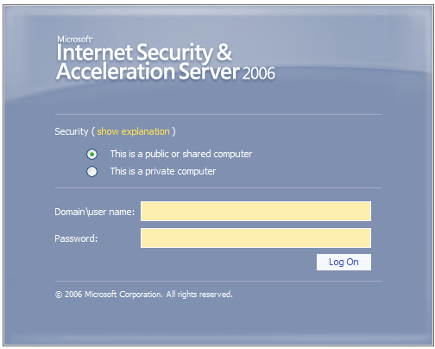
Fig: Login Screen.

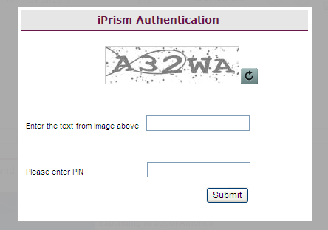

Fig: Captcha screen 1.

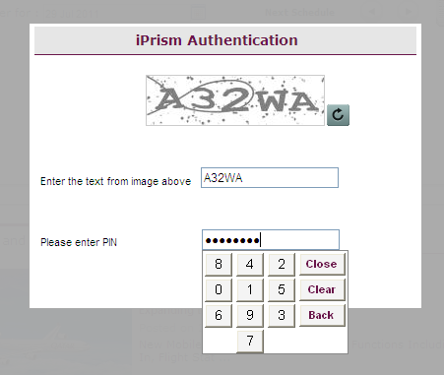
Fig: Captcha screen 2.

Accessing the Application
This section provides information on how to access the IPrism. Based on the assigned user role, this application can be accessed using one of the following methods:
The Crew Web Application is provided to the Cabin Crew, enabling them to access application from any location via the Intranet. To access the application using the Web Interface, perform the following steps: Open the link for the IPrism in the browser

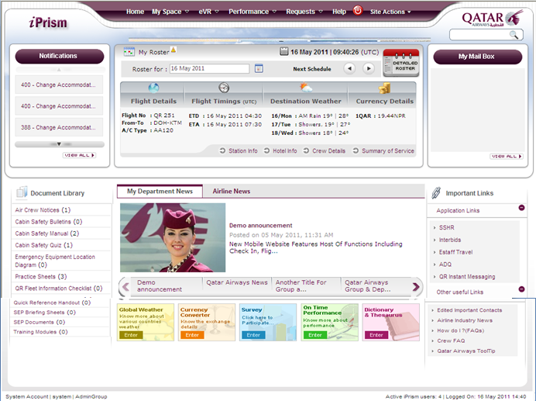

Fig: iPrism Home Page.

Using IPrism
This chapter provides information on the various modules of the IPrism.

My Roster (Roster Module)
My Roster web part on the home page is displays the duties/flight schedule of the selected date.
The date’s selection is set to the current day by default. User can scroll forward and backward to view the next/previous schedule.
User can also select a particular date to view the duty schedule for the desired day.

The flight schedule gives information on flight details/flight timings, Destination Weather and Currency details. The link for Detailed Roster, Station Info, Crew Details, Hotel Info and Summary of Services are also provided in this view.

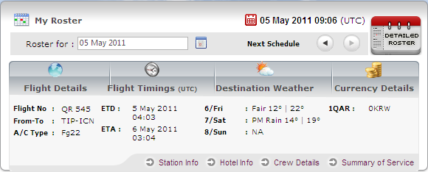

Fig: My Roster.

Detailed Roster
The Detailed Roster link navigates the user to the full view of the roster for the current month. The roster can be viewed in UTC time, Doha Time and Local base time as well through radio button options provided on the top right of the Detailed Roster screen. The Roster displays the Flight Details/Duty codes for each particular day of the month. User can click on the backward and forward buttons provided to view the past months rosters. Along with flight details and applicable Duty codes the crew members can also view information on the Code explanations, Flight Indicators, UTC difference and Monthly Block Hours.

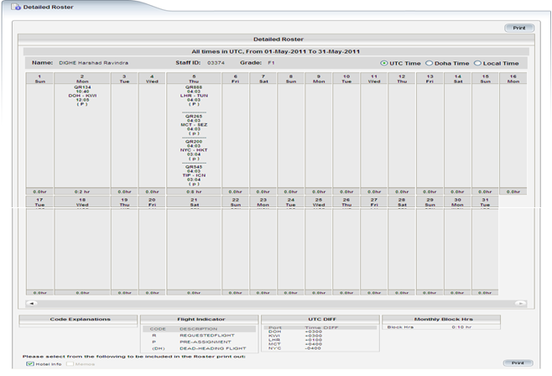
Fig: Detailed roster.

User can also print the entire roster along with Hotel info and Memos by clicking on Print button provided at the top and bottom right of the screen. By default the Hotel info option would be chosen. The user can select or deselect the options and print the roster along with required details.

When mouse pointer is hovered on particular flight duty on the detailed roster, a popup window is displayed providing links for Station Info, Hotel Info and Crew Details.

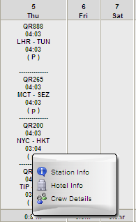

Fig: My Roster-Mouse Hover

Station Info
The Station information screen is displayed upon triggering the ‘Station Info’ link on the home page gives the details of the destination city to which the crew member is flying. The crew member can have the information relating to Local time, language, Currency, Country code, Handling agents, Catering and station contact. Along with station information the crew member can view the relevant Airport information as well. From the station info screen the user can navigate back to the home page or visit the Hotel Info, Summary of services or Crew details screen.

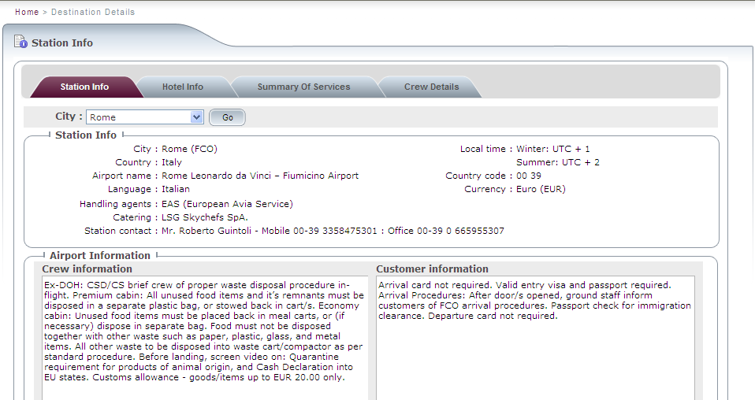

Fig: Station Info Screen

Hotel Info
The Hotel Information screen is displayed upon clicking the ‘Hotel Info’ tab. This screen gives the details of the hotel that the crew will be staying during the layover. Apart from getting the hotel address, telephone, fax, and hotel contact details, the crew can also get information on hotel discounts and benefits (if any). From the Hotel info screen the user can navigate back to the home page or visit the Station Info, Summary of services and Crew details screen.

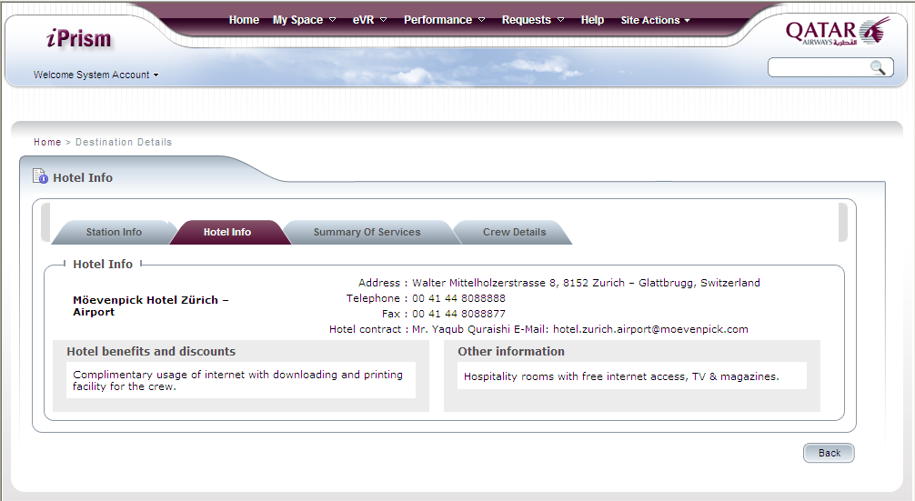

Fig: Hotel Info Screen.

Crew Details.
The Crew Details screen displayed upon clicking the ‘Crew details’ link. This screen gives the details of the other Crew operating the selected flight. User can select the date range and the desired flight from the drop down menu and view the details of crew members for the respective flight. User can also use the next and previous buttons to view the crew details for next flight schedule for the selected date range. From the Crew details screen the user can navigate back to the home page or visit the Station Info, Hotel Info and Summary of services screen.

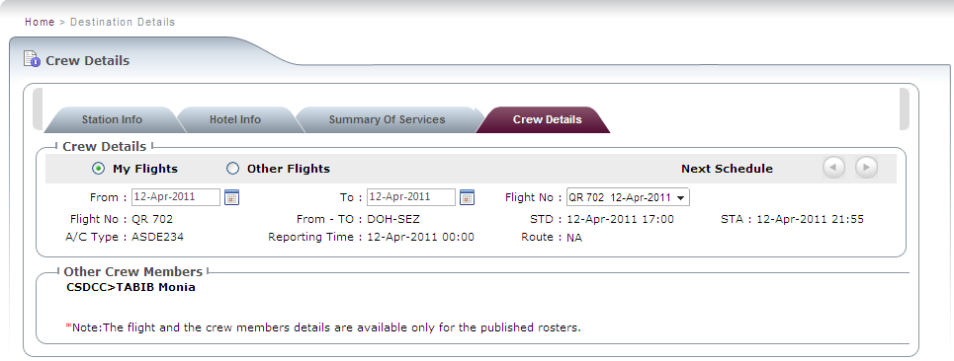

Fig: Crew Details Screen.

Summary of Services.
The Summary of Services Screen is displayed upon clicking the “Summary Of Services” link. Based on the selected flight, crew will be to view the summary of services for the entire leg. The leg can consist of other sectors as well. e.g. For a double sector or a paired flight, the screen will display the service type individually for each leg on the selected flight. It would display the service summary in grid format for Premium (Interim or NG, as applicable) and economy classes respectively. The page also has a link to view the Detailed Summary for all service types. Crew can search the Summary of services for Other QR Flights as well through the Search Option displayed on top of this screen.
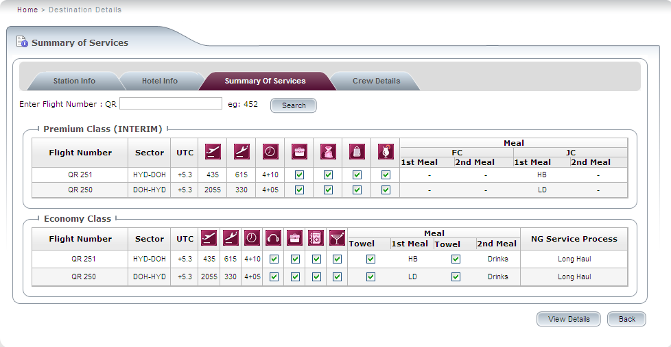
Fig: Summary of Services Screen.

Notifications
The Notifications window is displayed on the top left hand corner of the home page. Here, the user can view latest notifications/alerts. User can click on the required notification to view the details. The ‘View All’ button provided at the bottom of this window would take the user to ‘Search Notification’ page. Here the user can search for notifications based on Notification type, from date or To date. On clicking the Description (Hyperlink) user would be able to view the detailed Notification. Once the user clicks on the Acknowledge button the application would display a confirmation message. Once the message is acknowledged the notification would disappear from the notification list.

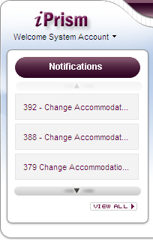

Fig: Notifications.

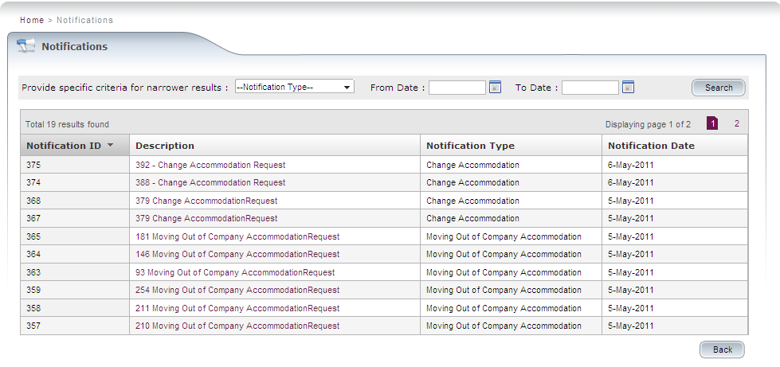
Fig: Search Notifications Screen.

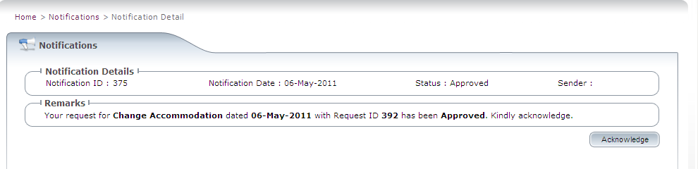

Fig: View Detailed Notification Screen.

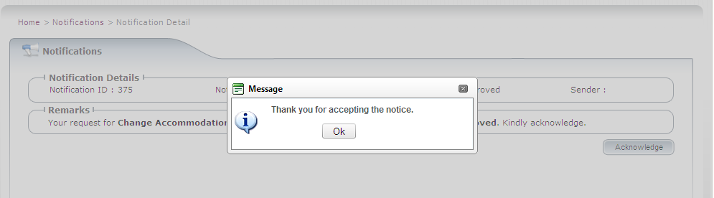

Fig: Acknowledge Notification Screen.

My Space
User can have access to My Information and My mail box from the My Space menu item. My Mail box would open the outlook inbox page of the user in a new window. Clicking on My Information menu item would display the Personal Profile of the user. User should be able to view the personal information like Photograph, Personal details, Destination visited, Milestones achieved, Qualification details, Training history and leave details. User should also be able to view and save personal documents like Passport, RP Copy etc.

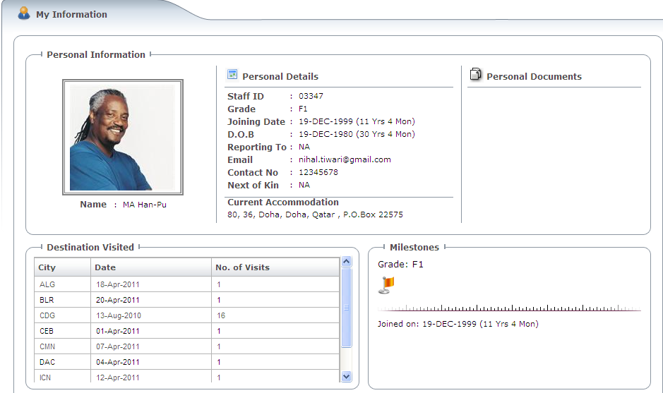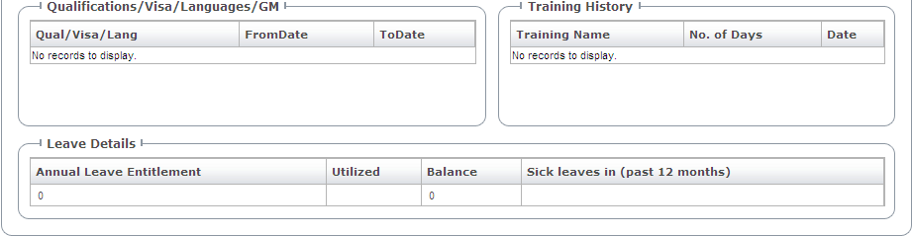

Fig: My Information Screen.

Global Weather
User can have access to Global weather Information from the link provided at the bottom of the Home page. The Global weather link would display the city weather page where the user should able to view 5 day weather report for all the QR destinations including maximum and minimum temperature. User can select the city from the drop down menu provided and click on the Go button. User can also navigate to Currency conversion and OTP page from this page.

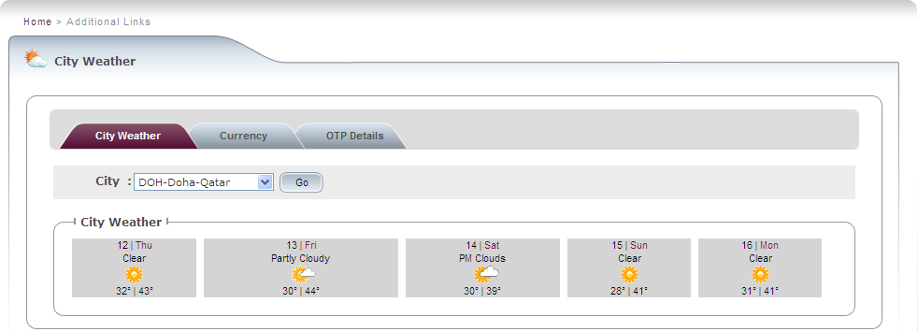

Fig: Global Weather Screen.

Currency Converter
User can have access to Currency Conversion Information from the link provided at the bottom of the Home page. The Currency Converter link would display the currency page where the user should be able to calculate currency and foreign exchange rates. User can enter the amount, select the currency from and currency to fields and click on the convert button to get the output. User can also navigate to Weather Information and OTP page from here.

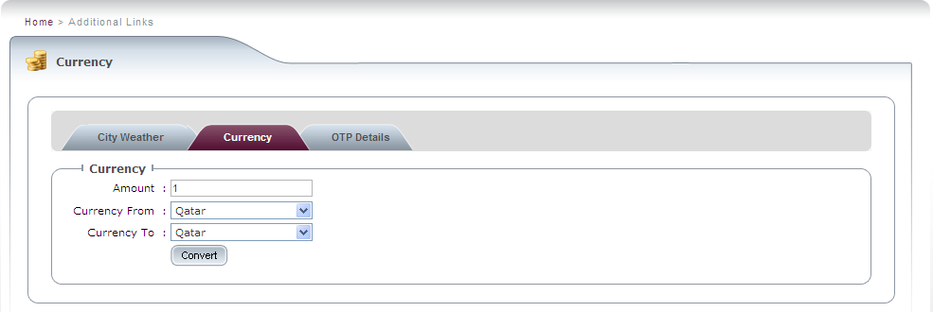

Fig: Currency Converter Screen.

OTP (On Time Performance)
User can have access to OTP details from the link provided at the bottom of the Home page. It displays OTP details of today, last week and last month. User can also navigate to Weather information and Currency page from here.

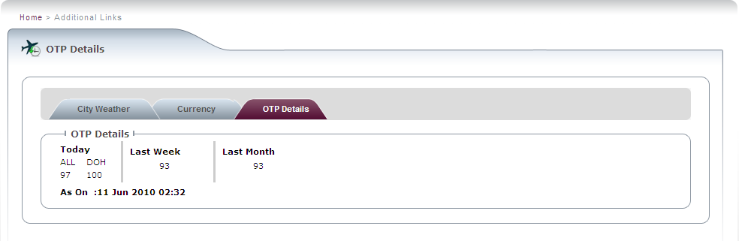
Fig: OTP Screen.

Document library
The Document Library displayed at the bottom left corner of the home page gives access to all the relevant and useful documents. User can have access to documents pertaining to Air crew notices, Cabin safety bulletins, Cabin safety manual, Cabin safety quiz, Practice sheets and various other documents type. These entire links would open a new window listing the relevant documents. User can click on the desired document link to view the detail document.

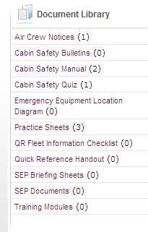
Fig: Document Library section

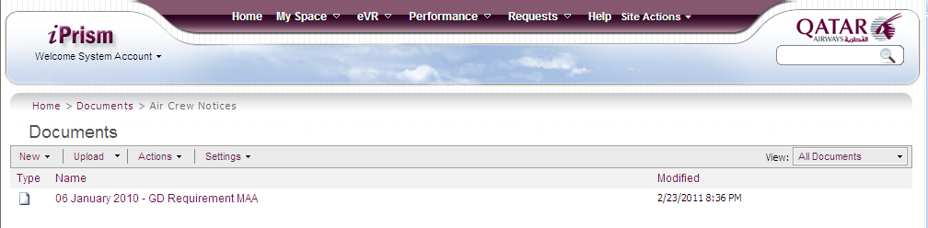
Fig: Document List.

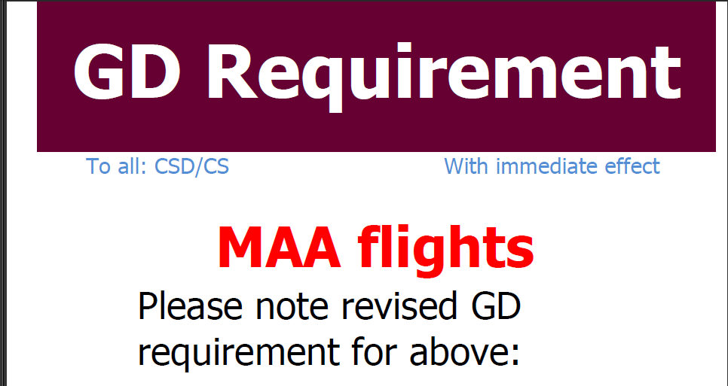

Fig: Document.

Important Links
User can have access to all the important applications under ‘Important Links’ section displayed on the bottom right hand corner. These links would directly take the user to the landing page of the particular application. Some of the important links accessible from the iPrism home page are listed below.

  - SSHR
  - Interbids
  - Estaff Travel
  - ADQ
  - OR Instant messaging

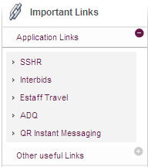
Fig: Important Links section.

News
User can view ‘My Department News’ and ‘Airline News’ from the home page. User can click on particular news heading to view the news in detail. User can scroll through the forward and backward buttons on the news bar to view all the news headings.

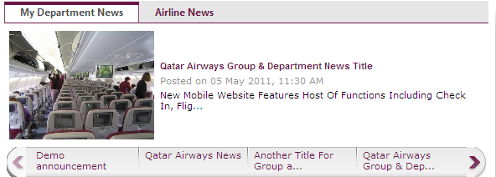
Fig: My Department News Section.

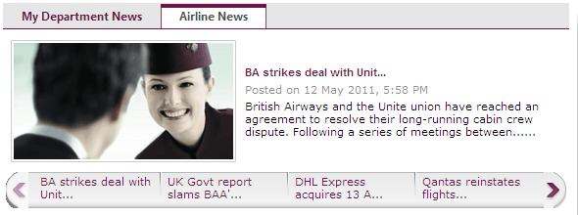

Fig: Airline News section.

eVR
The eVR module is available to crew who are eligible to enter Voyage Reports. This module can be accessed from the home page menu bar. User will have access to the following options:
- Enter eVR
- Add/Edit Flight Details
- Enter Flight Delay
- Search eVR
- Search Flight Delay

Clicking on the ‘Enter eVR’ option will take the user to the ‘Select Flight’ screen. Here the user can select from the list of flights for which an eVR has not been submitted previously. . On selecting a flight application displays three tabs i.e. -. Enter Flight Delay, Enter eVR and No eVR. User can click on any of the tab for the desired action.

On the same screen user can also view the list of eVRs for the last ten flights operated. User can either click on the eVR ID or select the flight and click on View eVR to view the entire voyage report.

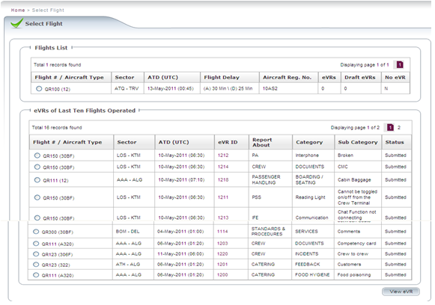
Fig: Select Flight Screen.

When user selects the ‘Enter eVR' option after selecting a flight, user will be directed to the ‘Add/Edit Flight Details’ screen to enter extended flight information. Most of the information is captured. User will need to complete the load details, additional details and crew positions.

ADD/Edit Flight Details

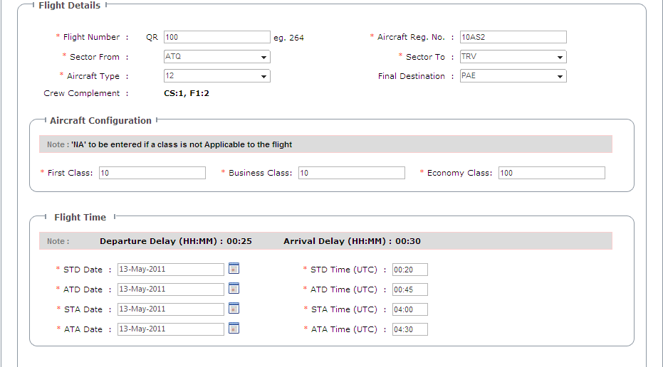
Fig: Add/Edit Flight Screen.

Clicking the ‘Add/Edit Flight Details’ option navigates the user to a screen where can search the flight for which eVR needs to be entered

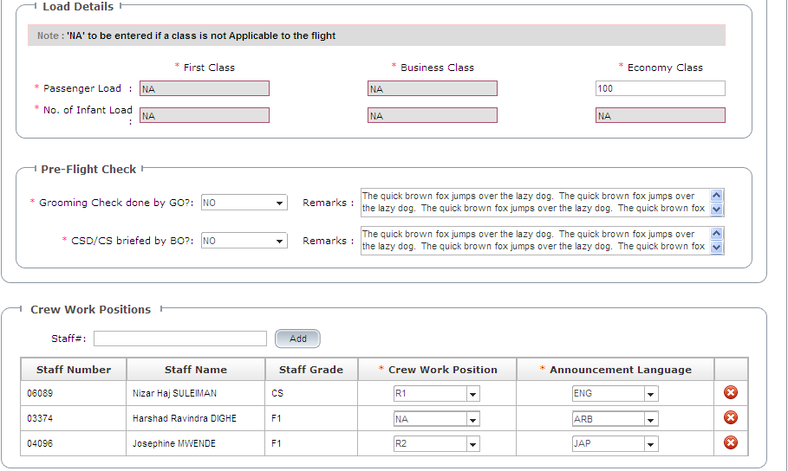
Fig: Crew Details Screen. Contd.

After updating the flight details, the user clicks on Enter EVR details like Select Report About, Passenger Details (Collapsible), Crew details (Collapsible). User also has to provide mandatory comments. User can also attach any desired document. Once all the details are entered the user can either save or submit the eVR

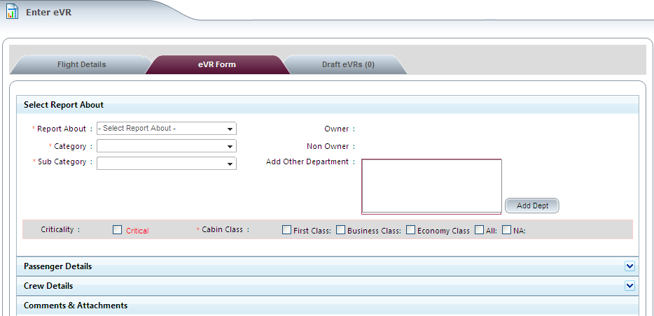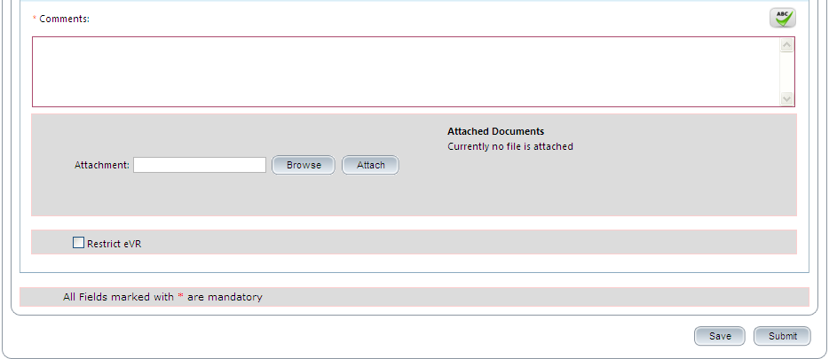
Fig: eVR Form Screen.

On clicking Enter Flight Details button application would display the enter Flight Details screen where the user can search the flight for which delay has to be entered. Once the flight is displayed user can select the flight. On selecting the user can enter and save the flight details as explained earlier. Once the flight details are entered user navigates to the Delay causes page where user can enter the Cause of arrival delay and Cause of departure delay with mandatory comments. Once the delay causes are entered user can submit the information.

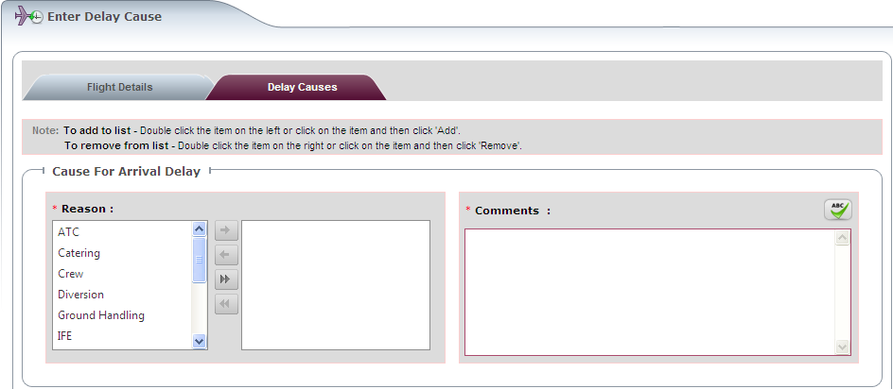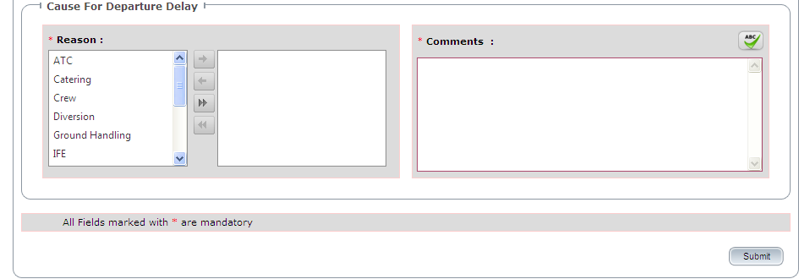
Fig: Enter Delay Cause Screen.

On clicking Search eVR user application displays the search eVR screen. User should be able to search eVR through following parameters.
- eVR ID
- Flight Number
- From date
- To date
- Sector from
- Sector to
- eVR status.

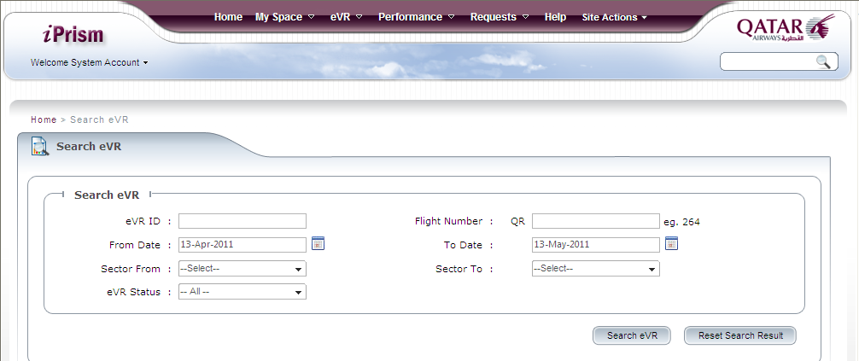
Fig: Search eVR Screen.

On clicking Search Flight Delay application displays the search Flight Delay screen. User should be able to search Flight Delay through following parameters.
- Delay Type
- Flight Number
- Comments
- Delay Reasons
- To date
- Sector from
- Sector to

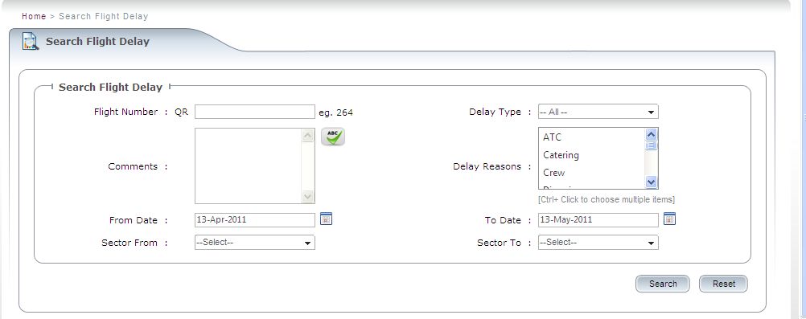
Fig: Search Flight Delay Screen.

Requests
The request option is available on the menu bar on the home page. Under Request option user will be able to find Housing sub option. On clicking the housing option application displays the Housing request page. Here user would able to make various types of housing request and can also view the list of the submitted housing requests. User can also search the submitted requests by Request type, From date and to date fields provided at the top of the page.

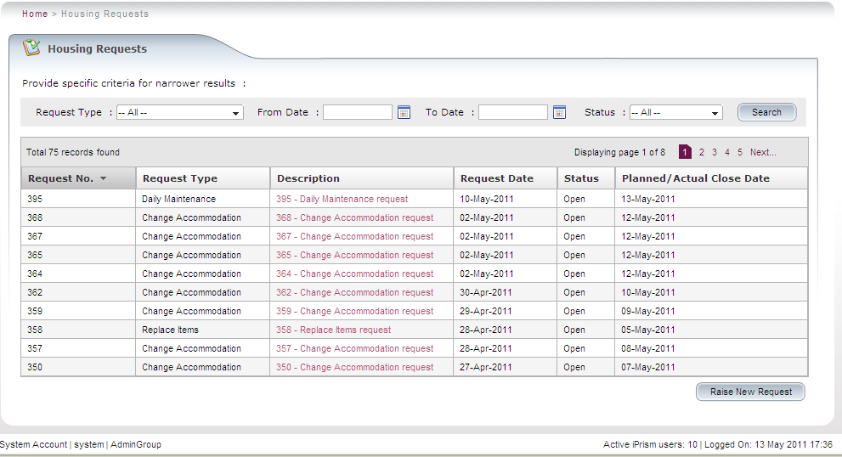
Fig: Search Housing Requests screen.

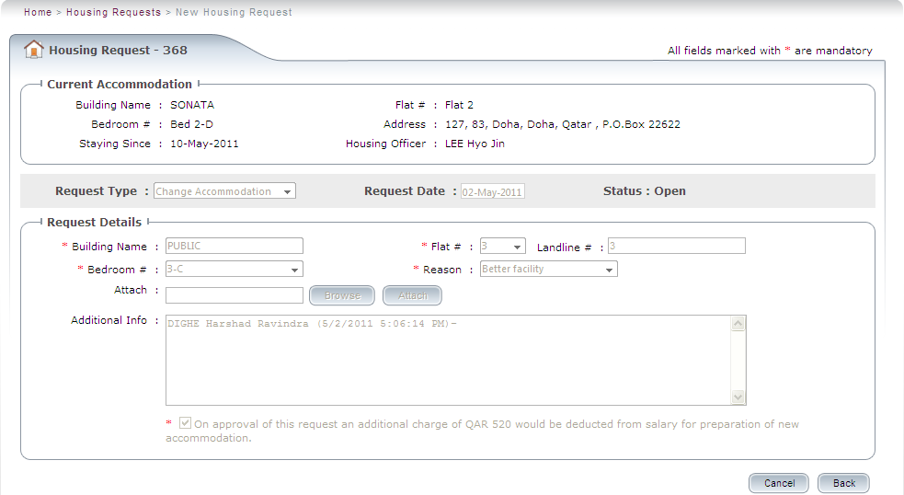
Fig: View Submitted Housing Request Screen.
User will be able to raise new housing request by clicking on the ‘Raise new Request’ button provided on the bottom right hand corner of the page. This would display ‘New Housing Request’ page where the user can raise a new request by selecting the request type from the drop down list. Once the request type is selected, application would display the Request details section along with required fields to be entered. User should enter all the required and mandatory information and click on the submit button. Once the submit button is clicked the application should display a confirmation message. The different types of housing requests that the user can raise are listed below.
- Change accommodation
- Daily maintenance
- Guest accommodation
- Moving In
- Moving out of company accommodation
- Replace items

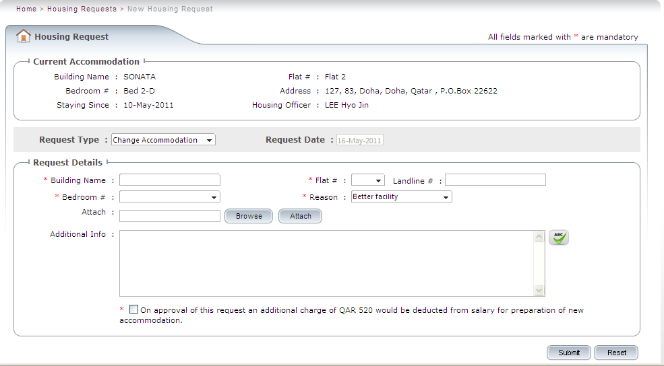
Fig: Raise Change accommodation request Screen.
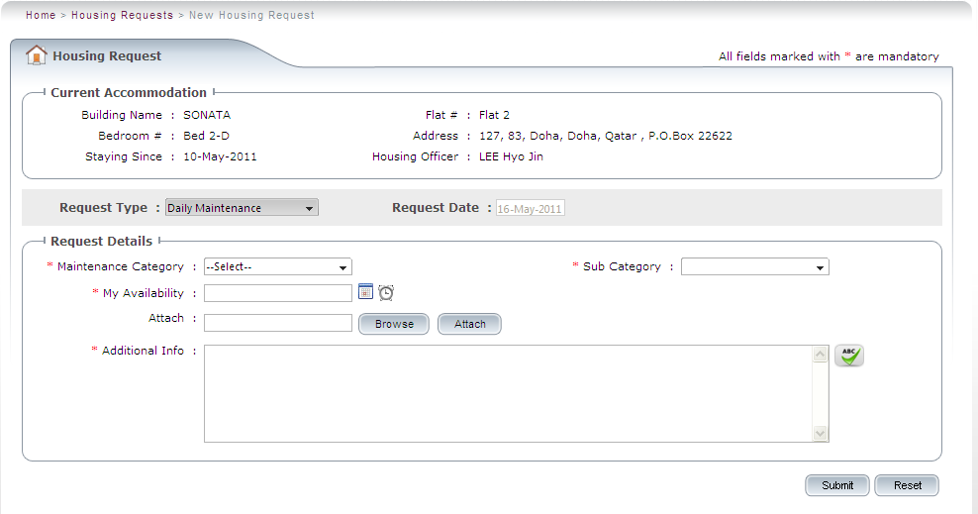
Fig: Raise Daily Maintenance request Screen

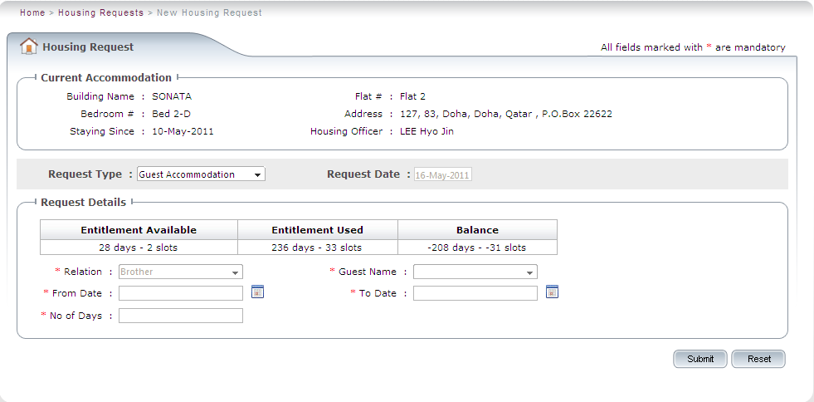
Fig: Raise Guest accommodation request Screen

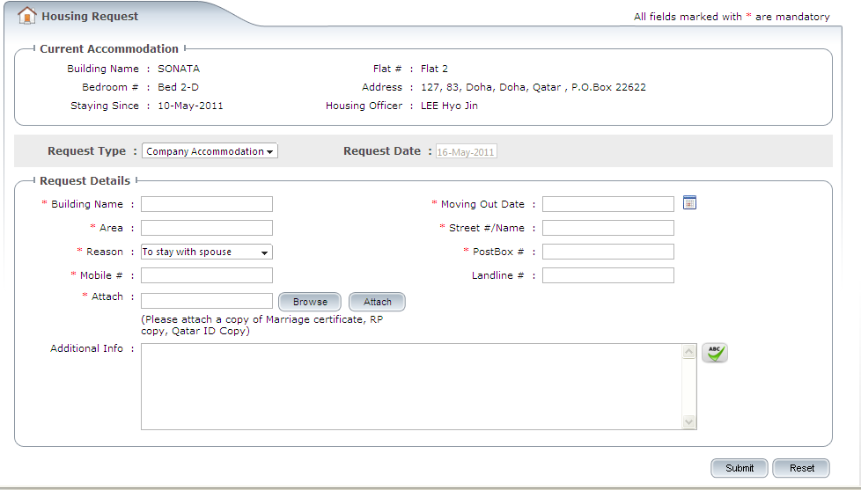
Fig: Raise Moving Out of Company Accommodation Request Screen.

Help
The help menu will have the links for the following documents.
- iPrism Administrator manual
- iPrism User Manual.
User can click on the above links to view the entire document.

End of the user reference guide

