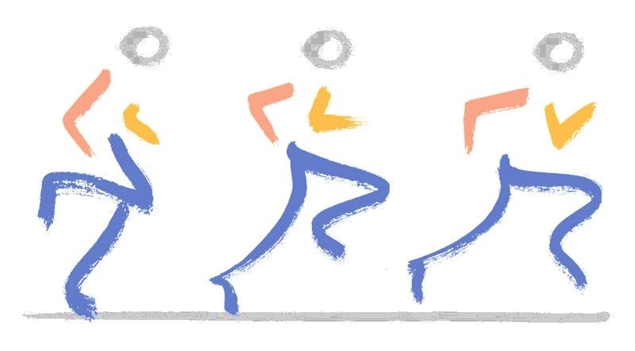

Mufaddal M. Gombera, MD

Orthopedic Surgery and Sports Medicine

Fondren Orthopedic Group

Hip Gluteus Tendon Repair (Open)

Post-Operative Instruction Checklist

FOLLOW-UP APPOINTMENT: _______________________________

DRESSING
- Maintain your operative dressing. You may remove the outer bulky dressing 48 hours after surgery.
- It is normal for the hip to bleed and swell or become bruised following surgery.
- Do not put any ointments or creams over the incisions.
- Keep the waterproof bandage on until your first postoperative visit.
- If dressing supplies were sent, remove the waterproof dressing and apply the new dressings starting on post op day 4.

BATHING
- Keep surgical incisions clean and dry. The waterproof dressing may stay on when bathing
- You may shower 48 hours after surgery.
- NO immersion of operative leg (i.e. bath)
- Brace should come off to shower

ACTIVITY
- Elevate the operative leg to chest level whenever possible to decrease swelling.
- You will be partial weight bearing (20#) with crutches after surgery for 6 weeks
- Use the brace when walking and sitting. It is not needed at night.
- Do not engage in activities which increase hip pain (prolonged periods of standing or walking).
- Avoid long periods of sitting or long distance traveling for 2 weeks after surgery.
- You may return to sedentary work or school 4-7 days after surgery, if pain is tolerable.

BRACE
- Your brace should be worn when walking for the first 4 weeks after surgery.
- The brace can be removed to shower, during exercises, and at night.

ICE THERAPY
- Icing is important in the initial post-operative period and should begin immediately after surgery.
- Use ice machine continuously or ice packs (if machine not purchased) for 30-45 minutes every 2 hours daily until your first post-operative visit.
- Care should be taken with icing to avoid frostbite to the skin.
- You do not need to wake up in the middle of the night to change over the ice machine or icepacks unless you are uncomfortable.

DRIVING
- Please do not drive while you are taking narcotic pain medication.
- It is best to wait to start driving until you are evaluated in the office after surgery.

EXERCISES
- Discomfort and hip stiffness is normal for a few days following surgery. It is safe to bend the hip within the brace parameters. Avoid flexing the hip past 90 degrees.
- Perform ankle pumps continuously throughout the day.
- Formal physical therapy (PT) typically begins 3-5 days after surgery. A prescription and protocol are provided with your discharge paperwork.

MEDICATIONS
- It is not uncommon for patients to encounter more pain on the first or second day after surgery when swelling peaks. Use your pain medication as directed.
- Common side effects of the pain medication are nausea, drowsiness, and constipation. To decrease the side effects, take the medication with food. If constipation occurs, consider taking an over the counter laxative and be sure to drink plenty of water.
- If you are having problems with nausea and vomiting, contact the office.
- Do not drive a car or operate machinery while taking the narcotic medication.
- Please avoid alcohol use while taking narcotic pain medication.
- For 2 weeks following surgery take one Aspirin 81mg tablet twice daily to lower the risk of developing a blood clot after surgery.

- Prescriptions Given:
  - BABY ASPIRIN (81mg) 1 TABLET TWICE A DAY
Take 1 Baby Aspirin twice daily for 2 weeks to reduce the risk of a blood clot
  - NORCO 1 TABLETS EVERY 6 HOURS AS NEEDED FOR PAIN
Do not exceed more than 4000mg of Acetaminophen per 24 hours
  - NAPROSYN 1 TABLET EVERY 12 HOURS WITH FOOD (Anti-inflammatory)
If you cannot tolerate this or NSAIDs, please let us know. Ok to take with Aspirin
Do not combine other NSAIDs (Ibuprofen, Advil, Aleve, Etodalac, etc.)
  - ROBAXIN 1 TABLET EVERY 12 HOURS AS NEEDED FOR PAIN
For the first week after surgery. Helps with pain control and muscle spasm.

FOLLOW-UP VISIT
- If you need to reschedule your follow-up appointment, please call us at 713-794-3457.
- Typically, the first post-operative appointment following surgery is 10-14 days following surgery.
- The first post-operative appointment will be with our Physician Assistant. She will assess the incision, go over the surgery and your recovery, and answer any questions you may have.

EMERGENCIES
- Contact us if any of the following are present:
  - Painful swelling or numbness (note that some swelling and numbness is normal)
  - Unrelenting pain
  - Fever (over 101° – it is normal to have a low grade following surgery) or chills
  - Continuous drainage or bleeding from incision (a small amount of drainage is expected)
  - Difficulty breathing
  - Excessive nausea/vomiting
  - Calf pain

For further questions, or if any problems develop, please call our office at (713) 794-3457.
During after-hours and weekends, you can reach the on-call physician at (713) 799-2300.

If you have an emergency that requires immediate attention proceed to the nearest emergency room.

