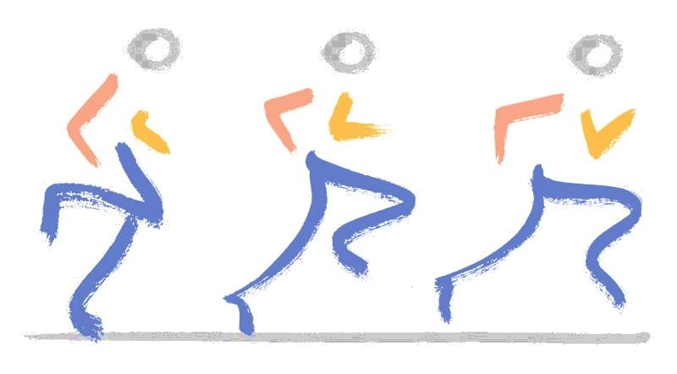
Mufaddal M. Gombera, MD
Orthopedic Surgery and Sports Medicine
Fondren Orthopedic Group

What to Expect from your Surgery for
Hip Gluteus Tendon Repair

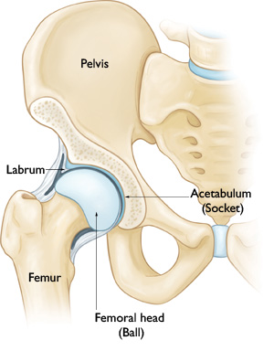
Hip Joint Diagram – Front View

A Patient’s Guide

I think many people can find going to see the doctor an emotional and sometimes difficult experience. I think it is more stressful when potential surgery is a consideration. While many of the things we discussed are simple, one may quickly forget the details. Hopefully this letter will serve to remind you of our meeting, review what was discussed, and answer any questions that arise.

Gluteus Medius/Minimus Tears
The gluteus medius and minimus are muscles on the outside of the hip, which is important for abduction (lateral movement away from the body). These muscles help one stand up right and walk without a limp.

Gluteus medius and minimus tears, also known as the rotator cuff tear of the hip, involve tearing of the gluteus medius muscle from its attachment to the greater trochanter, commonly known as the “lateral hip bone”. Gluteus medius/minimus tears may cause persistent pain mimicking trochanteric bursitis. They may also cause weakness and limping.

When physical therapy and injections in the trochanteric bursa do not provide lasting relief, the diagnosis of gluteus medius and/or minimus tear should be suspected. In many cases, a torn gluteus tendon can be repaired sewing the torn part of the gluteus tendon back to the bone using tiny suture-anchors. This procedure has a high success rate in treating pain, and may restore strength to the gluteus muscle.

How We Perform the Tendon Repair
We make a small incision in the outer part of your hip. We remove the irritated bursa (if present), and make a small window (fasciotomy) in the iliotibial (IT) band. We then have direct visualization of the gluteus tendon.

We then use small plastic screws (anchors) to suture the tendon back down to bone. This secures the repair and allows the tendon to heal.

The operation duration will vary depending on the problem in the hip joint but can last from 40 minutes to 80 minutes, or even more. At the end of the procedure medications may be injected into the hip to minimize pain after the surgery. The incisions are closed with sutures. Finally, a further dressing is placed over the incisions.

When you arrive at Texas Orthopedic Hospital a nurse will have you sign the Operative Permit. The name of the operation I will be doing is “Hip Gluteus Repair”. Additional procedures may be included depending upon the problem(s) in or around your hip joint.

Anesthesia
The surgery is almost always performed under general anesthesia. If a general anesthetic is given, then there may be an additional regional local anesthetic block.

Time in the Hospital
Patients enter the hospital in the morning, have the surgery and will typically spend one night in the hospital.

What do I need to do prior to surgery?
There is a pre-registration and a pre-admission process. Both must be completed no less than 7-days prior to your surgery. Both processes can be completed when you come in to pre-admission; however, the pre-registration process may also be completed on-line.

Pre-Registration
To pre-register on-line please visit www.texasorthopedic.com and go to the Menu tab in the top left corner. Scroll down to the “Patients & Visitors” tab, and click on “Online Pre-Registration”. In the middle of the page under “MyHealthOne”, click on “Create your account or Sign in”. You will then be taken though the pre-registration process.

Pre-Admission Testing (PreAdmit)
The PreAdmit appointment is MANDATORY and is necessary in order to obtain surgical clearance for you to receive anesthesia for your surgery. While in the PreAdmit department on the 3rd floor of Texas Orthopedic Hospital, you will be interviewed by the nursing and anesthesiology teams. If you would like to schedule an appointment, please call 713-794-3525 between the hours of 8 a.m. and 5 p.m. If you would like to be seen on a walk-in basis, their office hours are 8 a.m. to 5 p. m., Monday through Friday. This needs to be completed within 30 days but AT LEAST ONE WEEK PRIOR to surgery.

After Hip Surgery
Usually, you will feel some discomfort in your hip. In addition, discomfort can be experienced in the lower back, buttock, knee and ankle. The discomfort is normally reduced with appropriate pain medication. There is often some swelling in the groin, buttock and thigh. There is often bruising in the outer part of the leg. The swelling and bruising reduces over the following few days.

You will be asked to limit the amount of weight you put through your operated leg. For gluteus repairs, a period of protection is required for the tendon repair to heal. This typically requires 4 weeks on crutches or a walker. You will also use a brace for 4 to 6 weeks when walking that limits hip motion. It may be removed when bathing, exercising, sitting, and sleeping.

You will return to the clinic 10 to 14 days after the surgery for your first post-operative visit. At this appointment, your incision may be inspected. The incisions are closed with buried sutures under the skin, so no sutures will need to be removed. A further explanation of the surgery will be provided and there will be an opportunity for specific queries to be answered. Any subsequent appointments will be arranged and will be guided by the surgery performed.

We will employ an appropriate rehabilitation program for you following the surgery, depending on the surgery performed. Your physical therapist will guide your return to sporting activities (running etc.) depending on your progress. This is extremely variable between individuals, depending on the surgical findings and the length of symptoms prior to surgery.

My personal feeling is that the goal of this operation is to eliminate or diminish pain and allow you to comfortably perform normal activities of daily living.

In the majority of cases, 8 to 10 weeks after surgery you should be walking relatively pain-free. Remember, however, that it may take 6 months (or more) to return to an
elite level of competition/fitness. Any unexpected increase in pain can be treated with ice packs and anti-inflammatory medication.

There are some activities to avoid or take care with up to 8 weeks following surgery. These include the following:

- Prolonged standing, especially on hard surfaces.
- Prolonged walking i.e.; around shopping centres.
- Heavy lifting
- Squatting / crouching

Potential Risks and Complications
All surgery carries risks, although every effort is made to minimize them. The complications can be temporary or permanent. Reassuringly, permanent complications following hip surgery are rare and the majority are temporary. There are, however, risks which include the standard risks of undergoing general anaesthesia and specific risks associated with hip surgery.

Complications might include, but are not limited to: re-tear of the repair, infection, fracture, increased pain, impotence, bleeding, nerve palsies, abandoned procedure, deep-vein thrombosis, instrument breakage, avascular necrosis of femoral head, delayed wound healing, exacerbation of symptoms, development of arthritis, stiffness, need for further surgery, and the risk of anesthesia itself. However, many of these complications are extremely rare. For example, the exact rate of infection following hip surgery is less than 1 in 1000.

My purpose in listing the types of complications that could possibly occur is to inform, not frighten you. While it would be preferable if we could perform surgery without any risk, this is not the case. The complications are rare (less than 1%) but regrettably, in spite of our best efforts, they do occur. I feel it is your right to know.

Alternative Treatment Options
While I believe surgery is the best course of action, other treatments are available. These vary from no treatment, just living with the condition, to physical therapy exercises, medication or injections. You may have tried some or all of these already. We can arrange for any or all of these options if you desire.

What I Recommend
In view of your description of your problem, my physical examination and review of the X-Rays/MRI, I believe that surgery is medically indicated on your hip. The indications for surgery are persistent pain interfering with your activities of daily living, work and/or sports.

Success of the Surgery
This type of surgery is successful about 85-90% of the time. No hip operation is 100% successful in every individual but the procedures we perform are reliable and will help restore the potential function in your hip. The operation is most successful at relieving pain. What is harder to accomplish is the return to vigorous use of the leg in work and/or sports. Whether you can return to your previous level is an individual matter and depends on the damage to your hip, how well it heals, how well you rehabilitate and how strenuous is your desired level of work or sports. Because of the many variables involved, I can make no guarantees other than to assure you I will deliver the very best medical care possible.

Returning to Work
For most office jobs, I recommend 1-2 weeks off work. When you return to work your hip will be sore but you should be able to manage as long as you do no lifting, pushing, pulling or carrying. You will generally need 4 to 6 months before recovery is complete and return to heavy lifting. There are no fixed rules for return to work. What I have described above are reasonable guidelines that I hope will help you and your employer ease your return to the workplace.

Pain Medication after Surgery
Your pain medication prescription will be given to you the day of surgery. Because of Texas laws and regulations, a written copy must be given as we cannot call in strong pain medication. You may also be started on Aspirin or another blood thinner to prevent blood clots.

Please take your pain medication as directed. That means that you may take the pills every 3-4 hours as needed. Take the medicine with food in your stomach. Taking the medicine on an empty stomach can cause nausea. You do not have to take the pills if simple rest, repositioning or the ice pack controls the pain. When you need more medication, contact your pharmacy and they will call the office so that we may refill the prescription. We cannot do this after 5:00 PM, as no one will be in this office. We cannot refill narcotic medication on weekends. One of my colleagues at the Fondren Orthopedic Group is available 24 hours a day, 7 days a week but we ask that you restrict after hours and weekend call to emergencies only and let us handle less urgent problems during the week.

Questions About Your Health
Although the operation involves your hip, your entire body will react to the anesthesia and surgery. Your general medical condition is obviously important. Before surgery you must see the anesthesiologist. They will go over your medical condition and request any tests (blood tests or EKGs) or consultations with other physicians if necessary.

If You Have More Questions
We encourage you to return to the office for a further discussion at any time. We will do our best to answer any questions by phone as well. We have a lot of information on our website, www.gomberamd.com. There are surgical animations on the website as well.

How to Schedule Surgery

Contact our office at (713) 794-3457 or info@gomberamd.com

