# File overview

The email includes a number of attachments.

1. wuenic_ver_3.pl: This is the original file I received from the WHO (written by Tony Burton and Robert Kowalski). I made a few very minor modifications:

* estimation process is not “autostarted”, one has to invoke estimate manually.
* results are not written to the file wuenic.out, but to a file out/(countrycode).pl.v30.txt

2. wuenic_ver_3_9.P: This represents my first attempt to clean up the code from V3 without changing any of the results.

* results are written a file out/(countrycode).pl.v39.txt

If you check the two files out/(countrycode).pl.v30.txt and out/(countrycode).pl.v39.txt, they should be identical.

3. wuenic_ver_4.pl: This file includes a few more clean ups that change the output, but the WUENIC is still identical to V3.0 and V3.9. Changes mostly affect the order of the comments in the file. Unnecessary comments have been removed (e.g., corrections for recall bias in surveys that are ignored by the working group), and some messages have been cleaned up (e.g., consistent use of spaces).

* results are written a file out/(countrycode).pl.v40.txt

If you compare the two files out/(countrycode).pl.v39.txt and out/(countrycode).pl.v40.txt, they should yield identical WUENIC estimates.

4. wuenic_ver_4.R: This is the translation of the Prolog program to R statistical programming language.

* results are written a file out/(countrycode).pl.r.txt

If you compare the two files out/(countrycode).pl.v40.txt and out/(countrycode).pl.r.txt, they should be identical. Tested for all countries with country codes starting with A and B.

5. diff.R: This file is used to compare the WUENIC estimates from V3.9 (Attachment 2) and V4 (Attachment 3).

6. estimate.bat: This is a MS-Windows batch file that invokes XSB-Prolog to run Attachments 1 and 2, SWI-Prolog for Attachment 3 and the checksums, and R for attachments 4 and 5.

7. all.bat: This is a MS-Windows batch file that invokes estimate.bat for all countries.

8. 2023-12-08-matthias.pptx: Last weeks presentation that you liked so much 😊

9. readme.docx: The present document.

# Installation

It is easiest to clone the Github repository <https://github.com/mgondan/wuenic>. You should end up with a wuenic folder with subfolders xsb, R, ppt, prolog.

The next step is to install xsb prolog (for V3 and V3.9), SWI-Prolog (for V4) and R on your computer. Contact me in case you need help.

In the next step, you need to add the two prologs and R to your PATH variable. On my system (in German, sorry), it looks like this:

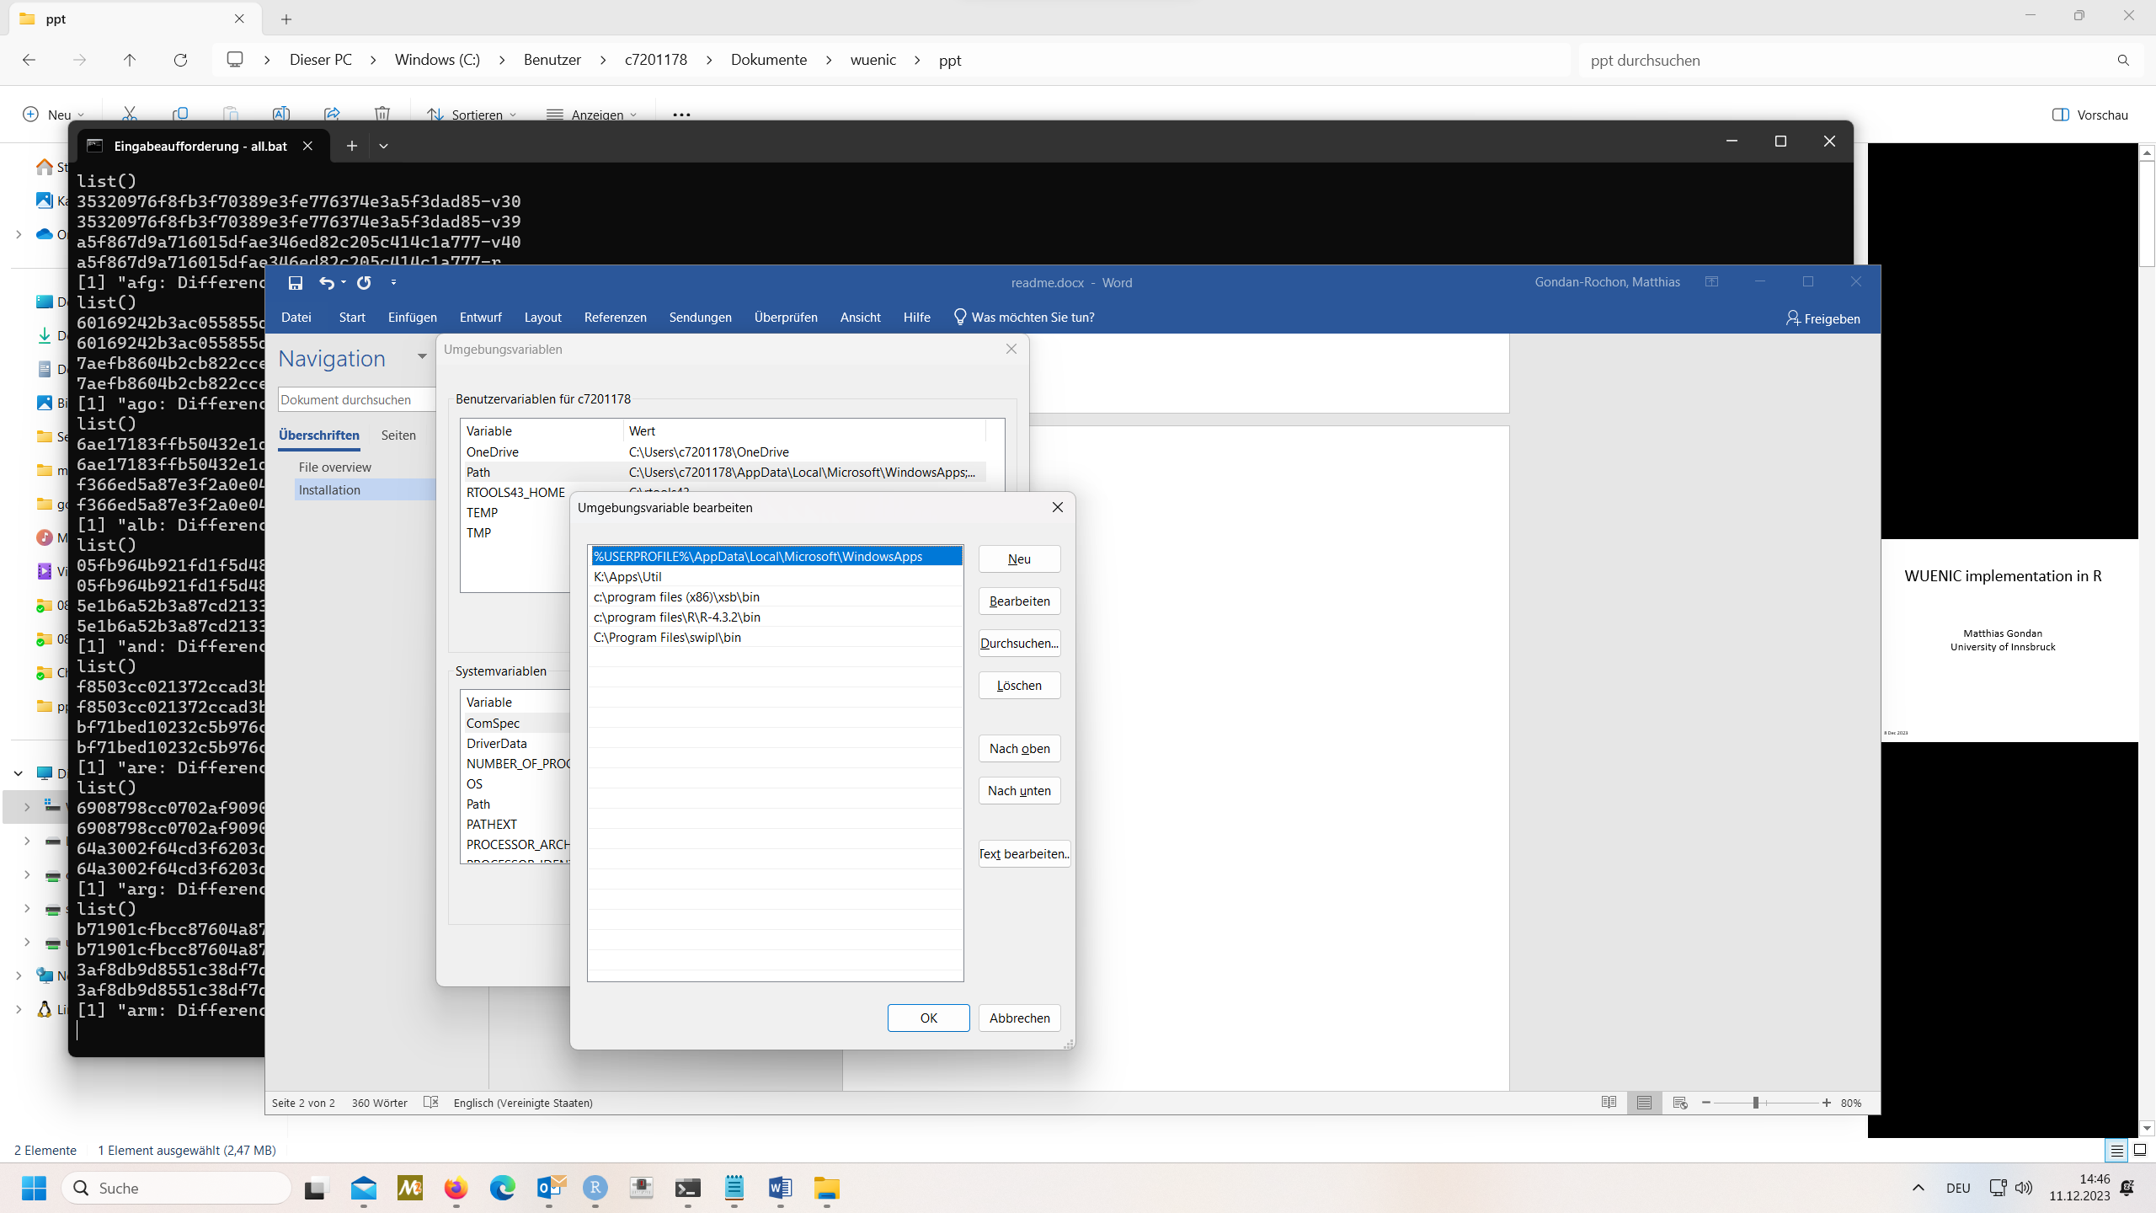

Then start a command line window, and run “all.bat” from the wuenic folder.

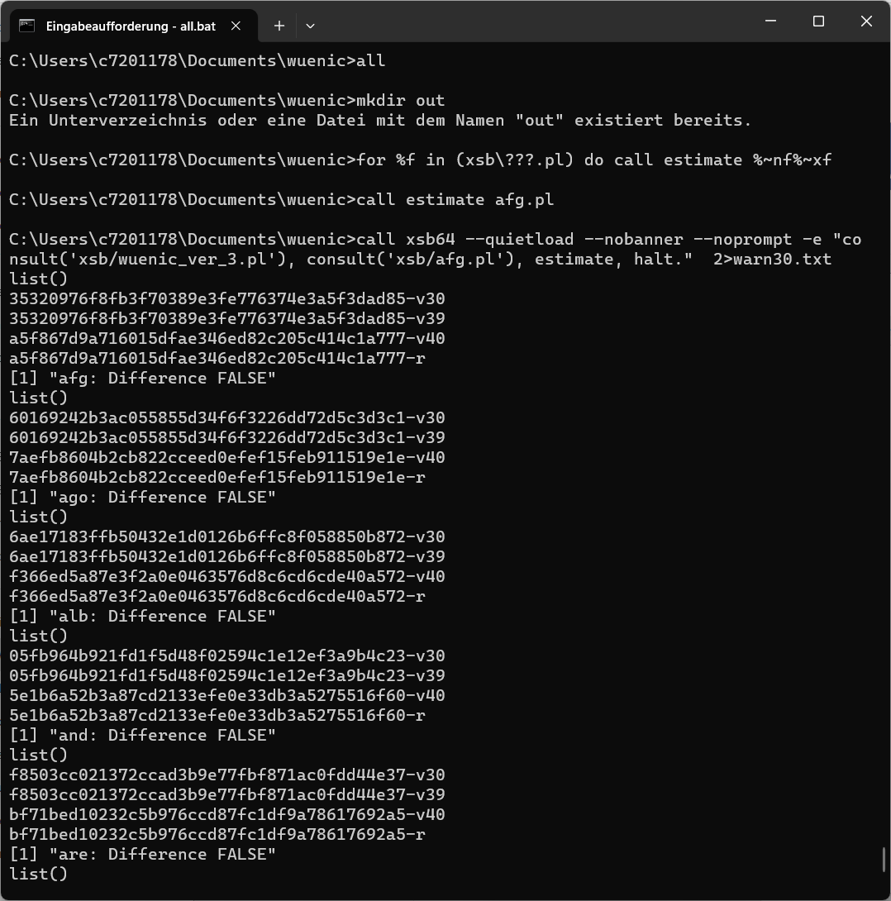

You typed in “all”, the other output is from the programs. We can see the two checksums from afg (Afghanistan) for V3 and V39 (identical), then the checksums for V4 and V4 in R (identical). The checksums for V39 and V4 differ, as expected, but the WUENIC estimates for V39 and V4 are the same (difference is FALSE).

I suggest another online meeting on Friday this week to dive into the technical details with the programmers of your group.

Best regards, Matthias