

Assignment 4.1 Exercise
In this assignment, you will extend the concepts demonstrated in the lab portion to analyze income levels within a specific ethnic group: Native Americans. The goal is to understand how applying differential privacy impacts our analysis when focusing on a smaller, often underrepresented population group.
Specifically, you will explore how the Laplace mechanism affects the income level counts for Native Americans. Education and other government funding often depend on accurate data about income levels, and differential privacy can introduce noise that may distort these figures. Your task will be to determine how varying the privacy budget (epsilon) changes the accuracy of these counts and to reflect on the broader implications of these changes, particularly when allocating resources to underrepresented groups.

Step 1: Calculate Original Counts for Income LevelsDisplay the original income counts for Native Americans:
Low: 45
Middle: 39
High: 27

Step 2: Apply Laplace Mechanism to Add Noise
Apply the Laplace mechanism to add noise with at least two epsilon values.
Attach a screenshot or output of your code here:
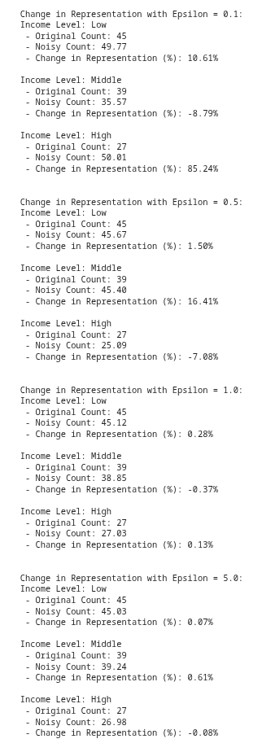

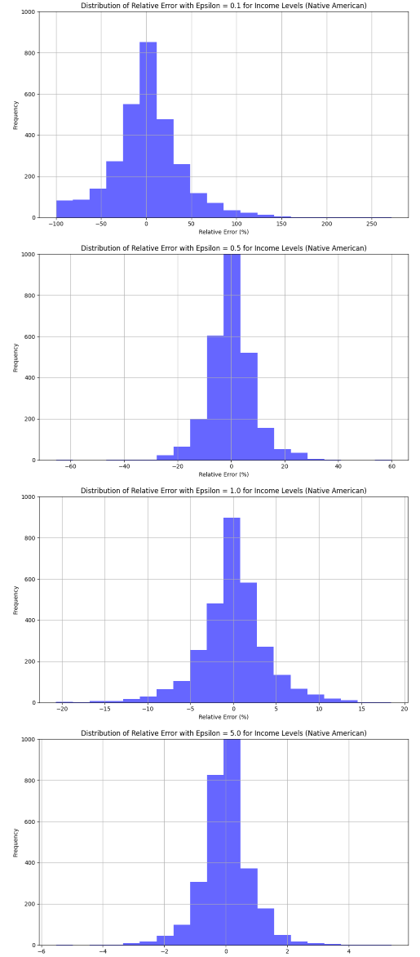
Step 3: Generate Relative Error Visualization
Screenshot the generated histograms for relative errors using the Laplace mechanism and paste your output for both below:

Step 4: Observation and Reflection
1. Briefly describe your findings. How does changing the value of epsilon affect the relative error?
Your response:
Epsilon has an inverse relationship with relative error. Lower epsilon values (0.1, 0.5) add more noise for stronger privacy but create relative errors of 30-100%+ for small populations. Higher epsilon values (1.0, 5.0) add less noise, producing errors typically under 10-15%. Small populations like Native Americans (111 total) are especially sensitive because the same absolute noise creates much larger percentage changes.
2. Is there an epsilon value that produces useful results while still providing privacy protection?
Explain your reasoning.
Your response:
Epsilon = 1.0 to 5.0 provides the best balance. Lower values (0.1, 0.5) distort small counts too much for useful policy decisions. ε=1.0 offers reasonable privacy with ~10-15% error, while ε=5.0 maximizes utility with ~5-10% error. The choice depends on whether privacy or accuracy is prioritized for resource allocation decisions.

3. Discuss how the trade-offs between privacy and data utility in differential privacy might impact smaller communities in a dataset (i.e. deflated or over-inflated representation). How might the added noise impact decision-making, especially in the context of census data?
Your response:
Differential privacy disproportionately harms smaller communities through:
  - Magnified relative errors (same noise = larger % error for small groups)
  - Invisibility (groups can appear to vanish or be severely misrepresented)
  - Resource mis-allocation (funding formulas based on noisy census data)
  - Perpetuating historical inequities (minorities already under-counted face worse data quality)

